Hallucination Reduction Experiment Report
This report includes tables and figures generated by the benchmark. Lower detector scores mean less hallucination.

Overall Results (All Models)
Overall hallucination scores
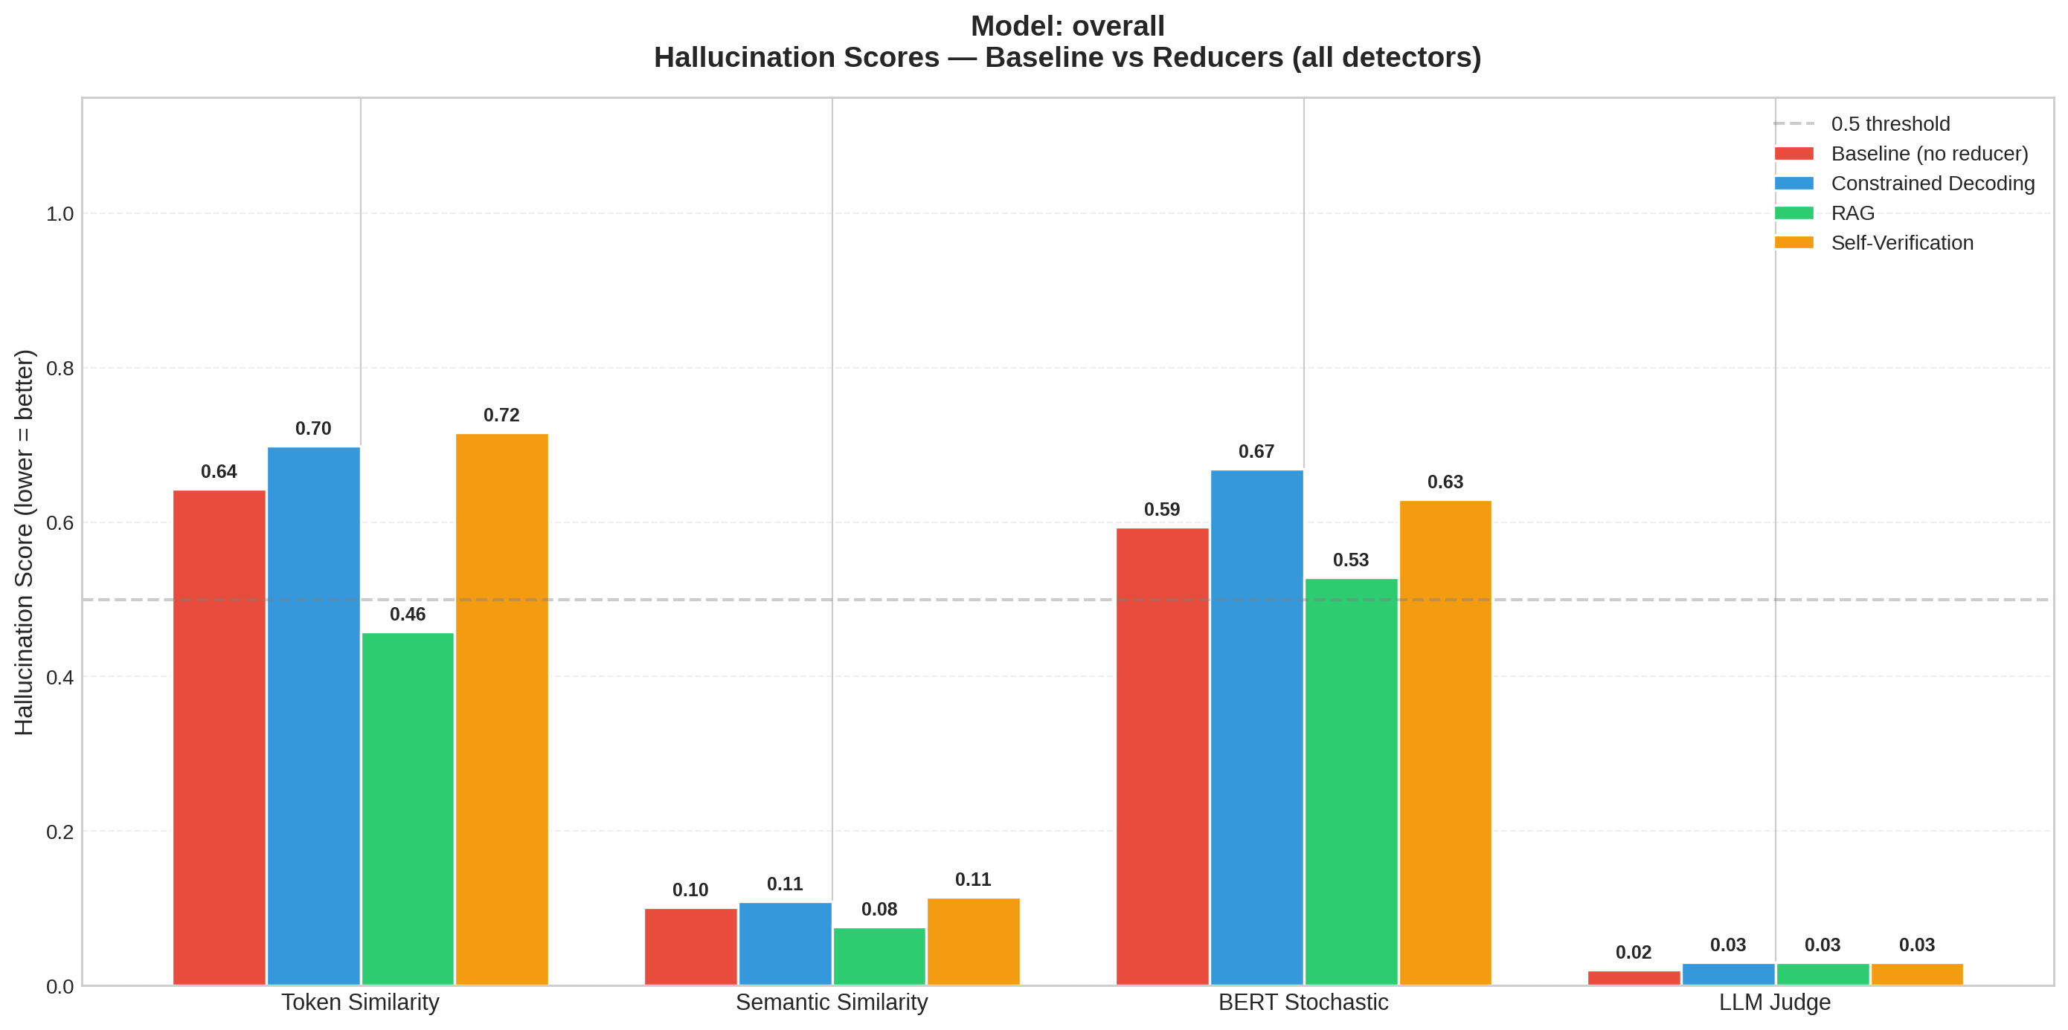
Overall per-detector scores
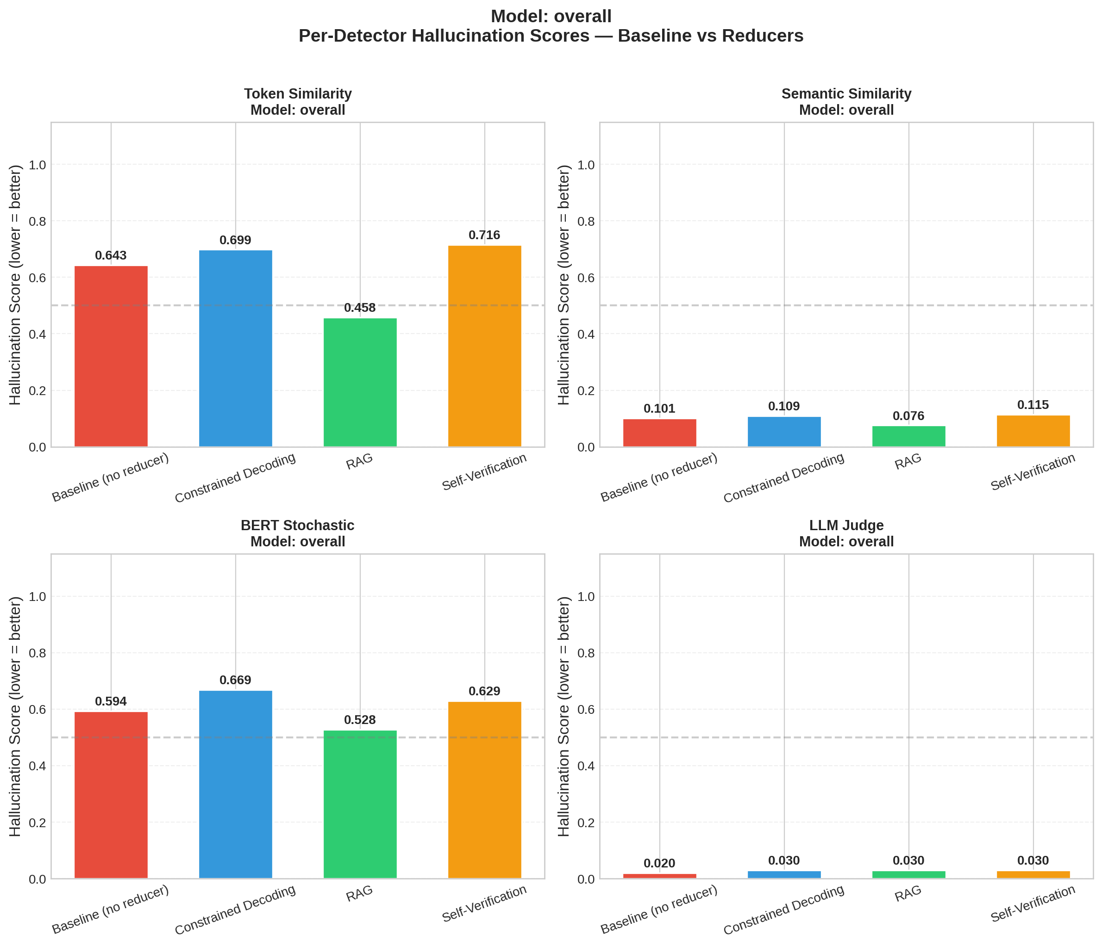
Overall score reductions vs baseline
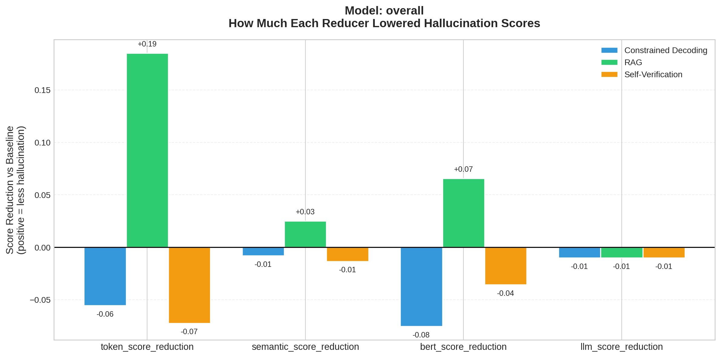
Overall latency
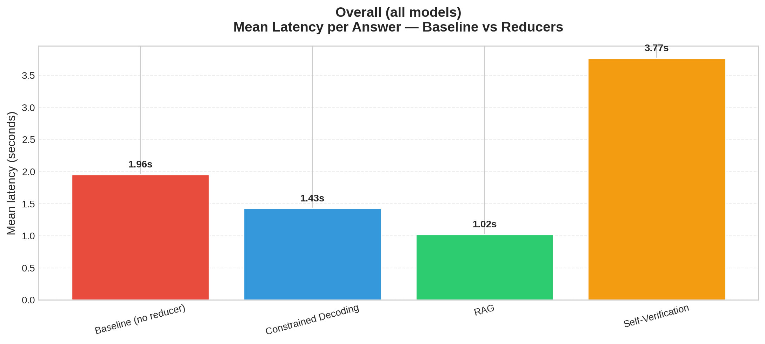

Per-Model Results

Model: llama3:latest
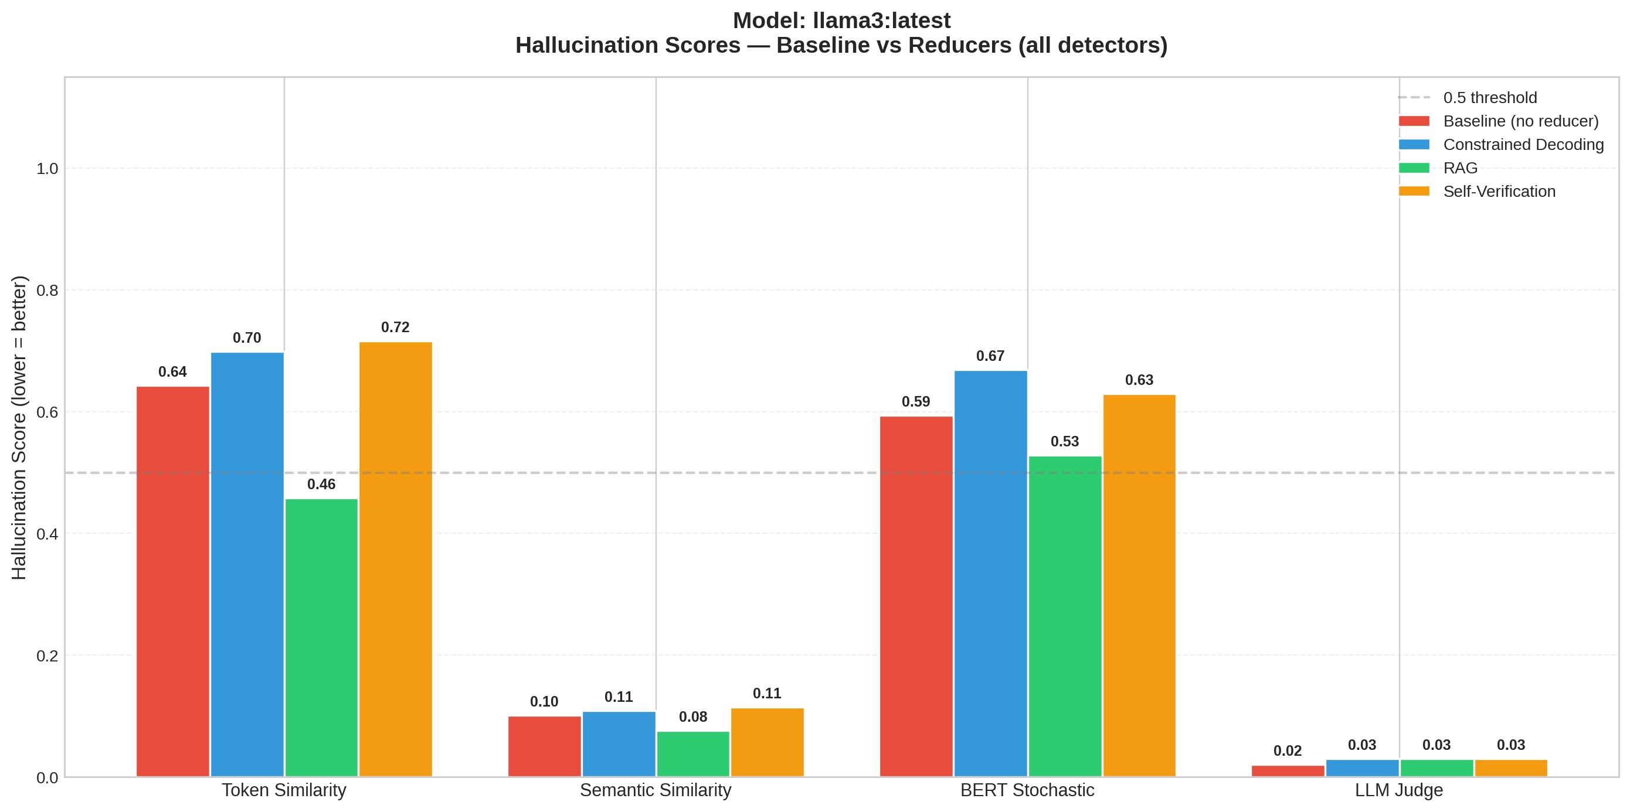
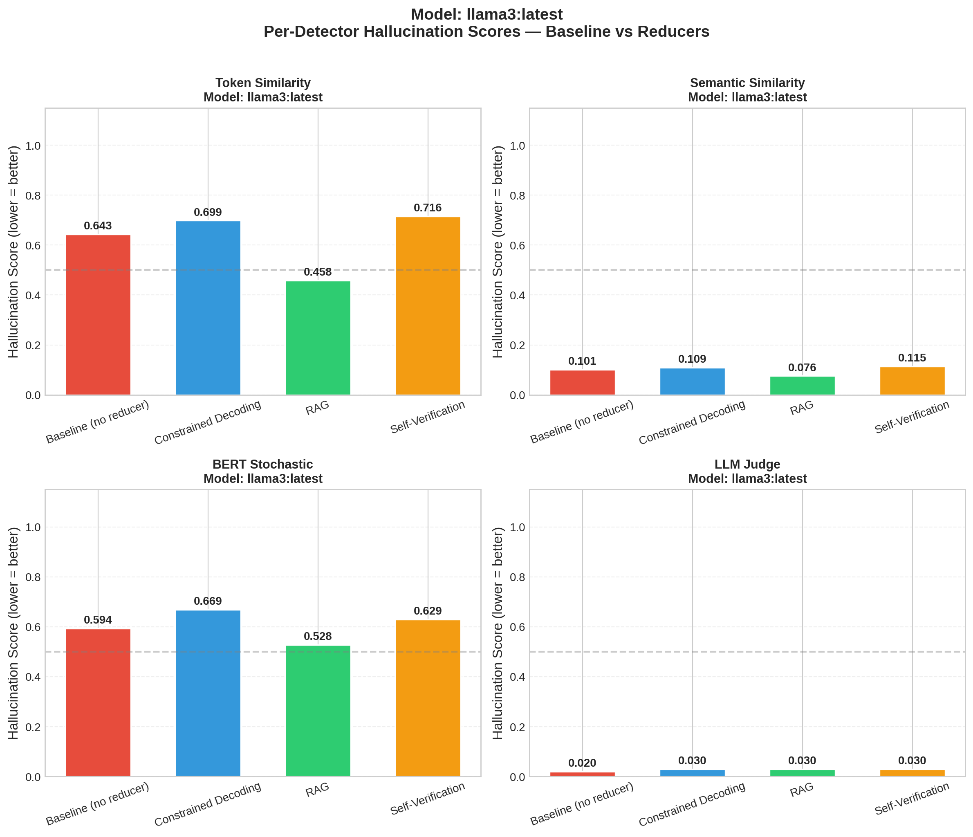
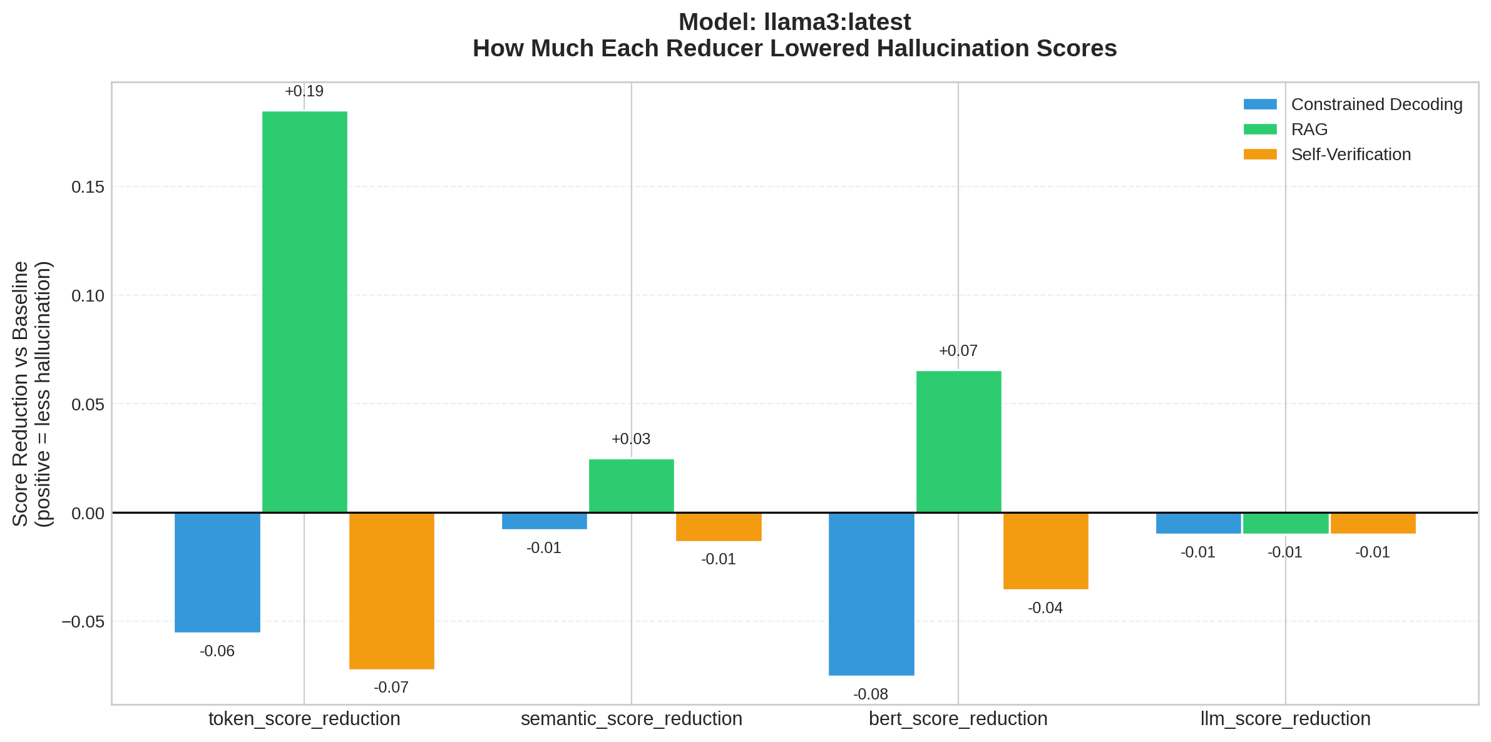
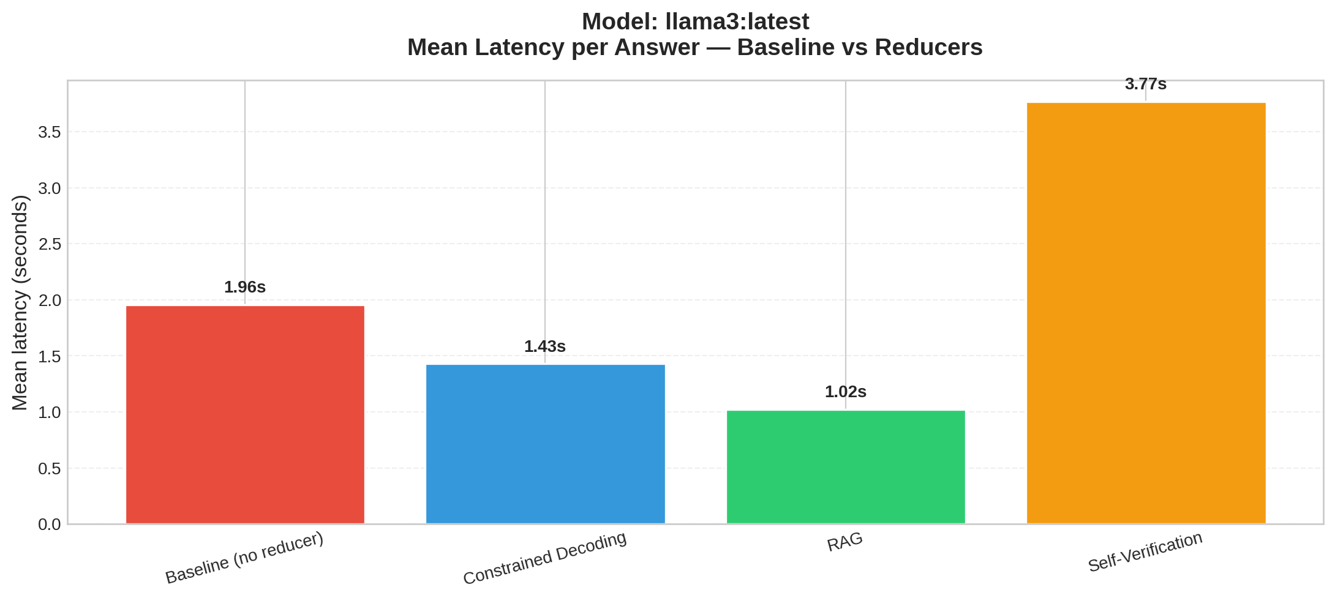

Summary Table (Mean Scores)
model | dataset | reducer | token_score | semantic_score | bert_score | llm_score | token_accuracy | semantic_accuracy | bert_accuracy | llm_accuracy | n_samples | mean_latency_s
llama3:latest | synthetic | baseline | 0.6433 | 0.1013 | 0.5937 | 0.02 | 0.4 | 1.0 | 0.2 | 1.0 | 5 | 1.956
llama3:latest | synthetic | constrained_decoding | 0.6989 | 0.1094 | 0.669 | 0.03 | 0.2 | 1.0 | 0.0 | 1.0 | 5 | 1.43
llama3:latest | synthetic | rag | 0.4583 | 0.0762 | 0.528 | 0.03 | 0.6 | 1.0 | 0.2 | 1.0 | 5 | 1.024
llama3:latest | synthetic | self_verification | 0.7157 | 0.1147 | 0.6293 | 0.03 | 0.2 | 1.0 | 0.0 | 1.0 | 5 | 3.77

Reductions vs Baseline
model | reducer | token_score_reduction | semantic_score_reduction | bert_score_reduction | llm_score_reduction | token_score_win_rate | semantic_score_win_rate | bert_score_win_rate | llm_score_win_rate
llama3:latest | constrained_decoding | -0.0556 | -0.0081 | -0.0754 | -0.01 | 0.4 | 0.2 | 0.4 | 0.0
llama3:latest | rag | 0.1851 | 0.0251 | 0.0656 | -0.01 | 0.8 | 0.2 | 0.8 | 0.2
llama3:latest | self_verification | -0.0724 | -0.0134 | -0.0357 | -0.01 | 0.4 | 0.2 | 0.6 | 0.0

