Hallucination Reduction Experiment Report
This report includes tables and figures generated by the benchmark. Lower detector scores mean less hallucination.

Overall Results (All Models)
Overall hallucination scores
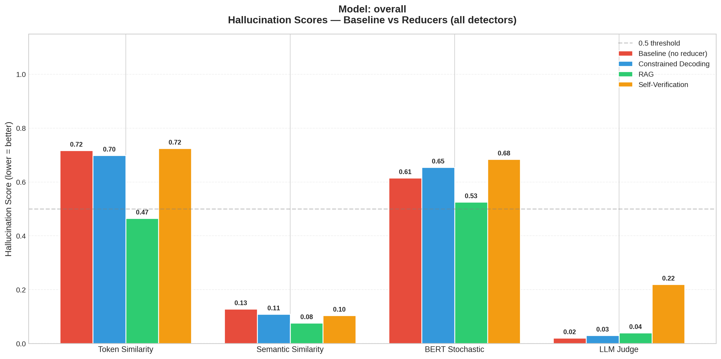
Overall per-detector scores
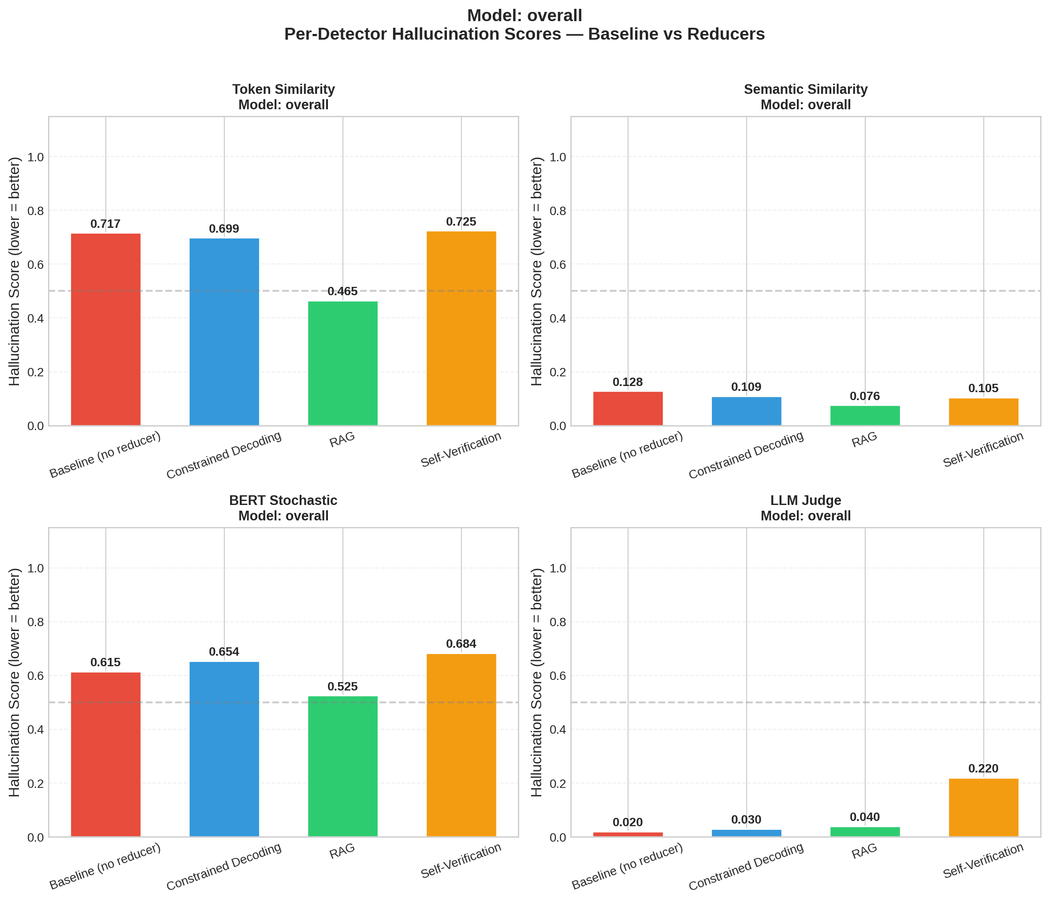
Overall score reductions vs baseline
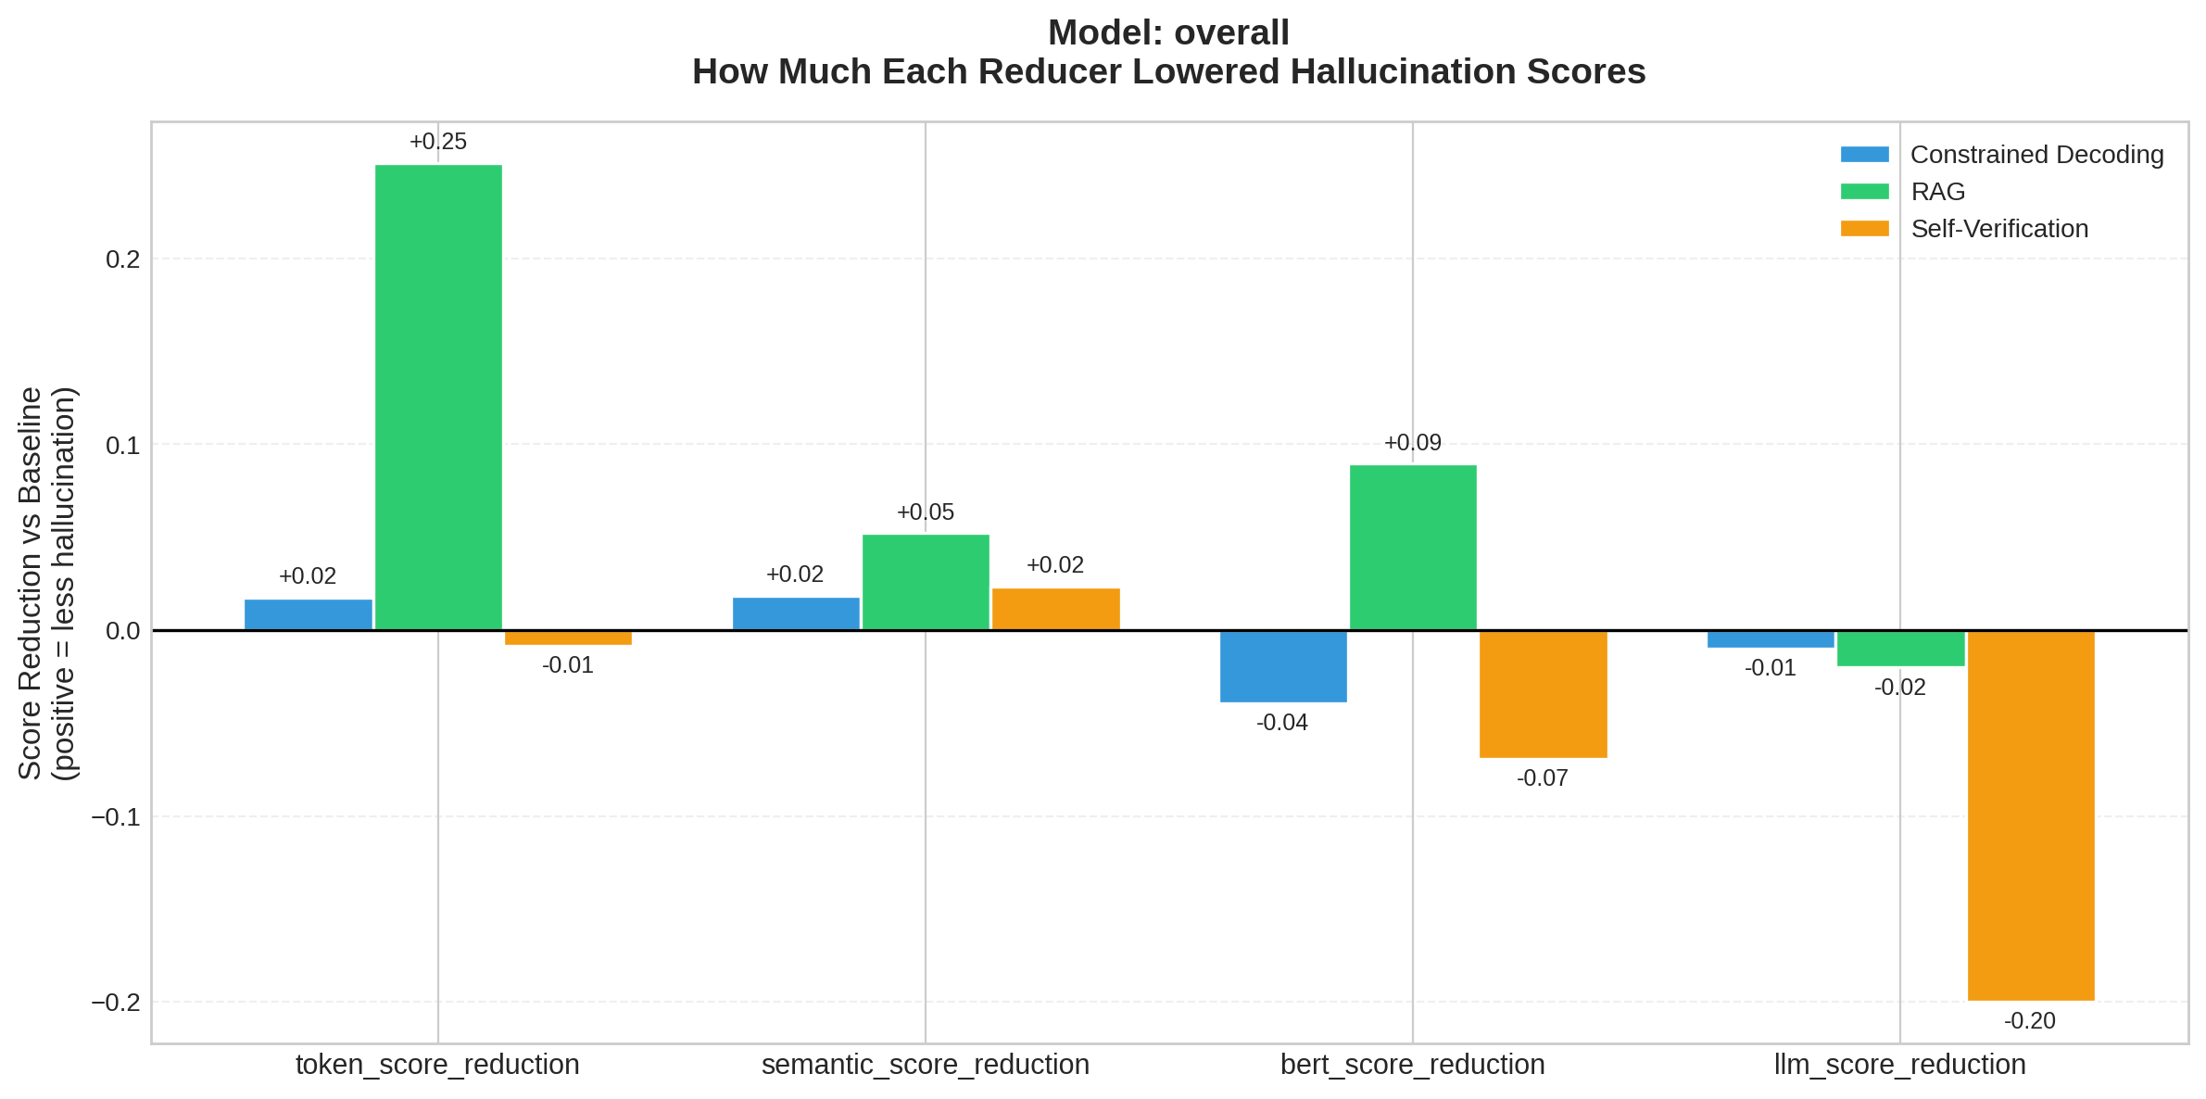
Overall latency
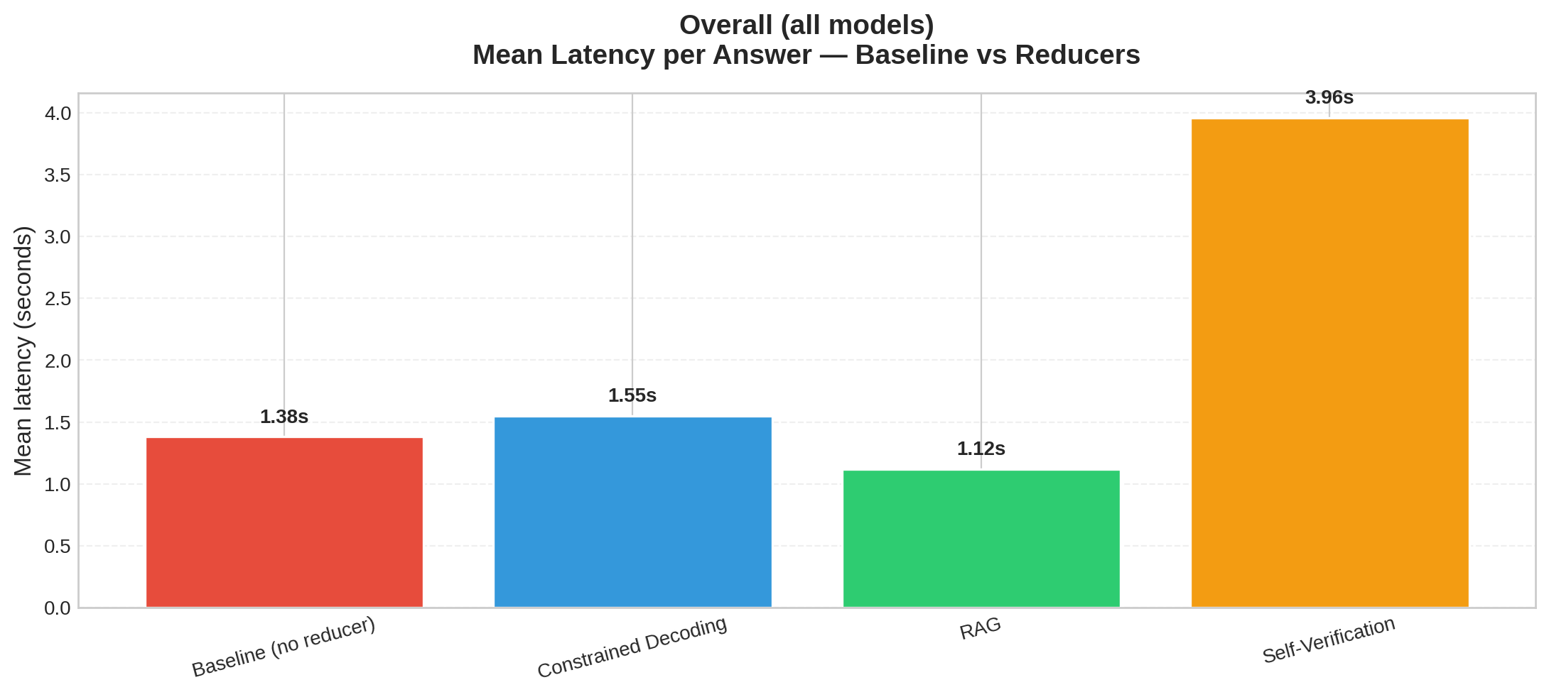

Per-Model Results

Model: llama3:latest
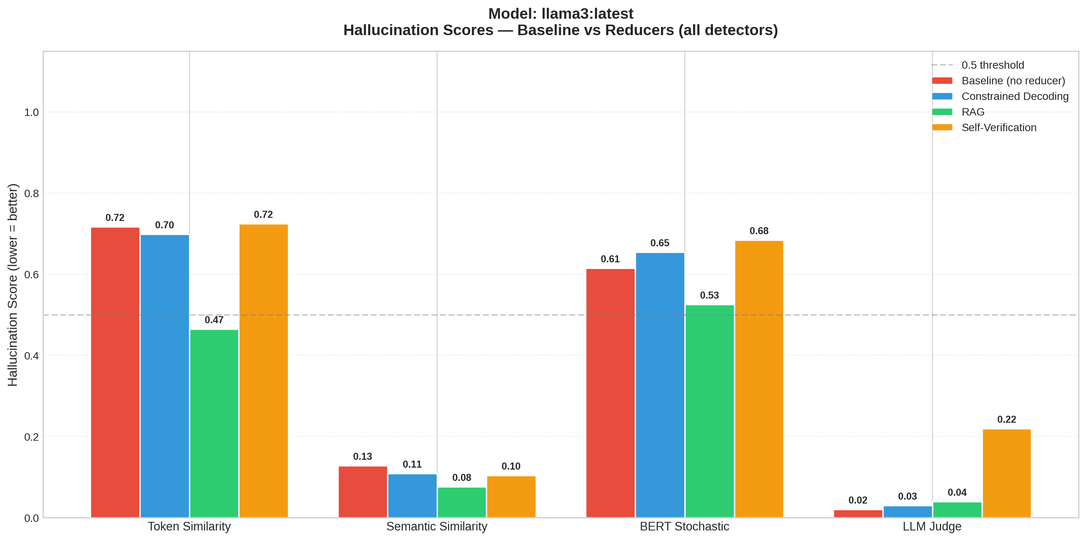
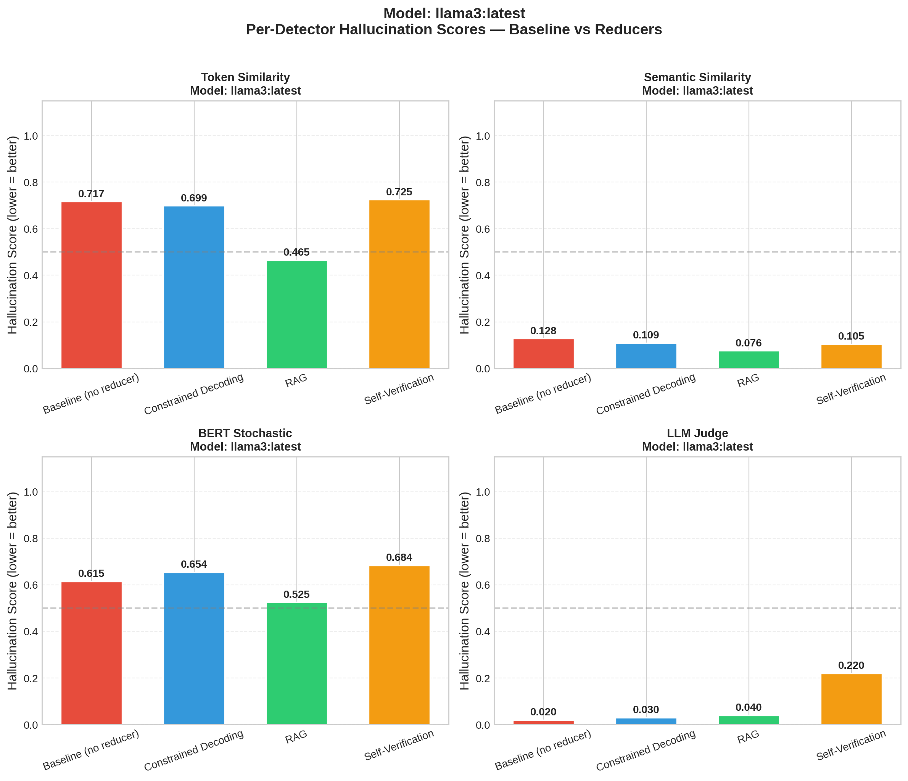
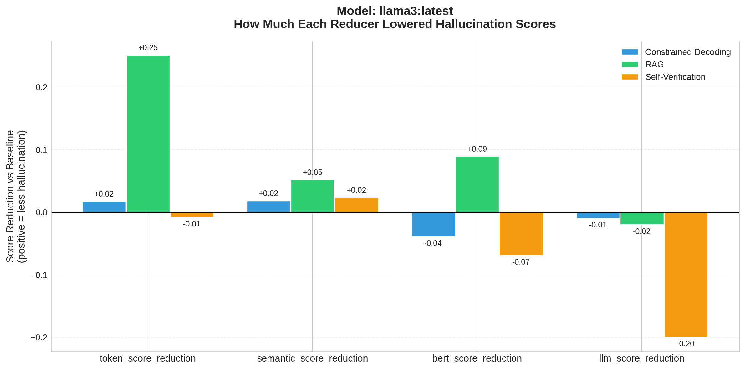
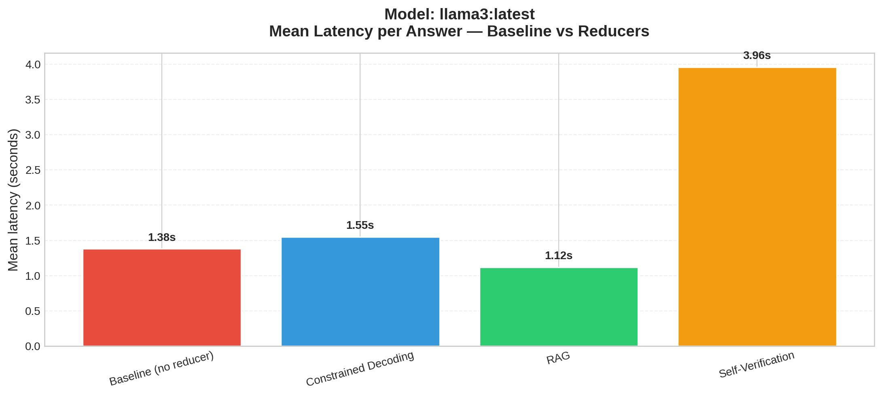

Summary Table (Mean Scores)
model | dataset | reducer | token_score | semantic_score | bert_score | llm_score | token_accuracy | semantic_accuracy | bert_accuracy | llm_accuracy | n_samples | mean_latency_s
llama3:latest | synthetic | baseline | 0.7165 | 0.128 | 0.6147 | 0.02 | 0.2 | 1.0 | 0.0 | 1.0 | 5 | 1.381
llama3:latest | synthetic | constrained_decoding | 0.6989 | 0.1094 | 0.6541 | 0.03 | 0.2 | 1.0 | 0.2 | 1.0 | 5 | 1.549
llama3:latest | synthetic | rag | 0.4652 | 0.0758 | 0.5251 | 0.04 | 0.6 | 1.0 | 0.4 | 1.0 | 5 | 1.119
llama3:latest | synthetic | self_verification | 0.7249 | 0.1046 | 0.6839 | 0.22 | 0.2 | 1.0 | 0.0 | 0.8 | 5 | 3.96

Reductions vs Baseline
model | reducer | token_score_reduction | semantic_score_reduction | bert_score_reduction | llm_score_reduction | token_score_win_rate | semantic_score_win_rate | bert_score_win_rate | llm_score_win_rate
llama3:latest | constrained_decoding | 0.0176 | 0.0186 | -0.0394 | -0.01 | 0.6 | 0.6 | 0.2 | 0.2
llama3:latest | rag | 0.2513 | 0.0522 | 0.0896 | -0.02 | 0.6 | 0.8 | 0.6 | 0.0
llama3:latest | self_verification | -0.0083 | 0.0234 | -0.0692 | -0.2 | 0.4 | 0.6 | 0.4 | 0.0

