Hallucination Reduction Experiment Report
This report includes tables and figures generated by the benchmark. Lower detector scores mean less hallucination.

Overall Results (All Models)
Overall hallucination scores
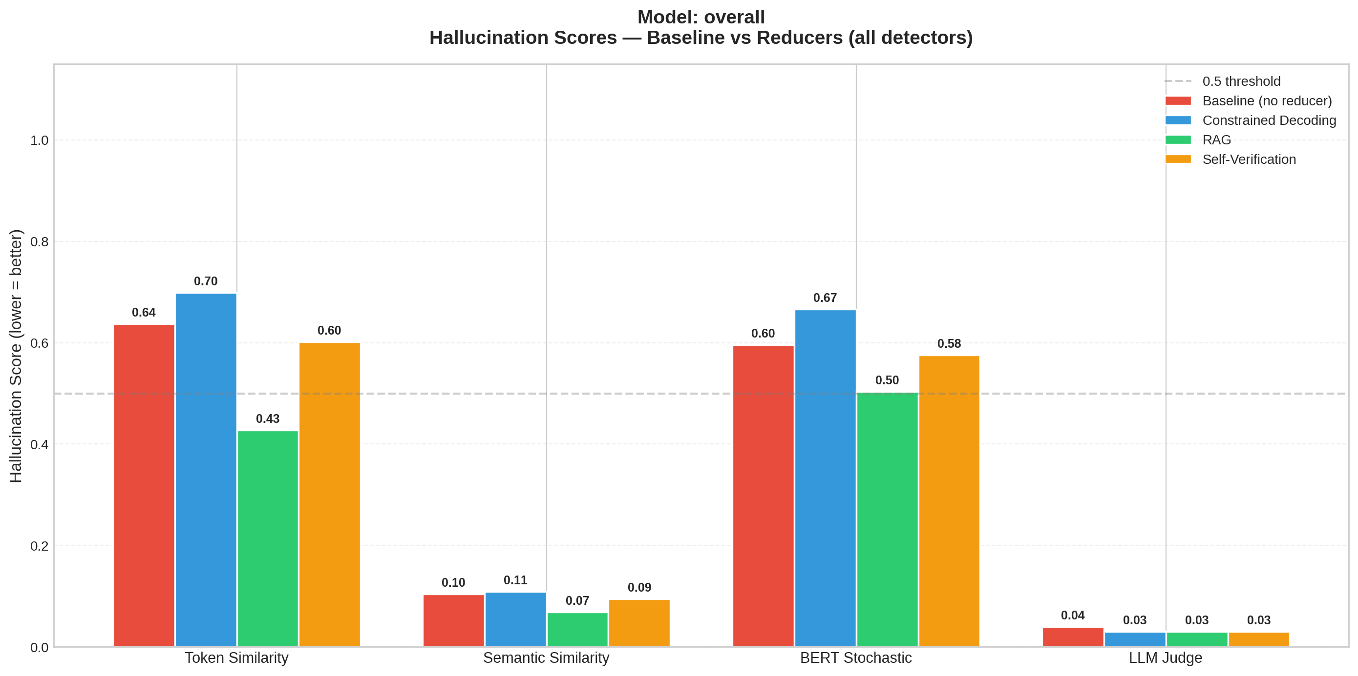
Overall per-detector scores
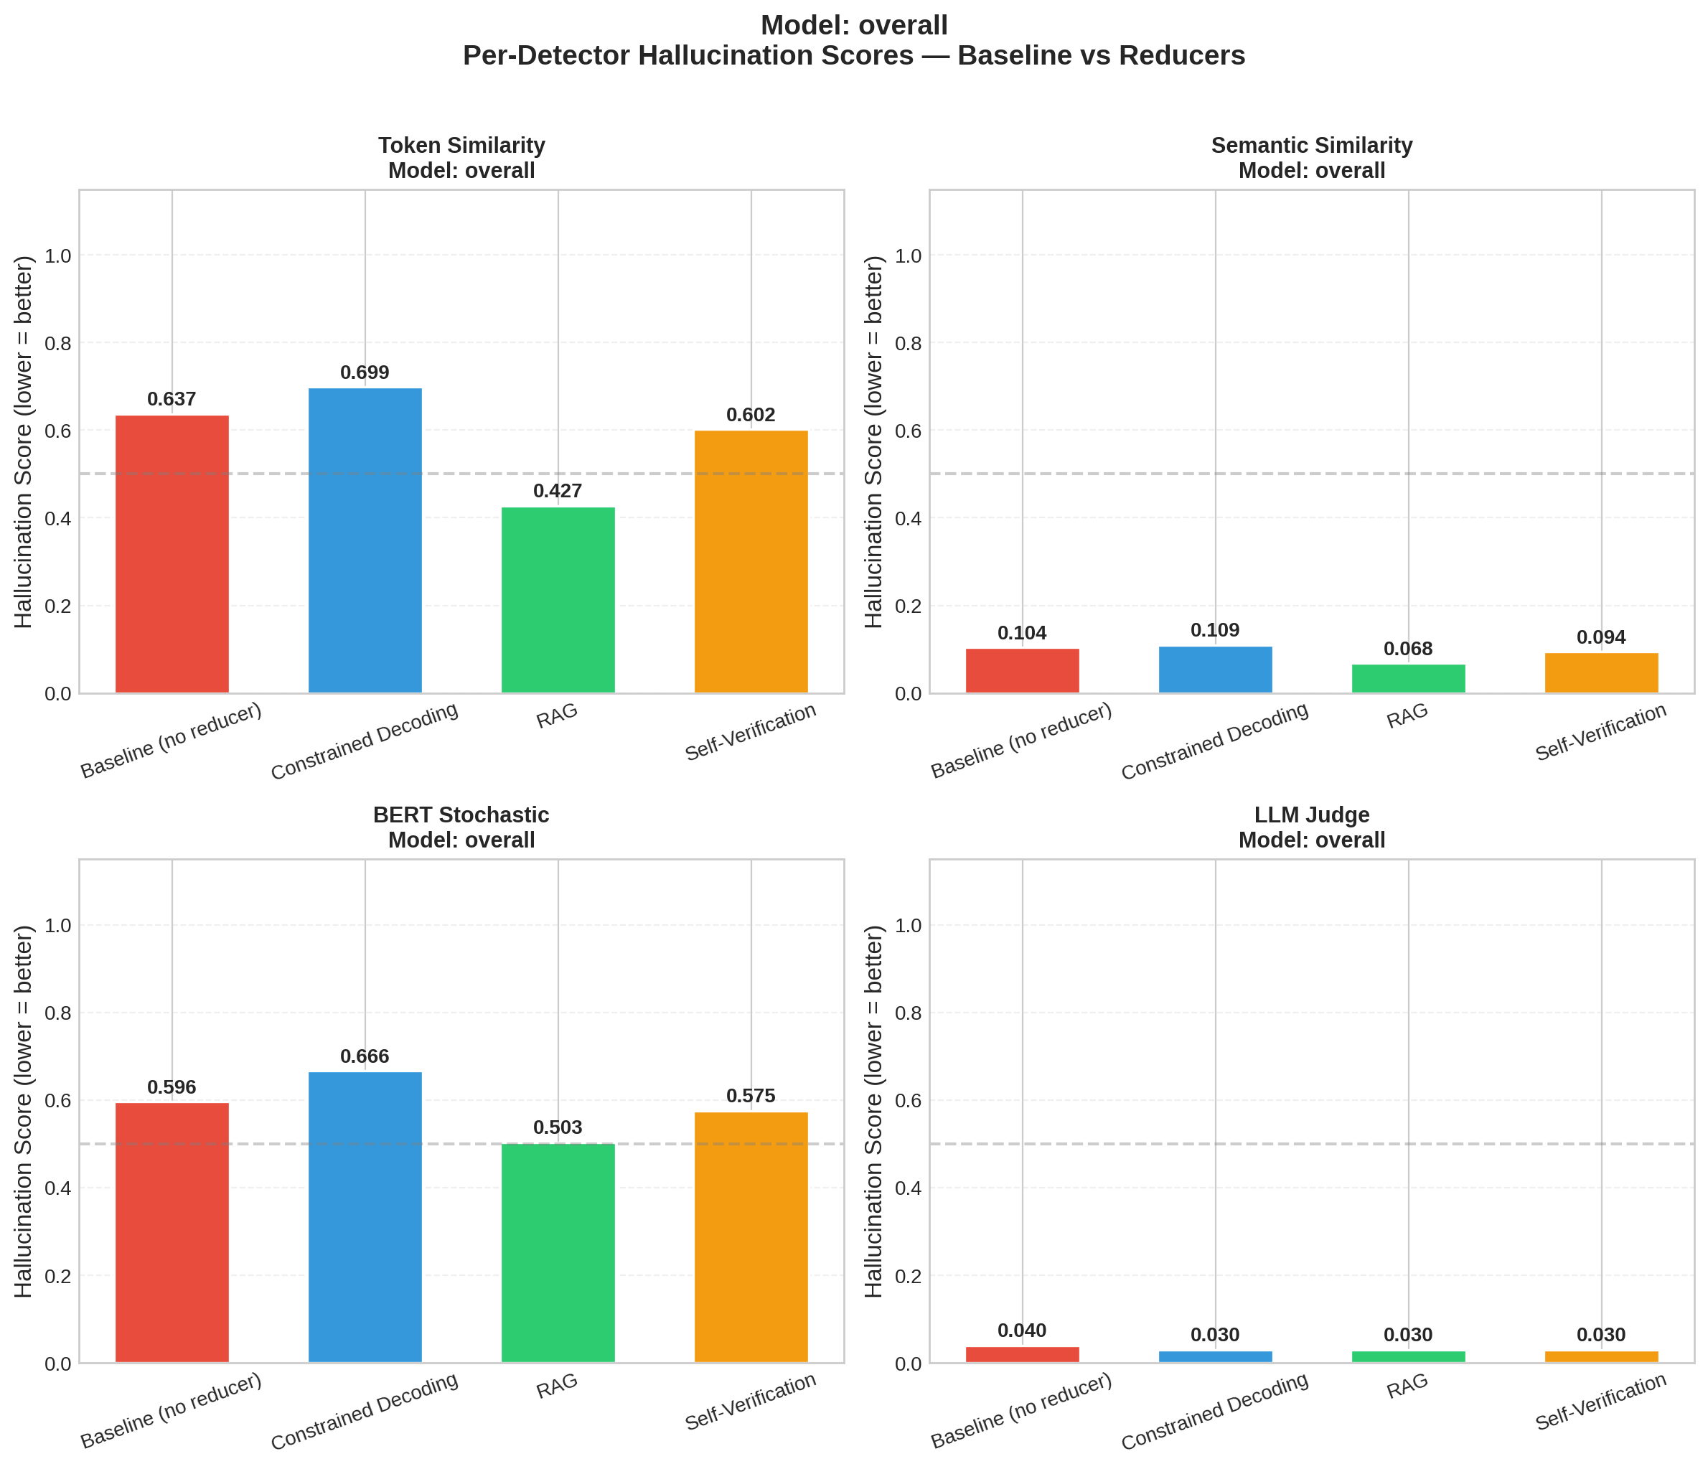
Overall score reductions vs baseline
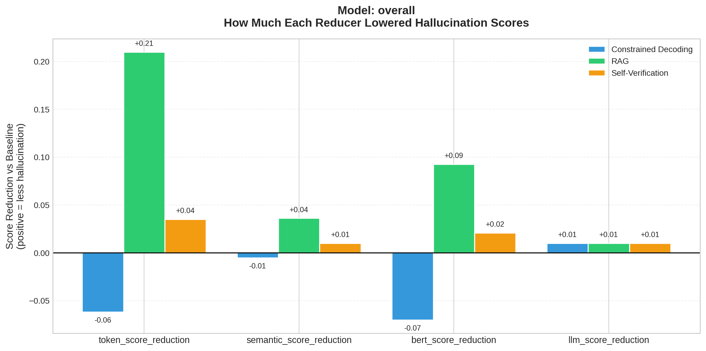
Overall latency
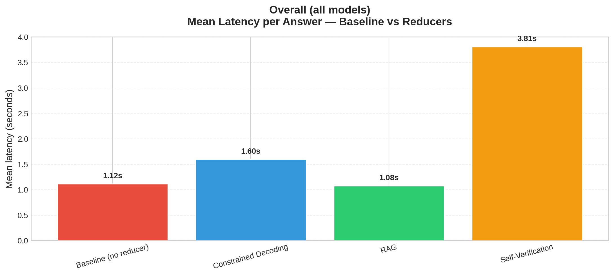

Per-Model Results

Model: llama3:latest
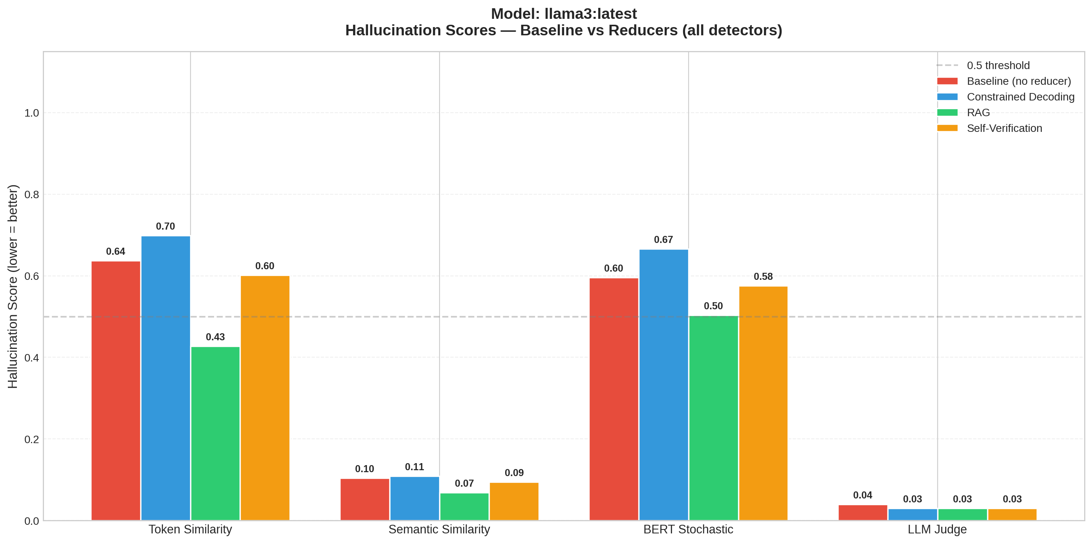
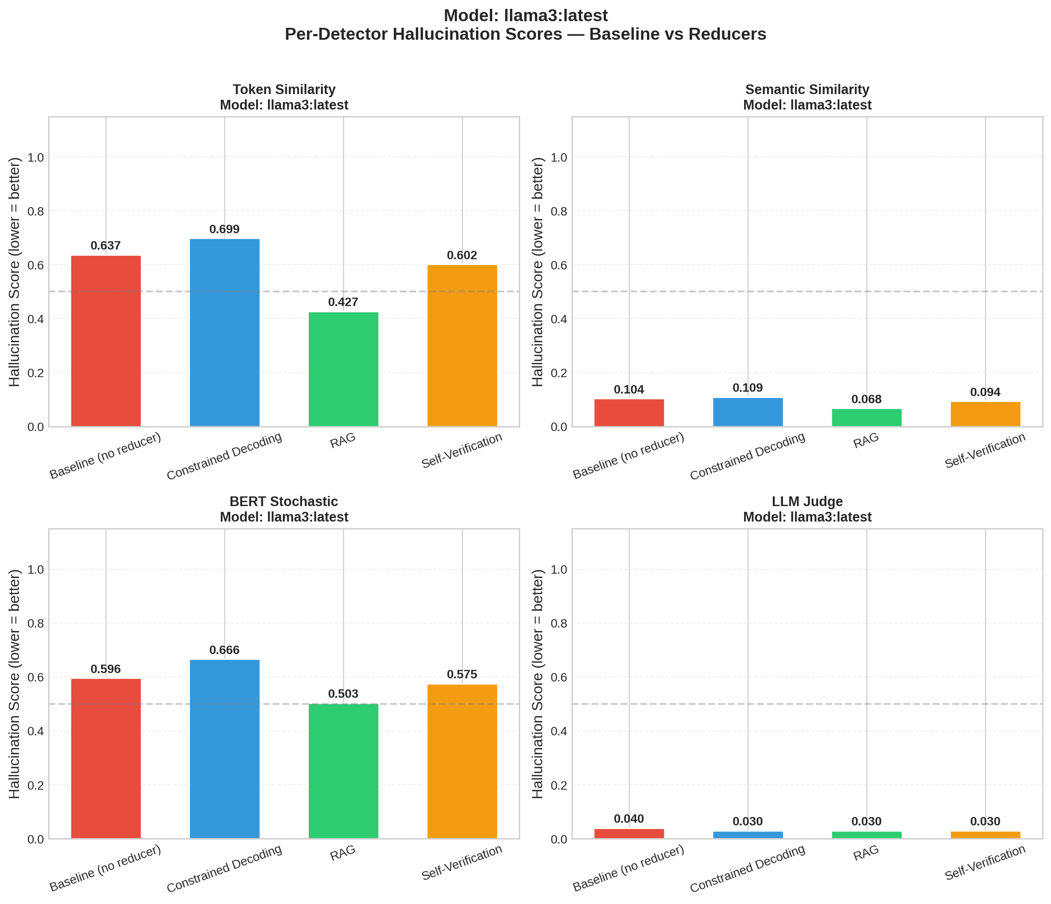
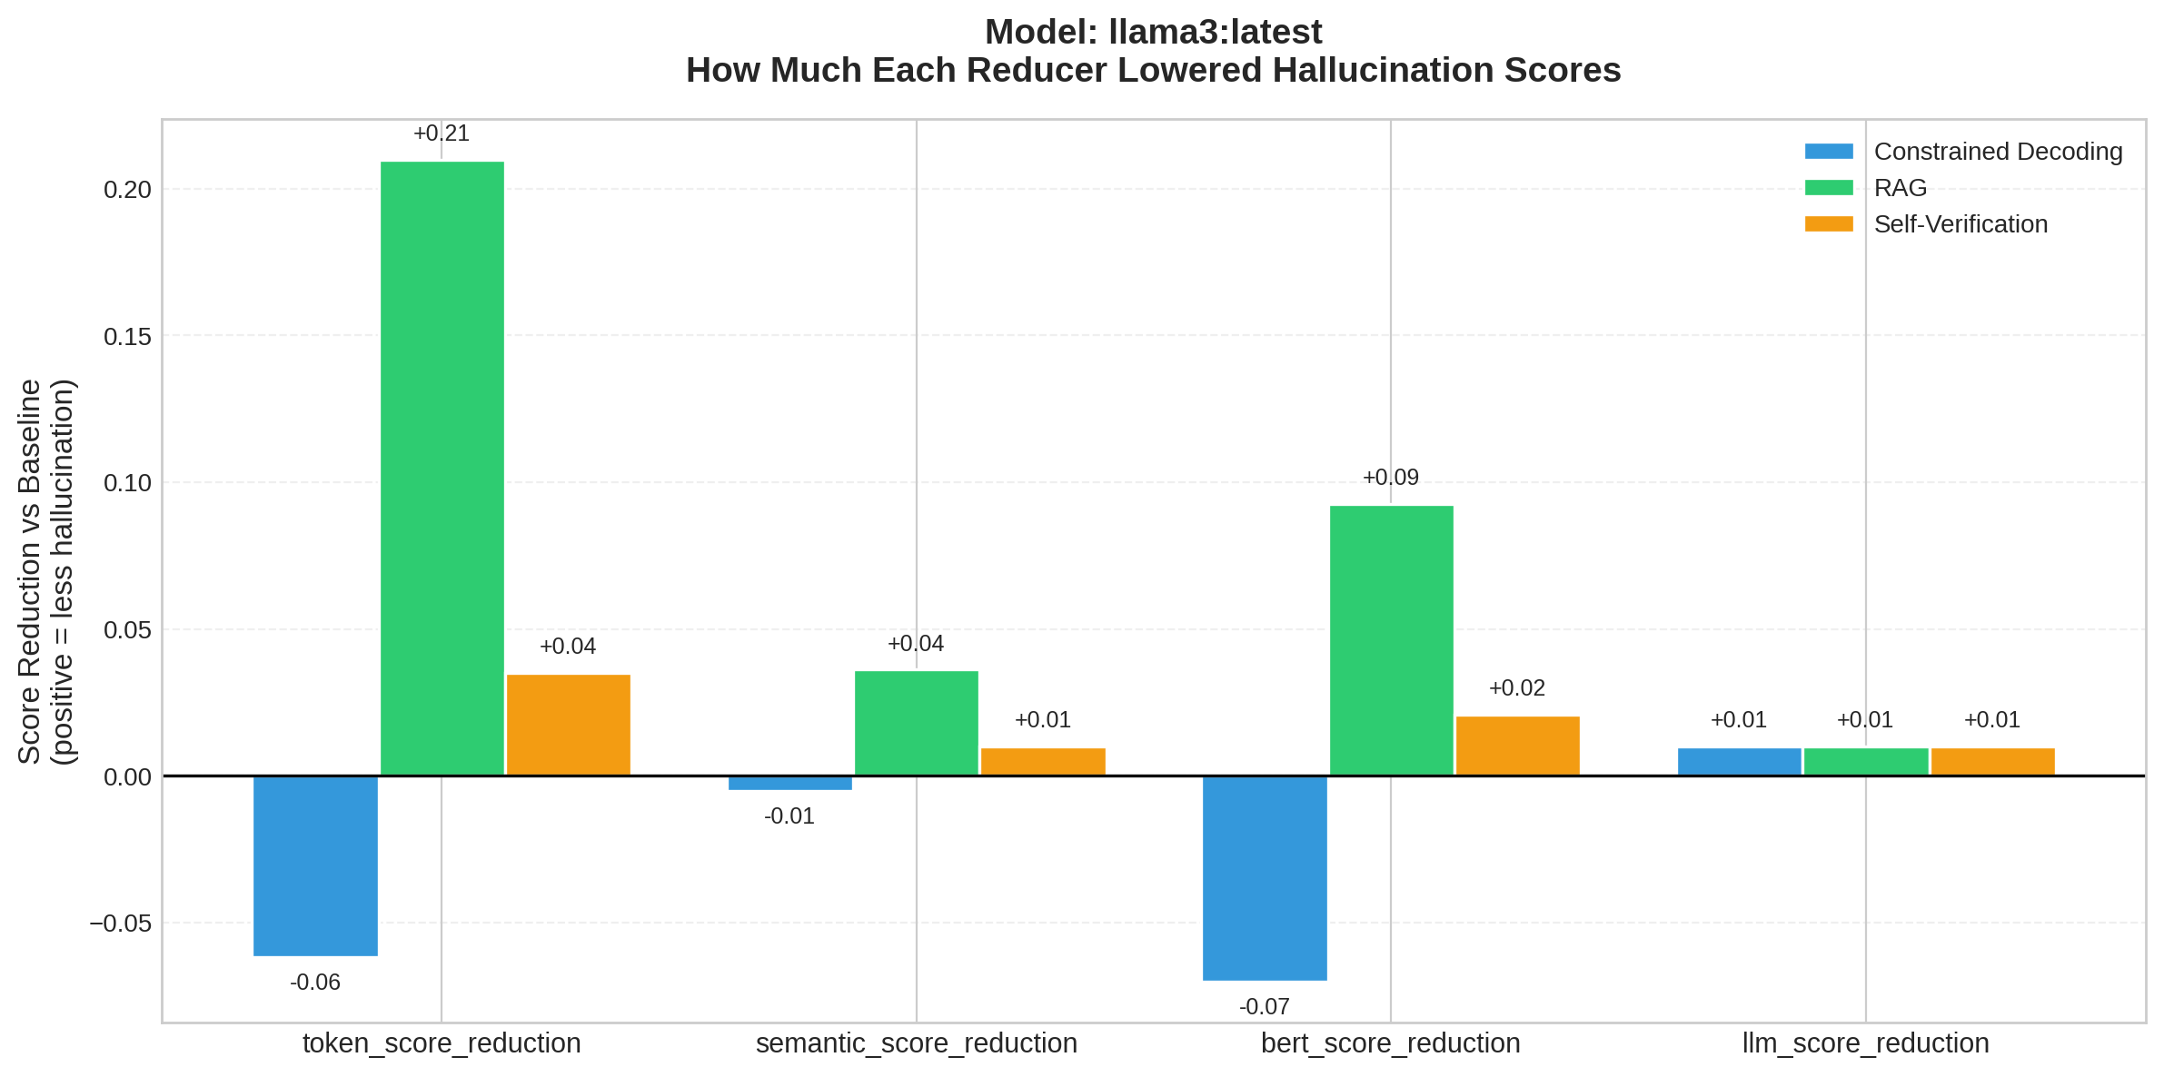
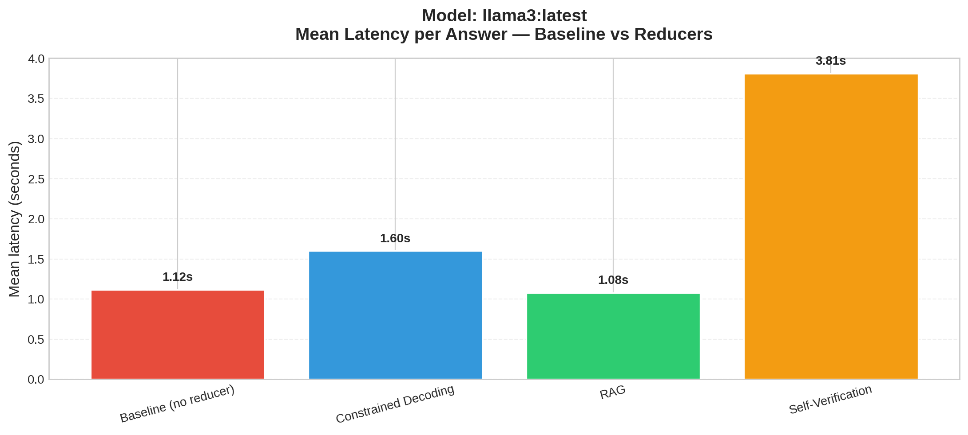

Summary Table (Mean Scores)
model | dataset | reducer | token_score | semantic_score | bert_score | llm_score | token_accuracy | semantic_accuracy | bert_accuracy | llm_accuracy | n_samples | mean_latency_s
llama3:latest | synthetic | baseline | 0.637 | 0.1042 | 0.5961 | 0.04 | 0.4 | 1.0 | 0.0 | 1.0 | 5 | 1.118
llama3:latest | synthetic | constrained_decoding | 0.6989 | 0.1094 | 0.6662 | 0.03 | 0.2 | 1.0 | 0.0 | 1.0 | 5 | 1.601
llama3:latest | synthetic | rag | 0.4272 | 0.0682 | 0.5035 | 0.03 | 0.6 | 1.0 | 0.4 | 1.0 | 5 | 1.078
llama3:latest | synthetic | self_verification | 0.6019 | 0.0941 | 0.5751 | 0.03 | 0.4 | 1.0 | 0.2 | 1.0 | 5 | 3.813

Reductions vs Baseline
model | reducer | token_score_reduction | semantic_score_reduction | bert_score_reduction | llm_score_reduction | token_score_win_rate | semantic_score_win_rate | bert_score_win_rate | llm_score_win_rate
llama3:latest | constrained_decoding | -0.0619 | -0.0052 | -0.0702 | 0.01 | 0.2 | 0.2 | 0.0 | 0.2
llama3:latest | rag | 0.2098 | 0.0361 | 0.0925 | 0.01 | 0.6 | 0.6 | 0.6 | 0.4
llama3:latest | self_verification | 0.0351 | 0.0101 | 0.0209 | 0.01 | 0.2 | 0.4 | 0.6 | 0.2

