

**DEEP LEARNING**

by

Dharamraj Bhatt

(1947216)

Under the guidance of

Dr. Nizar Banu PK

A seminar report submitted in partial fulfillment of the requirements for the award of degree of Master of Computer Applications / Master of Science (Computer Science) of CHRIST (Deemed to be University)

December - 2020

**ABSTRACT**

Deep Learning is a subset of Machine Learning, which on the other hand is a subset of Artificial Intelligence. Artificial Intelligence is a general term that refers to techniques that enable computers to mimic human behavior. Machine Learning represents a set of algorithms trained on data that make all of this possible.

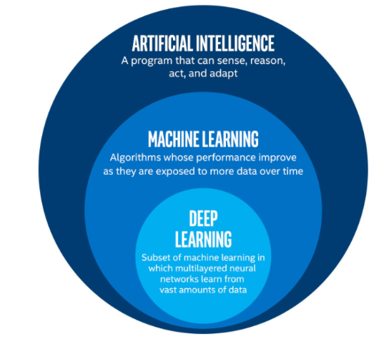

Fig.1: AI. vs ML. vs DL.

Deep Learning, on the other hand, is just a type of Machine Learning, inspired by the structure of a human brain. Deep learning algorithms attempt to draw similar conclusions as humans would by continually analyzing data with a given logical structure. To achieve this, deep learning uses a multi-layered structure of algorithms called neural networks.

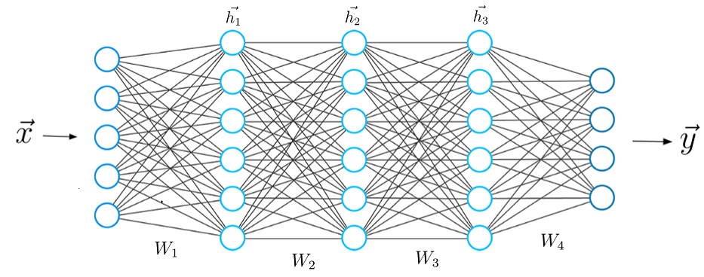

Fig.2: A typical Neural Network.

The design of the neural network is based on the structure of the human brain. Just as we use our brains to identify patterns and classify different types of information, neural networks can be taught to perform the same tasks on data. The individual layers of neural networks can also be thought of as a sort of filter that works from gross to subtle, increasing the likelihood of detecting and outputting a correct result. The human brain works similarly. Whenever we receive new information, the brain tries to compare it with known objects. The same concept is also used by deep neural networks. **Neural networks enable us to perform many tasks, such as clustering, classification or regression.** With neural networks, we can group or sort unlabeled data according to similarities among the samples in this data. Or in the case of classification, we can train the network on a labeled dataset in order to classify the samples in this dataset into different categories. *In general, neural networks can perform the same tasks as classical algorithms of machine learning. However, it is not the other way around.* Artificial neural networks have unique capabilities that enable deep learning models to solve tasks that machine learning models can never solve. All recent advances in artificial intelligence in recent years are due to deep learning. Without deep learning, we would not have self-driving cars, chatbots or personal assistants like Alexa and Siri. The Google Translate app would continue to be as primitive as 10 years ago (before Google switched to neural networks for this App), and Netflix or Youtube would have no idea which movies or TV series we like or dislike. Behind all these technologies are neural networks. **We can even go so far as to say that today a new industrial revolution is taking place, driven by artificial neural networks and deep learning.** At the end of the day, deep learning is the best and most obvious approach to real machine intelligence we’ve had so far.

The design of the neural network is based on the structure of the human brain. Just as we use our brains to identify patterns and classify different types of information, neural networks can be taught to perform the same tasks on data. The individual layers of neural networks can also be thought of as a sort of filter that works from gross to subtle, increasing the likelihood of detecting and outputting a correct result. The human brain works similarly. Whenever we receive new information, the brain tries to compare it with known objects. The same concept is also used by deep neural networks. **Neural networks enable us to perform many tasks, such as clustering, classification or regression.** With neural networks, we can group or sort unlabeled data according to similarities among the samples in this data. Or in the case of classification, we can train the network on a labeled dataset in order to classify the samples in this dataset into different categories. *In general, neural networks can perform the same tasks as classical algorithms of machine learning. However, it is not the other way around.* Artificial neural networks have unique capabilities that enable deep learning models to solve tasks that machine learning models can never solve. All recent advances in artificial intelligence in recent years are due to deep learning. Without deep learning, we would not have self-driving cars, chatbots or personal assistants like Alexa and Siri. The Google Translate app would continue to be as primitive as 10 years ago (before Google switched to neural networks for this App), and Netflix or Youtube would have no idea which movies or TV series we like or dislike. Behind all these technologies are neural networks. **We can even go so far as to say that today a new industrial revolution is taking place, driven by artificial neural networks and deep learning.** At the end of the day, deep learning is the best and most obvious approach to real machine intelligence we’ve had so far.

Why is deep learning and artificial neural networks so powerful and unique in today’s industry? And above all, why are deep learning models more powerful than machine learning models? Let me explain it to you. “*The first advantage of deep learning over machine learning is the needlessness of the so-called feature extraction. ”*Long before deep learning was used, traditional machine learning methods were mainly used. Such as Decision Trees, SVM, Naïve Bayes Classifier, and Logistic Regression. These algorithms are also called flat algorithms. Flat here means that these algorithms can not normally be applied directly to the raw data (such as .csv, images, text, etc.). We need a preprocessing step called Feature Extraction. The result of Feature Extraction is a representation of the given raw data that can now be used by these classic machine learning algorithms to perform a task. For example, the classification of the data into several categories or classes. Feature Extraction is usually quite complex and requires detailed knowledge of the problem domain. This preprocessing layer must be adapted, tested, and refined over several iterations for optimal results. On the other side are the artificial neural networks of Deep Learning. These do not need the Feature Extraction step. The layers are able to learn an implicit representation of the raw data directly and on their own. Here, a more and more abstract and compressed representation of the raw data is produced over several layers of artificial neural-nets. This compressed representation of the input data is then used to produce the result. The result can be, for example, the classification of the input data into different classes.

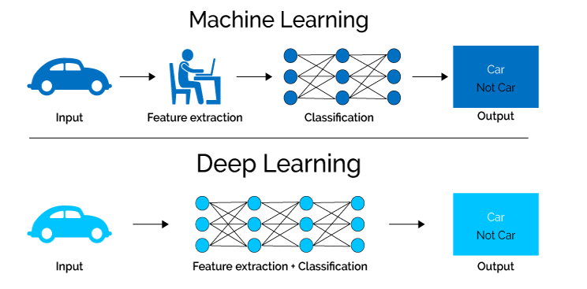

Fig.3: Feature Extraction is only required for ML Algorithms.

“In other words, we can also say that the feature extraction step is already part of the process that takes place in an artificial neural network. ”During the training process, this step is also optimized by the neural network to obtain the best possible abstract representation of the input data. This means that the models of deep learning thus require little to no manual effort to perform and optimize the feature extraction process. Let us look at a concrete example. For example, if you want to use a machine learning model to determine if a particular image is showing a car or not, we humans first need to identify the unique features or features of a car (shape, size, windows, wheels, etc.) extract the feature and give them to the algorithm as input data. In this way, the algorithm would perform a classification of the images. That is, in machine learning, a programmer must intervene directly in the action for the model to come to a conclusion. In the case of a deep learning model, the feature extraction step is completely unnecessary. The model would recognize these unique characteristics of a car and make correct predictions. That completely without the help of a human. In fact, refraining from extracting the characteristics of data applies to every other task you’ll ever do with neural networks. Just give the raw data to the neural network, the rest is done by the model.

**CONCLUSION**

While much has been written about the overwhelming array of applications and uses for artificial intelligence and deep learning, it’s important to bear in mind that the adoption of such technologies presents many challenges in addition to all the buzz and excitement. These challenges are by no means insurmountable, and both talented data scientists and developers work tirelessly to enhance and refine the underlying models. However, a more informed perspective can only be a good thing if you are to get the most from AI and deep learning.

**REFERENCES**

1. What is Deep Learning and How does it work? Artem Oppermann

https://towardsdatascience.com/what-is-deep-learning-and-how-does-it-work-2ce44bb692ac

1. Top 20 Applications of Deep Learning in 2020 Across Industries By  [Marina Chatterjee](https://www.mygreatlearning.com/blog/author/marina/) Feb 19, 2019

https://www.mygreatlearning.com/blog/deep-learning-applications/

1. The limits and challenges of deep learning By  [Ben Dickson](https://bdtechtalks.com/author/bendee983/) February 27, 2018

https://bdtechtalks.com/2018/02/27/limits-challenges-deep-learning-gary-marcus

1. 5 Key Deep Learning/AI Challenges in 2018 [Limor Wainstein](https://datafloq.com/user/limor-wainstein) , August 22, 2018

https://datafloq.com/read/5-key-deep-learning-ai-challenges-in-2018/5400