

**Product Dissection for Zerodha**

### **Company Overview:**

**Zerodha**, founded in 2010 by Nithin and Nikhil Kamath, has revolutionised the Indian financial landscape. With a mission to break down barriers to investing, Zerodha introduced a disruptive discount brokerage model that made stock trading accessible to the masses. By prioritising technology and user experience, the platform has transformed the way millions of Indians interact with the stock market. Zerodha's innovative approach to pricing, coupled with its user-friendly platforms, has propelled it to become a leading force in the Indian broking industry, democratising investments and empowering individuals to take control of their financial futures.

**Product Dissection and Real-World Problems Solved by Zerodha:**

Zerodha has effectively addressed the challenges of India’s complex financial landscape by providing a user-friendly platform that simplifies investing. The platform’s core offering, low-cost brokerage, directly tackles the longstanding issue of high transaction fees, making equity markets accessible to a broader investor base. By eliminating unnecessary complexities and providing intuitive tools, Zerodha empowers individuals with limited financial knowledge to participate in the stock market.

Zerodha’s suite of platforms, including Kite, Coin, and Console, has revolutionised how users manage their investments and engage with the financial markets. The Kite trading platform, with its intuitive interface and real-time data, addresses the complexity of traditional trading platforms, making it easier for users to navigate the markets and execute trades with precision. Coin, Zerodha’s direct mutual fund investment platform, solves the problem of hidden fees and commissions, allowing users to invest in mutual funds without any intermediary costs, thereby maximising their returns.

Zerodha’s commitment to education and transparency is another key factor in its success. Through its educational resources and open communication, the platform addresses the information asymmetry prevalent in the financial industry. By demystifying investment concepts and providing data-driven insights, Zerodha enables investors to make informed decisions. Additionally, the platform’s focus on technology has led to the development of robust trading platforms and mobile apps, solving the problem of cumbersome trading processes and enhancing the overall user experience.

In conclusion, Zerodha’s product design has effectively tackled real-world problems by creating a comprehensive ecosystem that fosters financial inclusion, simplifies trading, and enhances user education. Through its innovative features, Zerodha addresses the need for affordable trading, transparent investment options, and accessible financial education, reshaping the financial services industry and providing practical solutions to the evolving needs of its diverse user base.

### **Case Study: Real-World Problems and Zerodha’s Innovative Solutions**

Zerodha, India’s foremost brokerage firm, has not only transformed the way people invest and trade in financial markets but has also addressed significant real-world challenges through its innovative solutions. By understanding the needs of investors and leveraging cutting-edge technology, Zerodha has positioned itself as a solution-driven platform that promotes financial inclusion, simplifies investment processes, and empowers users to take control of their financial journeys.

#### **Problem 1: High Costs and Barriers to Entry in Financial Markets**

**Real-World Challenge:** Traditionally, investing in financial markets has been associated with high brokerage fees and complex processes, creating significant barriers to entry for small and medium investors. This made it difficult for many individuals to access and participate in the wealth-building opportunities that financial markets offer.

**Zerodha’s Solution:**

Zerodha identified the need to make investing more accessible and affordable for everyone. By introducing the discount brokerage model, Zerodha drastically reduced brokerage fees, eliminating one of the primary barriers to entry for new investors. The platform offers zero brokerage on equity investments and minimal charges on intraday and derivatives trading. This approach democratizes access to financial markets, allowing a broader segment of the population to engage in trading and investment activities without the burden of high costs. Through this innovative solution, Zerodha has effectively addressed the problem of high entry costs, fostering financial inclusion and empowering individuals to grow their wealth.

#### **Problem 2: Complex and Overwhelming Financial Data**

**Real-World Challenge:** For many investors, especially beginners, the sheer volume and complexity of financial data can be overwhelming. Navigating market information, analyzing portfolios, and making informed investment decisions can be daunting without the right tools and insights.

**Zerodha’s Solution:**

Zerodha addresses the challenge of complex financial data through its user-friendly platform, **Console**. The **console** acts as a centralised dashboard where users can view, analyze, and manage their investments with ease. By offering detailed reports, visual analytics, and simplified portfolio tracking, Console helps users make sense of vast amounts of financial data. Additionally, Zerodha’s **Kite** platform provides real-time market data and advanced charting tools in an intuitive interface, enabling users to make informed trading decisions without being overwhelmed by information. This approach streamlines the investment process, making it accessible and manageable for users of all experience levels, effectively mitigating the problem of information overload in the financial markets.

#### **Problem 3: Limited Access to Advanced Trading Strategies**

**Real-World Challenge:** Many retail investors and traders aspire to leverage advanced trading strategies, such as algorithmic trading, but lack the technical skills or resources to do so. This has traditionally limited their ability to compete with institutional investors who have access to sophisticated tools and technologies.

**Zerodha’s Solution:**

Zerodha addresses this challenge through **Streak**, a platform that democratizes algorithmic trading by allowing users to create, backtest, and deploy trading strategies without requiring any coding knowledge. Streak provides an intuitive interface where traders can design complex strategies using simple drag-and-drop tools and backtest them against historical data to ensure their viability. This solution enables retail traders to tap into the power of algorithmic trading, empowering them to implement advanced strategies and optimize their trading outcomes. By offering access to these powerful tools, Zerodha helps users overcome the barrier to advanced trading techniques, enabling them to explore and succeed in the world of algorithmic trading.

#### **Problem 4: Lack of Financial Education and Awareness**

**Real-World Challenge:** Many individuals are eager to participate in the financial markets but lack the necessary knowledge and understanding to make informed investment decisions. This lack of financial literacy can lead to poor investment choices and missed opportunities.

**Zerodha’s Solution:**

Zerodha addresses this challenge through **Varsity**, an educational platform that offers in-depth, easy-to-understand content on a wide range of financial topics. Varsity provides comprehensive modules on stock markets, trading, investing, and personal finance, empowering users to build their financial knowledge at their own pace. This platform solves the problem of limited financial education by making high-quality, accessible learning resources available to everyone, regardless of their background. By equipping users with the knowledge they need, Zerodha helps them establish a strong foundation in financial literacy, enabling them to make informed decisions and confidently build their financial futures.

#### **Conclusion:**

Zerodha's evolution from a pioneering discount broker to India's largest stockbroker is a testament to its ability to identify and solve real-world challenges in the financial markets. By democratizing access to trading, simplifying complex financial data, enabling advanced trading strategies, and promoting financial literacy, Zerodha has addressed the key obstacles faced by investors and traders. This case study highlights how Zerodha's innovative, user-centric approach has revolutionized the brokerage industry in India, empowering millions to take control of their financial futures and establishing Zerodha as a leader in the financial services domain.

### 

### **Top Features of Zerodha:**

1. **User Profiles:**

Zerodha provides users with a personalized digital dashboard, offering a comprehensive overview of their investment portfolio. This includes details such as account balance, holdings, order history, and account settings, empowering users to manage their finances efficiently.

1. **Trading Platforms:**

A core feature of Zerodha is its trading platforms, such as Kite and Varsity. These platforms allow users to execute trades, monitor market movements, and manage their portfolios. They offer advanced charting tools, real-time data, and a user-friendly interface for both novice and experienced traders.

1. **Investment Insights:**

Zerodha provides users with valuable market insights and analysis tools. This includes features like stock screeners, technical analysis, and access to research reports. Users can make informed decisions based on comprehensive data and market trends.

1. **Educational Resources:**

Zerodha emphasizes financial literacy through its Varsity platform, offering a wealth of educational content. This includes articles, videos, and courses on various investment topics, helping users build a strong foundation in financial markets.

1. **Low-Cost Brokerage:**

Zerodha differentiates itself by offering low-cost brokerage plans, making investing accessible to a wider audience. This cost-effective approach encourages more individuals to participate in the stock market.

1. **Customer Support:**

The platform emphasizes strong customer support, offering assistance through various channels such as chat, email, and phone. This ensures users receive timely help with their trading queries, account issues, or technical difficulties.

### **Schema Description:**

The schema for Zerodha involves several key entities that represent different components of the platform’s functionality. These entities include Users, Trades, Portfolios, Investments, MutualFunds, and more. Each entity has specific attributes that describe its properties and relationships with other entities.

**User Entity:**

Users are central to the Zerodha platform. The user entity contains information about each investor or trader:

* **UserID (Primary Key)**: A unique identifier for each user.
* **Username**: The chosen username for the user's account.
* **Email**: The user's email address for account-related communication.
* **Full_Name**: The user's full name as displayed on their profile.
* **Mobile_Numbe**r: User's mobile number.
* **Address**: User's address for KYC purposes.
* **PAN_Number**: User's PAN number for tax identification.
* **Demat_Account_Number**: Demat account number linked to the user.
* **Registration_Date**: The date when the user joined Instagram.

**Account Entity:** Accounts capture the financial details and settings for each user:

* **AccountID (Primary Key):** Unique identifier for each user account.
* **Account_Type:** Type of account (e.g., Demat, Trading, Mutual Fund).
* **Account_Number:** Account number assigned by Zerodha.
* **Opening_Date:** Date when the account was opened.
* **Balance:** Current balance in the account.

**Holding Entity:**

* **HoldingID (Primary Key):** Unique identifier for each holding.
* **Quantity**: Number of shares or units held.
* **Average_Price**: Average price at which the holding was acquired.
* **Current_Value**: Current market value of the holding.

**Order Entity:**

* **OrderID (Primary Key):** Unique identifier for each order.
* **Order_Type:** Type of order (e.g., Buy, Sell, Limit, Market).
* **Quantity:** Quantity of shares or units to be traded.
* **Order_Price:** Order price for limit orders.
* **Order_Date:** Date when the order was placed.
* **Order_Status:** Current status of the order (e.g., Pending, Filled, Cancelled).

**Transaction Entity:**

* **TransactionID (Primary Key):** Unique identifier for each transaction.
* **Transaction_Type**: Type of transaction (e.g., Buy, Sell).
* **Quantity**: Quantity of shares or units traded.
* **Price**: Transaction price.
* **Transaction_Date**: Date of the transaction.
* **Brokerage**: Brokerage charges for the transaction.

**EducationalResource Entity:** Educational resources offer learning materials to users:

* **ResourceID (Primary Key):** A unique identifier for each educational resource.
* **Title:** The title of the educational content.
* **Content_Type:** The type of content (e.g., article, video, course).
* **Content_URL:** The URL where the content can be accessed.
* **Publication_Date:** The date when the educational resource was published.

**SupportInteraction Entity:** Support interactions track user queries and support requests:

* **SupportID (Primary Key):** A unique identifier for each support interaction.
* **Interaction_Type:** The type of support interaction (e.g., chat, email, phone).
* **Query_Date:** The date when the query was made.
* **Resolution_Date:** The date when the issue was resolved.
* **Resolution_Details:** Details about how the issue was resolved.

### **Relationships:**

* **Users have Accounts:** One user can have multiple accounts. (1-M)
* **Users execute Trades:** One user can execute multiple trades. (1-M)
* **Accounts have Trades:** One account can have multiple trades. (1-M)
* **Users receive Market Insights:** One user can receive multiple market insights. (1-M)
* **Users access Educational Resources:** One user can access multiple educational resources. (1-M)
* **Users interact with Support:** One user can have multiple support interactions. (1-M)
* **Orders have transactions:** Each order has a unique transaction (1-1)

**ER Diagram:**

The ER (Entity-Relationship) Diagram for Zerodha will illustrate the relationships and attributes of the key entities within its data model. This visual representation will help in understanding the interactions and connections between different components of the platform. Here’s a description of the ER diagram for Zerodha:

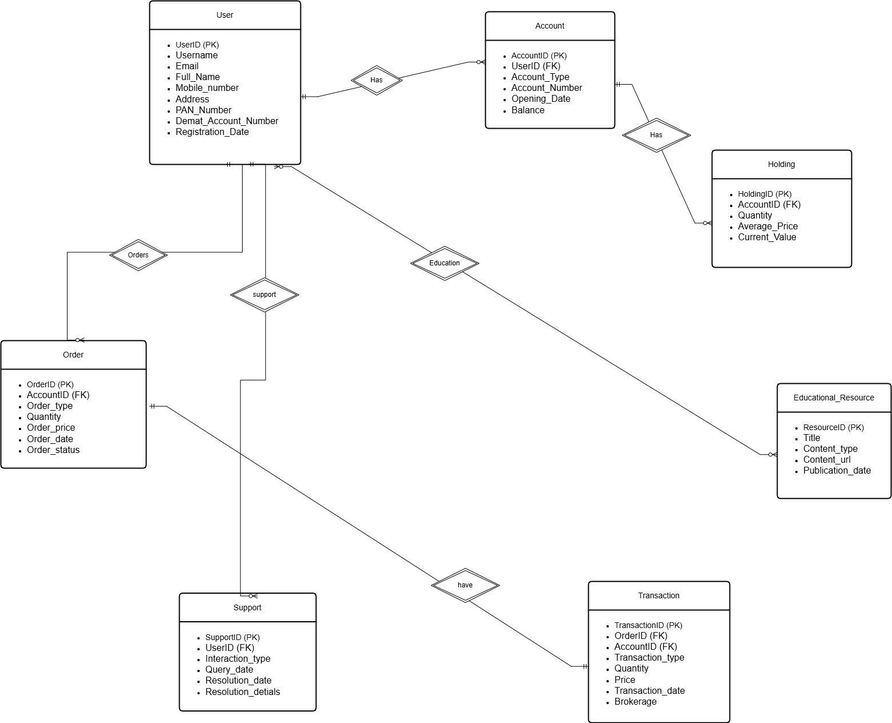

This ER diagram captures the primary entities and their relationships within the Zerodha platform, offering a comprehensive view of how data is organized and interconnected.

**Conclusion**

In this case study, we explored the schema and Entity-Relationship (ER) diagram of Zerodha, India’s leading stockbroker. Zerodha has transformed the financial trading landscape by providing accessible and innovative tools for investors and traders. Its sophisticated data model, encompassing entities like users, trades, portfolios, investments, mutual funds, and their interactions, underpins the platform's comprehensive functionality.

The schema reflects Zerodha's commitment to simplifying trading and investment processes while supporting advanced features like algorithmic trading and financial education. By understanding Zerodha's data architecture, we gain valuable insights into how the platform efficiently manages user activities, trading transactions, and investment portfolios. This well-designed schema supports Zerodha’s user-centric approach, empowering millions to take control of their financial futures and solidifying its position as a leader in the financial services domain.