

COLLEGE CODE: 8107

COURSE: Cloud Application Development

PHASE V: Project Documentation & Submission

PROJECT TITLE: Serverless IoT Data Processing

Team Members:

* CHANDANA SHREE S - 810721243014

[chandanashree.s@care.ac.in](mailto:chandanashree.s@care.ac.in)

* DHARANA SHRI K - 810721243016

[dharanashri.k@care.ac.in](mailto:dharanashri.k@care.ac.in)

* SUMITHRA A - 810721243051

[sumithra.a@care.ac.in](mailto:sumithra.a@care.ac.in)

* RAHAVI A - 810721243302

[rahavi.a.ai@care.ac.in](mailto:rahavi.a.ai@care.ac.in)

INTRODUCTION:

The project aims to transform a home into a smart living space using IBM Cloud Functions for IoT data processing. The goal is to collect data from various smart devices, process it in real-time, and automate routines for energy efficiency and home security. This involves designing the smart home setup, implementing data collection and processing, and leveraging IBM Cloud for storage and analysis.

PROJECT OBJECTIVE:

The primary objective of this project is to transform your home into a smart living space, leveraging IBM Cloud Functions for IoT data processing. This serverless smart home aims to enhance energy efficiency, elevate home security, and provide unmatched convenience to its residents. By collecting, processing, and analyzing data from a range of smart devices, including thermostats, motion sensors, and cameras, this project seeks to create a seamlessly automated, intelligent home ecosystem. The overarching goal is to offer residents the peace of mind that comes with a state-of-the-art, serverless smart home.

DESIGN THINKING:

* Device Integration:

In this phase, you'll identify and integrate various smart devices like thermostats, motion sensors, and cameras into your smart home ecosystem. These devices are selected to support your project's objectives, such as energy efficiency and home security.

* Data Collection:

Once the smart devices are integrated, you'll set up data collection from these devices using IoT protocols, such as MQTT or HTTP. This phase involves configuring the devices to transmit data to your chosen IoT platform, which is IBM Cloud IoT in this case.

* Real-Time Data Processing:

This phase involves implementing serverless functions using IBM Cloud Functions to process the incoming IoT data in real-time. You'll write code to define how the data should be processed as it's received, such as adjusting thermostat settings based on temperature data or sending alerts when motion is detected.

* Automation:

In the automation phase, you'll develop automated routines to optimize energy efficiency and enhance home security. These routines will define rules that govern the behavior of smart devices based on specific conditions, ensuring that devices respond to events in a way that aligns with your project's goals.

* Storage and Analysis:

The data collected from the smart devices is stored in IBM Cloud Object Storage. You'll set up this storage solution to maintain historical IoT data. Additionally, you'll develop analytics and insights generation mechanisms to extract valuable information from the stored data, such as energy consumption patterns and security event trends.

DEVELOPMENT PHASE:

The development phase of your project focuses on bringing your serverless smart home system to life. During this phase, you'll create and implement the core technical components, including serverless functions using IBM Cloud Functions. These functions will process real-time data from IoT devices, such as thermostats, motion sensors, and cameras, and enable automation for energy efficiency and home security. Event triggers will be set up to initiate actions based on specific events or conditions. Rigorous testing and validation will ensure that the system functions as intended. Depending on the project's scope, a user interface may be developed for residents to interact with the smart home. Deployment is the final step, ensuring that the system is operational in the real-world environment, bringing your vision of an efficient, secure, and convenient smart home one step closer to reality.

DEVICE INTEGRATION AND DATA COLLECTION:

* Import the required libraries and connect to the IOT platform:

We use libraries like paho-mqtt for MQTT communication, requests for HTTP requests, or device-specific libraries provided by device manufacturers.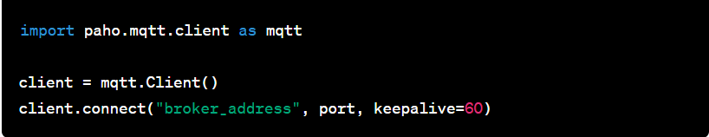

* Subscribe to Device Topics:

Subscribe to MQTT topics to receive data from your devices. Device-specific documentation will specify the topics used by your devices.

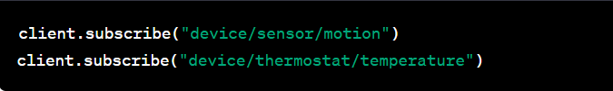

* Data Collection and Processing:

Set up callback functions to process incoming data from subscribed topics. Data is delivered to these callback functions when devices send updates.Process and store data as needed.

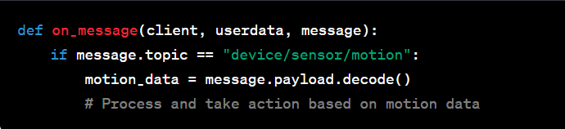

* Control Smart Devices:

We use the relevant libraries or APIs provided by the device manufacturers for controlling the smart devices.

We are using thermostat device that supports API control,so we import “request” library to set the thermostat temperature.

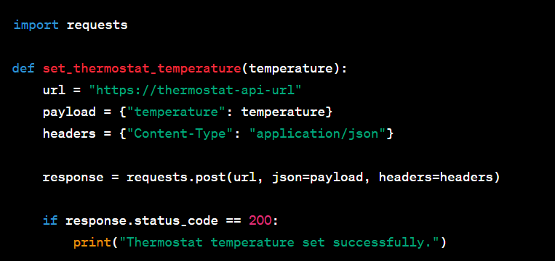

* Run the entire Data Collection Script:

Store the collected data which will connect to the IoT platform, subscribe to device topics, and collect data in real-ti

REAL TIME PROCESSING & AUTOMATION :

To use IBM Cloud Functions to process thermostat data and trigger automated routines in your smart home project, you would need to set up a serverless function to handle the data processing and automation logic.

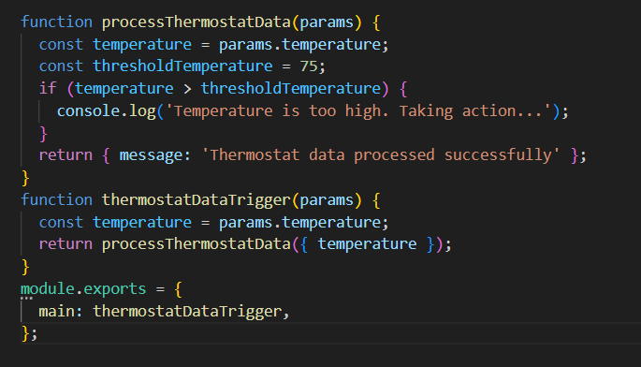

STORE THE DATA IN IBM CLOUD:

* Install IBM Cloud SDK using pip



* Store the data in IBM Cloud

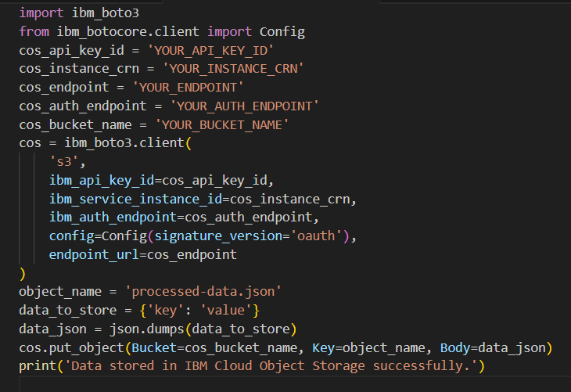

CONCLUSION:

In this solution, we successfully created a serverless IoT data processing system using IBM Cloud Functions. By following the problem definition, design thinking, development, and documentation phases, we designed and developed a smart home that collects data from various devices, processes it in real-time, and automates routines for energy efficiency and home security. The solution leverages IBM Cloud Object Storage for data storage and analysis, providing valuable insights and enhancing the convenience and peace of mind of a serverless smart home.