**WEEK-2**

**PL SQL HANDS ON**

**Exercise 1: Control Structures**

**Scenario 1**: The bank wants to apply a discount to loan interest rates for customers above 60 years old.

**Question:** Write a PL/SQL block that loops through all customers, checks their age, and if they are above 60, apply a 1% discount to their current loan interest rates.

**CODE:**

BEGIN

    FOR customerloop IN (SELECT CustomerID, DOB FROM Customers) LOOP

        IF FLOOR(MONTHS_BETWEEN(SYSDATE, customerloop.DOB) / 12) > 60 THEN

            UPDATE Loans

            SET InterestRate = InterestRate - 1

            WHERE CustomerID = customerloop.CustomerID;

        END IF;

    END LOOP;

END;

**OUTPUT:**

**Scenario 2:** A customer can be promoted to VIP status based on their balance.

**Question**: Write a PL/SQL block that iterates through all customers and sets a flag IsVIP to TRUE for those with a balance over $10,000.

**CODE:**

BEGIN

  FOR customer_record IN (

    SELECT CustomerID, Balance

    FROM Customers

  ) LOOP

    IF customer_record.Balance > 10000 THEN

      UPDATE Customers

      SET IsVIP = 'TRUE'

      WHERE CustomerID = customer_record.CustomerID;

    END IF;

  END LOOP;

  COMMIT;

END;

**OUTPUT:  
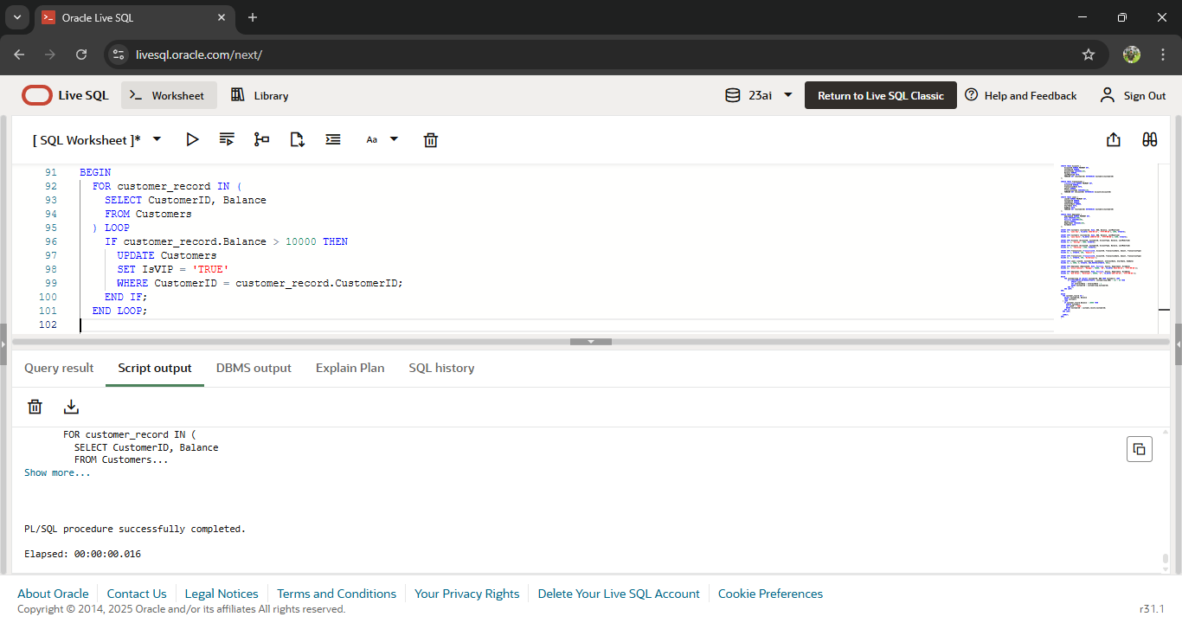**

**Scenario 3:** The bank wants to send reminders to customers whose loans are due within the next 30 days**.**

**Question:** Write a PL/SQL block that fetches all loans due in the next 30 days and prints a reminder message for each customer.

**CODE:**BEGIN

  FOR loan_due_record IN (

    SELECT c.Name AS customer_name, l.EndDate AS due_date

    FROM Loans l

    JOIN Customers c ON l.CustomerID = c.CustomerID

    WHERE l.EndDate <= SYSDATE + 30

  ) LOOP

    DBMS_OUTPUT.PUT_LINE(

      'Reminder: Loan for ' || loan_due_record.customer_name ||

      ' is due on ' || TO_CHAR(loan_due_record.due_date, 'YYYY-MM-DD')

    );

  END LOOP;

END;

**OUTPUT:**

**Exercise 2: Error Handling**

**Scenario 1:** Handle exceptions during fund transfers between accounts.

**Question:** Write a stored procedure SafeTransferFunds that transfers funds between two accounts. Ensure that if any error occurs (e.g., insufficient funds), an appropriate error message is logged and the transaction is rolled back.

**CODE:**

CREATE OR REPLACE PROCEDURE SafeTransferFunds (

    p_from_account_id IN NUMBER,

    p_to_account_id IN NUMBER,

    p_amount IN NUMBER

)

IS

BEGIN

    DECLARE

        v_balance NUMBER;

    BEGIN

        SELECT Balance INTO v_balance FROM Accounts WHERE AccountID = p_from_account_id FOR UPDATE;

        IF v_balance < p_amount THEN

            RAISE_APPLICATION_ERROR(-20001, 'Insufficient funds in source account.');

        END IF;

        UPDATE Accounts

        SET Balance = Balance - p_amount

        WHERE AccountID = p_from_account_id;

        UPDATE Accounts

        SET Balance = Balance + p_amount

        WHERE AccountID = p_to_account_id;

        COMMIT;

        DBMS_OUTPUT.PUT_LINE('Transfer completed successfully.');

    EXCEPTION

        WHEN OTHERS THEN

            ROLLBACK;

            DBMS_OUTPUT.PUT_LINE('Error during fund transfer: ' || SQLERRM);

    END;

END;

/

EXEC SafeTransferFunds(1, 2, 100);

**OUTPUT:**

**Scenario 2:** Manage errors when updating employee salaries.

**Question:** Write a stored procedure **UpdateSalary** that increases the salary of an employee by a given percentage. If the employee ID does not exist, handle the exception and log an error message.

**CODE:**

CREATE OR REPLACE PROCEDURE UpdateSalary (

    p_employee_id IN NUMBER,

    p_percentage IN NUMBER

)

IS

BEGIN

    UPDATE Employees

    SET Salary = Salary + (Salary * p_percentage / 100)

    WHERE EmployeeID = p_employee_id;

    IF SQL%ROWCOUNT = 0 THEN

        DBMS_OUTPUT.PUT_LINE('Error: Employee ID ' || p_employee_id || ' not found.');

    ELSE

        DBMS_OUTPUT.PUT_LINE('Salary updated successfully for Employee ID ' || p_employee_id);

        COMMIT;

    END IF;

EXCEPTION

    WHEN OTHERS THEN

        ROLLBACK;

        DBMS_OUTPUT.PUT_LINE('Unexpected error during salary update: ' || SQLERRM);

END;

/

EXEC UpdateSalary(2, 10);

**OUTPUT:**

**Scenario 3:** Ensure data integrity when adding a new customer.

**Question:** Write a stored procedure AddNewCustomer that inserts a new customer into the Customers table. If a customer with the same ID already exists, handle the exception by logging an error and preventing the insertion.

**CODE:**

CREATE OR REPLACE PROCEDURE AddNewCustomer (

    p_customer_id IN NUMBER,

    p_name        IN VARCHAR2,

    p_dob         IN DATE,

    p_balance     IN NUMBER

)

IS

BEGIN

    INSERT INTO Customers (

        CustomerID, Name, DOB, Balance, LastModified

    ) VALUES (

        p_customer_id, p_name, p_dob, p_balance, SYSDATE

    );

    COMMIT;

    DBMS_OUTPUT.PUT_LINE('Customer added successfully: ' || p_name);

EXCEPTION

    WHEN DUP_VAL_ON_INDEX THEN

        DBMS_OUTPUT.PUT_LINE('Error: Customer ID ' || p_customer_id || ' already exists.');

    WHEN OTHERS THEN

        DBMS_OUTPUT.PUT_LINE('Unexpected error during customer insertion: ' || SQLERRM);

END;

/

EXEC AddNewCustomer(1, 'Ravi Kumar', TO_DATE('1988-12-01','YYYY-MM-DD'), 5000);

**OUTPUT:  
**

**Exercise 3: Stored Procedures**

**Scenario 1**: The bank needs to process monthly interest for all savings accounts.

**Question:** Write a stored procedure ProcessMonthlyInterest that calculates and updates the balance of all savings accounts by applying an interest rate of 1% to the current balance.

**CODE:**CREATE OR REPLACE PROCEDURE ProcessMonthlyInterest

IS

BEGIN

  UPDATE Accounts

  SET Balance = Balance + (Balance * 0.01),

      LastModified = SYSDATE

  WHERE AccountType = 'Savings';

  COMMIT;

  DBMS_OUTPUT.PUT_LINE('Monthly interest applied to all savings accounts.');

EXCEPTION

  WHEN OTHERS THEN

    ROLLBACK;

    DBMS_OUTPUT.PUT_LINE('Error processing interest: ' || SQLERRM);

END;

/

**OUTPUT:  
**

**Scenario 2:** The bank wants to implement a bonus scheme for employees based on their performance.

**Question:** Write a stored procedure **UpdateEmployeeBonus** that updates the salary of employees in a given department by adding a bonus percentage passed as a parameter.

**CODE:**

CREATE OR REPLACE PROCEDURE UpdateEmployeeBonus (

  p_department IN VARCHAR2,

  p_bonus_percent IN NUMBER)

ISBEGIN

  UPDATE Employees

  SET Salary = Salary + (Salary * p_bonus_percent / 100)

  WHERE Department = p_department;

  IF SQL%ROWCOUNT > 0 THEN

    DBMS_OUTPUT.PUT_LINE('Bonus applied to employees in department: ' || p_department);

    COMMIT;

  ELSE

    DBMS_OUTPUT.PUT_LINE('No employees found in department: ' || p_department);

  END IF;

EXCEPTION

  WHEN OTHERS THEN

    ROLLBACK;

    DBMS_OUTPUT.PUT_LINE('Error applying bonus: ' || SQLERRM);

END;/

EXEC UpdateEmployeeBonus('IT', 10);

**OUTPUT:**

**Scenario 3:** Customers should be able to transfer funds between their accounts.

**Question:** Write a stored procedure **TransferFunds** that transfers a specified amount from one account to another, checking that the source account has sufficient balance before making the transfer.

**CODE:**

CREATE OR REPLACE PROCEDURE TransferFunds (

  p_from_account IN NUMBER,

  p_to_account IN NUMBER,

  p_amount IN NUMBER

)

IS

  v_balance NUMBER;

BEGIN

  SELECT Balance INTO v_balance

  FROM Accounts

  WHERE AccountID = p_from_account

  FOR UPDATE;

  IF v_balance < p_amount THEN

    DBMS_OUTPUT.PUT_LINE('Insufficient balance in account: ' || p_from_account);

    ROLLBACK;

    RETURN;

  END IF;

  UPDATE Accounts

  SET Balance = Balance - p_amount,

      LastModified = SYSDATE

  WHERE AccountID = p_from_account;

  UPDATE Accounts

  SET Balance = Balance + p_amount,

      LastModified = SYSDATE

  WHERE AccountID = p_to_account;

  COMMIT;

  DBMS_OUTPUT.PUT_LINE('Transfer of ' || p_amount || ' completed from Account ' ||

                        p_from_account || ' to Account ' || p_to_account);

EXCEPTION

  WHEN OTHERS THEN

    ROLLBACK;

    DBMS_OUTPUT.PUT_LINE('Error in fund transfer: ' || SQLERRM);

END;/

EXEC TransferFunds(1, 2, 500);

**OUTPUT:**

**Exercise 4: Functions**

**Scenario 1:** Calculate the age of customers for eligibility checks.

**Question:** Write a function CalculateAge that takes a customer's date of birth as input and returns their age in years.

**CODE:**

CREATE OR REPLACE FUNCTION CalculateAge (

  p_dob IN DATE

) RETURN NUMBER

IS

BEGIN

  RETURN FLOOR(MONTHS_BETWEEN(SYSDATE, p_dob) / 12);

END;

/

SELECT CalculateAge(TO_DATE('1990-06-29', 'YYYY-MM-DD')) AS Age FROM dual;

**OUTPUT:**

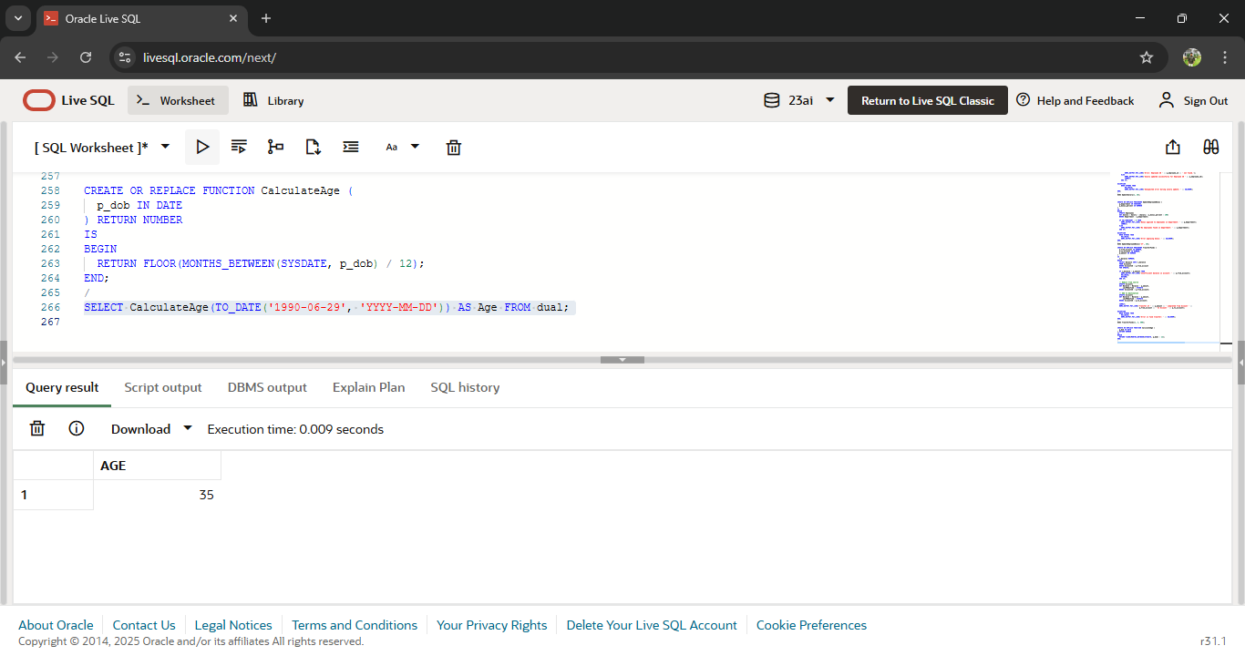

**Scenario 2:** The bank needs to compute the monthly installment for a loan.

**Question:** Write a function **CalculateMonthlyInstallment** that takes the loan amount, interest rate, and loan duration in years as input and returns the monthly installment amount.

**CODE:**

CREATE OR REPLACE FUNCTION CalculateMonthlyInstallment (

  p_loan_amount IN NUMBER,

  p_annual_rate IN NUMBER,

  p_years IN NUMBER

) RETURN NUMBER

IS

  v_monthly_rate NUMBER;

  v_months NUMBER;

  v_installment NUMBER;

BEGIN

  v_monthly_rate := p_annual_rate / 12 / 100;

  v_months := p_years * 12;

  v_installment :=

    p_loan_amount * v_monthly_rate * POWER(1 + v_monthly_rate, v_months)

    / (POWER(1 + v_monthly_rate, v_months) - 1);

  RETURN ROUND(v_installment, 2);

END;

/

SELECT CalculateMonthlyInstallment(100000, 6.5, 5) AS EMI FROM dual;

**OUTPUT:  
**

**Scenario 3**: Check if a customer has sufficient balance before making a transaction.

**Question:** Write a function HasSufficientBalance that takes an account ID and an amount as input and returns a boolean indicating whether the account has at least the specified amount.

**CODE:**

CREATE OR REPLACE FUNCTION HasSufficientBalance (

  p_account_id IN NUMBER,

  p_amount IN NUMBER

) RETURN BOOLEAN

IS

  v_balance NUMBER;

BEGIN

  SELECT Balance INTO v_balance

  FROM Accounts

  WHERE AccountID = p_account_id;

  RETURN v_balance >= p_amount;

EXCEPTION

  WHEN NO_DATA_FOUND THEN

    RETURN FALSE;

  WHEN OTHERS THEN

    RETURN FALSE;

END;

/

DECLARE

  result BOOLEAN;

BEGIN

  result := HasSufficientBalance(1, 5000);

  IF result THEN

    DBMS_OUTPUT.PUT_LINE('Sufficient balance.');

  ELSE

    DBMS_OUTPUT.PUT_LINE('Insufficient balance.');

  END IF;

END;

/

**OUTPUT:**

**Exercise 5: Triggers**

**Scenario 1:** Automatically update the last modified date when a customer's record is updated.

**Question:** Write a trigger **UpdateCustomerLastModified** that updates the LastModified column of the Customers table to the current date whenever a customer's record is updated

**CODE:**

CREATE OR REPLACE TRIGGER UpdateCustomerLastModified

BEFORE UPDATE ON Customers

FOR EACH ROW

BEGIN

:NEW.LastModified := SYSDATE;

END;

/**OUTPUT:**

**Scenario 2**: Maintain an audit log for all transactions**.**

**Question**: Write a trigger LogTransaction that inserts a record into an AuditLog table whenever a transaction is inserted into the Transactions table.

**CODE:**

CREATE TABLE AuditLog (

  LogID NUMBER GENERATED BY DEFAULT ON NULL AS IDENTITY PRIMARY KEY,

  TransactionID NUMBER,

  AccountID NUMBER,

  ActionType VARCHAR2(20),

  ActionDate DATE

);

CREATE OR REPLACE TRIGGER LogTransaction

AFTER INSERT ON Transactions

FOR EACH ROW

BEGIN

  INSERT INTO AuditLog (

    TransactionID, AccountID, ActionType, ActionDate

  ) VALUES (

    :NEW.TransactionID, :NEW.AccountID, 'INSERT', SYSDATE

  );

END;

/

**OUTPUT:**

**Scenario 3:** Enforce business rules on deposits and withdrawals.

**Question:** Write a trigger CheckTransactionRules that ensures withdrawals do not exceed the balance and deposits are positive before inserting a record into the Transactions table

**CODE:**

CREATE OR REPLACE TRIGGER CheckTransactionRules

BEFORE INSERT ON Transactions

FOR EACH ROW

DECLARE

  v_balance NUMBER;

BEGIN

  -- Get account balance

  SELECT Balance INTO v_balance FROM Accounts WHERE AccountID = :NEW.AccountID;

  -- Rule: Withdrawal must not exceed current balance

  IF :NEW.TransactionType = 'Withdrawal' AND :NEW.Amount > v_balance THEN

    RAISE_APPLICATION_ERROR(-20001, 'Withdrawal exceeds available balance.');

  END IF;

  -- Rule: Deposit must be positive

  IF :NEW.TransactionType = 'Deposit' AND :NEW.Amount <= 0 THEN

    RAISE_APPLICATION_ERROR(-20002, 'Deposit amount must be greater than zero.');

  END IF;

END;

/

**OUTPUT:**

**Exercise 6: Cursors**

**Scenario 1:** Generate monthly statements for all customers.

**Question:** Write a PL/SQL block using an explicit cursor GenerateMonthlyStatements that retrieves all transactions for the current month and prints a statement for each customer.

**CODE:**

SET SERVEROUTPUT ON;

DECLARE

  CURSOR transaction_cursor IS

    SELECT t.TransactionID, t.AccountID, t.TransactionDate, t.Amount, t.TransactionType, c.Name

    FROM Transactions t

    JOIN Accounts a ON t.AccountID = a.AccountID

    JOIN Customers c ON a.CustomerID = c.CustomerID

    WHERE TRUNC(t.TransactionDate, 'MM') = TRUNC(SYSDATE, 'MM');

  v_transaction transaction_cursor%ROWTYPE;

BEGIN

  OPEN transaction_cursor;

  LOOP

    FETCH transaction_cursor INTO v_transaction;

    EXIT WHEN transaction_cursor%NOTFOUND;

    DBMS_OUTPUT.PUT_LINE('Customer: ' || v_transaction.Name ||

                         ' | Date: ' || TO_CHAR(v_transaction.TransactionDate, 'YYYY-MM-DD') ||

                         ' | Type: ' || v_transaction.TransactionType ||

                         ' | Amount: ' || v_transaction.Amount);

  END LOOP;

  CLOSE transaction_cursor;

END;

**OUTPUT:  
**

**Scenario 2:** Apply annual fee to all accounts**.**

**Question**: Write a PL/SQL block using an explicit cursor ApplyAnnualFee that deducts an annual maintenance fee from the balance of all accounts.

**CODE:**

DECLARE

  CURSOR account_cursor IS

    SELECT AccountID, Balance FROM Accounts;

  v_account account_cursor%ROWTYPE;

  v_fee CONSTANT NUMBER := 100; -- Annual fee amount

BEGIN

  OPEN account_cursor;

  LOOP

    FETCH account_cursor INTO v_account;

    EXIT WHEN account_cursor%NOTFOUND;

    UPDATE Accounts

    SET Balance = Balance - v_fee,

        LastModified = SYSDATE

    WHERE AccountID = v_account.AccountID;

    DBMS_OUTPUT.PUT_LINE('Annual fee deducted from Account ID: ' || v_account.AccountID);

  END LOOP;

  CLOSE account_cursor;

  COMMIT;

END;

/

**OUTPUT:**

**Scenario 3:** Update the interest rate for all loans based on a new policy.

**Question**: Write a PL/SQL block using an explicit cursor UpdateLoanInterestRates that fetches all loans and updates their interest rates based on the new policy**.**

**CODE:**

DECLARE

  CURSOR loan_cursor IS

    SELECT LoanID, LoanAmount, InterestRate FROM Loans;

  v_loan loan_cursor%ROWTYPE;

  v_new_rate NUMBER;

BEGIN

  OPEN loan_cursor;

  LOOP

    FETCH loan_cursor INTO v_loan;

    EXIT WHEN loan_cursor%NOTFOUND;

    -- Apply new rate policy

    IF v_loan.LoanAmount >= 10000 THEN

      v_new_rate := 6;

    ELSE

      v_new_rate := 5;

    END IF;

    UPDATE Loans

    SET InterestRate = v_new_rate

    WHERE LoanID = v_loan.LoanID;

    DBMS_OUTPUT.PUT_LINE('Loan ID: ' || v_loan.LoanID ||

                         ' | Old Rate: ' || v_loan.InterestRate ||

                         ' | New Rate: ' || v_new_rate);

  END LOOP;

  CLOSE loan_cursor;

  COMMIT;

END;

/

**OUTPUT:**

**Exercise 7: Packages**

**Scenario 1:** Group all customer-related procedures and functions into a package.

**Question:** Create a package CustomerManagement with procedures for adding a new customer, updating customer details, and a function to get customer balance**.**

**CODE:**CREATE OR REPLACE PACKAGE CustomerManagement AS

  PROCEDURE AddCustomer(

    p_customer_id IN NUMBER,

    p_name IN VARCHAR2,

    p_dob IN DATE,

    p_balance IN NUMBER

  );

  PROCEDURE UpdateCustomerDetails(

    p_customer_id IN NUMBER,

    p_name IN VARCHAR2,

    p_dob IN DATE

  );

  FUNCTION GetCustomerBalance(p_customer_id IN NUMBER) RETURN NUMBER;

END CustomerManagement;

/

CREATE OR REPLACE PACKAGE BODY CustomerManagement AS

  PROCEDURE AddCustomer(

    p_customer_id IN NUMBER,

    p_name IN VARCHAR2,

    p_dob IN DATE,

    p_balance IN NUMBER

  ) IS

  BEGIN

    INSERT INTO Customers (CustomerID, Name, DOB, Balance, LastModified)

    VALUES (p_customer_id, p_name, p_dob, p_balance, SYSDATE);

    COMMIT;

  EXCEPTION

    WHEN DUP_VAL_ON_INDEX THEN

      DBMS_OUTPUT.PUT_LINE('Customer already exists.');

  END;

  PROCEDURE UpdateCustomerDetails(

    p_customer_id IN NUMBER,

    p_name IN VARCHAR2,

    p_dob IN DATE

  ) IS

  BEGIN

    UPDATE Customers

    SET Name = p_name,

        DOB = p_dob,

        LastModified = SYSDATE

    WHERE CustomerID = p_customer_id;

    COMMIT;

  END;

  FUNCTION GetCustomerBalance(p_customer_id IN NUMBER) RETURN NUMBER IS

    v_balance NUMBER;

  BEGIN

    SELECT Balance INTO v_balance FROM Customers WHERE CustomerID = p_customer_id;

    RETURN v_balance;

  EXCEPTION

    WHEN NO_DATA_FOUND THEN

      RETURN 0;

  END;

END CustomerManagement;

/

**OUTPUT:**

**Scenario 2:** Create a package to manage employee data.

**Question**: Write a package EmployeeManagement with procedures to hire new employees, update employee details, and a function to calculate annual salary.

**OUTPUT:**

CREATE OR REPLACE PACKAGE EmployeeManagement AS

  PROCEDURE HireEmployee(

    p_emp_id IN NUMBER,

    p_name IN VARCHAR2,

    p_position IN VARCHAR2,

    p_salary IN NUMBER,

    p_department IN VARCHAR2,

    p_hire_date IN DATE

  );

  PROCEDURE UpdateEmployee(

    p_emp_id IN NUMBER,

    p_salary IN NUMBER,

    p_department IN VARCHAR2

  );

  FUNCTION CalculateAnnualSalary(p_emp_id IN NUMBER) RETURN NUMBER;

END EmployeeManagement;

/

CREATE OR REPLACE PACKAGE BODY EmployeeManagement AS

  PROCEDURE HireEmployee(

    p_emp_id IN NUMBER,

    p_name IN VARCHAR2,

    p_position IN VARCHAR2,

    p_salary IN NUMBER,

    p_department IN VARCHAR2,

    p_hire_date IN DATE

  ) IS

  BEGIN

    INSERT INTO Employees (EmployeeID, Name, Position, Salary, Department, HireDate)

    VALUES (p_emp_id, p_name, p_position, p_salary, p_department, p_hire_date);

    COMMIT;

  END;

  PROCEDURE UpdateEmployee(

    p_emp_id IN NUMBER,

    p_salary IN NUMBER,

    p_department IN VARCHAR2

  ) IS

  BEGIN

    UPDATE Employees

    SET Salary = p_salary,

        Department = p_department

    WHERE EmployeeID = p_emp_id;

    COMMIT;

  END;

  FUNCTION CalculateAnnualSalary(p_emp_id IN NUMBER) RETURN NUMBER IS

    v_salary NUMBER;

  BEGIN

    SELECT Salary INTO v_salary FROM Employees WHERE EmployeeID = p_emp_id;

    RETURN v_salary * 12;

  EXCEPTION

    WHEN NO_DATA_FOUND THEN

      RETURN 0;

  END;

END EmployeeManagement;

/

**OUTPUT:**

**Scenario 3**: Group all account-related operations into a package.

**Question:** Create a package AccountOperations with procedures for opening a new account, closing an account, and a function to get the total balance of a customer across all accounts.

**CODE:**

CREATE OR REPLACE PACKAGE AccountOperations AS

  PROCEDURE OpenAccount(

    p_account_id IN NUMBER,

    p_customer_id IN NUMBER,

    p_type IN VARCHAR2,

    p_balance IN NUMBER

  );

  PROCEDURE CloseAccount(p_account_id IN NUMBER);

  FUNCTION GetTotalBalance(p_customer_id IN NUMBER) RETURN NUMBER;

END AccountOperations;

/

CREATE OR REPLACE PACKAGE BODY AccountOperations AS

  PROCEDURE OpenAccount(

    p_account_id IN NUMBER,

    p_customer_id IN NUMBER,

    p_type IN VARCHAR2,

    p_balance IN NUMBER

  ) IS

  BEGIN

    INSERT INTO Accounts (AccountID, CustomerID, AccountType, Balance, LastModified)

    VALUES (p_account_id, p_customer_id, p_type, p_balance, SYSDATE);

    COMMIT;

  END;

  PROCEDURE CloseAccount(p_account_id IN NUMBER) IS

  BEGIN

    DELETE FROM Accounts WHERE AccountID = p_account_id;

    COMMIT;

  END;

  FUNCTION GetTotalBalance(p_customer_id IN NUMBER) RETURN NUMBER IS

    v_total NUMBER;

  BEGIN

    SELECT SUM(Balance) INTO v_total FROM Accounts WHERE CustomerID = p_customer_id;

    RETURN NVL(v_total, 0);

  END;

END AccountOperations;

/

**OUTPUT:**

