 | 
KALASALINGAM ACADEMY OF RESEARCH AND EDUCATION
(Deemed to be University) • Krishnankoil, Srivilliputhur, Tamil Nadu 626126
Project Report On
“DEVELOPMENT OF A MULTI-PROTOCOL INDUSTRIAL COMMUNICATION GATEWAY”
Submitted in partial fulfillment of the requirements for the
Semester III
Mini Project Work [ECE221]
Bachelor of Engineering in
Electronics and Communication Engineering
of Kalasalingam Academy of Research and Education
By
TEAM 07 (QUANTUM FORGE)
S.No | Name of the Student | Register Number
1 | DHARANEESWARAN M (Team Leader) | 9925005044
2 | SAKTHI MURUGAN M V | 9925005134
3 | AAKASH M | 9925005084
4 | KODIESWARAN R | 9925005083

Mr. Pavan Kumar E  External Guide  Manager R&D  Nanochip Solutions | Prof. Mrs. Loyola Jasmine  Internal Guide  Assistant Professor  Dept. of ECE, KARE
Department of Electronics and Communication Engineering
Kalasalingam Academy of Research and Education
2026-27

CERTIFICATE
It is certified that Dharaneeswaran M, Sakthi Murugan M V, Aakash M and Kodieswaran R (Team 07 – Quantum Forge), bearing Register Numbers 9925005044, 9925005134, 9925005084 and 9925005083 respectively, are bonafide students of Kalasalingam Academy of Research and Education and have completed the project entitled “Development of a Multi-Protocol Industrial Communication Gateway” in partial fulfillment of the requirements for the Semester III Bachelor of Engineering in Electronics and Communication Engineering during the academic year 2026-2027.
It is certified that all corrections and suggestions indicated for project assessment have been incorporated in this report. The report has been approved as it satisfies the academic requirements in respect of the project work prescribed for the Bachelor of Engineering degree.

Mr. Pavan Kumar E  External Guide  Manager R&D  Nanochip Solutions | Prof. Mrs. Loyola Jasmine  Internal Guide  Assistant Professor  Dept. of ECE, KARE
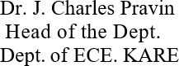

External Viva
S.No | Name of the Examiner | Signature with date
1.
2.

DECLARATION
We, the members of Team 07 (Quantum Forge) – Dharaneeswaran M (9925005044), Sakthi Murugan M V (9925005134), Aakash M (9925005084) and Kodieswaran R (9925005083) – bonafide students of Kalasalingam Academy of Research and Education, declare that the project entitled “Development of a Multi-Protocol Industrial Communication Gateway” is a record of original work carried out by us for the partial fulfillment of the requirements for the Semester III Bachelor of Engineering in Electronics and Communication Engineering during the academic year 2026-2027.
We also declare that, to the best of our knowledge and belief, the work reported here does not form part of any other report on the basis of which a degree or award was conferred on an earlier occasion on this or any other student.

Date:
Place:
Dharaneeswaran M Signature: ____________________
Sakthi Murugan M V Signature: ____________________
Aakash M Signature: ____________________
Kodieswaran R Signature: ____________________

ABSTRACT
Industrial systems rarely use a single communication interface: sensors, controllers, displays and monitoring units are connected through different serial protocols. A gateway that can collect device data, carry it over more than one interface and report the health of each link is therefore a basic building block of connected industrial equipment. This project presents the development of a multi-protocol industrial communication gateway as a working two-node prototype built on ESP32 DevKit V1 boards running MicroPython.
Node 1 reads acceleration and angular-velocity data from an MPU6050 motion sensor over I²C and forms a common sensor packet. The same packet is transmitted to Node 2 simultaneously through a hardware UART link (115200 baud, 8-N-1) and a software-implemented SPI link (Mode 0, MSB first). On the SPI path each packet is carried in a 69-byte frame, a 5-byte preamble followed by a 64-byte ASCII payload, which is 552 bits.
Node 2 acts as the gateway. It buffers and synchronises the incoming data, decodes the packet, validates its eight fields and numeric values, and updates separate counters for UART and SPI. Link health is determined from the time of the last valid packet: a protocol is OK if a valid packet arrived within 6 seconds, LOST otherwise, and WAIT before the first packet. UART is preferred and SPI is selected as the backup when UART is lost. Live readings and communication statistics are shown on an SSD1306 OLED and on a browser dashboard hosted by Node 2 over its own Wi-Fi access point, so no PC server or internet connection is needed.
In testing, packets were received and validated on both paths with matching sequence numbers, the SPI receiver captured complete 552-bit frames, and the OLED and dashboard reported UART and SPI status and the active protocol correctly. The report also records the prototype’s limitations, mainly the software-timed SPI receiver and receiver-side (not sender-controlled) path selection, and outlines the improvements planned.

CONTENTS
Chapter 1 Introduction
Chapter 2 Case Study
Chapter 3 Methodology
Chapter 4 Literature Survey
Chapter 5 Implementation
Chapter 6 Flowchart / Algorithm
Chapter 7 Simulation / Result Analysis
Chapter 8 Conclusion and Future Scope
Chapter 9 References
Appendix Key Technical Specifications

CHAPTER 1: INTRODUCTION
Modern industrial equipment is built from many small subsystems – sensors, controllers, displays and monitoring units – that exchange data through different communication interfaces. I²C, UART and SPI are among the most common of these because they are simple, inexpensive and supported by almost every microcontroller. A system that must collect data from such devices, transport it reliably and show whether each communication link is healthy needs a gateway that understands more than one interface.
This project develops a prototype of such a gateway using two ESP32 boards programmed in MicroPython. The first board (Node 1) acquires motion data from an MPU6050 sensor and sends it to the second board (Node 2) over two independent paths, UART and software SPI. Node 2 validates what it receives, keeps track of the health of each path, chooses an active path and presents the information locally on an OLED and remotely on a browser dashboard.

1.1 Problem Statement
Industrial systems use different communication interfaces. A gateway must therefore collect device data, transport it, and monitor the health of the communication links. The problem addressed here is to build a compact two-node ESP32 gateway that demonstrates sensor acquisition and parallel serial communication, and that can detect when a link stops delivering valid data.

1.2 Proposed Solution
- Node 1 reads motion data from an MPU6050 using I²C.
- The same packet is sent to Node 2 using UART and software SPI.
- Node 2 validates packets, tracks protocol status and selects an active path.
- An OLED and a browser dashboard present live information.
The core idea of the design is: acquire once → transmit over two interfaces → validate at the gateway → monitor communication health.

1.3 Objectives
- To read acceleration and angular-velocity data from an MPU6050 using I²C.
- To transmit a common sensor packet from Node 1 to Node 2 through UART and software SPI.
- To decode and validate the received packet using a defined message format.
- To monitor UART and SPI availability using packet timestamps and a timeout.
- To select UART as the preferred path and SPI as the backup when the link status changes.
- To display live readings and communication statistics on an OLED and a local web dashboard.

1.4 Scope of the Project
The project covers the complete prototype chain: sensor interfacing over I²C, definition of a common packet and frame format, transmission over UART and software SPI, reception and validation at the gateway, timestamp-based link monitoring, and presentation of results on an OLED and a local web dashboard. The prototype uses a single MPU6050 sensor and a short-range local Wi-Fi dashboard. Sender-controlled failover, acknowledgement and retransmission, secure Wi-Fi and cloud logging are outside the present scope and are listed as future work in Chapter 8.

1.5 Organization of the Report
Chapter 2 presents the case study on multi-interface communication. Chapter 3 describes the methodology: architecture, hardware, protocols, packet format and monitoring rules. Chapter 4 reviews the technologies and references used. Chapter 5 describes the implementation of both nodes and the dashboard. Chapter 6 gives the flowcharts and algorithms. Chapter 7 presents the results. Chapter 8 concludes the report with limitations and future scope, and Chapter 9 lists the references.

CHAPTER 2: CASE STUDY

2.1 Multi-Interface Communication in Industrial Systems
In an industrial setting a single machine may contain a motion or vibration sensor on an I²C bus, a controller board talking to another controller over UART, and a peripheral connected through SPI. Each interface has its own signalling, speed and wiring. A gateway sits between these devices and the people or systems that need their data: it collects the readings, moves them over the available links, checks that the data arrives intact and reports the state of each link.

2.2 Roles of I²C, UART and SPI
The three interfaces used in this project have clearly different characteristics, which is why each is given a distinct role in the prototype (Table 2.1).
Table 2.1: Communication interfaces used in the prototype
Interface | Type | Signals used | Role in the prototype
I²C | Synchronous, two-wire, addressed bus | SDA, SCL | Sensor interface: Node 1 ↔ MPU6050; Node 2 → OLED
UART | Asynchronous serial | TX, RX (common GND) | Primary link, Node 1 → Node 2
Software SPI | Synchronous serial, Mode 0 | MOSI, SCLK, CS (MISO unused) | Backup link, Node 1 → Node 2

2.3 Case: Two-Node ESP32 Gateway Prototype
The prototype is designed to show, on low-cost hardware, how one set of sensor data can be carried over two interfaces at once and how a gateway can tell which of them is working. Table 2.2 contrasts the prototype with a simple single-link arrangement.
Table 2.2: Single-link arrangement versus the prototype gateway
Aspect | Single interface link | Prototype gateway
Data paths | One | Two (UART and software SPI) carrying the same packet
Packet checking | Not defined | Defined message format; 8 fields and numeric values validated
Link monitoring | None | Per-protocol status (OK / LOST / WAIT) from last valid packet, 6 s timeout
Path selection | Fixed | UART preferred, SPI selected as backup when UART is LOST
Visibility | Serial console only | OLED and browser dashboard (192.168.4.1)
External infrastructure | Often a PC or server | Dashboard served by Node 2 itself; no internet needed

2.4 Advantages and Potential Applications
Advantages demonstrated by the prototype
- Multiple communication interfaces are demonstrated in one gateway.
- A common sensor packet is used across two paths.
- Packet validation and link-health monitoring are included.
- Local OLED and browser-based visibility is provided.
- The whole system is built using ESP32 and MicroPython.
Potential applications
- Industrial sensor gateways.
- Machine-condition monitoring prototypes.
- Educational demonstrations of serial protocols.
- Multi-interface data acquisition systems.
- Future integration with cloud or plant monitoring systems.

CHAPTER 3: METHODOLOGY

3.1 System Architecture
The system consists of two ESP32 nodes. Node 1 is the sensing and transmitting node; Node 2 is the gateway. Node 1 reads the MPU6050 over I²C, forms the sensor packet and publishes the same packet over both a UART link and a software SPI link. Node 2 receives and monitors each path, drives the OLED and hosts the dashboard over its Wi-Fi access point (Figure 3.1).
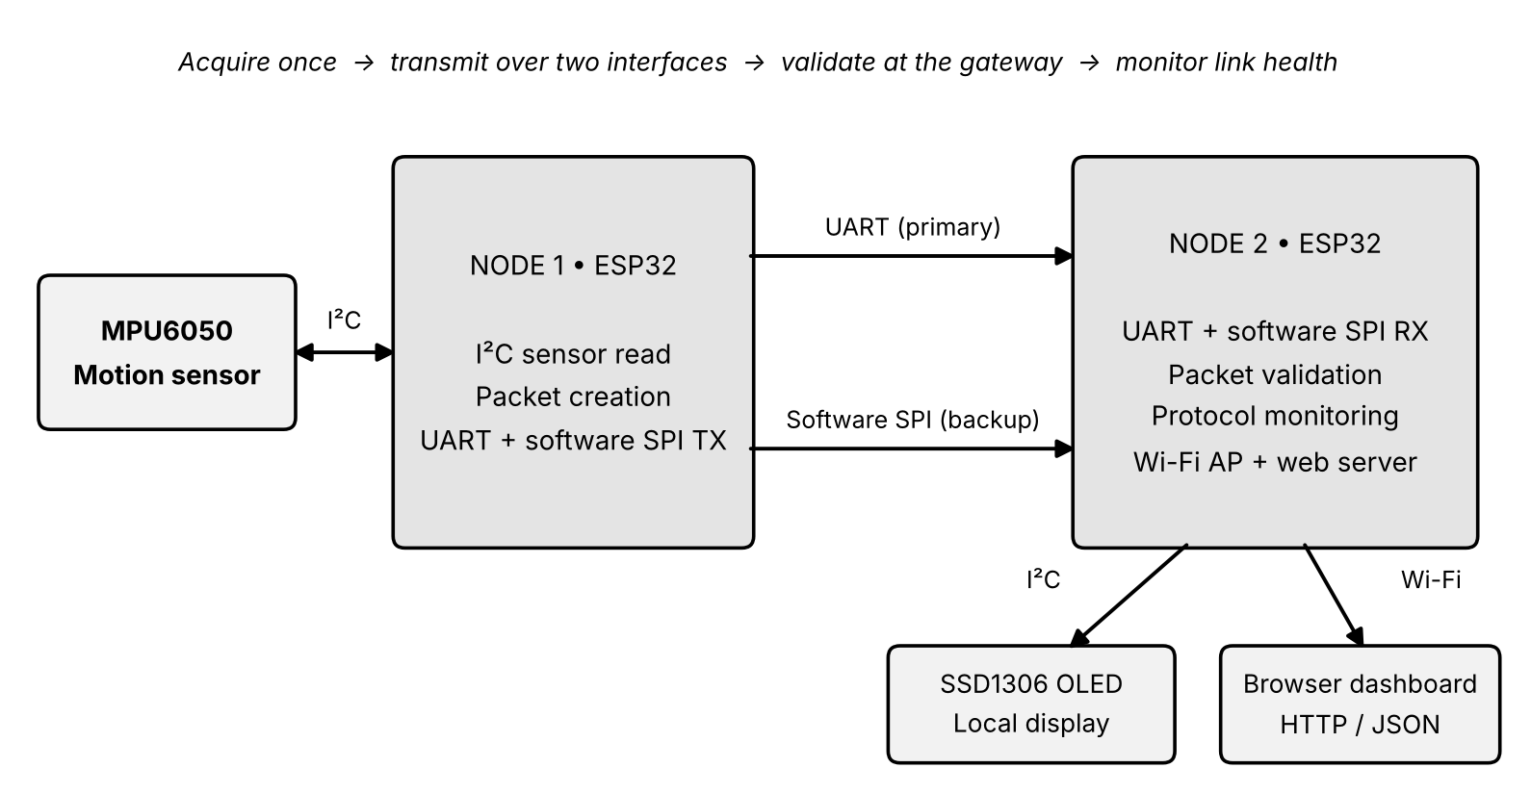
Figure 3.1: System architecture of the two-node gateway

3.2 Hardware Architecture

3.2.1 Node 1 – Sensor and transmitter
- ESP32 DevKit V1 (ESP32-WROOM-32).
- MPU6050 connected over I²C (SDA → GPIO 21, SCL → GPIO 22; I²C address 0x68).
- UART2 transmit and receive on GPIO 17 (TX) and GPIO 16 (RX).
- Software SPI outputs: MOSI → GPIO 23, SCLK → GPIO 18, CS → GPIO 5.

3.2.2 Node 2 – Gateway
- ESP32 DevKit V1 (ESP32-WROOM-32).
- SSD1306 OLED (128 × 64) over I²C (SDA → GPIO 21, SCL → GPIO 22; address 0x3C).
- UART receive on GPIO 16 (RX) and transmit on GPIO 17 (TX).
- Software SPI inputs: MOSI → GPIO 23, SCLK → GPIO 18, CS → GPIO 5.
- Wi-Fi access point and web server for the dashboard.

3.2.3 Inter-node wiring
Table 3.1: Connections between Node 1 and Node 2
Signal | Node 1 pin | Node 2 pin | Direction
UART data | TX – GPIO 17 | RX – GPIO 16 | Node 1 → Node 2
UART (reverse) | RX – GPIO 16 | TX – GPIO 17 | Node 2 → Node 1
SPI MOSI | GPIO 23 | GPIO 23 | Node 1 → Node 2
SPI SCLK | GPIO 18 | GPIO 18 | Node 1 → Node 2
SPI CS | GPIO 5 | GPIO 5 | Node 1 → Node 2
Ground | GND | GND | Common
Both ESP32 ground pins must be connected. SPI MISO is not used because the SPI link is one-way.

3.3 Communication Protocols

3.3.1 I²C – sensor interface
I²C is used between Node 1 and the MPU6050 and between Node 2 and the OLED. It needs two signal lines, SDA and SCL. Node 1 reads 14 bytes starting at register 0x3B of the MPU6050; the acceleration and gyroscope values contained in them are scaled into engineering units.

3.3.2 UART – primary link
The primary link is an asynchronous serial connection on UART2 at 115200 baud with 8 data bits, no parity and 1 stop bit. Node 1 sends each measurement as a newline-terminated text packet. Node 2 buffers the received bytes until a complete line has arrived and then processes it.

3.3.3 Software SPI – backup link
The backup link is a synchronous SPI link in Mode 0 with the most significant bit first. Node 1 generates MOSI, SCLK and CS using ordinary GPIO pins (software or “bit-banged” SPI). Node 2 samples MOSI on the rising edges of SCLK. Each transfer is a frame made of a preamble followed by a fixed-size payload.

3.4 Sensor Packet and Framing
A single payload is used on both paths so that the two links can be compared directly. The UART message is a comma-separated text line:
M,seq,ax,ay,az,gx,gy,gz
Example: M,43,1.01,0.06,0.03,0.51,2.06,1.50
The message ends with a newline character. The fields are described in Table 3.2.
Table 3.2: Packet fields
Field | Meaning
M | Message marker
seq | Sequence number
ax, ay, az | Acceleration along X, Y and Z
gx, gy, gz | Angular velocity about X, Y and Z
For the SPI link the same text is carried inside a fixed-size frame (Table 3.3). The preamble allows Node 2 to find the start of the payload in the captured bit stream.
Table 3.3: SPI frame format
Part | Content
Preamble | AA AA AA AA 7E (5 bytes)
Payload | 64 ASCII bytes, padded with spaces
Total frame | 5 + 64 = 69 bytes = 552 bits

3.5 Node 2 Gateway Processing
Node 2 processes every incoming packet in six stages:
- Receive – UART line buffer or SPI bit capture.
- Synchronize – SPI preamble search for the 0xAA7E pattern.
- Decode – convert the received bytes into the text packet.
- Validate – check that all 8 fields are present and the values are numeric.
- Update – counters, timestamps and the latest sensor values.
- Present – OLED and web dashboard.
A valid packet updates the latest sensor values and the counter of its source protocol. An invalid packet increments the invalid-packet counter.

3.6 Protocol Health Monitoring and Selection
Node 2 uses the time of the last valid packet received on each protocol to determine its status:
- A protocol is OK when a valid packet was received within the last 6 seconds.
- Otherwise its status becomes LOST.
- Before the first packet has been received, its status is WAIT.
The active path is then selected by priority: if UART is OK the active protocol is UART; otherwise, if SPI is OK, the active protocol is SPI; if neither is OK the active protocol is NONE. UART is therefore the preferred path and SPI the backup.
Implementation note. In the present prototype the health-based selection and status reporting are performed at Node 2. Node 1 continues to transmit on both paths, and the prototype does not yet command Node 1 to stop a failed interface or filter all displayed sensor values exclusively to the selected path.

3.7 Dashboard Architecture
Node 2 hosts a local web dashboard over its own Wi-Fi access point. The browser requests the page from Node 2; JavaScript on the page then polls the /api endpoint periodically, and Node 2 returns the current values as JSON. The dashboard therefore updates without any separate PC server and does not require an internet connection.

CHAPTER 4: LITERATURE SURVEY
This chapter summarises the technical references on which the design is based: the platform, the sensor, the display and the three communication interfaces.

4.1 ESP32 Platform
The ESP32 from Espressif Systems is a dual-core microcontroller with integrated Wi-Fi and Bluetooth and a rich set of peripherals, including multiple UART controllers, SPI and I²C interfaces and general-purpose I/O [1]. Its UART controllers, GPIO matrix and Wi-Fi access-point mode are the features on which this gateway relies, which is why the same board type is used for both nodes.

4.2 MicroPython for Embedded Systems
MicroPython is an implementation of Python 3 for microcontrollers. Its ESP32 port provides ready-made classes for GPIO, I²C, UART and Wi-Fi, which allowed both nodes to be developed and modified quickly during testing [2].

4.3 MPU6050 Motion Sensor
The MPU6050 integrates a 3-axis accelerometer and a 3-axis gyroscope and communicates over I²C [3]. Its register map places the accelerometer, temperature and gyroscope output registers consecutively starting at address 0x3B, so a single 14-byte burst read returns a complete measurement [4]. This is the read pattern used by Node 1.

4.4 I²C Bus
I²C is a two-wire, multi-device serial bus using a data line (SDA) and a clock line (SCL), in which every device is selected by an address [5]. It is well suited to short on-board connections such as a sensor or a small display, and is used here for the MPU6050 and the SSD1306 OLED [6].

4.5 UART and SPI
UART is an asynchronous serial interface in which both ends agree on the baud rate and frame format (here 115200 baud, 8-N-1) and no clock line is shared [1]. SPI is a synchronous interface in which the master supplies a clock (SCLK) and data is shifted on MOSI and MISO while chip select (CS) frames the transfer; the clock polarity and phase define the SPI mode, and Mode 0 samples data on the rising clock edge [7]. The prototype uses UART as the primary path and SPI Mode 0 as the backup path.

4.6 IoT Gateways
IoT architectures commonly place a gateway between constrained devices and the systems that use their data, so that devices with different interfaces can be collected, forwarded and monitored in one place [8]. The two-node prototype in this report applies that idea at a small scale: Node 2 collects data from Node 1 over two interfaces and exposes status through a local web interface.

4.7 Project Focus
The references above describe the individual interfaces and devices. This project combines them in one working prototype: a single sensor packet is carried over two different interfaces, validated against a defined format, and the health of each link is tracked with a timestamp and a timeout and made visible on an OLED and a browser dashboard.

CHAPTER 5: IMPLEMENTATION

5.1 Overview
The implementation consists of one MicroPython program per node. Node 1 acquires and transmits data; Node 2 receives, validates, monitors and presents it. Node 2 also serves the web dashboard, so the complete system runs on the two ESP32 boards without an external server. Figure 5.1 shows the assembled prototype.
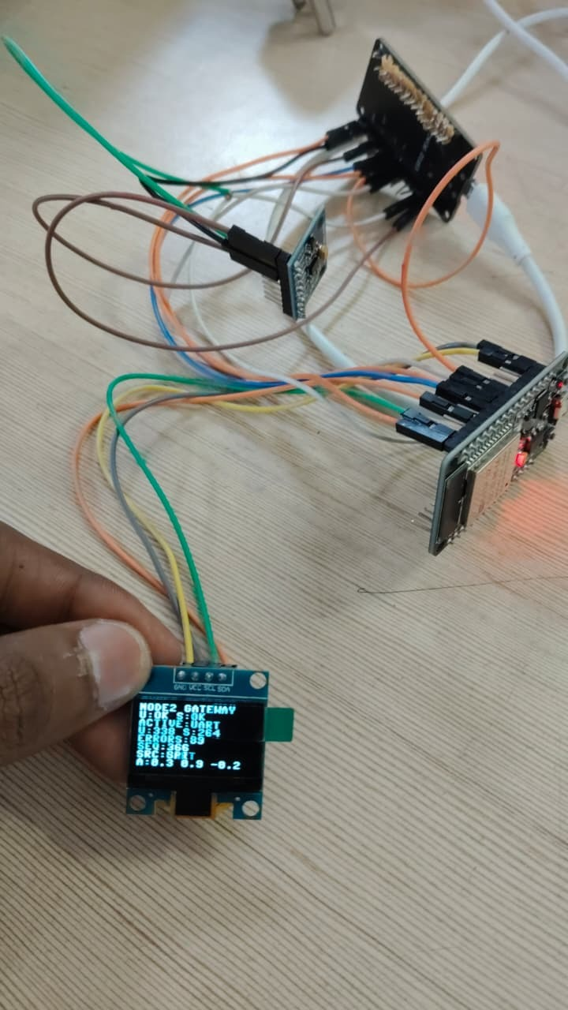
Figure 5.1: Hardware prototype – two ESP32 boards, MPU6050 and OLED showing the live gateway status

5.2 Node 1 – Acquisition and Transmission
- Sensor read: Node 1 reads 14 bytes starting at register 0x3B of the MPU6050 (address 0x68) over I²C and converts the raw acceleration and gyroscope values into engineering units.
- Packet creation: the values are formatted as M,seq,ax,ay,az,gx,gy,gz, with seq incremented for each measurement.
- UART transmission: the packet is sent on UART2 at 115200 baud (8-N-1), terminated by a newline.
- Software SPI transmission: the same packet is padded with spaces to a 64-byte ASCII payload, preceded by the preamble AA AA AA AA 7E, and shifted out on MOSI with SCLK and CS generated by GPIO (Mode 0, MSB first), giving a 69-byte (552-bit) frame.

5.3 Node 2 – Reception, Validation and Monitoring
- UART reception: bytes are buffered until a newline is received, giving one complete text packet.
- SPI reception: a software routine polls the GPIO pins and samples MOSI on SCLK rising edges. The bit stream is searched for the 0xAA7E preamble pattern and a full 552-bit frame is captured and converted to bytes.
- Decoding and validation: the text packet is split into its fields; it is accepted only if all 8 fields are present and the numeric fields can be converted to numbers. Otherwise the invalid-packet counter is incremented.
- Counters and timestamps: each valid packet updates the latest sensor values, the packet count of its source protocol, the latest sequence number and the time of the last valid packet for that protocol.
- Health and selection: the status of UART and SPI and the active protocol are recalculated from these timestamps using the 6-second rule of Section 3.6.

5.4 OLED Display
A 128 × 64 SSD1306 OLED connected over I²C (address 0x3C) shows the gateway state locally. In the prototype photograph (Figure 5.1) the display shows the Node 2 gateway title, the UART and SPI status, the active protocol, the UART and SPI packet counts, the error count, the latest sequence number, the source of the latest packet and the acceleration values.

5.5 Web Dashboard
Node 2 starts a Wi-Fi access point and a small web server. The access details are given in Table 5.1.
Table 5.1: Dashboard access details
Item | Value
Wi-Fi SSID | INDUSTRIAL_GATEWAY
Wi-Fi password | gateway123
Node 2 access-point address | 192.168.4.1
Browser URL | http://192.168.4.1
HTTP data endpoint | /api (JSON)
To use the dashboard, a laptop or phone is first connected to the ESP32 access point; no internet is needed. The page shows the information listed below, and Figure 5.2 shows the dashboard as seen in a browser.
- UART status, SPI status and the selected active protocol.
- MPU6050 acceleration (X, Y, Z) and gyroscope (X, Y, Z) readings.
- UART packet count, SPI packet count, invalid packet count and the latest sequence number and source.
- System information (gateway: ESP32 Node 2; sensor: MPU6050).
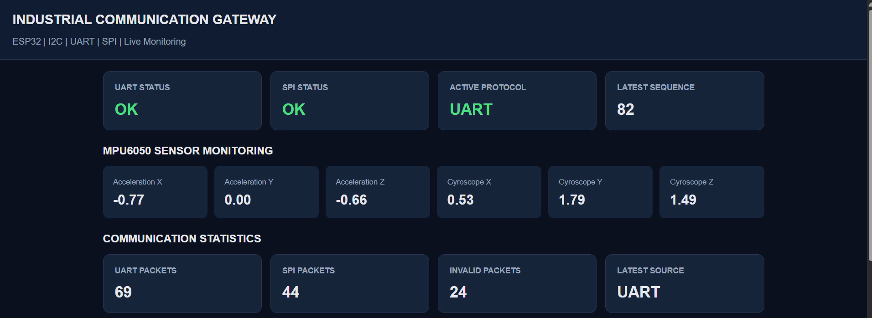
Figure 5.2: Browser dashboard served by Node 2 at 192.168.4.1

5.6 Hardware and Software Used
Table 5.2: Components and tools
Item | Specification / use
Controller | 2 × ESP32 DevKit V1 (ESP32-WROOM-32)
Motion sensor | MPU6050, I²C address 0x68
Display | SSD1306 OLED, 128 × 64, I²C address 0x3C
Interconnect | Jumper wires between the two nodes, common ground
Firmware | MicroPython on both ESP32 nodes
Dashboard | Web page served by Node 2 (HTML and JavaScript, JSON from /api)
Client device | Laptop or phone with a web browser, connected to the ESP32 access point

CHAPTER 6: FLOWCHART / ALGORITHM

6.1 Node 1 Algorithm
- Initialise I²C on GPIO 21 (SDA) and GPIO 22 (SCL).
- Initialise UART2 at 115200 baud, 8-N-1 (TX GPIO 17, RX GPIO 16).
- Initialise the software SPI pins: MOSI GPIO 23, SCLK GPIO 18, CS GPIO 5.
- Read 14 bytes from the MPU6050 starting at register 0x3B.
- Scale the acceleration and gyroscope values into engineering units.
- Increment the sequence number and build the packet M,seq,ax,ay,az,gx,gy,gz.
- Send the packet, terminated by a newline, on UART.
- Pad the packet to 64 ASCII bytes, add the preamble AA AA AA AA 7E and transmit the 69-byte frame by software SPI (Mode 0, MSB first).
- Repeat from step 4.

6.2 Node 2 Algorithm
The processing performed by Node 2 for every received packet is shown in Figure 6.1.
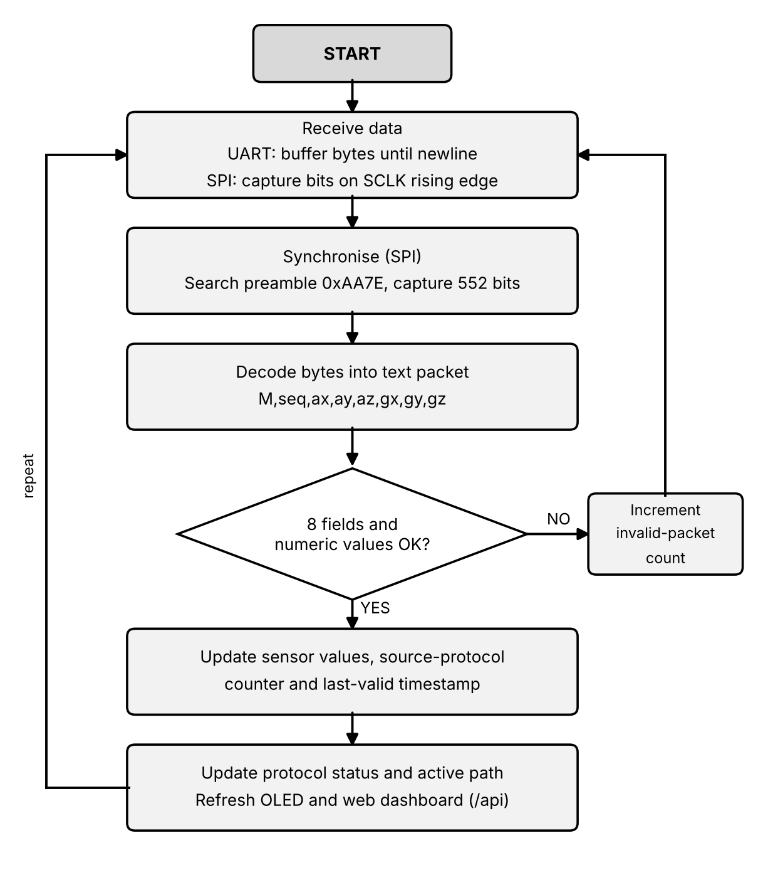
Figure 6.1: Node 2 packet-processing flowchart
- Start the UART receiver, the SPI capture routine, the OLED and the Wi-Fi access point with its web server.
- Receive data: buffer UART bytes until a newline; capture SPI bits on SCLK rising edges.
- For SPI, search the bit stream for the preamble 0xAA7E and capture a full 552-bit frame.
- Decode the bytes into the text packet.
- Check that all 8 fields are present and numeric.
- If valid: update the latest sensor values, the counter of the source protocol and its last-valid-packet time. If invalid: increment the invalid-packet counter.
- Update protocol status and the active path (Section 6.3), refresh the OLED and make the values available to the dashboard through /api.
- Repeat from step 2.

6.3 Protocol Health and Selection Algorithm
The status of each protocol and the choice of the active path follow Figure 6.2.
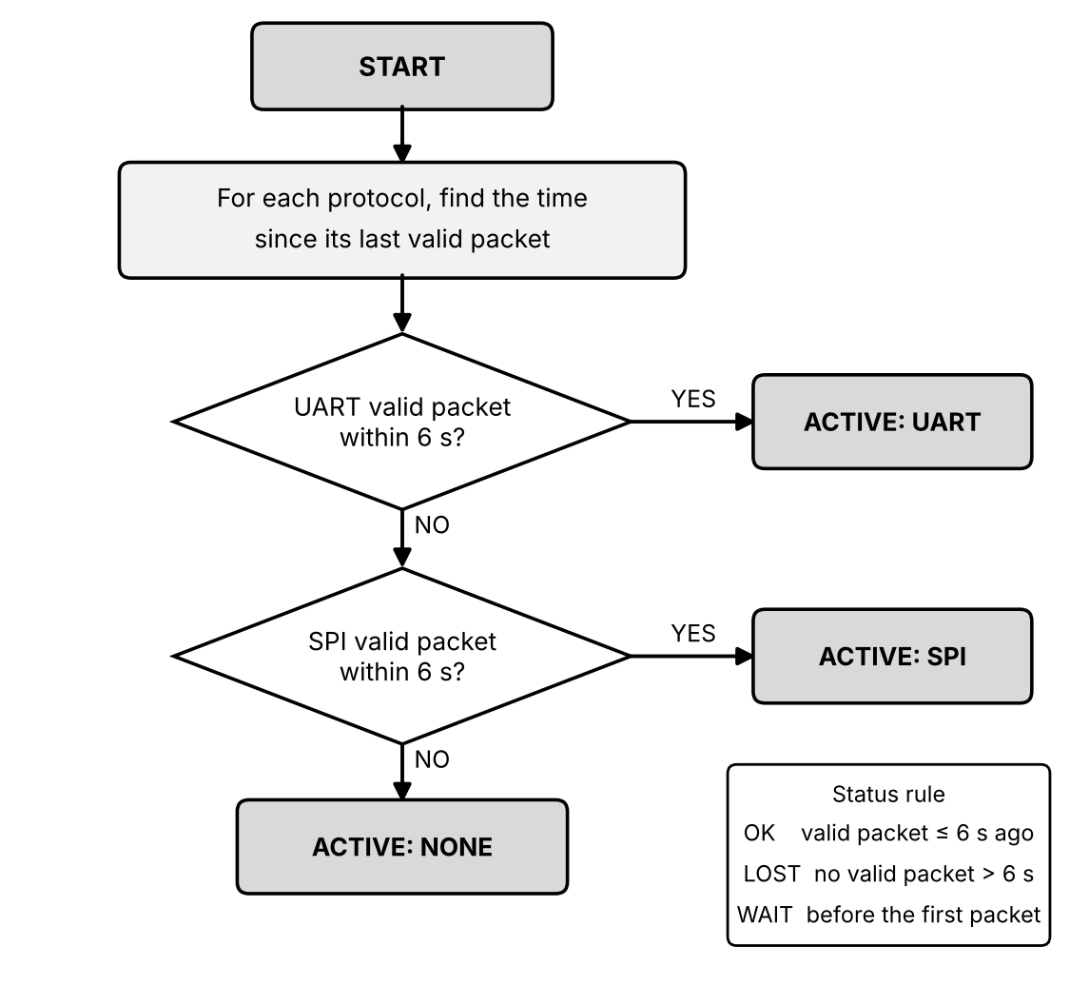
Figure 6.2: Protocol health monitoring and active-path selection
- For each protocol, compute the time since its last valid packet.
- Set the status to OK if this time is within 6 seconds, to LOST if it is longer, and to WAIT if no packet has been received yet.
- If UART is OK, set ACTIVE: UART.
- Else, if SPI is OK, set ACTIVE: SPI.
- Else set ACTIVE: NONE.
SOFTWARE AND HARDWARE USED:

SOFWARE USED: Thonny with Micropython

CODE:

FOR NODE 1:

from machine import Pin, I2C, UART
import time

# =====================================================
# SETTINGS
# =====================================================
SPI_PAYLOAD_SIZE = 64 # bytes, padded with spaces
PREAMBLE = b'\xAA\xAA\xAA\xAA\x7E'
HALF_BIT_US = 1000 # 1 ms per half clock (about 500 bit/s)
CS_LEAD_MS = 100 # CS LOW before first clock
CS_TAIL_MS = 50 # CS LOW after last clock
UART_TO_SPI_GAP_MS = 300 # lets Node 2 finish UART work first
LOOP_DELAY_MS = 500

# =====================================================
# 1. MPU6050 (I2C: SDA=21, SCL=22)
# =====================================================
i2c = I2C(0, scl=Pin(22), sda=Pin(21), freq=400000)
MPU_ADDR = 0x68

if MPU_ADDR not in i2c.scan():
print("ERROR: MPU6050 NOT FOUND")
raise Exception("Check MPU6050 wiring")

print("MPU6050 CONNECTED")
i2c.writeto_mem(MPU_ADDR, 0x6B, b'\x00') # wake up
time.sleep_ms(100)

# =====================================================
# 2. UART (TX=17, RX=16)
# =====================================================
uart = UART(2, baudrate=115200, bits=8, parity=None, stop=1,
tx=Pin(17), rx=Pin(16))
print("UART INITIALIZED")

# =====================================================
# 3. SOFTWARE SPI MASTER (MOSI=23, SCK=18, CS=5)
# =====================================================
mosi = Pin(23, Pin.OUT)
sck = Pin(18, Pin.OUT)
cs = Pin(5, Pin.OUT)

mosi.value(0)
sck.value(0)
cs.value(1)
print("SOFTWARE SPI MASTER INITIALIZED")

# =====================================================
# 4. MPU6050 READ
# =====================================================
def read_signed_16(data, index):
value = (data[index] << 8) | data[index + 1]
if value >= 32768:
value -= 65536
return value

def read_mpu6050():
data = i2c.readfrom_mem(MPU_ADDR, 0x3B, 14)

ax = read_signed_16(data, 0) / 16384.0
ay = read_signed_16(data, 2) / 16384.0
az = read_signed_16(data, 4) / 16384.0

gx = read_signed_16(data, 8) / 131.0
gy = read_signed_16(data, 10) / 131.0
gz = read_signed_16(data, 12) / 131.0

return ax, ay, az, gx, gy, gz

# =====================================================
# 5. SPI SEND (mode 0, MSB first)
# frame = preamble + 64-byte payload
# =====================================================
def spi_send(payload):
frame = PREAMBLE + payload

cs.value(0)
time.sleep_ms(CS_LEAD_MS)

for byte in frame:
for bit in range(7, -1, -1):
mosi.value((byte >> bit) & 1)
time.sleep_us(HALF_BIT_US)
sck.value(1) # rising edge: Node 2 samples
time.sleep_us(HALF_BIT_US)
sck.value(0)

time.sleep_ms(CS_TAIL_MS)
cs.value(1)
mosi.value(0)

# =====================================================
# 6. PACKET
# Format: M,seq,ax,ay,az,gx,gy,gz
# =====================================================
def create_packet(counter, ax, ay, az, gx, gy, gz):
return "M,{},{:.2f},{:.2f},{:.2f},{:.2f},{:.2f},{:.2f}".format(
counter, ax, ay, az, gx, gy, gz)

# =====================================================
# 7. STARTUP
# =====================================================
counter = 0

print("\n================================")
print("NODE 1 INDUSTRIAL SENSOR NODE")
print("================================")
time.sleep(1)

# =====================================================
# 8. MAIN LOOP
# =====================================================
while True:
try:
ax, ay, az, gx, gy, gz = read_mpu6050()
message = create_packet(counter, ax, ay, az, gx, gy, gz)

# --- UART first ---
uart.write(message + "\n")
print("UART SENT:", message)

# --- give Node 2 time to finish processing UART ---
time.sleep_ms(UART_TO_SPI_GAP_MS)

# --- SPI ---
payload = message.encode("ascii")
if len(payload) > SPI_PAYLOAD_SIZE:
print("SPI SKIPPED: packet too long", len(payload))
else:
payload += b' ' * (SPI_PAYLOAD_SIZE - len(payload))
spi_send(payload)
print("SPI SENT:", counter)

counter = (counter + 1) % 1000000
time.sleep_ms(LOOP_DELAY_MS)

except Exception as e:
cs.value(1) # never leave CS LOW on error
sck.value(0)
print("NODE 1 ERROR:", repr(e))
time.sleep_ms(1000)

NODE 2:

from machine import Pin, I2C, UART
import time
import ssd1306

# =====================================================
# SETTINGS
# =====================================================
DEBUG = True # prints SPI bit counts
SPI_PAYLOAD_SIZE = 64
FULL_FRAME_BITS = (5 + SPI_PAYLOAD_SIZE) * 8 # preamble + payload = 552
SYNC = 0xAA7E # last 2 preamble bytes (AA 7E)
MAX_BITS = 700
SPI_TIMEOUT_MS = 500

# =====================================================
# 1. OLED (SDA=21, SCL=22)
# =====================================================
i2c = I2C(0, scl=Pin(22), sda=Pin(21), freq=400000)

oled = None
found = i2c.scan()
for addr in (0x3C, 0x3D):
if addr in found:
oled = ssd1306.SSD1306_I2C(128, 64, i2c, addr)
break

print("OLED INITIALIZED" if oled else "WARNING: OLED NOT FOUND, continuing")

# =====================================================
# 2. UART (Node 1 TX17 -> Node 2 RX16)
# =====================================================
uart = UART(2, baudrate=115200, bits=8, parity=None, stop=1,
tx=Pin(17), rx=Pin(16), rxbuf=1024)
uart_buffer = b""
print("UART INITIALIZED")

# =====================================================
# 3. SOFTWARE SPI SLAVE (mode 0: sample MOSI on rising edge)
# =====================================================
mosi = Pin(23, Pin.IN, Pin.PULL_DOWN)
sck = Pin(18, Pin.IN, Pin.PULL_DOWN)
cs = Pin(5, Pin.IN, Pin.PULL_UP)

bits = bytearray(MAX_BITS) # one bit per byte
print("SOFTWARE SPI RECEIVER READY")

# =====================================================
# 4. GLOBALS
# =====================================================
uart_packets = 0
spi_packets = 0
invalid_packets = 0

latest_source = "WAITING"
latest_sequence = 0
ax = ay = az = gx = gy = gz = 0.0
display_dirty = True

# =====================================================
# 5. OLED DISPLAY
# =====================================================
def show_oled():
global display_dirty
display_dirty = False
if oled is None:
return
oled.fill(0)
oled.text("NODE2 GATEWAY", 0, 0)
oled.hline(0, 10, 128, 1)
oled.text("SRC:" + latest_source, 0, 13)
oled.text("SEQ:" + str(latest_sequence), 0, 23)
oled.text("A%5.2f%5.2f%5.2f" % (ax, ay, az), 0, 33)
oled.text("G%5.0f%5.0f%5.0f" % (gx, gy, gz), 0, 43)
oled.text("U:%d S:%d E:%d" % (uart_packets, spi_packets, invalid_packets), 0, 54)
oled.show()

# =====================================================
# 6. PACKET PARSING
# Format: M,seq,ax,ay,az,gx,gy,gz
# =====================================================
def parse_packet(message):
parts = message.strip().split(",")
if len(parts) != 8 or parts[0] != "M":
return None
try:
return int(parts[1]), [float(p) for p in parts[2:8]]
except ValueError:
return None

def process_packet(message, source):
global uart_packets, spi_packets, invalid_packets
global latest_source, latest_sequence, display_dirty
global ax, ay, az, gx, gy, gz

message = message.strip()
if not message:
return

result = parse_packet(message)
if result is None:
invalid_packets += 1
display_dirty = True
print("INVALID [%s]: %r" % (source, message))
return

seq, v = result
ax, ay, az, gx, gy, gz = v
latest_source = source
latest_sequence = seq

if source == "UART":
uart_packets += 1
else:
spi_packets += 1

print("%s #%d A(%.2f, %.2f, %.2f) G(%.2f, %.2f, %.2f) OK" %
(source, seq, ax, ay, az, gx, gy, gz))

display_dirty = True

# =====================================================
# 7. UART RECEIVER
# =====================================================
def clean_ascii(raw):
return bytes([c for c in raw if 32 <= c < 127]).decode()

def receive_uart():
global uart_buffer

if uart.any():
data = uart.read()
if data:
uart_buffer += data
if len(uart_buffer) > 1024:
uart_buffer = b""
return

while b"\n" in uart_buffer:
line, uart_buffer = uart_buffer.split(b"\n", 1)
text = clean_ascii(line)
idx = text.rfind("M,") # skip boot noise before the packet
if idx > 0:
text = text[idx:]
if text:
process_packet(text, "UART")

# =====================================================
# 8. SOFTWARE SPI RECEIVER (preamble sync)
# =====================================================
def capture_spi_bits():
"""Sample MOSI on each SCK rising edge until CS goes HIGH."""
n = 0

t0 = time.ticks_ms()
while sck.value() == 1: # joined while clock HIGH: wait for LOW
if cs.value() == 1:
return 0
if time.ticks_diff(time.ticks_ms(), t0) > SPI_TIMEOUT_MS:
return 0

while True:
t0 = time.ticks_ms()
while sck.value() == 0: # wait rising edge
if cs.value() == 1:
return n
if time.ticks_diff(time.ticks_ms(), t0) > SPI_TIMEOUT_MS:
return n

if n < MAX_BITS:
bits[n] = mosi.value()
n += 1

t0 = time.ticks_ms()
while sck.value() == 1: # wait falling edge
if cs.value() == 1:
return n
if time.ticks_diff(time.ticks_ms(), t0) > SPI_TIMEOUT_MS:
return n

def decode_spi(n):
"""Find the AA 7E preamble in the bit stream, decode payload after it."""
w = 0
start = -1
for i in range(n):
w = ((w << 1) | bits[i]) & 0xFFFF
if i >= 15 and w == SYNC:
start = i + 1
break

if start < 0:
return None

nbytes = (n - start) // 8
if nbytes < 20:
return None

out = bytearray(nbytes)
for i in range(nbytes):
v = 0
base = start + i * 8
for j in range(8):
v = (v << 1) | bits[base + j]
out[i] = v

for c in out:
if c < 32 or c > 126:
return None

return out.decode().strip()

def receive_spi_packet():
global invalid_packets, display_dirty

n = capture_spi_bits()

t0 = time.ticks_ms() # wait for CS HIGH
while cs.value() == 0:
if time.ticks_diff(time.ticks_ms(), t0) > 2000:
break
time.sleep_ms(1)

if n < 64:
return # partial or garbage frame

if DEBUG:
print("SPI BITS:", n, "(full frame =", FULL_FRAME_BITS, ")")

msg = decode_spi(n)
if msg and parse_packet(msg):
process_packet(msg, "SPI")
else:
invalid_packets += 1
display_dirty = True
print("SPI FAILED, bits:", n, "decoded:", repr(msg))

# =====================================================
# 9. STARTUP
# =====================================================
if oled:
oled.fill(0)
oled.text("INDUSTRIAL", 20, 5)
oled.text("GATEWAY NODE 2", 10, 20)
oled.text("UART READY", 20, 38)
oled.text("SPI READY", 20, 50)
oled.show()

print("\n================================")
print("NODE 2 INDUSTRIAL GATEWAY")
print("================================")

time.sleep(2)
show_oled()

# =====================================================
# 10. MAIN LOOP
# =====================================================
while True:
if cs.value() == 0: # SPI has priority
receive_spi_packet()
else:
receive_uart()
if display_dirty and cs.value() == 1:
show_oled()

time.sleep_ms(1)

CHAPTER 7: SIMULATION AND RESULT ANALYSIS

7.1 Test Setup
The results were obtained on the working hardware prototype shown in Figure 5.1: Node 1 with the MPU6050, Node 2 with the SSD1306 OLED, the two boards wired as in Table 3.1, and both boards running the MicroPython firmware. Observations were taken from the Node 2 serial monitor, the OLED and the browser dashboard.

7.2 Observed Results
Table 7.1: Summary of observed results
Area | Observation
UART reception | Packets were received and validated; sequence numbers advanced continuously; sensor values were decoded successfully.
SPI reception | The SPI capture reported 552 bits per frame (the full frame size); preamble synchronisation and decoding succeeded; packets were validated with sequence numbers matching the UART path.
Monitoring | The OLED showed U:OK and S:OK; the active protocol was shown as UART; packet counters and the error count updated.
An example of the observed Node 2 serial-monitor output is shown below.
UART #252 ... OK
SPI BITS: 552 (full frame = 552)
SPI #252 ... OK
The matching sequence number (#252) on both paths shows that the same measurement was delivered and validated through UART and through SPI.

7.3 Dashboard and Display Readings
The dashboard in Figure 5.2 shows UART status OK, SPI status OK and the active protocol UART, together with the six MPU6050 readings and the communication statistics. The OLED in Figure 5.1 shows the same information locally. Table 7.2 lists two snapshots of the packet counters taken from the dashboard and the OLED.
Table 7.2: Packet-counter snapshots
Snapshot | UART packets | SPI packets | Invalid / errors
Browser dashboard (latest sequence 82) | 69 | 44 | 24
OLED display (sequence 366) | 338 | 264 | 89

7.4 Analysis
- Both communication paths worked: UART and SPI each delivered valid packets, the 552-bit frame was captured completely and the sequence numbers matched.
- Node 2 correctly reported the status of each link and selected UART as the active protocol while both links were healthy, as specified by the selection rule.
- The OLED and the browser dashboard gave the same view of the system, so the gateway state can be observed locally or from any phone or laptop connected to the access point.
- In both snapshots of Table 7.2 the SPI packet count is lower than the UART count and the invalid-packet count is not zero. These are single readings and not a controlled test, so no error rate is claimed. However, they are consistent with the limitation noted in Chapter 8: the SPI receiver is implemented by software GPIO polling, which can be sensitive to Wi-Fi and other processing load. Measuring the packet delivery ratio, latency and error rate of each path under controlled conditions is listed as future work.
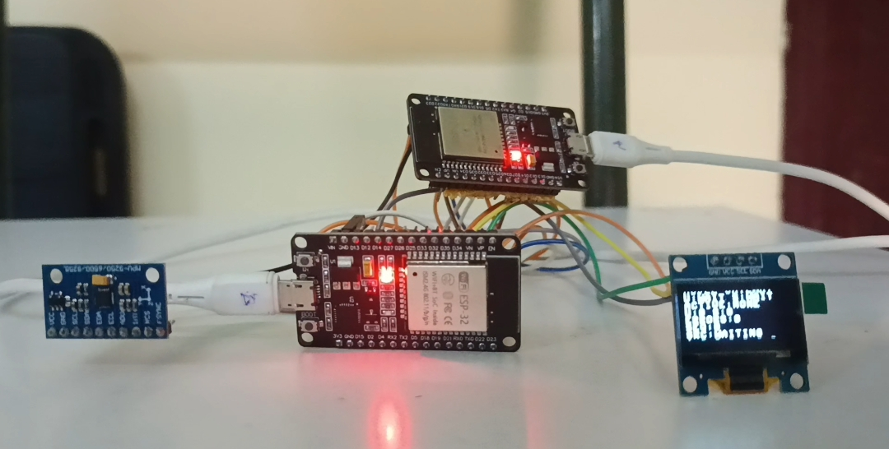

CHAPTER 8: CONCLUSION AND FUTURE SCOPE

8.1 Conclusion
A two-node ESP32 gateway was developed to acquire MPU6050 data and deliver it to a second ESP32 through UART and software SPI. I²C is used for sensor interfacing, UART and SPI provide two independent data paths, Node 2 validates packets and monitors link health, and an OLED and a local web dashboard provide system visibility. The prototype therefore demonstrates the main functions of a multi-protocol gateway – acquisition, transport over more than one interface, validation and link-health reporting – on low-cost hardware with MicroPython.
Key achievements of the project:
- Acquired motion data from the MPU6050 over I²C and defined a common sensor packet.
- Transmitted the same packet over UART (115200, 8-N-1) and over software SPI (Mode 0, 552-bit frame).
- Decoded and validated packets at Node 2 and kept separate counters for UART, SPI and invalid packets.
- Implemented timestamp-based health monitoring (OK / LOST / WAIT, 6 s timeout) with UART as the preferred path and SPI as backup.
- Provided live visibility on an SSD1306 OLED and a browser dashboard served by Node 2 without any separate PC server.

8.2 Limitations
- The SPI receiver is implemented by software GPIO polling and not by a hardware SPI-slave peripheral.
- Software-timed SPI can be sensitive to Wi-Fi and other processing load.
- The present selection logic reports the preferred healthy link; it is not a sender-controlled switchover.
- The prototype uses a single MPU6050 sensor and a short-range local Wi-Fi dashboard.

8.3 Future Scope
- Add a source-specific data buffer so that only the selected path is displayed.
- Add acknowledgement and retransmission, or sender-side failover control.
- Measure packet delivery ratio, latency and error rate under controlled tests.
- Add more sensor nodes and industrial interfaces.

CHAPTER 9: REFERENCES
[1] Espressif Systems, “ESP32 Technical Reference Manual.” [Online]. Available: https://www.espressif.com/sites/default/files/documentation/esp32_technical_reference_manual_en.pdf
[2] MicroPython Documentation, “Quick reference for the ESP32.” [Online]. Available: https://docs.micropython.org/en/latest/esp32/quickref.html
[3] InvenSense Inc., “MPU-6000 and MPU-6050 Product Specification,” Rev. 3.4, 2013.
[4] InvenSense Inc., “MPU-6000 and MPU-6050 Register Map and Descriptions,” Rev. 4.2, 2013.
[5] NXP Semiconductors, “UM10204: I²C-bus specification and user manual,” Rev. 7.0, 2021.
[6] Solomon Systech, “SSD1306: 128 × 64 Dot Matrix OLED/PLED Segment/Common Driver with Controller,” Rev. 1.1, 2008.
[7] P. Dhaker, “Introduction to SPI Interface,” Analog Dialogue, vol. 52, no. 3, Sep. 2018.
[8] A. Zanella, N. Bui, A. Castellani, L. Vangelista and M. Zorzi, “Internet of Things for Smart Cities,” IEEE Internet of Things Journal, vol. 1, no. 1, pp. 22–32, 2014.

APPENDIX: KEY TECHNICAL SPECIFICATIONS
Quick reference for the project viva and question-and-answer session.
Parameter | Specification
Controller | 2 × ESP32 DevKit V1 (ESP32-WROOM-32)
Sensor | MPU6050, I²C address 0x68
Display | SSD1306 OLED, 128 × 64, I²C address 0x3C
UART | UART2, 115200 baud, 8-N-1; TX GPIO 17 / RX GPIO 16
Software SPI | MOSI GPIO 23, SCLK GPIO 18, CS GPIO 5; Mode 0, MSB first
SPI frame | 5-byte preamble + 64-byte payload = 552 bits
Monitoring timeout | 6 seconds since last valid packet
Dashboard | Node 2 access point; 192.168.4.1 (when AP mode is running)

