Streamlining IT Procurement: Automating Standard Laptop Orders with Flow Designer
Milestone 2 : Flow assignment
Select Maintain Items.
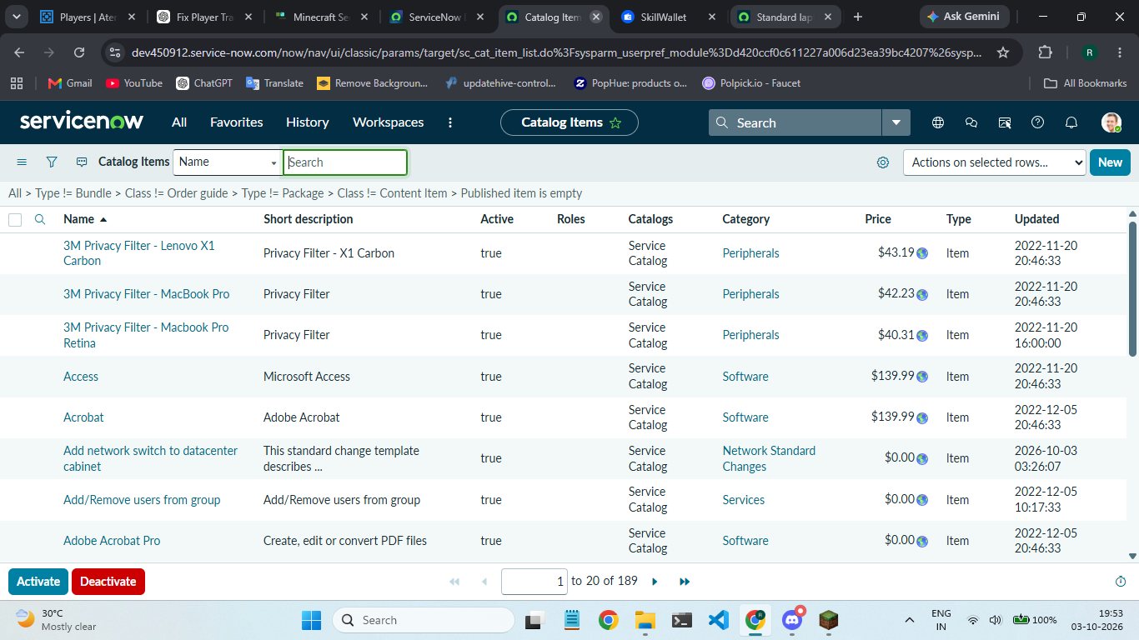
Under the name field search for Standard Laptop Select that record.
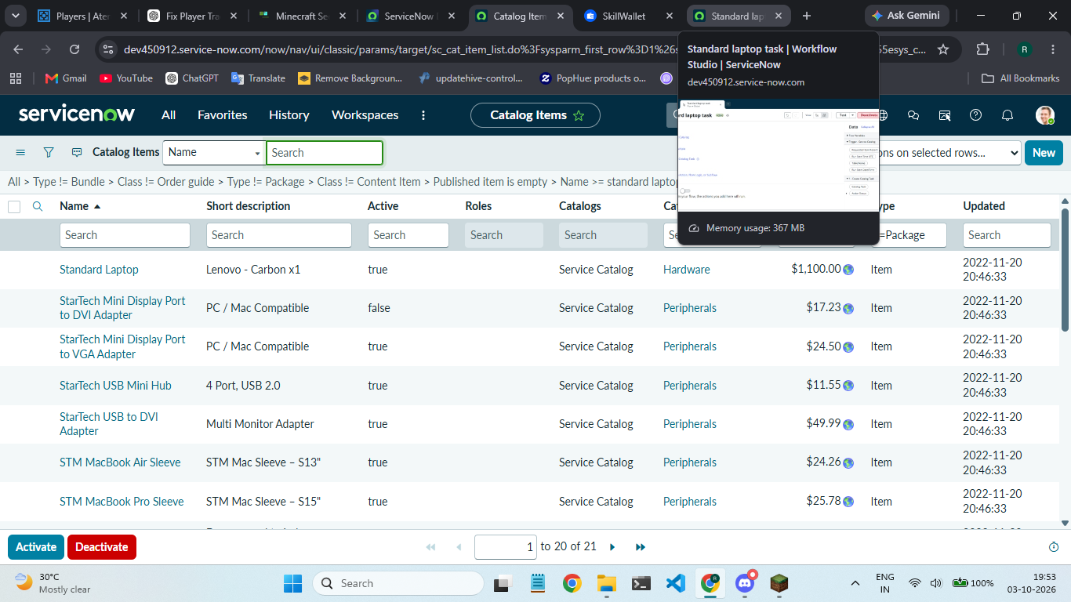
Under that record select Process engine 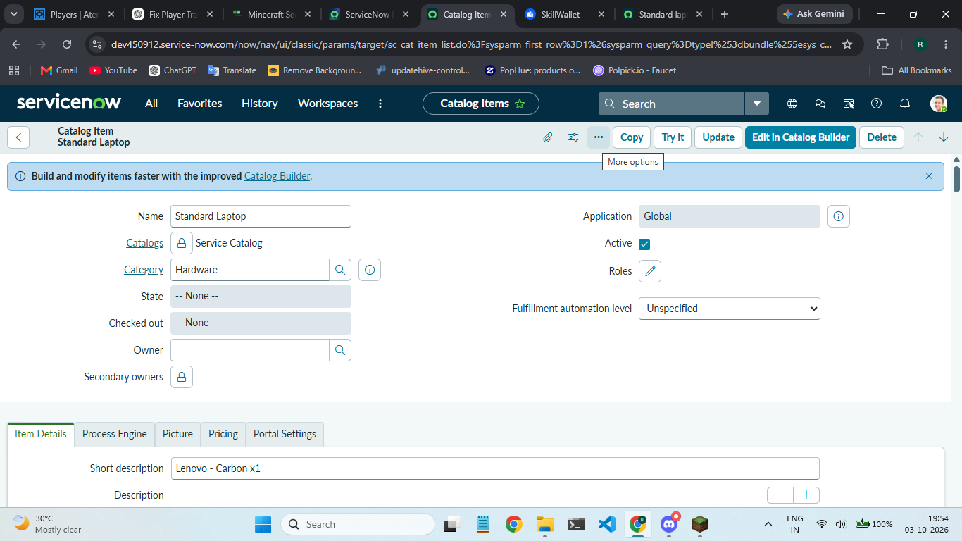
Add the flow that was created with the name “ Standard Laptop Task”.