**Name:- Dharan Gowda Superset id:-6387532**

**Exercise 1: Setting Up JUnit Scenario: You need to set up JUnit in your Java project to start writing unit tests.**

**Solution:-**

**Step 1:- Create a new Java project in your IDE (e.g., IntelliJ IDEA, Eclipse).**

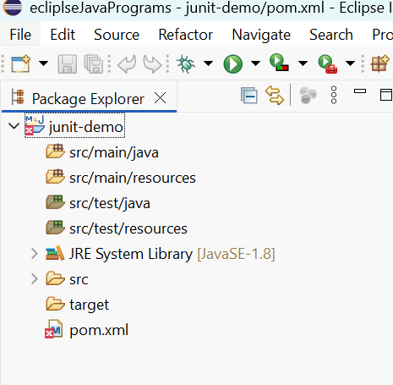

**Step 2:- Add JUnit dependency to your project. If you are using Maven, add the following to your pom.xml:**

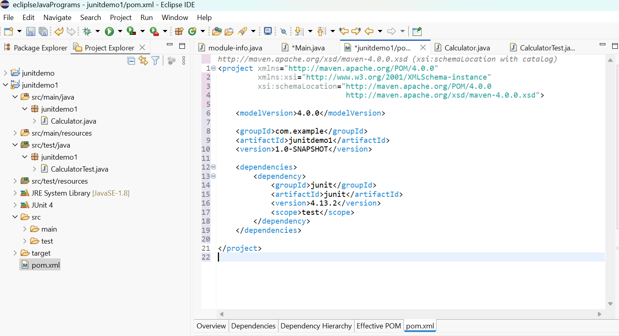

**3. Create a new test class in your project.**

**\*) Calculator class to test**

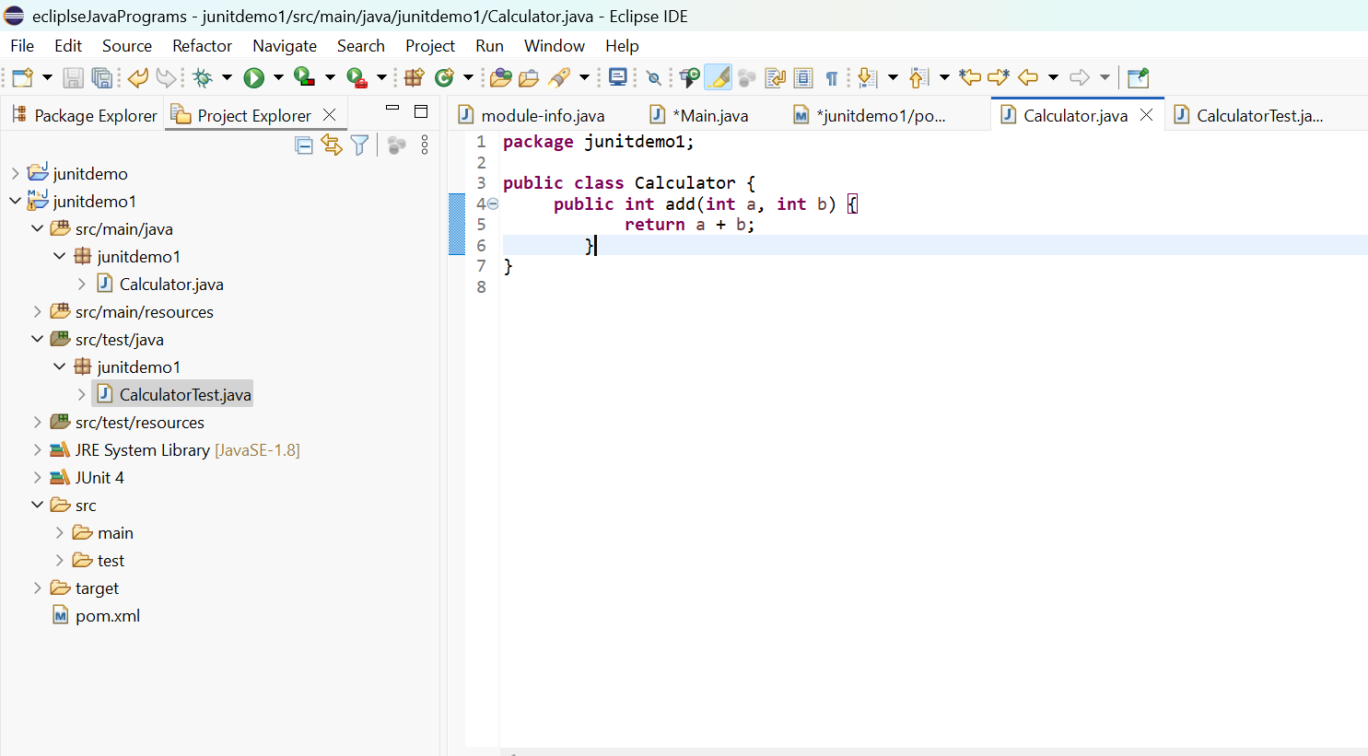

**\*)CalculatorTest class to test Calculator class**

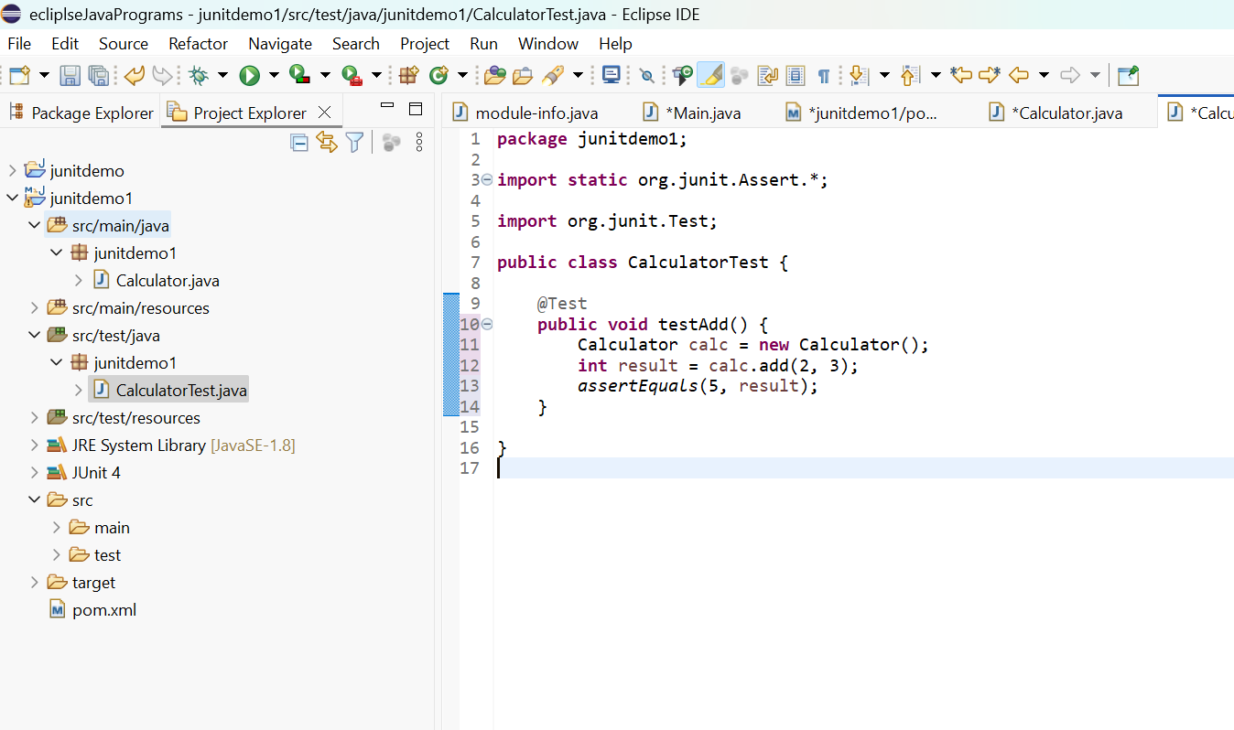

**Output of the test :-**

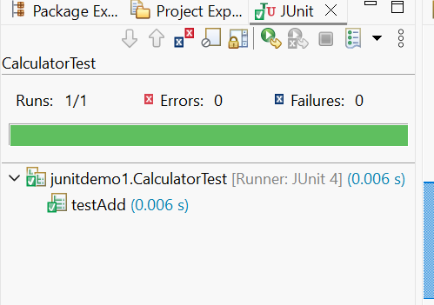

**Exercise 3: Assertions in Junit**

**Scenario: You need to use different assertions in JUnit to validate your test results**

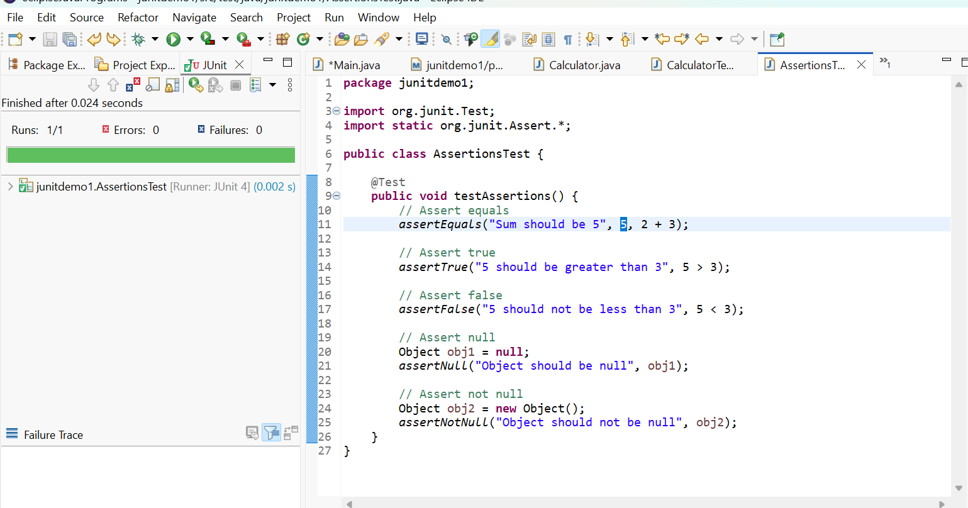

**Exercise 4: Arrange-Act-Assert (AAA) Pattern, Test Fixtures, Setup and Teardown Methods in Junit**

**Scenario: You need to organize your tests using the Arrange-Act-Assert (AAA) pattern and use setup and teardown methods.**

**Steps: 1. Write tests using the AAA pattern.**

**2. Use @Before and @After annotations for setup and teardown methods**

**Output:-**

