**Name:- Dharan Gowda Superset id:-6387532**

**Logging using SLF4J Hands-On Exercises**

**Exercise 1: Logging Error Messages and Warning Levels Task: Write a Java application that demonstrates logging error messages and warning levels using SLF4J.**

1. **Add SLF4J and Logback dependencies to your `pom.xml` file**

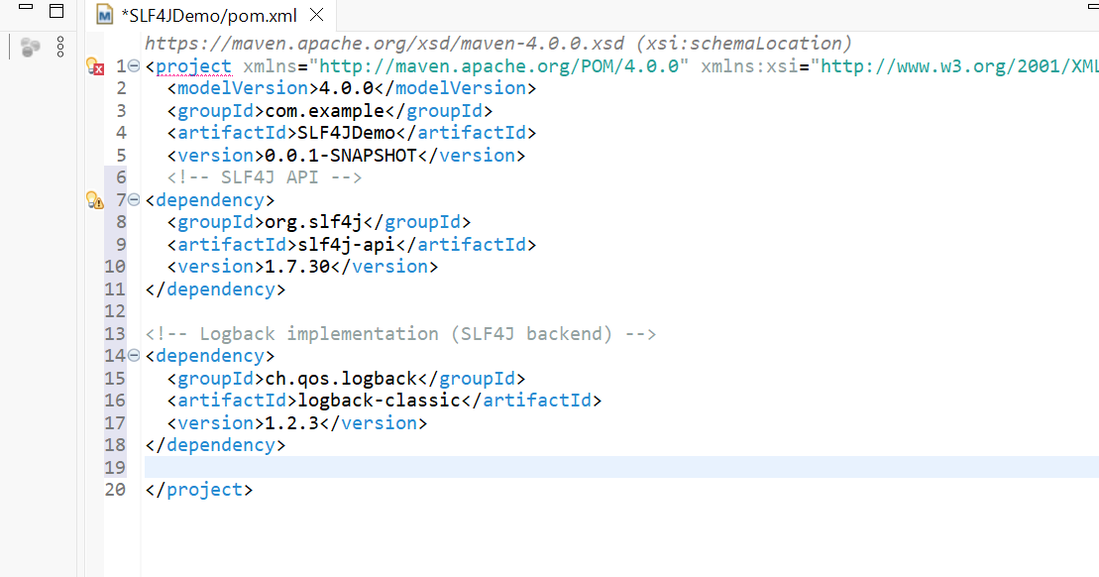

1. **Create a Java class that uses SLF4J for logging:-**

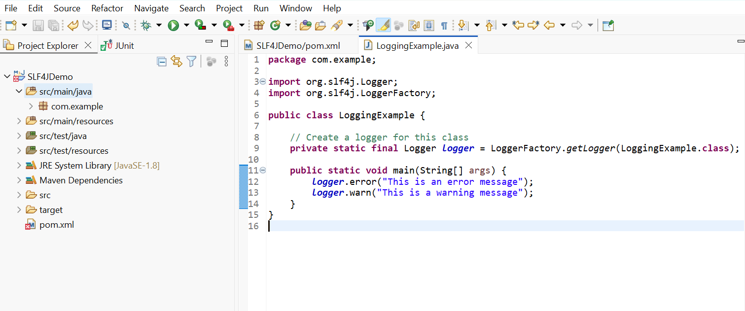

**OUTPUT:-**

