**Name:- Dharan Gowda Superset id:-6387532**

**Mockito Hands-On Exercises**

**Exercise 1: Mocking and Stubbing Scenario: You need to test a service that depends on an external API. Use Mockito to mock the external API and stub its methods.**

**Solution :-**

1. **Create a mock object for the external API**

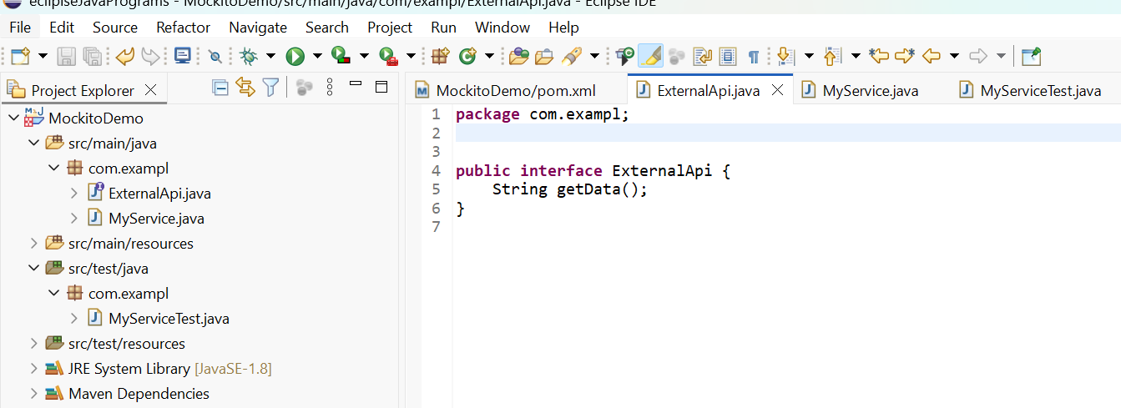

1. **Stub the methods to return predefined values**

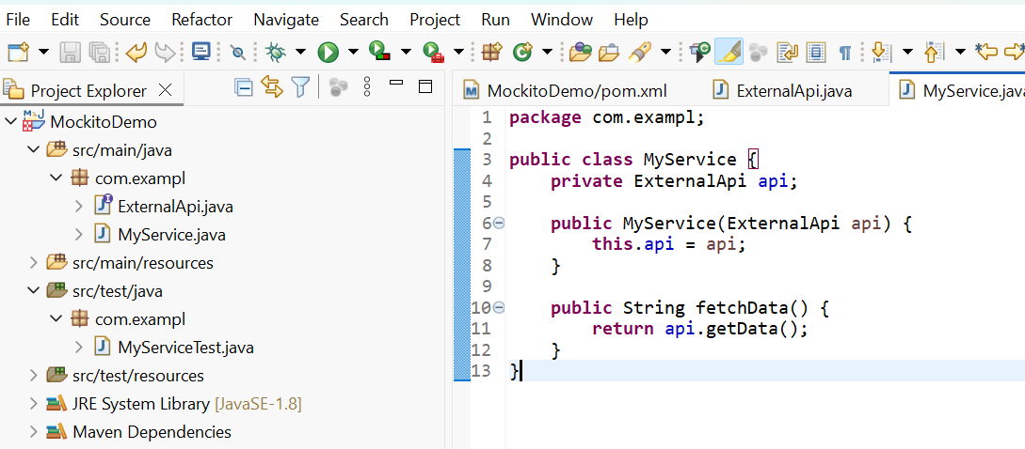

1. **Write a test case that uses the mock object**

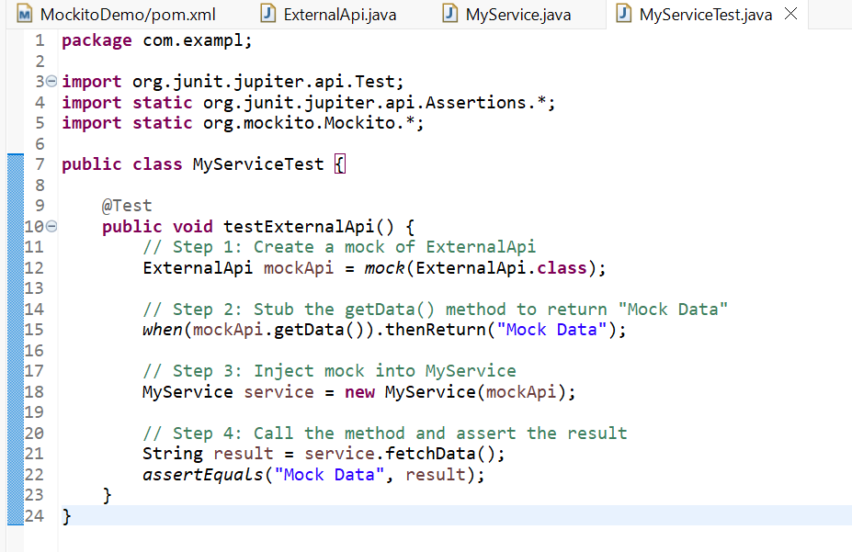

**Output :- test pass**

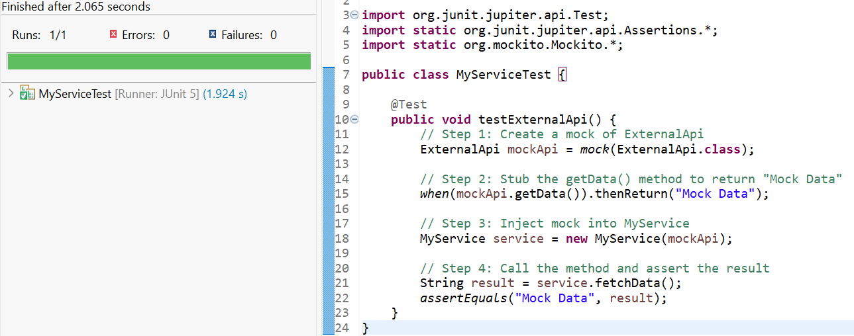

**Exercise 2: Verifying Interactions**

**Scenario: You need to ensure that a method is called with specific arguments.**

Steps: 1. Create a mock object.

**Code :- ExternalApi mockApi = Mockito.mock(ExternalApi.class);**

2. Call the method with specific arguments**.**

**Code:- MyService service = new MyService(mockApi);**

**service.fetchData();**

3. Verify the interaction.

**Code:- verify(mockApi).getData();**

**Output:- Test successful**

