**Name:- Dharan Gowda Superset id:-6387532**

**II. spring-rest-handson-2**

1. **Hello World RESTful Web Service**

**Step 1:-** **Set Server Port in application.properties**

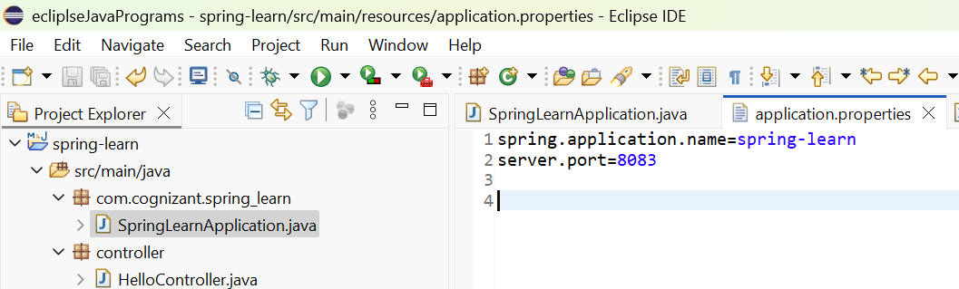

**Step 2:-** **Create the Controller Class**

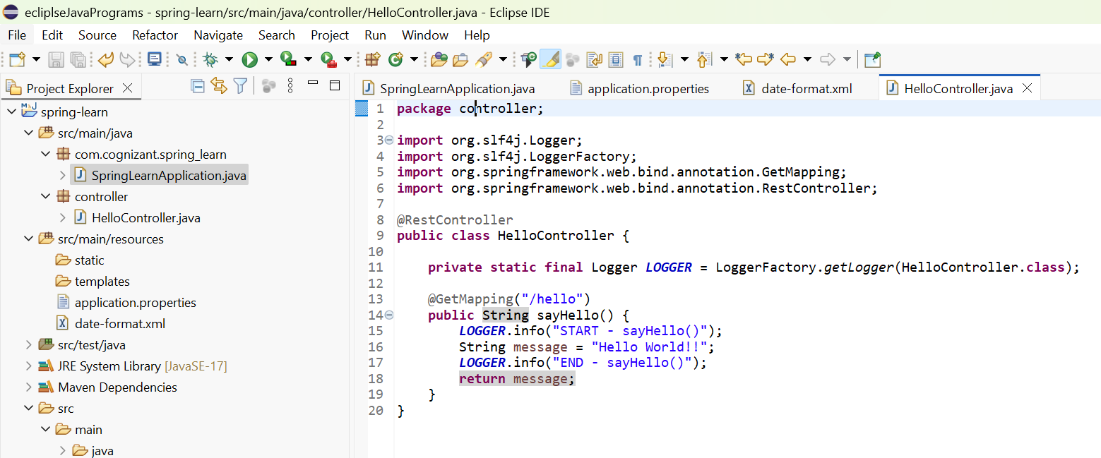

**Step 3:- Verify Main Class Has Component Scan**

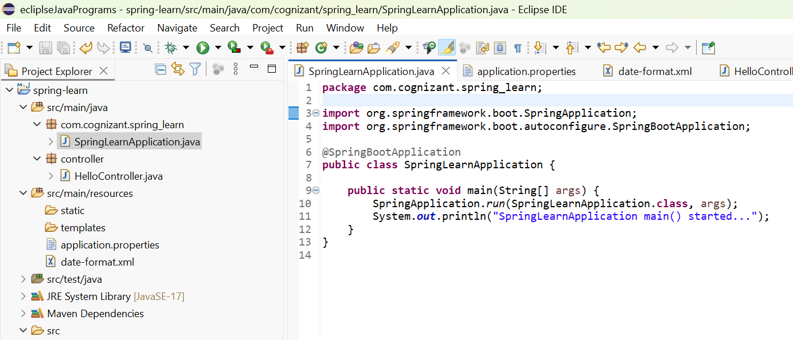

**Step 4:- Run the Application**

**Output:-**

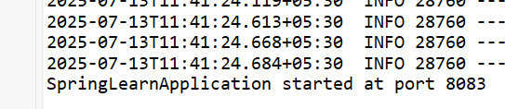

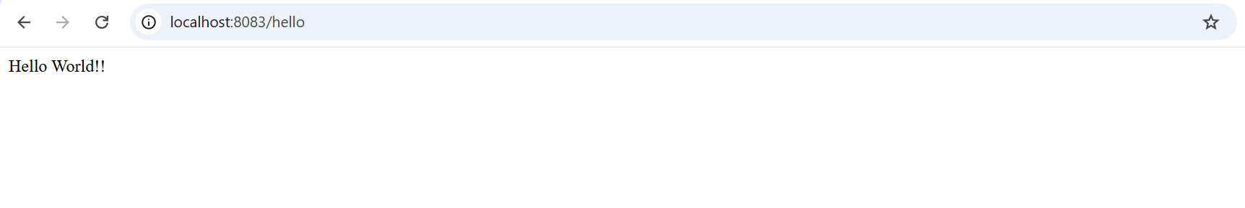

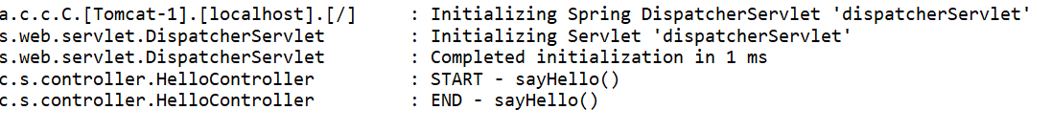

**REST - Country Web Service**

2) Write a REST service that returns India country details in the earlier created spring learn application

1. **Create Country Bean**

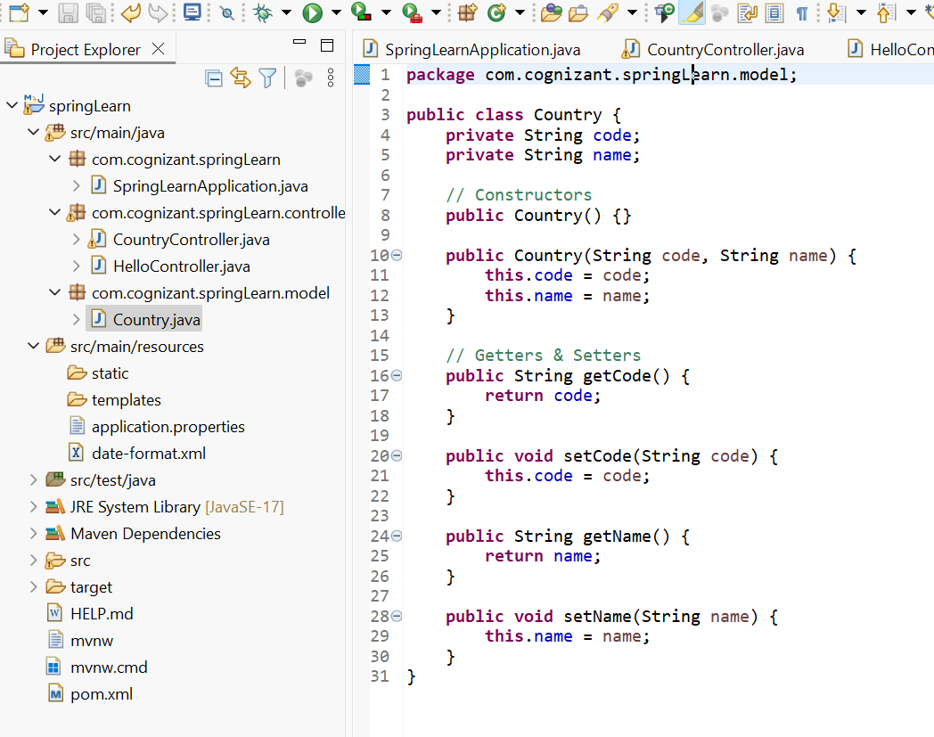

1. **Define the Country Bean in spring-config.xml**

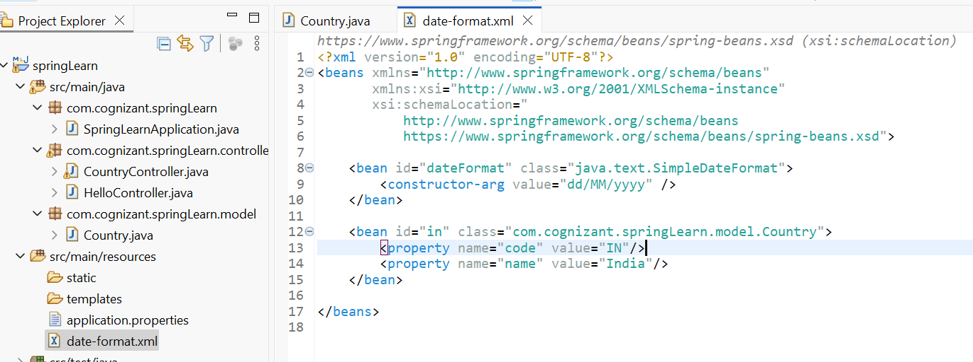

1. **Controller to Load Bean and Return JSON**

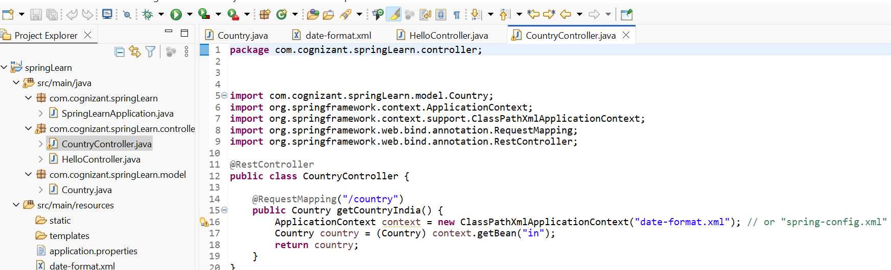

1. **Run the Application**

Output:-

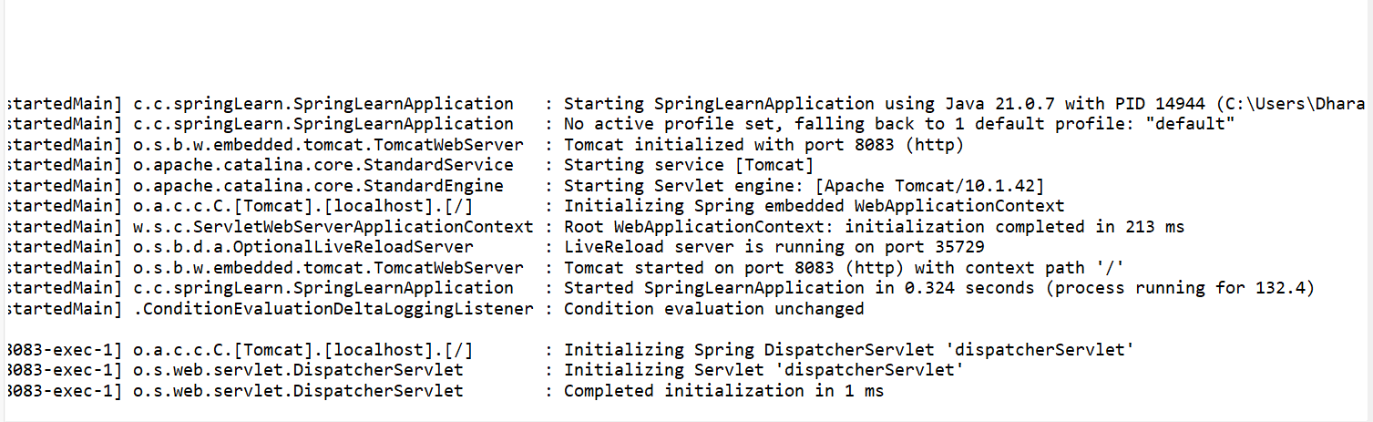

**URL:** <http://localhost:8083/country>

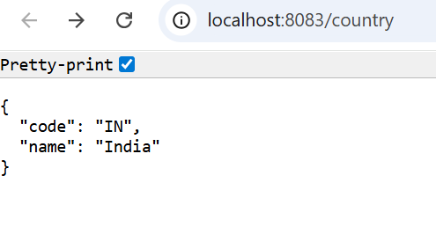

**REST - Get country based on country code**   
3) Write a REST service that returns a specific country based on country code. The country code should be case insensitive.

1. **Update country.xml with a list of countries**

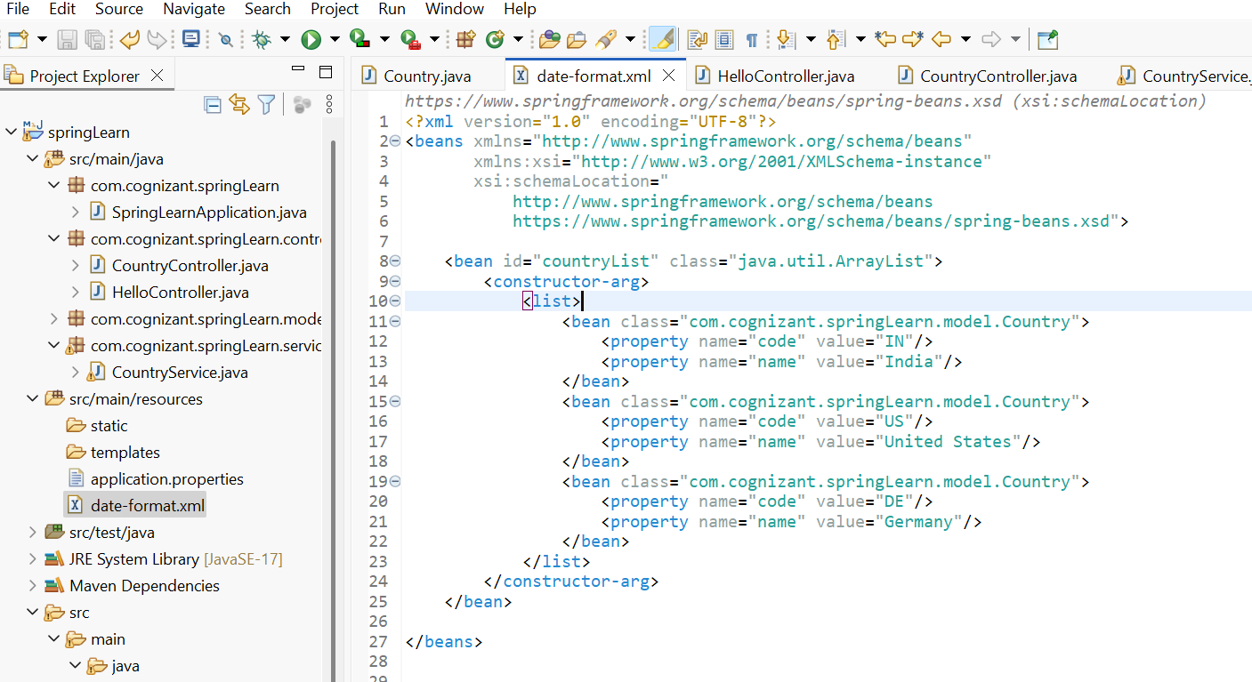

1. **Create CountryService.java**

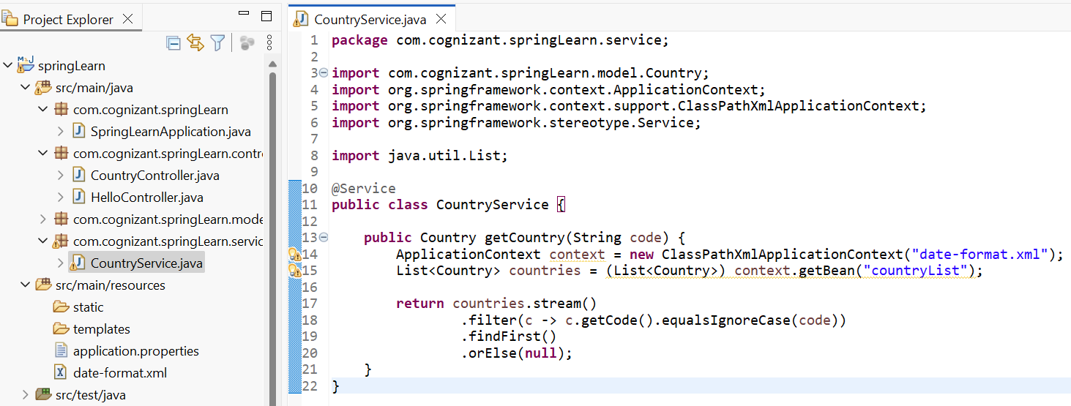

1. **Update CountryController.java**

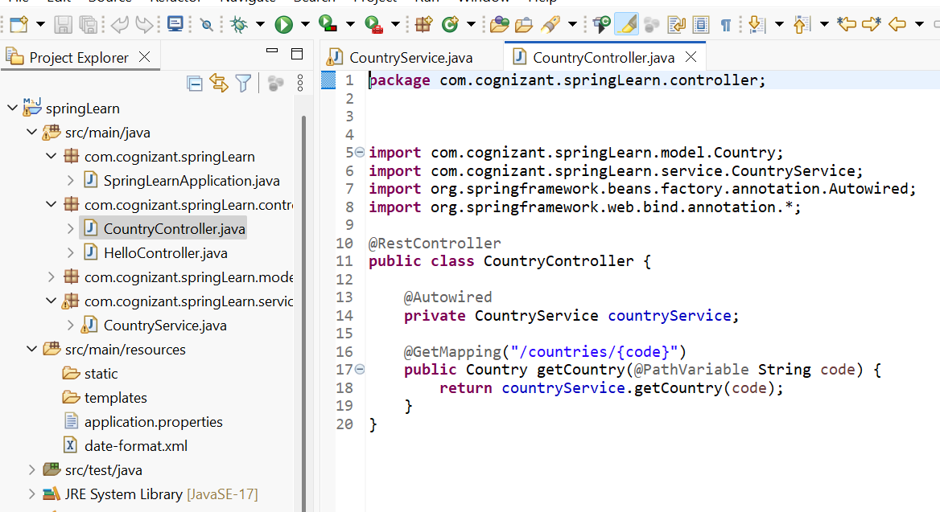

1. **Run and Test**

Sample Request: **http://localhost:8083/country/in**

