**Name:- Dharan Gowda Superset id:-6387532**

**Create authentication service that returns JWT**   
As part of first step of JWT process, the user credentials needs to be sent to authentication service request that generates and returns the JWT.

**Step 1: Create a New Spring Boot Project**

**Step 2: Add JWT Dependency in pom.xml**

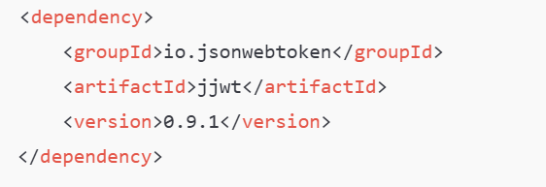

**Step 3: Create Security Configuration**

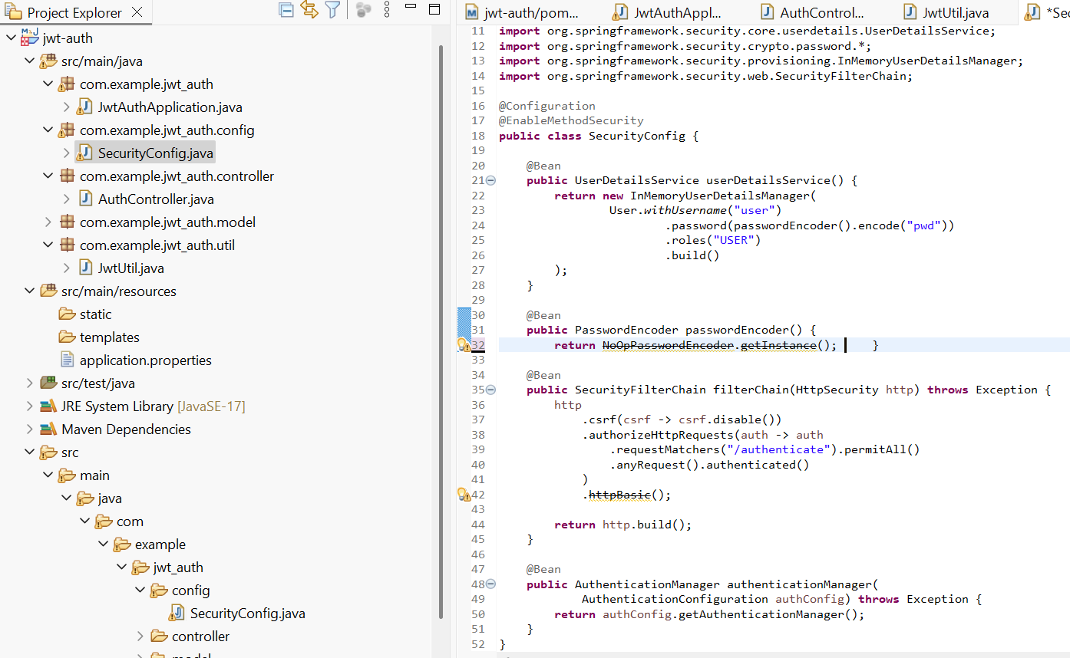

**Step 4: Create JWT Utility**

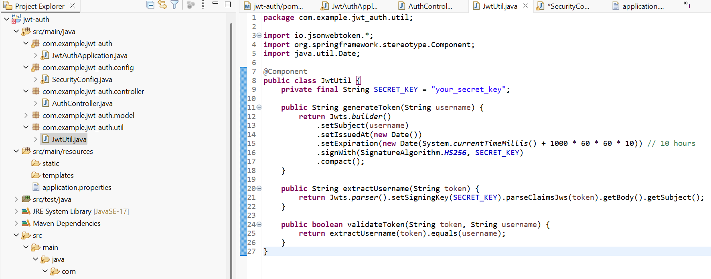

**Step 5: Create Authentication Controler**

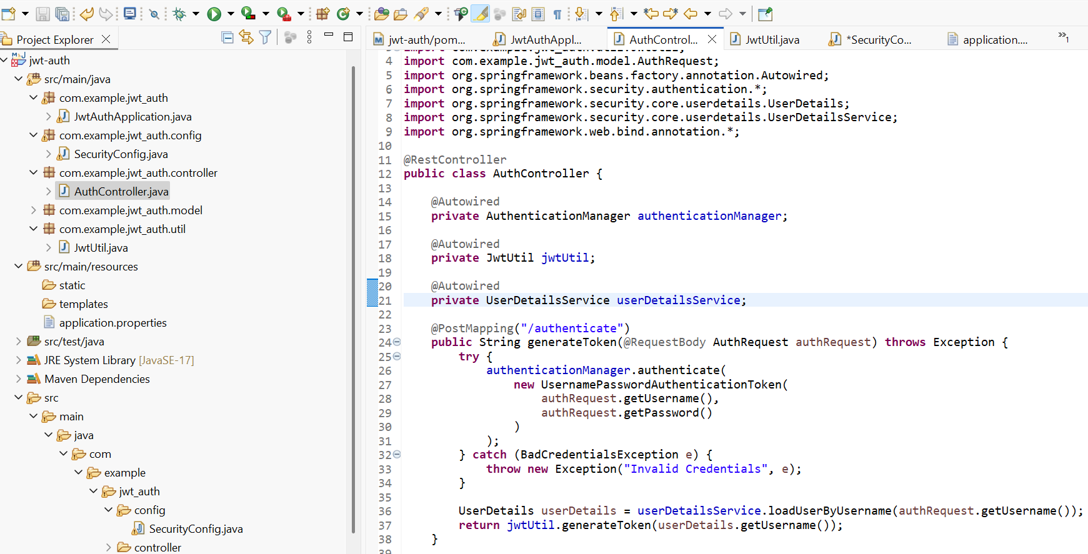

**Step 6: Run and Test**

**Run the application on port 8090**

**Output:-**

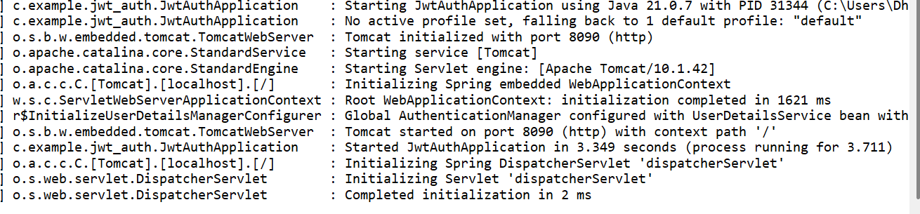

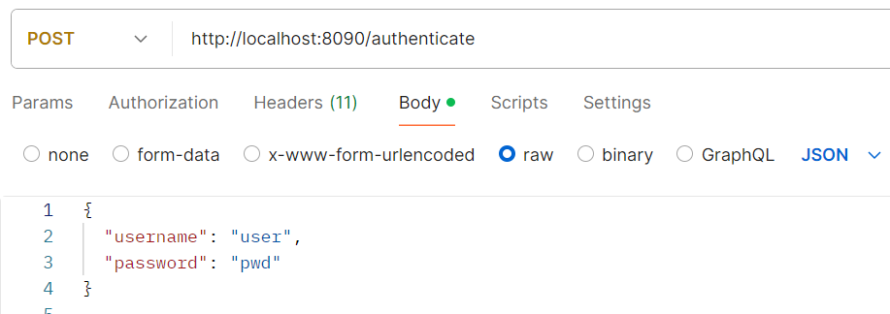

**Main Output (token)**

