**Name:- Dharan Gowda Superset id:-6387532**

**I. spring-rest-handson-1**

1. **Create a Spring Web Project using Maven**

**Step 1:-createing and setting up the project with all required dependencies**

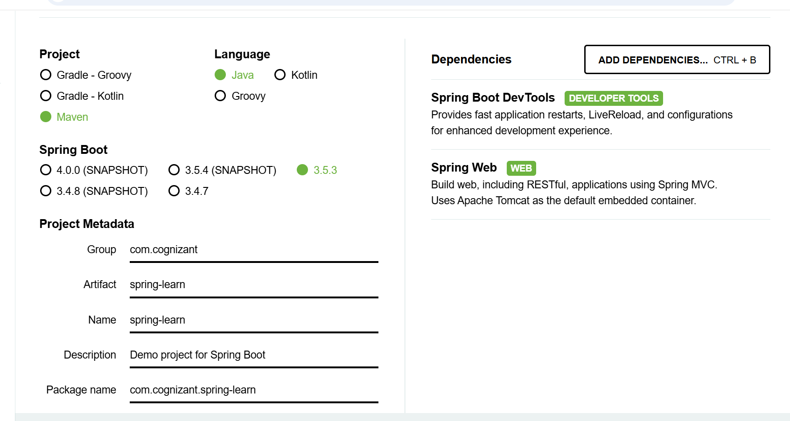

**Step 2 :- filling the up the main function code**

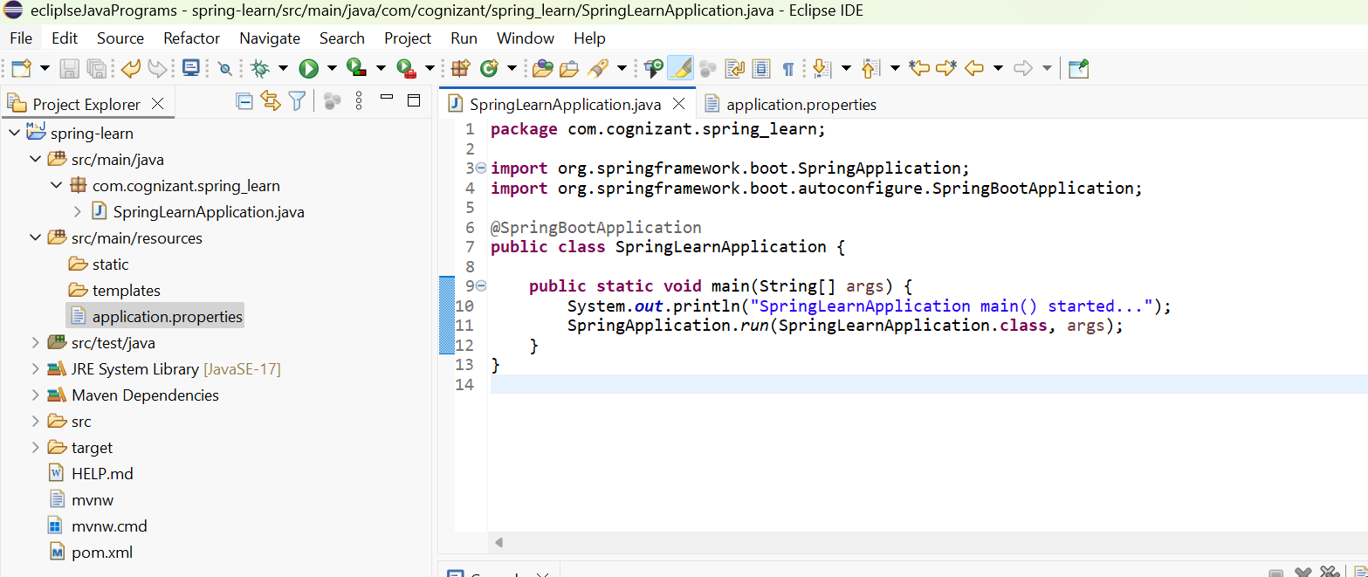

**Step 3:- Run the Application:**

**Output :-**

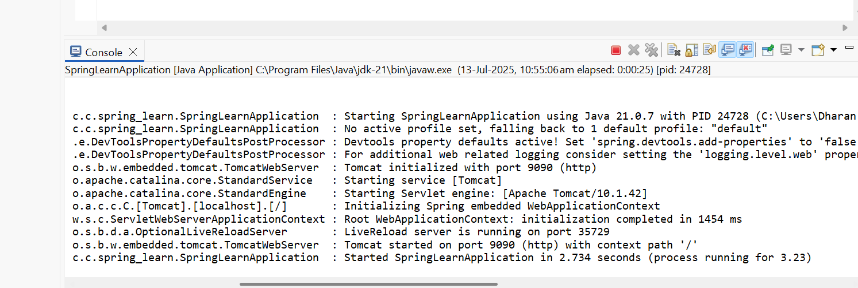

**Hands on 2**

**Spring Core – Load SimpleDateFormat from Spring Configuration XML**

1. **Create the XML Configuration File**

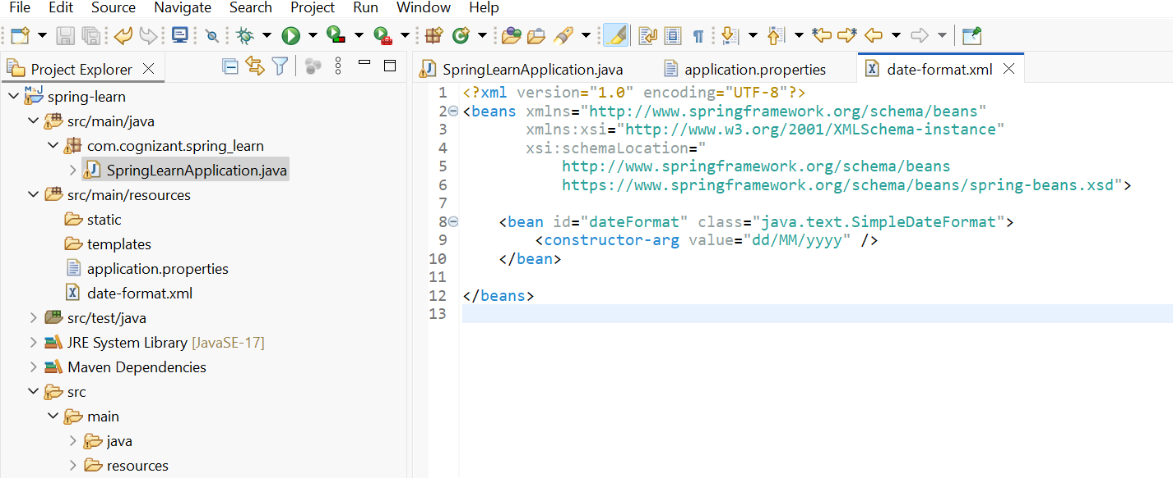

1. **Modify SpringLearnApplication.java**

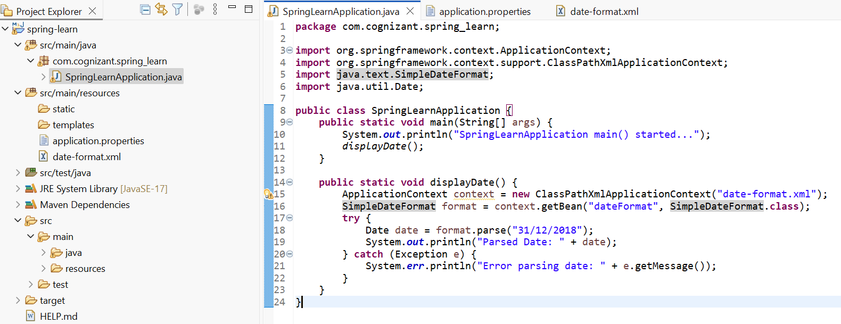

**Step 3:- Run the Application:**

**Output :-**

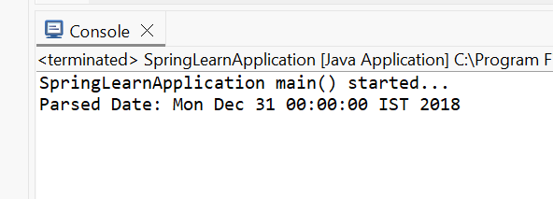

**II. spring-rest-handson-2**

1. **Hello World RESTful Web Service**

**Step 1:-** **Set Server Port in application.properties**

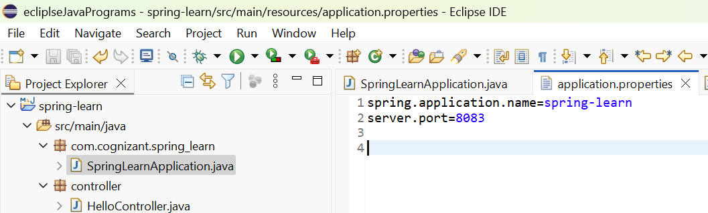

**Step 2:-** **Create the Controller Class**

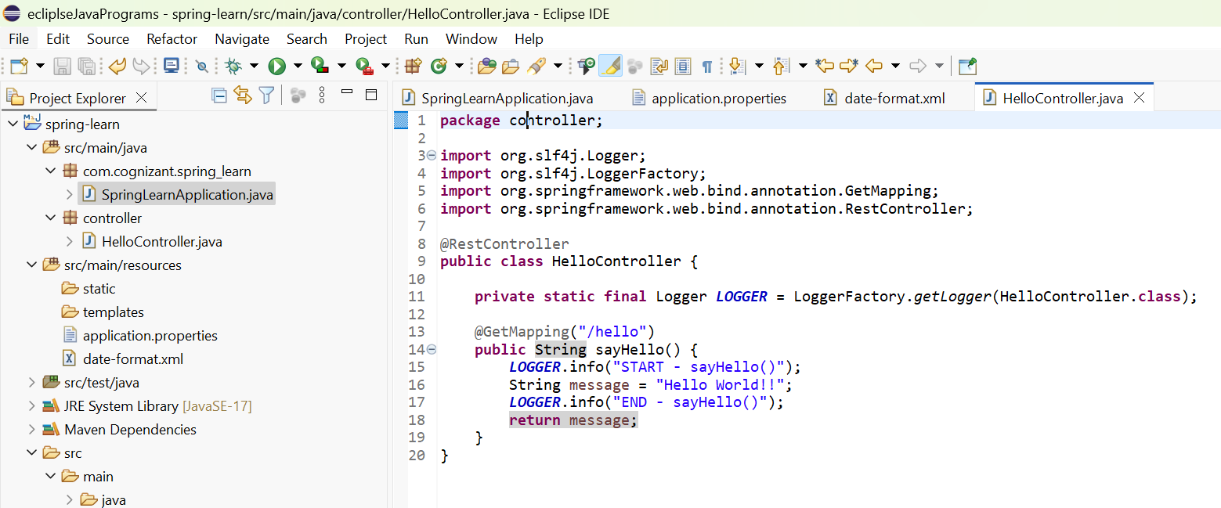

**Step 3:- Verify Main Class Has Component Scan**

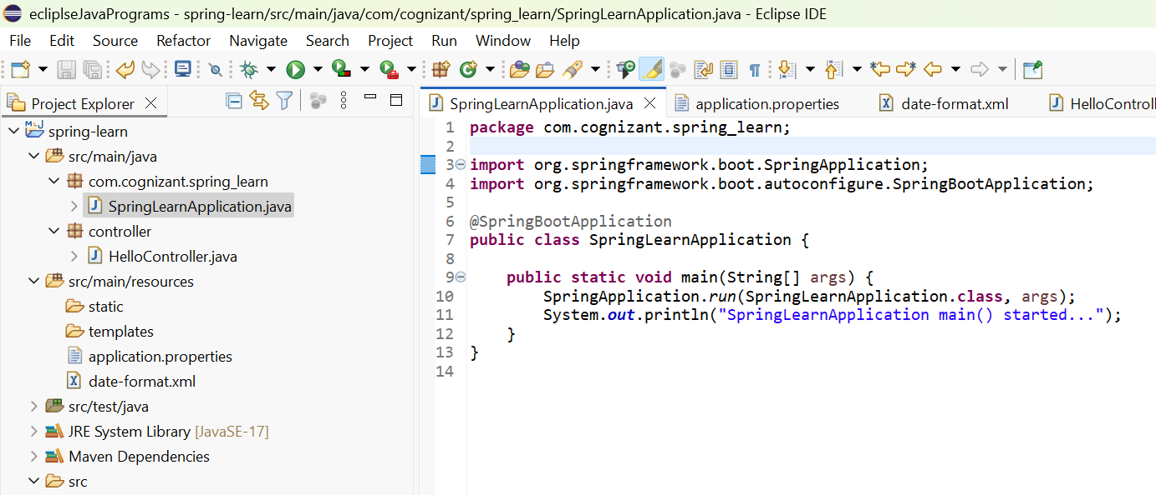

**Step 4:- Run the Application**

**Output:-**

