Data visualization 1:

The pie charts show that reading scores account for the largest percentage in both genders, with writing and math scores following closely behind. This suggests that, regardless of gender, students perform better in reading on average than in writing and math.

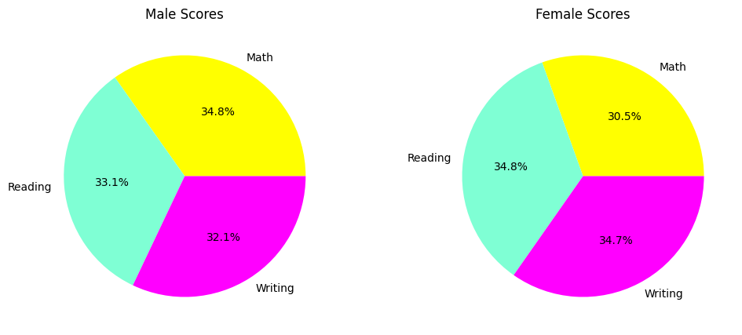

Data visualization 2:

Comparing students with parents who have lower levels of education to those whose parents have higher levels, we can see from the bar plot that the former typically achieve higher average scores across all subjects. Furthermore, average scores rise noticeably as parents' educational attainment increases from high school to a bachelor's degree or above, suggesting a positive relationship between parental education and students' academic success.

Data visualization 3:

With group C being the most represented and group A being the least represented, it looks that there is a fairly even distribution among the various racial/ethnic groups based on the count plot of race/ethnicity distribution. Furthermore, it doesn't appear that any one racial or ethnic group dominates the dataset or is significantly imbalanced.

Data visualization 4:

We can see differences in math performance across various racial or ethnic groups from the box plot of math scores by race/ethnicity. The data suggests that certain demographic groups exhibit a tendency to have higher median math scores than others. Additionally, there are variations in the distribution of scores within each group, suggesting varying levels of math achievement.

Data visualization 5:

The relationship between reading and writing scores is visualized in this scatter plot, where math scores are represented by color. It implies that there is a positive correlation between reading and writing scores, and that students who score well in math may also be proficient in other academic areas. In general, higher math scores are linked to higher reading and writing scores.

