* **Name:** Nallamari Dharani
* **Roll No:** 224E1A4712
* **Course:** Data Analytics with Tableau
* **Assignment 2**

**I Revolution : A data driven exploration of apples iphone impact in india.**

**VISUALIZATIONS:**

-Country wise best selling smart phones

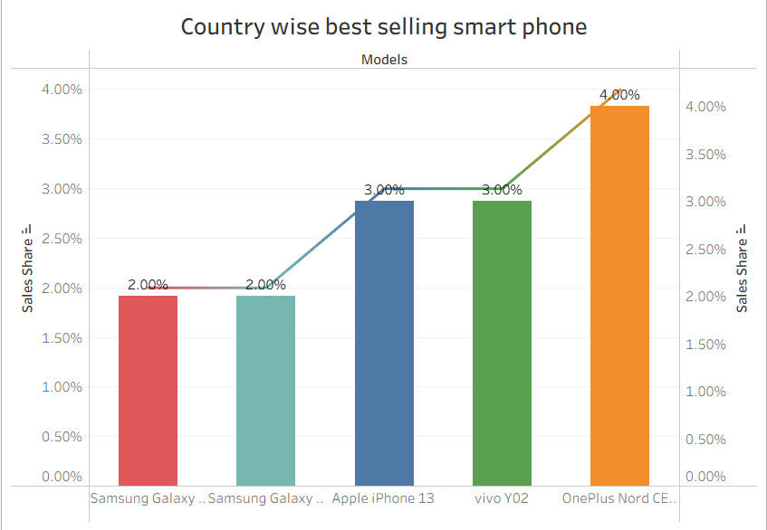

-Quaterly Share

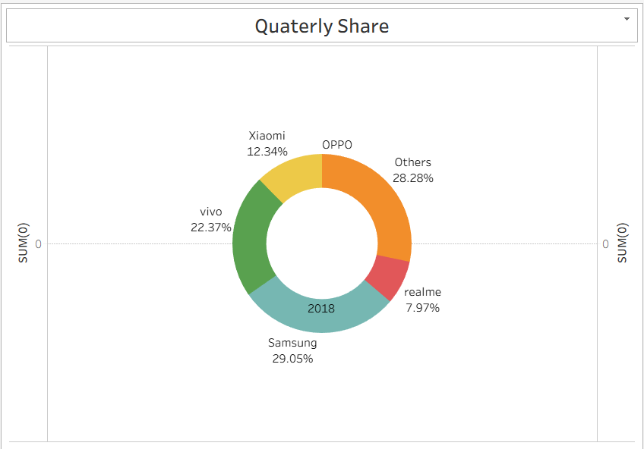

-Annual Revenue

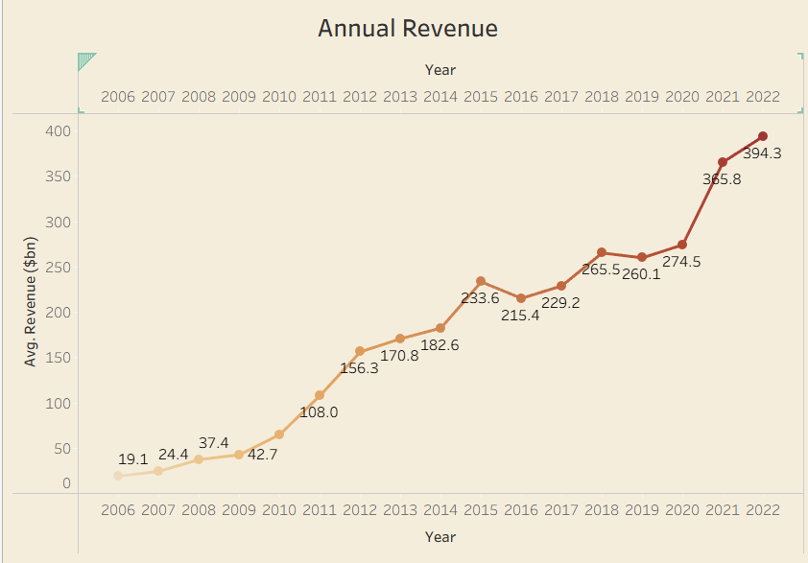

-GMS (Global Market Share)

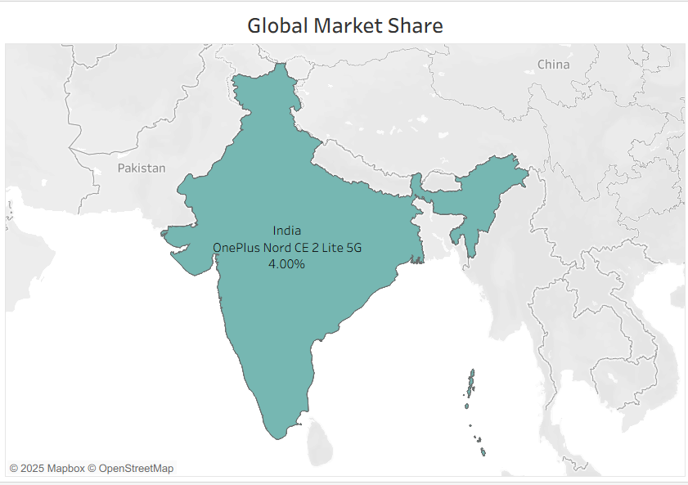

-KPI 2

