* **Name:** Nallamari Dharani
* **Roll No:** 224E1A4712
* **Course:** Data Analytics with Tableau
* **Assignment 1**

**I Revolution : A data driven exploration of apples iphone impact in india.**

**INTRODUCTION:**

Development of an Apple smartphone began in 2004, when Apple started to gather a team of 1,000 employees led by hardware engineer Tony Fadell, software engineer Scott Forsta l, and design officer Jony Ive to work on the highly confidential “Project Purple”.

**VISUALISATIONS:**

- KPI

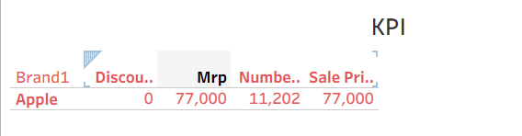

- Model Specification

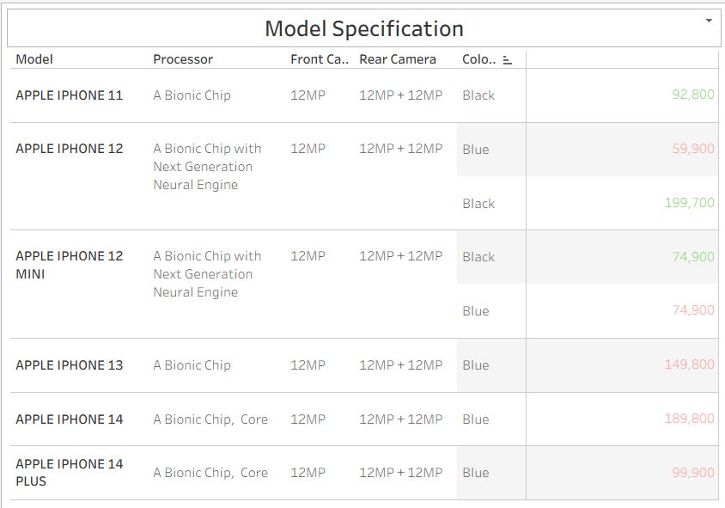

- Battery Type

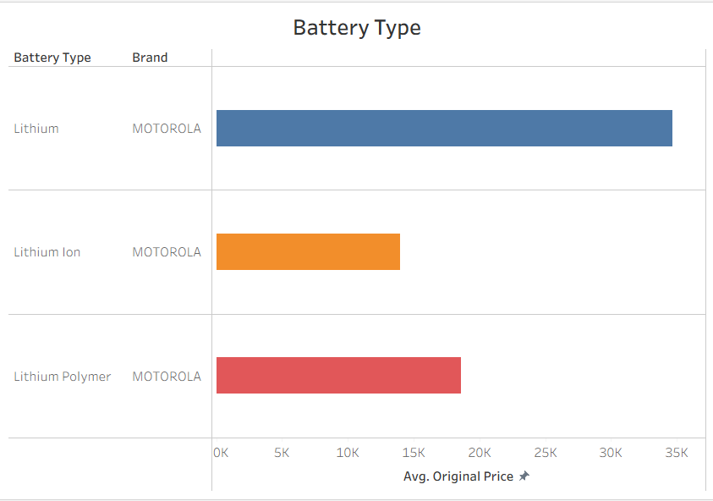

-Brand Price Comparison

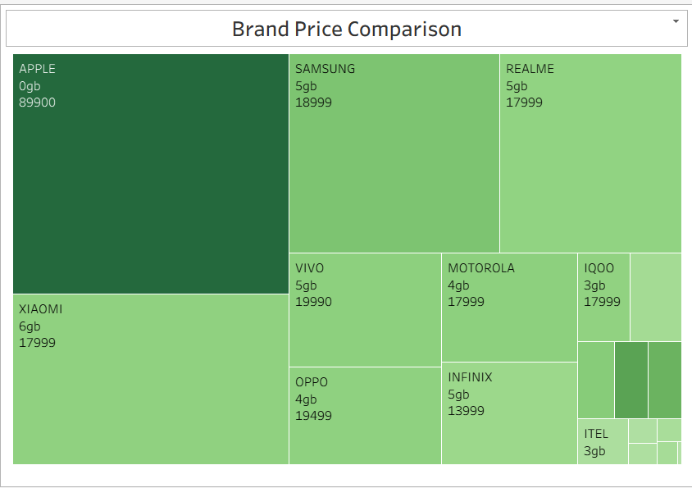

- Model Share

