* **Name:** Nallamari Dharani
* **Roll No:** 224E1A4712
* **Course:** Data Analytics with Tableau
* **Assignment 3**

**I Revolution : A data driven exploration of apples iphone impact in india.**

**VISUALIZATIONS:**

**Dash board:**

**-D**asboard 1

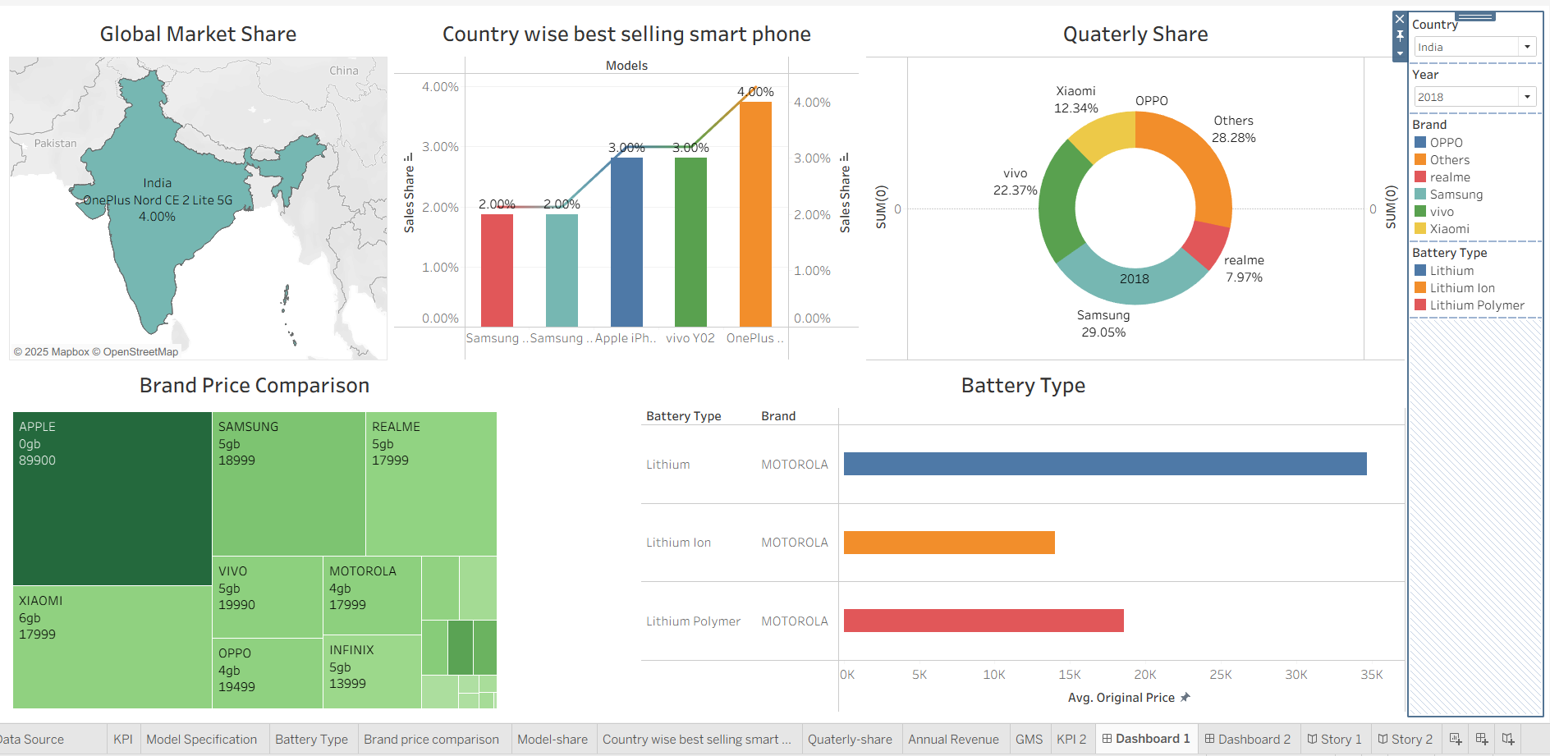

**-**Dashboard 2

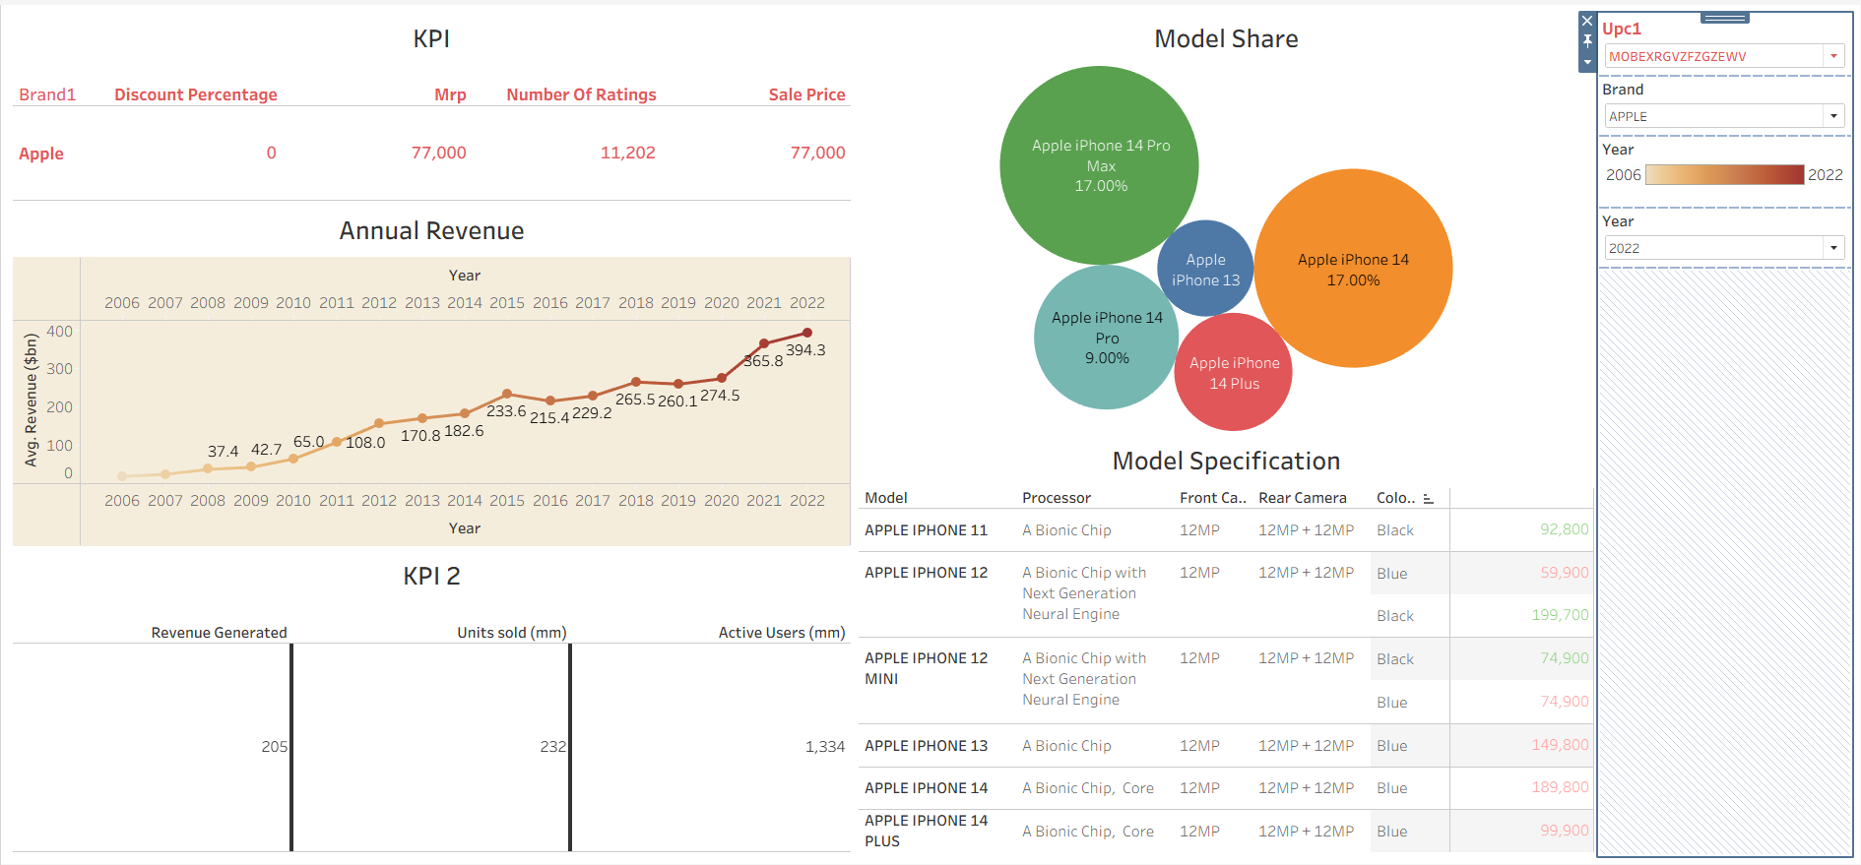

**Story:**

