CREATE A BLOG SPOT

<https://suzhalkappu.blogspot.com/>

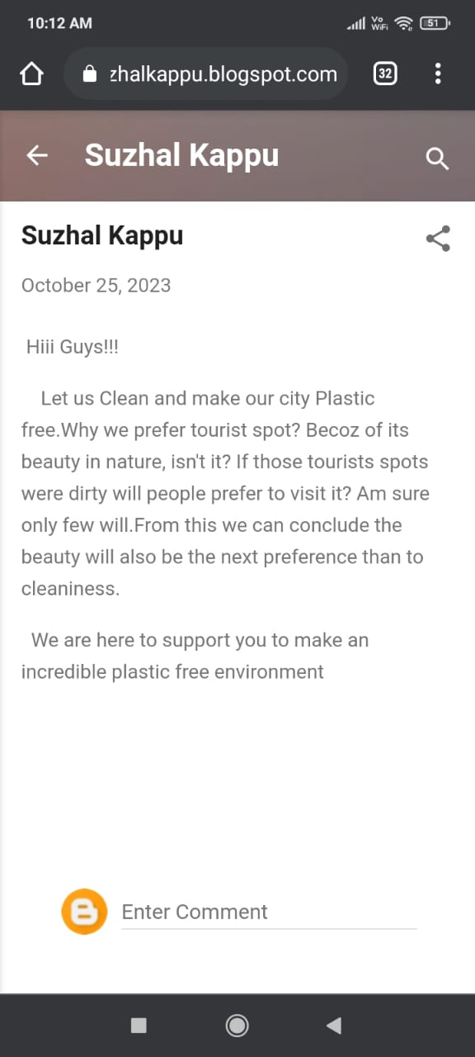

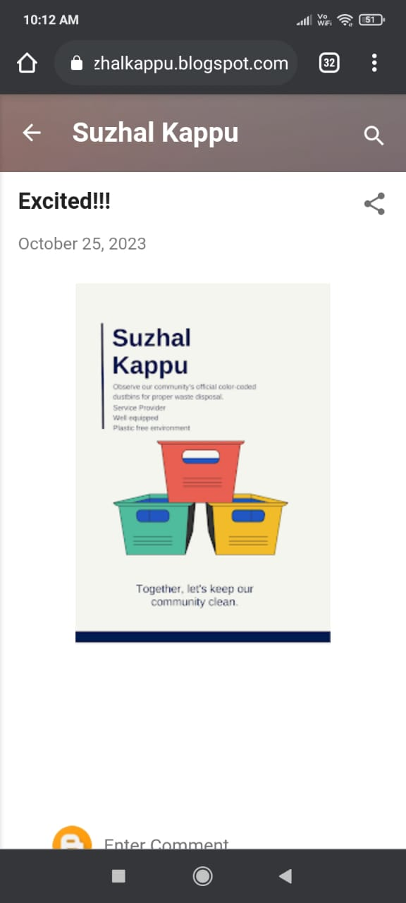

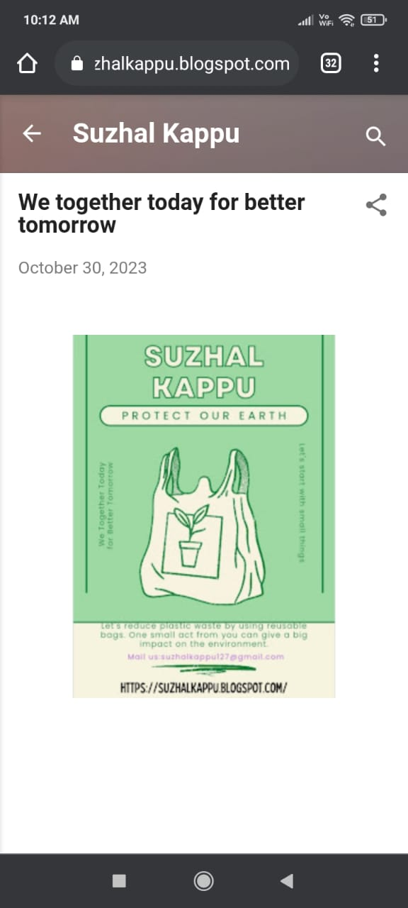

CREATE A FACEBOOK PAGE

<https://www.facebook.com/profile.php?id=61552961910840&mibextid=ZbWKwL>

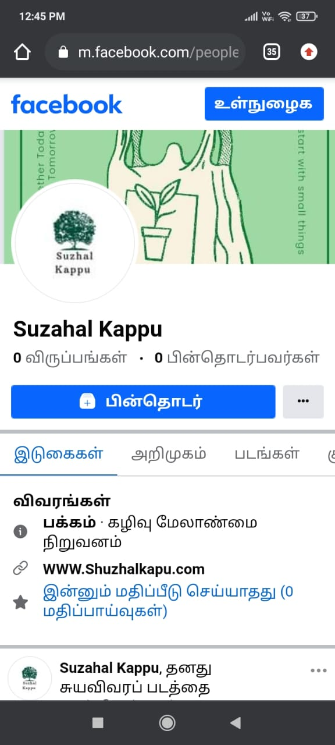

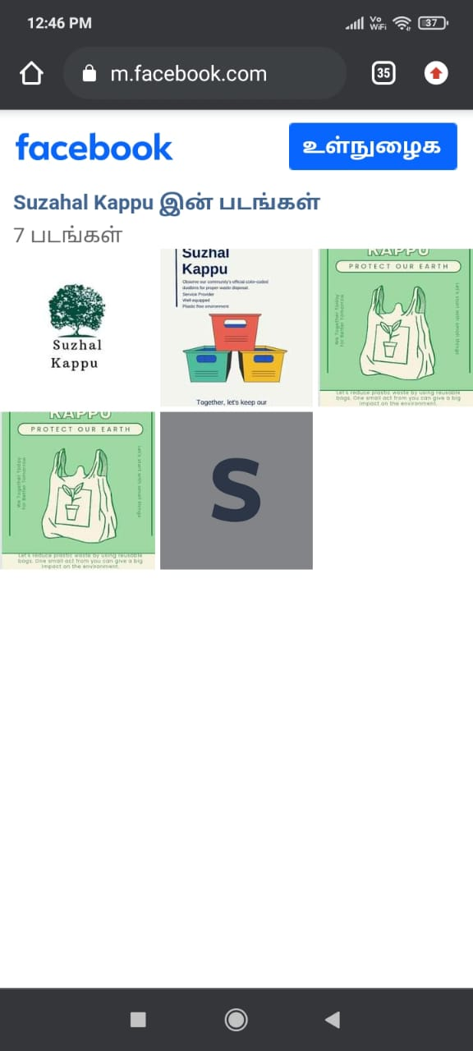

CREATE A CANVA DESIGN

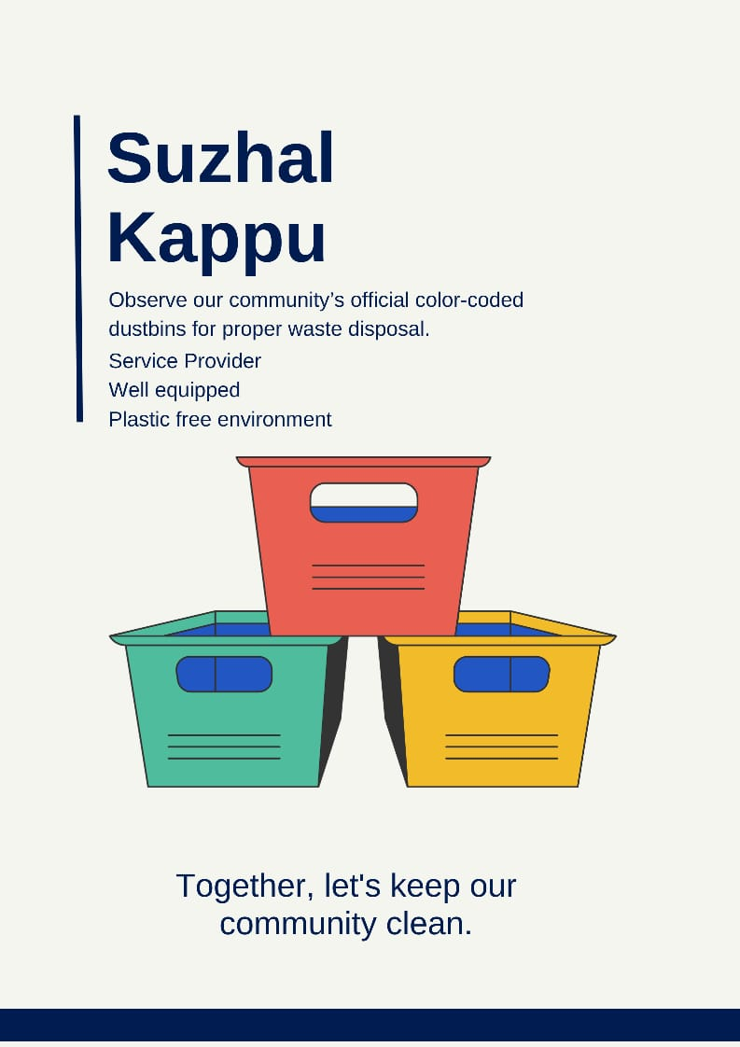

LOGO



CREATE A NEWSLETTER

