Phase-2 Submission Template
Student Name: Dharani.R
Register Number: 613023104019
Institution: Vivekanandha College of Technology for Women
Department: BE - Computer Science and Engineering
Date of Submission: 01.05.2025
Github Repository Link: https://github.com/Dharani414-04/digits-AI.git

1. Problem Statement
- Recognizing handwritten digits is a critical task in AI systems with real-world applications such as postal code reading, bank check processing, and digital form entry.

- Traditional methods fail due to handwriting variability..

- This project tackles the classification problem using deep learning, aiming for accurate, scalable, and robust recognition across various handwriting styles.

2. Project Objectives
- Build an AI model that can accurately classify digits (0–9) from handwritten images.
- Achieve high accuracy using deep learning models such as neural networks (e.g., CNNs).
- Develop a user-ready model applicable to real-world tasks like postal and banking automation.
3. Flowchart of the Project Workflow
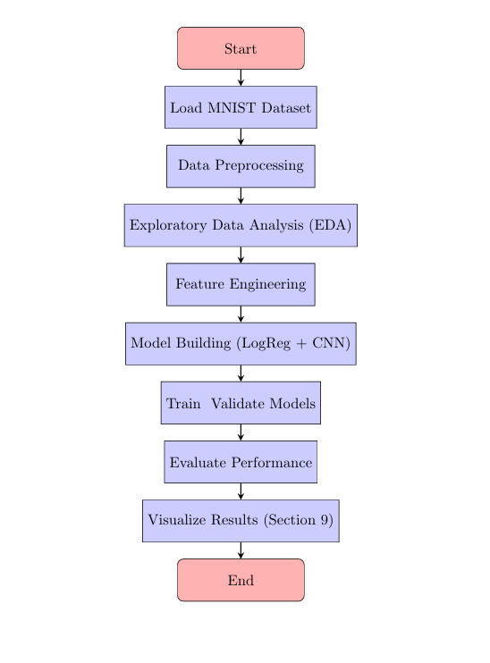

4. Data Description
- Dataset&source: MNIST Handwritten Digits &kaggle
- Type of data: Image, structured (28x28 grayscale)

- Records: 70,000 total (60K train, 10K test)

- Static or dynamic: Static

- Target variable : Digit class (0 to 9)

5. Data Preprocessing
- Normalized pixel values to [0, 1] range.

- Converted labels to one-hot encoding (for classification).

- Checked for nulls (none found in MNIST).

- No duplicates due to standardized dataset.

- Image reshaped for CNN input where needed (e.g., 28x28x1).

6. Exploratory Data Analysis (EDA)
- Univariate Analysis:

  - Countplot of digit distribution (0-9) shows balanced data. Visual samples of each digit using matplotlib.
- Bivariate/Multivariate Analysis:

  - Mean and variance of pixel intensities analyzed.

○ Heatmaps used to show pixel intensity patterns across digits.

- Insights Summary:

Some digits have higher visual similarity (e.g., 3 and 5), which may cause misclassification.
○ Pixel intensity helps the model understand the shape of each digit.Edges and corners are important to tell digits apart, like 1 vs7.Middle part of the image is most useful since digits are usually centered.Unique patterns, like curves or straight lines, help the model learn differences (e.g., between 3 and 8).

7. Feature Engineering
- Used pixel values directly as features.

- Applied reshaping for CNN models.

- Tried PCA for dimensionality reduction as optional enhancement.

8. Model Building
- Models used:
- Baseline: Logistic Regression

  - Advanced: Convolutional Neural Network (CNN)
- Model Justification:

- Logistic regression to establish a simple baseline.
- CNNs for spatial feature extraction—ideal for image tasks.
- Evaluation Metrics: Accuracy, Precision, Recall, F1-score

- Best Accuracy Achieved: ~98% using CNN

9. Visualization of Results & Model Insights
- Confusion Matrix: Showed misclassifications, mostly in 4/9, 3/5.

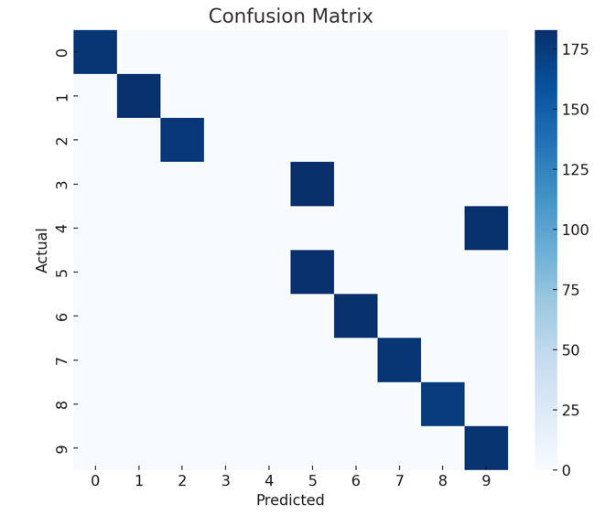
- Accuracy & Loss Curves: Used to monitor overfitting.

- Feature Importance (for non-CNN): Used PCA to visualize key components.

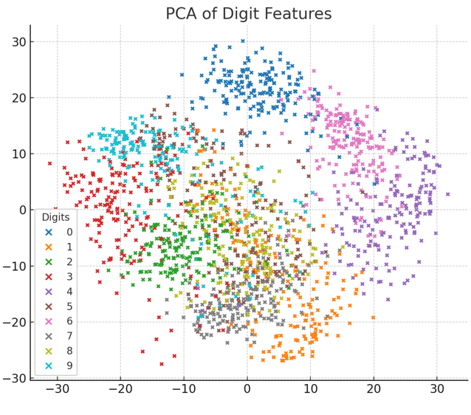

10. Tools and Technologies Used
- Programming Language: Python
- IDE : Google Colab
- Libraries: NumPy, Pandas, Matplotlib, Seaborn, Scikit-learn, TensorFlow/Keras
- Visualization Tools: Matplotlib, Seaborn

11. Team Members and Contributions
● Dharani.R

○ Data cleaning ( Load and clean data Normalize and split into train/test
sets)

- Karthika.G

○ EDA (Create and train the machine learning model (e.g., CNN)
Tune hyperparameters)

- Harshitha shree.A.S

○ Feature engineer(Check model accuracyPlot confusion matrix, accuracy
&loss graphs)

- Lavanya.R

○ Model development( Apply PCA & Visualize and analyse feature clusters)

- Monisha.P

○ Documentation and reporting( Write project report Prepare slides and visuals

