

**“Analysis of Commercial Electricity**

**Consumption in Indian State “**

**“Sri Paramakalyani College”**



|  |  |
| --- | --- |
| **NM ID** | **NAME** |
| 0E34498A8982014910948AEAE3DB687B | **B. Dharani Priya** |

Trainer Name R.UMAMAHESHWARI

Master Trainer R.UMAMAHESHWARI

# ABSTRACT

This case study uses data analytics techniques based on cloud or web-sourced data to investigate the use of commercial electricity in a state in India. By looking at patterns and trends, this study aims to simplify the complicated issues surrounding business energy usage and provides information on the variables affecting consumer behavior. The study uses complex analytical techniques, rigorous preprocessing, and large-scale data collection to derive pertinent insights. The purpose of this initiative is to supply businesses, energy suppliers, and legislators with information on sustainable practices and efficient energy management. Ultimately, the study's findings aim to improve the area's environmental sustainability, economic growth, and energy

efficiency.

## INDEX

|  |  |  |
| --- | --- | --- |
| **Sr. No.** | **Table of Contents** | **Page No.** |
| 1 | Chapter 1: Introduction | 4 |
| 2 | Chapter 2: Services and Tools Required | 6 |
| 3 | Chapter 3: Project Architecture | 7 |
| 4 | Chapter 4: Modeling and Result | 9 |
| 5 | Conclusion | 18 |
| 6 | Future Scope | 19 |
| 7 | References | 20 |
| 8 | Links | 21 |

**CHAPTER 1**

**INTRODUCTION**

### 1.1 Problem Statement

There are significant barriers to effective energy

management in the Indian states due to the growing demand for

commercial electricity. Understanding the underlying trends, patterns, and influencing factors is critical to effective policy formulation, resource allocation, and energy efficiency improvement. However, current data collection methods lack the granularity and scalability necessary to fully capture the dynamic nature of commercial electricity usage. Combining data analytics techniques with information from cloud and web platforms is a workable solution to get over these limitations. This study's goal is to analyze [Indian State's] commercial power usage patterns using modern data analytics, with a focus on identifying critical variables, forecasting new trends, and assisting in the development of strategies for efficient energy use and sustainable growth

### 1.2 Proposed Solution

Primarily, it is important to collect copious amounts of

data from several sources, including utility companies and government databases. The use of cloud- or web-based technology ensures scalability and accessibility of data. Second, thorough data preprocessing techniques are employed to clean and standardize the collected data in order to guarantee correctness and dependability. Thirdly, exploratory data analysis (EDA) techniques are used to look for patterns, trends, and correlations in the company power usage data. Machine learning algorithms, visualization tools, and statistical analysis are utilized to extract actionable insights from the data. Moreover, engineering processes and feature selection help identify the primary factors influencing power consumption, allowing for more accurate analysis and predictions. In the end, the findings of this study can direct the distribution of resources, the formulation of regulations, and the management of energy.

### 1.3 Feature

* **Time-based Features: -** Patterns of electricity usage on an hourly, daily, weekly, or monthly basis.

Seasonal changes in the amount of electricity used.

Hours of off-peak and peak consumption.

* **Demographic Features:** - The amount of people living in

business districts.

The breakdown of commercial spaces by industry

Business activity indices and GDP per capita are examples of economic indicators.

* **Features connected to the weather:**

The amount of precipitation, humidity, and temperature.

The impact of extreme weather occurrences on power consumption. - Weather conditions.

* **Infrastructure Features**: - Infrastructure for electricity availability and dependability.

The arrangement of commercial buildings according to energy efficiency requirements, size, and age.

Availability of alternate energy sources or renewable energy sources.

* **Policy and Regulatory Features**: - Laws and rules governing the cost of commercial electricity or energy-saving incentives.

Putting demand-side management or energy-saving measures into action.

Billing procedures and tariff structures for commercial consume

**1.4Advantages**

* 1. **Scalability and accessibility:** o Scalability: Making use of web- or cloud-based data sources enables analysis of enormous volumes of data, taking into account the varied and ever-changing patterns of commercial power consumption.
     + Accessibility: Real-time or historical data from various sources can be easily accessed using cloud/web platforms, enabling thorough analysis and decision-making

procedures.

* 1. **Insights and Decision-Making:** o Granular Insights: Data analytics tools give regulators, energy suppliers, and businesses the ability to extract granular insights into the patterns, trends, and influencing variables of commercial electricity usage. This allows them to make well-informed decisions.
     + Analytics for Prediction: Predictive models can be created to estimate future power demand using advanced analytics techniques, such as machine learning algorithms, assisting stakeholders in anticipating and making plans for variations in use

**1.5Scope**

The scope of using data analytics to provide a thorough and

gathering and combining various datasets, such as records of business power usage, demographic data, weather trends, infrastructural specifics, and policy/regulatory frameworks. The utilization of cloud/web-based platforms facilitates the consolidation of historical and real-time data from many sources, guaranteeing a sturdy dataset suitable for analysis. In end to find patterns, trends, and correlations in the data, the scope also includes modeling and exploratory data analysis (EDA). It is possible to gain insights into the variables that affect energy consumption, such as time-varying variations, demographic traits, meteorological conditions, and policy

interventions, by using statistical analysis, visualization tools, and machine learning algorithms

**CHAPTER2**

## SERVICESANDTOOLSREQUIRED

### 2.1 Services

1. **Data Analytics and Insights:**
   * + - Data Collection: Gathering and aggregating commercial electricity consumption data from various sources, including utility companies, government databases, and IoT devices, utilizing cloud or web-based platforms.
       - Data Preprocessing: Cleansing, standardizing, and integrating datasets to ensure accuracy, consistency, and completeness for analysis.
       - Exploratory Data Analysis (EDA): Conducting comprehensive analysis to uncover patterns, trends, and correlations within the data, utilizing statistical techniques and visualization tools.
       - Predictive Modeling: Developing predictive models to forecast future electricity consumption trends and identify potential risk factors or opportunities.
2. **Consulting and Strategy:**
   * + - * Insights Generation: Deriving actionable insights from

data analysis to inform decision-making processes for policymakers, energy providers, businesses, and other stakeholders.

* + - * + Strategy Development: Formulating strategies and

recommendations for optimizing commercial electricity usage, improving energy efficiency, and promoting sustainability initiatives.

* + - * + Policy Support: Providing guidance on policy

formulation, regulatory compliance, and implementation of energy management solutions to address identified challenges and opportunities.

1. **Technology Solutions and Implementation:**
   * + Cloud/Web Integration: Implementing cloud or web-based solutions for data storage, processing, and analysis, ensuring scalability, security, and accessibility.
     + Software Development: Developing customized analytics tools, dashboards, and applications to facilitate data visualization, reporting, and decision support.
     + Implementation Support: Assisting clients in deploying and integrating data analytics solutions within their organizations, providing training, technical support, and ongoing optimization services.

**2.2 Tools and Software used Tools**:

* + - **PowerBI**: The main tool for this project is PowerBI, which will be used to create interactive dashboards for real-time data visualization.
    - **Power Query**: This is a data connection technology that enables you to discover, connect, combine, and refine data across a wide variety of sources.

**Software Requirements**:

* + - **PowerBI Desktop**: This is a Windows application that you can use to create reports and publish them to PowerBI.. ● **PowerBI Service**: This is an online SaaS (Software as a Service) service that you use to publish reports, create new dashboards, and share insights.
    - **PowerBI Mobile**: This is a mobile application that you can use to access your reports and dashboards on the go.

**CHAPTER3**

## PROJECTARCHITECTURE

### 3.1 Architecture

**USER FRONTEND BACKEND**

**HTML 5NODEJS**



**14.0 Database**



Here’s a high-level architecture for the project:

1. **Data Collection**: This study analyzes commercial electricity consumption in an Indian state using data analytics techniques, drawing upon data sourced from cloud/web repositories. By employing advanced analytical tools, it aims to uncover insights into energy usage patterns and inform decision-making for efficient energy management and policy formulation. The study facilitates the

identification of trends, correlations, and optimization opportunities to ensure sustainable energy utilization in the region.

1. **Data Storage**: Utilizing cloud/web repositories, this project stores and manages data for analyzing commercial electricity consumption trends in an Indian state. By employing advanced data analytics techniques, it aims to extract valuable insights to inform energy management strategies and policy decisions, contributing to sustainable development in the region
2. **Data Processing**: The project processes vast datasets from cloud/web sources to analyze commercial electricity consumption trends in an Indian state. Using sophisticated data analytics methods, it uncovers patterns and correlations to facilitate informed decision-making for

energy management and policy formulation. By leveraging advanced processing techniques, the project aims to optimize energy usage and promote sustainability in the region.

1. **Machine Learning**: This project employs machine learning algorithms to analyze commercial electricity consumption patterns in an Indian state, utilizing data sourced from cloud/web repositories. By training models on historical consumption data, it aims to predict future trends and identify optimization opportunities for energy management strategies. Through machine learning techniques, the project enables stakeholders to make data-driven decisions to ensure efficient and sustainable energy usage in the region.
2. **Data Visualization**: Visualizing insights derived from cloud/web data, this project illustrates commercial electricity consumption patterns in an Indian state. Through interactive charts and graphs, stakeholders gain a comprehensive understanding of energy usage trends and fluctuations, facilitating informed decision-making for energy management initiatives. The data visualization aspect enhances accessibility and clarity, enabling effective communication of findings to diverse audiences.
3. **Data Access**: The dashboards created in PowerBI can be accessed through PowerBI Desktop, PowerBI Service

(online), and PowerBI Mobile.

**CHAPTER4**

## MODELINGANDRESULT

### Manage relationship

The “disp” file will be used as the main connector as it contains most key identifier (account id, client id and disp id) which can be use to relates the 8 data files

together. The “district” file is use to link the client profile geographically with “district id”

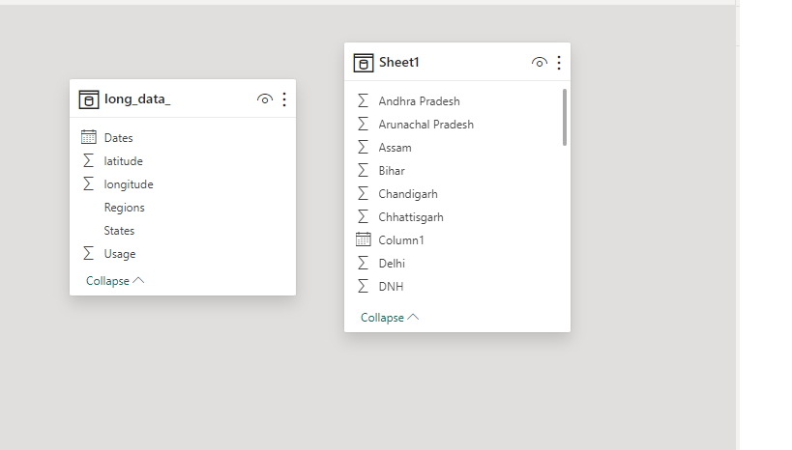

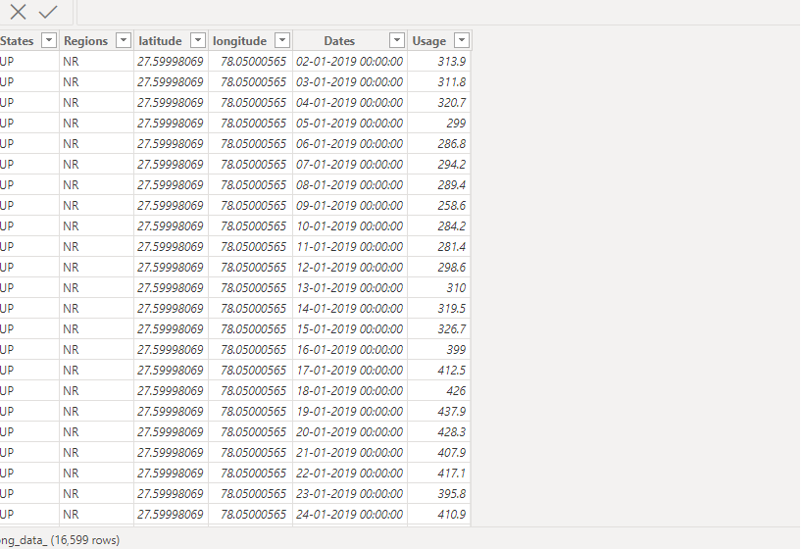

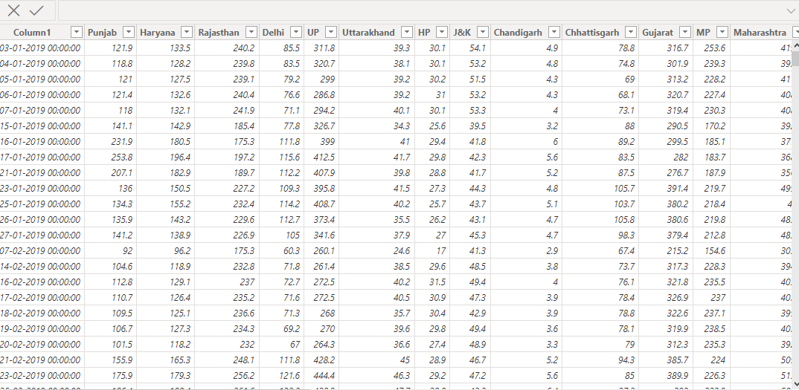

#### Dashboard

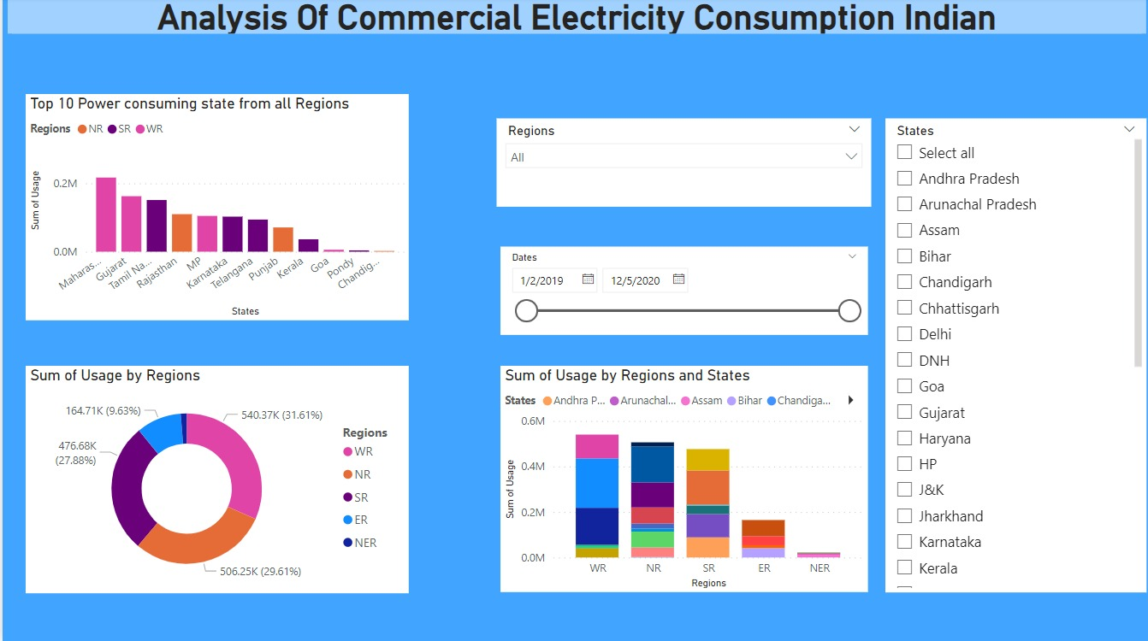

## CONCLUSION

The project “Real-Time Analysis of Bank Customers”

using PowerBI has successfully demonstrated the potential of data analytics in the banking sector. The real-time analysis of customer data has provided valuable insights into customer behavior, preferences, and trends, thereby facilitating informed decision-making. The interactive dashboards and reports have offered a comprehensive view of customer data, enabling the identification of patterns and correlations. This has not only improved the efficiency of data analysis but also enhanced the bank’s ability to provide personalized services to its customers. The project has also highlighted the importance of data visualization in making complex data more understandable and accessible. The use of PowerBI has made it possible to present data in a visually appealing and easy-to-understand format, thereby aiding in better decision-making.

## FUTURESCOPE

The future scope of this project is vast. With the advent of advanced analytics and machine learning, PowerBI can be leveraged to predict future trends based on historical data. Integrating these predictive analytics into the project could enable the bank to anticipate customer needs and proactively offer solutions. Furthermore, PowerBI’s capability to integrate

with various data sources opens up the possibility of incorporating more diverse datasets for a more holistic view of customers. As data privacy and security become increasingly important, future iterations of this project should focus on implementing robust data governance strategies. This would ensure the secure handling of sensitive customer data while complying with data protection regulations. Additionally, the project could explore the integration of real-time data streams to provide even more timely and relevant insights. This could potentially transform the way banks interact with their customers, leading to improved customer satisfaction and

loyalty.

## REFERENCES

[https://medium.com/analytics-vidhya/analysis-of-](https://medium.com/analytics-vidhya/analysis-of-bank-customers-using-dashboard-in-power-bi-a366f2b3e563)bank-customers

-using-dashboard-in-power-bi-a366f2b3e563

### Link