**Digital Design and Computer Organisation Laboratory**

**3rd Semester, Academic Year 2025**

Date:07-08-2025

| Name: Dharani S | SRN: PES2UG24CS157 | Section  : c |
| --- | --- | --- |

Week Number: 1

TITLE: Basic Logic Gates.

1. OR gate:

Verilog Code:

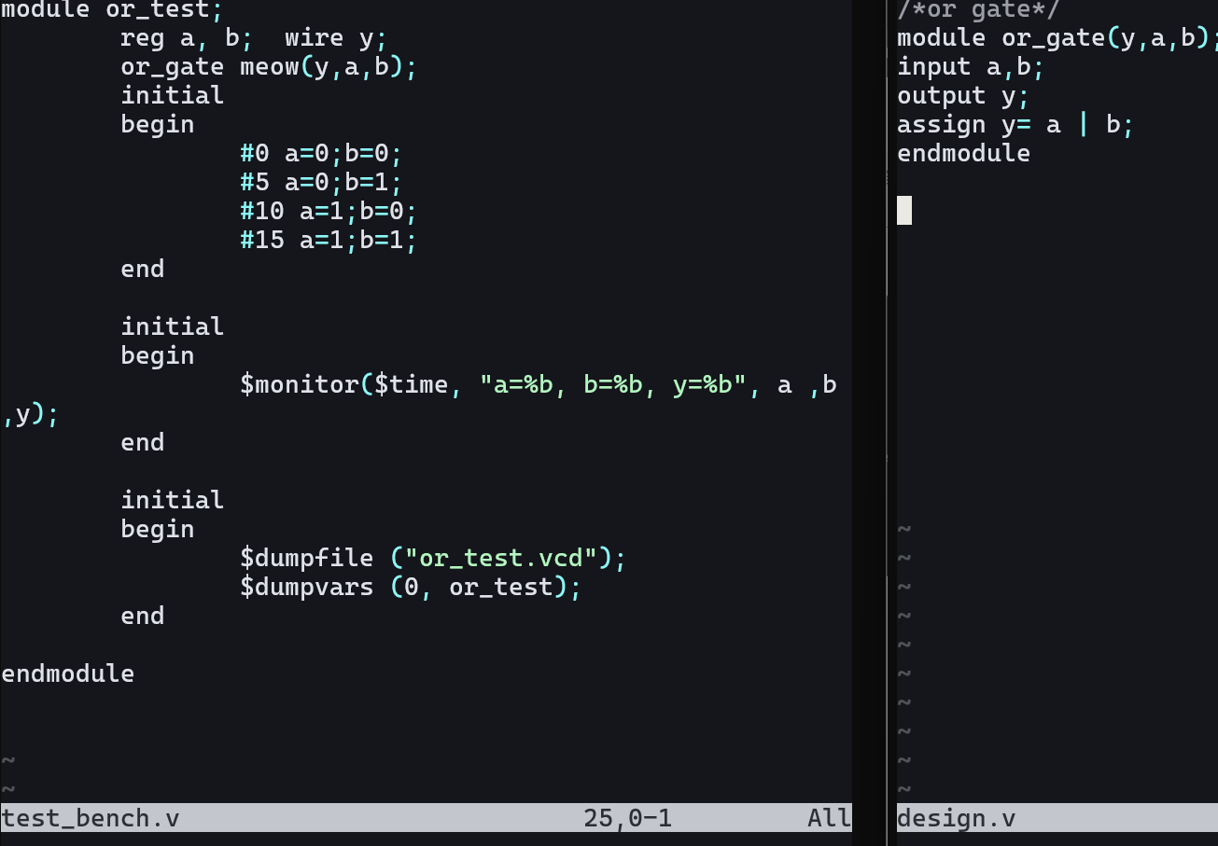

Vvp o/p:

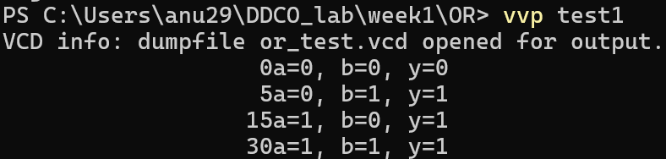

Gtkwave:

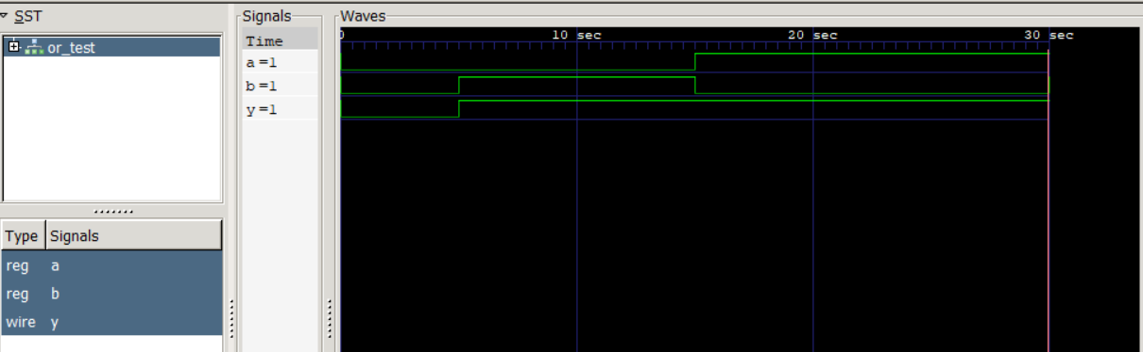

1. XOR

Verilog code

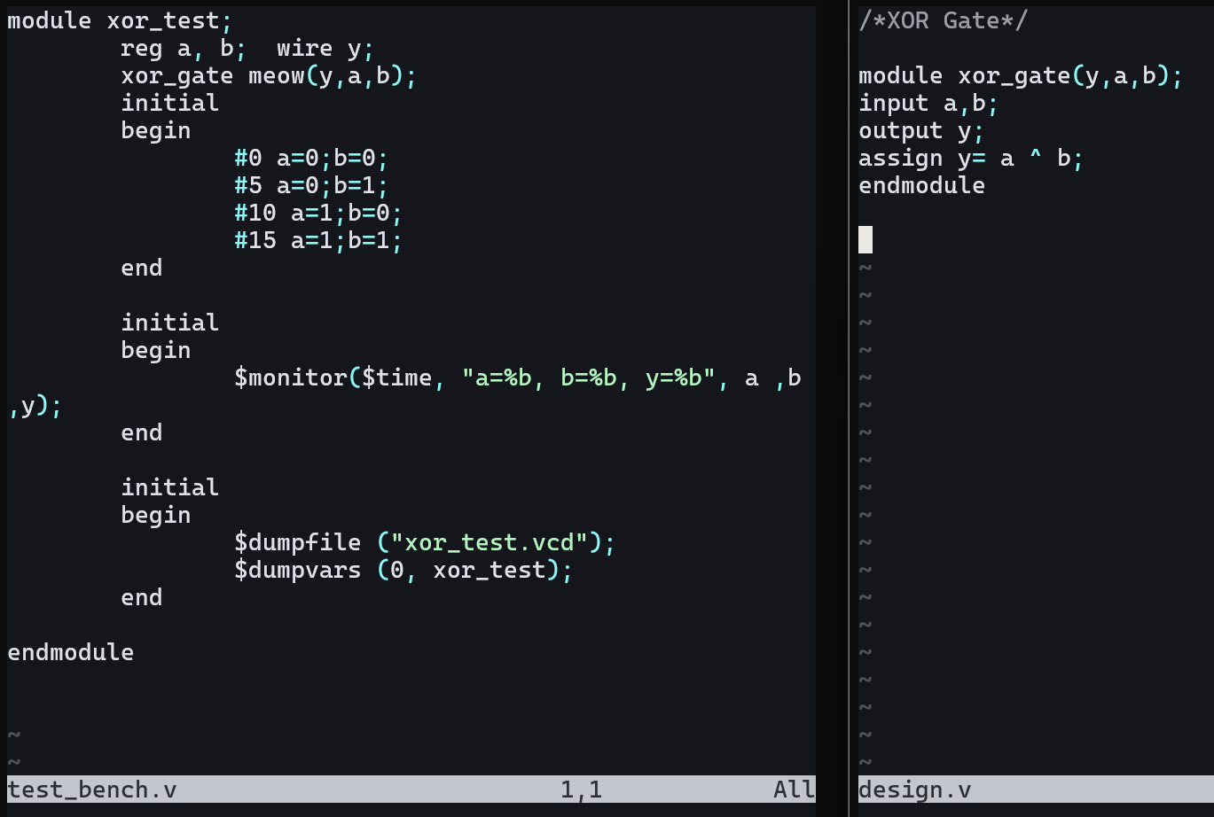

Vvp o/p

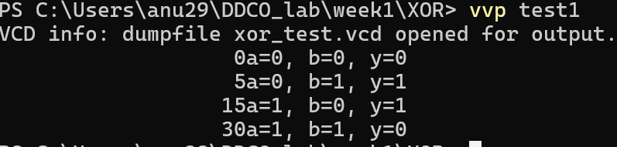

Gtkwave: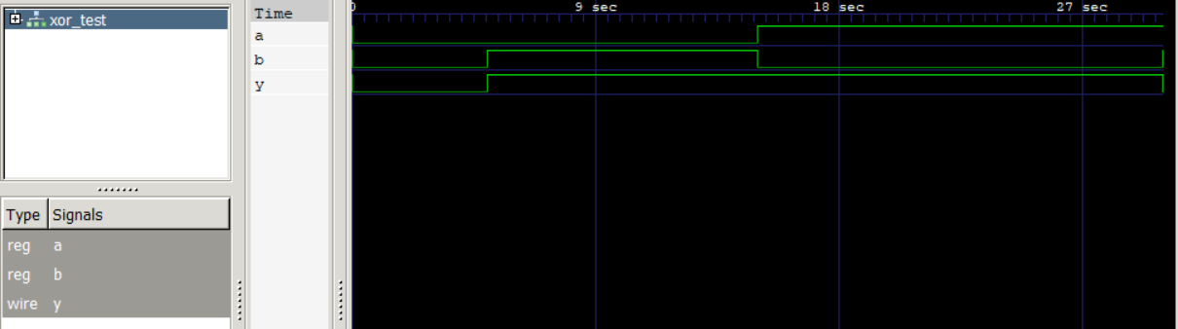

1. NOR

Verilog code:

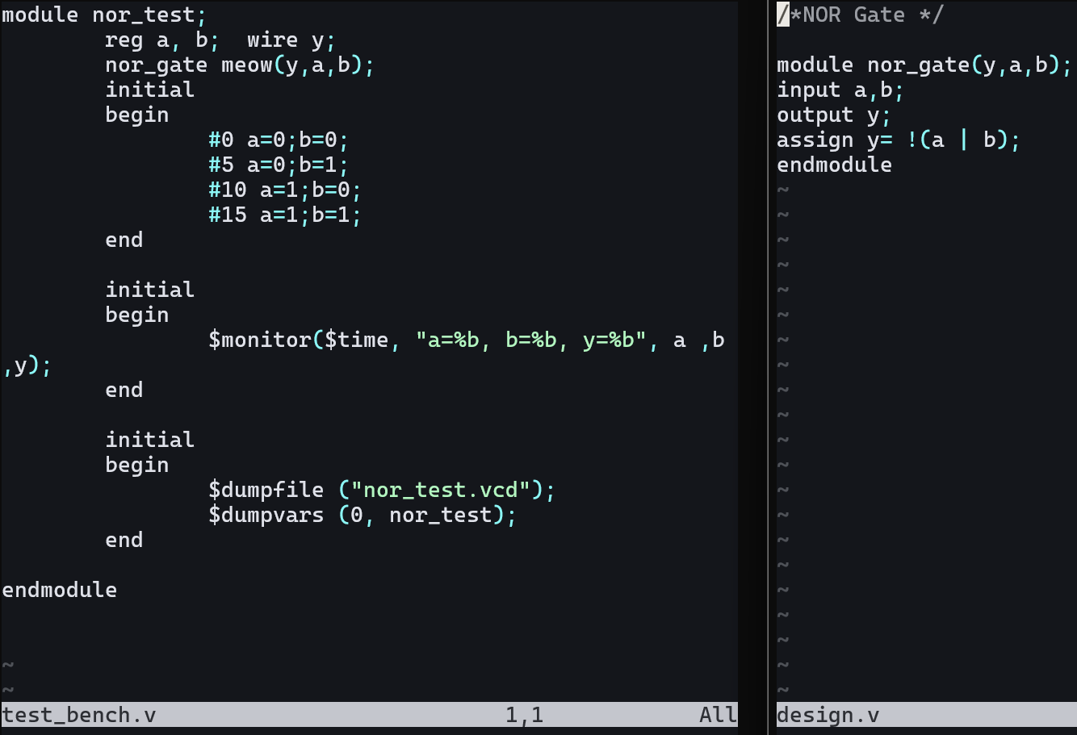

Vvp o/p:

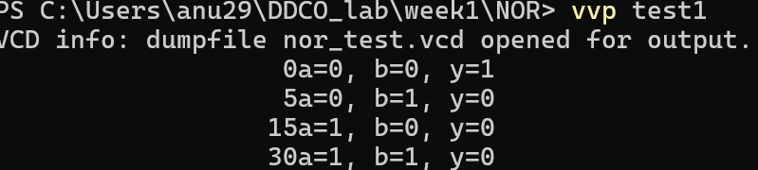

Gtk wave:

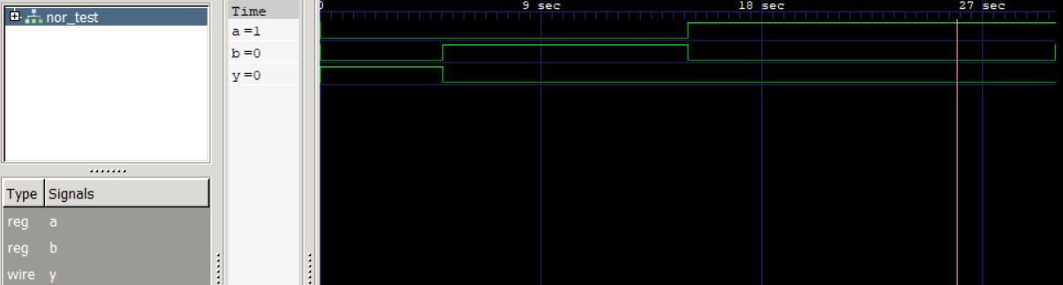

1. NOT

Verilog code:

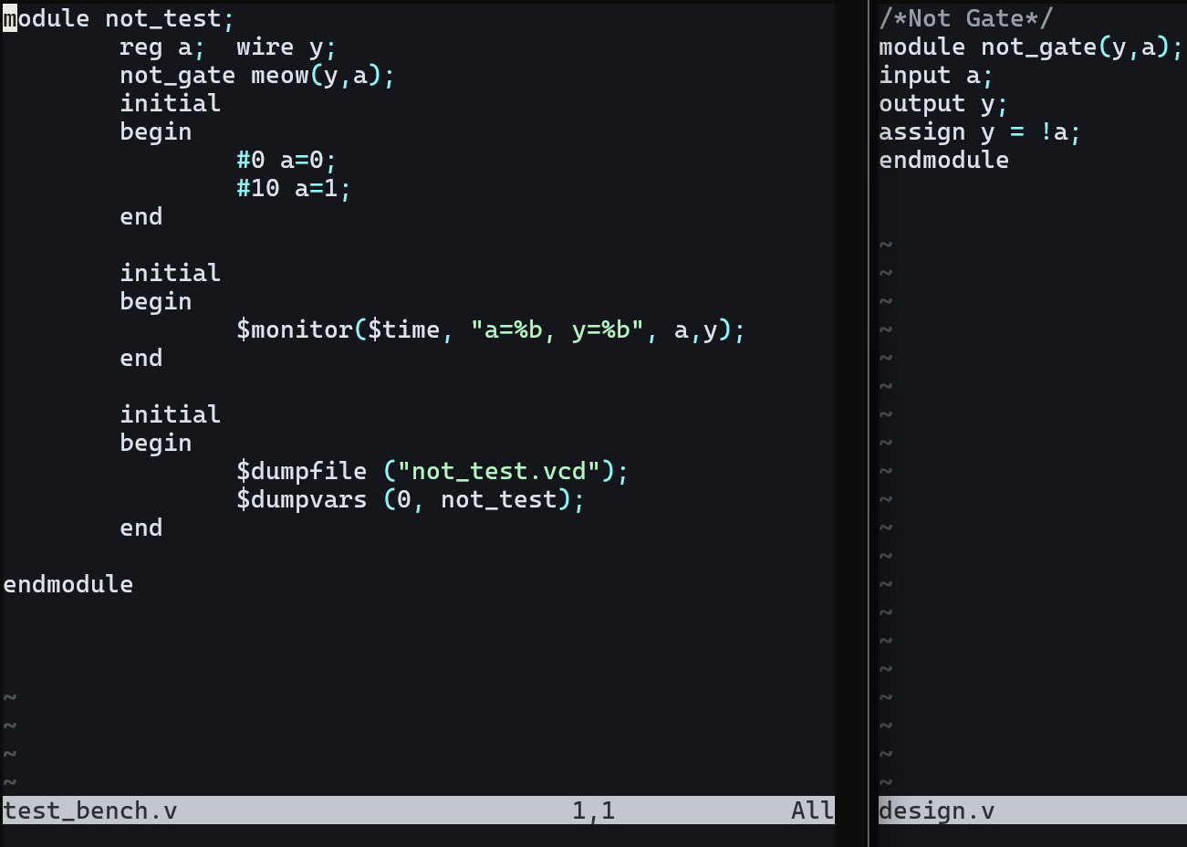

Vvp o/p:

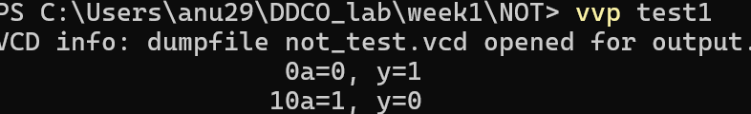

Gtk wave:

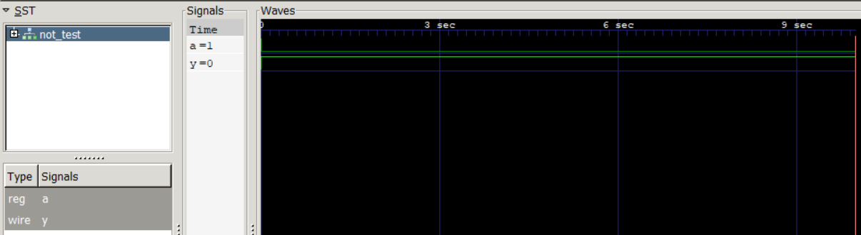

1. NAND

Iverilog code: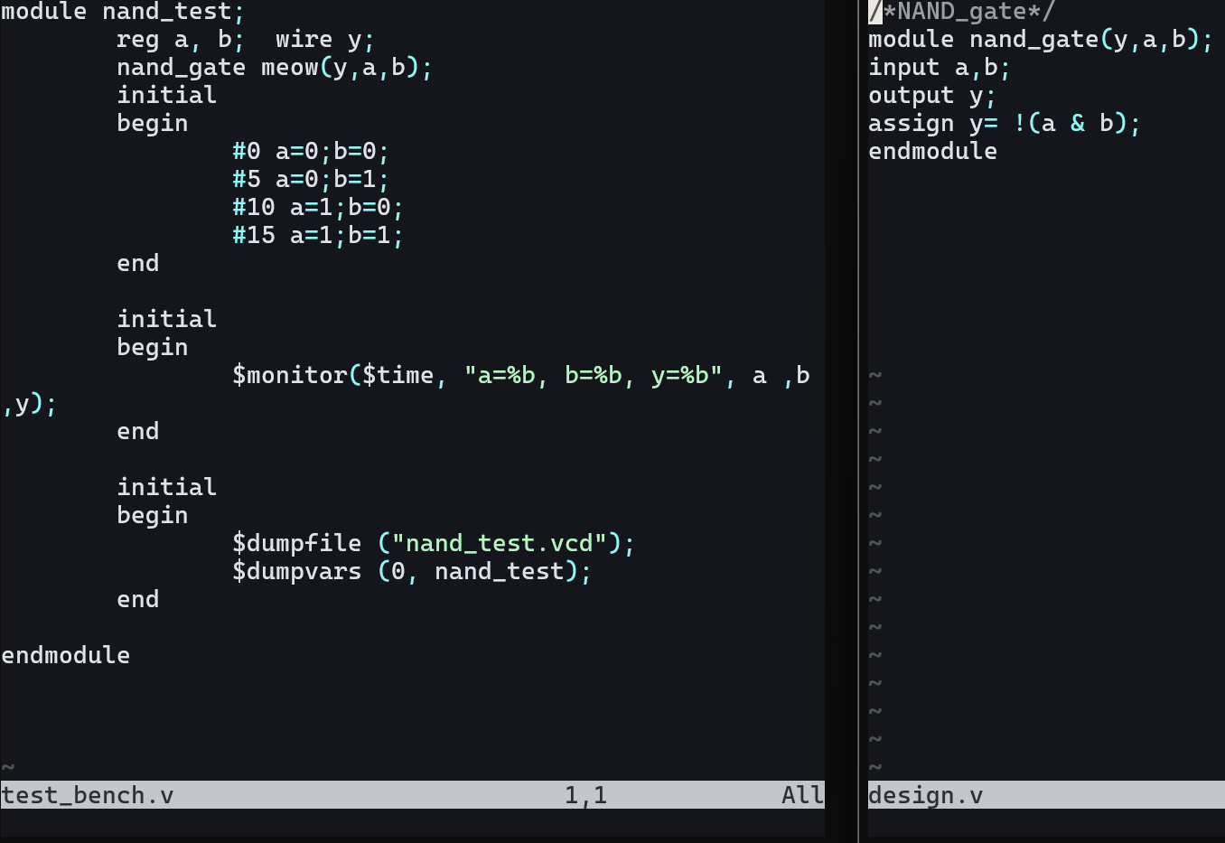

Vvp o/p:

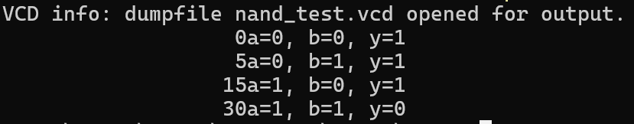

Gtkwave:

