ETRM System
Master Data Entry — Technical Design
Two-tier UI/API architecture for 135 master data tables
Version 1.0 — June 2026
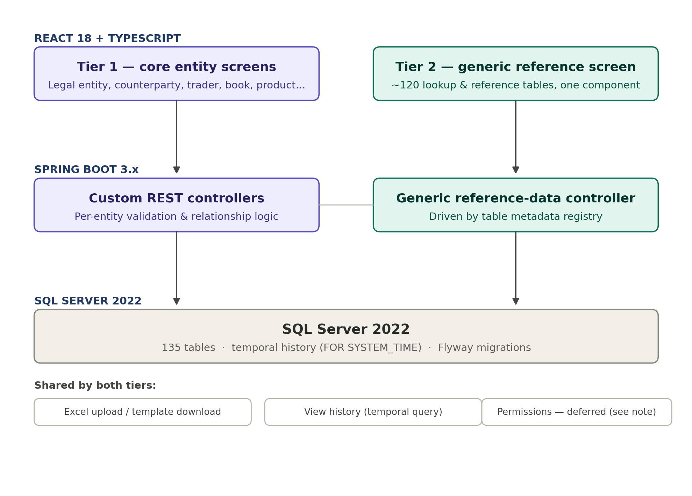

1. Problem & Approach
The schema has 135 master data tables across 10 segments — far more than any team can justify hand-building a dedicated screen and controller for each. Most of these tables are simple reference/lookup data (a handful of columns, a CHECK-constrained enum, audit fields) that all share the same shape. A small minority are genuinely complex entities with relationships, multi-step capture, and business rules worth custom UI.
This document splits master data entry into two tiers accordingly, rather than picking one extreme:
- Tier 1 — Custom screens for ~15 core entities with real relationships and business logic.
- Tier 2 — One generic, metadata-driven screen covering the remaining ~120 reference/lookup tables.
Permission levels are intentionally excluded from this design. The current RBAC role list (TRADER, SENIOR_TRADER, RISK_MANAGER, BACK_OFFICE, COMPLIANCE, ADMIN, APPROVER, SYSTEM) is being superseded for master data purposes by a separate, more granular role table — see Section 6.

2. Tier 1 — Custom Entity Screens
Tier 1 covers entities with one or more of: nested child records (addresses, contacts, bank accounts), cross-entity relationships that need lookups/typeaheads, multi-step or wizard-style capture, or business rules beyond a CHECK constraint (e.g. trader limit approval chains, product spec inheritance).

Candidate Tier 1 entities
Entity | Why it's Tier 1 | Source segment
legal_entity | Polymorphic address/tax/bank child records; temporal | Master Data Foundation
counterparty | KYC status, polymorphic child records; temporal | Master Data Foundation
trader | Limits, approver chain, desk linkage; temporal | Master Data Foundation
book | Hierarchy, legal entity linkage; temporal | Master Data Foundation
desk | Head trader linkage, org hierarchy | Master Data Foundation
product | Spec template inheritance, commodity linkage | Master Data Foundation
product_spec_template / value | Multi-row min/max/typical capture per product | Product Spec / MOT / Pipeline
location | Polymorphic address; capacity/type-dependent fields | Master Data Foundation
vessel | Certificates, ownership, capacity attributes | Product Spec / MOT / Pipeline
pipeline | Segments, points, tariffs, cycles — multi-table capture | Product Spec / MOT / Pipeline
storage_facility | Capacity, polymorphic address | Financial & Operational MD
market | Exchange linkage, hours, holiday calendar | Market, Price Source & Period
pricing_rule | Component formula builder; temporal | Pricing Triggers & Rules
generation_asset | Zone/BA linkage, ownership, fuel/technology | Power Schema
balancing_authority | Anchors zones/interconnectors/schedule cycles below it | Power Schema
This list is a starting proposal, not final — confirm or adjust before build.

Tier 1 pattern
- React: one screen per entity (tabs for child records where applicable), Ant Design Form + AG Grid list view — same pattern as the existing prototype (App.tsx, services/api.ts).
- Spring Boot: one @RestController + @Service + JPA @Entity per table, with Jakarta Bean Validation annotations mirroring the DB CHECK constraints (validation should never rely on the DB to catch a bad value first).
- Excel upload/download: reuse and extend services/upload.ts — per-entity column mapping, duplicate detection, row-level validation, downloadable template.

3. Tier 2 — Generic Reference Data Screen
Tier 2 covers every table not listed in Tier 1 — roughly 120 tables: currency, commodity, incoterm, credit_rating, charter_party_type, load_shape_template, transmission_zone, every *_type reference table, and so on. These are all structurally the same: a handful of columns, zero or more CHECK-constrained enums, zero or more foreign keys to other simple tables, and standard audit columns. One generic screen and one generic API handles all of them.

master_data_table_registry
A new, small control table drives the generic screen — it is the only thing that needs a new row when a new Tier 2 table is added; no new code.
Column | Type | Purpose
registry_id | INT PK | Identity
table_name | VARCHAR(50) | Physical table name, e.g. 'charter_party_type'
display_name | VARCHAR(100) | Human label shown in the UI, e.g. 'Charter Party Types'
module_group | VARCHAR(50) | Sidebar grouping, e.g. 'Freight', 'Power', 'Pricing'
allow_create / edit / delete | BIT each | Per-table write permission toggles, independent of role
allow_excel_upload | BIT | Whether bulk upload is offered for this table
is_enabled | BIT | Hide a table from the generic screen without dropping the registry row
display_order | SMALLINT | Sidebar ordering within module_group

Generic REST API
Endpoint | Purpose
GET /api/v1/reference-data | List all registered tables (drives the sidebar)
GET /api/v1/reference-data/{table}/metadata | Column metadata: name, SQL type, nullable, PK/FK, CHECK enum values
GET /api/v1/reference-data/{table} | Paginated list of rows
GET /api/v1/reference-data/{table}/{id} | Single row
POST /api/v1/reference-data/{table} | Create row
PUT /api/v1/reference-data/{table}/{id} | Update row
DELETE /api/v1/reference-data/{table}/{id} | Delete or deactivate row, per registry policy
POST /api/v1/reference-data/{table}/upload | Excel bulk upload, reusing Tier 1's validation pattern

How metadata is derived
At startup (or on a cache-refresh trigger), the metadata service queries SQL Server's system catalogs directly rather than relying on hand-written per-table DTOs:
- INFORMATION_SCHEMA.COLUMNS — column names, types, nullability, defaults
- sys.check_constraints + sys.foreign_keys — enum values for dropdowns, FK targets for lookup/typeahead fields
- sys.tables (temporal_type) — whether the table supports history, to decide if a "View History" action is shown
Cache this per table in Spring (e.g. Caffeine), invalidate via an admin-only endpoint when the schema changes — don't re-query the catalog on every request.

Generic React component
<ReferenceDataTable tableName="charter_party_type" />
One component renders an AG Grid list plus an Ant Design form, both built dynamically from the /metadata response: text inputs for VARCHAR, numeric inputs for DECIMAL/INT, a Select for any column with CHECK-enum values, and a searchable Select (typeahead) for any column that's a foreign key. This is the same dynamic-validation idea already used in services/upload.ts for Excel import, applied to the live form too.

4. Shared Across Both Tiers

Excel upload / download
Extend the existing services/upload.ts pattern (parsing, duplicate detection, row-level validation, downloadable template) so it works against both a Tier 1 controller and the generic Tier 2 endpoint. The validation rules come from the same source either way — Tier 1's Bean Validation annotations and Tier 2's catalog-derived metadata both ultimately mirror the same DB CHECK constraints, so upload validation logic can share one core implementation.

Audit / view history
Every temporal table (currently: legal_entity, app_user, book, counterparty, pricing_rule, trade_pricing_schedule, trade — see the separate Temporal Tables Fix Patch) already gets full field-level history from SQL Server with zero application code. A "View History" button on any Tier 1 or Tier 2 screen for a temporal table runs a FOR SYSTEM_TIME ALL query and renders a simple timeline — no custom audit-logging code needed anywhere in this design.

Soft delete vs hard delete
Tables with an is_active flag should deactivate, not delete, by default (preserves referential integrity for historical trades/positions referencing them). Pure lookup tables with no live FK dependents can support hard delete. This should be a per-table flag on master_data_table_registry for Tier 2, and a per-entity decision in the Tier 1 service layer.

5. Example Data Flow — Tier 2
Walkthrough: a back-office user adds a new charter_party_type row.
- 1. React sidebar (grouped by module_group) — user selects "Freight" → "Charter Party Types".
- 2. <ReferenceDataTable tableName="charter_party_type" /> mounts, calls GET /reference-data/charter_party_type/metadata.
- 3. Spring returns cached column metadata, including the rate_basis CHECK enum values pulled from sys.check_constraints.
- 4. Grid + "Add new" form render automatically — rate_basis renders as a Select populated from the enum, no hand-written form code.
- 5. User submits → POST /reference-data/charter_party_type → Spring validates against the same catalog metadata → INSERT → DB CHECK constraint is the final backstop either way.
- 6. Grid refreshes via React Query cache invalidation.
6. Permissions — Deferred
Out of scope for this design pass, by request. Noted here so the architecture above doesn't silently assume the wrong access model later.
Permission levels will be flexible, not the fixed 8-value RBAC enum already in the handoff doc. Indicative role codes mentioned: MO-READ-ONLY, MO_SR_TEAM, BO-READ-ONLY, BO_SR_TEAM, BO_MGR, BO_ADMIN (Middle Office / Back Office tiers, read-only through admin). This implies roles are data, not an enum — a separate role table, decoupled from both Tier 1 entity controllers and the Tier 2 generic controller, to be designed when this is picked back up.
Placeholder shape to revisit (not built):
- role — role_code, role_name, role_group (MO/BO/etc.), is_active
- role_permission or master_data_table_registry extension — per role, per table (or per module_group), CRUD-level grants
- user_role — app_user to role, many-to-many, time-bounded (mirrors the trader_commodity_limit time-bounding pattern already used elsewhere)
Until this lands, every endpoint in this design should be treated as authenticated-but-unrestricted at the role level (standard JWT auth still applies) — do not hardcode the current 8-value RBAC enum into the master data controllers, since it will need to be replaced.

7. Open Items
- Confirm or adjust the Tier 1 entity list in Section 2.
- Seed master_data_table_registry with all ~120 Tier 2 tables (mechanical task once the list is confirmed).
- Design the role table properly when permissions are picked back up (Section 6).
- Decide soft-delete vs hard-delete policy per table.

