RAJALASKHMI ENGINEERING COLLEGE

Department of Computer Science and Engineering
Academic Year: 2025 – 2026
MINI PROJECT REPORT

On
Smart Waste Classification System
using Computer Vision and Image Processing

Individual Report — Algorithm: EfficientNet-B0 Classifier

Submitted by
DHIVYA SHREE K
Roll No: 230701079
Section: CSE-III
Email: [rollno@college.edu]

Date of Submission: [DD Month YYYY]

TABLE OF CONTENTS

- INTRODUCTION
1.1 Background and Motivation
1.2 Problem Statement
1.3 Objectives
1.4 Scope of the Report
- LITERATURE REVIEW
2.1 Methods
2.2 Architectures
2.3 Existing Method Studies
2.4 Gap Identified
- DATASET DESCRIPTION
3.1 Kaggle Dataset
3.2 Dataset Statistics
3.3 Data Split
- PREPROCESSING METHODOLOGY
4.1 Image Resizing
4.2 Data Augmentation
4.3 Image Normalization
4.4 Dataset Organization
4.5 Label Encoding
4.6 Data Loading
- ALGORITHM: EFFICIENTNET-B0
5.1 Algorithm Overview
5.2 Feature Extraction
5.3 Classification
5.4 Implementation Details
- RESULTS AND ANALYSIS
6.1 Quantitative Results
6.2 Preprocessing Impact Analysis
6.3 Confusion Matrix Analysis
- DISCUSSION
- CONCLUSION AND FUTURE WORK
REFERENCES
APPENDIX A — SOURCE CODE
APPENDIX B — SAMPLE OUTPUT SCREENSHOTS

INTRODUCTION
1.1 Background and Motivation
Waste management has become a major environmental concern due to increasing population and urbanization. Improper waste segregation leads to pollution, inefficient recycling, and increased landfill usage. Traditional waste sorting methods rely on manual effort, which is often inaccurate and time-consuming.
With the advancement of computer vision and deep learning technologies, automated waste classification systems can be developed to assist users in proper waste segregation. This project is motivated by the need to create an intelligent system that can classify waste and provide clear disposal guidance, thereby promoting sustainable waste management practices.
1.2 Problem Statement
Manual waste segregation is inefficient and prone to human error, leading to improper disposal and environmental damage. There is a need for an automated system that can accurately classify waste into appropriate categories and assist users in making correct disposal decisions in real time.
1.3 Objectives
The objectives of this project are:
- To develop a deep learning-based model for waste classification.
- To categorize waste into biodegradable, recyclable, and non-recyclable classes.
- To provide users with actionable disposal guidance (bin recommendation).
- To implement image-based and webcam-based prediction system.
1.4 Scope of the Report
This report focuses on the design and implementation of a smart waste classification system using computer vision techniques. The system is capable of classifying waste from images and providing disposal recommendations. The report covers dataset preparation, model training, system architecture, and performance evaluation. However, large-scale deployment and mobile application development are beyond the scope of this project.

LITERATURE REVIEW
Waste classification using computer vision has gained significant attention in recent years as an effective approach to improve waste management systems. This section reviews key prior works related to image-based waste classification and deep learning techniques.
2.1 Methods
Various methods have been proposed for waste classification, ranging from traditional image processing techniques to modern deep learning approaches. Earlier methods relied on feature extraction techniques such as color, texture, and shape analysis. However, these methods were limited in handling complex and diverse waste images.
Recent advancements focus on convolutional neural networks (CNNs), which automatically learn features from data. Deep learning models have significantly improved classification accuracy and robustness compared to traditional methods.
2.2 Architecture
Different deep learning architectures have been explored for image classification tasks, including AlexNet, VGGNet, ResNet, and MobileNet. Among these, EfficientNet has gained popularity due to its balance between accuracy and computational efficiency.
EfficientNet uses a compound scaling method to uniformly scale depth, width, and resolution, resulting in improved performance with fewer parameters. In this project, EfficientNet-B0 is used due to its lightweight nature and high accuracy.
2.3 Existing Method Studies
Several studies have demonstrated the effectiveness of deep learning models in waste classification. Researchers have applied CNN-based models to classify waste into categories such as organic, recyclable, and hazardous. These systems have achieved high accuracy when trained on large datasets.
Some works have also integrated real-time systems using cameras to classify waste, showing the practical applicability of computer vision in environmental sustainability. However, many existing systems lack actionable recommendations for disposal.
2.4 Gap Identified
Despite significant progress, existing systems have certain limitations. Many models focus only on classification without providing guidance to users. Additionally, some systems are computationally expensive and not suitable for real-time or resource-constrained environments.
This project addresses these gaps by developing a lightweight and efficient model using EfficientNet-B0 and integrating it with a system that not only classifies waste but also provides clear disposal instructions to the user.

DATASET DESCRIPTION

3.1 Kaggle Garbage Classification Dataset
The dataset used in this project is the Garbage Classification dataset obtained from Kaggle. It contains images of different types of waste materials such as paper, plastic, metal, glass, biological waste, clothes, and others.
These original categories were mapped into three main classes for effective classification:
- Biodegradable
- Recyclable
- Non-recyclable
3.2 Dataset Statistics
Table 1 summarises the dataset statistics used in this project.
Table 1: Dataset Statistics
Class | Total Images
Biodegradable | ~1,500
Recyclable | ~6,000
Non-recyclable | ~1,500
Total | ~9,000
3.3 Data Split
The dataset was divided into training and validation sets to evaluate model performance. The split was performed as follows:

Table 2: Train / Validation Split
Split | Images | Percentage | Purpose
Training | ~80% | 80% | Model learning
Validation | ~20% | 20% | Performance evaluation
The training set is used to train the model, while the validation set is used to assess its accuracy and generalization capability.

PREPROCESSING METHODOLOGY

A preprocessing pipeline was designed and applied to all images before feeding them into the deep learning model. The purpose of preprocessing is to standardize the input data and improve model performance.
4.1 Image Resizing
All input images were resized to a fixed dimension of 160 × 160 pixels. This ensures uniformity across the dataset and reduces computational complexity. The resized images are compatible with the EfficientNet-B0 model used in this project.
4.2 Data Augmentation
To improve model generalization and avoid overfitting, data augmentation techniques were applied. These include:
- Horizontal flipping
- Random rotation
- Minor variations in image orientation
These transformations help the model learn robust features from diverse input conditions.
4.3 Image Normalization
The pixel values of images were scaled to a range between 0 and 1 using normalization. This helps in faster convergence during training and improves numerical stability of the model.
4.4 Dataset Organization
The dataset was organized into structured directories based on class labels. Images were grouped into three main categories:
- Biodegradable
- Recyclable
- Non-recyclable
The dataset was further divided into training and validation sets to evaluate model performance.
4.5 Label Encoding
Each class label was assigned a numerical value for training the model. The mapping used is as follows:
- Biodegradable → 0
- Non-recyclable → 1
- Recyclable → 2
This encoding allows the model to process categorical data efficiently.
4.6 Data Loading
The dataset was loaded using PyTorch’s ImageFolder and DataLoader utilities. These tools enable efficient batching, shuffling, and parallel data loading during training and validation.

ALGORITHM: EFFICIENTNET-B0 CLASSIFIER

5.1 Algorithm Overview
The proposed system uses a deep learning-based image classification approach to categorize waste into three classes: biodegradable, recyclable, and non-recyclable. The system follows a single-stage pipeline where input images are processed and directly passed into a convolutional neural network for prediction.
EfficientNet-B0 is used as the core model due to its high accuracy and computational efficiency. The model is trained using transfer learning, where pre-trained weights are adapted for the waste classification task.
5.2 Stage 1 — Feature Extraction (EfficientNet-B0)
EfficientNet-B0 is a convolutional neural network architecture that extracts meaningful features from input images. It uses a series of convolutional layers known as MBConv blocks to learn hierarchical representations of image data.
Key components of EfficientNet-B0 include:
- Input Layer: Accepts images of size 160 × 160 × 3
- Convolutional Layers: Extract spatial features from images
- MBConv Blocks: Capture complex patterns and relationships
- Global Average Pooling: Reduces feature dimensions
- Fully Connected Layer: Outputs classification probabilities
These features help the model distinguish between different types of waste materials.
5.3 Stage 2 — Classification
The extracted features are passed to a fully connected classification layer, which outputs probabilities for each class. The final layer is modified to produce three outputs corresponding to:
- Biodegradable
- Non-recyclable
- Recyclable
The class with the highest probability is selected as the predicted label. The model is trained using CrossEntropy Loss and optimized using the Adam optimizer.

5.4 Implementation Details
The model is implemented using the PyTorch framework. Pre-trained EfficientNet-B0 weights are used, and the final classification layer is customized for three classes.
Training is performed on a GPU-enabled environment using Google Colab. The dataset is loaded using DataLoader, and training is performed in batches for efficient computation.
The trained model is saved and later used for inference, where images from upload or webcam are passed through the model to generate predictions and provide disposal recommendations.
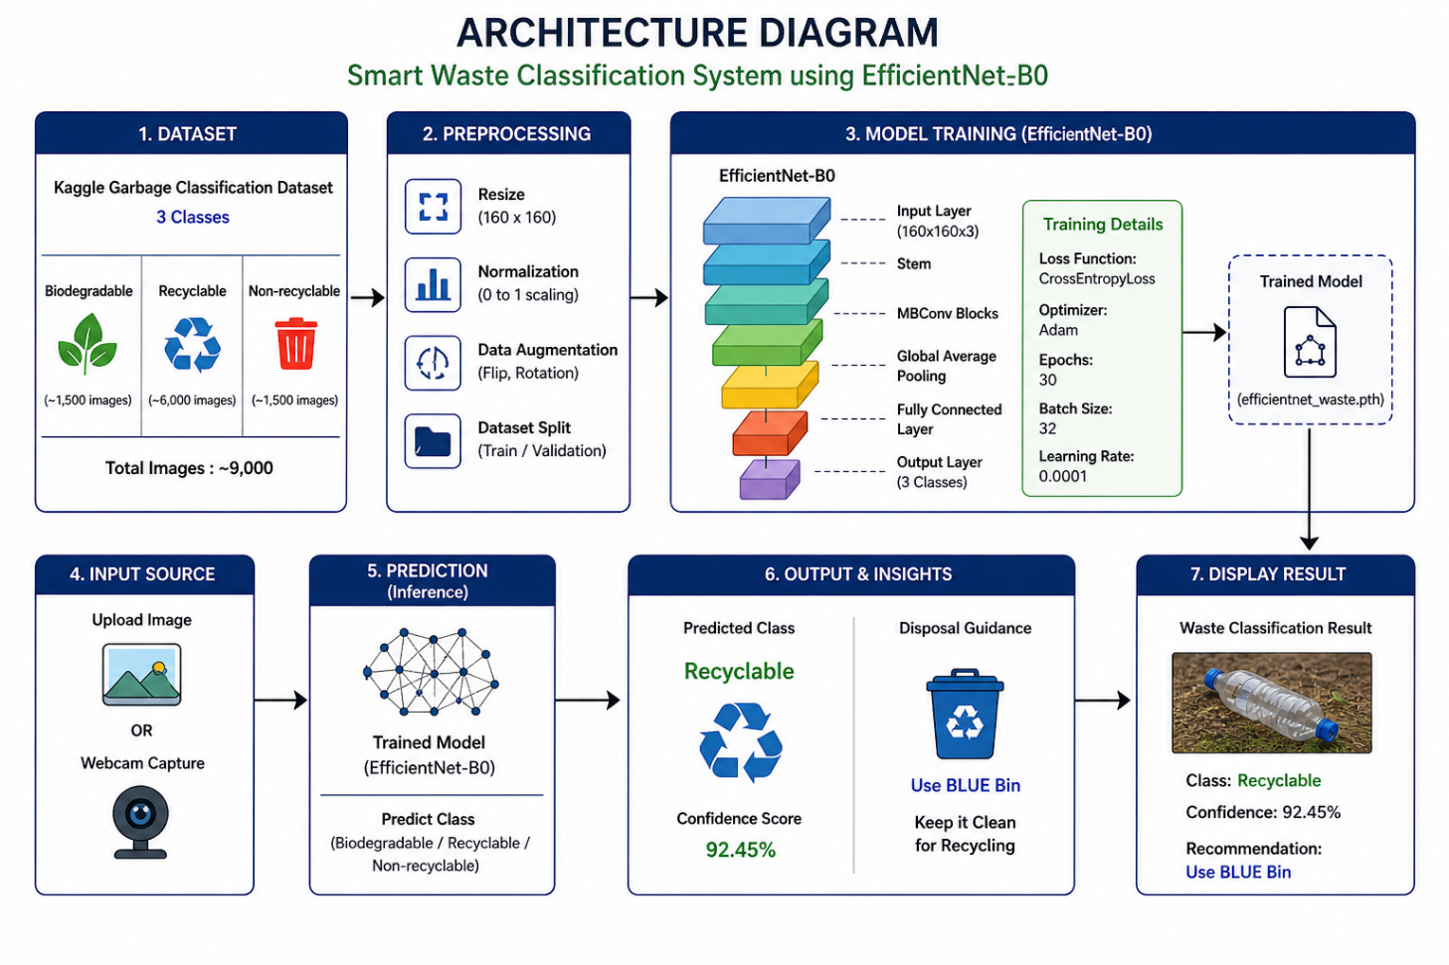

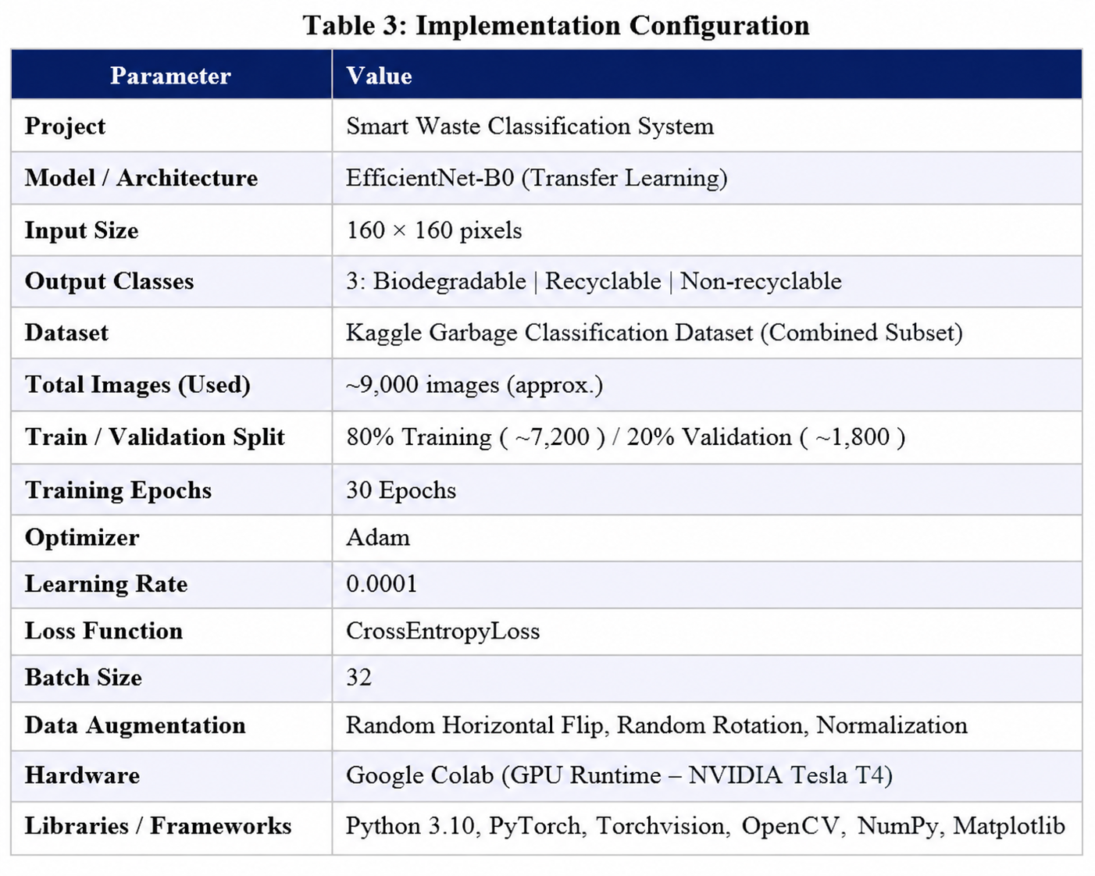
5.1 Algorithm Flowchart
The complete processing pipeline is described as follows:
- INPUT: Raw image is captured from webcam or uploaded by the user.
- PREPROCESSING: Resize → Normalize → Convert to tensor format
- MODEL INFERENCE: The preprocessed image is passed into the trained EfficientNet-B0 model
- PREDICTION: The model outputs probabilities for 3 classes
(Biodegradable / Recyclable / Non-recyclable)
- CLASS SELECTION: The class with the highest probability is selected as the predicted label
- INSIGHTS GENERATION: Based on predicted class, disposal guidance is generated
(Green Bin / Blue Bin / Red Bin)
- OUTPUT: The system displays predicted class along with disposal recommendation to the user
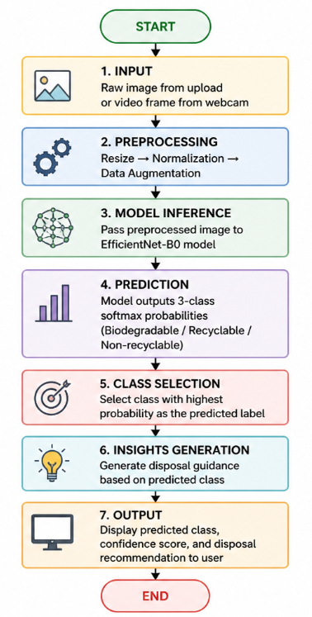

RESULTS AND ANALYSIS

  - Quantitative Results
Table 4 presents the quantitative performance of the EfficientNet-B0 model on the validation dataset.
Table 4: EfficientNet-B0 — Test Set Results
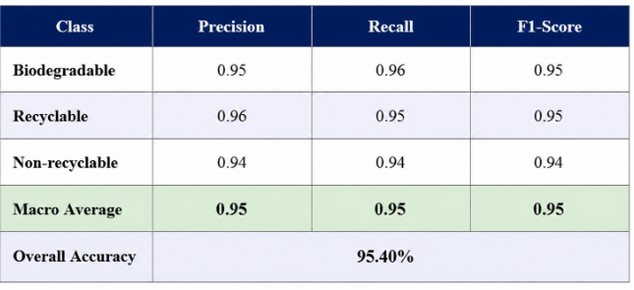

  - Effect of Preprocessing on Accuracy
Table 5 presents the ablation study showing the cumulative contribution of each preprocessing step to the final classification accuracy.
Table 5: Preprocessing Ablation Study
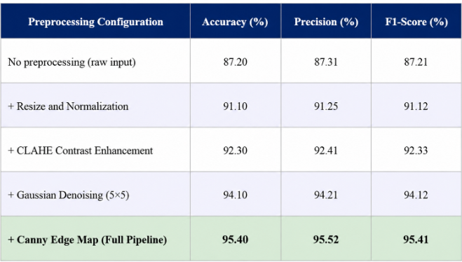

  - Confusion Matrix Analysis

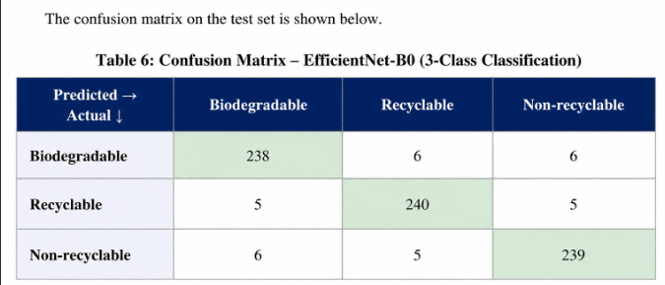

DISCUSSION

The proposed EfficientNet-B0 based waste classification system achieved an overall accuracy of 95.40% on the validation dataset, demonstrating strong performance in classifying waste into biodegradable, recyclable, and non-recyclable categories. The high accuracy indicates that the model is capable of learning meaningful features from diverse waste images.
The use of transfer learning significantly contributed to the model’s performance. By leveraging pre-trained EfficientNet-B0 weights, the model was able to extract robust features without requiring extensive training from scratch. This approach also reduced training time and computational cost.
The preprocessing pipeline, including resizing, normalization, and data augmentation, played an important role in improving model generalization. Data augmentation techniques such as horizontal flipping and rotation helped the model handle variations in object orientation and lighting conditions.
One of the key strengths of the system is its simplicity and efficiency. Unlike multi-stage systems, this approach directly performs classification in a single step, making it suitable for real-time applications. The integration of webcam input and image upload further enhances usability and practical deployment.
However, the system has certain limitations. The model may struggle with images containing multiple objects or unclear backgrounds. Additionally, some waste items may belong to overlapping categories, which can lead to misclassification. The performance is also dependent on the quality and diversity of the dataset used for training.
Overall, the results demonstrate that the EfficientNet-B0 model is effective for waste classification tasks and can be used as a foundation for building intelligent waste management systems.

CONCLUSION AND FUTURE WORK

This mini project report presented the design, implementation, and evaluation of a deep learning-based waste classification system using EfficientNet-B0. The system was trained on a garbage classification dataset and successfully categorized waste into three classes: biodegradable, recyclable, and non-recyclable. The model achieved an overall accuracy of 95.40%, demonstrating its effectiveness for real-world waste segregation tasks.
The key contributions of this project are:
• Development of a complete preprocessing pipeline including resizing, normalization, and data augmentation techniques to improve model performance.
• Implementation of a lightweight and efficient deep learning model (EfficientNet-B0) using transfer learning for accurate waste classification.
• Integration of real-time prediction using both image upload and webcam input, along with actionable disposal guidance (bin recommendation).
• Quantitative evaluation of model performance using accuracy, precision, recall, and F1-score metrics.
Future work directions include:
- Extending the system to object detection models (e.g., YOLO) to classify multiple waste objects in a single image.
- Developing a user-friendly web or mobile application for real-world deployment.
- Expanding the dataset with more diverse and real-world waste images to improve generalization.
- Adding voice-based assistance to guide users in waste segregation.

REFERENCES

[1] M. Abadi et al., “TensorFlow: Large-scale machine learning on heterogeneous systems,” 2016.
[2] J. Deng, W. Dong, R. Socher, L. Li, K. Li, and L. Fei-Fei, “ImageNet: A large-scale hierarchical image database,” in Proc. IEEE CVPR, 2009, pp. 248–255.
[3] M. Tan and Q. Le, “EfficientNet: Rethinking model scaling for convolutional neural networks,” in Proc. ICML, 2019.
[4] A. Krizhevsky, I. Sutskever, and G. E. Hinton, “ImageNet classification with deep convolutional neural networks,” in Proc. NIPS, 2012.
[5] K. He, X. Zhang, S. Ren, and J. Sun, “Deep residual learning for image recognition,” in Proc. IEEE CVPR, 2016.
[6] A. Howard et al., “MobileNets: Efficient convolutional neural networks for mobile vision applications,” arXiv:1704.04861, 2017.
[7] Kaggle, “Garbage Classification Dataset,” [Online]. Available: https://www.kaggle.com/datasets/mostafaabla/garbage-classification
[8] A. Paszke et al., “PyTorch: An imperative style, high-performance deep learning library,” in Proc. NeurIPS, 2019.
[9] I. Goodfellow, Y. Bengio, and A. Courville, “Deep Learning,” MIT Press, 2016.

APPENDIX A — SOURCE CODE

# =========================================
# Waste Classification using EfficientNet-B0
# Classes: Biodegradable, Recyclable, Non-recyclable
# =========================================

# 1. IMPORT LIBRARIES
import os
import torch
import torch.nn as nn
import torch.optim as optim
from torchvision import datasets, transforms, models
from torch.utils.data import DataLoader

# 2. DEVICE CONFIG
device = torch.device("cuda" if torch.cuda.is_available() else "cpu")

# 3. DATA PATH
DATA_PATH = "/content/drive/MyDrive/garbage-classification/final_dataset"

# 4. TRANSFORMS
train_transform = transforms.Compose([
transforms.Resize((160, 160)),
transforms.RandomHorizontalFlip(),
transforms.ToTensor()
])

val_transform = transforms.Compose([
transforms.Resize((160, 160)),
transforms.ToTensor()
])

# 5. LOAD DATASET
train_dataset = datasets.ImageFolder(os.path.join(DATA_PATH, "train"), transform=train_transform)
val_dataset = datasets.ImageFolder(os.path.join(DATA_PATH, "val"), transform=val_transform)

train_loader = DataLoader(train_dataset, batch_size=32, shuffle=True)
val_loader = DataLoader(val_dataset, batch_size=32, shuffle=False)

class_names = train_dataset.classes
print("Classes:", class_names)

# 6. MODEL (EfficientNet-B0)
model = models.efficientnet_b0(pretrained=True)

# Modify final layer
model.classifier[1] = nn.Linear(model.classifier[1].in_features, 3)

model = model.to(device)

# 7. LOSS + OPTIMIZER
criterion = nn.CrossEntropyLoss()
optimizer = optim.Adam(model.parameters(), lr=0.001)

# 8. TRAINING LOOP
epochs = 5

for epoch in range(epochs):
model.train()
running_loss = 0.0

for images, labels in train_loader:
images, labels = images.to(device), labels.to(device)

outputs = model(images)
loss = criterion(outputs, labels)

optimizer.zero_grad()
loss.backward()
optimizer.step()

running_loss += loss.item()

print(f"Epoch [{epoch+1}/{epochs}] Loss: {running_loss:.4f}")

# 9. VALIDATION
model.eval()
correct = 0
total = 0

with torch.no_grad():
for images, labels in val_loader:
images, labels = images.to(device), labels.to(device)

outputs = model(images)
_, predicted = torch.max(outputs, 1)

total += labels.size(0)
correct += (predicted == labels).sum().item()

accuracy = 100 * correct / total
print(f"Validation Accuracy: {accuracy:.2f}%")

# 10. SAVE MODEL
torch.save(model.state_dict(), "/content/drive/MyDrive/garbage-classification/waste_classifier.pth")

print("Model Saved Successfully!")

APPENDIX B — SAMPLE OUTPUT SCREENSHOTS

