

ASE_Lab6 Report

Nodejs and Express. js application

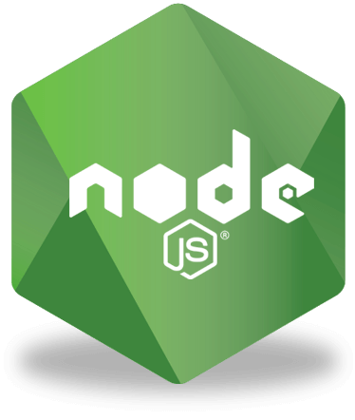



March 02, 2019

Authorized by:

Dharani Muli (Class ID : 18),

Chakra Pavan Kumar (Class ID: 13)



Introduction

Objectives

1. Understand the source code app.js, note.js
2. Apply what you have learnt by creating a new CRUD API for Customers data with some fields like customer_id, customer_name, customer_email etc. Create methods for adding a new customer, listing all the customers, updating a customer and deleting a customer.
3. No UI is needed, create functions only using the given source code
4. & express framework

Design/Implementation

We have followed below steps to successfully complete this lab assignment:

**Step -1:** We make sure all the pre-requisites are ready before start of the project and below are the technologies/languages used:

1. Java (recommended version JDK8)
2. Gradle
3. Android Studio
4. Android SDK
5. Create Android Virtual Device and Setup

(We referred this link for installing and configuring above software’s: https://ionicframework.com/docs/installation/android#java)

1. WebStorm IDE
2. Node
3. Npm
4. Ionic : npm install -g ionic
5. Cordova: npm install -g cordova
6. Angular
7. TypeScript
8. Bootstrap

Issues/Limitations:

None

Conclusion:

We got hands-on