

ASE_Lab8 Report

JWT Authentication



March 23, 2019

Documented by:

Dharani Muli (Class ID : 18),

Chakra Pavan Kumar (Class ID: 13)

Introduction

Objectives

User Authentication using JWT token

Design/Implementation

We have followed below steps to successfully complete this lab assignment:

**Step -1:** We make sure all the pre-requisites are ready before start of the project and below are the technologies/languages used:

1. WebStorm IDE
2. Node
3. Npm
4. Expressjs :
   1. **Installation**: npm install express
   2. **Importing**: const app= express();
5. Angular
6. JWT:
   1. **Installation**: npm install jsonwebtoken
   2. **Importing**: const jwt= require(‘jsonwebtoken’);
7. Cors: below are commands used
   1. **Installation**: npm install cors
   2. **Importing**: const cors = require(‘cors’);
   3. **Enabling cors**: app.use(cors());
8. Also need to setup nodejs for porting

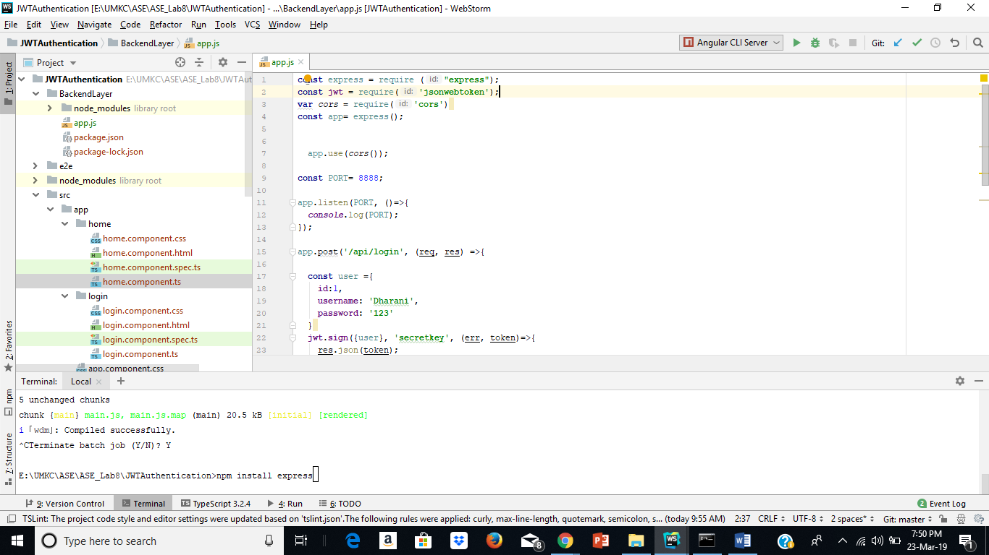

**Step-2:** As we are using Angular, we should create project using command “ ng new JWTAuthentication” and Using this command I have created components :

ng g c login and mg g c home

**Step-3:** We have done the required configurations for components in the app.routing.module.ts file

**Step-4:** We have written below html code for home and login page as below

Login.html

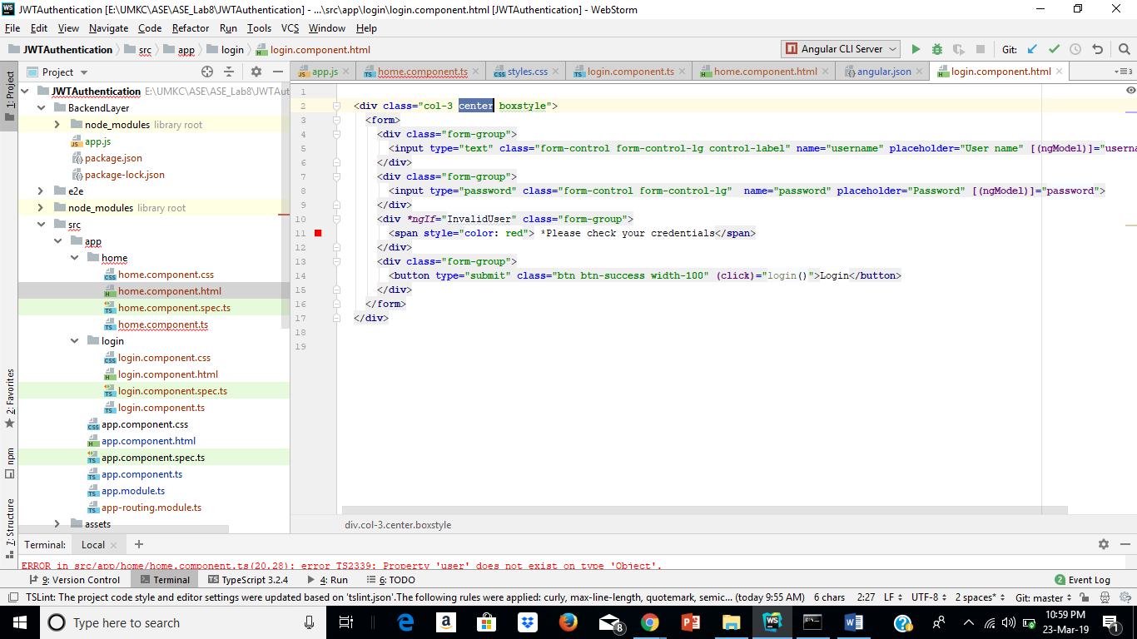

Home.html

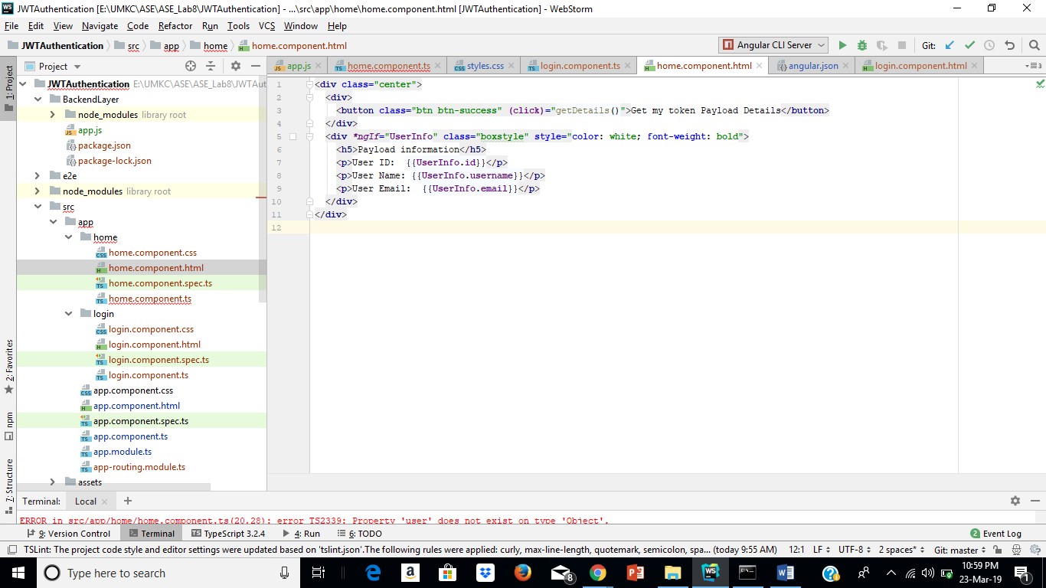

**Step-5:** Our login.components.ts is sending a request to nodejs server using url:

[**http://localhost:8888/api/login**](http://localhost:8888/api/login) forauthentication and then it store received response into local storage and navigate to home page along with response data received.

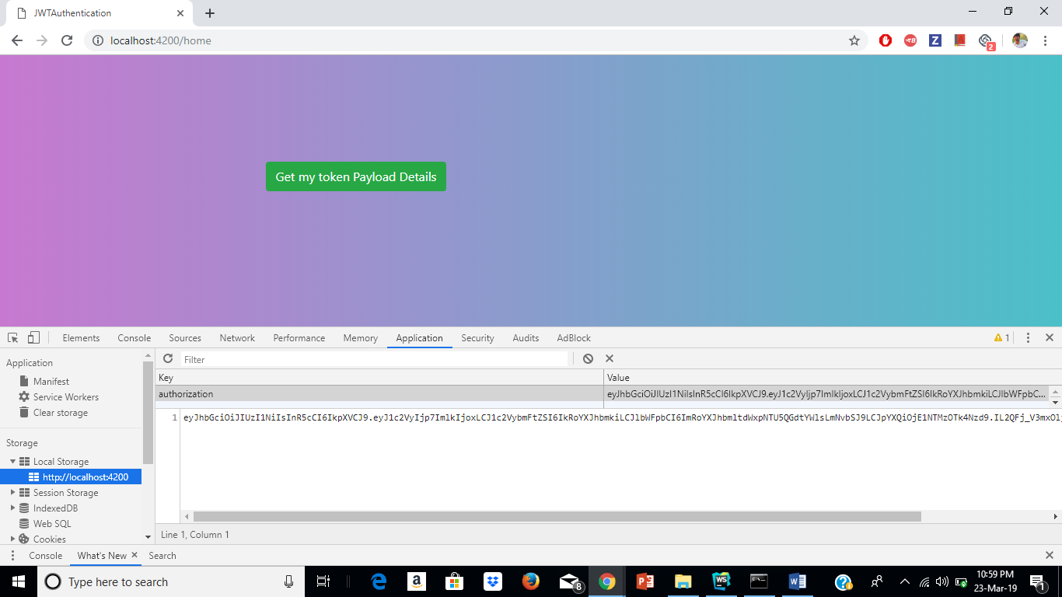

**Step-6:** We have our backend layer which handles authentication and creation of JWT token. By receiving request from “login” it creates token and send as the same with the response header and when it receives request from “getDetails” it verify the token received and authenticate and sends the payload as one of the response.

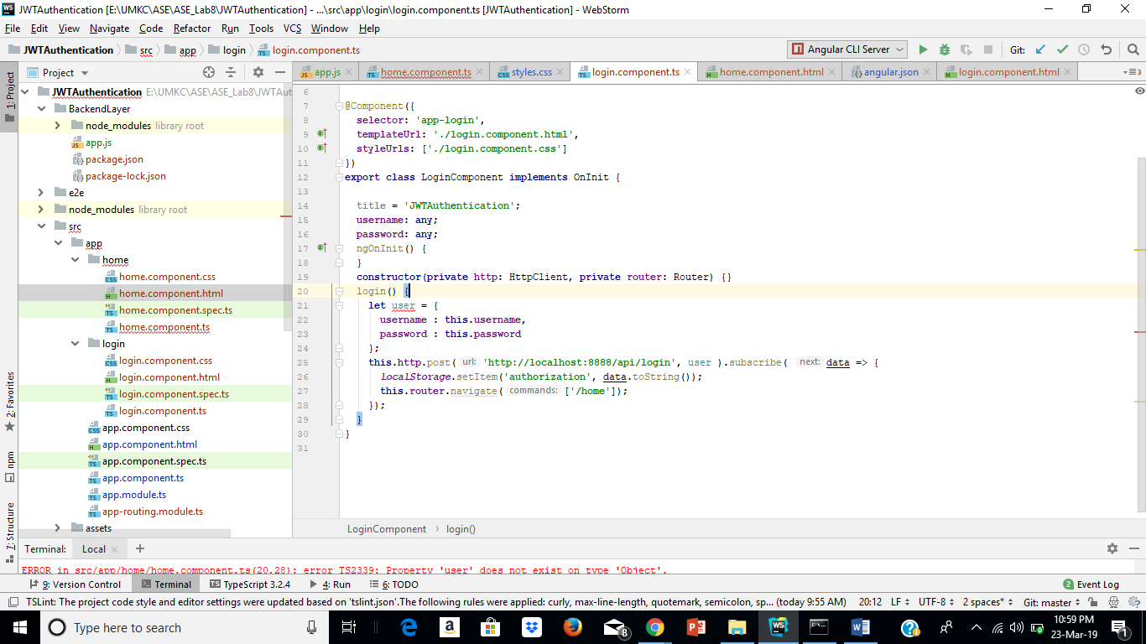

**Step-7:** We are using local storage to get data from login component and sending a request along with “token” for verification using HttpHeaders and receiving payload as a response.

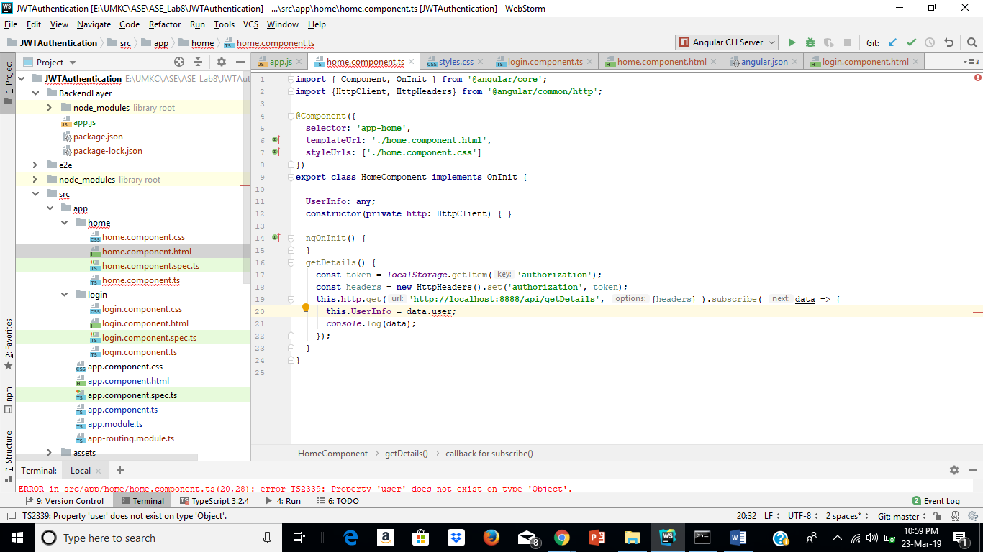

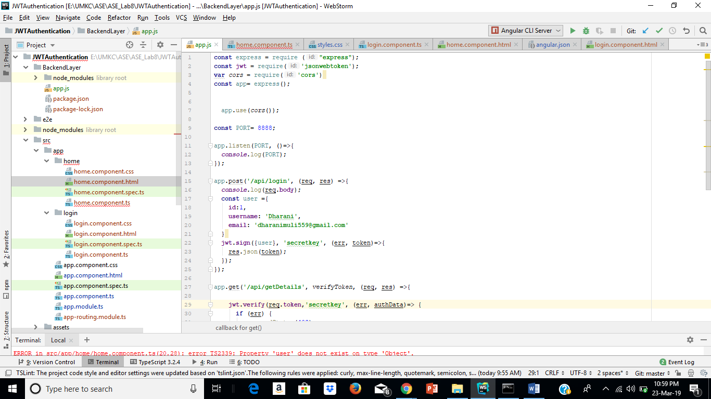

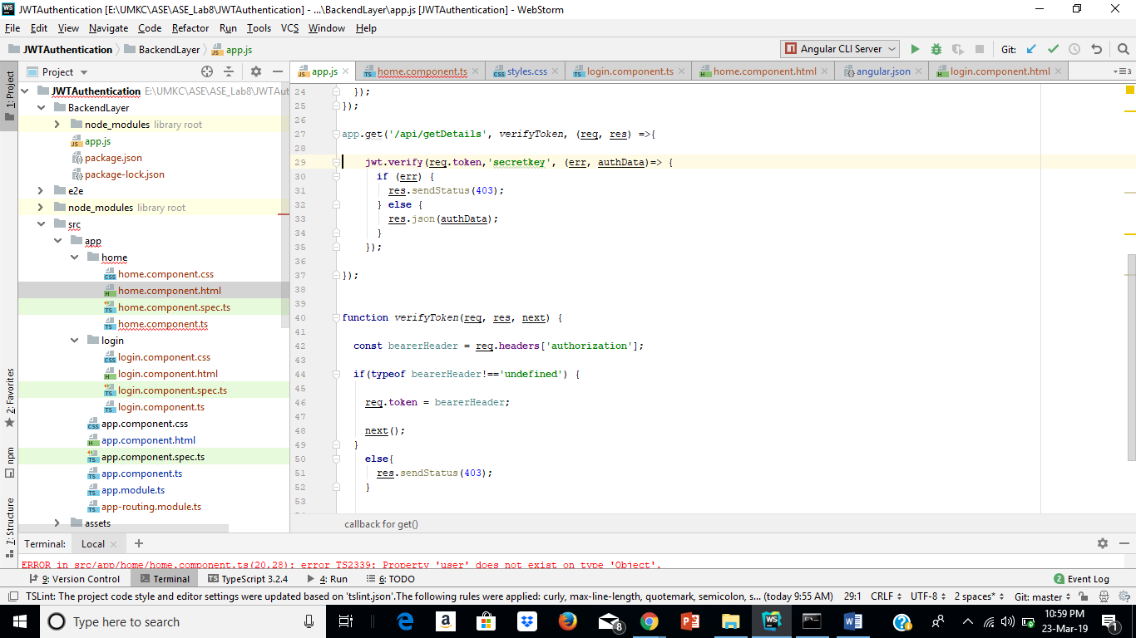

**Sample output**

1. 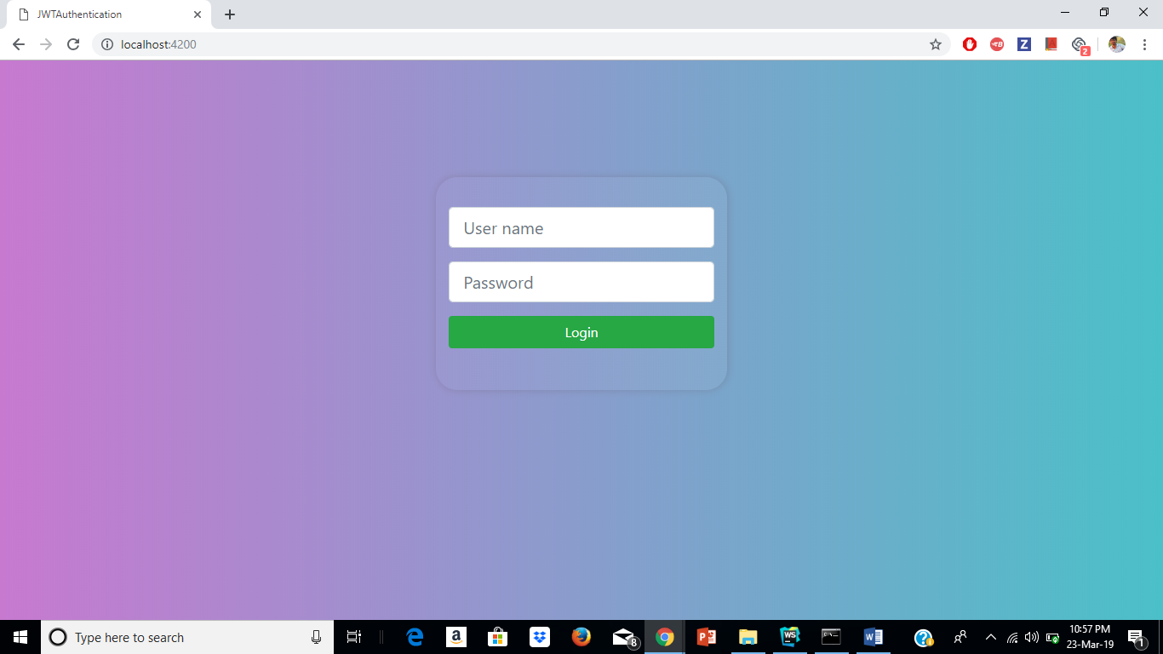Login page

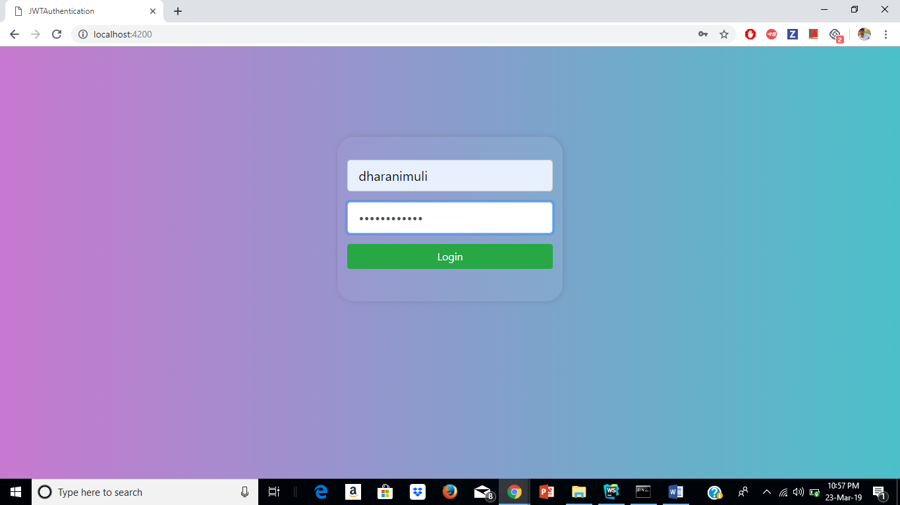

1. 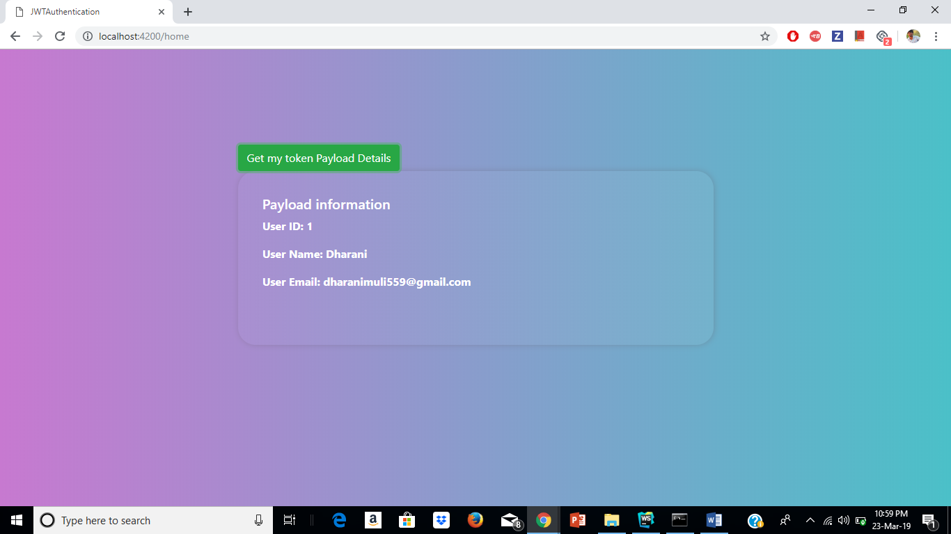Home Page

Issues/Limitations:

None

Team Contribution

Dharani:

1. Implemented Login and JWToken generation.
2. Contributed in the creation of Wiki page, report and lab submission.

Chakra Pavan Kumar Kota:

1. Implemented Home page and JWT verification part.
2. Contributed creation of Wiki page, report and lab submission.

Conclusion:

 As part of this exercise we gained new technique that is token based Authentication using JWT which we can also use this in our upcoming projects.