

ASE_Lab10 Report





April 12, 2019

Documented by:

Dharani Muli (Class ID : 18),

Chakra Pavan Kumar (Class ID: 13)

Introduction

Objectives

Deploy Lab Assignment-9 to Heroku.

Design/Implementation

We have followed below steps to successfully complete this lab assignment:

**Step -1:** We make sure all the pre-requisites are ready before start of the project and below are the technologies/languages used:

1. WebStorm IDE
2. Node
3. Npm
4. Expressjs
5. Install Heroku Cli

**Step-2:** Created an Heroku Account and created a new app in the Heroku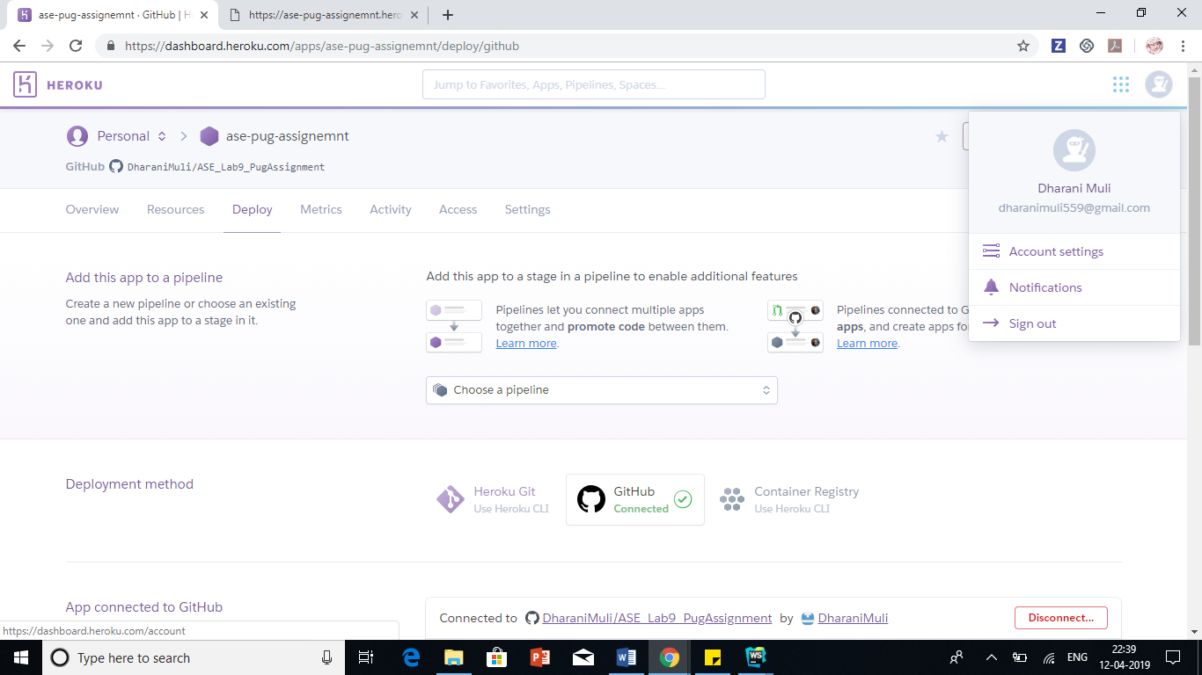

**Step-3:** Logged into Heroku using command “heroku login” where in it navigated me to browser to login.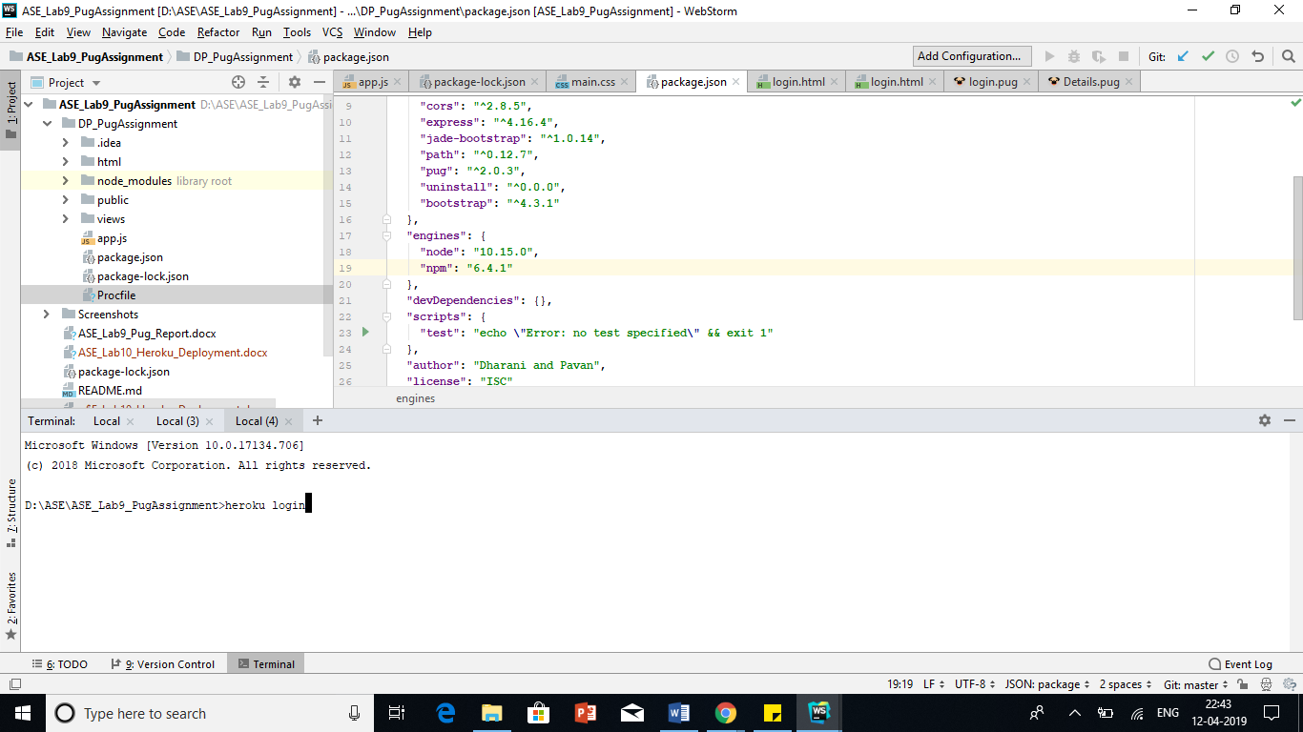

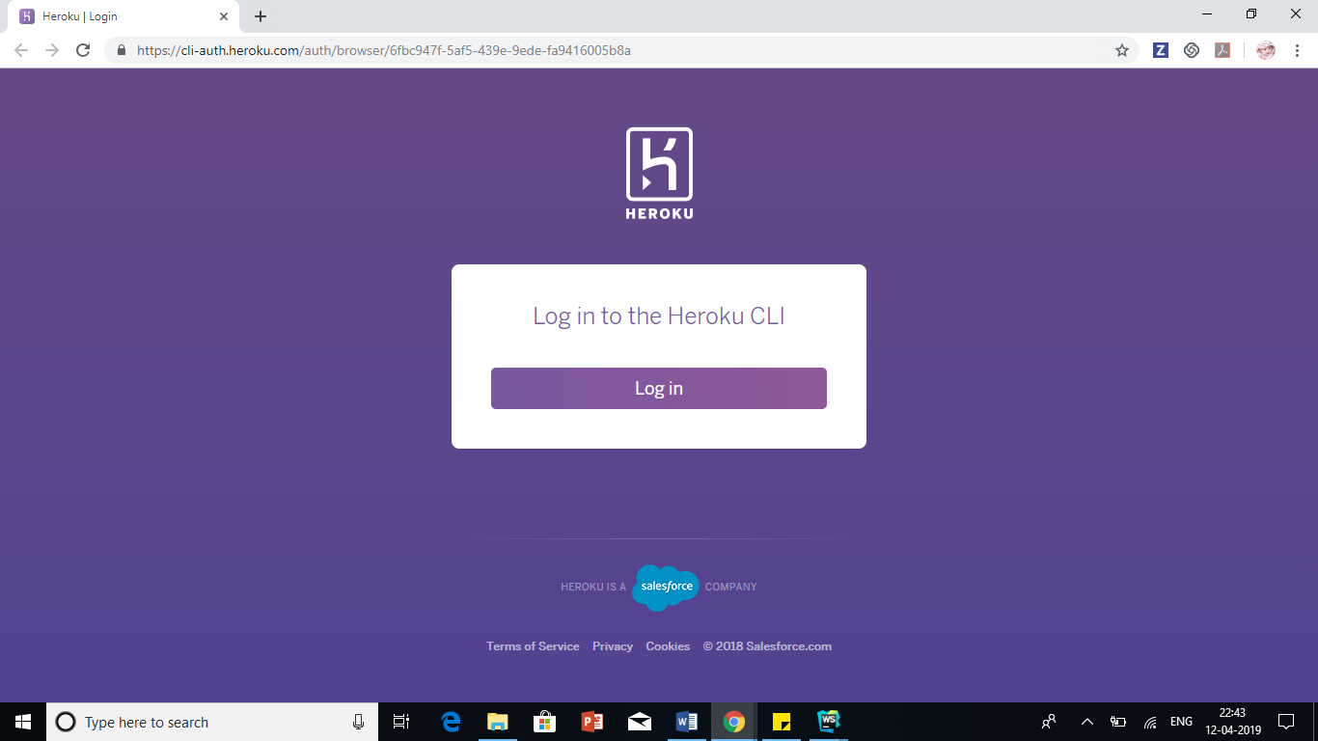

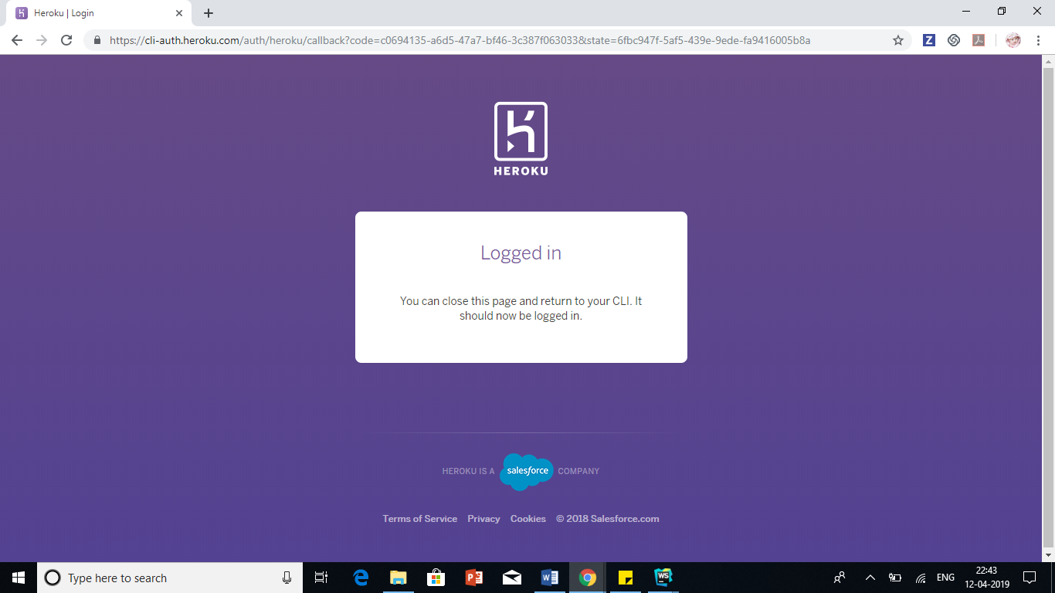

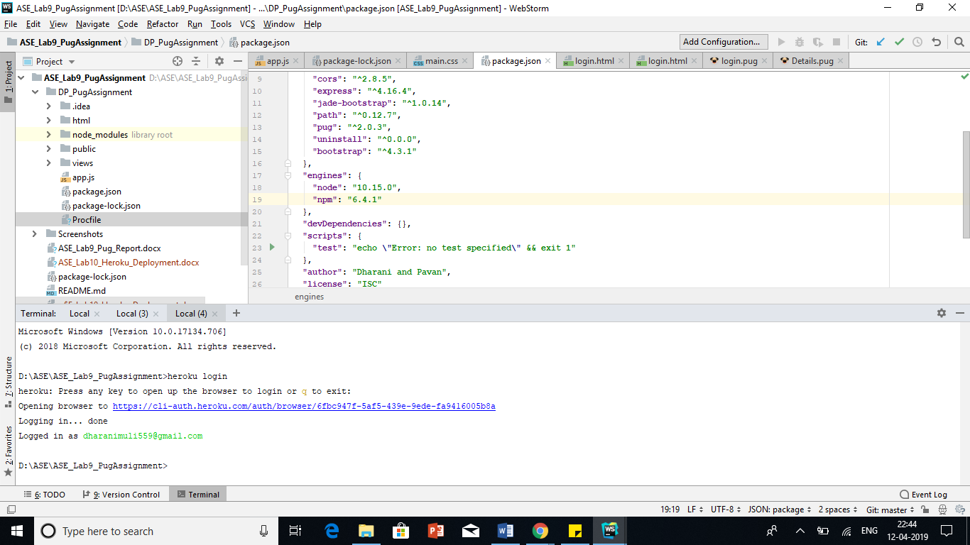

**Step-4:** I make sure that node and npm versions in package.json is correct and also created “Procfile”.

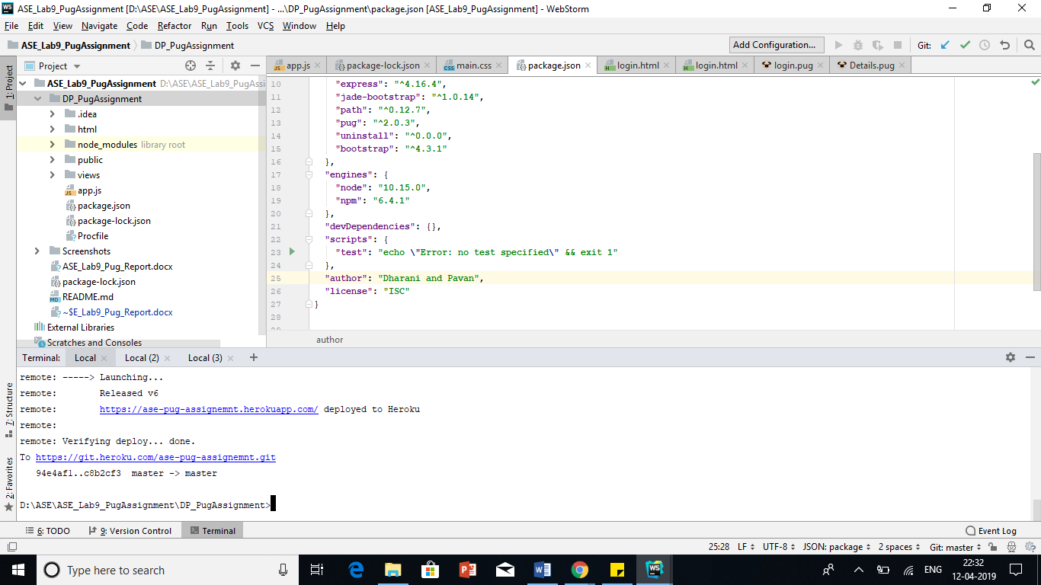

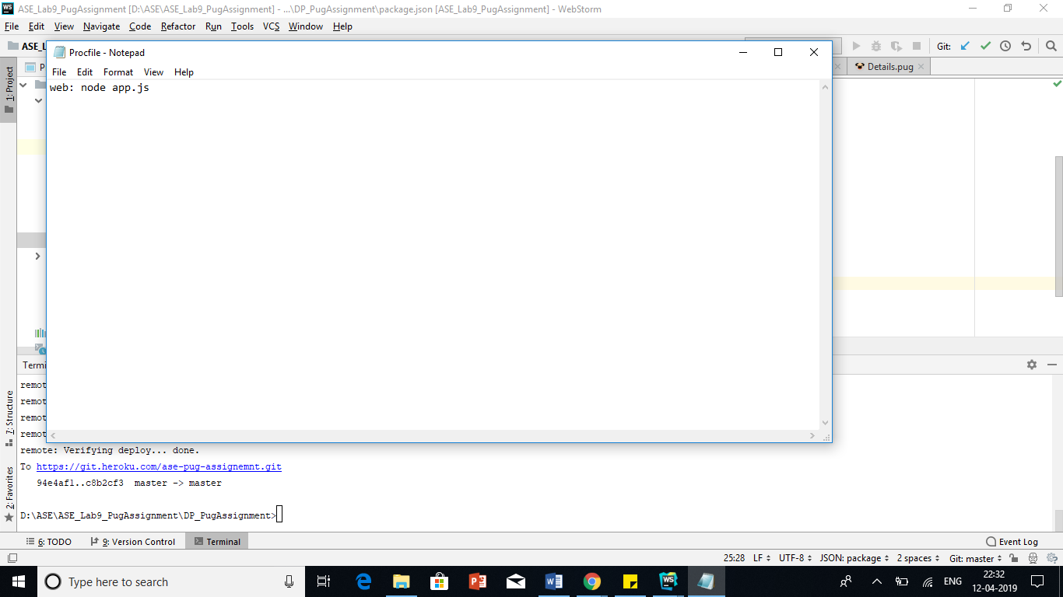

**Step-5:** As server has to listen to port number that Heroku gives so I added “**process.env.PORT** || 3000” to my app.js file “ so that now server will listen to Heroku port number if not it listen to my local host number.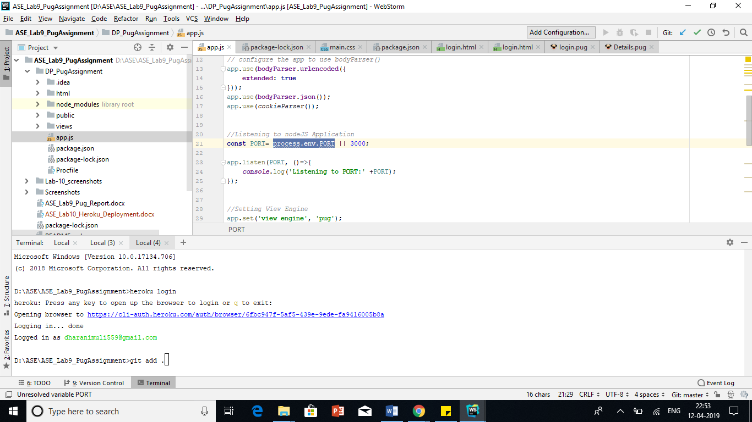

**Step-6:** Once I made these changes I committed my code to git and pushed into Heroku using below commands

>git add .

>git commit -am "Initial Deployment"

>git push heroku master

**Sample output**

1. 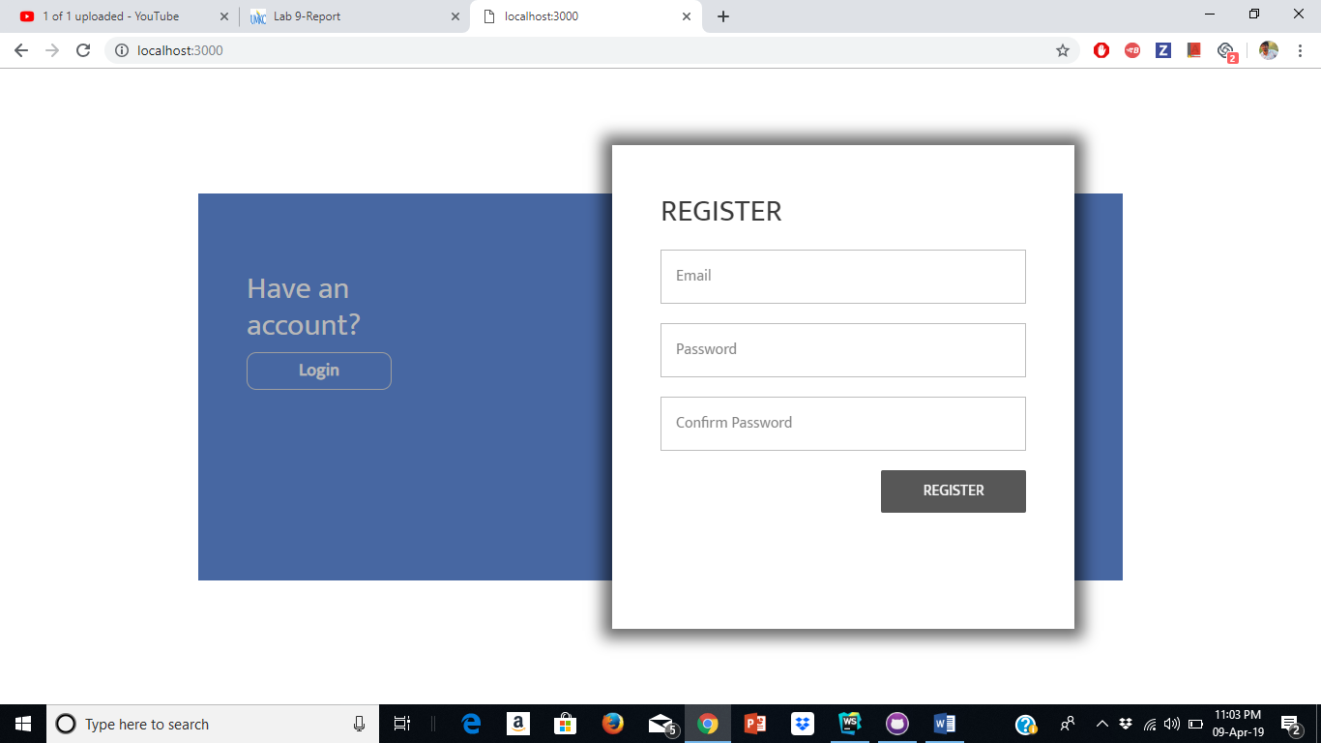Register page
2. Login page

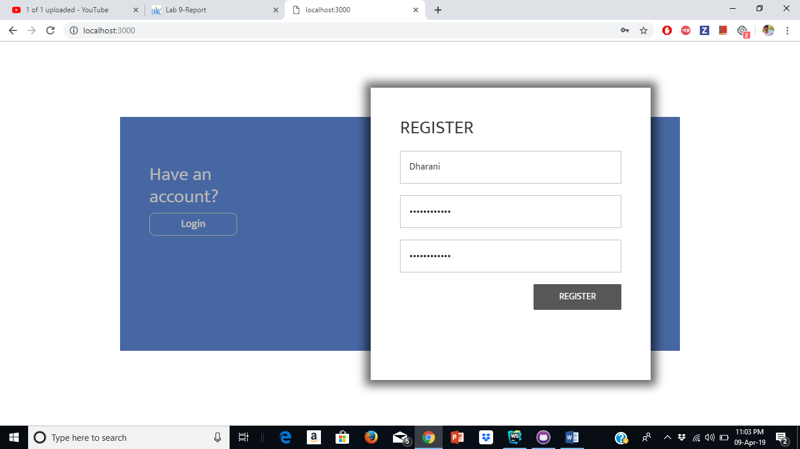

1. Details page

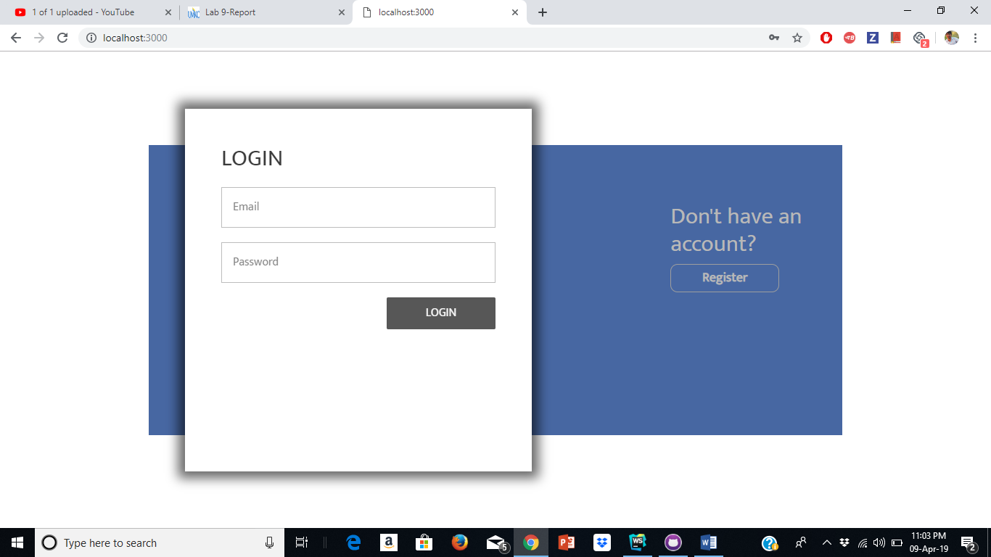

1. Cookies storage and rendering

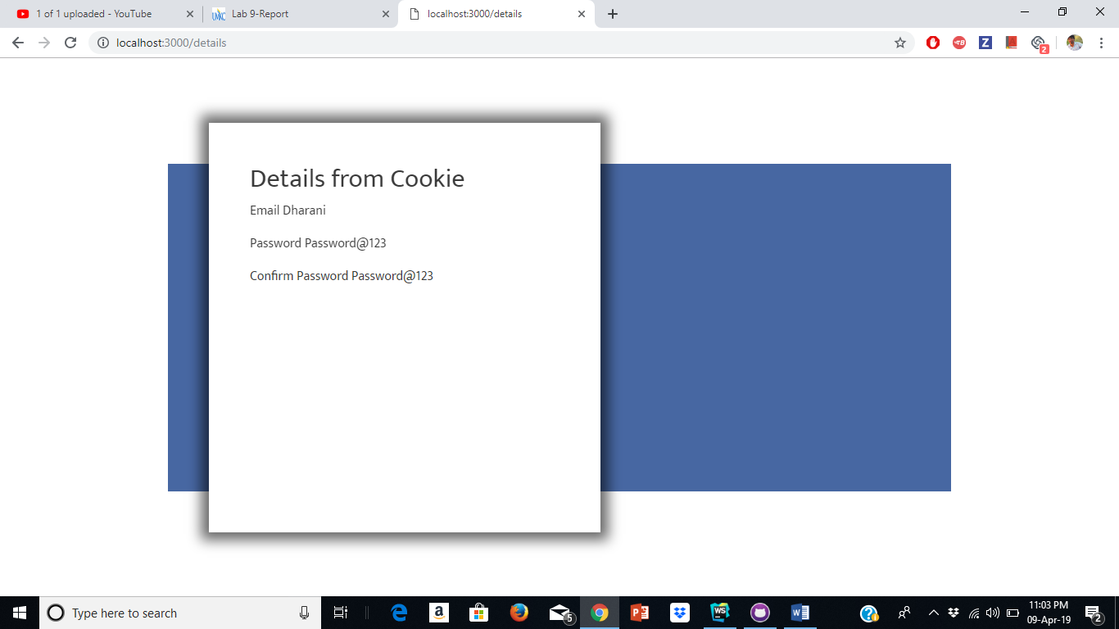

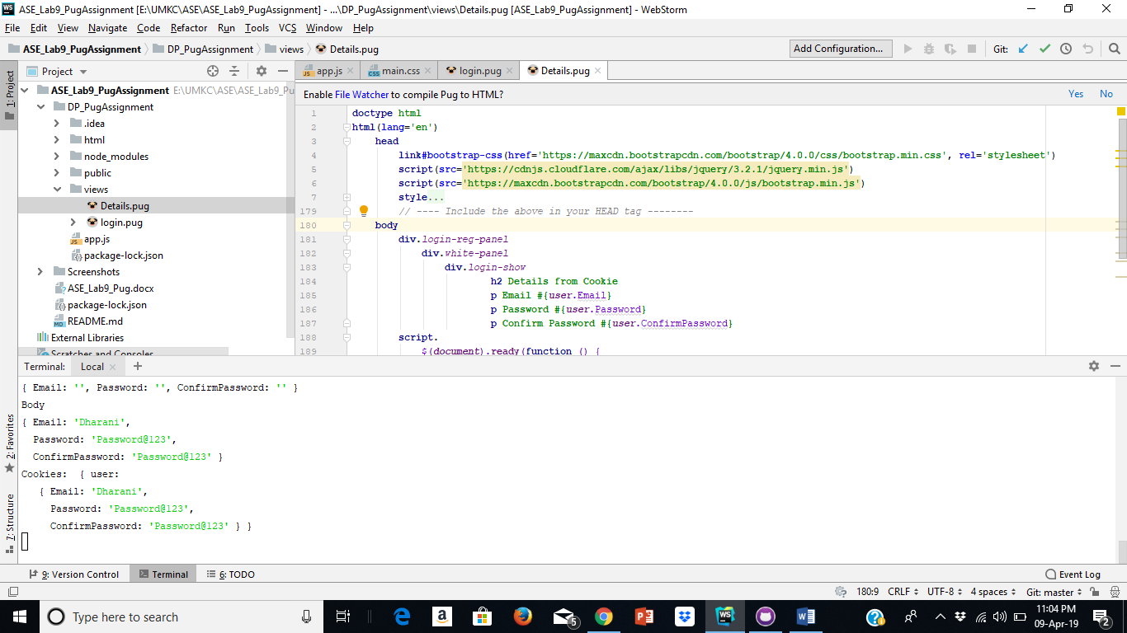

Issues/Limitations:

None

Team Contribution

Dharani:

1. Created Login and Registration pages using pug.
2. Contributed in the creation of Wiki page, report and lab submission.

Chakra Pavan Kumar Kota:

1. Implemented Details and cookies retrieval part of the assignment.
2. Contributed creation of Wiki page, report and lab submission.

Conclusion:

 As part of this exercise we were able to understand the template rendering engine in nodejs. Rendering engine compiles the html in server and sends the plain html to the front end. Pug is one such engine.