

ASE_Lab9 Report



PUG



April 04, 2019

Documented by:

Dharani Muli (Class ID : 18),

Chakra Pavan Kumar (Class ID: 13)

Introduction

Objectives

User Authentication using JWT token

Design/Implementation

We have followed below steps to successfully complete this lab assignment:

**Step -1:** We make sure all the pre-requisites are ready before start of the project and below are the technologies/languages used:

1. WebStorm IDE
2. Node
3. Npm
4. Expressjs :
   1. **Installation**: npm install express
   2. **Importing**: const app= express();
5. Pug :
   1. **Installation**: npm install pug –save
6. Pug-cli: npm install pug-cli -g

This package is used to render files in a particular directly. -g specifies global installation of package.

**Step-2:** Created sample pug file under view directory using “.pug” as a extension

Image 1

**Step-3:** Created html folder and using below command I rendered my pug file as html page.

**>pug -w ./ -o ./html -P**

Image 2

**Step-3:** Created app.js and done the set up to run our pug file

Image 3

**Step-3:** Run nodejs file using “node app.js” command and check the output

Image 4 and image 5

**Sample output**

1. 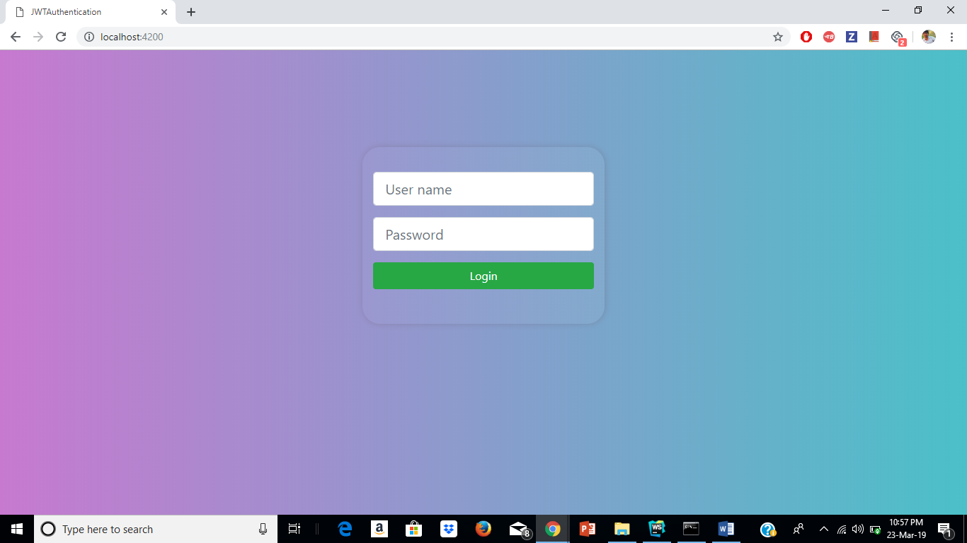Login page

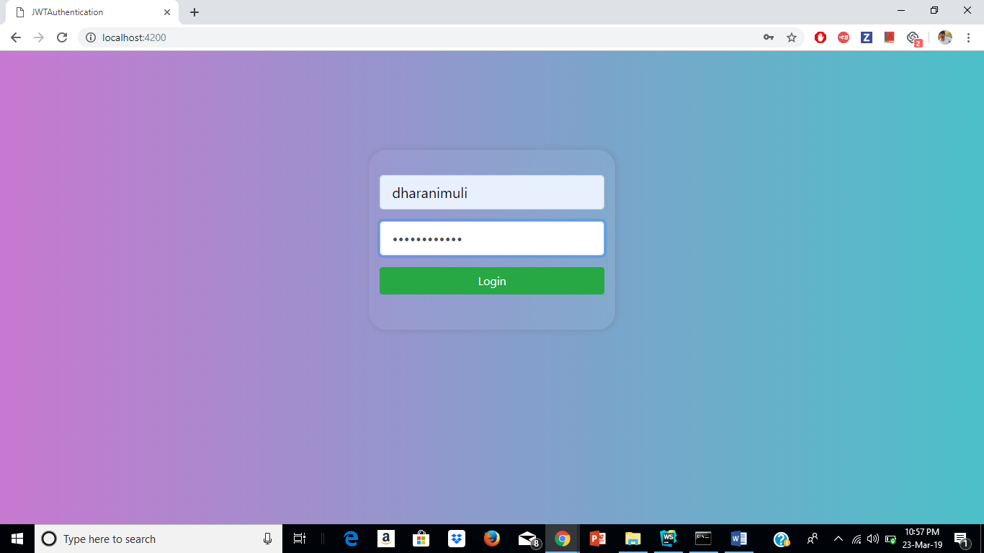

1. 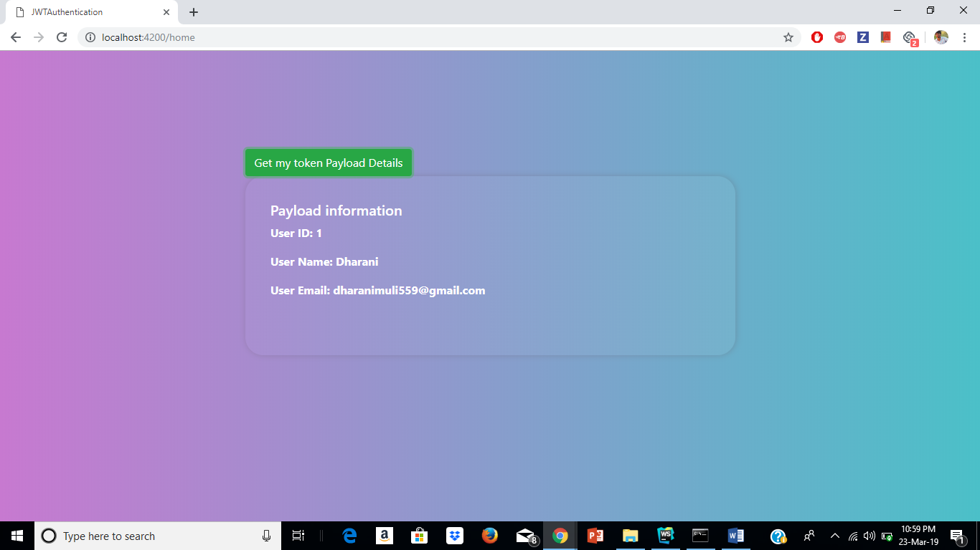Home Page

Issues/Limitations:

None

Team Contribution

Dharani:

1. Implemented Login and JWToken generation.
2. Contributed in the creation of Wiki page, report and lab submission.

Chakra Pavan Kumar Kota:

1. Implemented Home page and JWT verification part.
2. Contributed creation of Wiki page, report and lab submission.

Conclusion:

 As part of this exercise we gained new technique that is token based Authentication using JWT which we can also use this in our upcoming projects.