

ASE_Lab9 Report



PUG



April 09, 2019

Documented by:

Dharani Muli (Class ID : 18),

Chakra Pavan Kumar (Class ID: 13)

Introduction

Objectives

To created login page using pug template engine and implement retrieving of cookies in nodejs. Load the css file using express.static() methos.

Design/Implementation

We have followed below steps to successfully complete this lab assignment:

**Step -1:** We make sure all the pre-requisites are ready before start of the project and below are the technologies/languages used:

1. WebStorm IDE
2. Node
3. Npm
4. Expressjs :
   1. **Installation**: npm install express
   2. **Importing**: const app= express();
5. Pug :
   1. **Installation**: npm install pug –save
6. Pug-cli: npm install pug-cli -g

This package is used to render files in a particular directly. -g specifies global installation of package.

**Step-2:** Created sample pug file under view directory using “.pug” as a extension

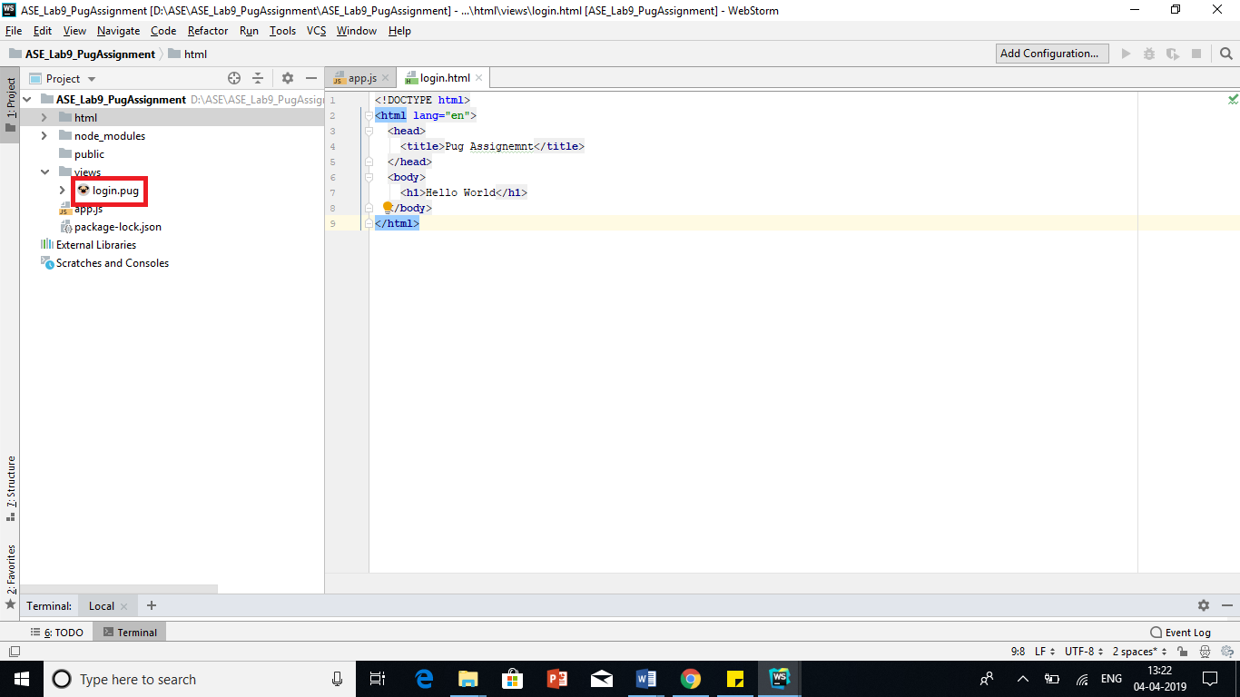

**Step-3:** Created html folder and using below command I rendered my pug file as html page.

**>pug -w ./ -o ./html -P**

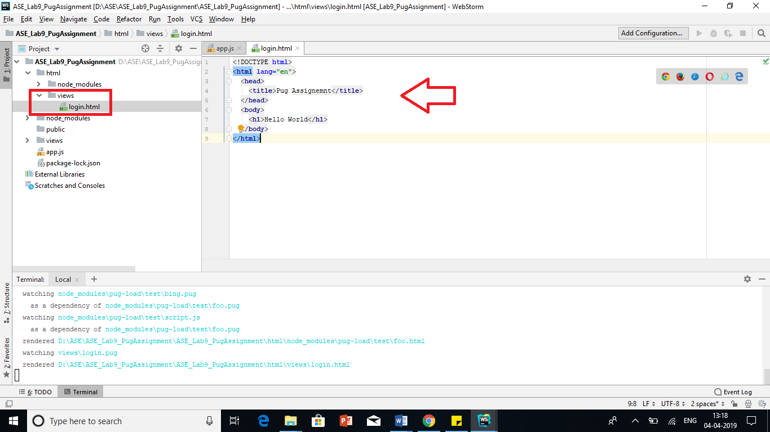

**Step-4:** Created app.js and done the set up to run our pug file

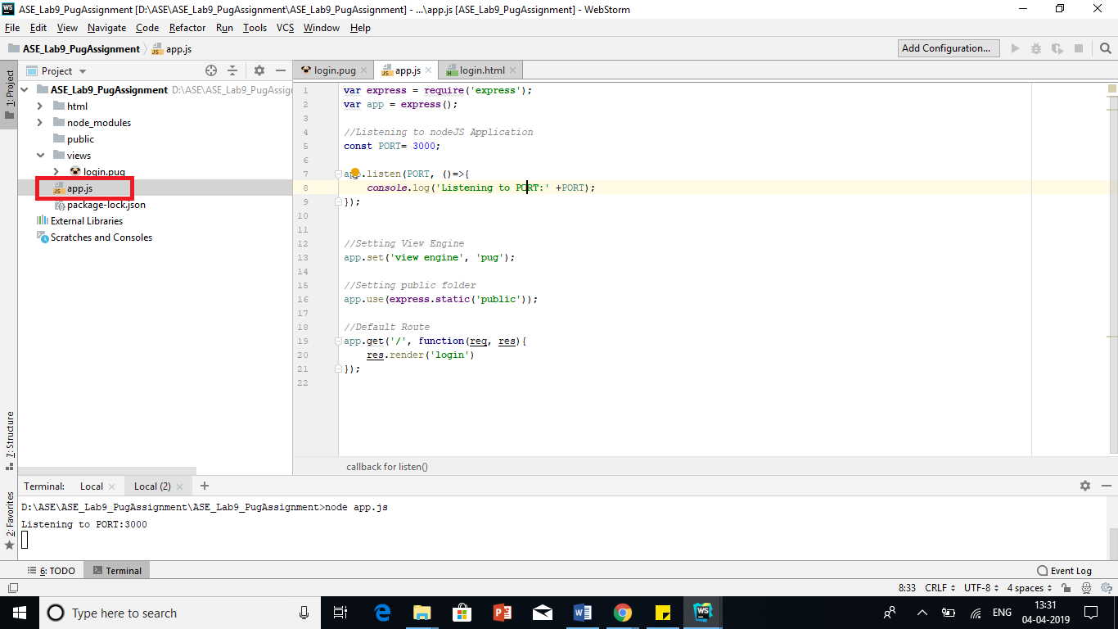

**Step-5:** Run nodejs file using “node app.js” command and check the output

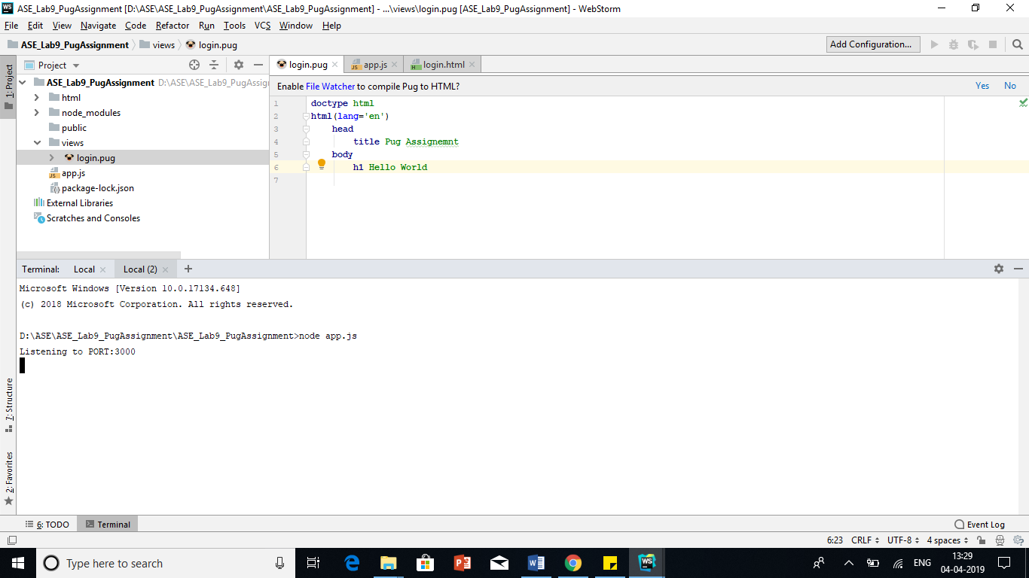

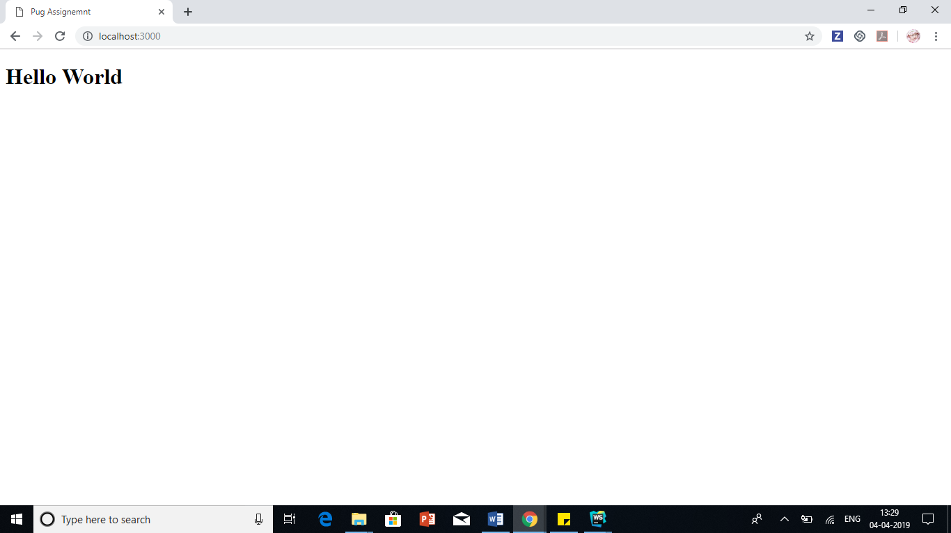

**Step-6:** We have successfully done with “Hello World”. Now comes our real assignment. We have created login and registration pages using pug syntaxes.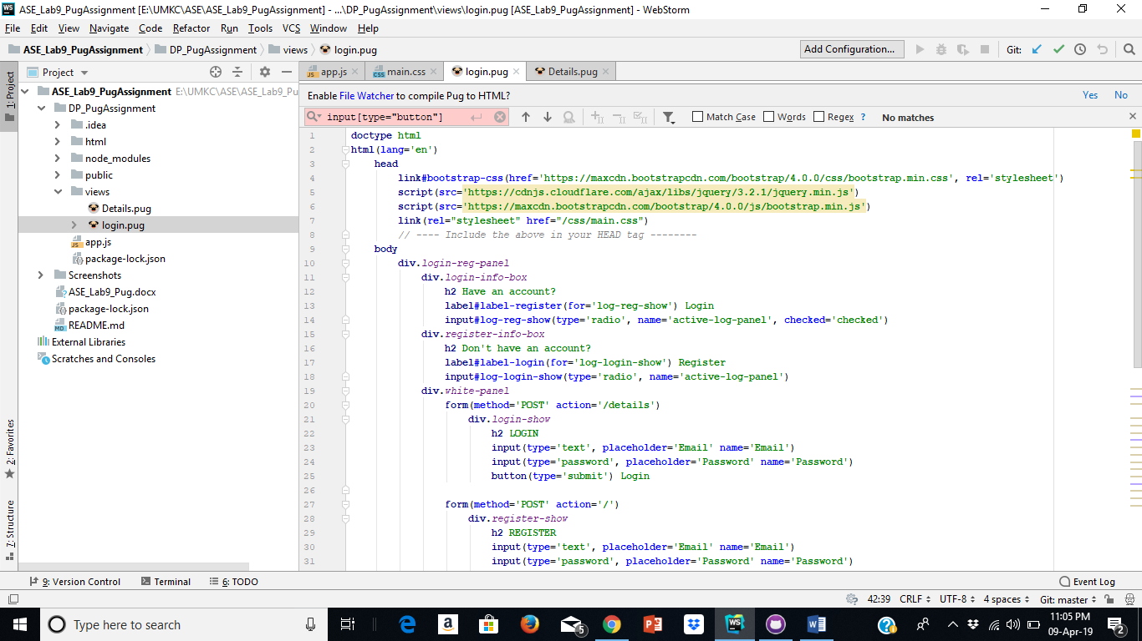

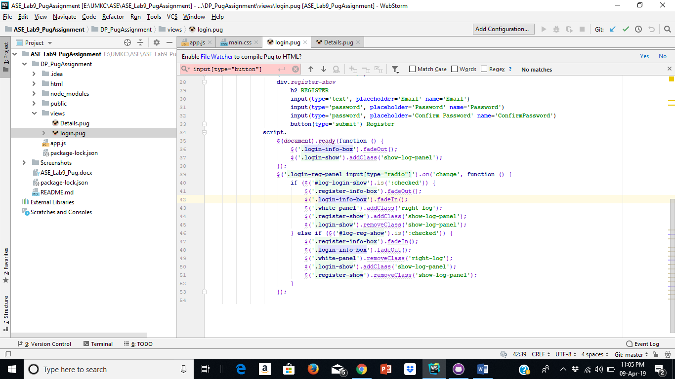

**Step-7:** We have created external css and rendered in html using express.static() method.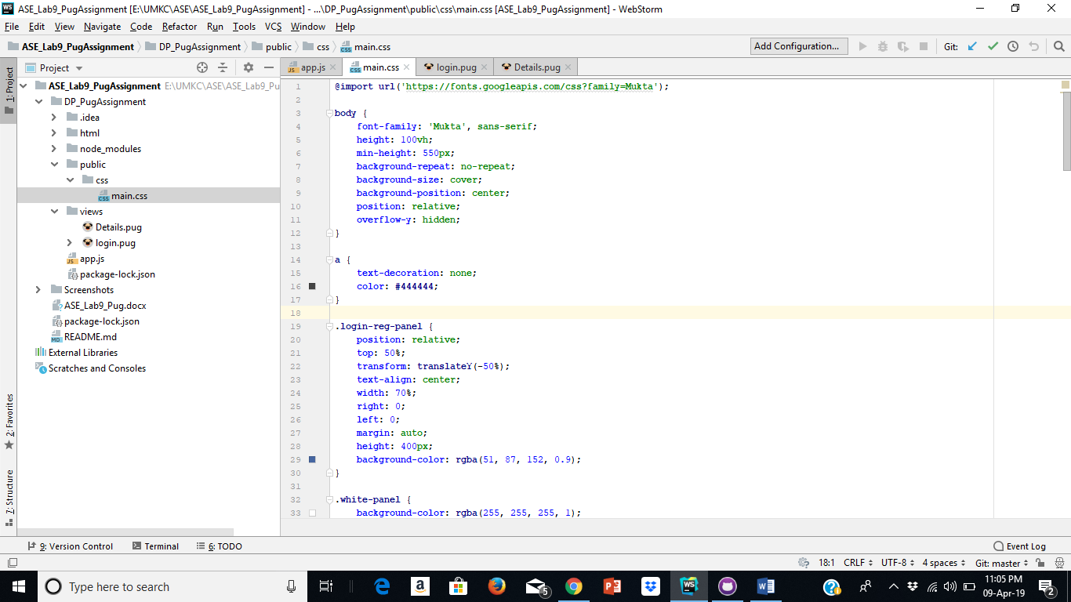

**Step-8:**We have installed cookie parser middleware using below command

“npm install –save cookie-parser”

In the register method cookies are sent with the response using “res.cookie(name,value)”

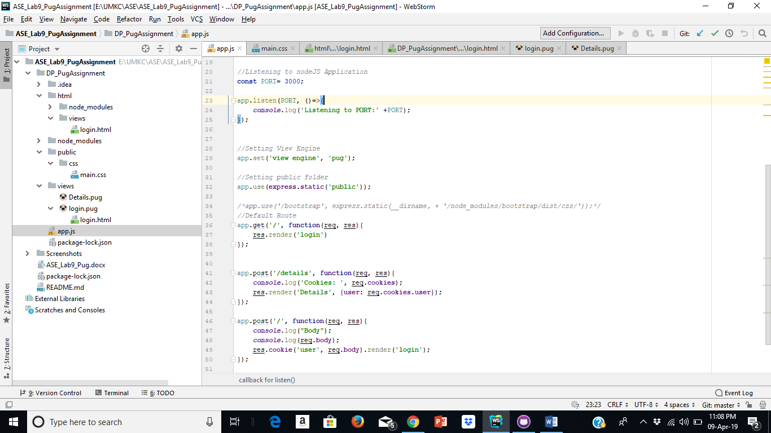

**Step-8:** Which In the details method the cookies are retrieved and sent as input to Details.pug which renders the cookies**.**

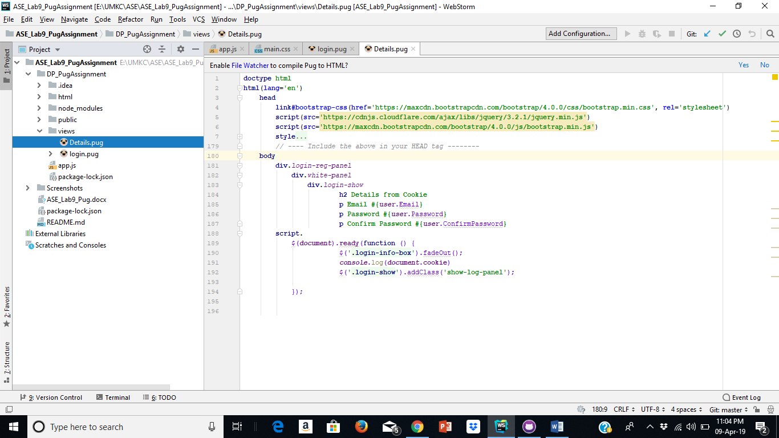

**Sample output**

1. 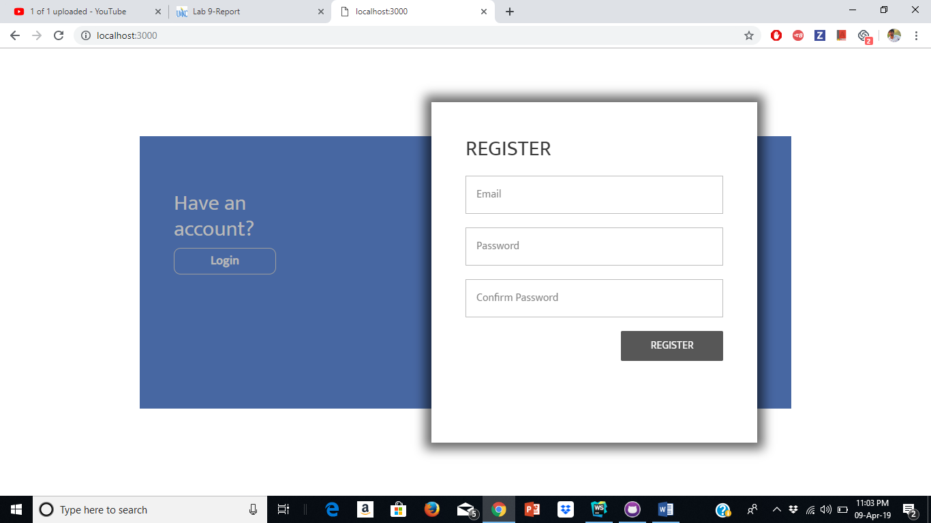Register page
2. Login page

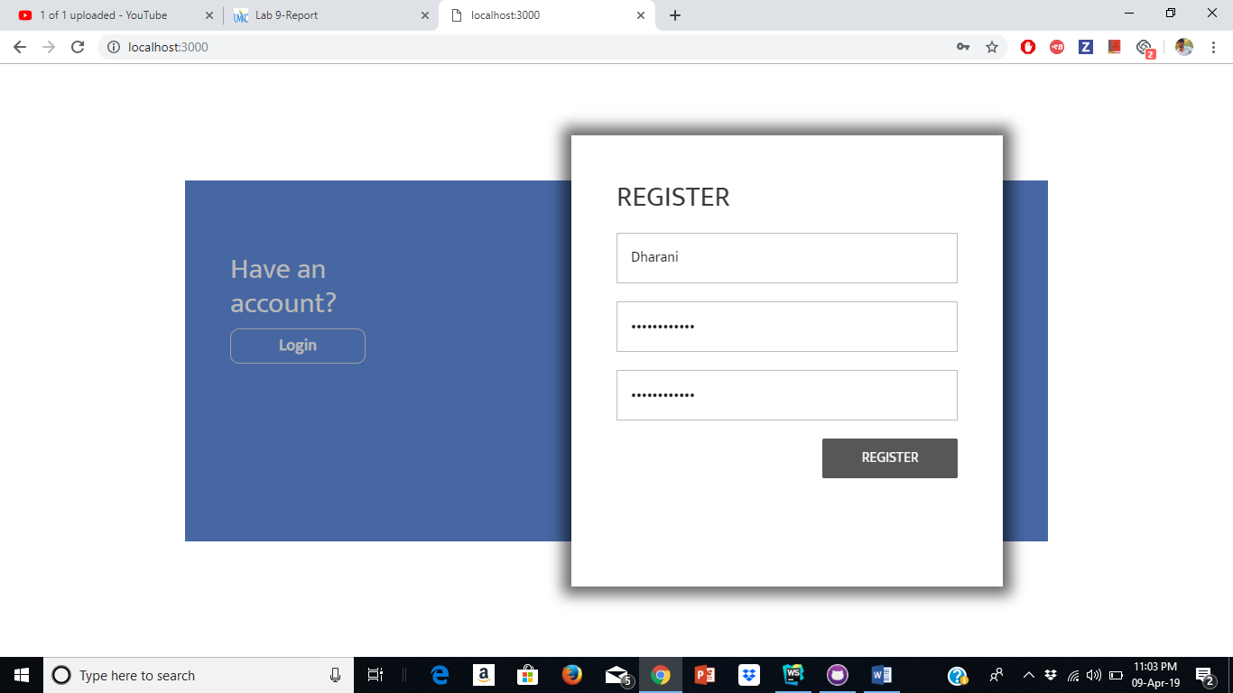

1. Details page

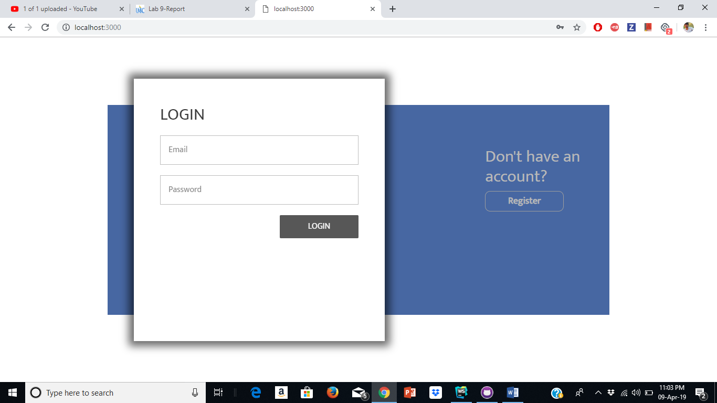

1. Cookies storage and rendering

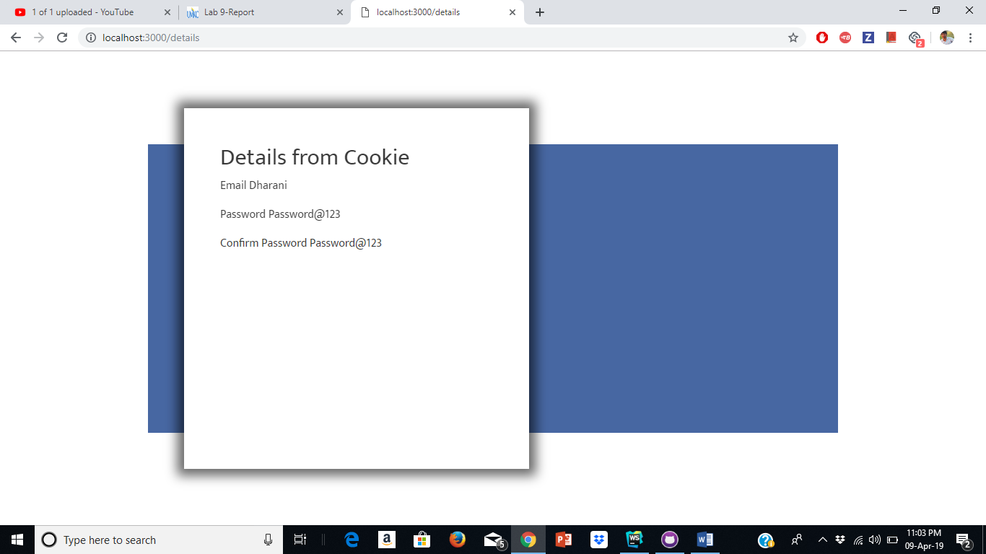

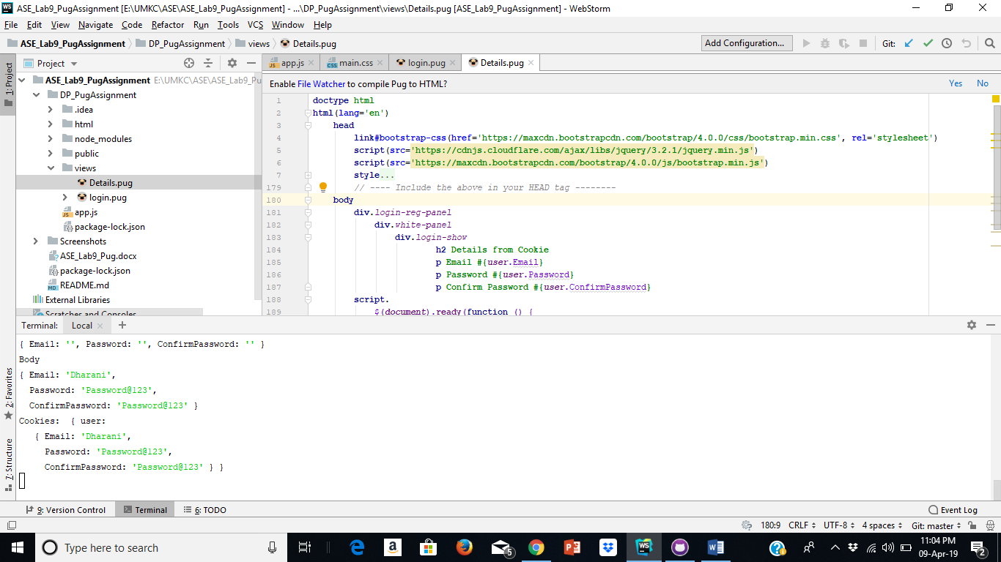

Issues/Limitations:

None

Team Contribution

Dharani:

1. Created Login and Registration pages using pug.
2. Contributed in the creation of Wiki page, report and lab submission.

Chakra Pavan Kumar Kota:

1. Implemented Details and cookies retrieval part of the assignment.
2. Contributed creation of Wiki page, report and lab submission.

Conclusion:

 As part of this exercise we were able to understand the template rendering engine in nodejs. Rendering engine compiles the html in server and sends the plain html to the front end. Pug is one such engine.