**ACD_BDDOF_Session_1_Assignment_1_Main**

**Imported acadgild vm using Oracle vm:**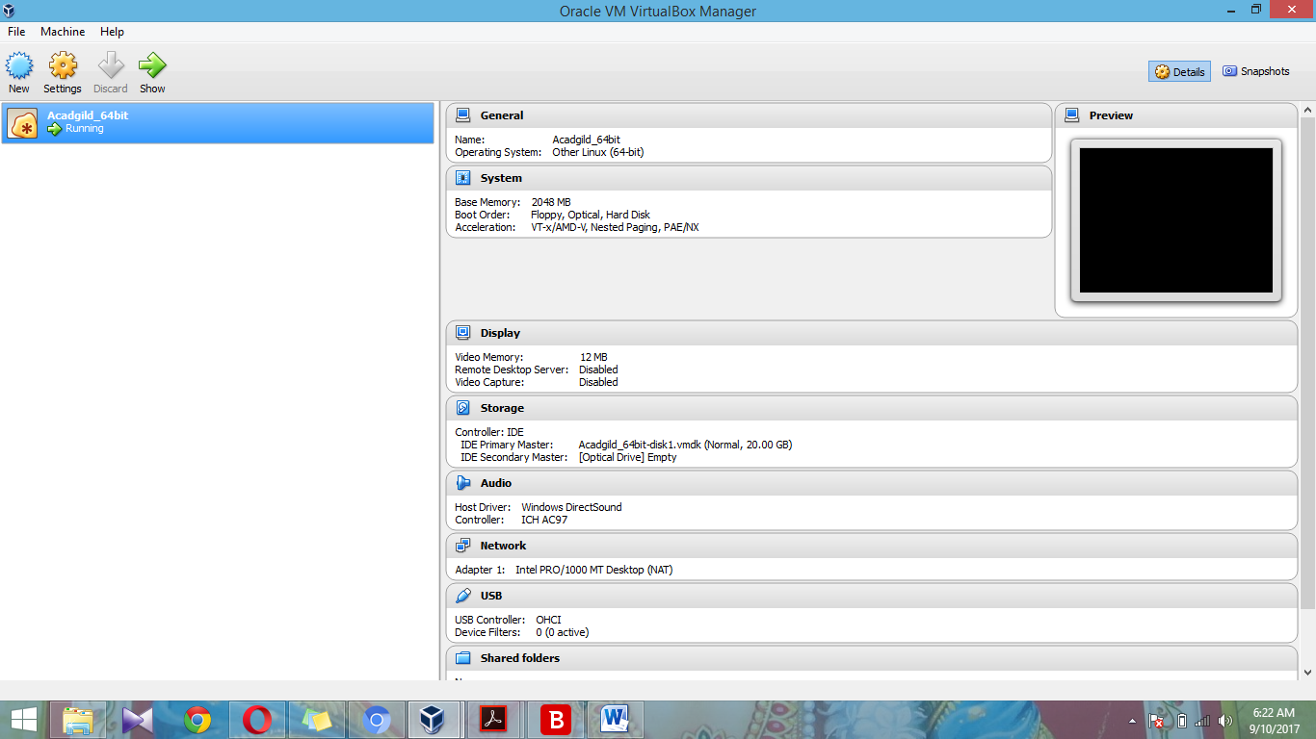

**Command jps to check the list of daemons:**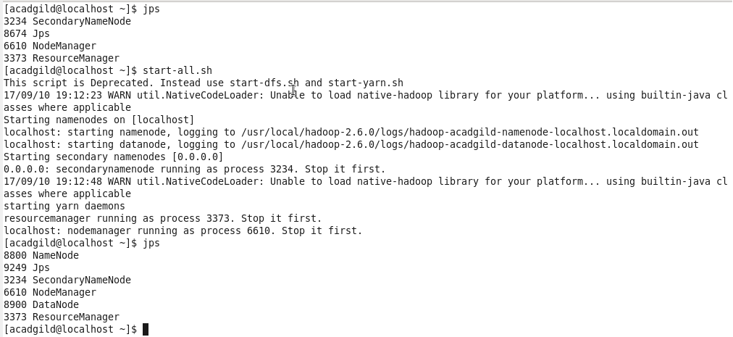

**Start the ssh server:**

**Start all the daemons:**



**Start the historyserver:**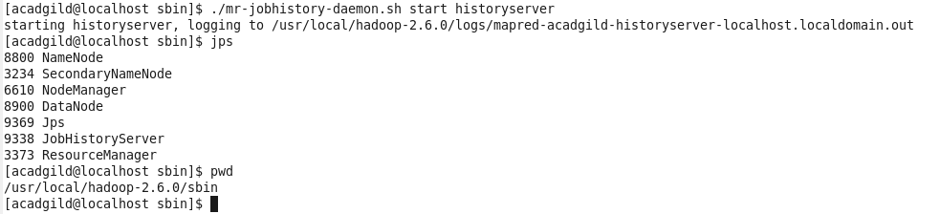

**Start Pig in hdfs mode:**

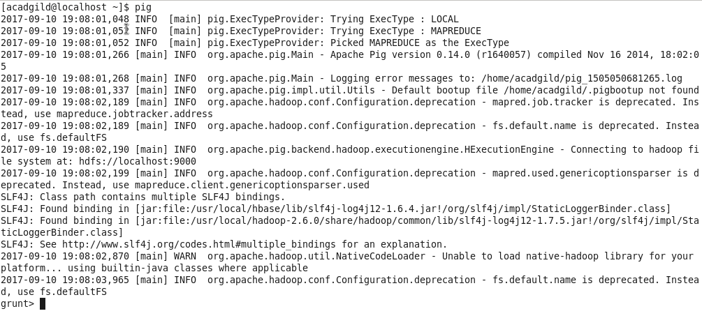

**Start mysql service:**

**Start hive:**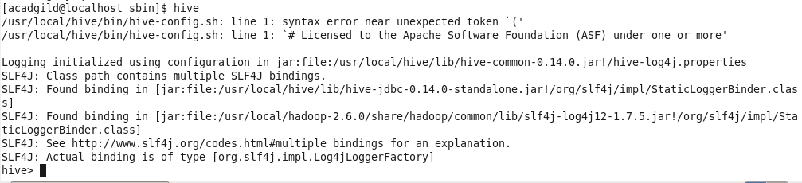

**Start hbase:**