**ACD_BDDOF_Session_1_Assignment_2_Main**

**Problem Statement:**

Explain the linux commands with an example:

1. **pwd:**



**2. vi:**

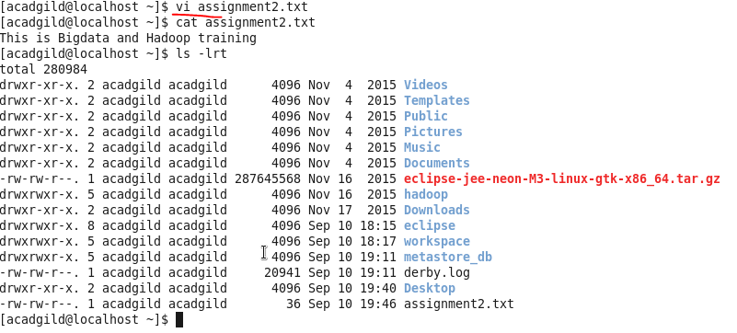

**3. touch**

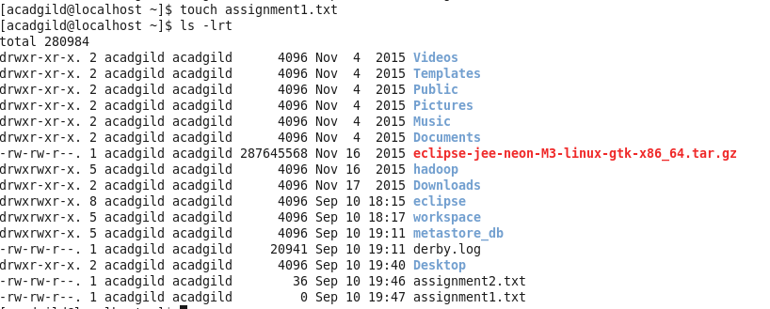

**4. mkdir**

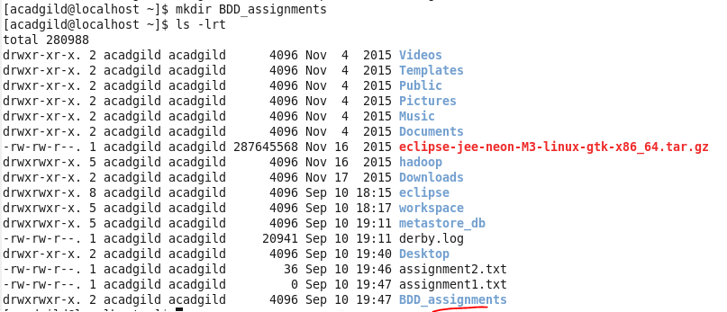

**5. rm**

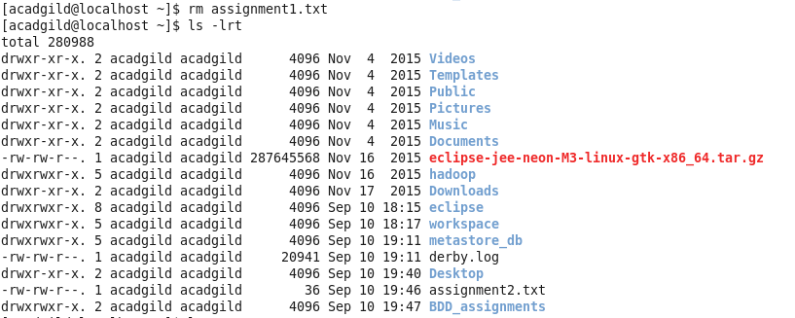

**6. ls**



**7. echo**



**8. cat**



**9. who**



**10.cd**



**11.date**

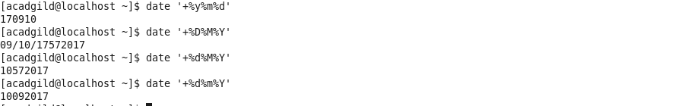

**12.cal**

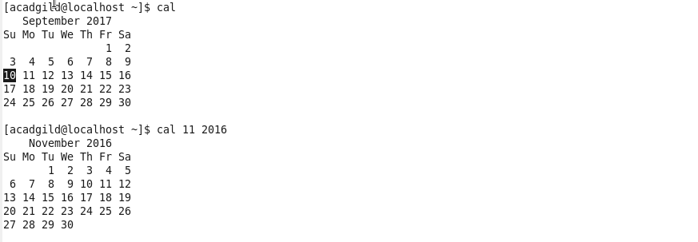

**13.mv**



**14.cp**

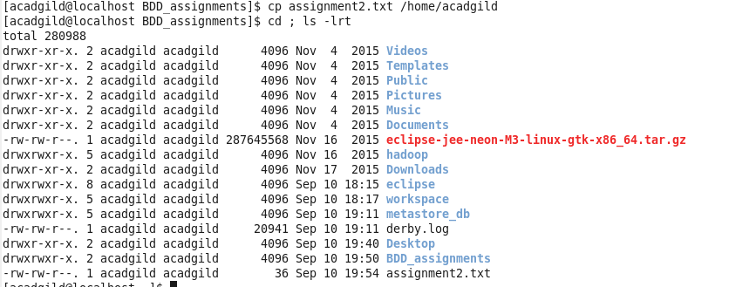

**15.which**

