**ACD_BDDOF_Session_1_Assignment_3_Main**

**Problem Statement:**

**Task 1:**

* Check whether /user/acadgild directory exists or not in the HDFS.
* If it doesn't exist, then Create a directory /user/acadgild/hadoop.

**Method 1: using mkdir –p – creates a directory if not exists**

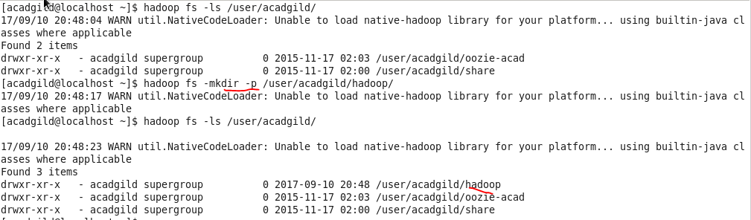

**(OR)**

**Method 2: - using mkdir**

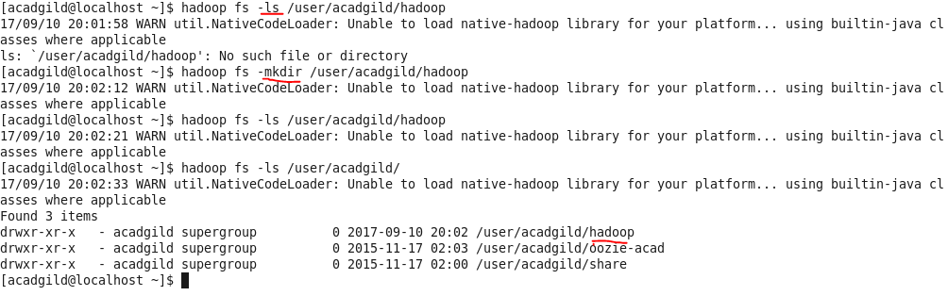

**Task 2:**

Create a file in HDFS under directory /user/acadgild/hadoop, with name word-count.txt.

* Used **–touchz** for creating zero byte file in HDFS

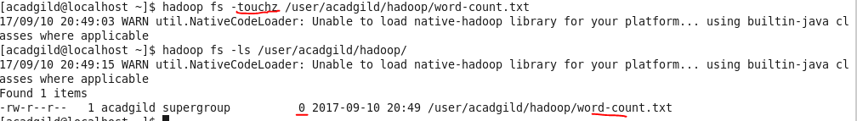

Whatever we type on screen should get appended to file

* Used command **–appendToFile**

