**ACD_BDDOF_Session_1_Assignment_4_Main**

**Problem Statement:**

**Task 3:**

Create a file max-temp.txt in local FS in the format dd-mm-yyyy,temperature

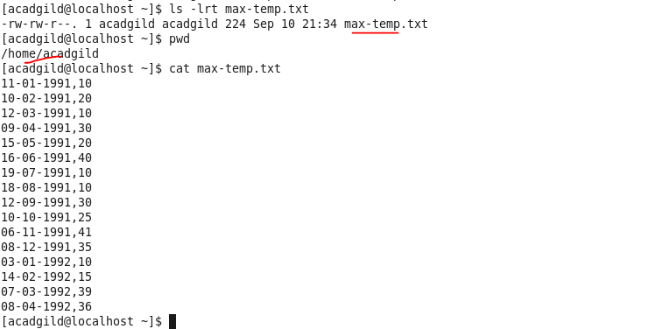

Move this file to HDFS at /user/acadgild/hadoop.

* Used put command to move the file from local fs to HDFS

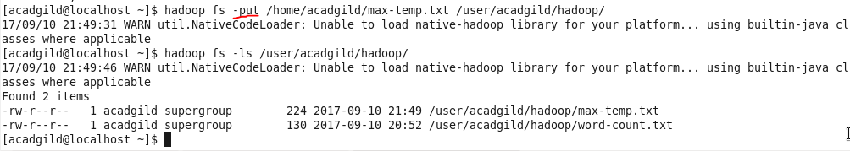

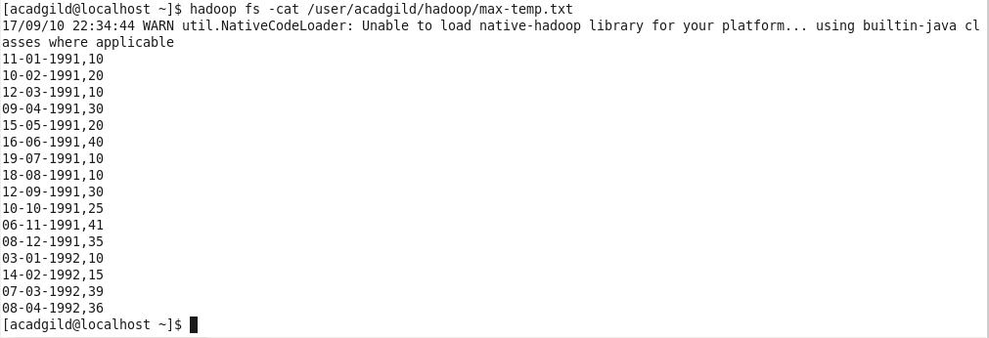

**Task 4:**

Change the permission of the file /user/acadgild/hadoop/max-temp.txt, such that

* Only the owner and the group members have full control over the file.
* Others do not have any control over it.

Method 1:

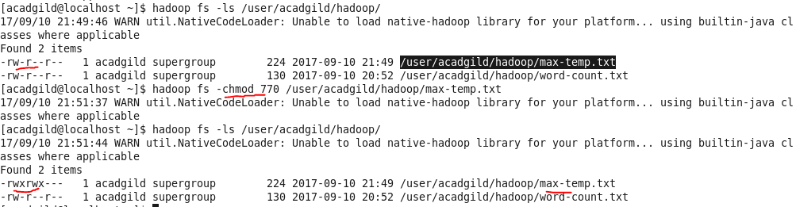

**(OR)**

Method 2:

Modified the command –

* others would have read access to the file and
* owner & group would have full control over the file

