**ACD_BDDOF_Session_2_Assignment_3_Main**

**Problem Statement:**

Write a program to implement wordcount using Pig.

**Program – S2_assignment3_word_count_pgm.pig:**

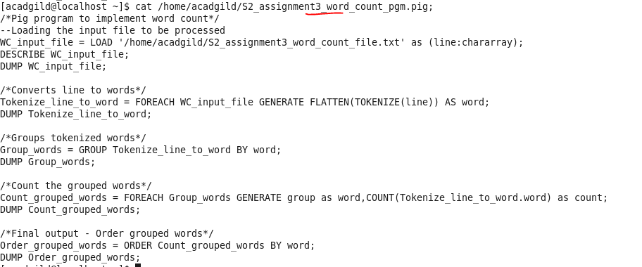

Share the screenshots of the commands used with its associated output.

**Snapshot of input file:**

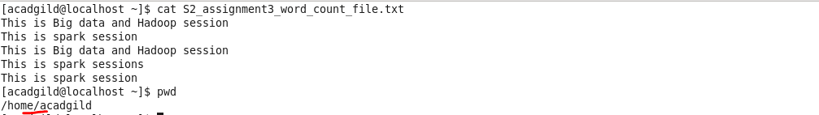

**Program execution:**



**Final output:**

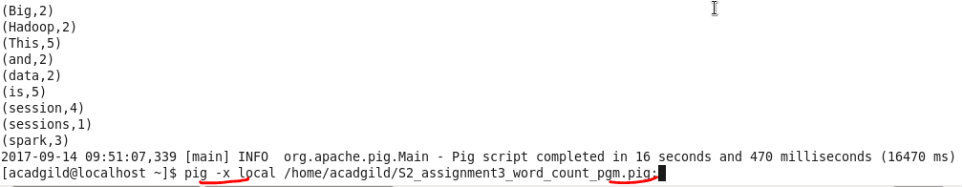

**Command i):**

Loading the input file (as full line – no delimiters)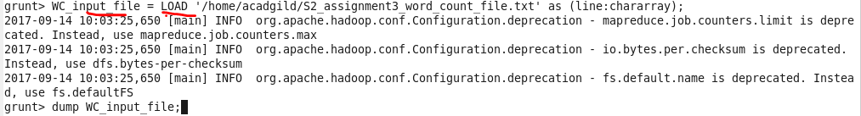

**Output i):**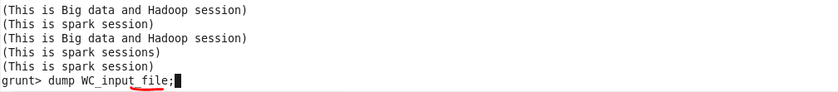

**Command ii):**

Converts line to tokens (TOKENIZE) and then to words(FLATTEN)



**Output ii):**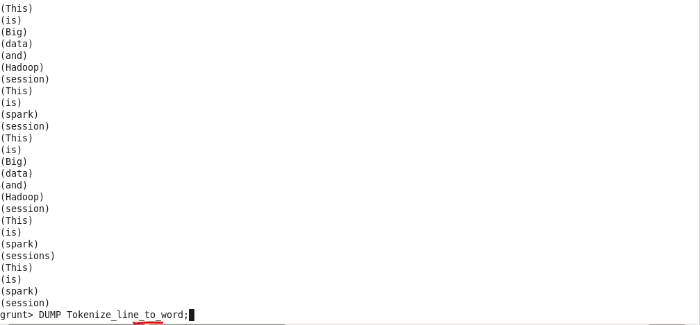

**Command iii):**

Group tokenized words

**Output iii):**

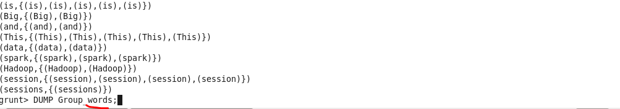

**Command iv):**

Count grouped words



**Output iv):**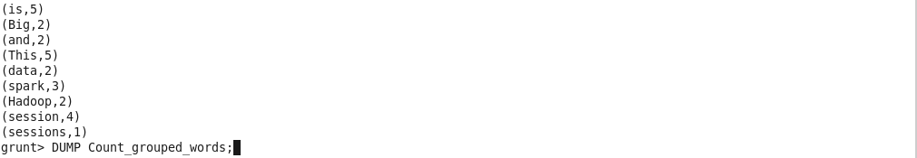

**Command v):**

Order grouped words



**Final output v):**