**ACD_BDDOF_Session_3_Assignment_2_Main**

**Problem Statement:**

**Input dataset:**

File is tab separated “\t”.

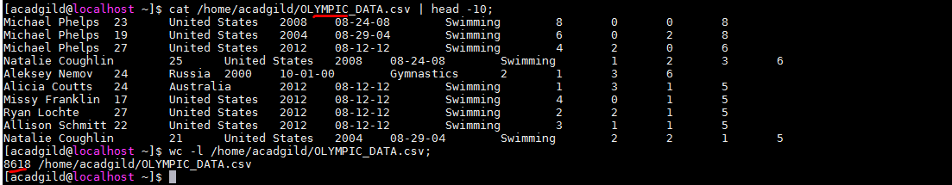

**Table creation:**

Created a table “OLYMPIC_DATA” with fields terminated by ‘\t’. IF NOT EXISTS will suppress warnings if table already exists else table will be created.

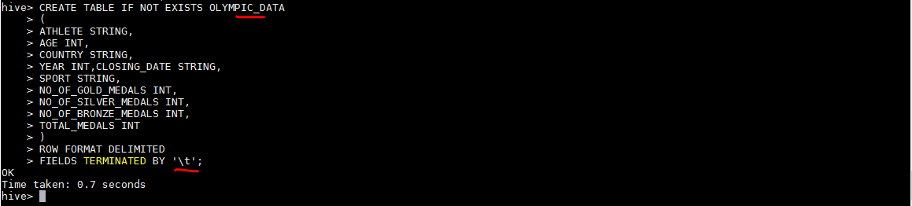

**Data load:**

All the records from input dataset is loaded to the table.





1. Write a Hive program to find the number of medals won by each country in swimming.

**Hive Program:**

Grouped by COUNTRY,SPORT and got SUM(TOTAL_MEDALS) for records having SPORT as “Swimming”.

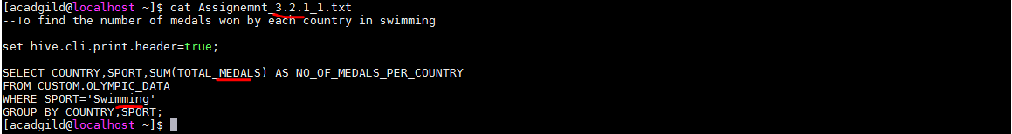

**Hive program execution:**

**Output:**

Displays Country, Sport(swimming),no of total medals for each country.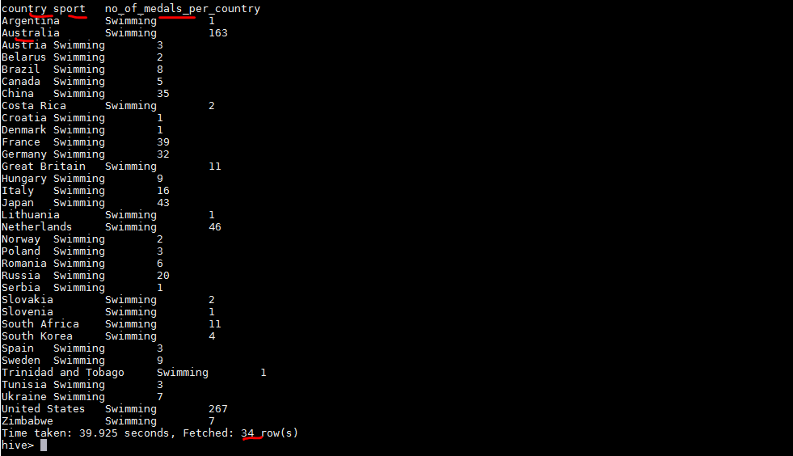

(OR)

**Alternative:**

There is other sport called Synchronized Swimming. To get both swimming **g**rouped by COUNTRY,SPORT and got SUM(TOTAL_MEDALS) for records having SPORT like “%Swimming%”- will get both Synchronized Swimming & Swimming .





**Output:**

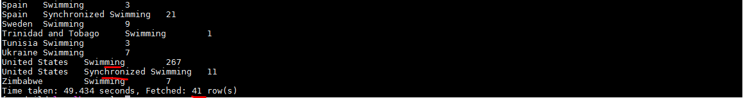

2. Write a Hive program to find the number of medals that India won year wise.**Hive Program:**

Grouped by COUNTRY,YEAR and got SUM(TOTAL_MEDALS) for records having COUNTRY as ‘INDIA’.

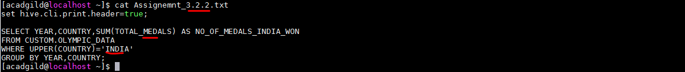

**Hive Program execution:**



**Output:**

Displays the SUM(TOTAL_MEDALS) across different YEAR,COUNTRY(INDIA).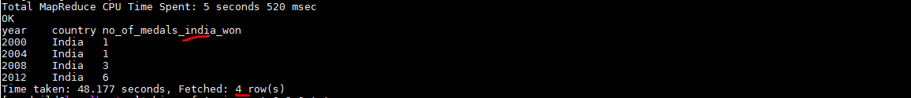

3. Write a Hive Program to find the total number of medals each country won.

**Hive Program:**

Grouped by COUNTRY and got SUM(TOTAL_MEDALS) across all records.

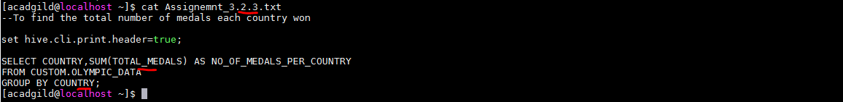

**Hive Program execution:**



**Output:**

Displays the SUM(TOTAL_MEDALS) for every country.

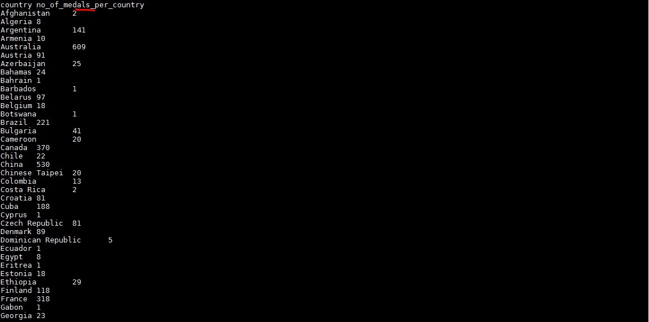

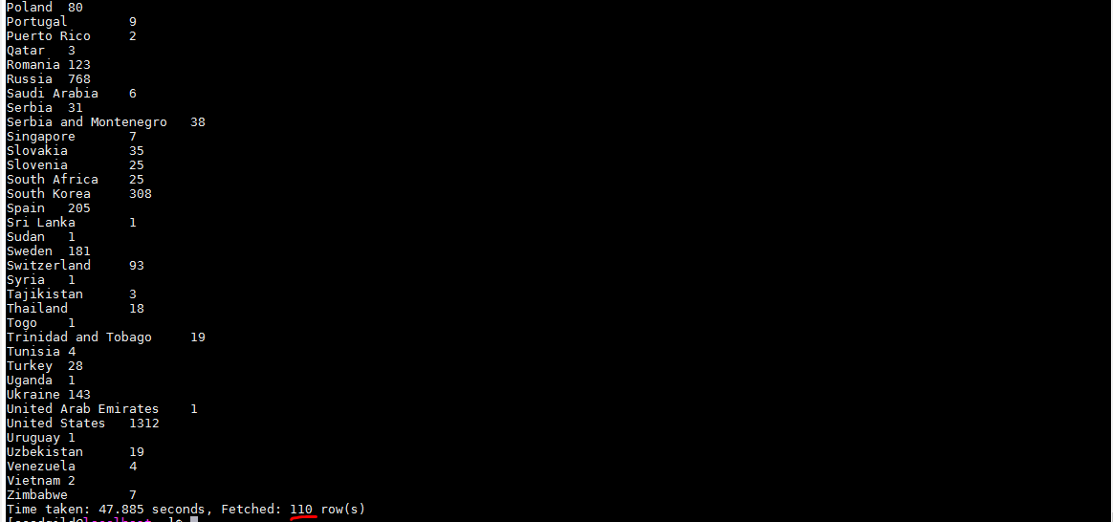

4.Write a Hive program to find the number of gold medals each country won.

**Hive Program:**

Grouped by COUNTRY and got SUM(GOLD_MEDALS) .



**Hive program execution:**



**Output:**

Displays the SUM(GOLD_MEDALS) for every country.