**ACD_BDDOF_Session_6_Assignment_7_Main**

**Problem Statement:**

1) Considering age groups of < 20 , 20-35, 35 > ,Which age group spends the most

amount of money travelling.

2) What is the amount spent by each age-group, every year in travelling?

**Scala code:**

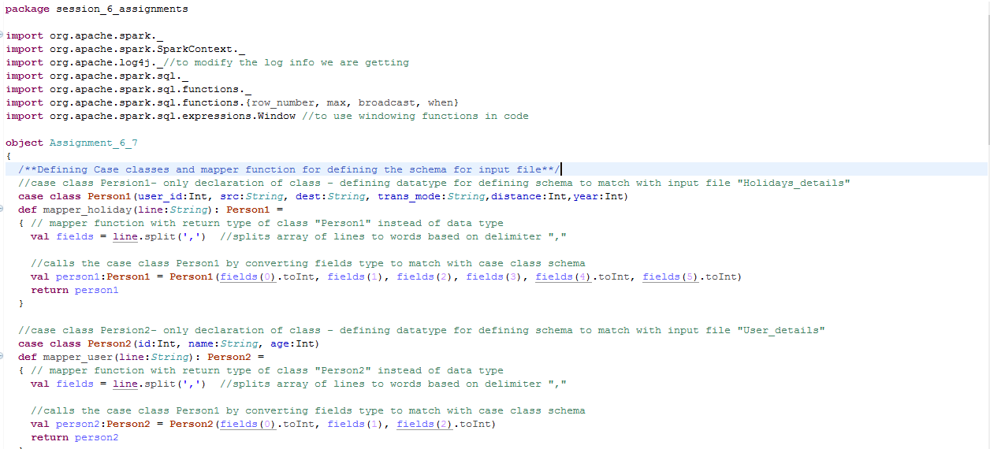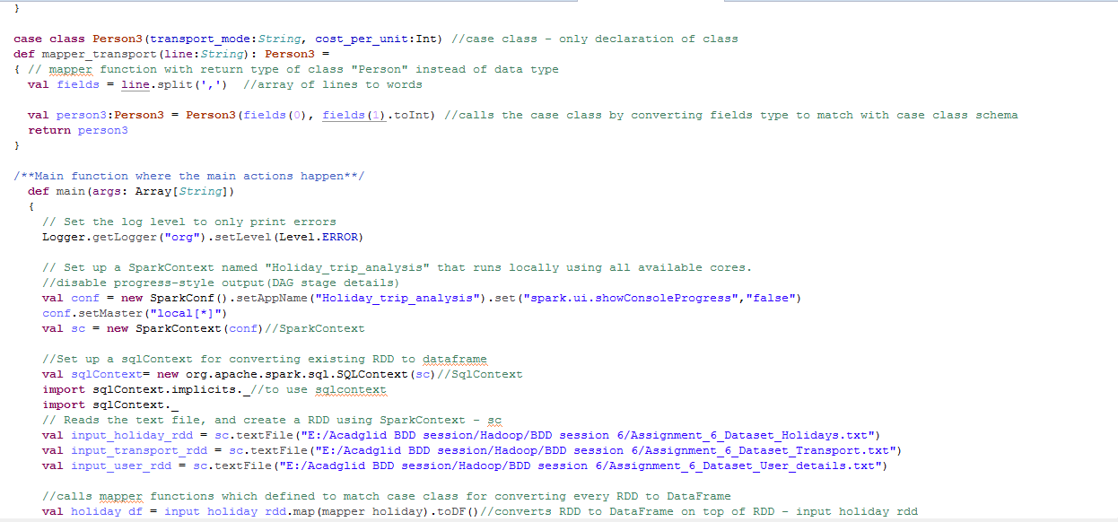

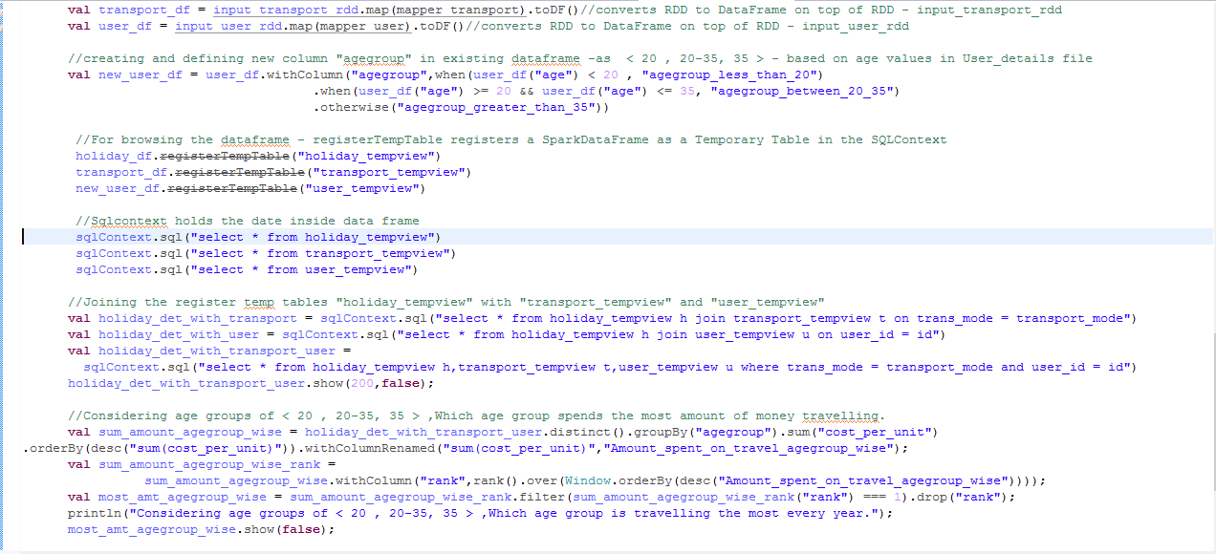 

**Explanation:**

* Created 3 **case classes** called “Person1”,”Person2”,Person3” for defining the schema and name of the fields in input file

Person1(Holidays file),Person2(Transport file),Person3(User_details file)



* Created 3 **mapper functions** for all 3 input files – which will convert the datatype of the fields to match with corresponding Person class schema and returns “Person” type

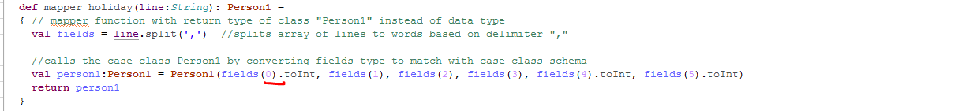

* Set the **log level to “Error”** to display only error messages - Logger.getLogger("org").setLevel(Level.ERROR) **and disabled progress-style** output(DAG stage details) - set("spark.ui.showConsoleProgress","false")
* Set up a **SparkContext** named – sc – for application "Holiday_trip_analysis" that runs locally using all available cores.
* Set up a **sqlContext** for converting existing RDD to **dataframe**



* Reads the text file, and create a RDD using SparkContext – sc



* Calls mapper functions which defined to match case class for converting every RDD to DataFrame
* Calls mapper functions by passing mapper function with RDD and retunrs Dataframe as toDF() is used



* For the problem statement, **created and defined a new column "agegroup" in existing dataframe** -as < 20 , 20-35, 35 > - based on age values in User_details file using withColumn – which **is to create or add columns dynamically to the new data frame from existing DF**



* For browsing the dataframe **- registerTempTable registers a SparkDataFrame** as a Temporary Table in the SQLContext and Sqlcontext holds the date of data frame



* Now as the data from RDD is converted to Dataframe,it can be queried with “SparkContext”.

**Joins:**

* Joined the registered temp table “"holiday_tempview" with "transport_tempview" based on transport_mode to get the value of “cost_per_unit” from transport file with SqlContext
* Joined the registered temp table “"holiday_tempview" with "user_tempview" based on id to get the value of “age” from user file.
* Joined the registered temp table “"holiday_tempview" with "transport_tempview" and “user_tempview” based on id and transport_mode **(three table join**) to get the value of **“agegroup” from “user_details”** file and **“cost_per_unit” from “transport”** file for each user_id for every **“year” from “holidays” file**(holiday_det_with_trasnport_user).



**Snapshot of input file:**

User: id, name, age – Assignment_6_Dataset_User_details

Transport: transport_mode, cost_per_unit - Assignment_6_Dataset_Transport

Holidays: id, src, dest, transport_mode, distance, year - Assignment_6_Dataset_Holidays

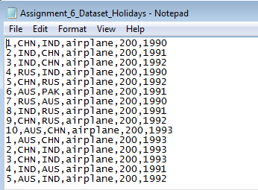

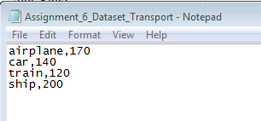 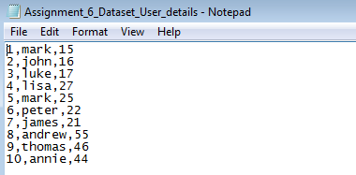

**1) Considering age groups of < 20 , 20-35, 35 > ,Which age group spends the most**

**amount of money travelling.**

Created a **new column age group “agegroup_less_than_20”,” agegroup_between_20-35”,” agegroup_greater_than_35>”**already based on age present in user_details file



* Grouped data based **on agegroup and taken sum(cost_per_unit)** in every group – will hold the **sum(amount_spent) according to each agegroup.**
* Using Windowing **function generated rank column based (ordered) based on sum(amount_spent)** - will display agegroup and sum(amount_spent) in all years according to agegroup ordered based on amount in descending
* And **taken first ro**w – to get **the age group which spends most of the money** in travelling– will hold the agegroup name which had spent most of the money in travelling across all year along with amount spent.

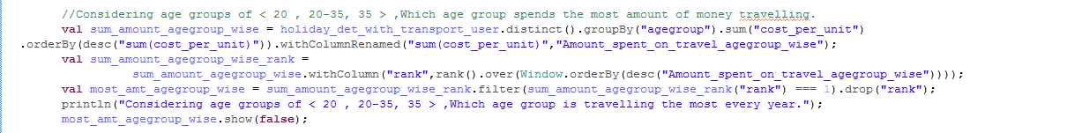

**Output:**

Displays the agegroup which had spent most of the money in travelling across all year along with amount spent by that agegroup.

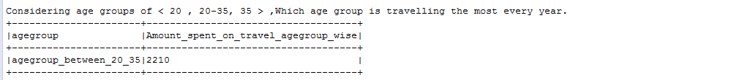

**2) What is the amount spent by each age-group, every year in travelling?**

Created a **new column age group “agegroup_less_than_20”,” agegroup_between_20-35”,” agegroup_greater_than_35>”**already based on age present in user_details file



* Grouped data based on **agegroup,year and taken sum(cost_per_unit)** in every group – will hold the sum(amount_spent) spent by each agegroup year wise.
* Displays the grouped data using show(false) – which will disable the truncation of column values in output console

**Output:**

Displays the amount spent by each agegroup, every year in travelling.