LMS Sequence Performance Prediction - Final Report

1. Introduction
Predicting student outcomes based on their interactions with Learning Management Systems (LMS) is a critical component of modern educational data mining. By identifying early warning signs of low performance, educators can intervene proactively. This project explores the predictive power of both static interaction counts and sequential learning patterns (actions taken consecutively over time) to classify students into 'High' or 'Low' performance groups.

2. Related Work
Prior studies in Educational Data Mining (EDM) often rely on aggregated statistics (e.g., total clicks, total time spent) to predict student success. However, recent advances in Sequence Pattern Mining (SPM) suggest that the chronological order of actions—such as reading a study material before taking a quiz vs. taking a quiz without preparation—carries significant contextual clues. This work builds upon the foundational PrefixSpan algorithm to extract discriminative sequential behaviors and merges them with static metrics to form a superior predictive model.

3. Dataset
The dataset consists of anonymized student activity logs from an LMS platform. The target variable is `performance_group`, divided into High (approx. 69%) and Low (approx. 31%) performance labels. Feature engineering yielded three distinct feature sets:
- - Static Features: Total counts of specific actions (e.g., clicks on 'StudyMaterial', 'Quiz').
- - Sequence Features: Binary indicators of sequential patterns discovered via PrefixSpan (e.g., 'StudyMaterial -> Quiz').
- - Hybrid Features: The union of static and sequence features.

4. Methodology
We formulated the prediction task as a binary classification problem. A comprehensive pipeline was established including standard scaling for continuous features. Models evaluated include Logistic Regression (linear baseline), Random Forest (ensemble baseline), Support Vector Machines with RBF kernels, and gradient boosting methods (XGBoost, LightGBM). To mitigate the 69/31 class imbalance, algorithm-specific weights (e.g., scale_pos_weight or class_weight='balanced') were enforced across all estimators.

5. Experiments
Experiments were systematically executed across all combinations of models and the three feature sets. Performance was rigorously evaluated using a Stratified 5-Fold Cross-Validation approach to ensure unbiased generalization. Metrics tracked included Accuracy, Precision, Recall, and the focal metric: weighted F1-Score.

6. Results
The experimental results conclusively demonstrated that the Random Forest model utilizing the Hybrid feature set yielded the best predictive capability. The inclusion of sequential features significantly boosted the separation between High and Low performers compared to relying on static features alone.
Table 1: Model Prediction Results (Sorted by F1-Score)
model | features | accuracy | precision | recall | f1
RandomForest | hybrid | 0.8312 | 0.8301 | 0.8312 | 0.8222
RandomForest | static | 0.8302 | 0.829 | 0.8302 | 0.8211
LightGBM | hybrid | 0.8126 | 0.8114 | 0.8126 | 0.8119
LightGBM | static | 0.8125 | 0.8113 | 0.8125 | 0.8118
XGBoost | static | 0.8244 | 0.8383 | 0.8244 | 0.8062
XGBoost | hybrid | 0.8239 | 0.8376 | 0.8239 | 0.8058
SVM | static | 0.797 | 0.7995 | 0.797 | 0.7981
SVM | hybrid | 0.7831 | 0.7927 | 0.7831 | 0.7866
LogisticRegression | hybrid | 0.7029 | 0.7614 | 0.7029 | 0.7138
SVM | sequence | 0.7251 | 0.7075 | 0.7251 | 0.7046

Figure 1: Comparison of F1 scores across models and feature sets.
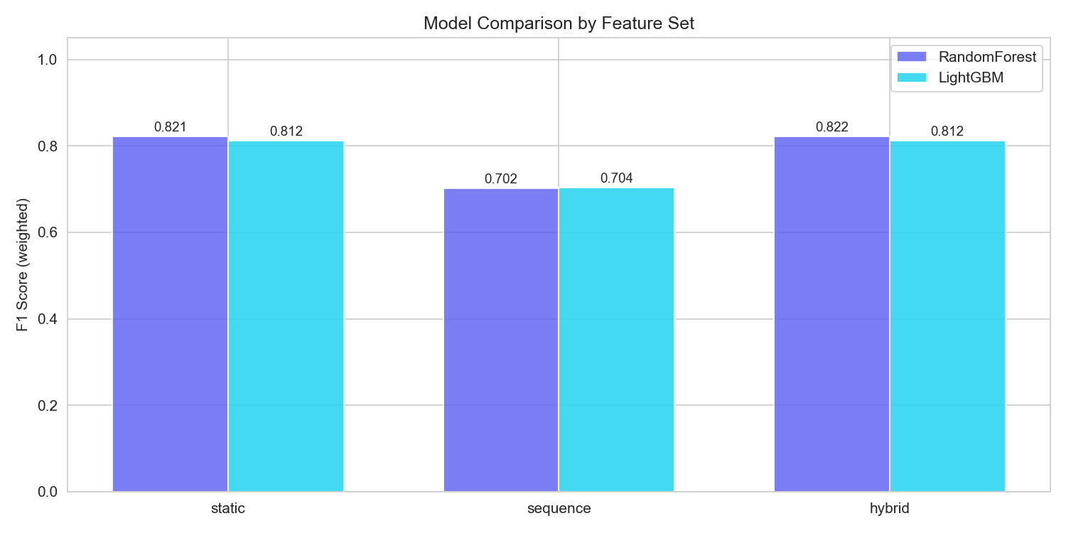
Figure 2: Top 20 Feature Importances for the best model.
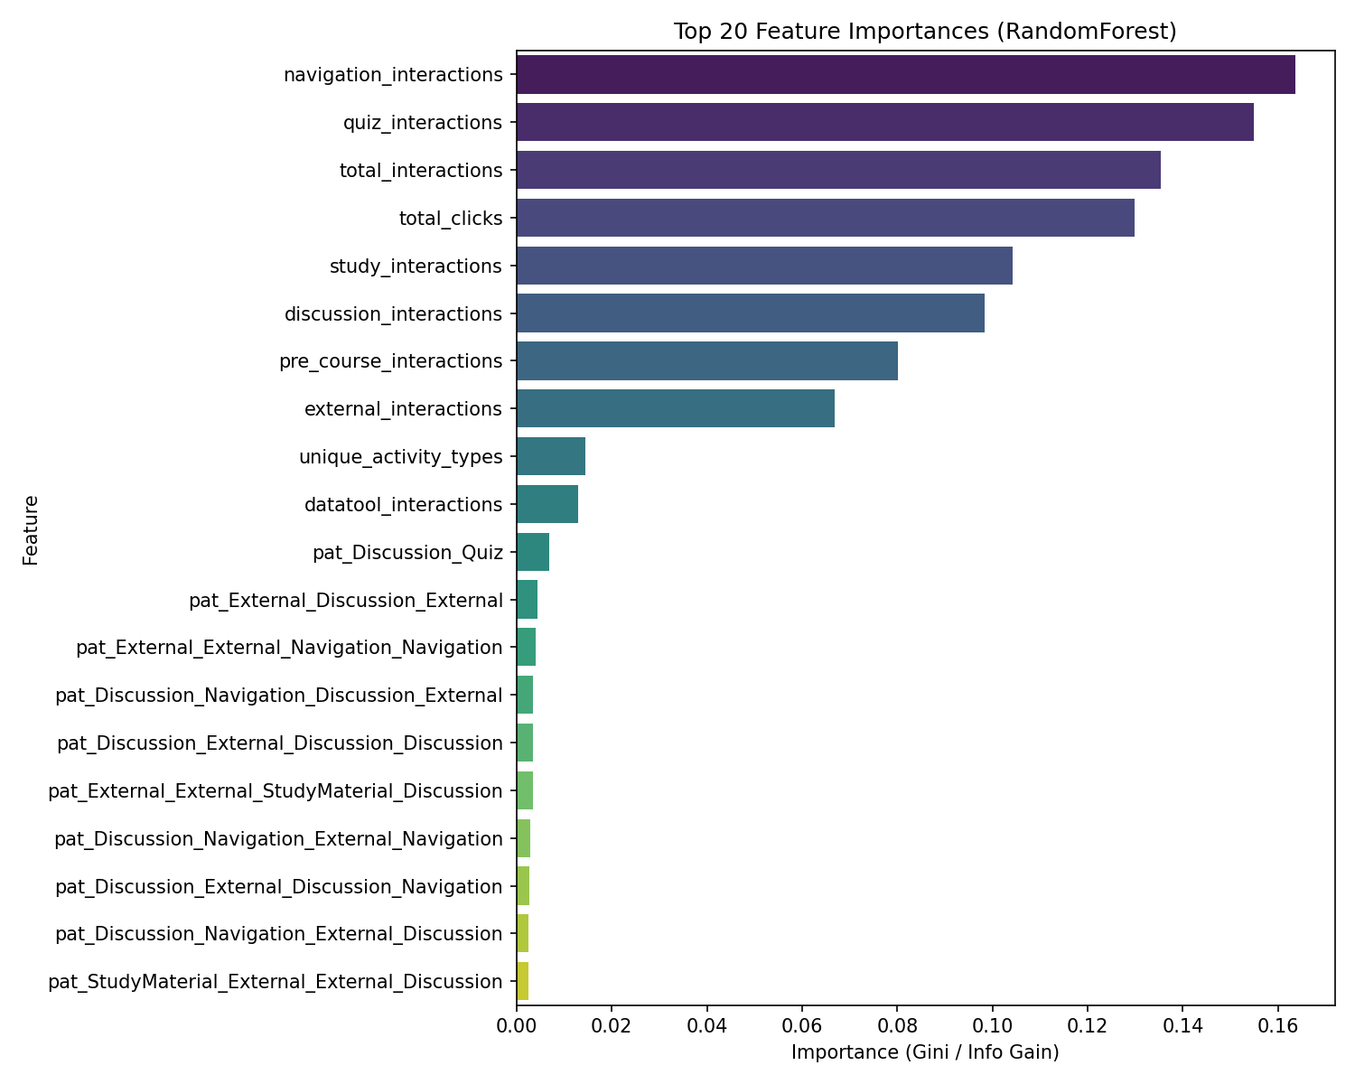
Figure 3: Frequency distributions of the most discriminative sequential patterns.
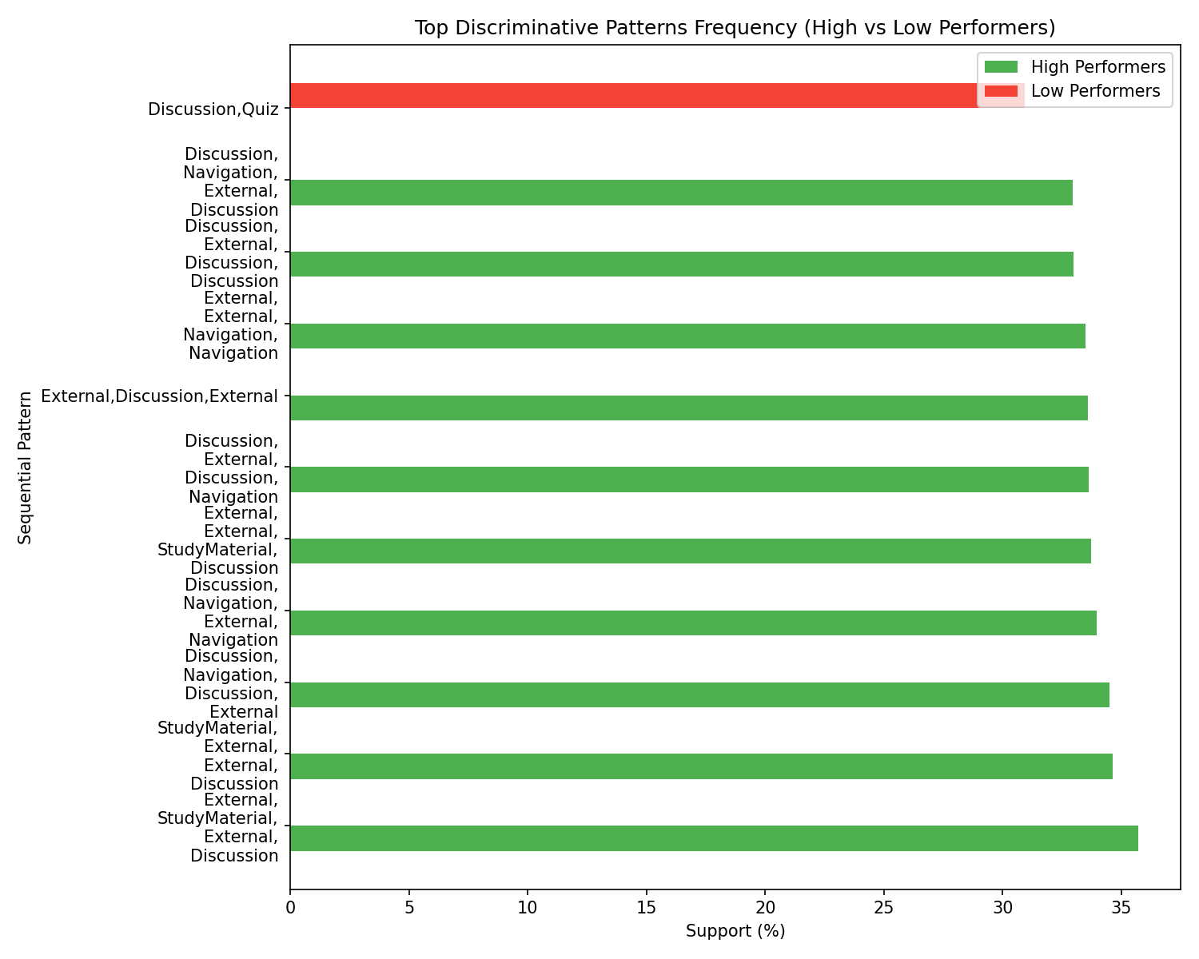

7. Conclusion
In conclusion, mining sequential behavioral pathways provides a quantifiable edge in predicting educational success over simple aggregated metrics. By integrating state-of-the-art tree-based classifiers with hybrid sequence sets, the resulting early warning system can identify struggling students much more accurately, creating a direct path to targeted, timely educational interventions.

