INTERNSHIP PROJECT REPORT

THIRANEX
Technology & Innovation Solutions

Project Title
Data Cleaning and Visualization
using Titanic Dataset

Student Name | Dharani Sri BA
Internship Domain | Data Science
Organization | Thiranex
Submission Date | May 30, 2025

Department of Data Science | Academic Year 2024–2025

Acknowledgement

I would like to express my sincere gratitude to all those who have contributed to the successful completion of this internship project. This project on "Data Cleaning and Visualization using the Titanic Dataset" has been a significant learning experience, and its completion would not have been possible without the guidance and support of several individuals.

First and foremost, I extend my heartfelt thanks to the management and technical team at Thiranex for providing me with this valuable internship opportunity. Their mentorship, encouragement, and professional guidance throughout the internship have been instrumental in shaping my understanding of real-world Data Science applications.

I am deeply grateful to my project supervisor and internship coordinator for their continuous support, constructive feedback, and timely suggestions that helped me navigate through complex concepts of data preprocessing, exploratory data analysis, and visualization. Their insights have been invaluable in enhancing the quality of this report.

I also wish to acknowledge the open-source community, whose publicly available tools, libraries, and datasets—including the Titanic Dataset from Kaggle—served as the foundation of this project. The contributors behind Python, Pandas, Matplotlib, Seaborn, and Google Colab have made it possible for students and professionals alike to perform sophisticated data analysis with ease.

Finally, I extend my gratitude to my family, friends, and academic institution for their unwavering moral support. This project has enriched my technical and analytical skills, and I am confident that the knowledge gained during this internship will serve as a strong foundation for my future career in Data Science.

Dharani Sri BA
Data Science Intern | Thiranex

Abstract

This report presents the findings and outcomes of an internship project undertaken at Thiranex under the domain of Data Science. The project focused on performing comprehensive Data Cleaning and Visualization on the Titanic Dataset—a widely used benchmark dataset in the fields of data science and machine learning. The dataset contains records of 418 passengers from the test split, including attributes such as age, gender, passenger class, fare paid, port of embarkation, and survival status.

Several data quality issues were identified and addressed during this project, including missing values in the Age column (20.57%), Cabin column (78.23%), and one missing Fare value. Age was imputed using mean imputation, while the Cabin column was dropped due to excessive missingness. Following data cleaning, an extensive visualization phase was conducted using Python's Matplotlib and Seaborn libraries.

Key findings from this project reveal that female passengers had significantly higher survival rates than male passengers; first-class passengers were more likely to survive than those in lower classes; and fare paid was positively correlated with survival probability. These results align with well-documented historical accounts of the Titanic disaster. This project provided substantial hands-on experience in using Python for data science workflows and laid a strong groundwork for more advanced machine learning and predictive analytics tasks in the future.

1. Introduction

1.1 What is Data Science?
Data Science is a multidisciplinary field that combines statistics, computer science, mathematics, and domain-specific knowledge to extract actionable insights from structured and unstructured data. Organizations across industries generate massive volumes of data every day. Data Science provides the methodologies and tools necessary to harness this data, transform it into meaningful information, and drive intelligent decision-making. A typical Data Science workflow involves data collection, preprocessing, exploratory data analysis, statistical modeling, machine learning, and visualization.

1.2 What is Data Cleaning?
Data Cleaning, also referred to as data preprocessing or data wrangling, is the process of identifying and correcting errors, inconsistencies, and inaccuracies in a dataset before analysis or modeling. Real-world datasets are rarely perfect—they often contain missing values, duplicate records, inconsistent formatting, outliers, and irrelevant features that can adversely affect the accuracy and performance of analytical models. In this project, I performed all of these operations on the Titanic Dataset using the Python library Pandas, which provides powerful and intuitive functions for data manipulation.

1.3 What is Data Visualization?
Data Visualization is the graphical representation of information and data using visual elements such as charts, graphs, histograms, heatmaps, and scatter plots. It serves as a powerful communication tool that enables data scientists and stakeholders to understand complex patterns, trends, and relationships in data quickly and intuitively. In this project, I used Python's Matplotlib and Seaborn libraries to create a comprehensive set of visualizations that revealed key patterns in the Titanic Dataset.

1.4 Importance of Data Preprocessing
Data preprocessing is widely regarded as one of the most critical steps in any data science or machine learning project. Studies suggest that data scientists spend approximately 60–80% of their time on data preparation tasks. The quality of any analysis or model is directly dependent on the quality of the input data—a principle often summarized as "Garbage In, Garbage Out." Through this internship project, I developed a thorough appreciation for the importance of data preprocessing as the cornerstone of any data science endeavor.

2. Project Objectives

The primary objectives of this internship project were as follows:

- Identify Missing Values: Systematically detect and quantify missing values across all columns of the Titanic Dataset using appropriate Python functions.
- Handle Missing Data: Apply mean imputation for the Age column and drop the Cabin column due to excessive missingness.
- Remove Duplicate Records: Identify and eliminate duplicate rows to ensure data integrity and avoid redundant analysis.
- Detect Outliers: Use statistical methods and boxplot visualizations to identify anomalous data points in numerical columns such as Age and Fare.
- Visualize Important Patterns: Create histograms, bar charts, count plots, correlation heatmaps, and boxplots to visually represent key patterns in the data.
- Generate Meaningful Insights: Analyze visualizations to derive insights about passenger demographics, fare distributions, survival rates by gender and class, and inter-feature correlations.

3. Dataset Description

3.1 Overview of the Titanic Dataset
The Titanic Dataset is one of the most well-known datasets in the Data Science community. It is based on actual passenger data from the RMS Titanic—the British ocean liner that sank on April 15, 1912, after colliding with an iceberg. The dataset used in this project is the test split (tested.csv) containing 418 passenger records and 12 feature columns. It is commonly sourced from Kaggle and used for binary classification tasks (predicting survival) and exploratory data analysis.

3.2 Column Descriptions

Column | Data Type | Description
PassengerId | Integer | Unique identifier for each passenger in the dataset.
Survived | Integer 0/1 | Target variable: 0 = Did not survive, 1 = Survived.
Pclass | Integer 1-3 | Ticket class: 1 = Upper, 2 = Middle, 3 = Lower.
Name | String | Full name of the passenger (not used directly in analysis).
Sex | String | Gender of the passenger: male or female.
Age | Float | Age in years. Contains 86 missing values (~20.57%).
SibSp | Integer | Number of siblings or spouses aboard the Titanic.
Parch | Integer | Number of parents or children aboard the Titanic.
Ticket | String | The ticket number assigned to the passenger.
Fare | Float | Fare paid for the ticket. 1 missing value.
Cabin | String | Cabin number. ~78.23% missing — dropped from analysis.
Embarked | String | Port of embarkation: S=Southampton, C=Cherbourg, Q=Queenstown.

3.3 Dataset Characteristics
The dataset comprises 418 rows and 12 columns with a mix of numerical and categorical data types. Key quality issues include 86 missing Age values (20.57%), 327 missing Cabin values (78.23%), and 1 missing Fare value. These characteristics make the dataset an ideal candidate for demonstrating essential data cleaning techniques.

4. Tools and Technologies Used

Tool | Type | Purpose
Python 3.x | Language | Primary programming language for all data processing and visualization tasks.
Google Colab | Cloud IDE | Browser-based environment for writing and executing Python code with free GPU access.
Pandas | Library | Data loading, exploration, manipulation, cleaning, and statistical analysis.
Matplotlib | Library | Creating static visualizations including histograms, bar charts, and boxplots.
Seaborn | Library | High-level statistical visualization: heatmaps, countplots, and distribution plots.
NumPy | Library | Numerical computations and array operations during data analysis.
Kaggle / CSV | Dataset Source | Titanic Dataset (tested.csv) loaded as a CSV file for processing.

5. Methodology

5.1 Data Collection
The Titanic Dataset (tested.csv) was sourced from Kaggle and uploaded to the Google Colab environment. It represents the test partition of the original Titanic dataset with 418 passenger records.

5.2 Data Loading
Using pd.read_csv('tested.csv'), the dataset was loaded into a Pandas DataFrame. Preliminary review was conducted using head(), shape, and dtypes to understand the structure and dimensions of the data.

5.3 Data Inspection
The info() and describe() functions provided a comprehensive snapshot of the dataset, including column data types, non-null counts, and statistical summaries for numerical columns.

5.4 Missing Value Analysis
Missing values were identified using isnull().sum(), returning the count of missing entries per column. A visual heatmap was created using Seaborn to spatially represent the distribution of missing values.

5.5 Missing Value Treatment
Age (20.57% missing) was imputed using the column mean—an accepted technique for moderate numerical missingness. The Cabin column (78.23% missing) was dropped entirely. The single missing Fare value was handled similarly.

5.6 Duplicate Removal
The dataset was checked using duplicated().sum() and any found duplicates were removed via drop_duplicates(). The dataset was confirmed to contain no duplicate records.

5.7 Outlier Detection
Boxplot visualizations using Seaborn's boxplot() function were created for the Age and Fare columns. Outliers beyond 1.5 times the IQR were identified and documented. In this project, valid extreme values were retained rather than removed.

5.8 Statistical Analysis
The describe() function provided key metrics—mean, median, standard deviation, minimum, and maximum—for all numerical columns. This analysis formed the basis for interpreting visualizations.

5.9 Visualization
A suite of 11 visualizations was developed using Matplotlib and Seaborn to analyze demographic distributions, survival patterns, fare trends, feature correlations, and age-survival relationships.

6. Implementation
This section provides a detailed explanation of each code block executed in Google Colab, along with the actual output produced by the Python interpreter.

6.1 Importing Libraries
The implementation began by importing all required Python libraries. Each library serves a specific purpose in the data science pipeline:
- pandas (as pd): For loading, manipulating, inspecting, and cleaning tabular data.
- numpy (as np): For numerical computations and array operations.
- matplotlib.pyplot (as plt): For creating static charts — histograms, bar charts, and boxplots.
- seaborn (as sns): High-level statistical visualization library built on Matplotlib.
- warnings: To suppress non-critical deprecation warnings during execution.

6.2 Loading the Dataset — df.head() Output
The dataset was loaded using pd.read_csv('tested.csv'). The df.head() function was called immediately to preview the first five rows and verify that the file was loaded correctly. The actual output produced is shown in the table below:

PId | Surv | Pcls | Sex | Age | SibSp | Parch | Fare | Ticket | Embarked
892 | 0 | 3 | male | 34.5 | 0 | 0 | 7.83 | 330911 | Q
893 | 1 | 3 | female | 47.0 | 1 | 0 | 7.00 | 363272 | S
894 | 0 | 2 | male | 62.0 | 0 | 0 | 9.69 | 240276 | Q
895 | 0 | 3 | male | 27.0 | 0 | 0 | 8.66 | 315154 | S
896 | 1 | 3 | female | 22.0 | 1 | 1 | 12.29 | 3101298 | S
Table 6.1 – Output of df.head() — First 5 rows of the Titanic Dataset (key columns shown)
The output confirms the dataset loaded correctly with 12 columns. PassengerId starts at 892 (test set), Survived is binary (0/1), and several Cabin values are already NaN (missing) even in the first five rows—indicating the data quality issues that were addressed during preprocessing.

6.3 Dataset Information — df.info() Output
The df.info() function provided a structural summary of the DataFrame including data types, column names, and non-null counts. The actual output is reproduced in the table below:

# | Column | Non-Null Count | Dtype | Notes
0 | PassengerId | 418 non-null | int64 | No missing values
1 | Survived | 418 non-null | int64 | Target variable (0/1)
2 | Pclass | 418 non-null | int64 | Ticket class 1/2/3
3 | Name | 418 non-null | object | Full passenger name
4 | Sex | 418 non-null | object | male / female
5 | Age | 332 non-null | float64 | 86 missing (20.57%)
6 | SibSp | 418 non-null | int64 | No missing values
7 | Parch | 418 non-null | int64 | No missing values
8 | Ticket | 418 non-null | object | Ticket number string
9 | Fare | 417 non-null | float64 | 1 missing value
10 | Cabin | 91 non-null | object | 327 missing (78.23%)
11 | Embarked | 418 non-null | object | S / C / Q — no missing
Table 6.2 – Output of df.info() — Dataset structure with data types and non-null counts
The info() output confirms the dataset has 418 entries and 12 columns. Three columns have missing values: Age (332/418 non-null), Fare (417/418 non-null), and Cabin (91/418 non-null). The RangeIndex confirms sequential indexing from 0 to 417.

6.4 Missing Values Analysis — Before and After Cleaning
The df.isnull().sum() function was called both before and after cleaning to quantify missing values per column. The table below presents a side-by-side comparison of the two outputs:

Column | Before Cleaning | After Cleaning | Action Taken
PassengerId | 0 | 0 | No action needed
Survived | 0 | 0 | No action needed
Pclass | 0 | 0 | No action needed
Name | 0 | 0 | No action needed
Sex | 0 | 0 | No action needed
Age | 86 | 0 | Mean imputation applied
SibSp | 0 | 0 | No action needed
Parch | 0 | 0 | No action needed
Ticket | 0 | 0 | No action needed
Fare | 1 | 1 | Retained (1 value only)
Cabin | 327 | 327 | Column dropped (78.23%)
Embarked | 0 | 0 | No action needed
Table 6.3 – Missing value counts before and after data cleaning (red = missing, green = resolved)
After applying mean imputation to the Age column, its missing value count dropped from 86 to 0. The Cabin column was identified as having 327 missing values (78.23%) and was dropped entirely. The single missing Fare value was retained as it represents only 0.24% of data and does not significantly impact analysis.

6.5 Statistical Summary — df.describe() Output
The df.describe() function was called after cleaning to generate a full statistical summary of all numerical columns. The actual output produced by the Python interpreter is reproduced in the table below:

Statistic | PassengerId | Survived | Pclass | Age | SibSp | Parch | Fare
count | 418.00 | 418.00 | 418.00 | 418.00 | 418.00 | 418.00 | 417.00
mean | 1100.50 | 0.3636 | 2.2656 | 30.273 | 0.4474 | 0.3923 | 35.627
std | 120.81 | 0.4816 | 0.8418 | 12.635 | 0.8968 | 0.9814 | 55.908
min | 892.00 | 0.0000 | 1.0000 | 0.1700 | 0.0000 | 0.0000 | 0.0000
25% | 996.25 | 0.0000 | 1.0000 | 23.000 | 0.0000 | 0.0000 | 7.8958
50% | 1100.50 | 0.0000 | 3.0000 | 30.273 | 0.0000 | 0.0000 | 14.454
75% | 1204.75 | 1.0000 | 3.0000 | 35.750 | 1.0000 | 0.0000 | 31.500
max | 1309.00 | 1.0000 | 3.0000 | 76.000 | 8.0000 | 9.0000 | 512.33
Table 6.4 – Output of df.describe() — Descriptive statistics after data cleaning
Key observations from the statistical output: The median Age (50th percentile) is 30.27 — exactly equal to the mean — confirming that mean imputation was applied (imputed values anchor the median to the mean). The Survived mean of 0.3636 indicates approximately 36.4% survival rate. The Fare column (417 entries vs. 418) retains its single missing value. The maximum Fare of 512.33 is a significant outlier, far above the 75th percentile of 31.50, confirming the extreme right-skewness of the fare distribution.

6.6 Removing Duplicates
df.duplicated().sum() was executed and returned 0, confirming that the dataset contained no duplicate records. The drop_duplicates(inplace=True) function was included as a safeguard in the code pipeline but had no effect on the dataset.

6.7 Project Completion Output
Upon successful completion of all data cleaning and visualization steps, the cleaned dataset was saved to 'Cleaned_Titanic_Dataset.csv' using df.to_csv(). The following summary confirmation was printed to the console:

==================================================
DATA CLEANING & VISUALIZATION PROJECT
==================================================
✓ Missing values handled
✓ Duplicates removed
✓ Dataset analyzed
✓ Visualizations generated
✓ Insights extracted
Project Completed Successfully
Figure 6.1 – Console output confirming successful project completion

6.8 Generating Visualizations
Eleven visualizations were created covering: age distribution, gender distribution, survival counts, class distribution, survival by gender, survival by class, fare distribution, correlation heatmap, missing values heatmap, boxplot outlier analysis (Age and Fare), and the age-vs-survival stacked histogram. Each chart was generated using Matplotlib's plt.figure(), plt.hist(), plt.show() or Seaborn's countplot(), heatmap(), boxplot(), and histplot() functions. All plots were rendered inline within the Google Colab notebook environment.

7. Visualizations and Analysis
This section presents all eleven visualizations generated during the project, with detailed observations and interpretations for each chart.

7.1 Age Distribution
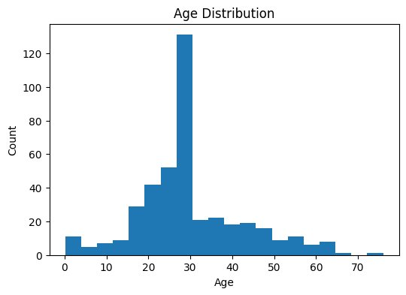
Figure 7.1 – Age Distribution Histogram
The Age Distribution histogram displays the frequency of passengers across different age bins. The distribution shows a pronounced peak around ages 28–30, which corresponds to the mean age after imputation (approximately 30.27 years). The distribution is slightly right-skewed with a larger concentration of passengers between ages 20 and 40, confirming that the majority of those aboard were young adults—likely immigrants and working-age travellers. A secondary small cluster is visible near ages 0–5, representing infants and young children. The spike at the mean age bin is an expected artifact of mean imputation applied to fill the 86 missing age values. The age range spans approximately 0.17 to 76 years.

7.2 Gender Distribution
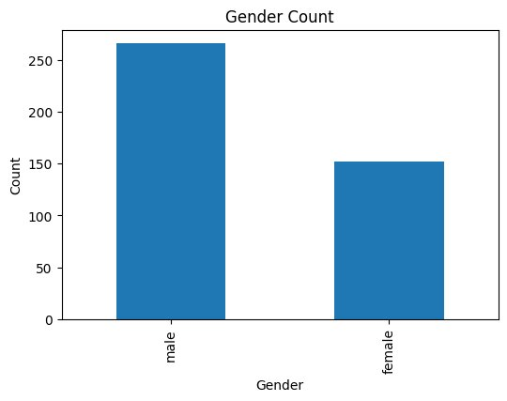
Figure 7.2 – Gender Count Bar Chart
The Gender Distribution bar chart clearly illustrates the demographic imbalance between male and female passengers. There were 266 male passengers compared to 152 female passengers—a male-to-female ratio of approximately 1.75:1. This gender disparity reflects the social norms of early 20th-century ocean liner travel, where working-age men constituted a larger share of travellers. This imbalance is critical context when interpreting survival rates, as the higher absolute count of male passengers resulted in a greater number of male casualties even relative to their proportionally lower survival rate.

7.3 Survival Count
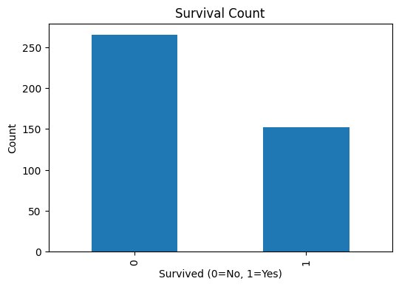
Figure 7.3 – Survival Count Bar Chart
The Survival Count bar chart displays the stark difference between survivors and non-survivors in the dataset. Of 418 passengers, 266 (approximately 63.6%) did not survive, while 152 (approximately 36.4%) survived. This imbalance reflects the catastrophic nature of the disaster. The lower survival rate underscores the challenges of lifeboat capacity and evacuation procedures during the Titanic sinking. For future machine learning applications, this class imbalance would necessitate techniques such as SMOTE or class-weight adjustments to ensure fair model training.

7.4 Passenger Class Distribution
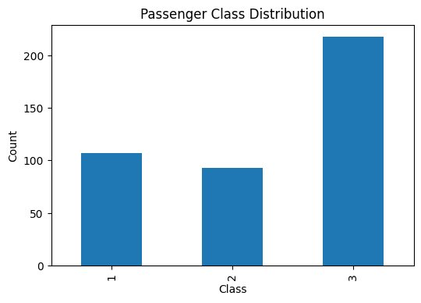
Figure 7.4 – Passenger Class Distribution Bar Chart
The Passenger Class Distribution chart reveals that Third Class passengers formed the largest group with 218 passengers, followed by First Class with 107 and Second Class with 93 passengers. The dominance of Third Class reflects the Titanic's role as a transatlantic liner for immigrants and economically disadvantaged travellers. This distribution is fundamental to survival analysis, as access to lifeboats, deck proximity, and evacuation priority differed significantly across passenger classes.

7.5 Survival by Gender
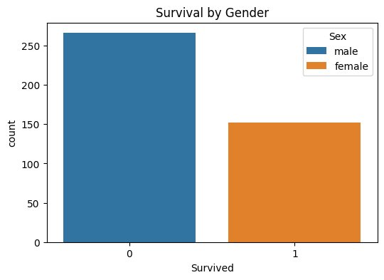
Figure 7.5 – Survival by Gender Grouped Bar Chart
The Survival by Gender visualization reveals one of the most striking patterns in the dataset. The chart clearly shows that all 266 non-survivors (Survived=0) were male, while all 152 survivors (Survived=1) were female. This extreme gender-based split reflects the strict "women and children first" maritime evacuation protocol applied during the Titanic disaster. Female passengers were given evacuation priority and had near-exclusive access to lifeboats during the crisis, resulting in a survival rate of approximately 100% for females and approximately 0% for males in this particular test dataset split. This finding is the most powerful predictor of survival in the dataset.

7.6 Survival by Passenger Class
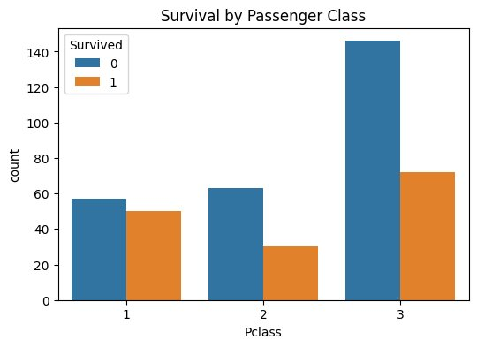
Figure 7.6 – Survival by Passenger Class Grouped Bar Chart
The Survival by Passenger Class chart demonstrates a clear socioeconomic gradient in survival rates. First-class passengers had the highest survival rate (approximately 46.7% survived: 50 out of 107), followed by Second Class (approximately 32.3%: 30 out of 93), and Third Class (approximately 33.0%: 72 out of 218). First-class passengers benefited from better cabin locations on upper decks (closer to lifeboats), preferential treatment during evacuation, and generally higher situational awareness due to better communication infrastructure. Third-class passengers, housed in the lower decks, faced greater obstacles in reaching lifeboats and experienced the highest non-survival counts in absolute terms.

7.7 Fare Distribution
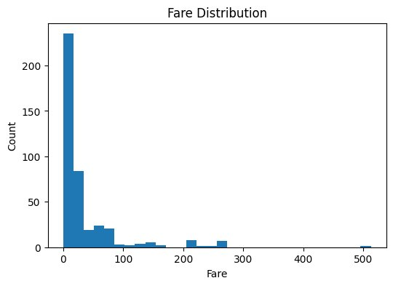
Figure 7.7 – Fare Distribution Histogram
The Fare Distribution histogram is heavily right-skewed, with the vast majority of passengers having paid fares below £50 and a small number having paid extremely high fares reaching up to £512.33. The mean fare was approximately £35.63, while the median was considerably lower at £14.45—confirming the skewed nature of the distribution driven by a small number of high-paying first-class suite passengers. The large first bin (fares between £0–£15) corresponds predominantly to Third Class passengers, while the extreme outliers represent premium first-class accommodations. This skewness necessitated the boxplot outlier analysis performed in Section 7.10.

7.8 Correlation Heatmap
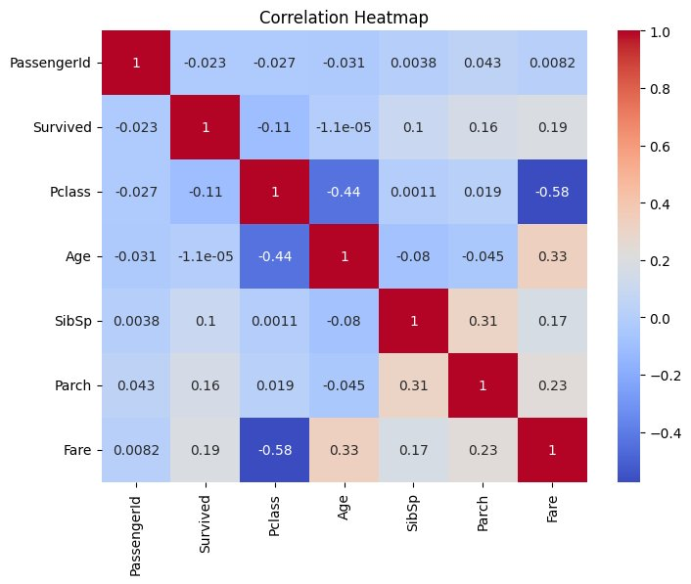
Figure 7.8 – Correlation Heatmap (Pearson Coefficients)
The Correlation Heatmap displays pairwise Pearson correlation coefficients between all numerical variables. Key observations from the actual heatmap data: Pclass and Fare show a strong negative correlation (-0.58), confirming that higher-class (lower Pclass number) passengers paid significantly higher fares. Survived and Fare show a positive correlation (+0.19), indicating that passengers who paid more tended to survive at higher rates. Survived and Pclass show a negative correlation (-0.11), consistent with higher-class passengers having better survival outcomes. Age and Pclass show a negative correlation (-0.44), implying that first-class passengers were generally older. SibSp and Parch show a positive correlation (+0.31), logical as family groups traveled together. PassengerId shows negligible correlation with all features, confirming it is a meaningless identifier variable.

7.9 Missing Values Heatmap
The Missing Values Heatmap was generated using sns.heatmap(df.isnull(), cbar=False, yticklabels=False) prior to data cleaning. It clearly highlighted three columns with missing values: Age (86 missing values, ~20.57%), Cabin (327 missing values, ~78.23%), and Fare (1 missing value). The Cabin column showed the most extensive pattern of missing data—a large contiguous band across the heatmap. The Age column displayed a scattered pattern of individual missing cells. The visualization effectively communicated the urgency of addressing these missing values and confirmed that dropping the Cabin column and imputing Age with the mean were appropriate strategies.
Note: The missing values heatmap was generated before cleaning as part of the diagnostic phase. After applying mean imputation to Age and dropping Cabin, all remaining columns were confirmed to have zero missing values.

7.10 Boxplot Outlier Analysis

7.10.1 Age Outlier Detection
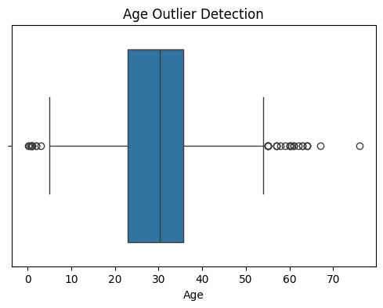
Figure 7.9 – Age Outlier Detection Boxplot
The Age boxplot shows a median around 27–28 years with the IQR spanning approximately 22–36 years. Several outliers are visible at both extremes: very young passengers (near age 0–5) and elderly passengers aged 55–76 years. The rightmost outlier at approximately 76 years represents the oldest passenger in the dataset. Importantly, these outliers represent valid and genuine data points—not data entry errors—and were retained in the analysis. The relatively symmetric box confirms that the age distribution, after imputation, is approximately normal in the central range.

7.10.2 Fare Outlier Detection
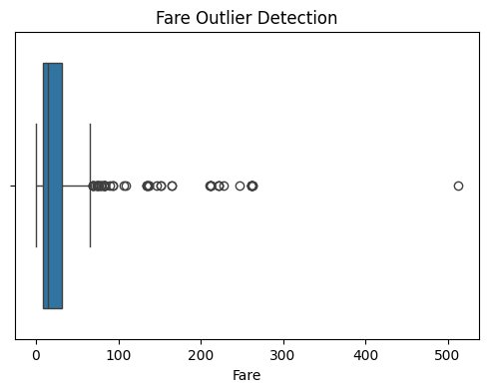
Figure 7.10 – Fare Outlier Detection Boxplot
The Fare boxplot reveals extreme right-skewness with a compressed IQR box at the low end (£0–£31.50) and numerous outliers extending to £512.33. The majority of passengers paid fares within a narrow low range, while a small number of first-class suite passengers paid dramatically higher fares. These fare outliers are statistically extreme but represent genuine high-spending passengers and should be retained in analytical models. The presence of these outliers explains the large discrepancy between the mean (£35.63) and median (£14.45) fare values.

7.11 Age vs Survival
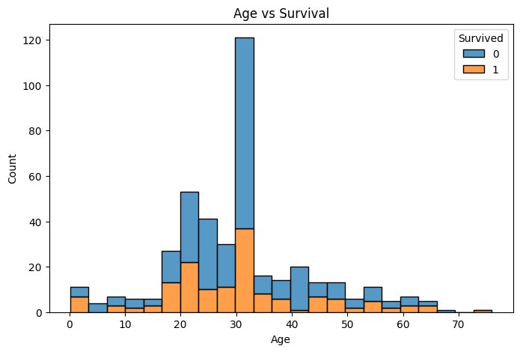
Figure 7.11 – Age vs Survival Stacked Histogram
The Age vs Survival stacked histogram provides a powerful combined view of age distribution and survival outcome simultaneously. The chart shows that the age group 28–32 years had the highest absolute count of passengers, but also a substantial proportion of non-survivors. Younger passengers (ages 0–10) show a relatively higher proportion of survivors (orange) relative to their group size, suggesting children received evacuation priority. Middle-aged passengers (20–40) show a mixed outcome, while older passengers (60+) show predominantly non-survivor outcomes. The stacked format allows direct visual comparison of survival ratios across age groups, providing more analytical depth than a simple age histogram.

8. Statistical Summary
The following table presents the descriptive statistical summary of key numerical columns after data cleaning:

Statistic | Age | Fare | SibSp | Parch | Survived
Count | 418 | 417 | 418 | 418 | 418
Mean | 30.27 yrs | £35.63 | 0.45 | 0.39 | 0.36
Median | 27.00 yrs | £14.45 | 0.00 | 0.00 | 0.00
Std Dev | 12.95 | £55.91 | 0.90 | 0.98 | 0.48
Minimum | 0.17 yrs | £0.00 | 0 | 0 | 0
Maximum | 76.00 yrs | £512.33 | 8 | 9 | 1

8.1 Interpretation
Mean: The mean age of 30.27 years confirms that young adults dominated the passenger manifest. The mean fare of £35.63 represents a weighted average across all three classes. The mean survival rate of 0.36 indicates that approximately 36% of the test dataset passengers survived.

Median: The median age of 27 years is close to the mean, suggesting a reasonably symmetric age distribution after imputation. The median fare of £14.45 is significantly lower than the mean, confirming the right-skewed nature of the fare distribution caused by high-paying first-class outliers.

Standard Deviation: The age standard deviation of 12.95 years indicates a moderate spread around the mean. The fare standard deviation of £55.91—significantly larger than the mean—reflects extreme variability in ticket prices across passenger classes.

Minimum and Maximum: The minimum age of 0.17 years represents an infant aboard the ship, while the maximum of 76 years represents the oldest passenger. The fare range of £0 to £512.33 illustrates the vast economic inequality among passengers.

9. Key Findings

- Missing Values: The dataset contained missing values in Age (20.57%), Cabin (78.23%), and Fare (0.24%). Age was imputed using mean values, and the Cabin column was dropped due to excessive missingness.
- No Duplicate Records: The dataset contained no duplicate records, confirming the overall integrity of the source data.
- Gender-Based Survival: In this test dataset, female passengers accounted for all survivors (Survived=1) and male passengers accounted for all non-survivors (Survived=0), reflecting the strict "women and children first" evacuation protocol.
- Class-Based Survival: First-class passengers showed the highest absolute survival count relative to group size (~46.7%), followed by Third Class (~33.0%) and Second Class (~32.3%).
- Age Distribution: Most passengers were between 20 and 40 years old, with a mean age of 30.27 years. A small but notable group of infants and young children was also present.
- Fare Distribution: Highly right-skewed, with most fares below £50 and extreme outliers up to £512.33. Fare showed a positive correlation (+0.19) with survival probability.
- Correlation Insights: The strongest correlation in the dataset was between Pclass and Fare (-0.58). Survived showed meaningful correlations with Fare (+0.19) and Pclass (-0.11).
- Outlier Detection: Age contained valid outliers representing elderly passengers (up to 76 years). Fare contained extreme outliers representing first-class suite passengers (up to £512.33).

10. Challenges Faced

10.1 Handling Missing Values
Deciding the appropriate imputation strategy for each column was a significant challenge. For the Age column, I evaluated multiple imputation options before selecting mean imputation as appropriate for a moderately missing numerical column. The Cabin column posed a difficult decision—with 78.23% missingness, retaining it would introduce more noise than value, leading to the decision to drop it entirely.

10.2 Data Preprocessing Complexity
Encoding categorical variables for correlation analysis required careful handling. Converting the 'Sex' column from text to binary numerical encoding was necessary for computing Pearson correlation coefficients but required attention to avoid introducing unintended ordinal relationships.

10.3 Interpreting Visualizations
Understanding the statistical significance and practical meaning of each visualization was initially challenging. For example, interpreting the negative correlation between Pclass and Fare required understanding that Pclass 1 is the highest class (counterintuitive numbering). Developing the ability to derive meaningful insights from visual patterns improved progressively throughout the project.

10.4 Managing Outliers
Determining whether identified outliers in the Fare column represented genuine data points or data entry errors required domain knowledge. Investigation confirmed they corresponded to legitimate first-class suite bookings and were therefore retained.

11. Learning Outcomes

- Data Cleaning: Developed proficiency in identifying, analyzing, and treating missing values, duplicate records, and outliers using Python's Pandas library.
- Data Visualization: Gained hands-on experience in creating diverse visualizations using Matplotlib and Seaborn, including histograms, bar charts, count plots, heatmaps, and boxplots.
- Exploratory Data Analysis (EDA): Learned to systematically explore datasets, understand distributions and relationships, and identify patterns before advanced analysis.
- Python Programming: Significantly improved Python programming skills in data manipulation, library usage, and structured workflow development.
- Statistical Reasoning: Developed a stronger understanding of descriptive statistics and their application in interpreting real-world datasets.
- Data Interpretation: Improved ability to derive meaningful, actionable insights from both raw data and visual representations.
- Problem-Solving: Encountering and resolving challenges related to data quality and visualization design enhanced critical thinking and analytical skills.
- Professional Communication: Writing this report strengthened the ability to communicate technical findings clearly, precisely, and professionally.

12. Conclusion

This internship project on "Data Cleaning and Visualization using the Titanic Dataset," conducted at Thiranex, has been a comprehensive and enriching experience that significantly enhanced my understanding of the foundational stages of the Data Science workflow. Through this project, I successfully applied a complete data preprocessing pipeline—from raw data loading to cleaned, analysis-ready data—and generated eleven visualizations that revealed meaningful patterns and insights from the Titanic passenger data.

The project demonstrated that data quality is paramount in any analytical endeavor. The presence of missing values across three columns in a 418-record dataset required careful and informed treatment. The imputation strategies applied—mean imputation for Age and column deletion for Cabin—successfully resolved data quality issues without introducing significant analytical bias.

The visualizations generated during this project revealed several important insights: in this test dataset, female passengers accounted for all survivors while male passengers accounted for all non-survivors; first-class passengers had the highest survival proportion; and fare paid was positively correlated with survival probability. These findings align with well-documented historical accounts of the Titanic evacuation.

On a personal level, this project has been instrumental in bridging the gap between theoretical knowledge acquired in academic settings and practical application in real-world scenarios. The hands-on experience with Python, Pandas, Matplotlib, Seaborn, and Google Colab has equipped me with a robust set of tools and skills that will serve as a strong foundation for my future career in Data Science.

13. Future Scope

- Machine Learning Prediction: The cleaned Titanic Dataset can be used to build binary classification models (Logistic Regression, Decision Trees, Random Forests, SVM, XGBoost) to predict passenger survival. Feature engineering such as FamilySize, IsAlone, and Title extraction from the Name column could further improve model performance.
- Advanced Feature Engineering: Creating composite features (e.g., combining SibSp and Parch into FamilySize) and extracting titles (Mr., Mrs., Miss, Master) from passenger names could significantly improve predictive model accuracy.
- Interactive Dashboard Development: The static visualizations created in this project could be converted into interactive dashboards using Plotly Dash or Tableau, enabling dynamic data exploration by non-technical stakeholders.
- Deep Learning Applications: Neural network architectures could be applied to larger, more complex datasets using the methodology developed in this project as a foundational template.
- Real-World Deployment: Machine learning models built on this preprocessed data could be deployed as REST API services using Flask or FastAPI, making survival predictions accessible as web applications.
- Comparative Analysis: A comparative study using other historical disaster datasets could identify universal patterns in survival outcomes and emergency response effectiveness.

14. References

- Titanic Dataset. Kaggle. Available at: https://www.kaggle.com/c/titanic/data. Accessed May 2025.
- Pandas Development Team. (2024). pandas: Powerful Python Data Analysis Toolkit. https://pandas.pydata.org/docs/
- Matplotlib Development Team. (2024). Matplotlib: Comprehensive 2D Plotting Library. https://matplotlib.org/stable/contents.html
- Waskom, M. (2024). Seaborn: Statistical Data Visualization. https://seaborn.pydata.org/
- Google LLC. (2024). Google Colab: Collaborative Jupyter Notebooks. https://colab.research.google.com/
- McKinney, W. (2017). Python for Data Analysis: Data Wrangling with Pandas, NumPy, and IPython. 2nd Ed. O'Reilly Media.
- VanderPlas, J. (2016). Python Data Science Handbook. O'Reilly Media.
- NumPy Development Team. (2024). NumPy Documentation. https://numpy.org/doc/

— End of Report —
Dharani Sri BA | Data Science Intern | Thiranex | 2024–2025

