Installation Of Simplicity Studio 5 IDE and Compilation of Source Code

Table Of Content

1. Download and Install Simplicity Studio 5 IDE 3
2. Build and flashing Procedure

Download and Install Simplicity Studio 5 IDE
To Download the offline Simplicity studio 5 IDE we have to register into Silicon lab Website with the below link:
(note: we have provided the iso file which we have used)
http://www.silabs.com/

Step1:
Go to account home by highlighting the person icon and selecting Account Home.

Step2:
Click Support in the upper right and select Simplicity Studio.

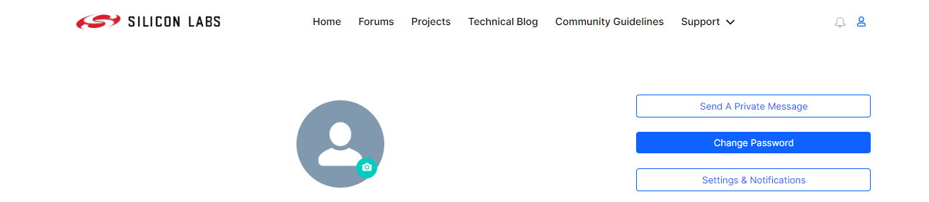

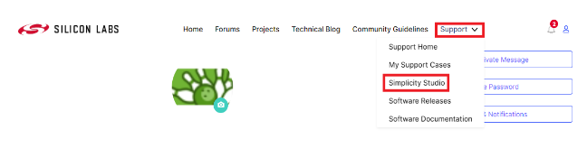

Step3:
After selecting simplicity studio the window will appear as below and to select the offline installers, click the All Software link and select Offline Installers and then the Filter button. This is the list of offline installers.

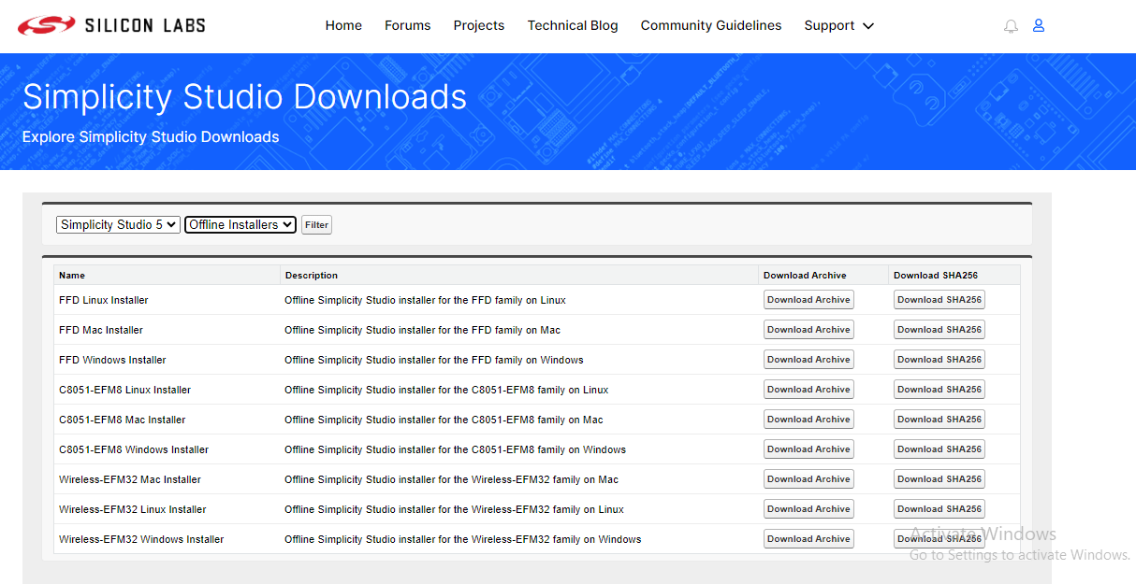

Step4: click the Download Archive for desired Software (We have downloaded Wireless-EFM32 Windows Installer Offline Simplicity Studio installer for the Wireless-EFM32 family on Windows).
The Windows package is an '.iso' disk image.

If one of the Wireless-EFM32 installers was used, it includes the latest GNU ARM tool chain, but since the Gecko SDK (GSDK) is hosted on GitHub, no GSDK is included in the offline installer. The GSDK must be cloned or the zip file downloaded from the GitHub site:https://github.com/SiliconLabs/gecko_sdk

(note: we provided the gecko_sdk package which we have used)

It can be added to a Simplicity Studio installation with Preferences -> Simplicity Studio -> SDKs -> Add... and then browsing to the expanded 'gecko_sdk' folder. A popup will be displayed asking you to Trust the Gecko SDK and after trusting the SDK it will be ready to use with Simplicity Studio.

Step5:
After the package finishes downloading, double-click it to mount the iso image as a drive and then double-click the setup.exe file inside the drive to launch the installer.

Step6:
When the SSv5 installer first launches, it presents a Simplicity Studio License Agreement dialog. Accept the terms of the agreement and click Next >.

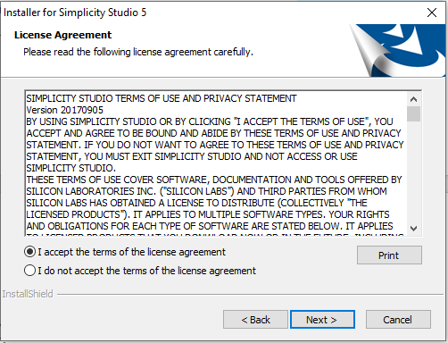

Step7:
Choose a destination location, click Next >, and then click Install.
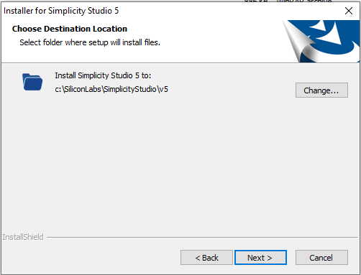

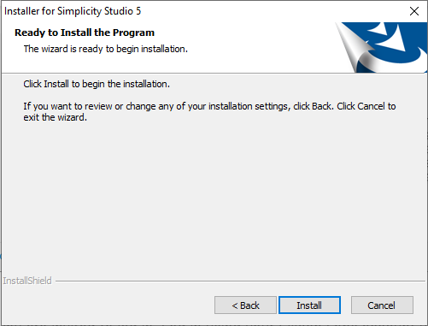

Step8:
When SSv5 launches, you are presented with one or more additional license agreements. You can accept them individually or all at once. Click on Done when finished.
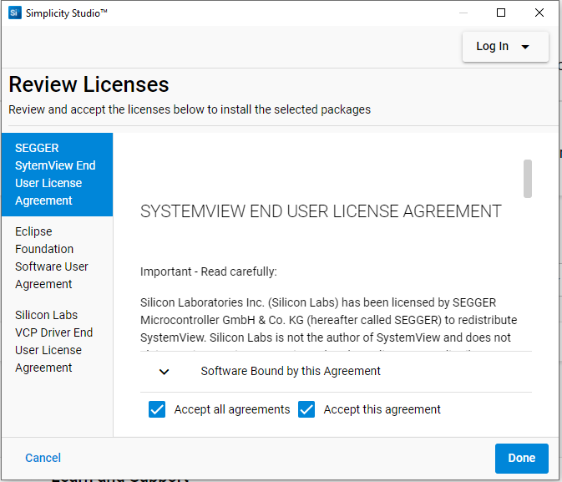

Step 9:
After Clicking done You will get the software window as below:

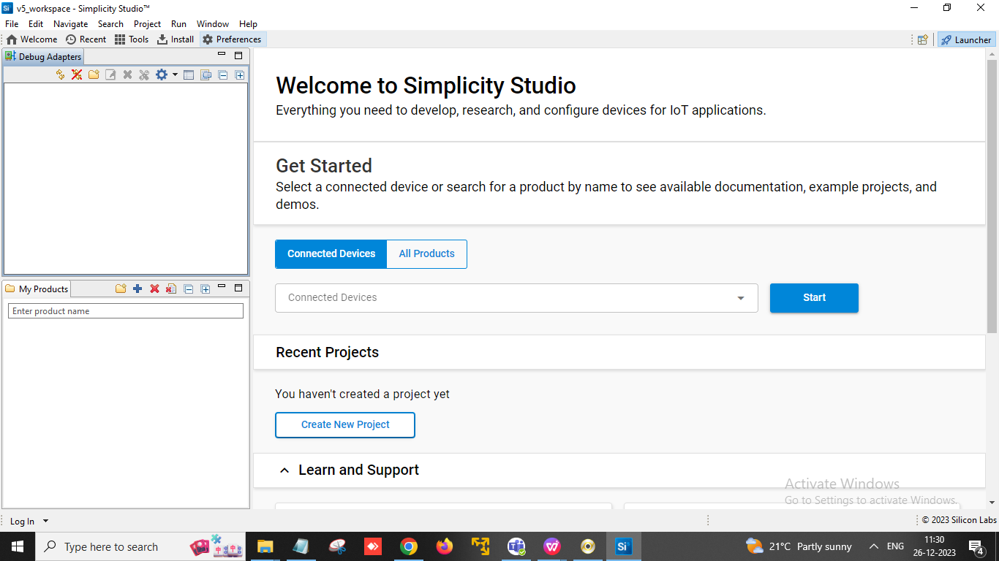
After you need to login with silicon lab account.You can log in by clocking log in prompt given in the above picture(in software window left below corner). and a popup will appear as below.
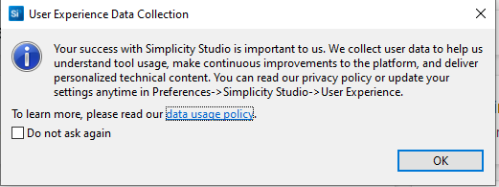
Step10: Click on install and you will get the window as below:
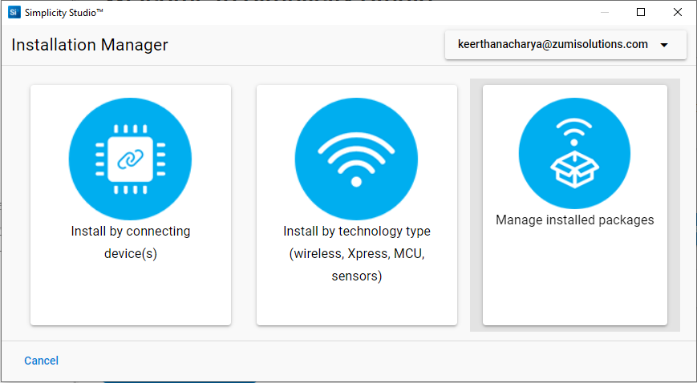

Step 11: Software install:
After SSv5 installation is complete, you are prompted to install software packages, such as the Gecko SDK (GSDK). SSv5 offers two options:
- Install by Connecting Device(s)
- Install by Technology Type
You do not need to have a target device connected to install by Technology Type. Click Install by Technology Type.(we have followed Install by Technology type steps).
Select the technology(s) to install and click NEXT. To install the Gecko SDK Suite, select 32-Bit and Wireless MCUs. The Matter Enablement Package is automatically selected when you select the GSDK.

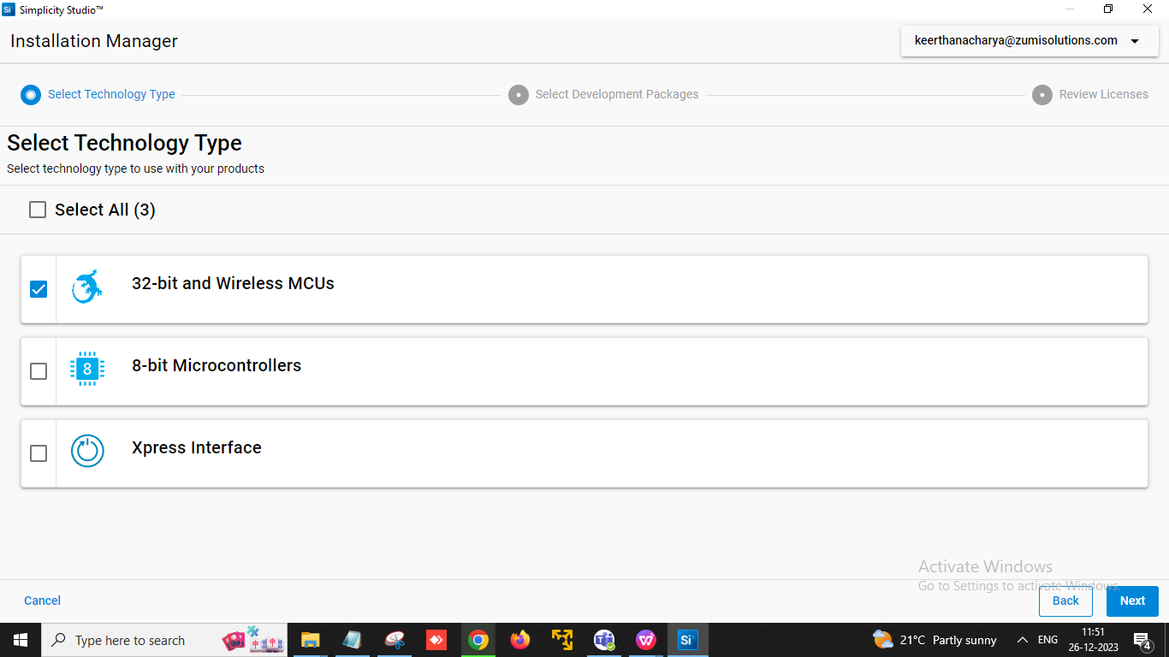

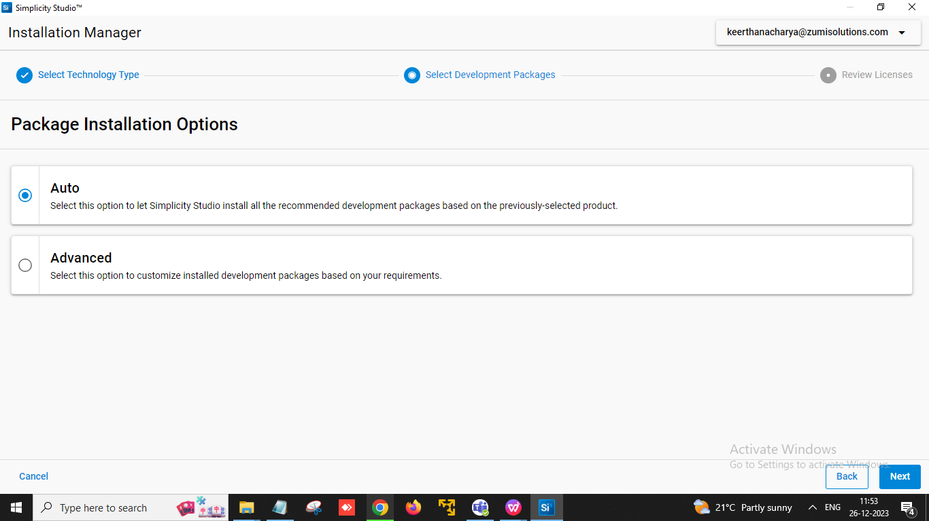
You have two installation options, Auto and Advanced
Step12: Select Auto to have SSv5 automatically download all packages related to the selected technologies and to which you have permissions based on your login.
(Select Advanced to select which packages you want to install.If you selected Advanced, all 'Required' packages must be installed. NOTE: Do not exclude packages unless you understand the full effect of the decision. Click Read More to see release notes for each item. Optionally change the default installation location for the Gecko SDK. The GSDK installs as a clone of a GitHub repository. Do not select an existing folder with other content already in it, as your cloned repository will no longer be clean. The Matter Enablement Package is automatically selected when you select the GSDK.)
Step13: Before installation begins, accept one or more software license agreements.
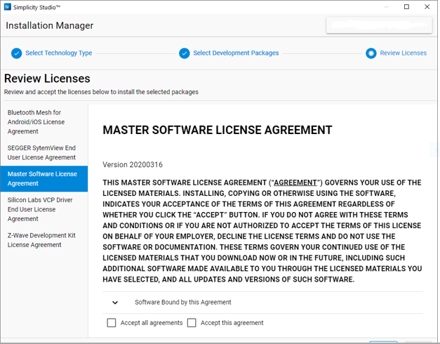
Once you click NEXT, installation begins.
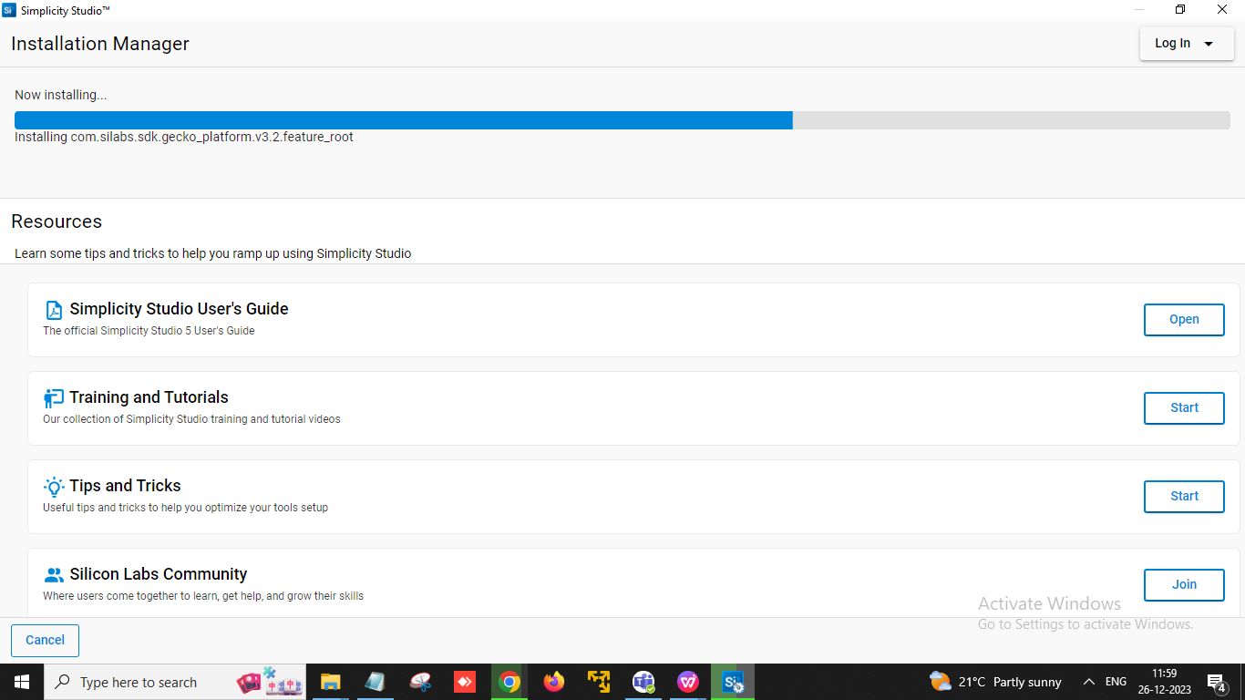
Depending upon your selections, installation may take some time. The progress bar may pause at points where large files are being installed, but will resume as they complete. If there is a problem during installation, SSv5 displays an error. You must restart SSv5 to resume.
When installation is complete, click CLOSE
Click RESTART to begin working with projects.
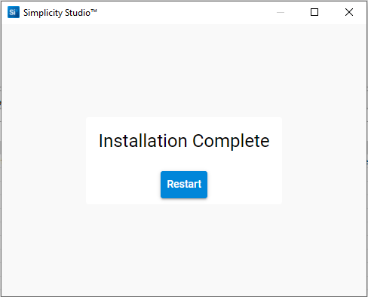
Step14: To select the proper tool chain we have to install the proper tool chain in our case it is GNU ARM Tool chain (v12.2.rel1.2023.7) - 12.2.2023 .10. To install this tool chain we have to click on install and you will get the window as shown below.
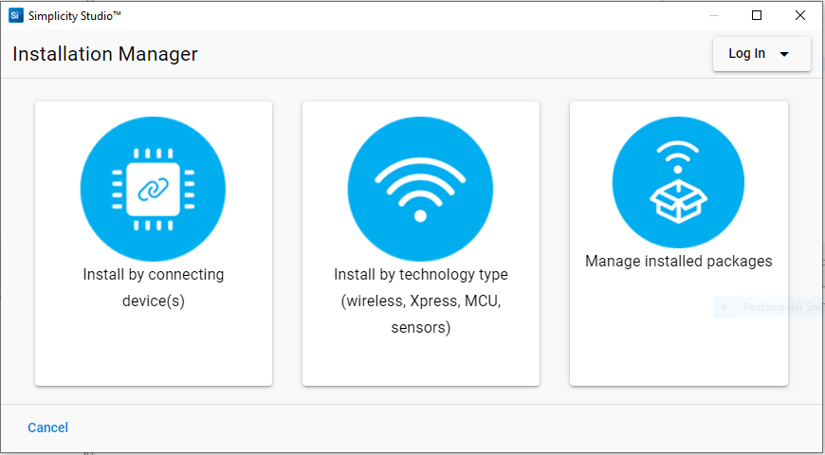
Step15: Select Manage installed packages,Then click on tool chain and install tool chain(GNU ARM Tool chain (v12.2.rel1.2023.7) - 12.2.2023 )

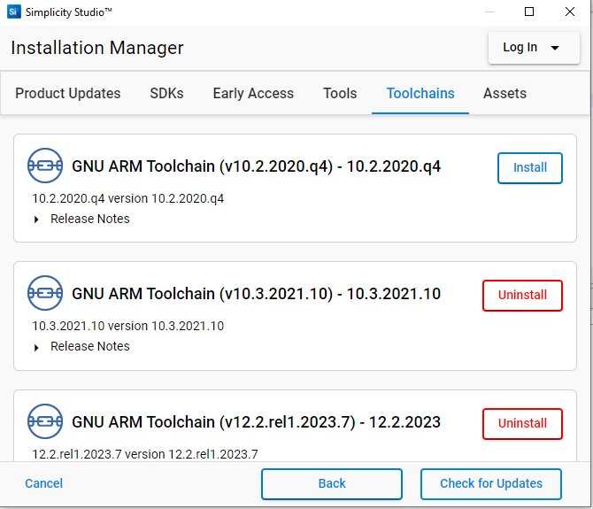

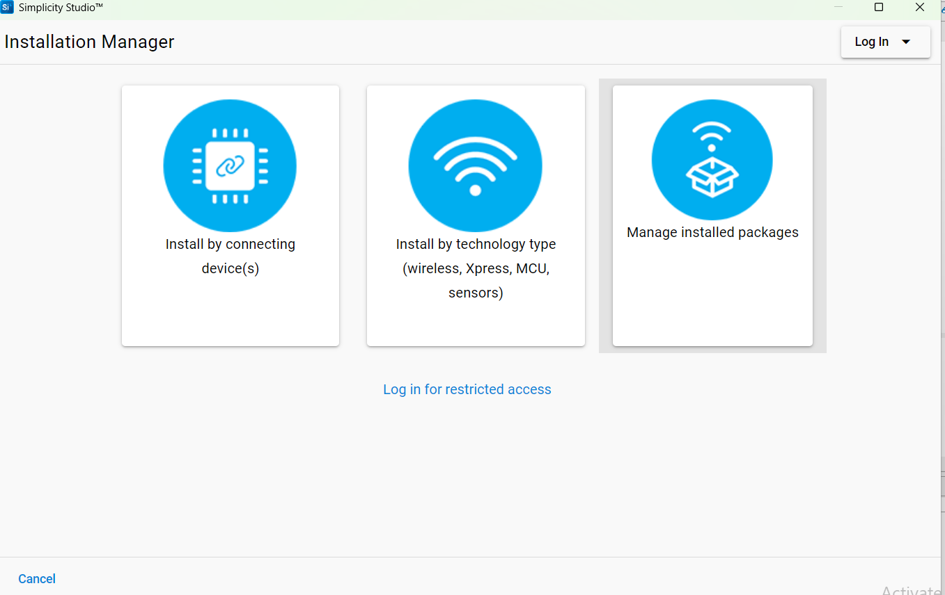
Step16: For SDK installtion Go to Help in that click Update software and thenbelow window will open click Manage Installed Package. The below window open in that selext SDKs by go to simplicity Studio Sdk there by default it will be 2025.6.1 version so we need to change version to 2024.12.1.0

Step17: Click change Version the below window will open there we select 2024.12.1.0 and click finish. It take sometime to download.
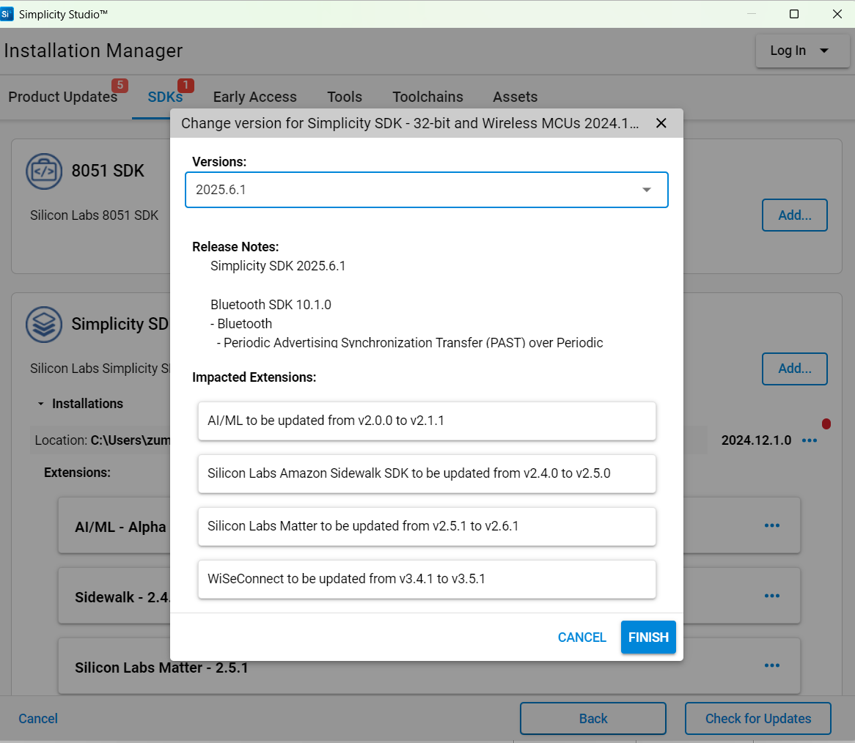

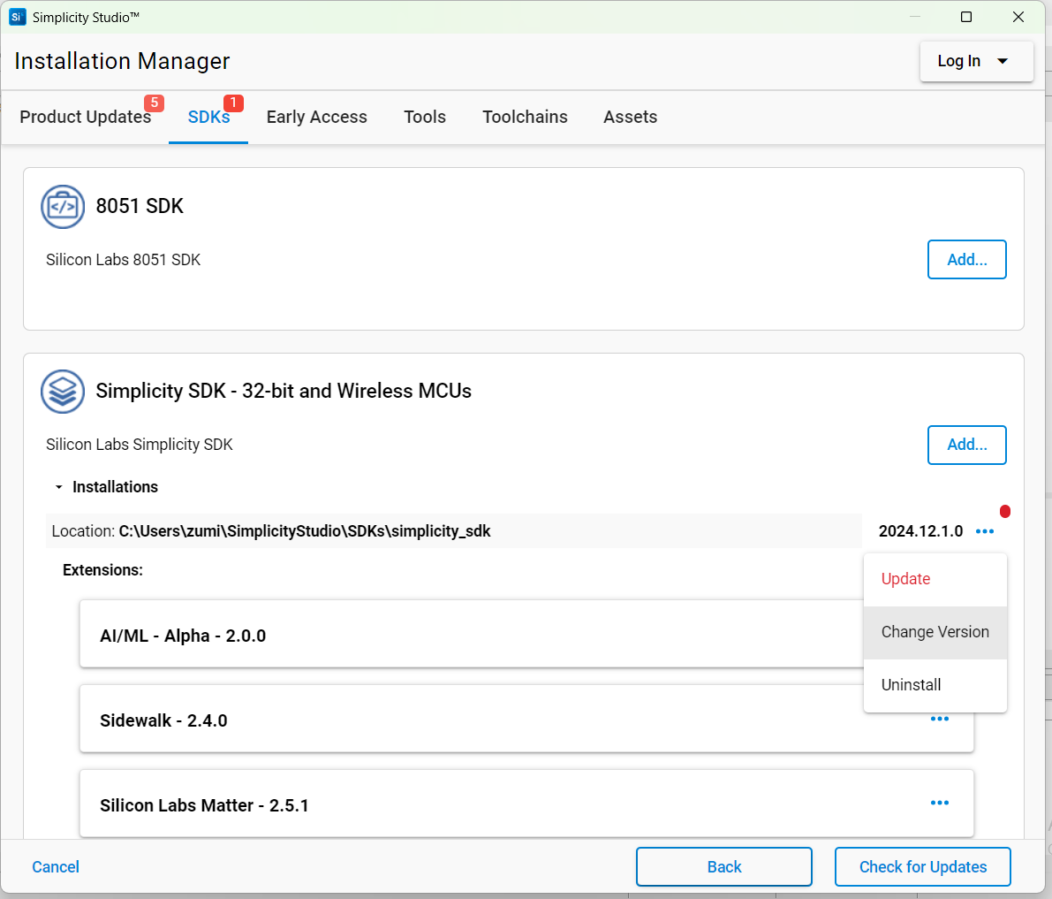

Step18: SDK is Selected
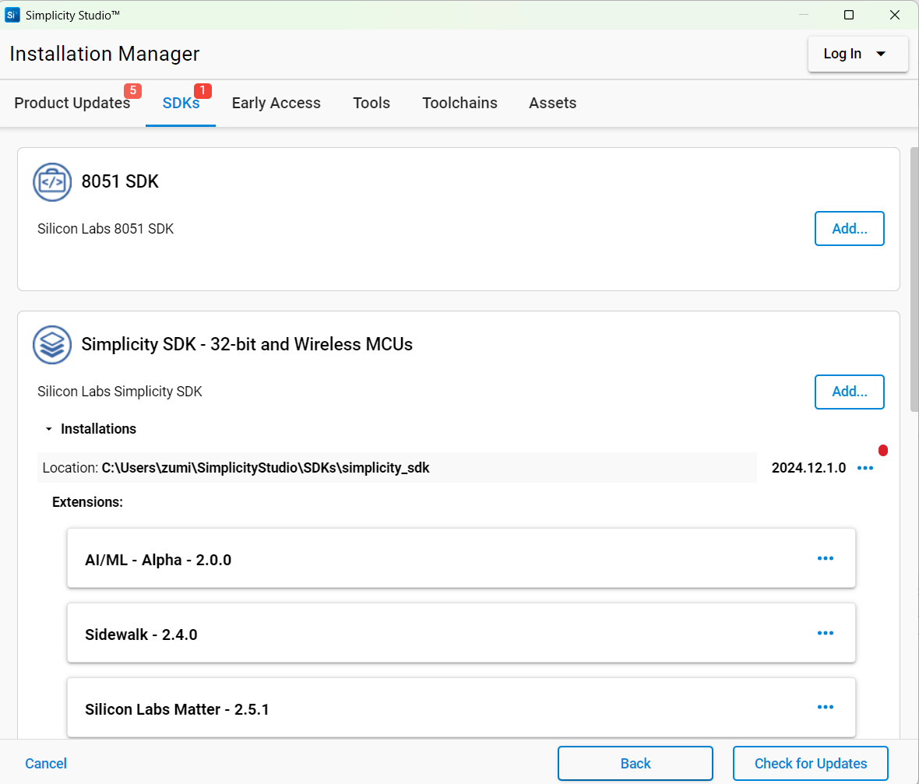

2. Build and flashing Procedure

Step1: Open the Simplicity studio 5 IDE click on file then select switch workspace
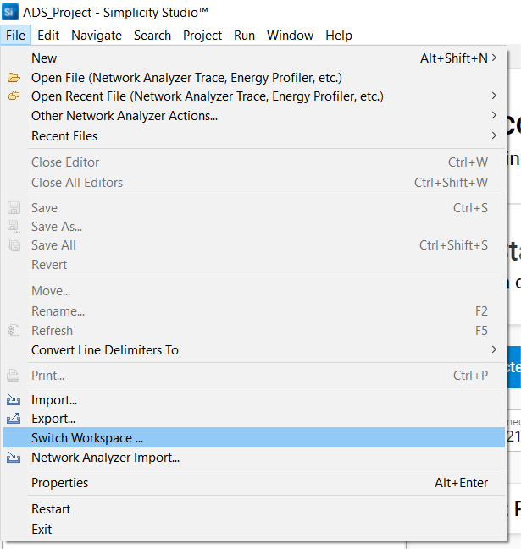

Step2: Once you click the “Switch Workspace”, the below screen will appear in the screen. Now you can create the new Workspace and add the project into this workspace.
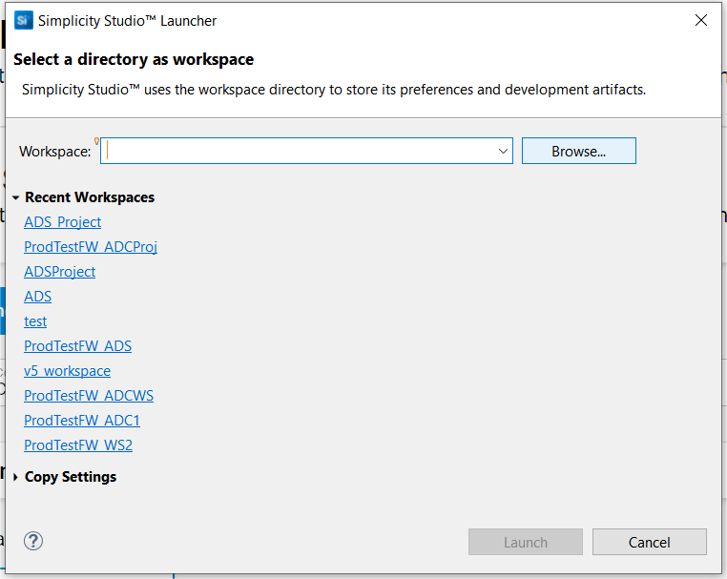

Create your own directory for the new Workspace and copy the Project to this workspace directory.

Step3: Select your own directory for the Workspace to be created and Click launch
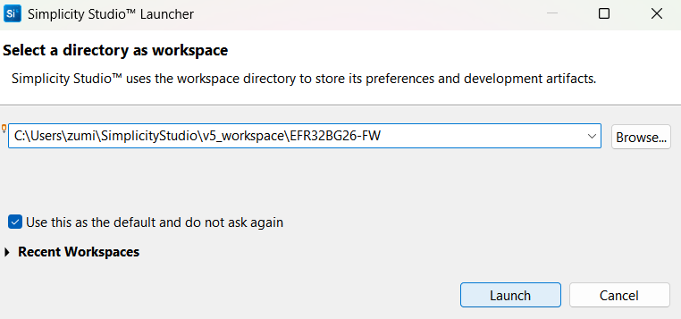

Once this step is Over, you will get the Simplicity Studio main windows with the new workspace name.

Step4: Click File Menu and click on file then select import shown below.
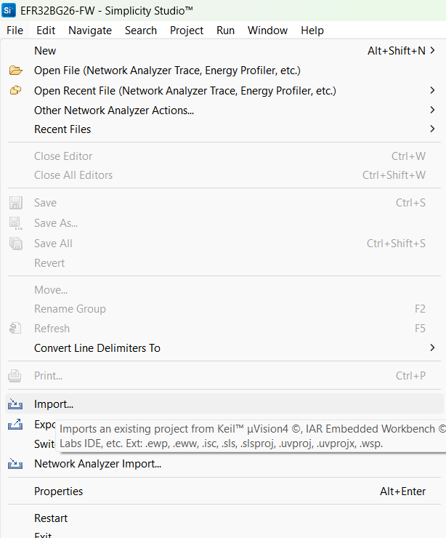

Step5: Goto the new Workspace directory and select the Project folder.

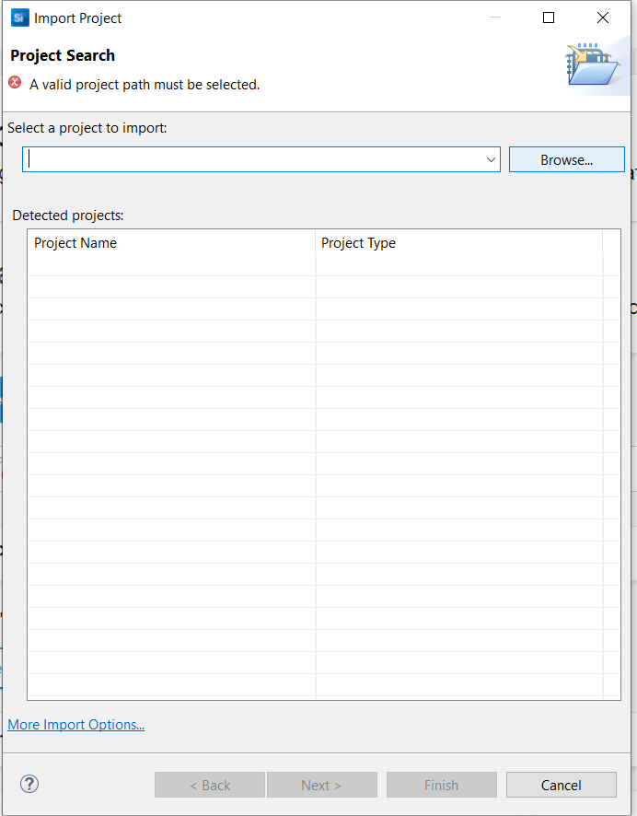

Once you selected the Project folder, you will get the below screen and here select the .sls extension and click Next
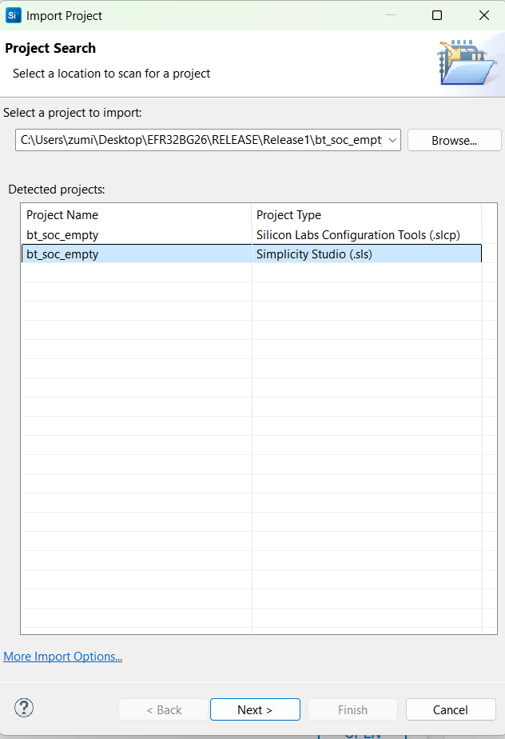

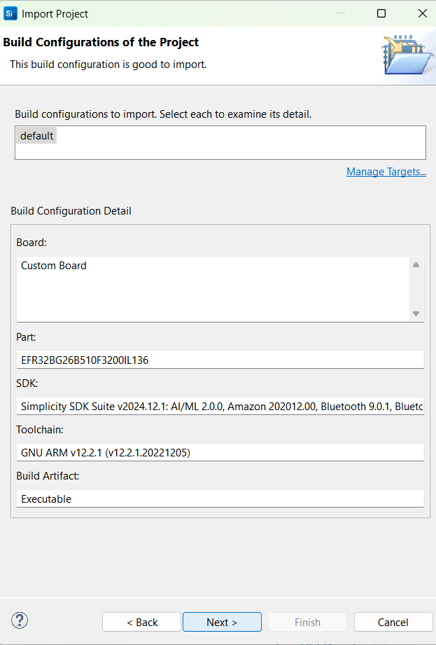
Step6: After selecting project path in project search. Then click Manage Targets link for checking SDK Version and ToolChain.

Once you click the “Manage Targets” Link, the below window will open

Step7: In Targets window select GNU ARM v12.2.1

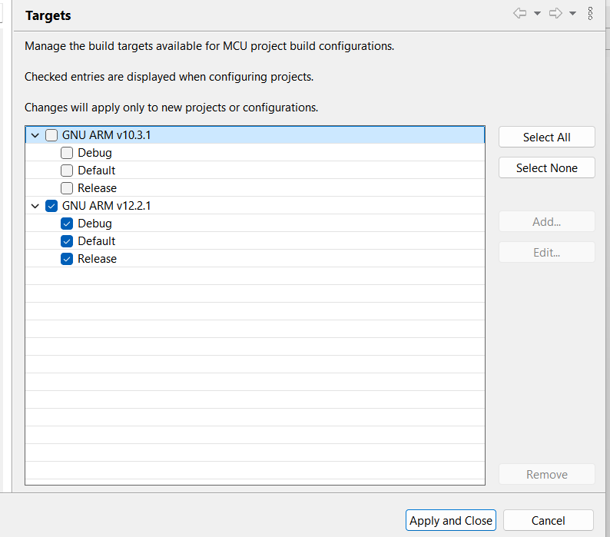

Step8: Now we need to Select the SDK, in that select Our Simplicity SDK v2024.12.1 and then click apply and close.

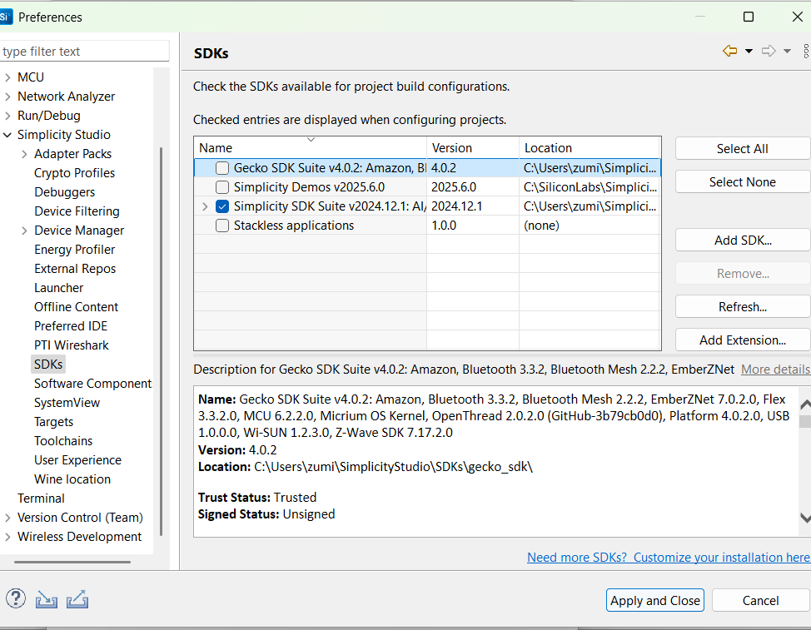

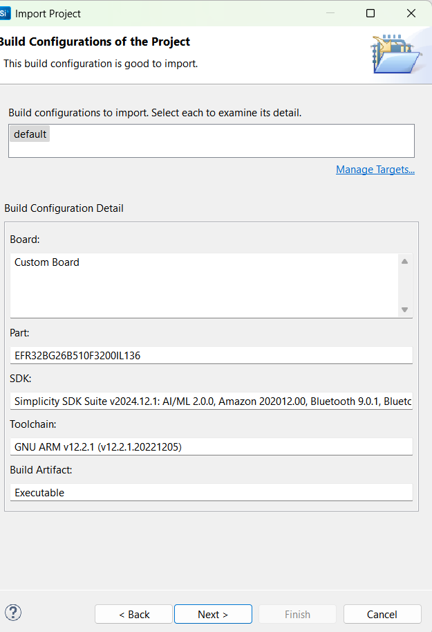

Step9: Give the same Project name and then click finish.
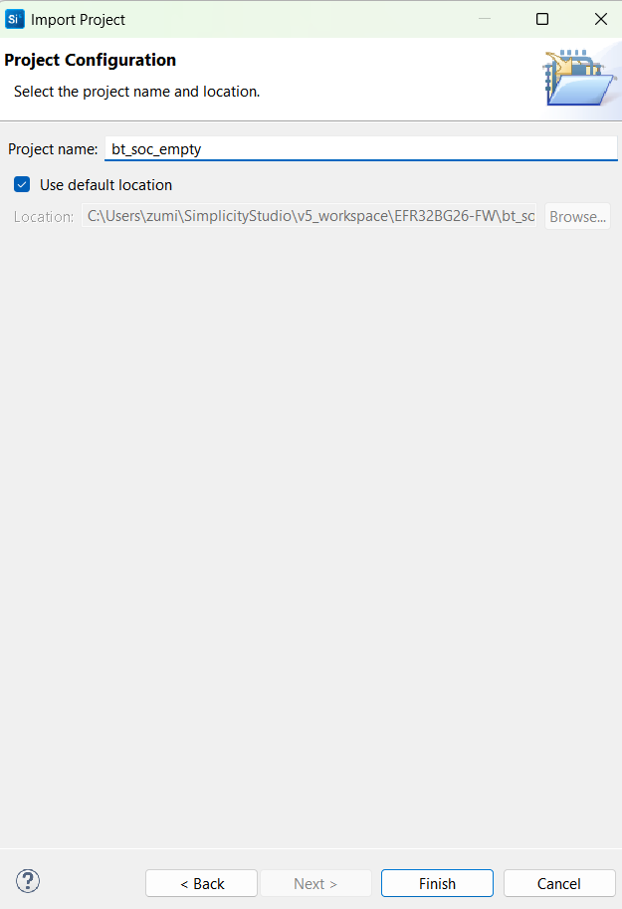

Step10: Then the below IDE will open.

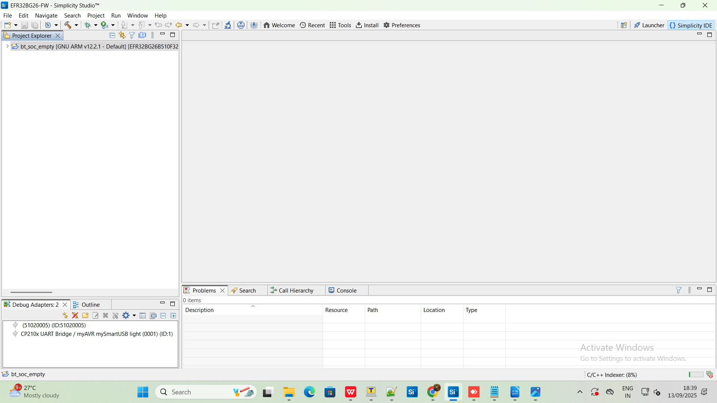
Step11: Right click on the project then click on Build project.

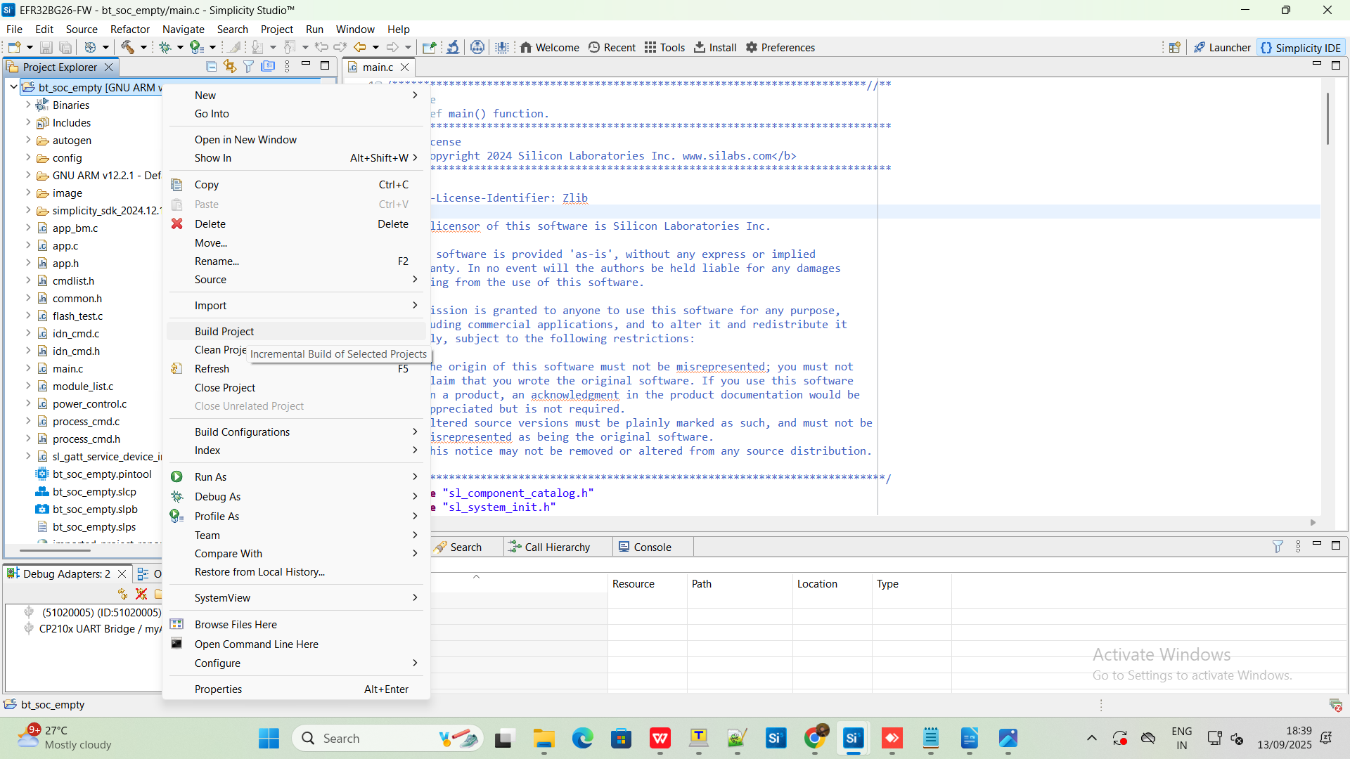

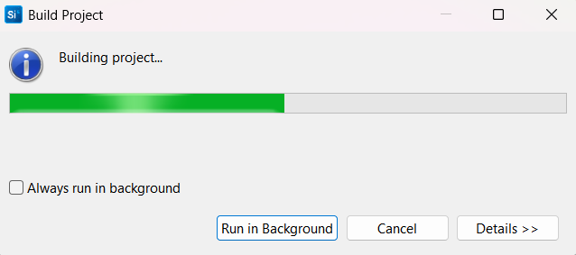

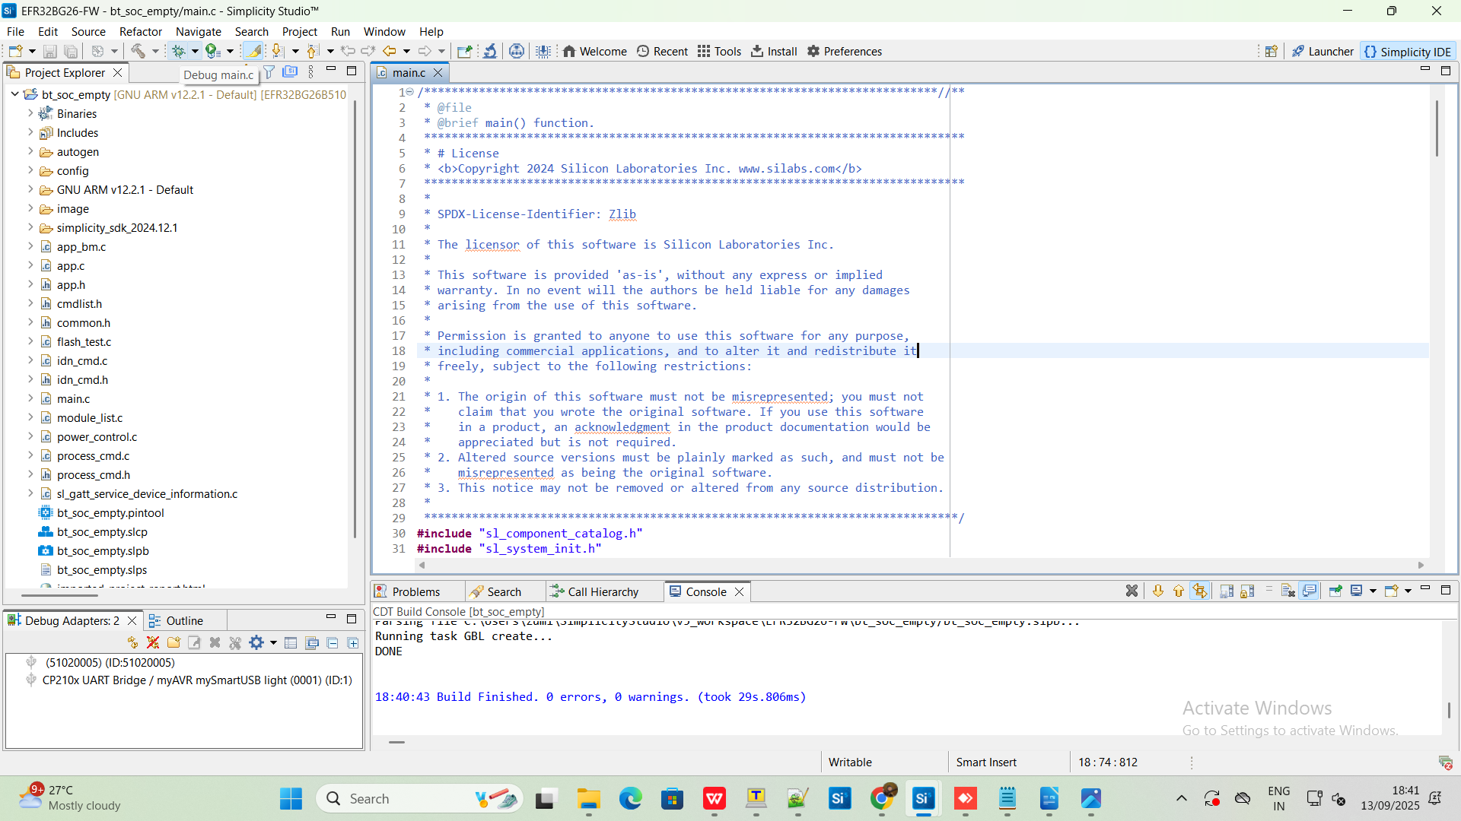

Step12: Once the build is successful, you will get the above screen. To flash the code into the device ,Connect the segger “J link” and debugger USB cable to the PC.

Step13: Power on the board. Click on the Debug symbol.
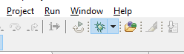
Step14: Device Selection windows will come appear and select the “J-Link” option click OK to flash the code.

