Binary Flashing Procedure

Step 1:
In the IDE, select TOOLS. In the Tools dialog, select Simplicity Commander.
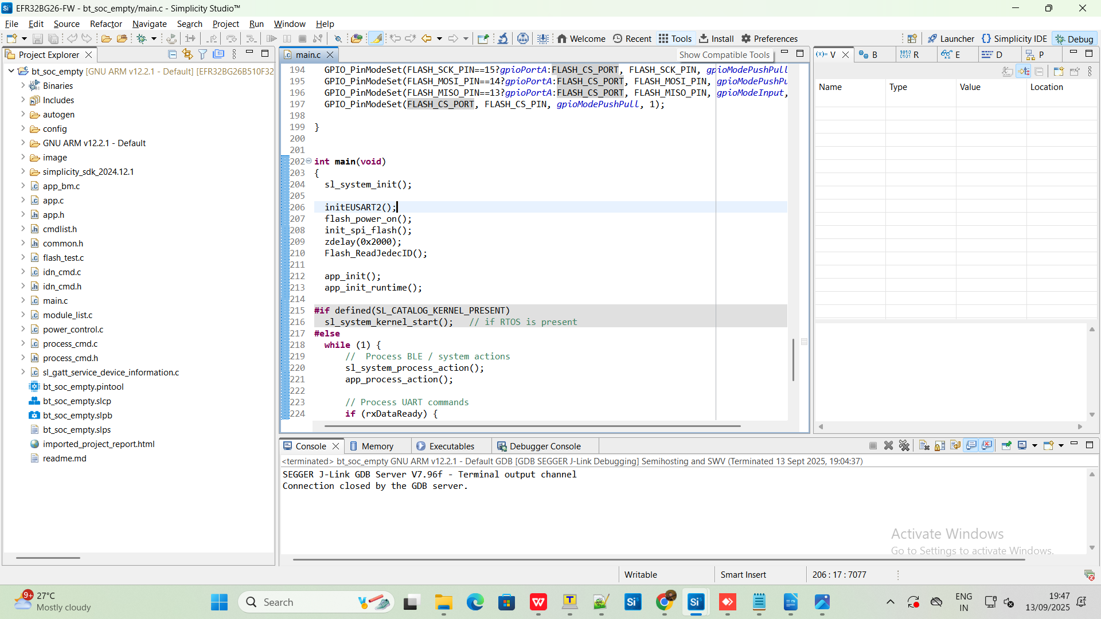

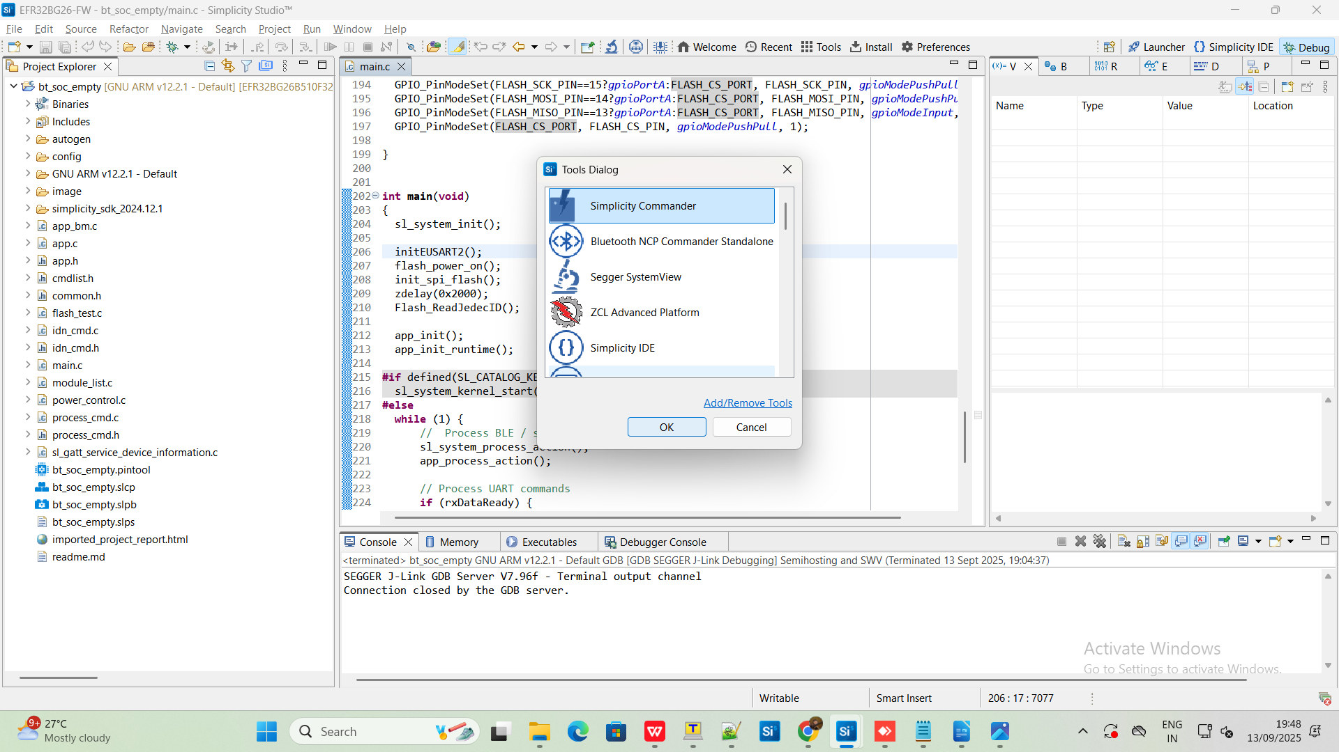

Step 2:
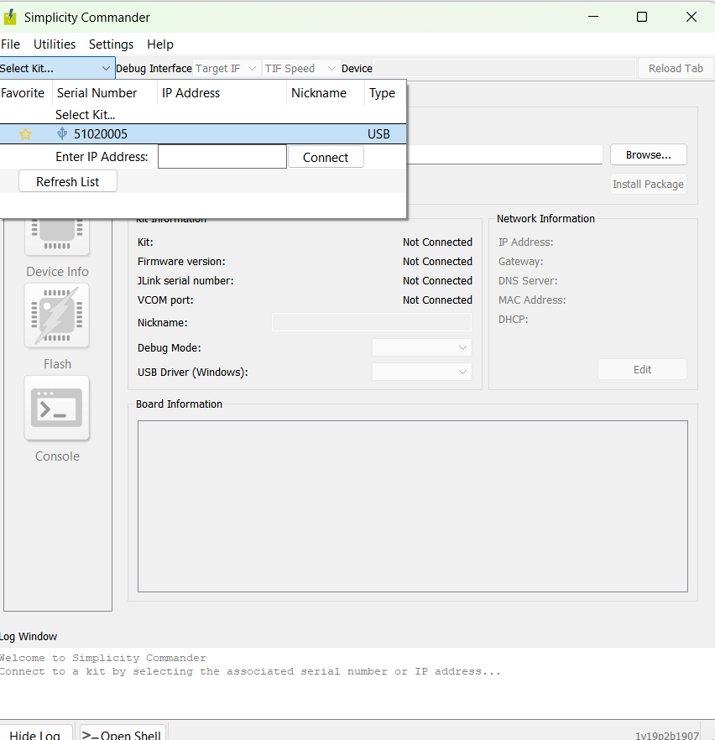
After selecting Simplicity Commander, select Kit. It will display your J-Link.

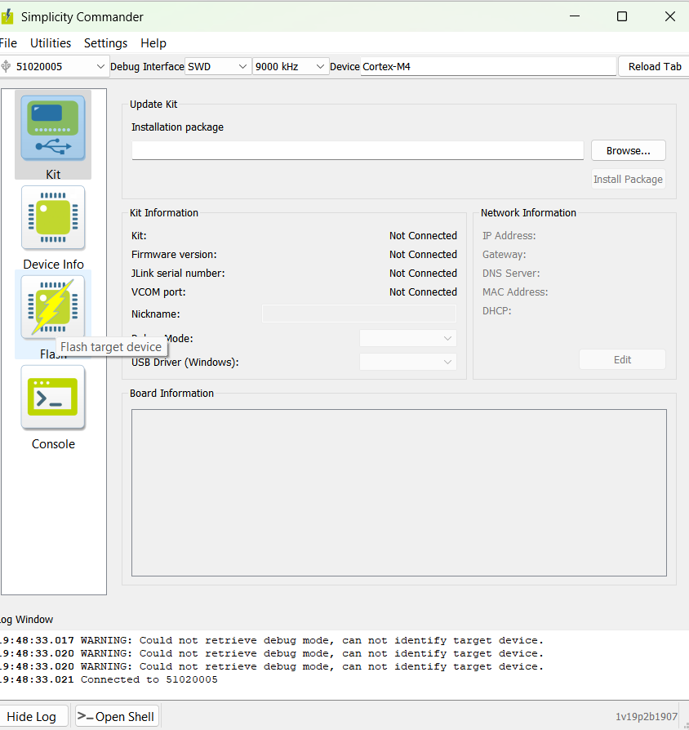

Step 3:
Next, select FLASH from the left column.

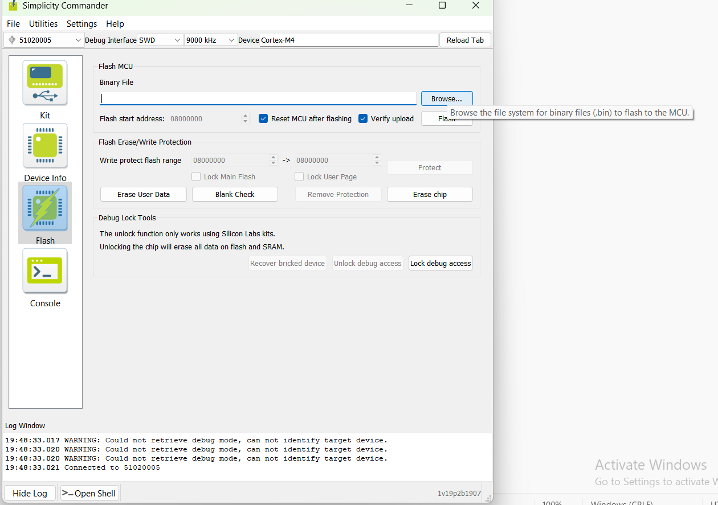

Step 4:
Browse and select the bt_soc_empty_2.bin file.
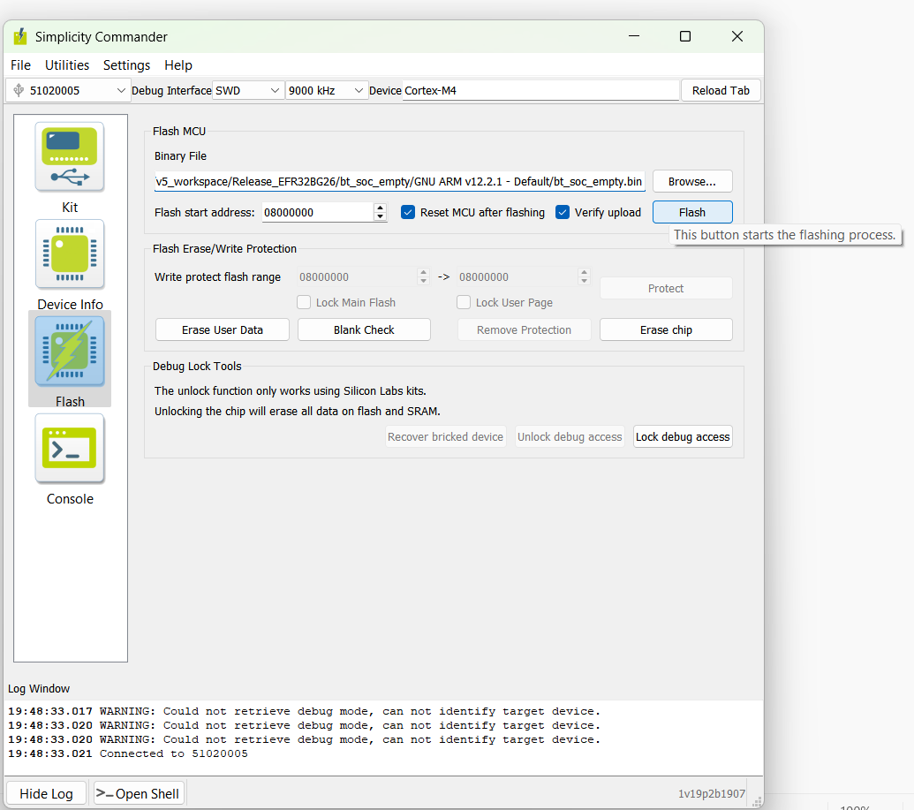

Step 5:
Now, click Flash. The code will be flashed Successfully .

