TESTING PROCEDURE

STEP 1

Before Opening the Debug Application:
- Download the application from the following link:
https://drive.google.com/drive/folders/1sJkkr4wi0dE8rRRF6e2P8BvkCDZE7fXo?usp=sharing
- Once the download is complete, go to your Downloads folder.
- Double-click the SERIAL PORT application to open it.

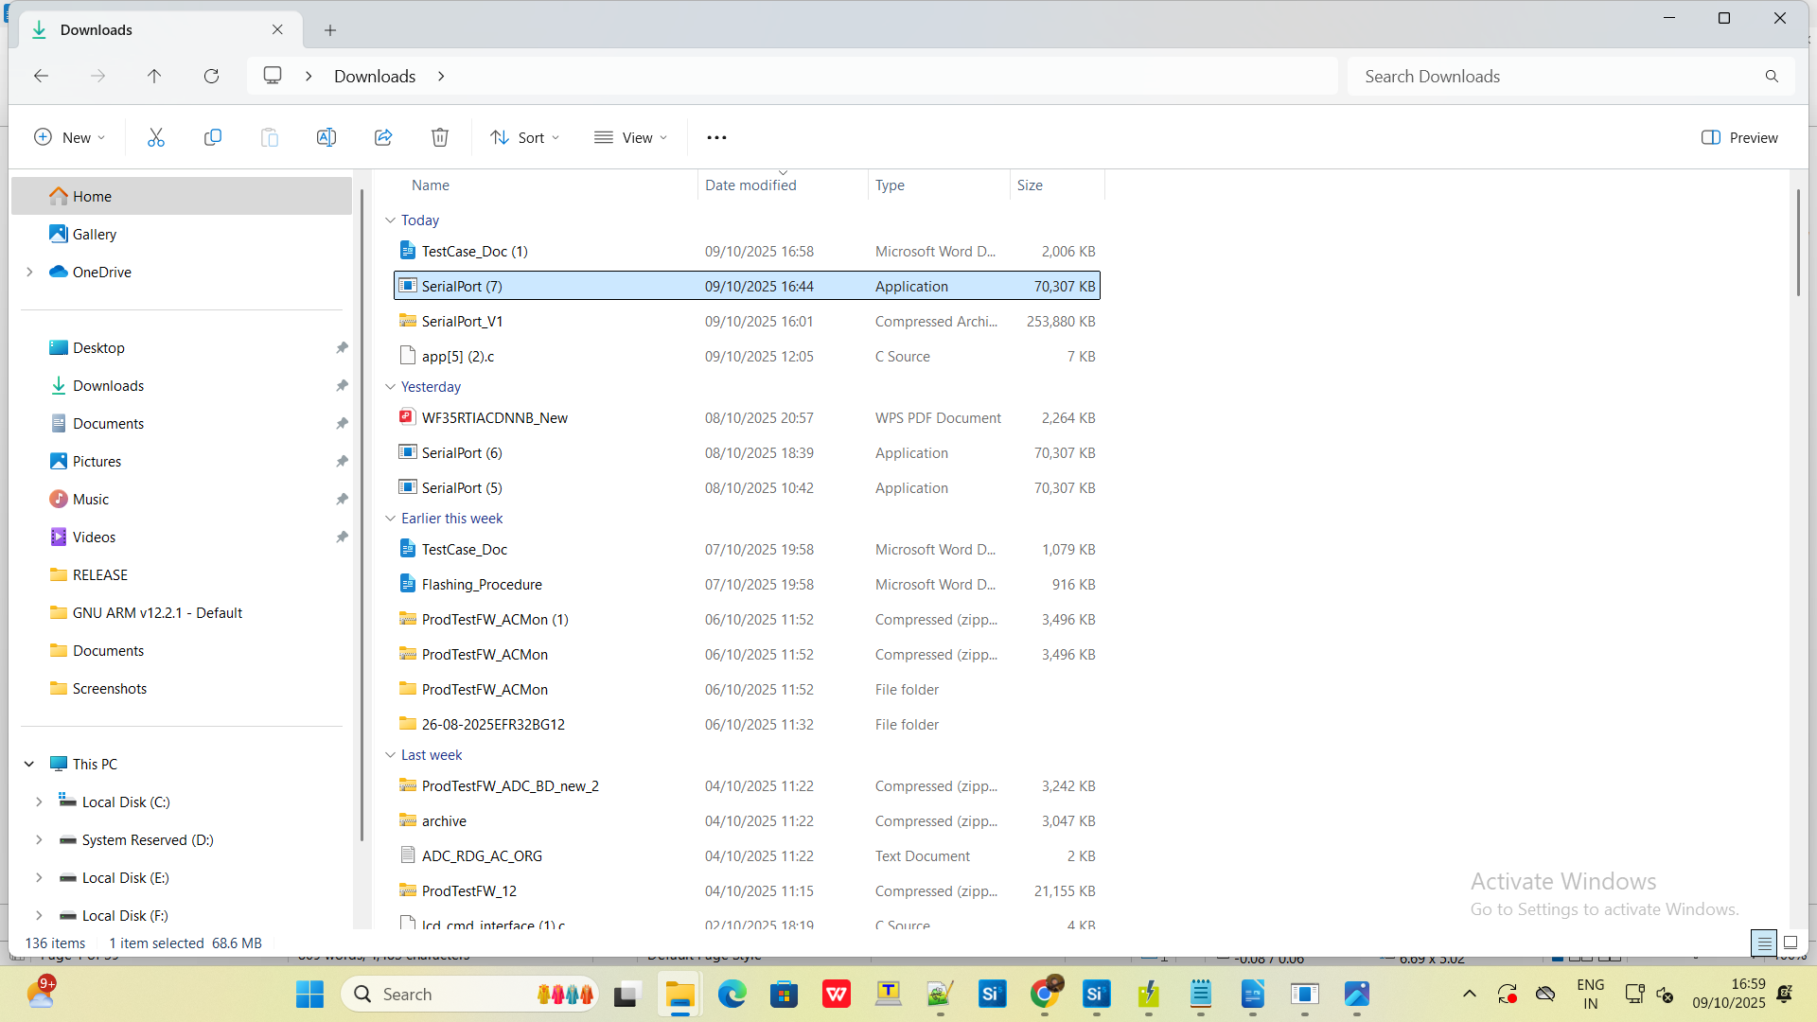

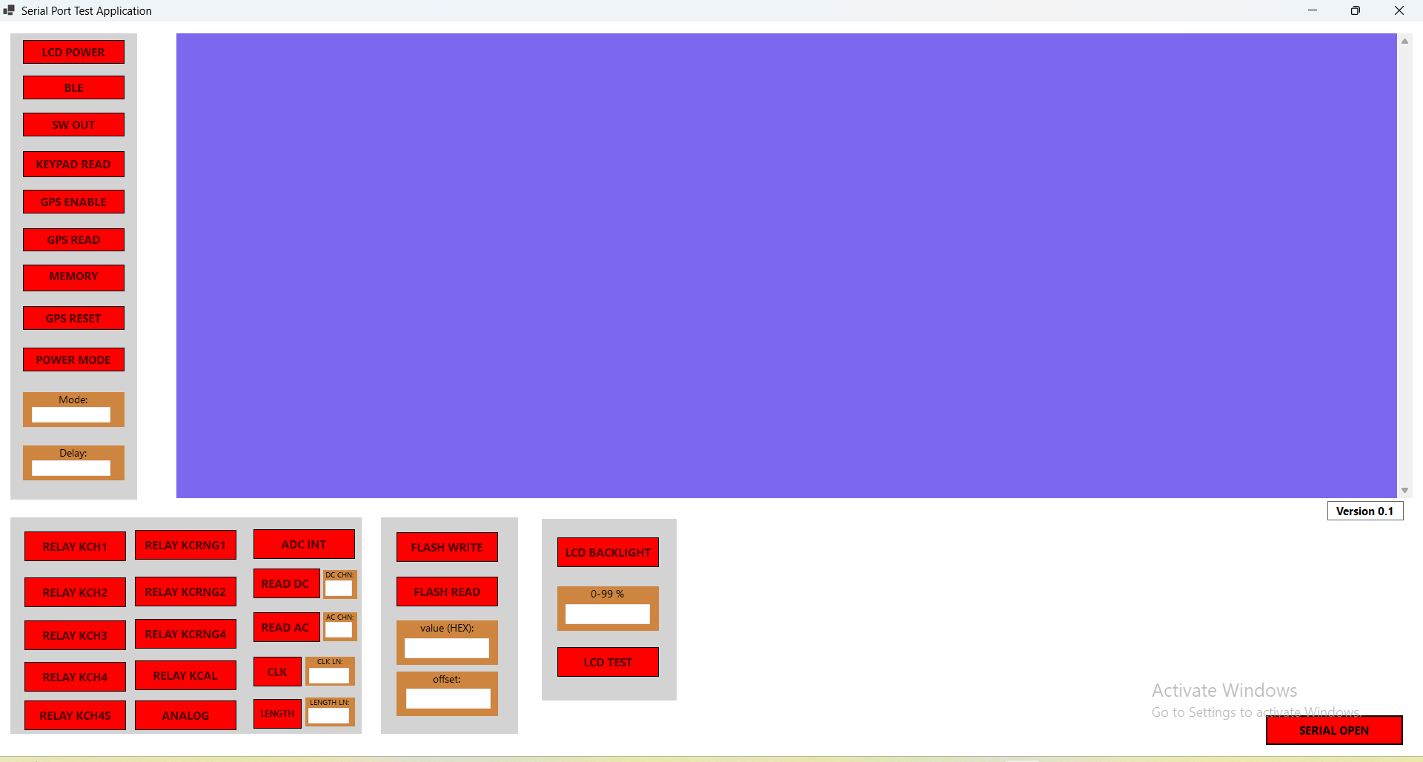

STEP 2

In the Debug Application:
Click the Serial Open button.
Set the:
  - Baud Rate (as 115200)
  - COM Port (matching the connected device)
Click the Connect button to establish the connection.

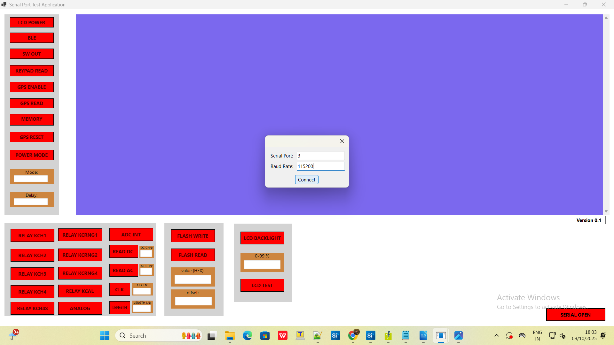

STEP 3
Once connected, the IDN command will automatically be sent, and you will receive an acknowledgment response from the device.

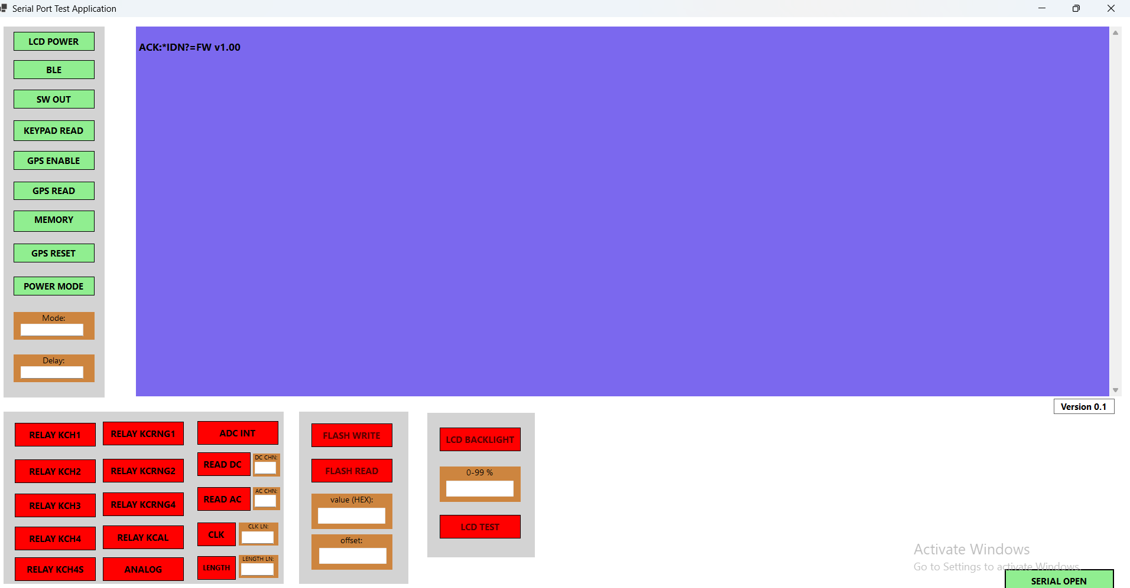

STEP 4
Click the LCD POWER button.
- Initially, this sets the pin HIGH.
- Next click the LCD TEST button, LCD will On. Bars will appear sequentially in both horizontal and vertical directions.

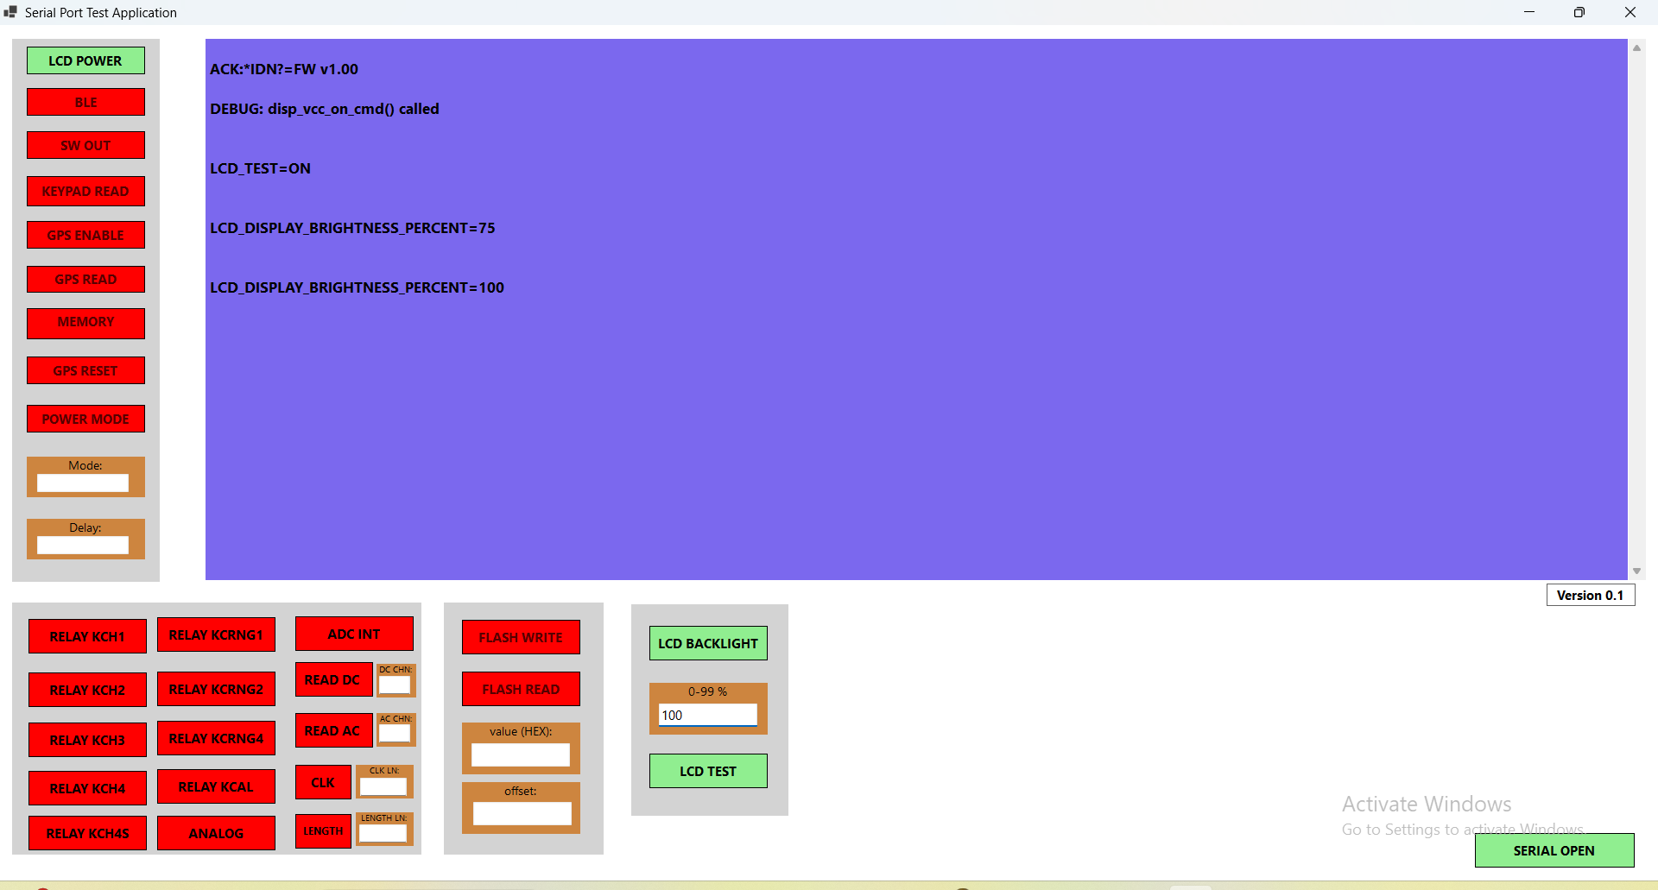

STEP 5:
- Use the LCD BACKLIGHT control to increase or decrease the LCD brightness according to your preference

To turn OFF the LCD, click the LCD POWER and LCD TEST buttons again:
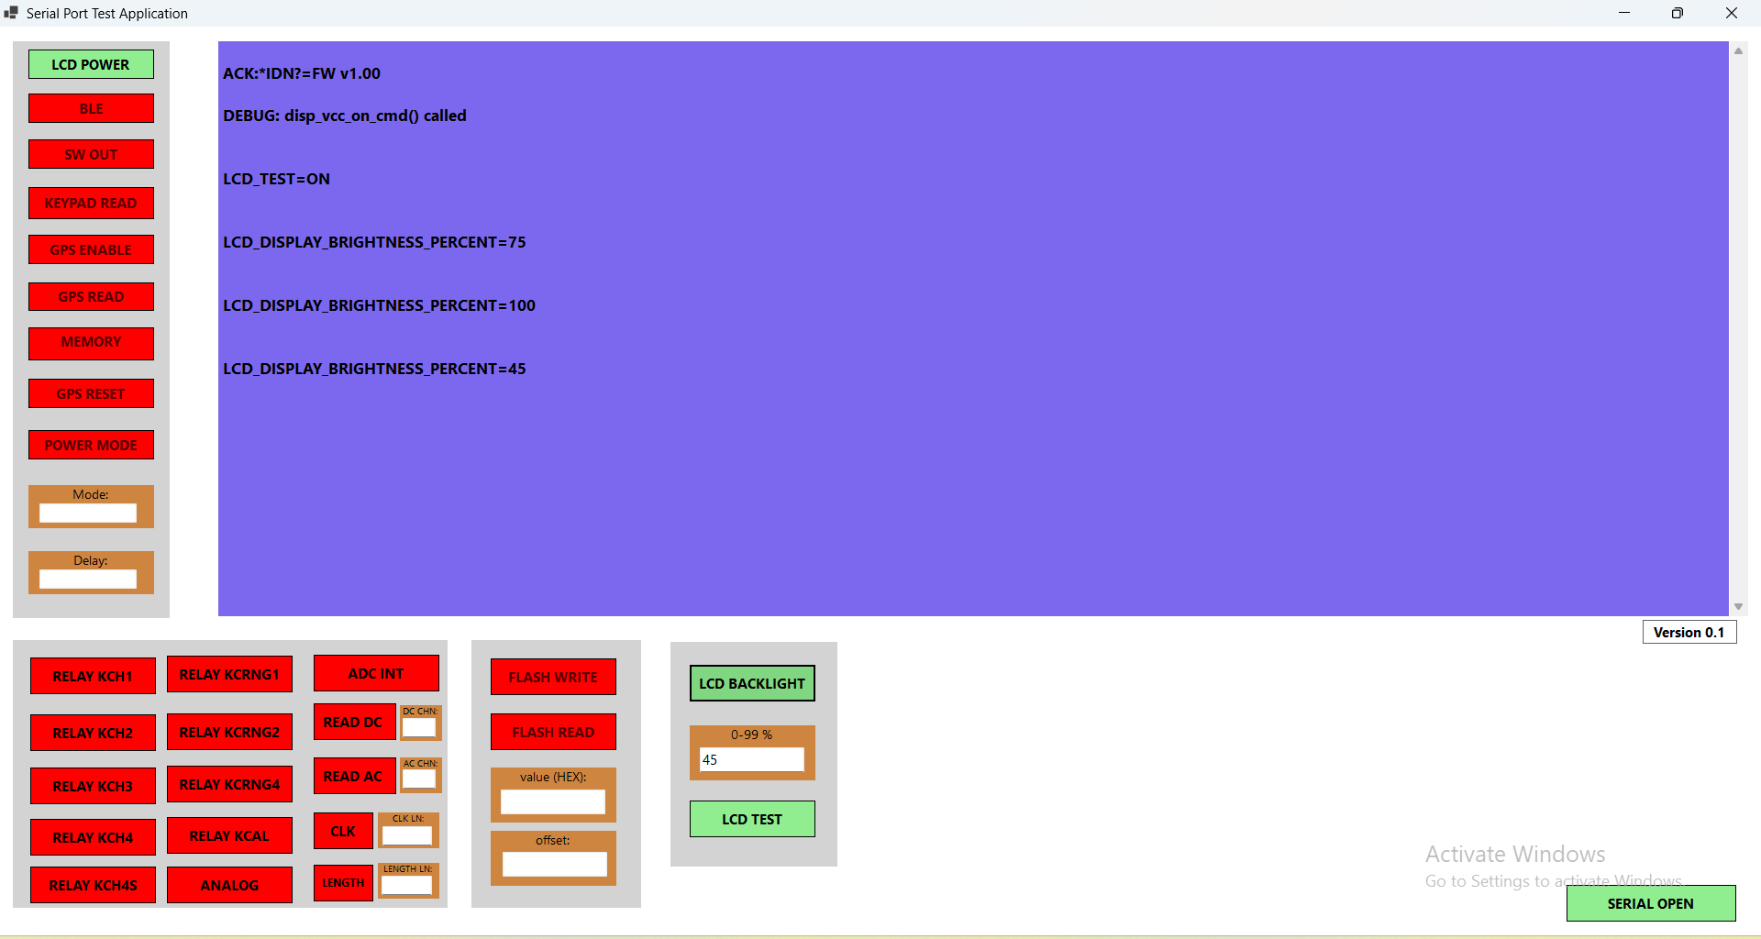
- These buttons act as toggles — clicking them again will turn OFF the LCD POWER and LCD TEST functions
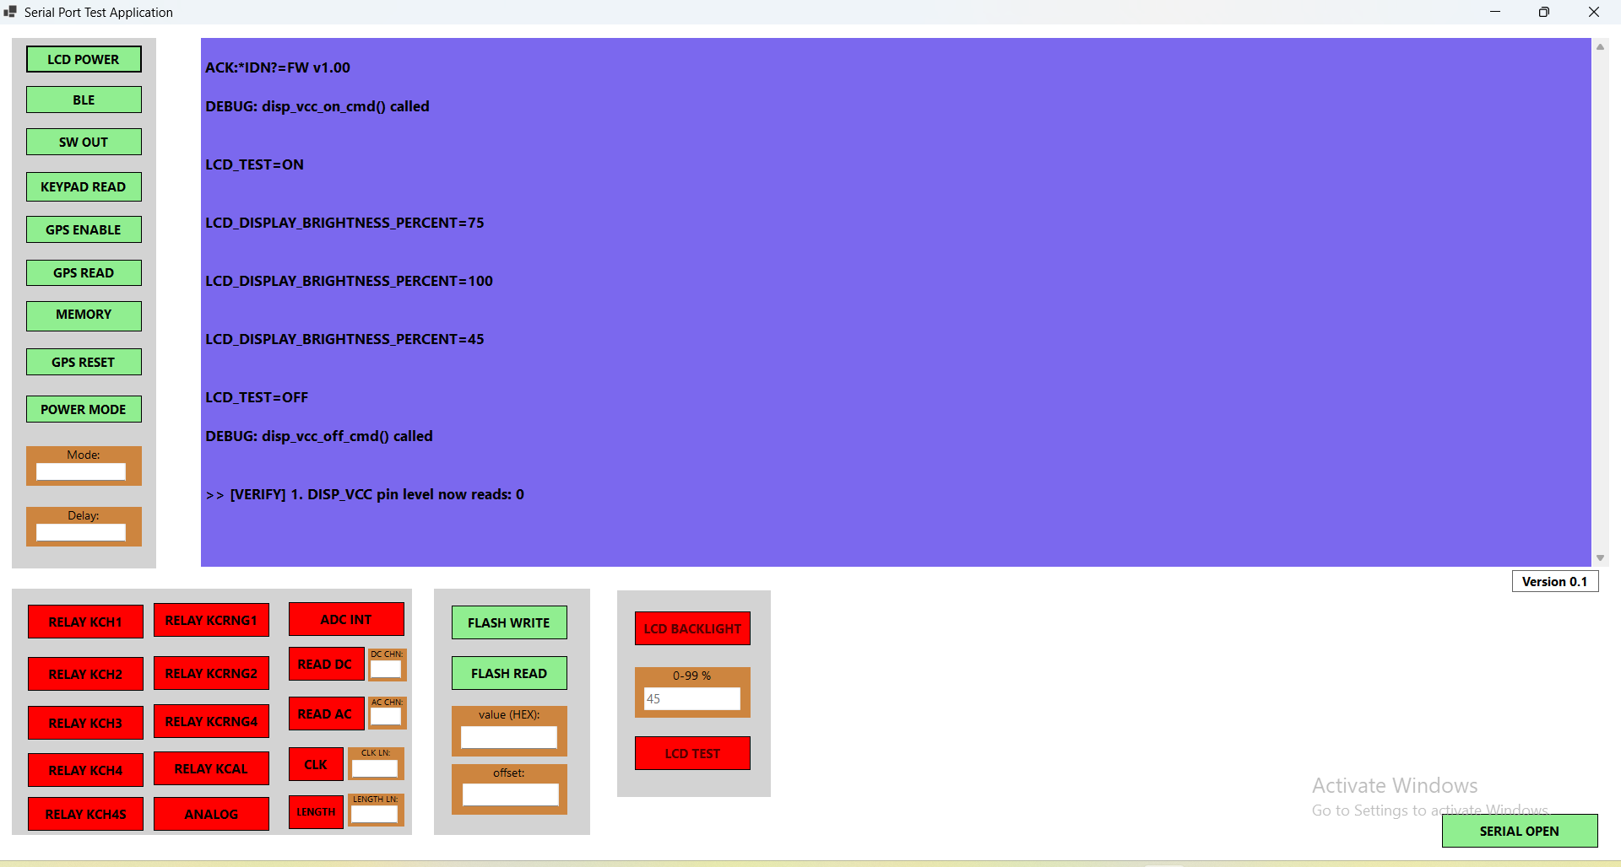

STEP 6:

BLUETOOTH:

Click the BLE button.
First click: Powers ON the BLE module and starts advertising.

Click again: Stops advertising (toggle behaviour).

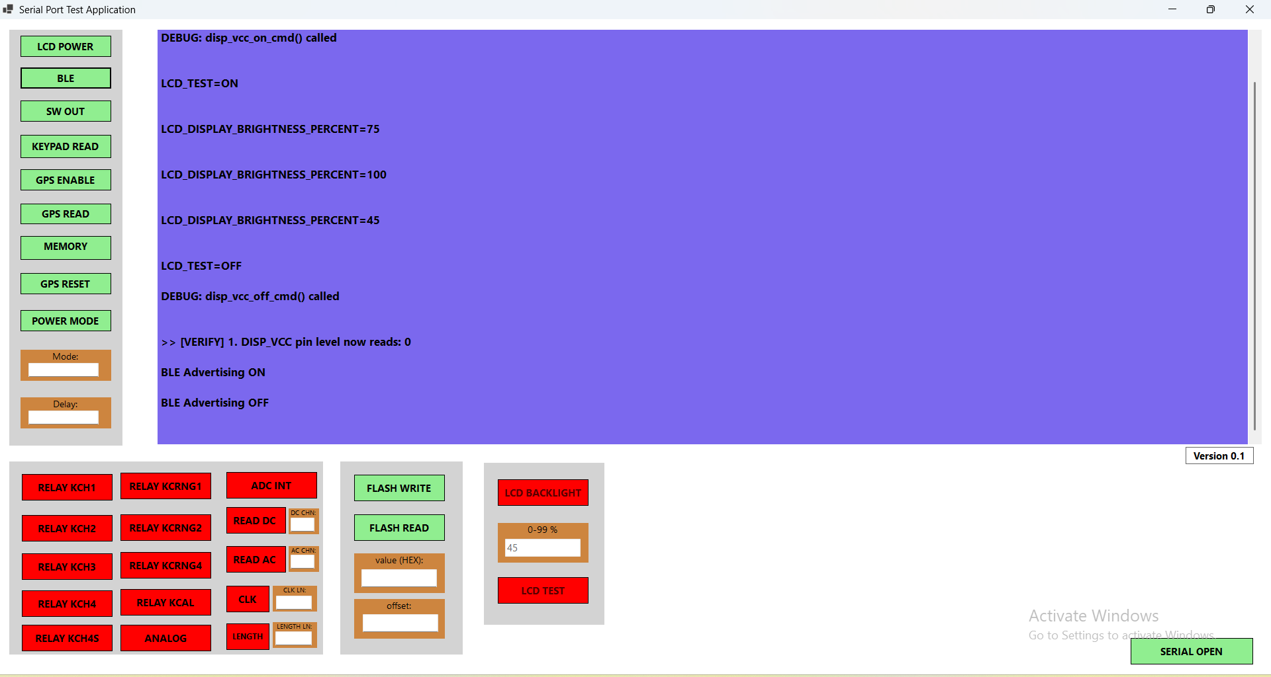

STEP 7:
SWOUT

Click the SWOUT button.
- Initially, this sets the pin HIGH.
- Clicking the same button again will pull the pin LOW.

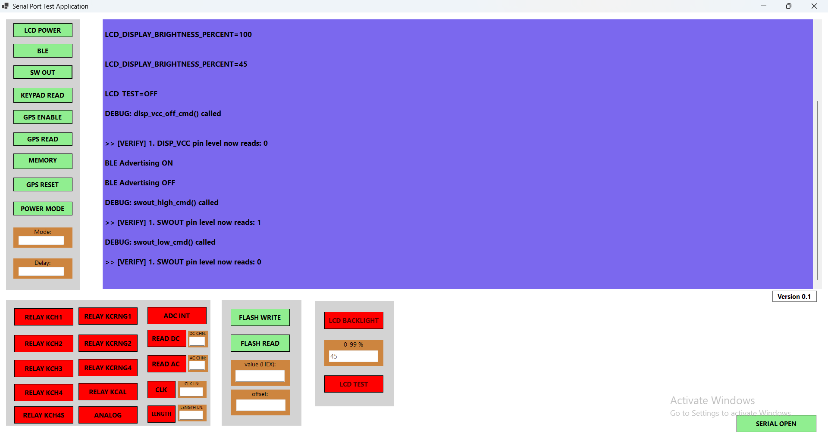

STEP 8:
KEYPAD
Click the KEYPAD READ button to enable keypad detection.
When you press a key, the pressed key is displayed.
Click the KEYPAD READ button again to stop keypad detection.
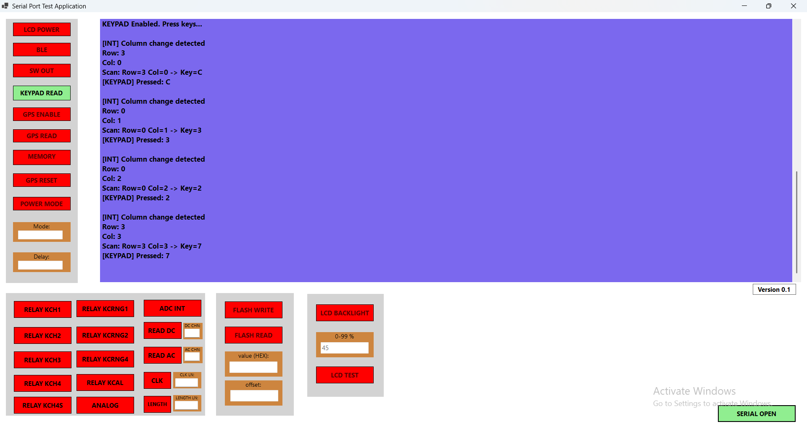

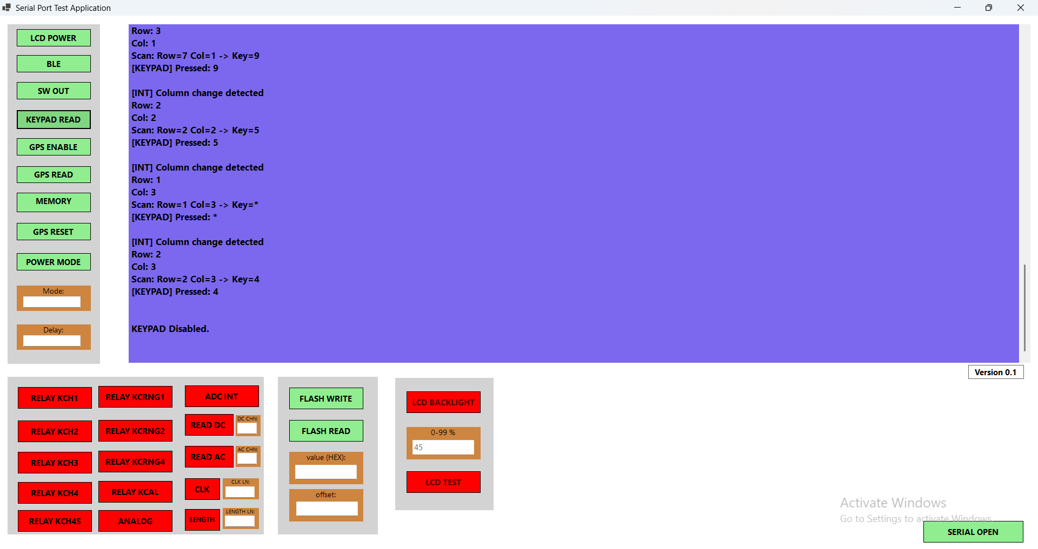

STEP 9:
GPS
- Click the GPS EN button
This also pulls the GPS power pin HIGH.
- Click the GPS RESET button
This pulls the GPS power pin HIGH.
- Click the GPS READ button
This starts continuous reading of GPS NMEA data.
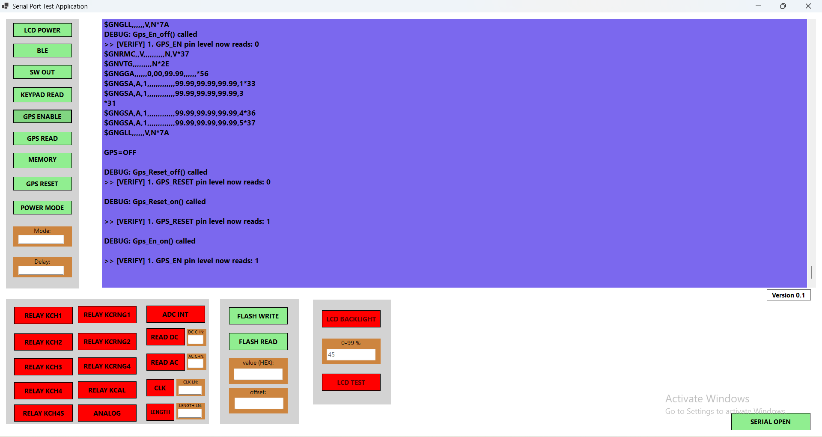

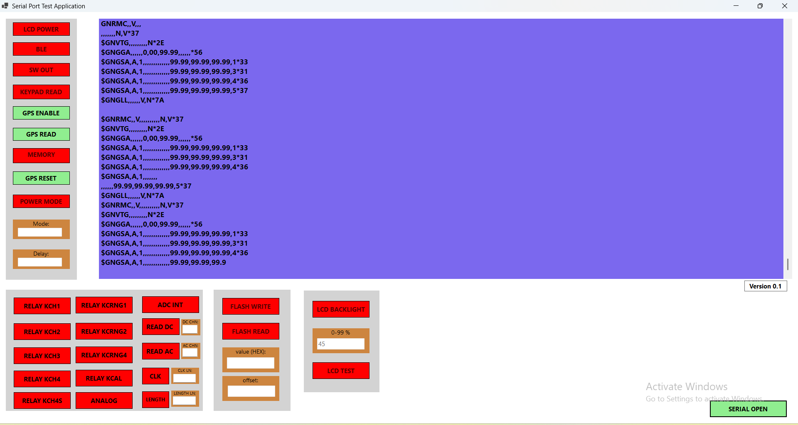

STEP 10:
Click the GPS READ button again to stop reading GPS NMEA data.
Then click the GPS EN and GPS RESET buttons to pull the GPS power pin LOW.
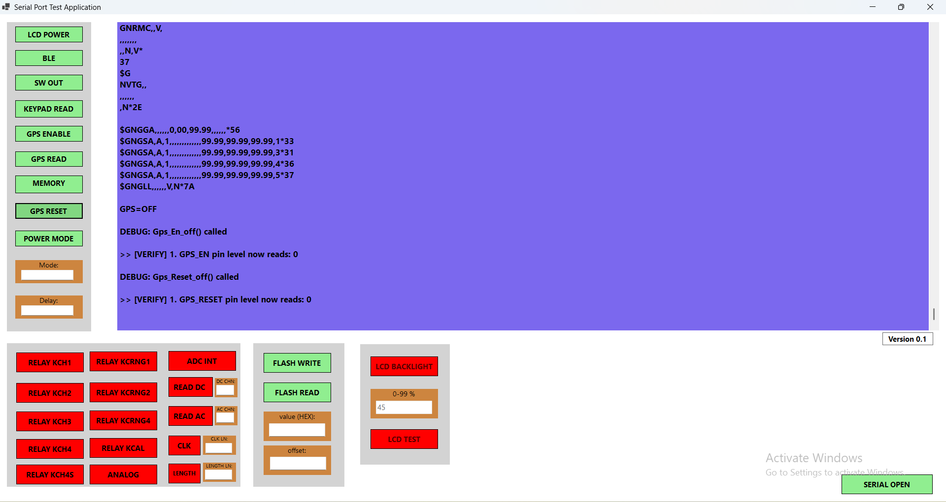

STEP 11:

Memory Power:
- Click the MEMORY button
  - The memory power pin will be pulled HIGH.
  - An ACK message will be shown for confirmation.
- Click the MEMORY button again
  - The memory power pin will be pulled LOW.

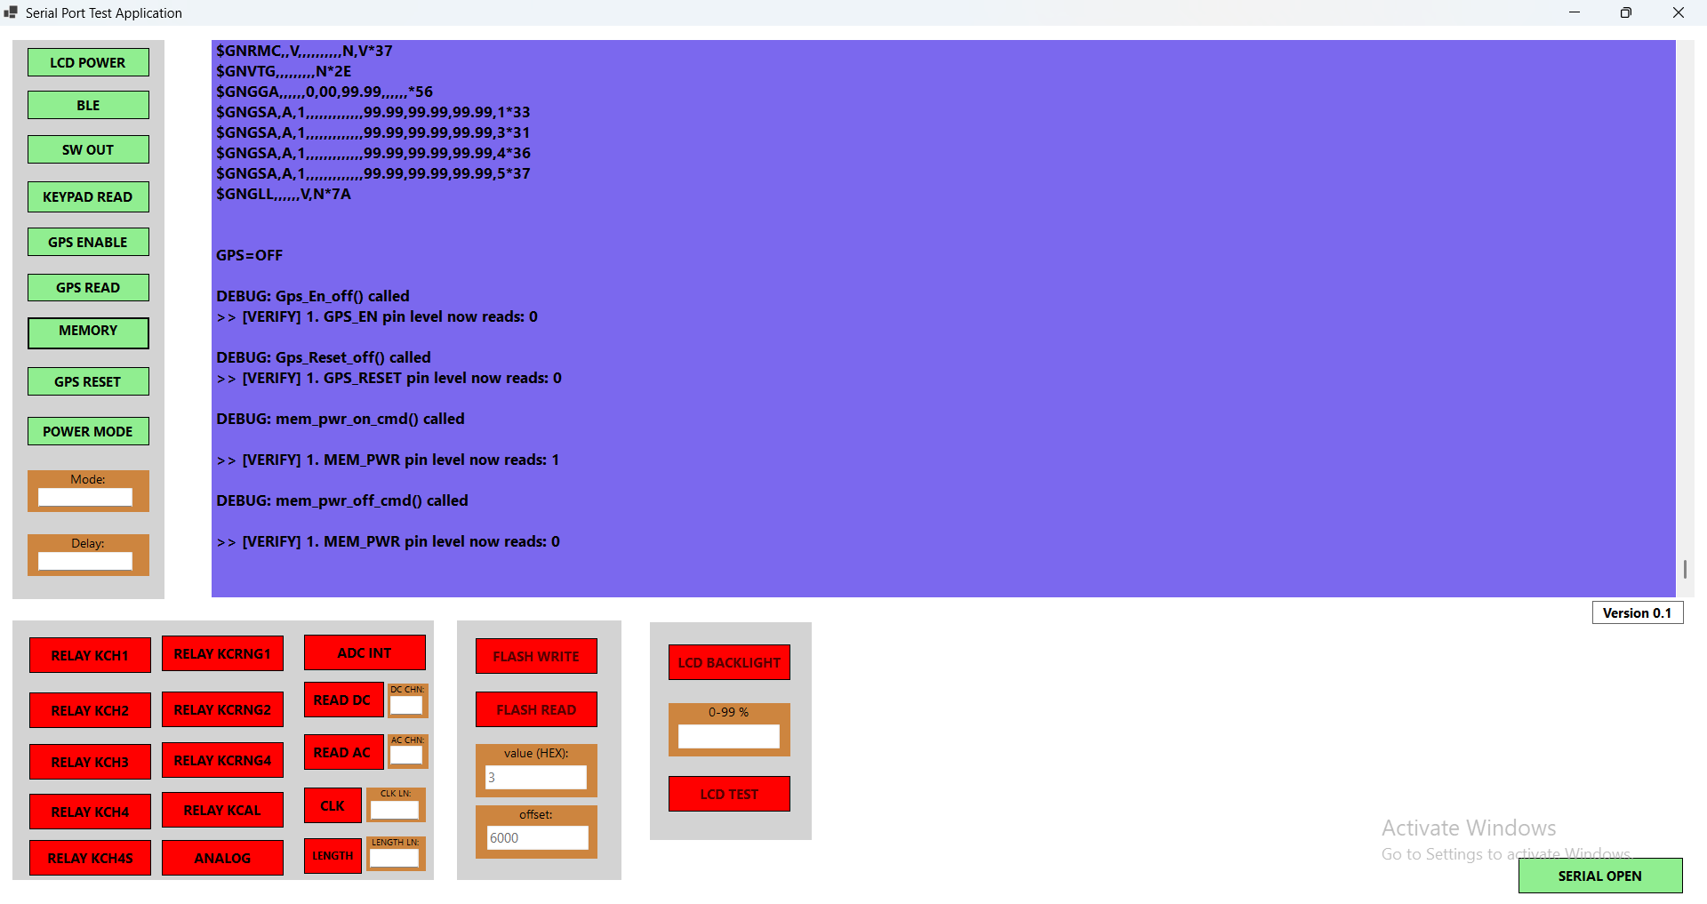

STEP 12:

FLASH Operation:

Click the FLASH READ button:
  - Displays the value and address.
  - Writing to flash is performed in the same way (using a similar process).

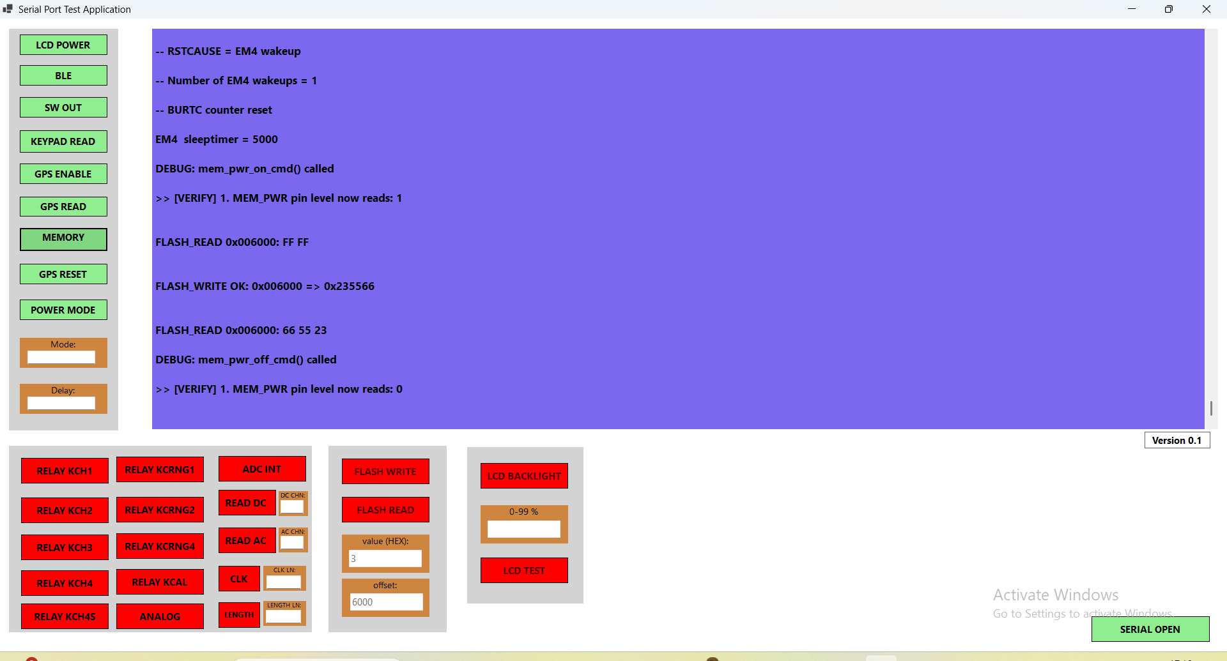

NOTE:

Analog Enable button should be HIGH before testing Relay and Both Internal & External ADC.

STEP 13:

Relay Control:
- Click any RELAY button (Relay 1 to Relay 9).
  - The selected relay will turn ON.
  - An ACK message will be displayed to confirm the action.
- Repeat this process to test other relays.
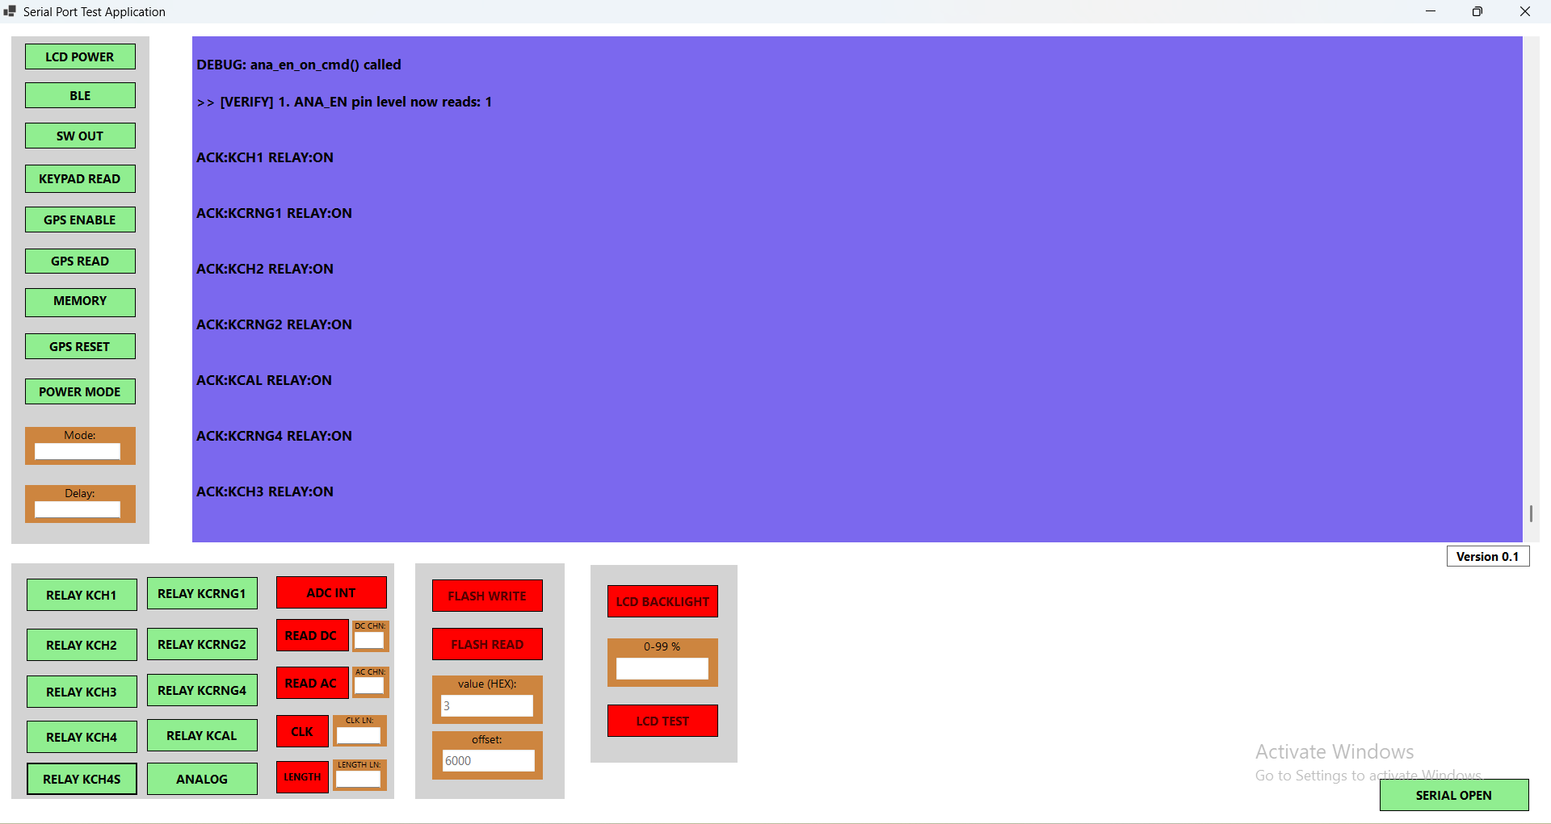

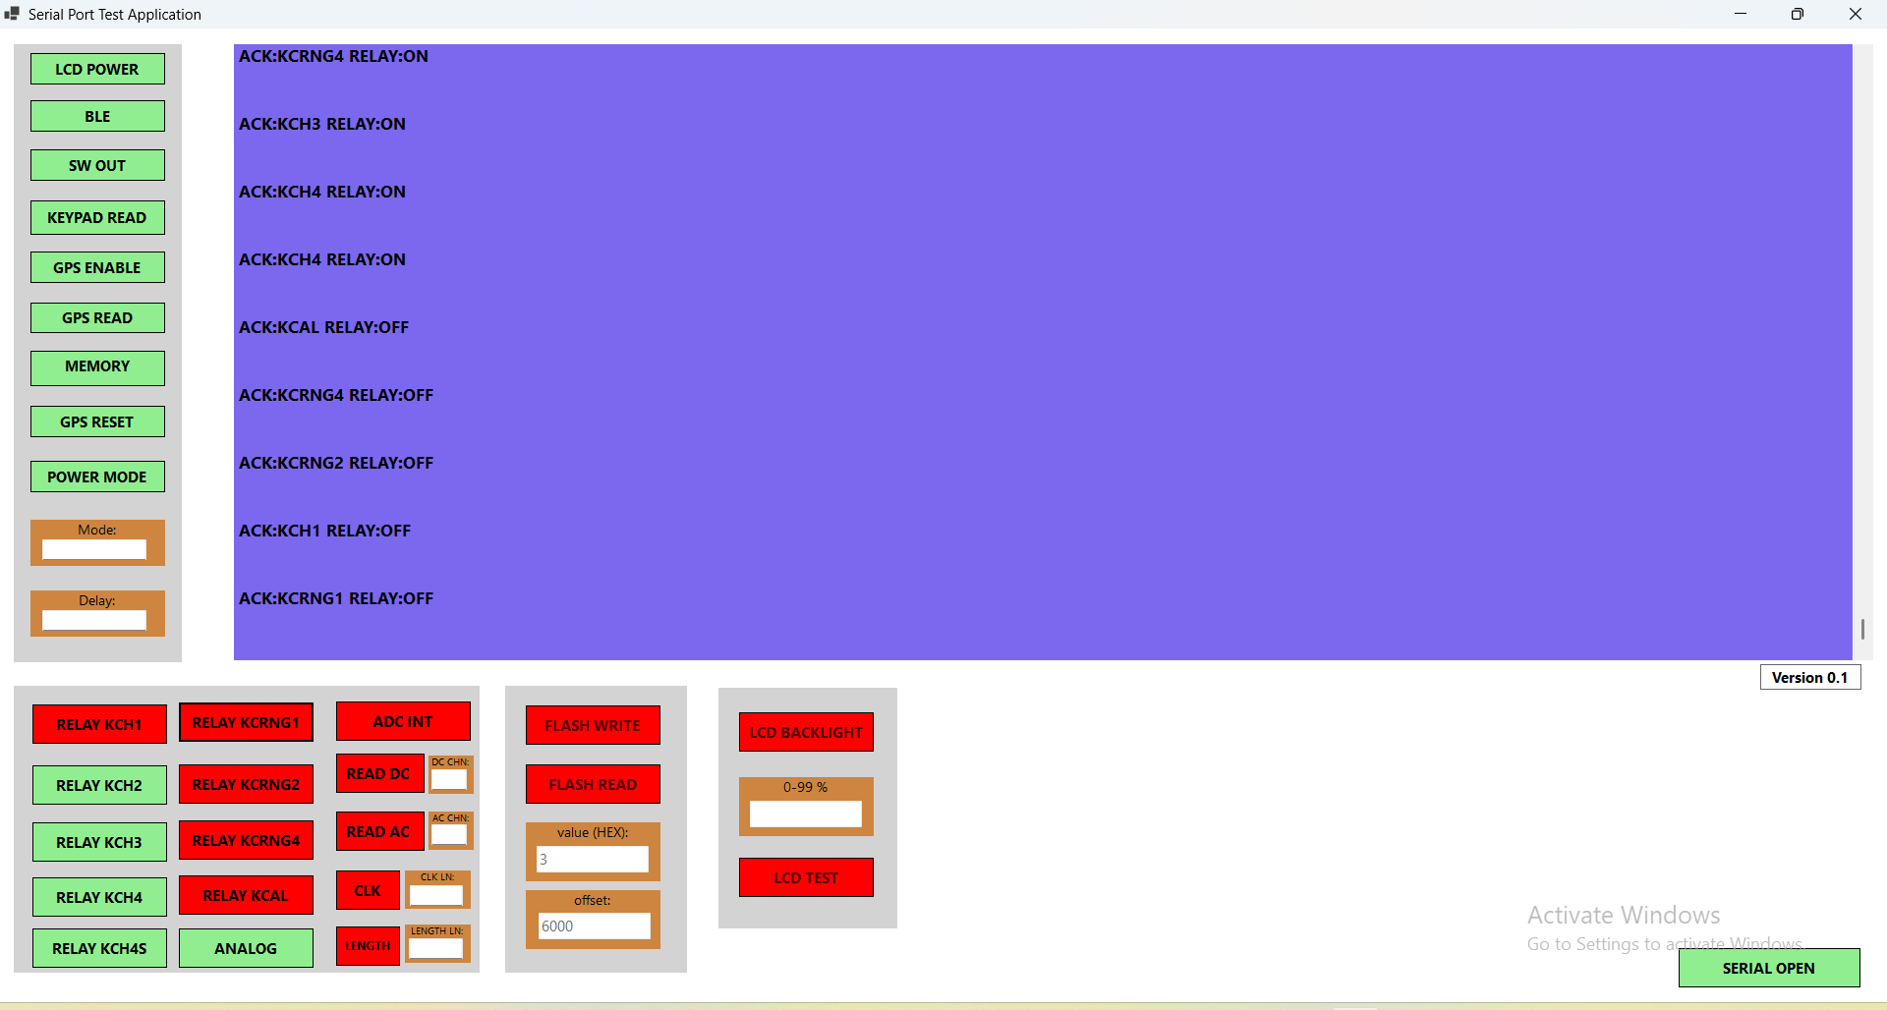

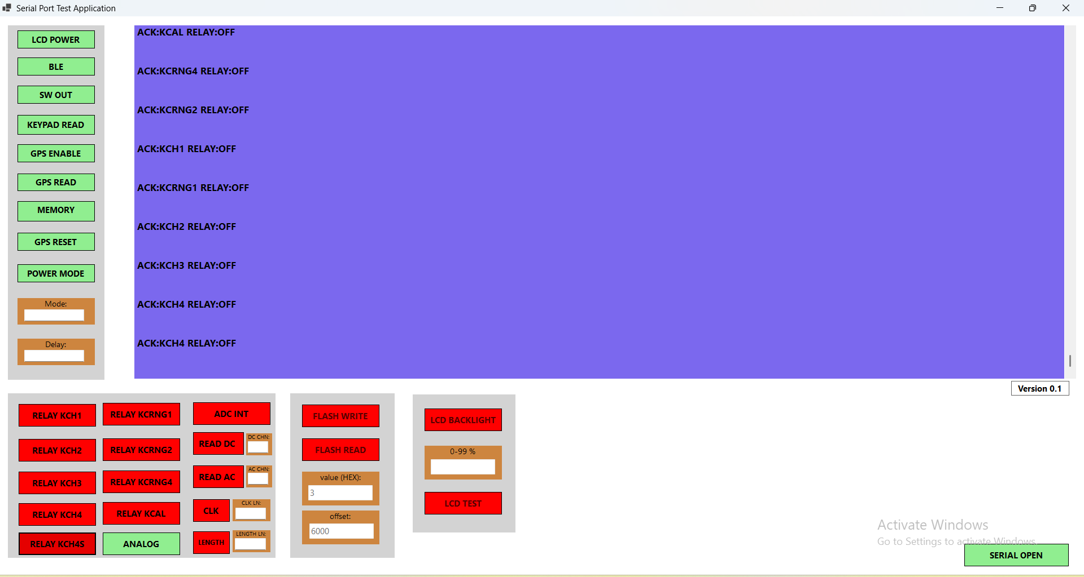

STEP14:

ADC TYPE

First, click the 'ADC TYPE' button to select the Internal ADC. Clicking the same button again will switch to the External ADC.

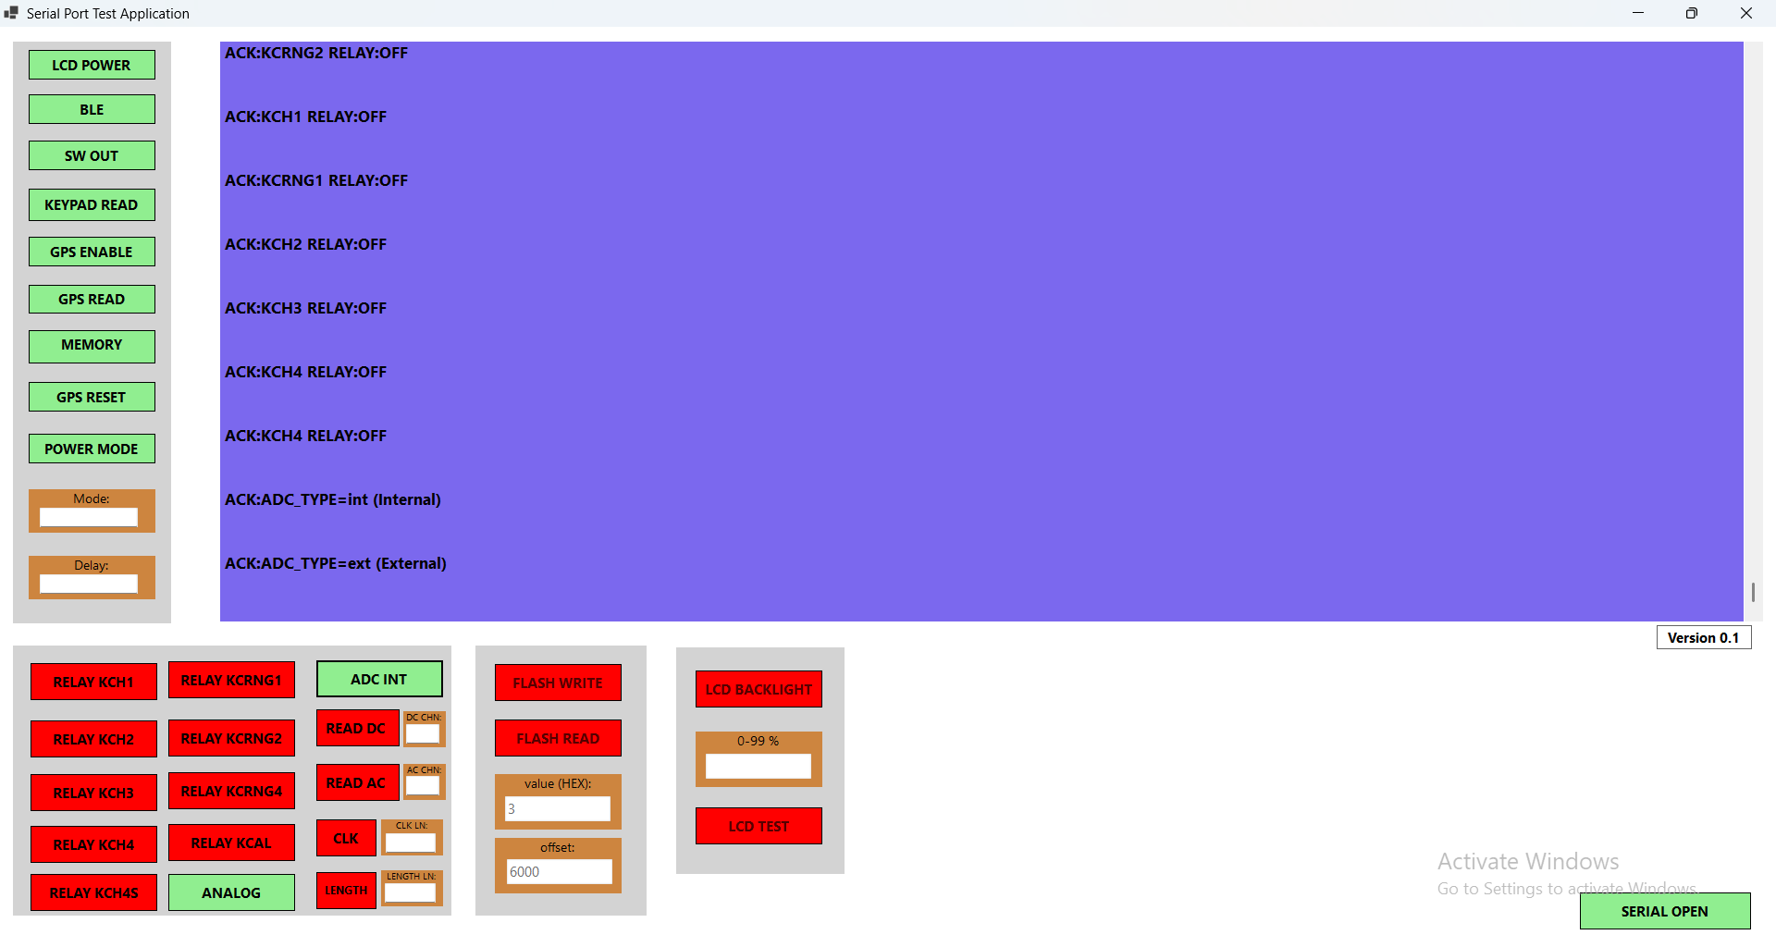

STEP 15:

ADC Sample Length & Clock Rate
ADC Sample Length
- Enter the desired sample length.
- Both the internal and external ADCs will use this length.
ADC Clock Rate
- Enter the desired clock rate (in kSPS).
- This sets the ADC sampling clock frequency.

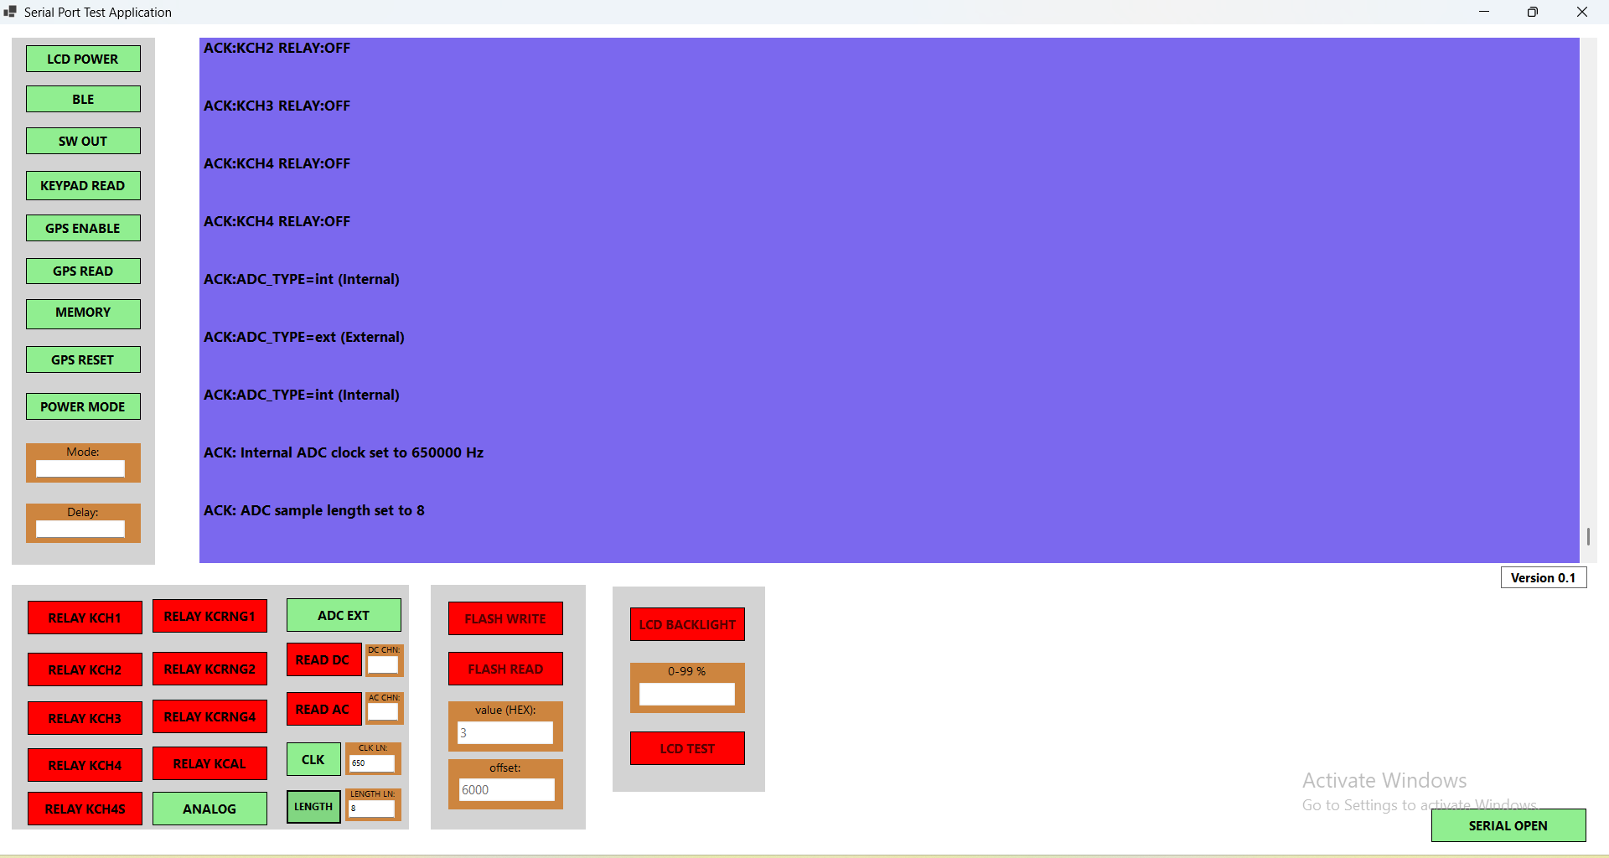

STEP16:

Internal ADC – DC Mode
- For DC mode, the necessary relay channels must be turned ON.
- For Channels 0 & 1, enable the following relays:
KCH1, KCRNG1, and KCAL.
- For Channels 2 & 3, enable the following relays:
KCH2, KCRNG2, and KCAL
- For Channel 4, enable the following relay:
KCH3.
- For Channel 5, enable the following relays:
KCH4, KCRNG4, and KCH4S.

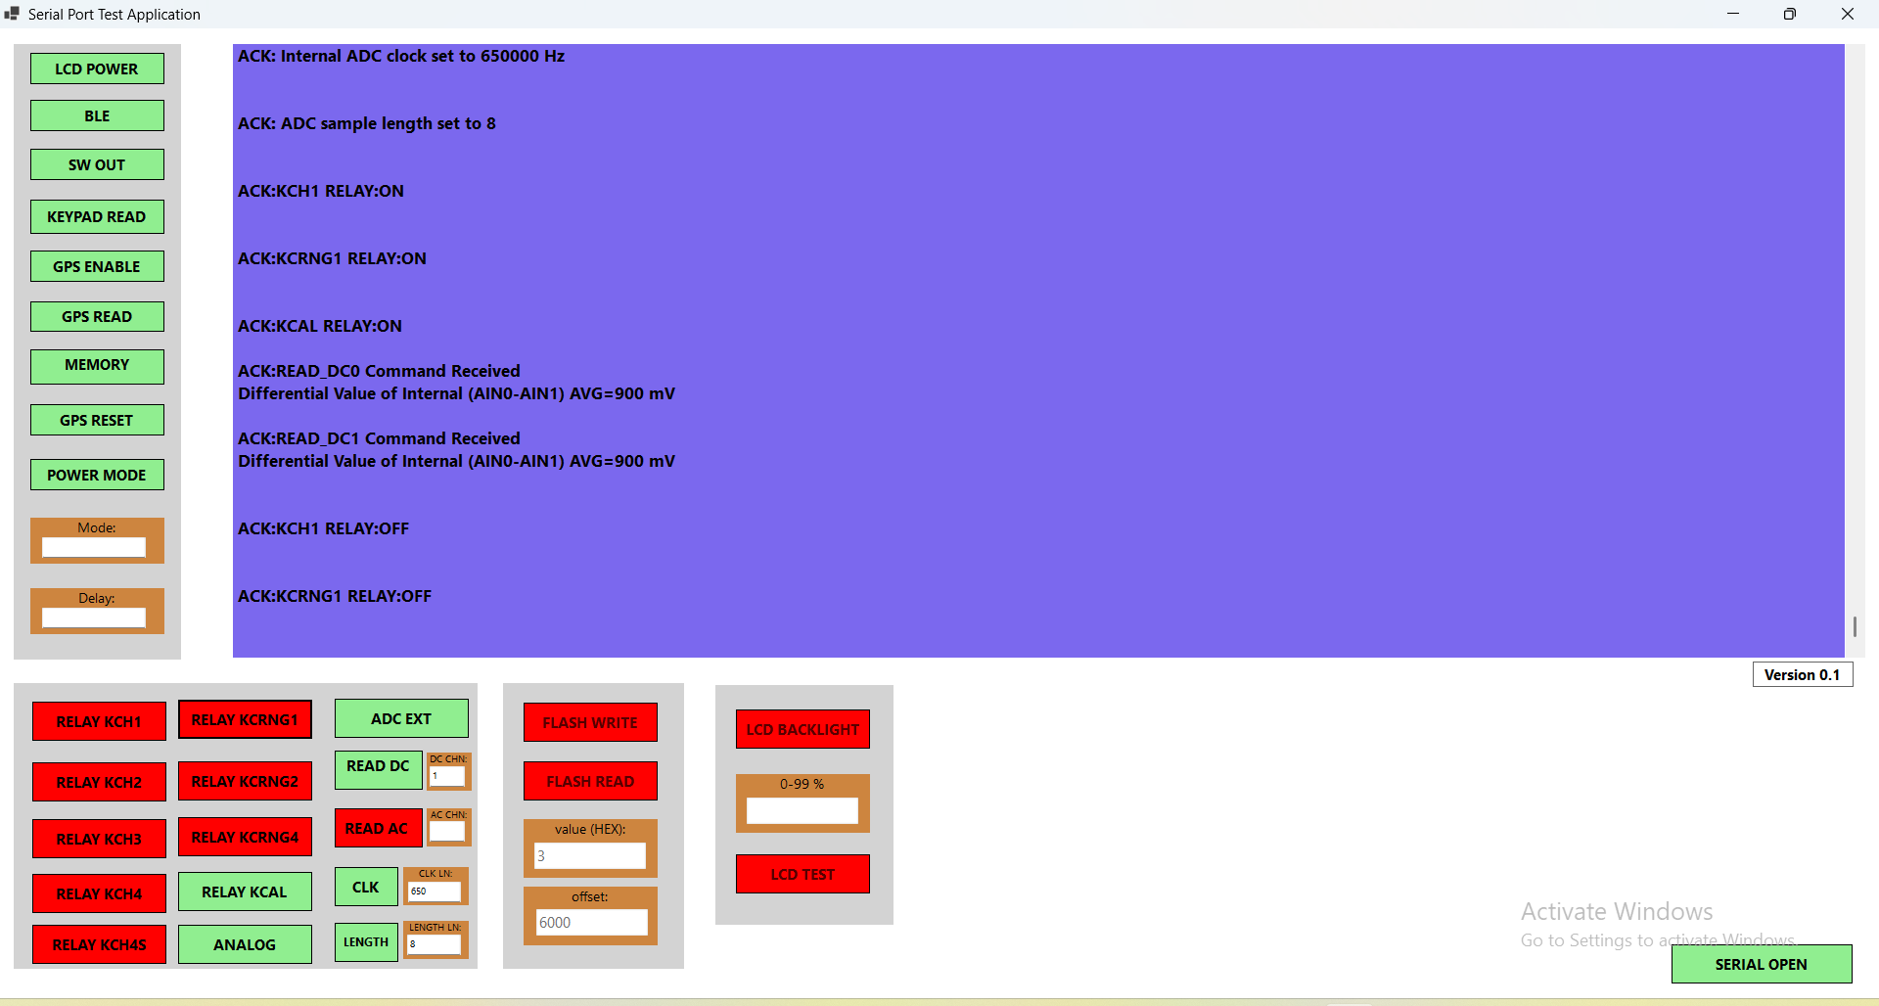
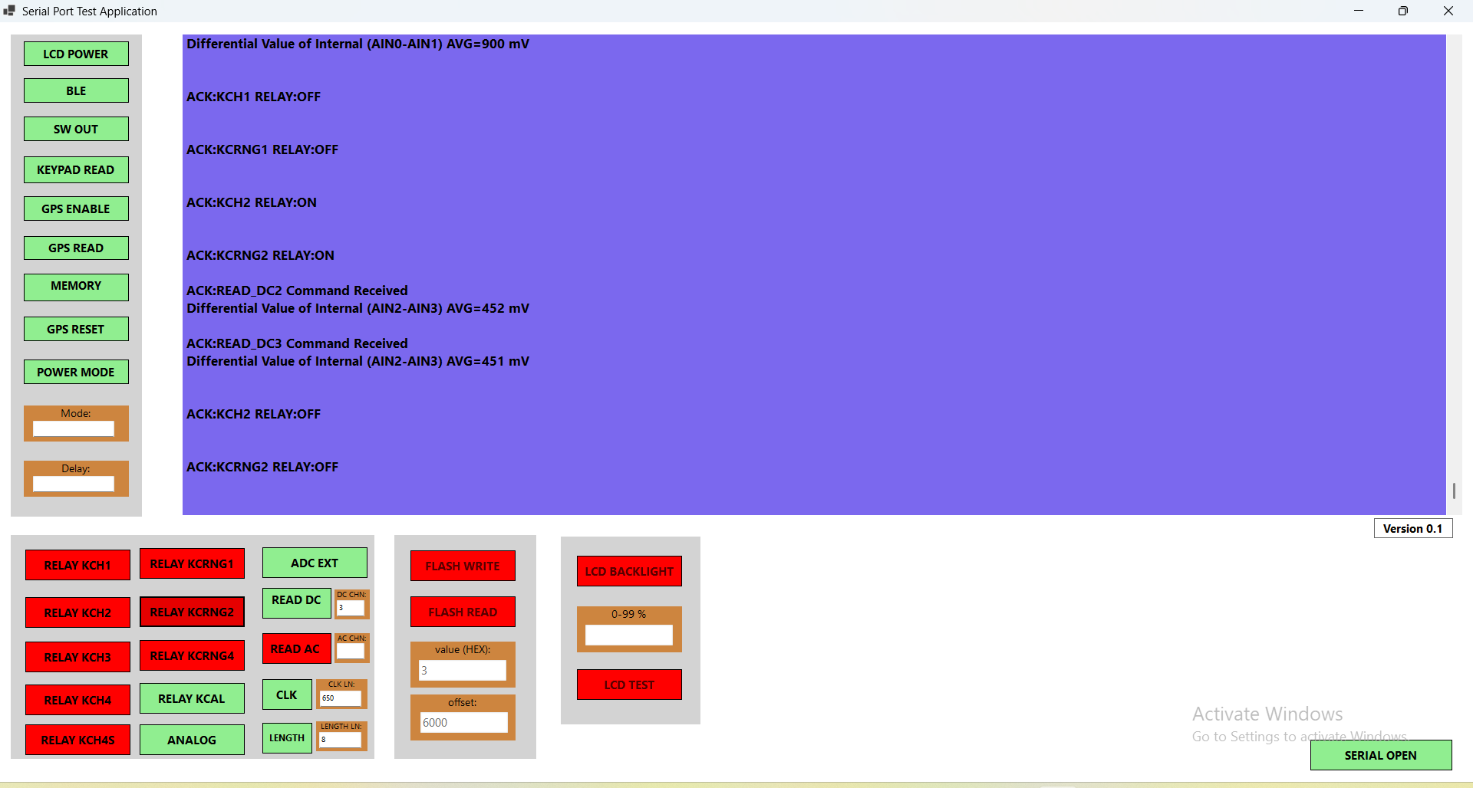

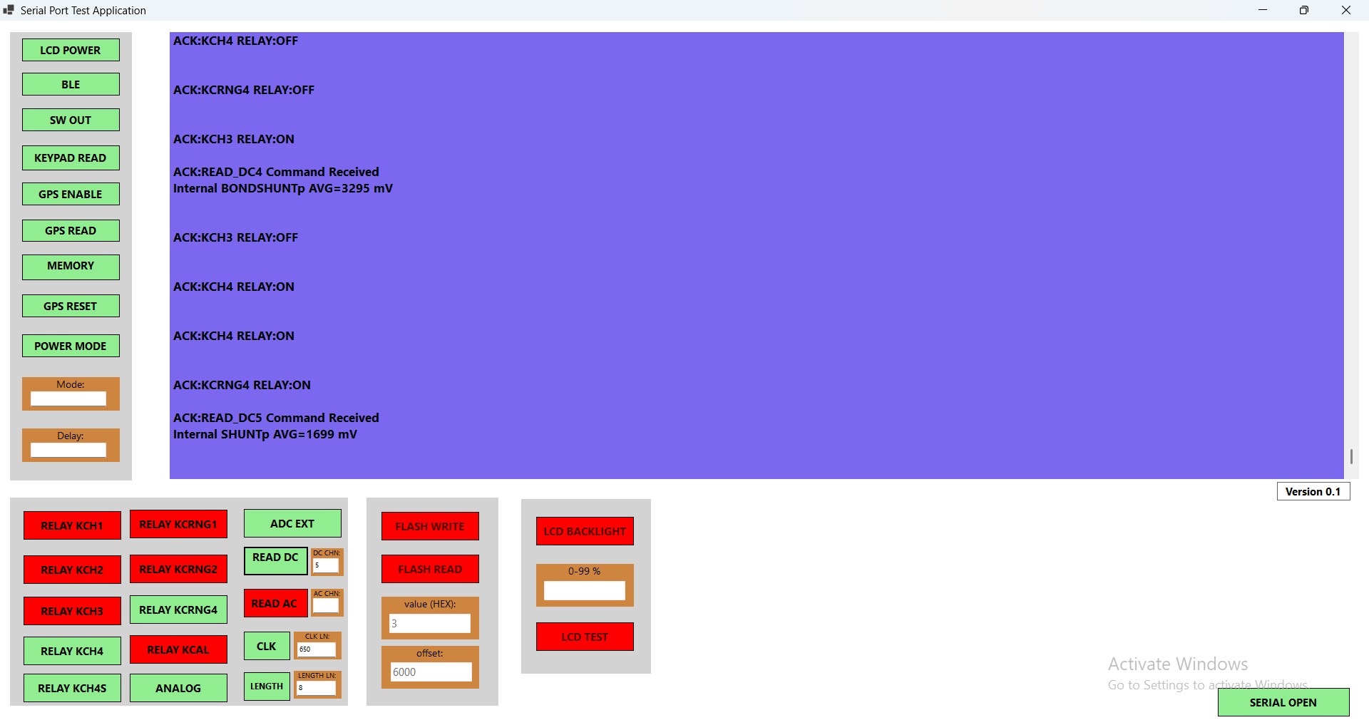

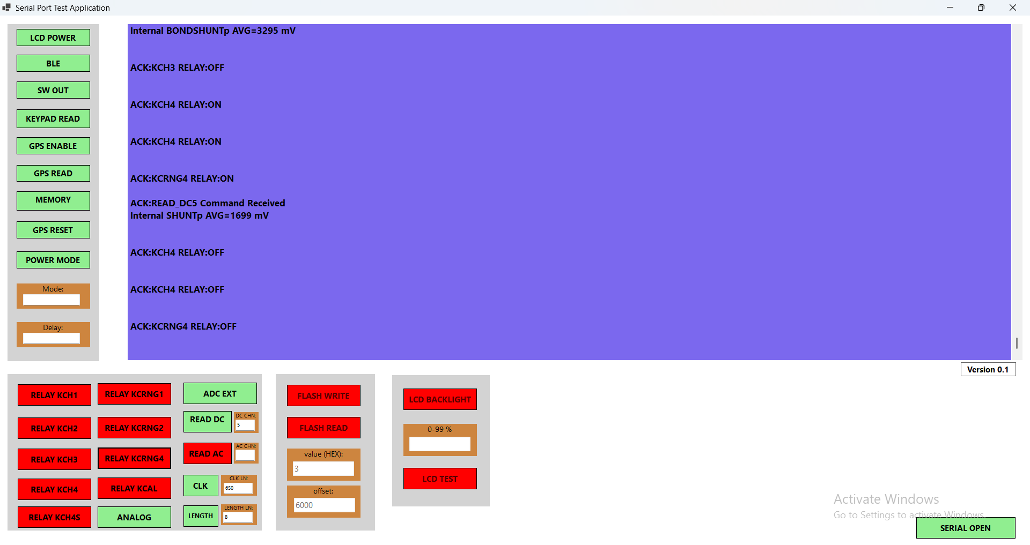

STEP17:
Internal ADC – AC Mode
- For AC mode, the necessary relay channels must be turned ON.
- For Channels 0 & 1, enable the following relays:
KCH1, KCRNG1, and KCAL
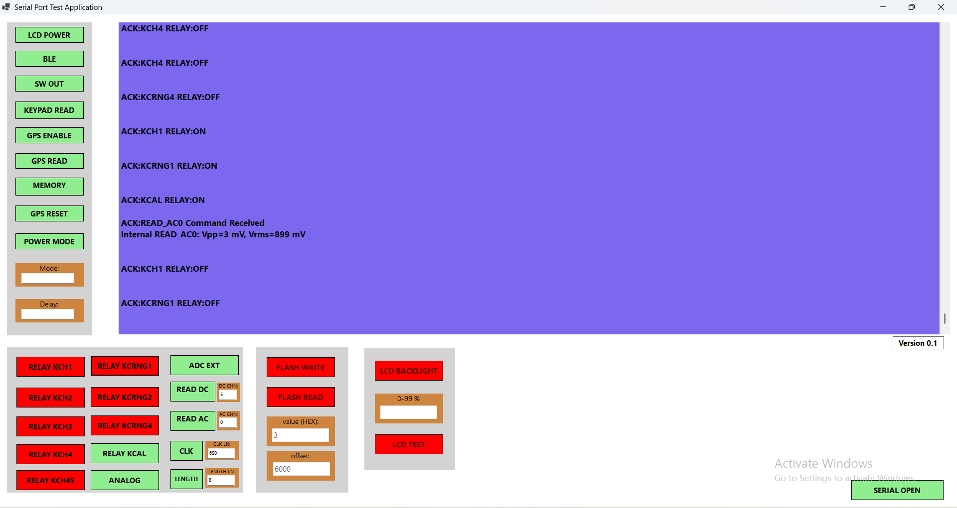
- For Channels 2 & 3, enable the following relays:
KCH2, KCRNG2, and KCAL
- For Channel 4, enable the following relay:
KCH3.
- For Channel 5, enable the following relays:
KCH4, KCRNG4, and KCH4S.

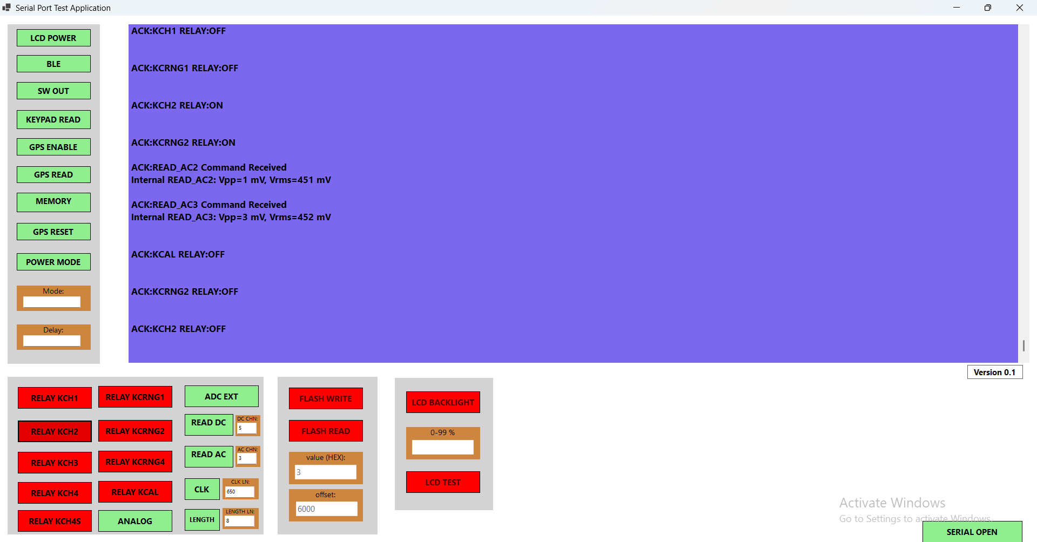

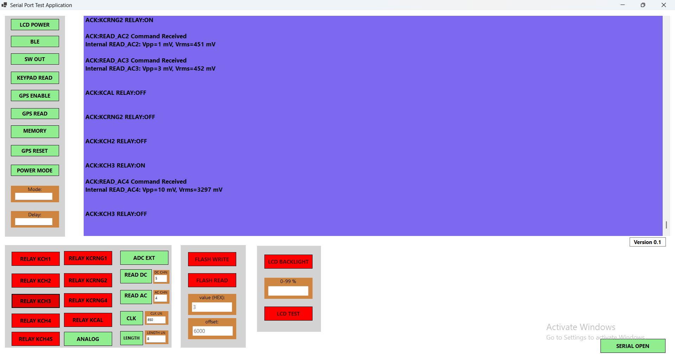

STEP 18:
External ADC – DC Mode
- For DC mode, the necessary relay channels must be turned ON.
- For Channels 0 & 1, enable the following relays:
KCH1, KCRNG1, and KCAL
- For Channels 2 & 3, enable the following relays:
KCH2, KCRNG2, and KCAL
- For Channel 4, enable the following relay:
KCH3.
- For Channel 5, enable the following relays:
KCH4, KCRNG4, and KCH4S.
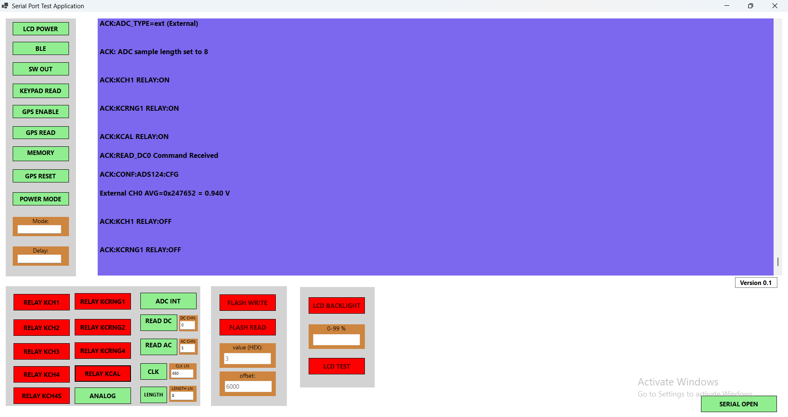

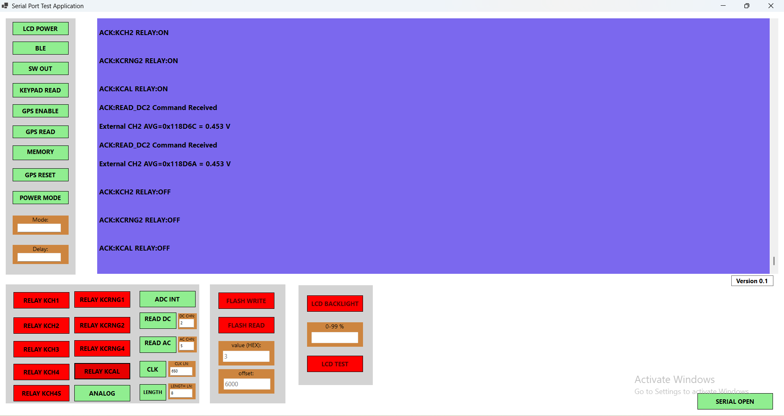
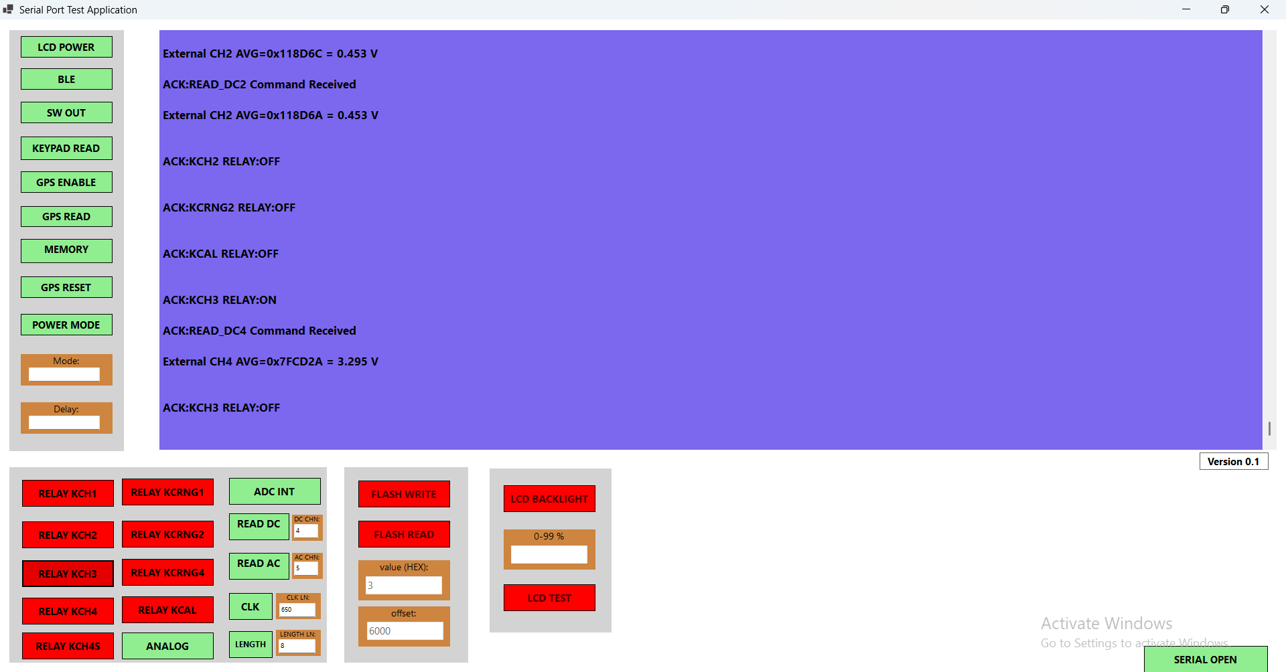

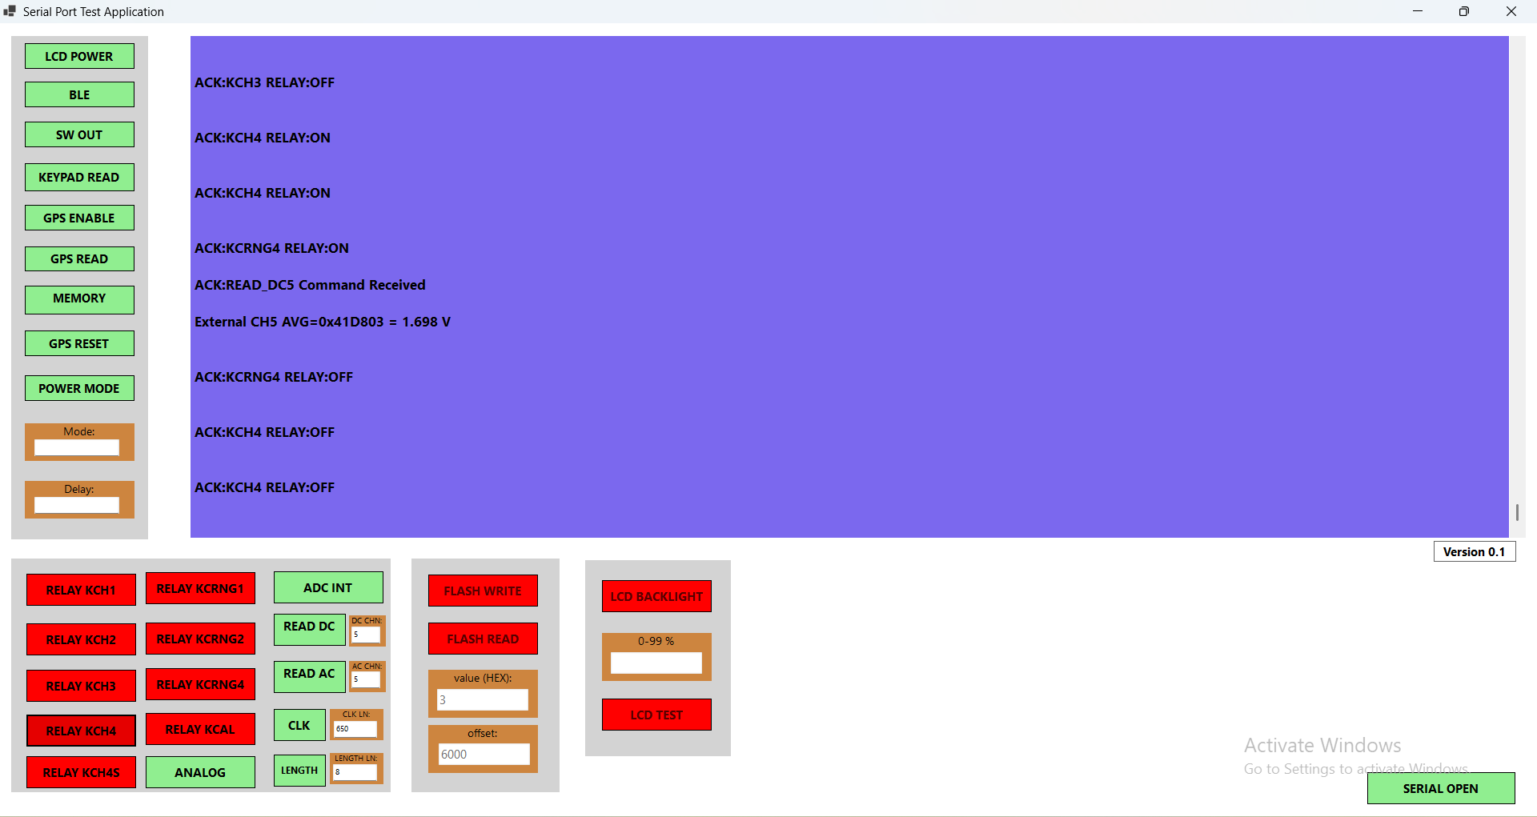

STEP 19:
External ADC – AC Mode
- For DC mode, the necessary relay channels must be turned ON.
- For Channels 0 & 1, enable the following relays:
KCH1, KCRNG1, and KCAL
- For Channels 2 & 3, enable the following relays:
KCH2, KCRNG2, and KCAL
- For Channel 4, enable the following relay:
KCH3.
- For Channel 5, enable the following relays:
KCH4, KCRNG4, and KCH4S.
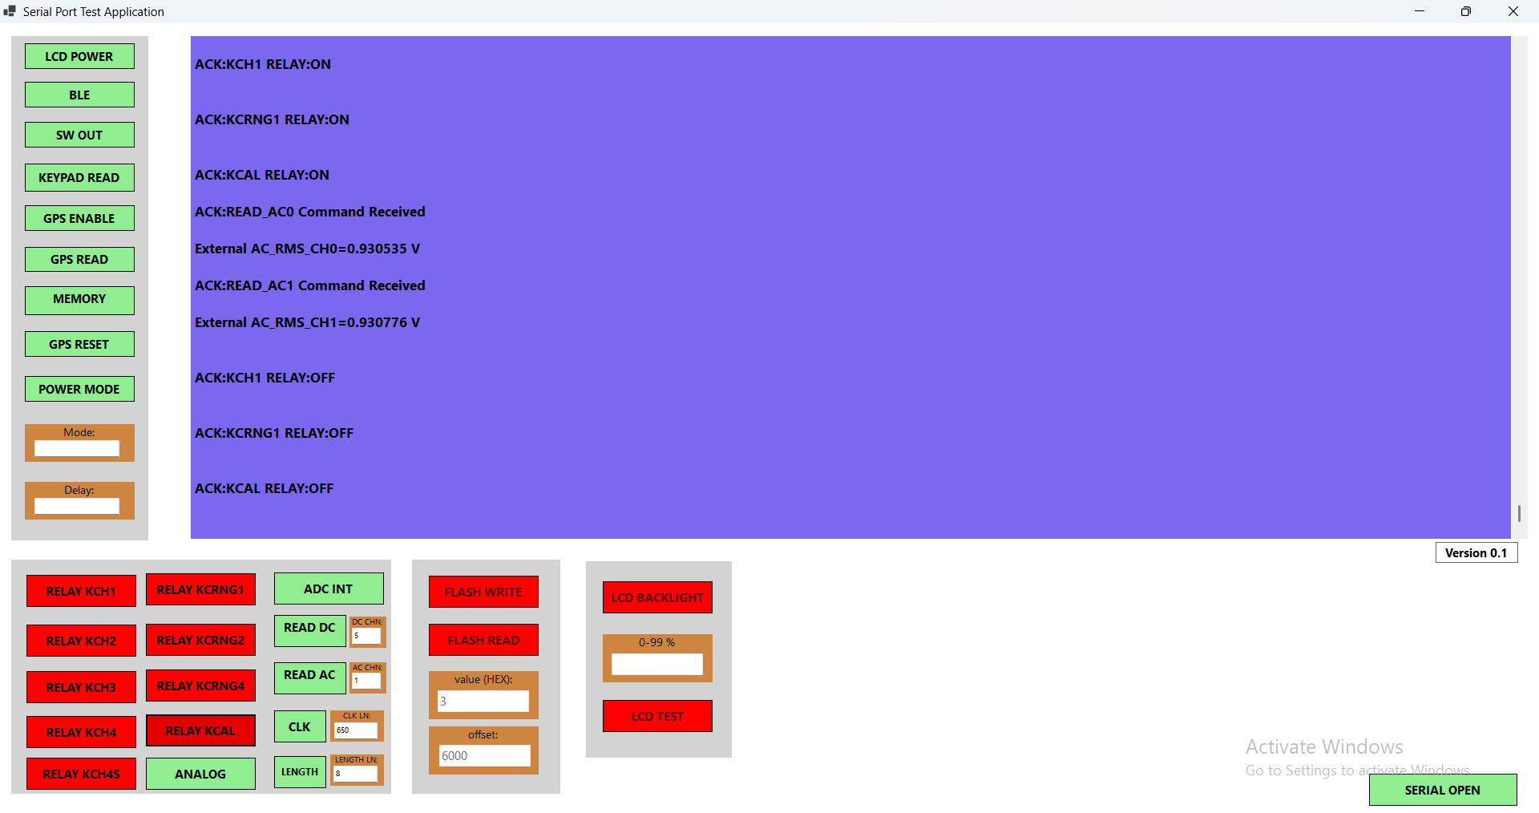

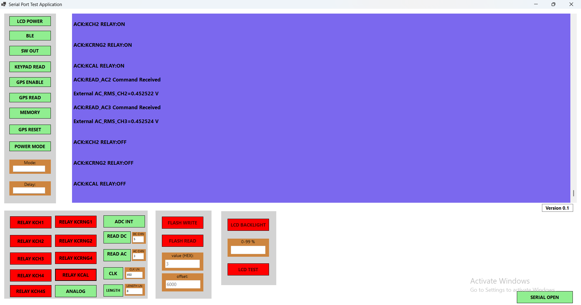
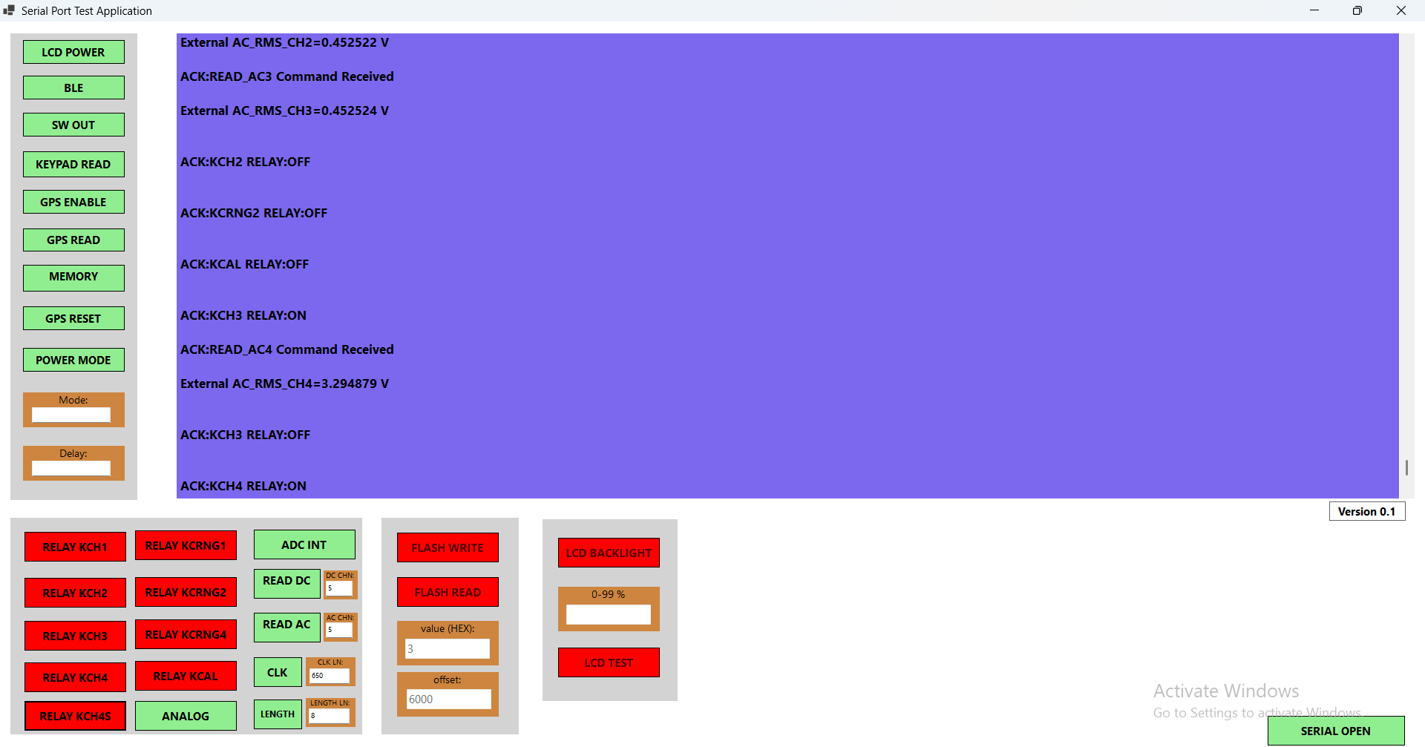

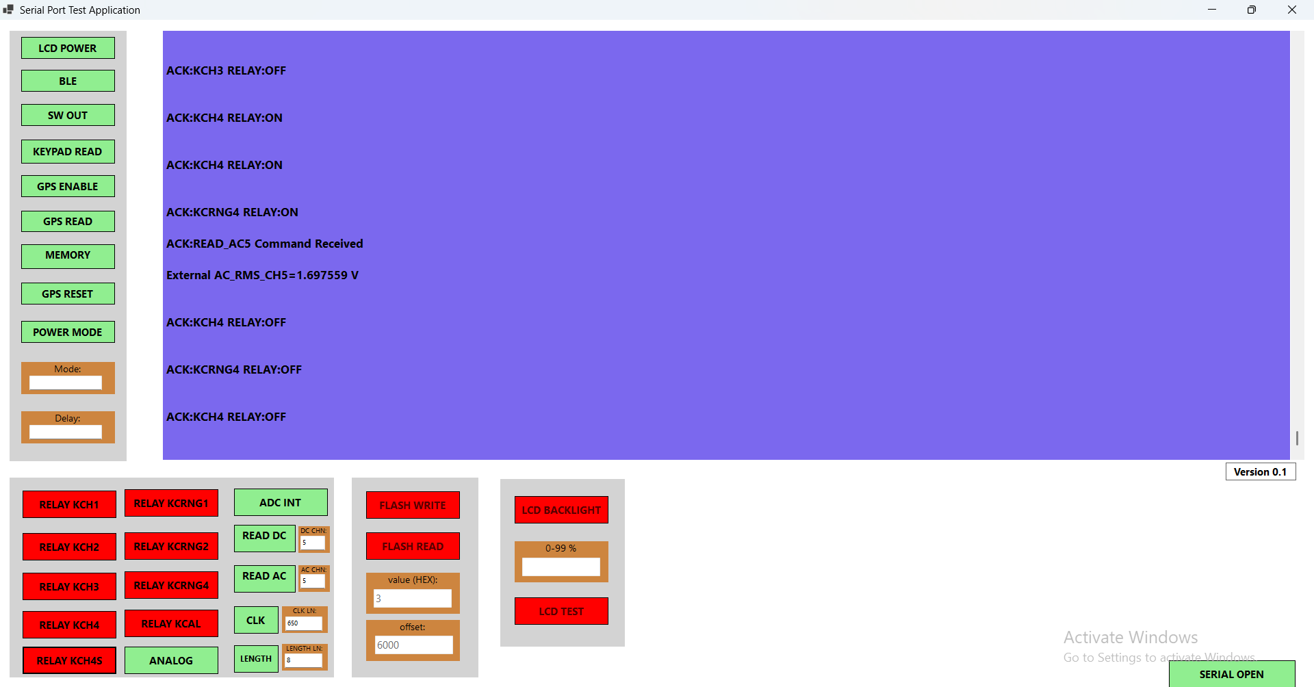

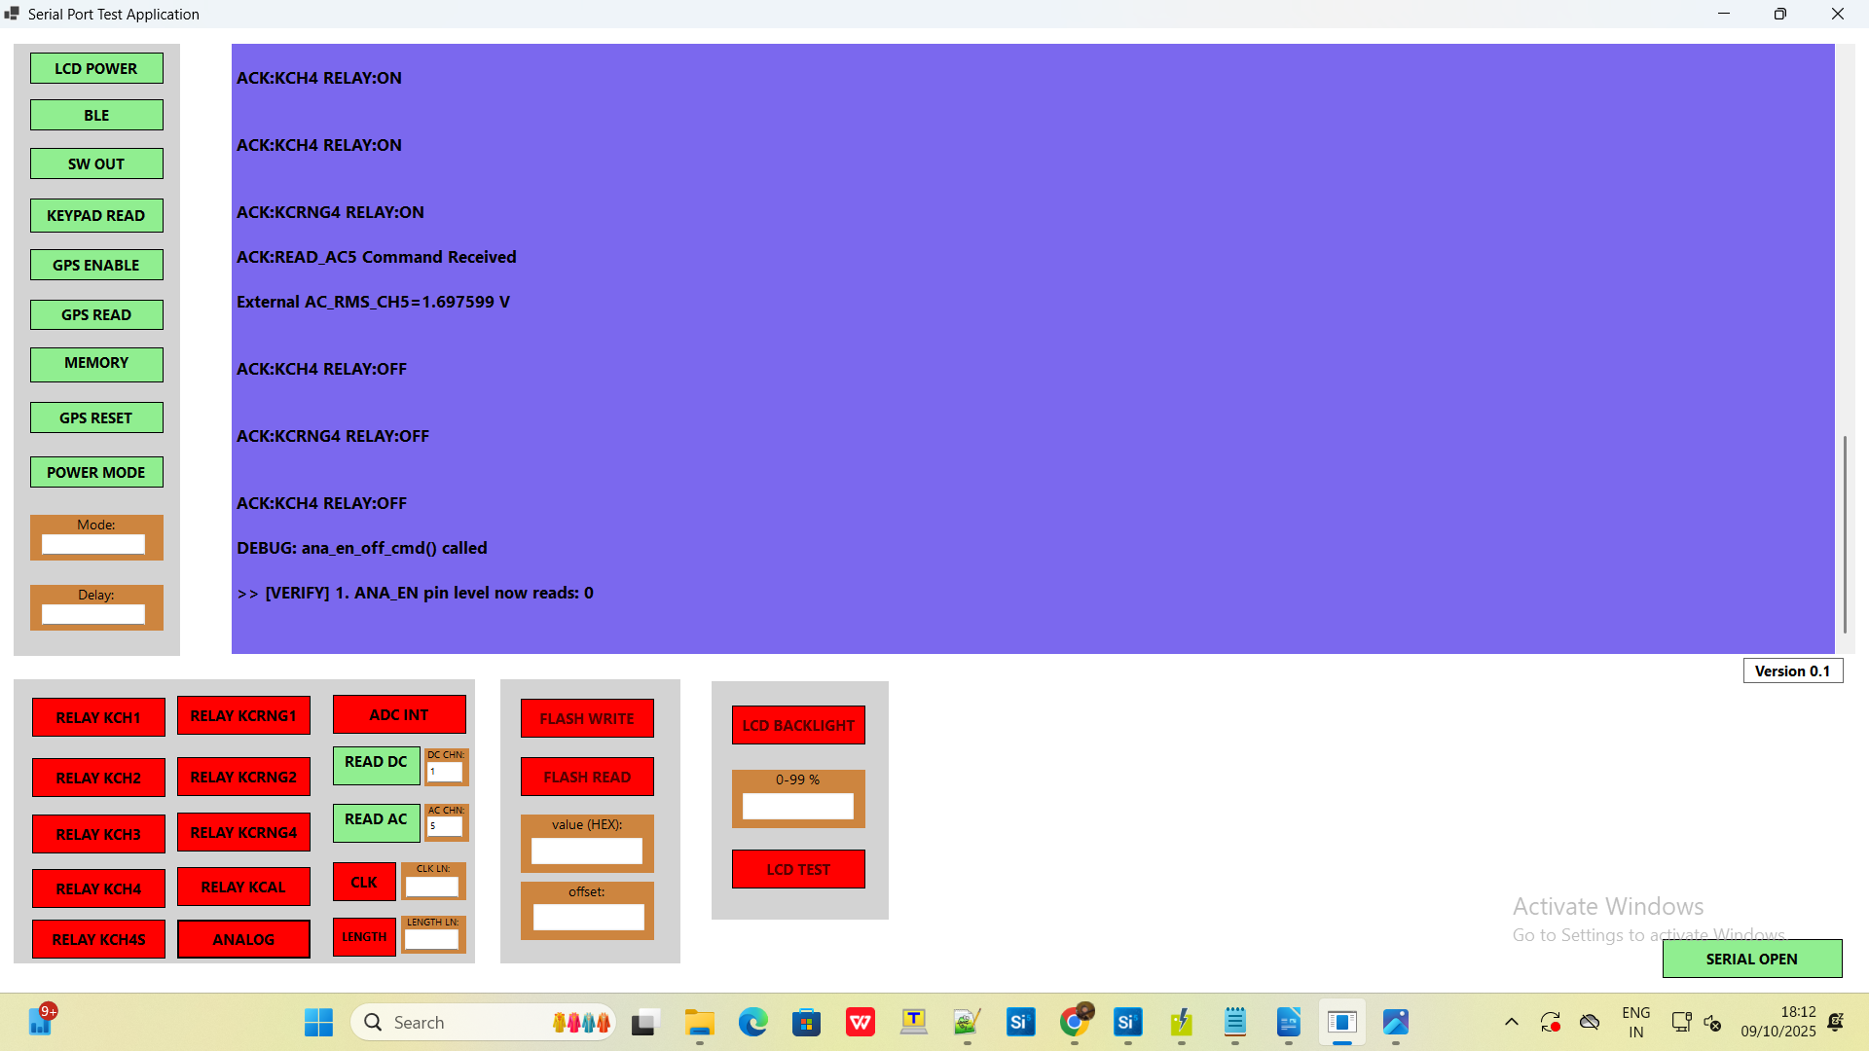

STEP 20:
Power Mode
Power Mode 2:
Sets the controller to low-frequency mode via Timer.
This reduces the operating frequency using a timer to lower power consumption.
Power Mode 4:
Sets the controller to deep sleep mode via BURTC (Backup Real-Time Counter).
After the delay, it will automatically restart.
This mode puts the controller in a very low power state and restarts it after a set period.

