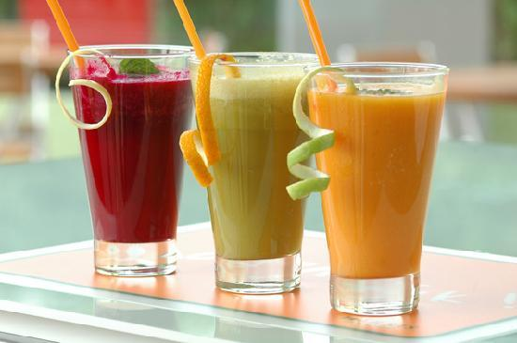

# John’s Juice Corner

John’s Juice corner was established in the year of 2002 by John. Initially it was started in a small shop. Today Juice corner has over 300 branches over USA. The secret behind this success story is the recipes of John’s Mother Angelica. She has discovered about 500 secret recipes which are all used by John.

|  |  |
| --- | --- |
| **Phone** | |
| Toll Free | 1-888-936-9648   1-919-481-1827 |
|  |  |
| **Fax** | |
| CaliforniaRest of USA | 1-919-573-0406  1-919-573-0806 |
|  |  |
| **Email** | |
| Enquiry | [john@juicecorner.com](mailto:john@juicecorner.com) |

|  |  |
| --- | --- |
| **Individual Products** | **Price** |
| « TableStart:Product_PriceList»«ProductName» | «Price»« TableEnd:Product_PriceList» |

|  |  |  |
| --- | --- | --- |
| **SNO** | **Product Name** | **Product Image** |
| **«TableStart:Products» «SNO»** | **«ProductName»** | **«Image:ProductImage»«TableEnd:Products»** |