Program 1:

import java.io.\*;

class count

{

public static int countWordsUsingSplit(String input)

{

if(input==null||input.isEmpty())

{

return 0;

}

String[] words=input.split("\\s+");

return words.length;

}

public static void main(String arg[])

{

System.out.println(countWordsUsingSplit("Java Programming"));

}

}

Output:

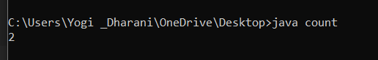

Program2:

import java.io.\*;

public class String1{

public static void main(String args[]){

Scanner sc=new Scanner(System.in);

System.out.println("Enter the first string:");

String str1=sc.nextLine();

System.out.println("Enter the second string:");

String str2=sc.nextLine();

System.out.println("Enter the Character to perform the index op: ");

char ch=sc.next().charAt(0);

System.out.println("Index of"+ch+"in str1:"+str1.indexOf(ch));

if(str1.compareTo(str2)==0)

System.out.println("Strings are equal");

else

System.out.println("Strings are not equal");

String str3=str1.concat("").concat(str2);

System.out.println(str3);

}

}

Output:

Program3:

import java.io.\*;

import java.util.\*;

class a

{

public static void main(String args[])

{

int a[]={5,10};

int b=5,y;

try

{

int x=a[2]/(a[1]-b);

System.out.println(x);

}

catch(Exception e)

{

System.out.println("Array index is out of bounds");

}

}

}

Output:

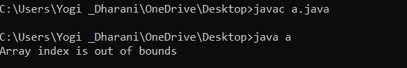

Program 4:

import java.io.\*;

import java.util.\*;

class b

{

public static void main(String args[])

{

int a[]={5,10};

int b=5,y;

try

{

int x=a[1]/(a[0]-b);

System.out.println(x);

}

catch(Exception e)

{

System.out.println("division by index");

}

}

}

Output:

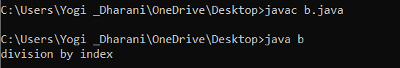

Program 5:

import java.io.\*;

import java.util.\*;

class y

{

public static void main(String args[])

{

try

{

int d,w,y,y1;

Scanner sc=new Scanner(System.in);

int nod=sc.nextInt();

if(nod<=0)

throw new ArithmeticException("Invalid due to zero");

y=nod%365;

y1=nod/365;

w=y1%7;

d=y1/7;

System.out.println("Year"+y);

System.out.println("weeks"+w);

System.out.println("Days"+d);

}

catch(ArithmeticException e)

{

System.out.println(e.getMessage());

}

catch(Exception e)

{

System.out.println("Invalid ");

}

}

}

Output:

