Program1: Rectangle Star Pattern

import java.io.\*;

import java.util.\*;

class rectstarpattern

{

public static void main(String args[])

{

try

{

int i,j;

Scanner sc=new Scanner(System.in);

System.out.println("Enter the number of rows:");

int r=sc.nextInt();

System.out.println("Enter the number of columns:");

int c=sc.nextInt();

for(i=1;i<=r;i++)

{

for(j=1;j<=c;j++)

{

System.out.print("\* ");

}

System.out.println();

}

}

catch(Exception e)

{

System.out.println("invalid");

}

}

}

Output:

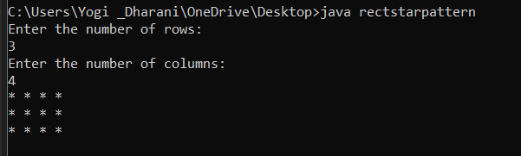

Program 2: Number Pattern

import java.io.\*;

import java.util.\*;

class consnumpattern

{

public static void main(String args[])

{

try

{

Scanner sc=new Scanner(System.in);

System.out.println("enter the number:");

int n=sc.nextInt();

for(int i=1;i<=n;i++)

{

for(int j=1;j<=i;j++)

{

System.out.print(i+" ");

}

System.out.println();

if(i==n)

break;

}

for(int i=n-1;i>=1;i--)

{

for(int j=1;j<=i;j++)

{

System.out.print(i+" ");

}

System.out.println();

}

}

catch(Exception e)

{

System.out.println("invalid");

}

}

}

Output:

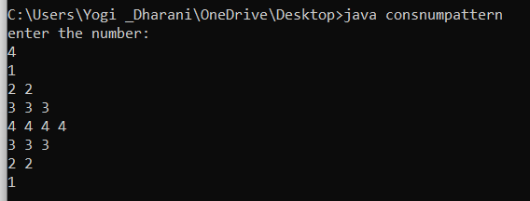

Program 3: Number pattern

import java.io.\*;

import java.util.\*;

class numpattern

{

public static void main(String args[])

{

try

{

Scanner sc=new Scanner(System.in);

System.out.println("Enter the number:");

int n=sc.nextInt();

for(int i=1;i<=n;i++)

{

for(int j=1;j<=i;j++)

{

System.out.print(i+" ");

}

System.out.println();

}

}

catch(Exception e)

{

System.out.println("Invalid");

}

}

}

Output:

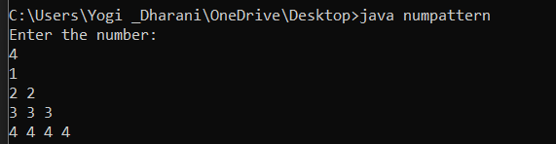

Program 4:

import java.io.\*;

import java.util.\*;

class symbol

{

public static void main(String args[])

{

try

{

Scanner sc=new Scanner(System.in);

System.out.println("Enter the number:");

int n=sc.nextInt();

for(int i=1;i<=n;i++)

{

for(int j=1;j<=i;j++)

{

System.out.print("%");

}

System.out.println();

}

}

catch(Exception e)

{

System.out.println("Invalid");

}

}

}

Output:

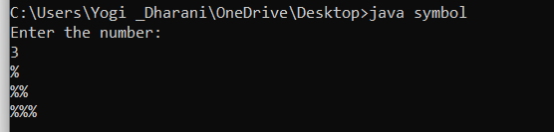

Program 5:

import java.io.\*;

import java.util.\*;

class sqrnumpattern

{

public static void main(String args[])

{

try

{

Scanner sc=new Scanner(System.in);

System.out.println("Enter the number:");

int n=sc.nextInt();

int a=1;

for(int i=1;i<=n;i++)

{

for(int j=1;j<=i;j++)

{

System.out.print(a\*a+" ");

a++;

}

System.out.println();

}

}

catch(Exception e)

{

System.out.println("Invalid");

}

}

}

Output:

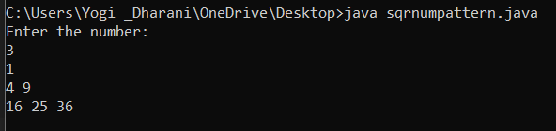

Program 6:

import java.io.\*;

import java.util.\*;

class hollowsqrpattern

{

public static void main(String args[])

{

try

{

Scanner sc=new Scanner(System.in);

System.out.println("Enter the number of rows:");

int n=sc.nextInt();

for(int i=1;i<=n;i++)

{

for(int j=1;j<=n;j++)

{

if(i==n||j==n||i==1||j==1)

{

System.out.print("@");

}else

System.out.print(" ");

}

System.out.println();

}

}

catch(Exception e)

{

System.out.println("invalid");

}

}

}

Output:

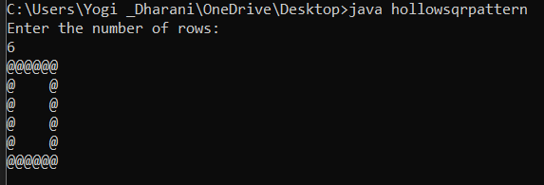

Program 7: Diff number pattern

import java.io.\*;

import java.util.\*;

class r {

public static void main(String[] args) {

int rows = 6, coef = 1;

for(int i = 0; i < rows; i++) {

for(int space = 1; space < rows - i; ++space) {

System.out.print(" ");

}

for(int j = 0; j <= i; j++) {

if (j == 0 || i == 0)

coef = 1;

else

coef = coef \* (i - j + 1) / j;

System.out.printf("%4d", coef);

}

System.out.println();

}

}

}

Output:

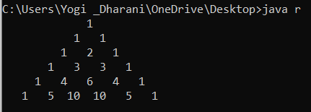

Program 8:Inverted Full pyramid pattern

import java.io.\*;

class GFG{

public static void main (String[] args)

{

int number = 7;

int i, j;

for(i = number; i >= 1; i--)

{

for(j = i; j < number; j++)

{

System.out.print(" ");

}

for(j = 1; j <= (2 \* i - 1); j++)

{

System.out.print("\*");

}

System.out.println("");

}

}

}

Output:

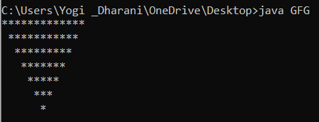

Program 9:

import java.io.\*;

import java.util.\*;

class Pattern {

public static void main(String[] args) {

int n = 3;

for (int i = 1; i <= n; i++) {

for (int j = 1; j <= i; j++) {

System.out.print(1);

}

System.out.println();

}

for (int i = n - 1; i >= 1; i--) {

for (int j = 1; j <= i; j++) {

System.out.print(1);

}

System.out.println();

}

}

}

Output:

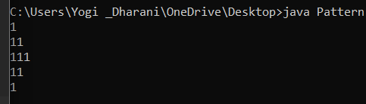

Program 10: Pyramid star pattern

import java.io.\*;

import java.util.\*;

public class fullpyramid1

{

public static void main(String args[])

{

int i, j, row = 6;

for (i=0; i<row; i++)

{

for (j=row-i; j>1; j--)

{

System.out.print(" ");

}

for (j=0; j<=i; j++ )

{

System.out.print("\* ");

}

System.out.println();

}

}

}

Output:

