**1.User-Item Matrix:**

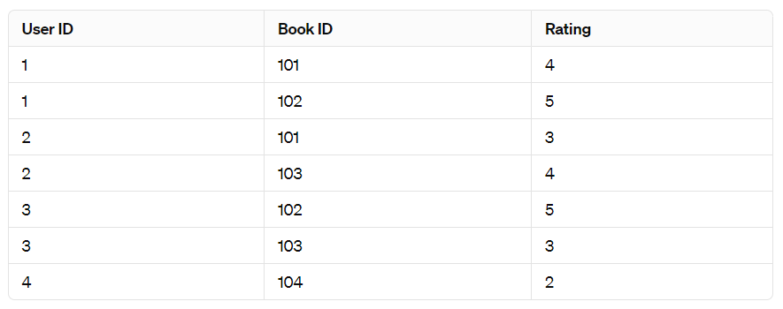

**Identify Users and Items**: We have 4 users (IDs 1, 2, 3, and 4) and 4 books (IDs 101, 102, 103, and 104).

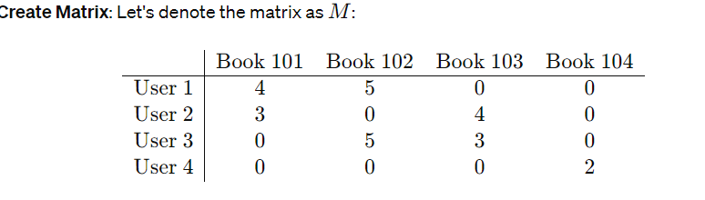**Fill in the Matrix**: Populate the matrix with the ratings provided by users for books. If a user hasn't rated a book, we put a 0 or leave the cell empty.

**Handle Sparsity**: As in the previous example, the matrix may be sparse due to incomplete ratings.

**Normalize Data (Optional)**: Skipping normalization for simplicity.

**Apply Algorithms**: We can apply recommendation algorithms to this user-item matrix to generate book recommendations for users.

**Evaluate and Iterate**: Evaluate the recommendation system's performance using appropriate metrics and iterate on algorithms to enhance recommendation quality.

This adapted example demonstrates the process with books instead of movies, but the fundamental approach remains the same.

**2.Collaborative filtering can filter out items that a user might like based on reaction by similar user comment on it:**

Yes, that's correct! Collaborative filtering is a type of recommendation algorithm that filters out items that a user might like based on the reactions or preferences of similar users. There are two main types of collaborative filtering: user-based and item-based.

* **User-Based Collaborative Filtering**
* **Item-Based Collaborative Filtering**

Both user-based and item-based collaborative filtering can effectively filter out items that a user might like based on the reactions of similar users or items. These approaches leverage the wisdom of the crowd to provide personalized recommendations to users.

**3.flow of collaborative filtering based Recommender systems for books**

Here's a high-level overview of the flow of a collaborative filtering-based recommender system for books:

**Data Collection**: Gather data on user interactions with books. This data typically includes user-book interactions such as ratings, reviews, purchases, or browsing history.

**Preprocessing**: Clean the data and prepare it for modeling. This may involve handling missing values, removing outliers, and transforming the data into a suitable format for analysis.

**User-Item Matrix Formation**: Construct a user-item matrix where rows represent users, columns represent books, and each cell contains a rating or some measure of interaction between the user and the book. If a user has not interacted with a book, the corresponding cell may be left empty or filled with a default value.

**Similarity Computation**: Calculate the similarity between users or items based on their interactions. Common similarity measures include cosine similarity, Pearson correlation, or Jaccard similarity.

**Neighborhood Selection**: Identify a set of similar users or items for each target user or item. This step involves selecting a neighborhood of users or items based on their similarity scores.

**Prediction Generation**: Generate predictions for the target user or item based on the interactions of its neighbors. For user-based collaborative filtering, predictions are typically generated by taking a weighted average of the ratings of similar users. For item-based collaborative filtering, predictions are generated based on the ratings of similar items.

**Recommendation Generation**: Recommend the top-N items to the target user based on the predictions generated in the previous step. These recommendations can be ranked based on the predicted ratings or other relevance measures.

**Evaluation**: Evaluate the performance of the recommender system using metrics such as precision, recall, mean absolute error, or mean squared error. This step helps assess the accuracy and effectiveness of the recommendations.

**Model Tuning and Optimization**: Fine-tune the model parameters and algorithms to improve recommendation quality. This may involve experimenting with different similarity measures, neighborhood sizes, or recommendation strategies.

**Deployment**: Deploy the trained model in a production environment where it can generate real-time recommendations for users based on their interactions with books.

This flow represents a general process for building and deploying a collaborative filtering-based recommender system for books. Implementation details may vary depending on factors such as the specific dataset, choice of algorithms, and performance requirements.

**4. Calculate similarities between movies based on ratings:**

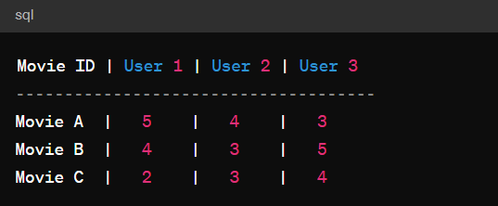

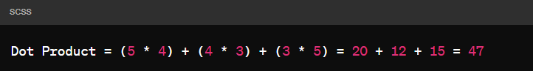

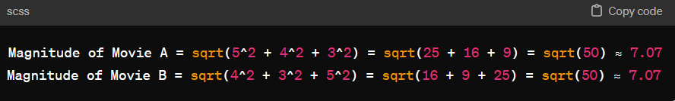

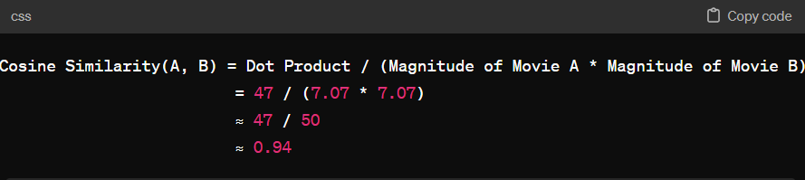

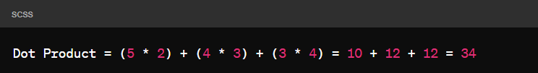

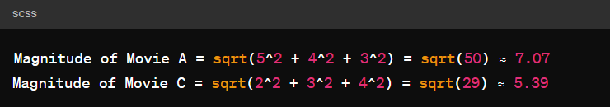

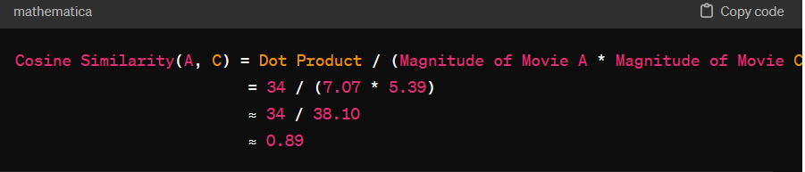

Now, we have calculated the cosine similarities between Movie A and Movie B, and between Movie A and Movie C. These values indicate the similarity in ratings between the pairs of movies. Higher values imply greater similarity in ratings, while lower values imply less similarity.

**5. Nearest Neighbours:**

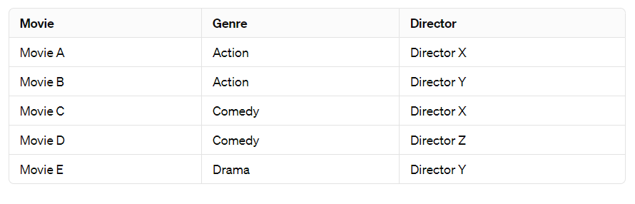

We want to find the nearest neighbors of "Movie A" based on genre and director.

**Compute Feature Vectors**:

Convert the genre and director information into feature vectors. For simplicity, let's represent genres and directors as binary features (1 if the movie belongs to the genre/director, 0 otherwise).

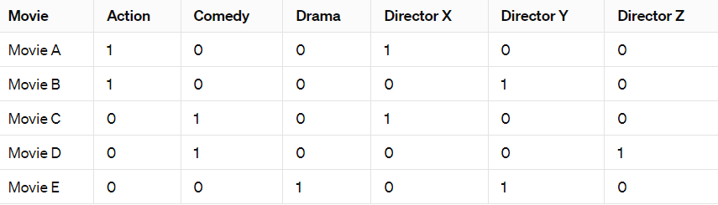

**Compute Cosine Similarity**:

Calculate the cosine similarity between the feature vector of "Movie A" and the feature vectors of all other movies.

For example, to calculate the cosine similarity between "Movie A" and "Movie B":

Compute the dot product of their feature vectors.

Compute the magnitude of each feature vector.

Calculate the cosine similarity using the formula.

Repeat this process for all other movies to get their cosine similarity with "Movie A".

**Identify Nearest Neighbors**:

Sort the movies based on their cosine similarity values in descending order.

Select the top �*k* movies as the nearest neighbors.

**Example**:

Let's assume we're considering the top 3 nearest neighbors.

After computing cosine similarities, suppose we find the following results:

Similarity(Movie A, Movie B) = 0.8

Similarity(Movie A, Movie C) = 0.6

Similarity(Movie A, Movie D) = 0.3

Similarity(Movie A, Movie E) = 0.4

The top 3 nearest neighbors of "Movie A" based on genre and director are "Movie B", "Movie C", and "Movie E".

This approach allows us to identify movies with similar genres and directors to a given movie. Adjustments can be made to include additional features or refine the similarity calculation based on specific requirements and preferences.

**6. identify the type of filtering** - neighbourhood based

The type of filtering described in the previous response, where we identify the nearest neighbors of a movie based on genre and director, falls under the category of **neighborhood-based filtering**, specifically item-item collaborative filtering.

identify the type of filtering - create as model by using data

**model-based filtering** or **model-based collaborative filtering**.

identify the type of filtering - uses similarity between items to determine if a user would like it or not

**collaborative filtering**.

identify the type of filtering - it makes recommender based on user preference

**user-based collaborative filtering**.

**7.MATCH:**

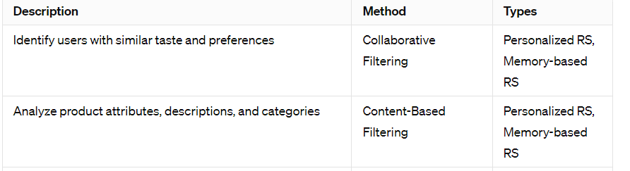

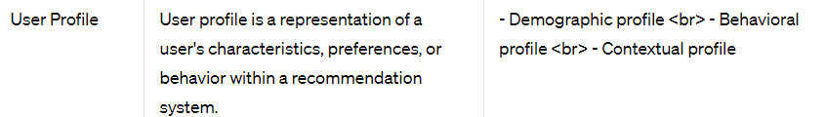

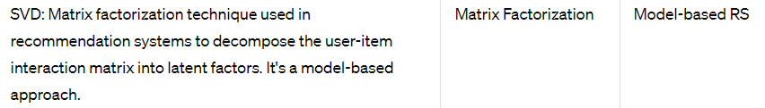

**8.Rearranging:**

Personalised recommendations based on the user profiles.

Similarity to previously liked movies.

Genre match with user preferences.

Diversity of movie recommendations.

**9.** **Infer the effective method for learning user profiles based on user ratings or user viewing behaviour**

One effective method for learning user profiles based on ratings or viewing behavior is collaborative filtering, leveraging user-item interactions to identify patterns. This approach can include user-based or item-based techniques to assess similarities. Additionally, matrix factorization methods like Singular Value Decomposition (SVD) capture latent factors in user-item matrices, enhancing recommendation accuracy. Content-based filtering analyzes item attributes to infer user preferences, complementing collaborative approaches. Sequence models, such as Recurrent Neural Networks (RNNs), capture temporal dependencies in user behavior for dynamic profiling. Machine learning models trained on user data, like decision trees or neural networks, offer predictive insights into user preferences. Hybrid approaches combine multiple methods for improved performance, combining collaborative, content-based, and machine learning techniques. Iterative refinement based on user feedback enhances profile learning accuracy and recommendation relevance. Evaluation metrics like precision and recall gauge the effectiveness of learned profiles. Ultimately, a combination of techniques tailored to the dataset and domain yields optimal user profile learning outcomes.

**10. Create a music recommendation system for 4 users (A,B,C,D) to recommend the songs based on similarities:**

**Data Collection**: Gather data on songs listened to or liked by users A, B, C, and D, including song titles, artists, and genres.

**Build User-Item Matrix**: Create a user-item matrix where rows represent users and columns represent songs. Populate the matrix with binary values indicating whether a user likes a song.

**Calculate Similarities**: Use similarity measures such as cosine similarity to compute the similarity between users based on their listening preferences.

**Identify Similar Users**: For each user, identify the most similar users based on their listening preferences.

**Generate Recommendations**: Recommend songs to each user based on the songs liked by similar users. Filter recommendations to exclude songs already listened to by the target user.

**Evaluate Recommendations**: Assess the quality of recommendations using metrics such as precision and recall.

**Feedback Loop**: Incorporate user feedback to refine the recommendation system and improve accuracy over time.

**User Interface**: Develop a user-friendly interface for users to view and interact with recommended songs.

**Privacy Considerations**: Ensure user privacy by implementing appropriate data protection measures and anonymizing user data.

**Scalability**: Design the recommendation system to scale efficiently as the number of users and songs increases.

11.**Infer the process of linear Regression:**

**Data Collection**: Gather data consisting of paired observations for an independent variable (predictor) and a dependent variable (response).

**Data Preprocessing**: Clean and preprocess the data, handling missing values, outliers, and scaling or normalizing variables if necessary.

**Model Specification**: Choose the appropriate form of linear regression model based on the relationship between the independent and dependent variables (e.g., simple linear regression for one independent variable, multiple linear regression for multiple independent variables).

**Model Training**: Use the training data to estimate the coefficients (parameters) of the linear regression model. This involves minimizing the error between the observed and predicted values of the dependent variable using methods like Ordinary Least Squares (OLS).

**Model Evaluation**: Evaluate the performance of the trained model using validation techniques such as cross-validation or by splitting the data into training and testing sets. Common evaluation metrics include Mean Squared Error (MSE), Root Mean Squared Error (RMSE), Mean Absolute Error (MAE), and R-squared (R2).

**Coefficient Interpretation**: Interpret the coefficients of the linear regression model to understand the relationship between the independent and dependent variables. Each coefficient represents the change in the dependent variable for a one-unit change in the corresponding independent variable, holding all other variables constant.

**Prediction**: Use the trained model to make predictions on new data. Given values of the independent variables, the model predicts the corresponding value of the dependent variable.

**Assumption Checking**: Verify whether the assumptions of linear regression are met, including linearity, independence of errors, homoscedasticity (constant variance of errors), and normality of errors.

**Residual Analysis**: Examine the residuals (the differences between observed and predicted values) to assess the model's fit and identify any patterns or outliers.

**Model Refinement**: Refine the model if necessary by considering alternative model specifications, including interaction terms or polynomial features, and by incorporating additional predictor variables to improve prediction accuracy. Regularization techniques like Ridge or Lasso regression can also be applied to prevent overfitting.

1. **predict performance of +ve PPV and -ve NPV**

Logistic regression does not directly predict Positive Predictive Value (PPV) and Negative Predictive Value (NPV). Instead, they are evaluation metrics calculated from the confusion matrix. PPV measures the proportion of true positives among all predicted positives, while NPV measures the proportion of true negatives among all predicted negatives. Logistic regression predicts probabilities of class membership, and thresholds can be adjusted to classify instances. The performance of PPV and NPV depends on the chosen threshold and the model's ability to discriminate between classes. Evaluation on validation data is crucial to determine optimal thresholds and assess model performance in predicting positives and negatives.