Project: Yuva Intern | August 2026
Week 3 Report

Advanced Data Analysis and Visualization in Logistics
Exploratory analysis of delivery performance, cost drivers and bottlenecks using Python

Prepared by: Dharanidharan P

1. Introduction and Objective
Weeks 1 and 2 defined the logistics scenario and prepared clean data. Week 3 turns that data into insight. The objective is to explore a hypothetical delivery dataset, measure performance with the KPIs defined in Week 1, and use visualizations to find what drives cost, what causes late deliveries and where the bottlenecks are.
Summary of findings: the network delivers 91.9% of shipments on time overall, but this average hides three concentrated problems: the festival season (22.4% late vs 4.4% in normal weeks), two vans (V07 and V11) that are late about 25.7% of the time, and the two long-distance districts, Salem and Madurai. Distance is by far the largest cost driver.

2. Data Simulation

2.1 Dataset Structure
A hypothetical dataset of 8,000 shipments (2025-10-01 to 2026-09-30) was generated for the SouthRoute Retail scenario from Week 1: one warehouse in Tiruchirappalli delivering to eight districts with a fleet of 12 vans. Relationships such as "longer distance means higher cost" and "festival weeks are busier" were built in deliberately, then the analysis tests whether EDA can recover them. All figures in this report therefore describe simulated data, not real company performance.

Variable | Type | Description
order_date | Date | Date the order was placed; 12 months
district | Category | Destination: Trichy, Pudukkottai, Perambalur, Thanjavur, Ariyalur, Karur, Madurai, Salem
distance_km | Numeric | Road distance from warehouse (about 10 to 140 km)
shipping_mode | Category | Standard (3 days), Express (2 days), Priority (1 day)
weight_kg, units | Numeric | Shipment weight and item count (shipment volume)
van_id | Category | Delivery van V01 to V12
dispatch_delay_hr | Numeric | Hours between order and van leaving the warehouse
scheduled_days, actual_days | Numeric | Promised and actual delivery time in days (delivery time)
transport_cost | Numeric | Cost of moving the shipment in INR (transportation cost)
festival_season, weekend_order | Binary | Flags for 15 Oct - 20 Nov and for Saturday/Sunday orders
delay_days, is_late, cost_per_km | Derived | actual - scheduled days; 1 if delay > 0; cost / distance

2.2 Simulation Code
import numpy as np, pandas as pd

rng = np.random.default_rng(42)
n = 8000

# --- Dates: 12 months, heavier volume in the festival window (15 Oct - 20 Nov)
days = np.arange(365)
w = np.where((days >= 14) & (days <= 50), 2.2, 1.0)
day = rng.choice(days, n, p=w / w.sum())
order_date = pd.Timestamp("2025-10-01") + pd.to_timedelta(day, unit="D")
festival = ((day >= 14) & (day <= 50)).astype(int)
weekend = (order_date.dayofweek >= 5).astype(int)

# --- Destination district and road distance from the central warehouse (km)
dist_base = {"Trichy": 10, "Pudukkottai": 55, "Perambalur": 55, "Thanjavur": 60,
"Ariyalur": 70, "Karur": 80, "Madurai": 130, "Salem": 140}
district = rng.choice(list(dist_base), n, p=[.28, .10, .08, .14, .07, .10, .12, .11])
distance_km = np.array([dist_base[d] for d in district]) + rng.normal(0, 6, n)
distance_km = distance_km.clip(3)

# --- Shipment attributes
mode = rng.choice(["Standard", "Express", "Priority"], n, p=[.60, .30, .10])
sched = pd.Series(mode).map({"Standard": 3, "Express": 2, "Priority": 1}).values
weight_kg = rng.lognormal(3.0, 0.7, n).round(1)
units = rng.poisson(weight_kg / 4).clip(1)
van = rng.choice([f"V{i:02d}" for i in range(1, 13)], n)
dispatch_delay_hr = (rng.lognormal(1.0, 0.6, n) + 2 * festival).round(1)

# --- Delivery time: driven by distance, warehouse delay, festival load, weekends, weak vans
van_penalty = np.where(np.isin(van, ["V07", "V11"]), 0.7, 0.0)
delay = (-1.3 + 0.006 * distance_km + 0.05 * dispatch_delay_hr + 0.5 * festival
+ 0.2 * weekend + van_penalty + rng.normal(0, 0.45, n))
actual_days = np.maximum(1, sched + np.round(delay)).astype(int)

# --- Transport cost (INR): distance x mode rate, weight effect, festival surcharge
rate = pd.Series(mode).map({"Standard": 5.5, "Express": 7.5, "Priority": 10}).values
cost = 60 + distance_km * rate * (1 + weight_kg / 200) + 0.8 * weight_kg + 40 * festival + rng.normal(0, 40, n)

df = pd.DataFrame({
"shipment_id": np.arange(1, n + 1), "order_date": order_date, "district": district,
"distance_km": distance_km.round(1), "shipping_mode": mode, "weight_kg": weight_kg,
"units": units, "van_id": van, "dispatch_delay_hr": dispatch_delay_hr,
"scheduled_days": sched, "actual_days": actual_days, "transport_cost": cost.clip(50).round(2),
"festival_season": festival, "weekend_order": weekend})

df["delay_days"] = df["actual_days"] - df["scheduled_days"]
df["is_late"] = (df["delay_days"] > 0).astype(int)
df["cost_per_km"] = df["transport_cost"] / df["distance_km"]
df["month"] = df["order_date"].dt.to_period("M").astype(str)
df["weekday"] = df["order_date"].dt.day_name()
print(df.shape); print(df.head(3).T)

3. Exploratory Data Analysis

3.1 Central Tendency and Spread
key = ["distance_km", "weight_kg", "units", "dispatch_delay_hr",
"actual_days", "delay_days", "transport_cost", "cost_per_km"]

summary = df[key].agg(["mean", "median", "std", "min", "max", "skew"]).T.round(2)
print(summary)

print("Overall on-time rate: %.1f%%" % ((1 - df["is_late"].mean()) * 100))
print("Mode of delivery days:", df["actual_days"].mode()[0])
print(df.groupby("shipping_mode")[["transport_cost", "cost_per_km", "delay_days"]].mean().round(2))
Variable | Mean | Median | Std dev | Min | Max | Skew
Distance (km) | 65.5 | 60.5 | 45.1 | 3.0 | 158.7 | 0.35
Weight (kg) | 25.6 | 19.9 | 21.0 | 1.0 | 415.2 | 3.59
Units | 6.5 | 5.0 | 5.8 | 1.0 | 112.0 | 3.18
Dispatch delay (hr) | 3.6 | 3.2 | 2.3 | 0.3 | 40.6 | 2.11
Actual days | 2.1 | 2.0 | 0.9 | 1.0 | 5.0 | 0.30
Delay (days) | -0.4 | 0.0 | 0.7 | -2.0 | 2.0 | 0.22
Transport cost (INR) | 571.4 | 518.4 | 366.9 | 50.0 | 2327.3 | 0.85
Cost per km (INR) | 11.6 | 9.0 | 7.8 | 4.2 | 92.5 | 3.43

Interpretation: distance is fairly symmetrical (mean 65.5 km, median 60.5 km), while weight, units and cost per km are strongly right-skewed (skew above 3). A few very heavy shipments and very short trips (where fixed costs dominate cost per km) pull the means above the medians. For reporting, the median is therefore a more honest "typical" value than the mean for these variables. Average actual delivery time is exactly 2.1 days with a median delay of 0.0 days, which means a typical shipment arrives on its promised day, but the mean delay of -0.4 days shows a tail of late orders.
Cost by shipping mode: average cost rises from INR 500 (Standard) to INR 629 (Express) and INR 823 (Priority), and cost per km from 10.2 to 15.8. However, the late rate is almost the same across modes (8.4%, 7.7%, 7.7%), so the faster and more expensive modes do not deliver better reliability.

4. Visualizations and Insights
Each chart type was chosen for the question it answers. Python code, justification and interpretation are given together. The figures were created with matplotlib and seaborn; plotly would be a suitable replacement where interactive hover or zoom is needed in a dashboard.

4.1 Trend: Monthly Volume and On-Time Rate
import matplotlib.pyplot as plt
import seaborn as sns
sns.set_theme(style="whitegrid", font_scale=1.0)
BLUE, ORANGE, RED = "#1F4E79", "#E07B00", "#C0392B"

# Figure 1: monthly volume (bars) and on-time rate (line) - trend over time
monthly = df.groupby("month").agg(shipments=("shipment_id", "count"),
ontime=("is_late", lambda s: (1 - s.mean()) * 100))
fig, ax1 = plt.subplots(figsize=(8, 4))
ax1.bar(monthly.index, monthly["shipments"], color=BLUE, alpha=.8)
ax1.set_ylabel("Shipments"); ax1.tick_params(axis="x", rotation=45)
ax2 = ax1.twinx()
ax2.plot(monthly.index, monthly["ontime"], color=ORANGE, marker="o", lw=2)
ax2.set_ylabel("On-time rate (%)"); ax2.grid(False)
ax1.set_title("Monthly Shipment Volume vs On-Time Delivery Rate")
plt.tight_layout(); plt.savefig("figs/fig1_trend.png", dpi=150); plt.close()
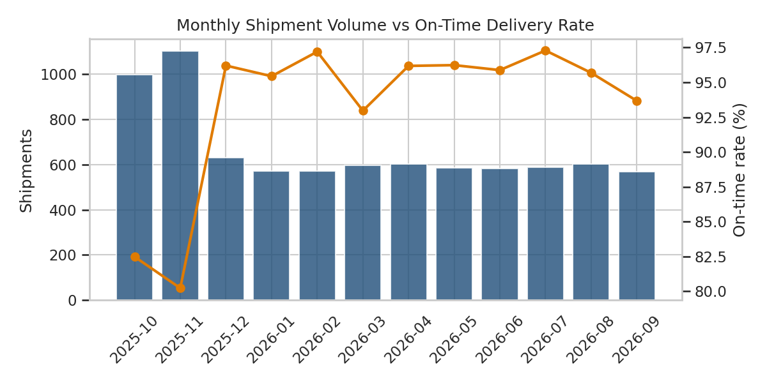
Figure 1: Monthly shipment volume (bars) and on-time delivery rate (line)

Why this chart: a time series answers "how is performance changing?". Bars show volume and a line on a second axis shows the on-time rate, so the two can be compared on the same time scale.

What it shows: volume jumps to about 1,103 shipments in November, against roughly 590 in a normal month, and on-time delivery drops at the same time to 80.2% (October: 82.5%), compared with an average of 95.7% in the other ten months. Performance falls when demand peaks, a sign that the network lacks surge capacity.

4.2 Distribution of Delivery Delay and Cost by Mode
# Figure 2: distribution of delivery delay (days beyond promise)
fig, ax = plt.subplots(figsize=(8, 4))
sns.histplot(df["delay_days"], discrete=True, color=BLUE, ax=ax)
ax.axvline(0, color=RED, ls="--", label="Promised date")
ax.set_xlabel("Delay (actual - scheduled days)"); ax.set_ylabel("Shipments"); ax.legend()
ax.set_title("Distribution of Delivery Delay")
plt.tight_layout(); plt.savefig("figs/fig2_delay_dist.png", dpi=150); plt.close()

# Figure 3: transport cost by shipping mode (box plot shows spread and outliers)
fig, ax = plt.subplots(figsize=(8, 4))
sns.boxplot(data=df, x="shipping_mode", y="transport_cost",
order=["Standard", "Express", "Priority"], palette=[BLUE, ORANGE, RED], ax=ax)
ax.set_xlabel("Shipping mode"); ax.set_ylabel("Transport cost (INR)")
ax.set_title("Transport Cost by Shipping Mode")
plt.tight_layout(); plt.savefig("figs/fig3_cost_mode.png", dpi=150); plt.close()
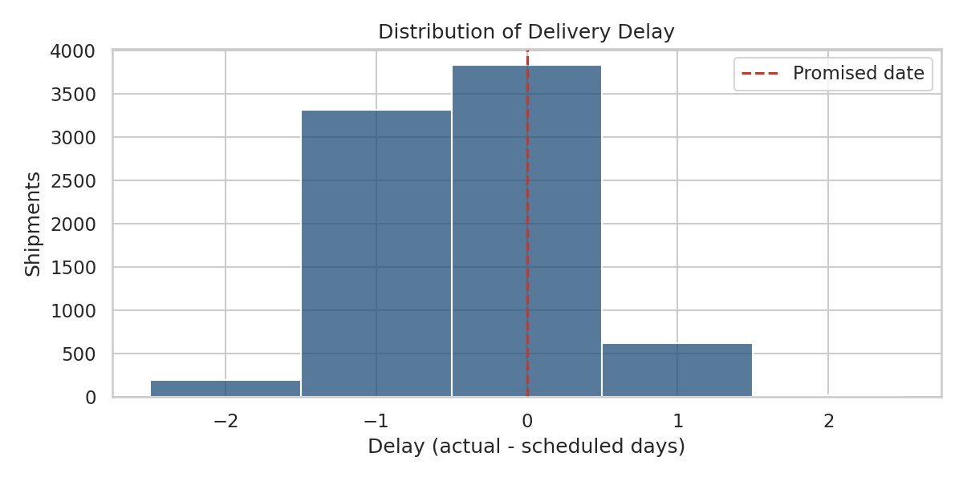
Figure 2: Histogram of delay (actual minus scheduled days)
Why this chart: a histogram shows the whole shape of a variable, not just its average. With discrete day counts, one bar per value is the clearest view.
What it shows: about 47.9% of shipments arrive exactly on time and 44.0% arrive early, while 8.1% are late, nearly all of them by one day. Many early arrivals suggest the delivery promises are padded; tighter promises could be offered to customers on shorter routes without hurting reliability.
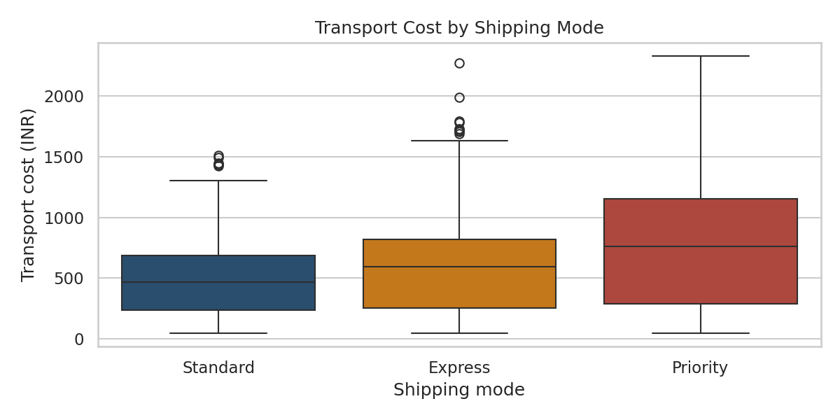
Figure 3: Box plot of transport cost by shipping mode
Why this chart: a box plot compares the median, spread and outliers of several groups side by side, which a table of means cannot do.
What it shows: both the median and the spread of cost grow from Standard to Priority. Priority has the widest range, up to about INR 2,300, so a mis-priced long-distance priority order can cost several times a normal one. A visible set of high outliers in Express and Standard likely reflects heavy, long-distance shipments.

4.3 Relationships: Correlation and Distance vs Cost
# Figure 4: correlation heatmap of numeric variables
num = ["distance_km", "weight_kg", "units", "dispatch_delay_hr",
"scheduled_days", "actual_days", "delay_days", "transport_cost"]
corr = df[num].corr().round(2)
fig, ax = plt.subplots(figsize=(7, 5.5))
sns.heatmap(corr, annot=True, cmap="RdBu_r", center=0, vmin=-1, vmax=1, fmt=".2f", ax=ax)
ax.set_title("Correlation Matrix of Shipment Variables")
plt.tight_layout(); plt.savefig("figs/fig4_corr.png", dpi=150); plt.close()

# Figure 5: distance vs cost, coloured by mode, with fitted lines
fig, ax = plt.subplots(figsize=(8, 4.5))
sns.scatterplot(data=df.sample(1500, random_state=1), x="distance_km", y="transport_cost",
hue="shipping_mode", hue_order=["Standard", "Express", "Priority"],
palette=[BLUE, ORANGE, RED], alpha=.5, s=18, ax=ax)
for m, col in zip(["Standard", "Express", "Priority"], [BLUE, ORANGE, RED]):
d = df[df["shipping_mode"] == m]
k, b0 = np.polyfit(d["distance_km"], d["transport_cost"], 1)
xs = np.linspace(0, 150, 50); ax.plot(xs, k * xs + b0, color=col, lw=2)
ax.set_xlabel("Distance (km)"); ax.set_ylabel("Transport cost (INR)")
ax.set_title("Transport Cost vs Distance by Shipping Mode")
plt.tight_layout(); plt.savefig("figs/fig5_dist_cost.png", dpi=150); plt.close()
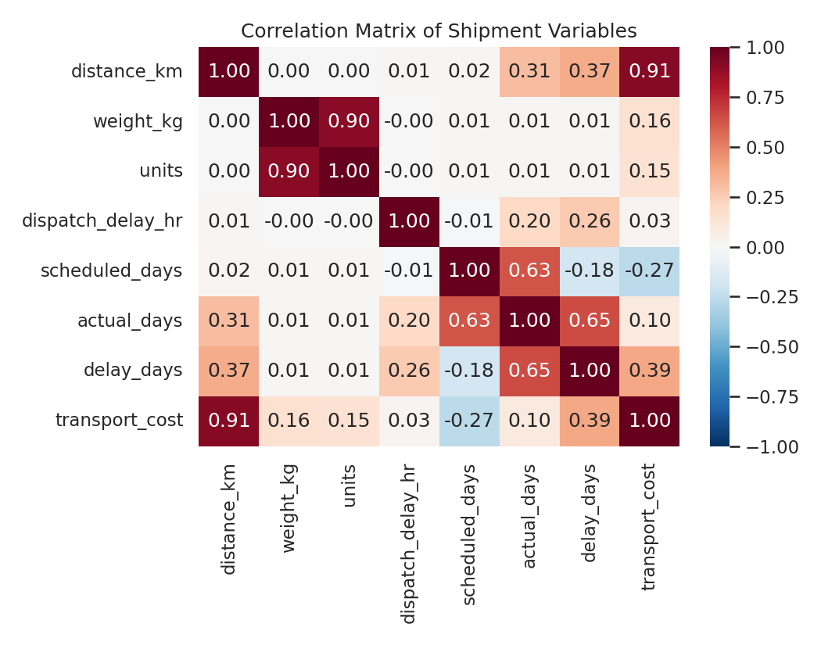
Figure 4: Correlation matrix of shipment variables
Why this chart: a heatmap of correlations screens many variable pairs at once, so the strongest relationships can be found quickly before deeper analysis.
What it shows: transport cost is very strongly correlated with distance (r = 0.91), and only weakly with weight (0.16). Delay is moderately related to distance (0.37) and dispatch delay (0.26). Weight and units are almost perfectly redundant (r = 0.90), so only one of them is needed in a predictive model. Correlation only measures linear association and does not prove cause.
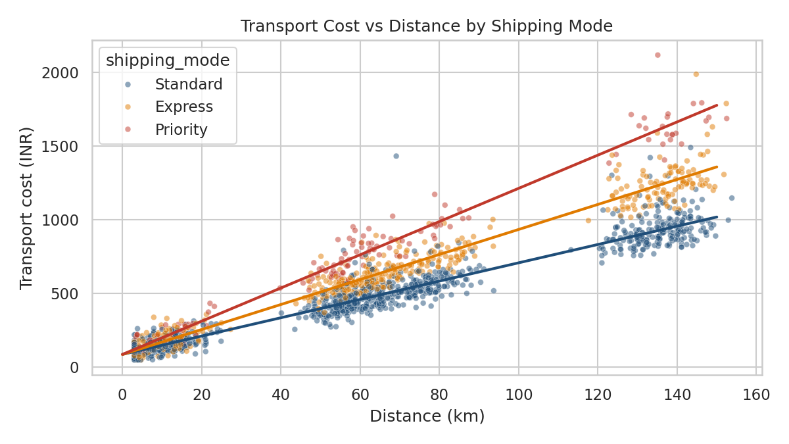
Figure 5: Transport cost vs distance, with a fitted line for each shipping mode

Why this chart: a scatter plot shows how two continuous variables move together; colouring by mode and fitting a line per mode exposes differences in cost per kilometre.

What it shows: cost rises linearly with distance, and the slope (cost per km) is steepest for Priority and flattest for Standard. The points form clear clusters at roughly 10, 55 to 80 and 130 to 150 km, which are the district groups. The vertical spread at a fixed distance comes mostly from shipment weight.

4.4 Bottlenecks: Districts, Vans and Warehouse Dispatch
# Figure 6: late-delivery rate by district (ranked bar chart)
dist_late = (df.groupby("district")["is_late"].mean() * 100).sort_values(ascending=False)
fig, ax = plt.subplots(figsize=(8, 4))
sns.barplot(x=dist_late.values, y=dist_late.index, color=BLUE, ax=ax)
ax.axvline(df["is_late"].mean() * 100, color=RED, ls="--", label="Network average")
ax.set_xlabel("Late deliveries (%)"); ax.set_ylabel(""); ax.legend()
ax.set_title("Late-Delivery Rate by District")
plt.tight_layout(); plt.savefig("figs/fig6_district_late.png", dpi=150); plt.close()

# Figure 7: late-delivery rate by van (bottleneck check)
van_late = (df.groupby("van_id")["is_late"].mean() * 100)
colors = [RED if v > van_late.mean() + 8 else BLUE for v in van_late]
fig, ax = plt.subplots(figsize=(8, 4))
ax.bar(van_late.index, van_late.values, color=colors)
ax.axhline(df["is_late"].mean() * 100, color="black", ls="--", lw=1, label="Network average")
ax.set_ylabel("Late deliveries (%)"); ax.set_xlabel("Van"); ax.legend()
ax.set_title("Late-Delivery Rate by Van")
plt.tight_layout(); plt.savefig("figs/fig7_van_late.png", dpi=150); plt.close()
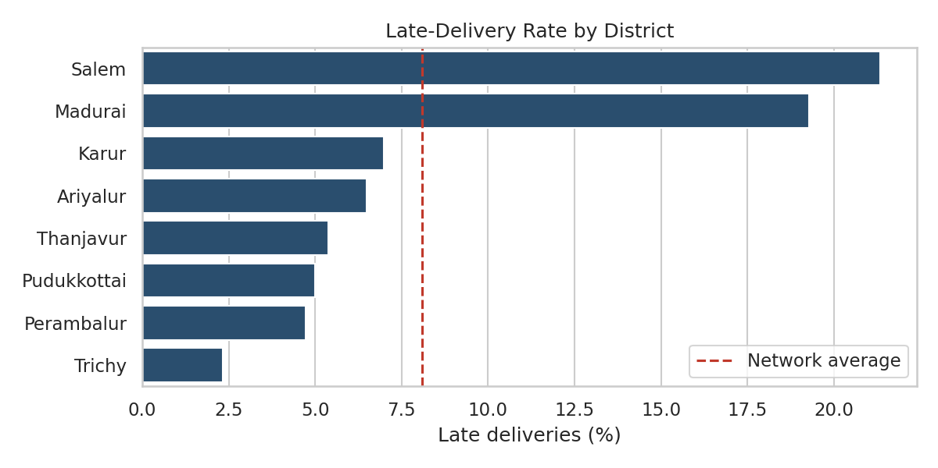
Figure 6: Late-delivery rate by district
Why this chart: a ranked horizontal bar chart with an average line makes it easy to see which categories are above or below the norm.
What it shows: Salem (21.3%) and Madurai (19.3%) are far above the network average of 8.1% late, and about three times the rate of the mid-distance districts, which sit at 4.7% to 7.0%. These are the two long-distance routes (130 to 140 km). Trichy, the nearest district, is the best at 2.3%.
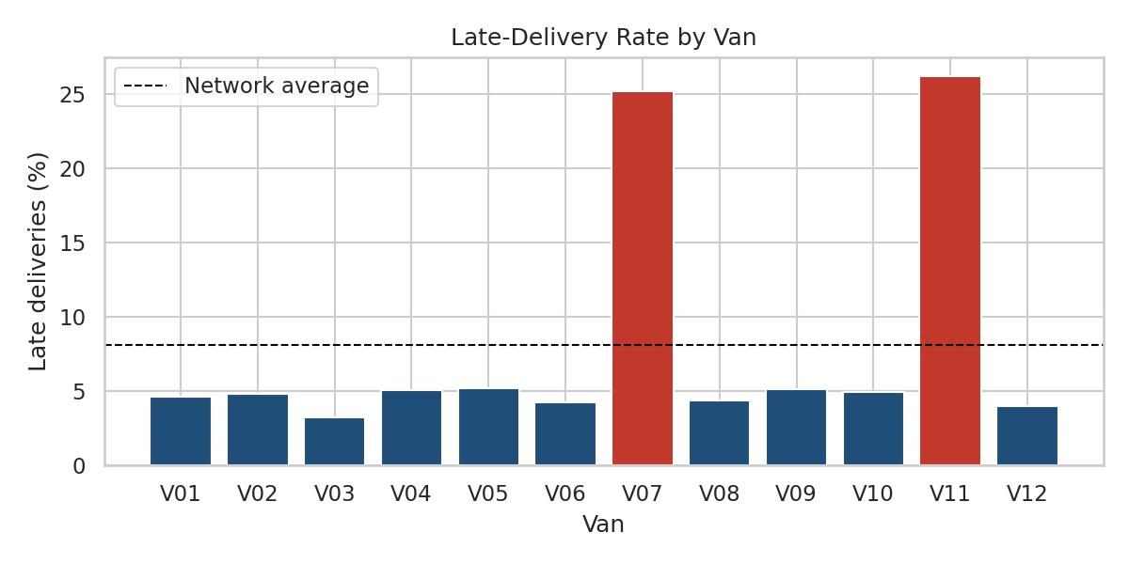
Figure 7: Late-delivery rate by van (red bars are far above average)
Why this chart: comparing the 12 vans on one axis makes outlier vehicles obvious, and colouring the bad performers directs attention to them.
What it shows: vans V07 and V11 are late 25.2% and 26.2% of the time, against an average of 4.6% for the other ten vans. Because the other ten are uniformly good, the cause is likely specific to those two vehicles (age, breakdowns, or their routes) and not a network-wide problem. These two vans account for a disproportionate share of all late deliveries while carrying only one-sixth of the volume.
# Figure 8: warehouse dispatch delay vs lateness, split by festival season
df["dispatch_bin"] = pd.cut(df["dispatch_delay_hr"], [0, 3, 4.5, 6, 100],
labels=["<3h", "3-4.5h", "4.5-6h", ">6h"])
pivot = (df.pivot_table(index="dispatch_bin", columns="festival_season",
values="is_late", aggfunc="mean", observed=True) * 100).round(1)
pivot.columns = ["Normal season", "Festival season"]
fig, ax = plt.subplots(figsize=(7, 4))
sns.heatmap(pivot, annot=True, fmt=".0f", cmap="YlOrRd", cbar_kws={"label": "Late (%)"}, ax=ax)
ax.set_xlabel(""); ax.set_ylabel("Warehouse dispatch delay")
ax.set_title("Late-Delivery Rate: Dispatch Delay x Season")
plt.tight_layout(); plt.savefig("figs/fig8_dispatch.png", dpi=150); plt.close()
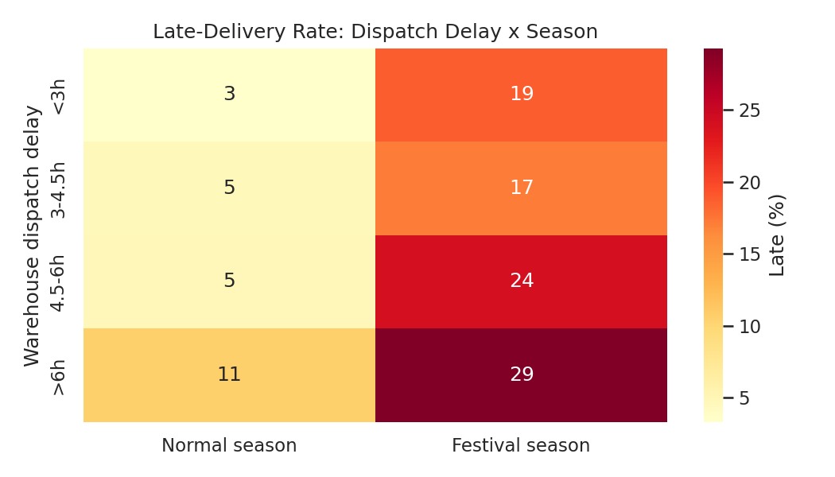
Figure 8: Late-delivery rate by warehouse dispatch delay and season
Why this chart: a two-way heatmap shows how two conditions combine, here warehouse delay and season, which a single bar chart cannot.
What it shows: in normal weeks, lateness stays at 3.3% to 4.8% until warehouse delay passes 6 hours, where it rises to 10.6%. In festival season every band is much worse (18.8% to 29.3%), even when dispatch is fast. Average dispatch delay nearly doubles in the festival period (3.2 to 5.2 hours), so the warehouse is one bottleneck, but road capacity is another because fast dispatch alone does not fix peak-season lateness.

5. Cost Driver and Late-Delivery Analysis
To measure cost drivers on a common scale, a linear regression was fitted on standardized inputs. Each coefficient shows the change in cost (INR) for a one standard deviation increase in the input, so the sizes can be compared directly.
from sklearn.linear_model import LinearRegression
from sklearn.preprocessing import StandardScaler

# Cost drivers: standardised regression coefficients (comparable across variables)
X = df[["distance_km", "weight_kg", "festival_season"]].copy()
X["express"] = (df["shipping_mode"] == "Express").astype(int)
X["priority"] = (df["shipping_mode"] == "Priority").astype(int)
y = df["transport_cost"]

Xs = StandardScaler().fit_transform(X)
lr = LinearRegression().fit(Xs, y)
drivers = pd.Series(lr.coef_, index=X.columns).sort_values(ascending=False).round(1)
print(drivers); print("R-squared: %.2f" % lr.score(Xs, y))

# Late-delivery drivers: share of late orders by condition
print(df.groupby("festival_season")["is_late"].mean().round(3))
print(df.groupby("weekend_order")["is_late"].mean().round(3))
print(df.groupby(df["van_id"].isin(["V07", "V11"]))["is_late"].mean().round(3))
Cost driver | Effect on cost (INR) | Meaning
Distance | +334.7 | By far the largest driver
Priority mode | +99.3 | Premium for 1-day service
Express mode | +67.9 | Premium for 2-day service
Weight | +60.4 | Moderate effect
Festival season | +16.5 | Small surcharge effect

Interpretation: the model explains 94% of the variation in cost (R-squared 0.94). Distance contributes about three times the effect of the next driver, so route design matters more than shipment weight or service level for controlling cost. The festival effect on cost is small (average cost INR 562 normal vs INR 610 festival) compared with its effect on lateness, so peak season is mainly a service problem and less a cost problem.

Late-delivery summary
Condition | Late rate | Comparison
Festival season vs normal | 22.4% vs 4.4% | About 5.1 times higher
Weekend vs weekday orders | 12.0% vs 6.6% | About 1.8 times higher
Vans V07 and V11 vs other vans | 25.7% vs 4.6% | About 5.6 times higher
Salem and Madurai vs Trichy | 20.3% vs 2.3% | Long-distance routes are weakest

6. How the Visualizations Support Logistics Performance Measurement
Chart | KPI / question | Decision it supports
Trend (Fig. 1) | On-time rate and volume over time | When to add capacity before peaks
Histogram (Fig. 2) | Delay distribution | How tight delivery promises can be
Box plot (Fig. 3) | Cost per shipment by mode | Pricing and mode-mix decisions
Heatmap (Fig. 4) and scatter (Fig. 5) | Cost drivers, relationships | Which variables to model or control
Bar charts (Figs. 6, 7) | On-time rate by district and van | Where to fix routes and fleet
Two-way heatmap (Fig. 8) | Warehouse delay x season | Warehouse versus road capacity investment

7. Recommendations
- Inspect and service vans V07 and V11 first. Bringing them to the fleet average (about 4.6% late) would remove a large share of all late deliveries at low cost.
- Plan festival-season capacity early. Add temporary vans, extend warehouse shifts, and start dispatch earlier from mid-October. Fast dispatch alone does not solve peak lateness, so road capacity also needs to expand.
- Redesign the Salem and Madurai routes. Consider consolidated runs, a mid-point hub, or realistic longer promise dates for these districts.
- Review the Priority and Express offers. Their higher prices are not matched by better on-time performance; either improve reliability or adjust pricing.
- Tighten promises where there is slack. The large share of early arrivals suggests safer customers can be offered shorter delivery dates in nearby districts.
- Add weekend staffing. Weekend orders are late about twice as often as weekday orders.

8. Limitations and Next Steps
- The data is simulated with built-in relationships, so the findings show the method works. Real data must be analysed before any business decision is made.
- Correlation is not causation; the van and district effects overlap if some vans serve specific districts, and this should be checked with real route assignments.
- Next step (Week 4): build predictive models (late-delivery classification and cost regression), cluster delivery zones and test route optimisation on the same dataset.

9. Conclusion
Exploratory analysis and well-chosen visualizations converted raw shipment records into specific, actionable findings: the overall on-time rate of 91.9% is concealed by sharp problems in peak season, two weak vans and two long routes, while distance dominates cost. Each chart answered one operational question, and together they point to clear priorities for improvement.

References
- pandas documentation: Group by, Pivot tables, Descriptive statistics. pandas.pydata.org
- Hunter, J. D. (2007). Matplotlib: A 2D graphics environment. Computing in Science and Engineering, 9(3).
- Waskom, M. (2021). seaborn: statistical data visualization. Journal of Open Source Software, 6(60).
- scikit-learn documentation: Linear models; Preprocessing. scikit-learn.org
- Tukey, J. W. (1977). Exploratory Data Analysis. Addison-Wesley.

