Project: Yuva Intern | August 2026
Week 4 Report

Predictive Modeling and Optimization in Logistics Systems

Forecasting delivery delay and turning predictions into resource, route and capacity decisions

Prepared by: Dharanidharan P
1. Introduction and Problem Definition
Week 3 showed where delivery performance breaks down. Week 4 moves from describing the past to predicting the future and acting on it. The work has two parts: build and validate predictive models, then use the model outputs to design optimization strategies.

1.1 Prediction Problem
Primary target (regression): delivery delay in days (actual delivery days minus promised days) for each shipment, predicted at dispatch time. A positive value means late.
Secondary target (classification): whether the shipment will be late (delay greater than 0), used as a risk flag.
Business value: knowing at dispatch which shipments are likely to be late allows managers to re-assign vans, add capacity before peaks, set realistic promises and warn customers early, which protects the On-Time Delivery KPI defined in Week 1.

1.2 Summary of Results
- Best delay model: Gradient Boosting (tuned) with test MAE 0.38 days, RMSE 0.48 days and R-squared 0.42. The baseline that always predicts the average has RMSE 0.65, so the model cuts typical error by about 25%.
- Late-shipment risk flag: ROC-AUC of about 0.91. Inspecting only the riskiest 20% of shipments catches 77% of the late ones.
- Optimization: risk-aware van allocation cuts expected late shipments by about 37%; route sequencing shortens a sample run by 45%; and capacity planning shows the festival peak needs roughly twice normal capacity.
Note: all results come from the simulated SouthRoute Retail dataset used in Week 3, so they demonstrate the method and not real company performance. Cost figures use stated assumptions.

2. Dataset and Feature Design
The dataset has 8,000 simulated shipments over 12 months (October 2025 to September 2026), generated with the same code and random seed as Week 3 (listed in Appendix A). It contains the relationships found in Week 3: distance, festival season, weekends, warehouse delay and two weak vans (V07 and V11) all increase lateness, plus random noise.
Feature | Type | Reason for inclusion
distance_km | Numeric | Longer routes take longer and have more risk
weight_kg | Numeric | Heavy loads may slow loading and delivery (units dropped: 0.90 correlated with weight)
dispatch_delay_hr | Numeric | Warehouse delay eats into the delivery window
scheduled_days | Numeric | The promise made to the customer (encodes shipping mode)
festival_season, weekend_order | Binary | Peak-load and weekend effects
van_id | Category (one-hot) | Vehicle-specific reliability
delay_days | TARGET (regression) | actual_days minus scheduled_days
is_late | TARGET (classification) | 1 if delay_days > 0

2.1 Preventing Data Leakage
Only information available at dispatch time is used. actual_days and cost are excluded because they are known only after delivery; including them would make the model look accurate but make it useless in practice.

2.2 Time-Based Train/Test Split
Shipments before 1 July 2026 (6,240 rows) are used for training and the last three months (1,760 rows) for testing. A random split would let the model learn from the future to predict the past and overstate accuracy. The test period contains no festival weeks, so festival behaviour is learned from training data but not evaluated on the test set (see Limitations).
from sklearn.compose import ColumnTransformer
from sklearn.preprocessing import OneHotEncoder
from sklearn.pipeline import Pipeline
from sklearn.model_selection import TimeSeriesSplit, GridSearchCV, cross_val_score
from sklearn.metrics import mean_absolute_error, mean_squared_error, r2_score

df = df.sort_values("order_date").reset_index(drop=True)

# Features known at dispatch time (no actual_days, no cost -> no leakage)
num_features = ["distance_km", "weight_kg", "dispatch_delay_hr",
"scheduled_days", "festival_season", "weekend_order"]
features = num_features + ["van_id"]
target = "delay_days"

# Time-based split: train on the past, test on the most recent 3 months
cutoff = pd.Timestamp("2026-07-01")
train, test = df[df.order_date < cutoff], df[df.order_date >= cutoff]
X_train, y_train = train[features], train[target]
X_test, y_test = test[features], test[target]
print(len(train), len(test))

# One-hot encode the van; numeric columns pass straight through
prep = ColumnTransformer([("van", OneHotEncoder(handle_unknown="ignore"), ["van_id"])],
remainder="passthrough")

3. Model Selection and Evaluation Metrics

3.1 Candidate Models and Rationale
Model | Why it was chosen | Limitation
Baseline (mean) | Gives the minimum standard any useful model must beat | Ignores all features
Linear Regression | Simple, fast, interpretable; shows whether effects are mostly additive | Cannot capture interactions (for example festival season combined with distance)
Decision Tree | Easy to explain as rules; handles non-linear effects | Unstable; overfits if deep
Random Forest | Averages many trees; robust to noise and mixed feature types | Less interpretable; slower
Gradient Boosting | Builds trees in sequence to correct earlier errors; often the most accurate on tabular data | Needs tuning; can overfit noisy data

3.2 Evaluation Metrics
Metric | Meaning | Why used here
MAE | Average absolute error in days | Easy to explain: "off by about X days on average"
RMSE | Square root of average squared error; penalises large misses | Large delay mistakes are costly, so they should weigh more
R-squared | Share of variation in delay explained by the model | Shows how much better the model is than guessing the average
ROC-AUC | Ability to rank late shipments above on-time ones (0.5 = random, 1 = perfect) | Threshold-independent measure for the late-risk flag
PR-AUC, precision, recall, F1 | Quality of late-shipment alerts; important when late cases are rare | Accuracy alone is misleading with about 8% late shipments

4. Delay Prediction: Training, Validation and Tuning

4.1 Model Training and Cross-Validation
Each model is wrapped in a pipeline with the preprocessing step, so encoding is learned from training data only. Cross-validation uses TimeSeriesSplit with five folds: every fold trains on earlier shipments and validates on the next block, which respects time order. The CV RMSE shows how stable the model is on unseen periods; test metrics are computed once on the held-out last three months.
from sklearn.dummy import DummyRegressor
from sklearn.linear_model import LinearRegression
from sklearn.tree import DecisionTreeRegressor
from sklearn.ensemble import RandomForestRegressor, GradientBoostingRegressor

models = {
"Baseline (mean)": DummyRegressor(strategy="mean"),
"Linear Regression": LinearRegression(),
"Decision Tree": DecisionTreeRegressor(max_depth=5, min_samples_leaf=20, random_state=42),
"Random Forest": RandomForestRegressor(n_estimators=200, min_samples_leaf=5,
random_state=42, n_jobs=-1),
"Gradient Boosting": GradientBoostingRegressor(random_state=42),
}

tscv = TimeSeriesSplit(n_splits=5) # each fold trains on the past only
rows = []
for name, m in models.items():
pipe = Pipeline([("prep", prep), ("model", m)])
cv_rmse = -cross_val_score(pipe, X_train, y_train, cv=tscv,
scoring="neg_root_mean_squared_error").mean()
pipe.fit(X_train, y_train)
pred = pipe.predict(X_test)
rows.append({"model": name, "CV_RMSE": cv_rmse,
"MAE": mean_absolute_error(y_test, pred),
"RMSE": np.sqrt(mean_squared_error(y_test, pred)),
"R2": r2_score(y_test, pred)})
results = pd.DataFrame(rows).set_index("model").round(3)
print(results)
Model | CV RMSE | Test MAE | Test RMSE | Test R-sq
Baseline (mean) | 0.695 | 0.575 | 0.645 | -0.047
Linear Regression | 0.515 | 0.400 | 0.501 | 0.368
Decision Tree | 0.546 | 0.392 | 0.512 | 0.341
Random Forest | 0.521 | 0.365 | 0.489 | 0.398
Gradient Boosting | 0.510 | 0.370 | 0.479 | 0.423

Reading the table: every model beats the baseline clearly. Linear regression is already close (R-squared 0.37), which shows that most effects are additive. The tree ensembles add a small gain by capturing interactions, for example the combined effect of festival season and long distance on whether a delay tips over into a late delivery. The single decision tree is the weakest of the real models, as expected from its instability.

4.2 Hyperparameter Tuning
Grid search with the same time-aware cross-validation was used for the two strongest candidates. Selecting by cross-validation error, and not test error, keeps the test set an honest final check.
# Hyperparameter tuning: grid search with time-aware cross-validation
cv = TimeSeriesSplit(n_splits=5)
searches = {
"Random Forest (tuned)": (RandomForestRegressor(random_state=42, n_jobs=-1),
{"model__n_estimators": [100, 200], "model__max_depth": [4, 6, 8, None],
"model__min_samples_leaf": [5, 20, 50]}),
"Gradient Boosting (tuned)": (GradientBoostingRegressor(random_state=42),
{"model__n_estimators": [100, 200], "model__learning_rate": [0.05, 0.1],
"model__max_depth": [2, 3, 4], "model__subsample": [0.8, 1.0]})}

tuned, fitted = {}, {}
for name, (est, grid) in searches.items():
gs = GridSearchCV(Pipeline([("prep", prep), ("model", est)]), grid, cv=cv,
scoring="neg_root_mean_squared_error", n_jobs=-1).fit(X_train, y_train)
p = gs.predict(X_test)
tuned[name] = {"CV_RMSE": -gs.best_score_, "MAE": mean_absolute_error(y_test, p),
"RMSE": np.sqrt(mean_squared_error(y_test, p)), "R2": r2_score(y_test, p),
"params": gs.best_params_}
fitted[name] = gs
print(name, gs.best_params_, "CV RMSE %.3f" % -gs.best_score_)

# Select the final model on cross-validation error (not on the test set)
best_name = min(tuned, key=lambda k: tuned[k]["CV_RMSE"])
search = fitted[best_name]; best = search.best_estimator_
pred_best = best.predict(X_test)
print("Final model:", best_name, {k: round(v, 3) for k, v in tuned[best_name].items() if k != "params"})
Tuned model | CV RMSE | Test MAE | Test RMSE | Test R-sq
Random Forest (tuned) | 0.514 | 0.364 | 0.487 | 0.403
Gradient Boosting (tuned) | 0.507 | 0.378 | 0.482 | 0.416

Selected model: Gradient Boosting (tuned), with learning rate 0.05, 200 trees of depth 2 and subsample 0.8. It has the lowest cross-validation error (0.507). The shallow trees and low learning rate show that a deliberately simple, regularised model fits best on noisy data. Tuning gave only a small gain over default settings (default test RMSE 0.479 vs tuned 0.482), which is a useful finding: once the right features exist, the exact settings matter less.

4.3 Visual Evaluation
import matplotlib.pyplot as plt, seaborn as sns
sns.set_theme(style="whitegrid")
BLUE, ORANGE, RED, GREEN = "#1F4E79", "#E07B00", "#C0392B", "#2E8B57"

# Figure 1: model comparison on the held-out test set
comp = results[["MAE", "RMSE"]].copy()
for k in tuned: comp.loc[k] = [tuned[k]["MAE"], tuned[k]["RMSE"]]
ax = comp.plot(kind="barh", figsize=(8, 4.6), color=[BLUE, ORANGE])
ax.set_xlabel("Error (days) - lower is better"); ax.set_ylabel("")
ax.set_title("Model Comparison on Test Set"); plt.tight_layout()
plt.savefig("figs/fig1_models.png", dpi=150); plt.close()

# Figure 2: predicted vs actual delay (mean prediction for each actual value)
cmp_df = pd.DataFrame({"actual": y_test.values, "pred": pred_best})
fig, ax = plt.subplots(figsize=(7, 4))
sns.boxplot(data=cmp_df, x="actual", y="pred", color=BLUE, ax=ax)
ax.set_xlabel("Actual delay (days)"); ax.set_ylabel("Predicted delay (days)")
ax.set_title("Predicted vs Actual Delay (Test Set)"); plt.tight_layout()
plt.savefig("figs/fig2_pred_actual.png", dpi=150); plt.close()

# Figure 3: feature importance of the tuned forest
final = best.named_steps["model"]
names = best.named_steps["prep"].get_feature_names_out()
names = [n.replace("van__van_id_", "van ").replace("remainder__", "") for n in names]
imp = pd.Series(final.feature_importances_, index=names).sort_values().tail(10)
fig, ax = plt.subplots(figsize=(8, 4.2))
imp.plot(kind="barh", color=BLUE, ax=ax)
ax.set_xlabel("Importance"); ax.set_title("Top 10 Feature Importances (Final Delay Model)")
plt.tight_layout(); plt.savefig("figs/fig3_importance.png", dpi=150); plt.close()

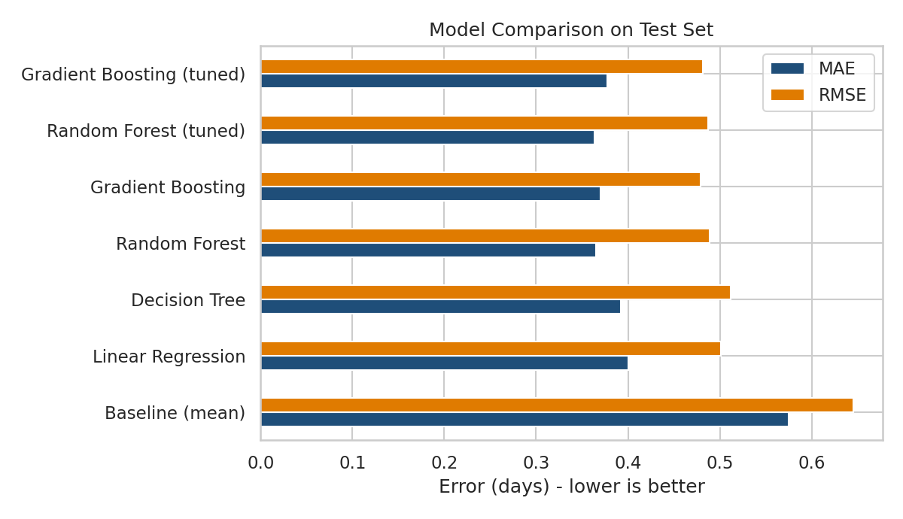
Figure 1: Test-set error of all models (lower is better)
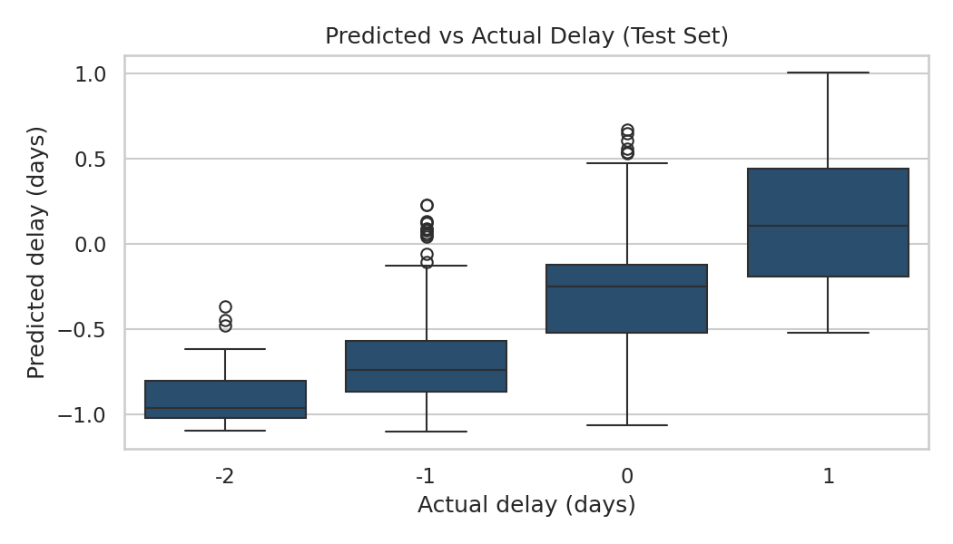
Figure 2: Predicted vs actual delay on the test set
Figure 2 interpretation: the median prediction rises steadily from about -1 day (actual -2) to above 0 (actual +1), so the model has learned the right direction. The boxes overlap, which reflects the random component of delay that no model can predict. This is why R-squared is about 0.42 and not close to 1. The model is more reliable for ranking risk than for predicting the exact day.
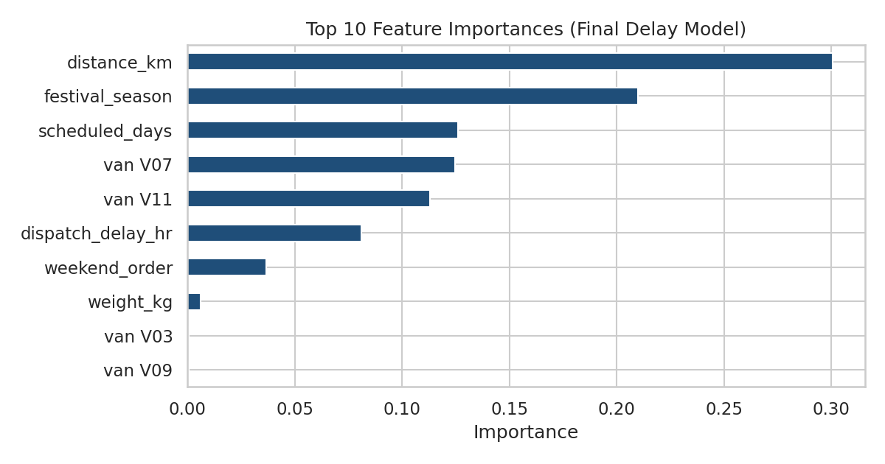
Figure 3: Feature importance of the final delay model
Figure 3 interpretation: distance is the strongest predictor (30.1% of importance), followed by festival season (21.0%) and the scheduled promise (12.6%). Vans V07 and V11 appear individually (12.5% and 11.3%), while the healthy vans contribute almost nothing, which confirms the model has isolated the two problem vehicles. Warehouse dispatch delay adds 8.1% and weekends 3.7%. Weight is negligible. These agree with the patterns found in Week 3, a useful check that the model is learning real structure.

5. Late-Shipment Risk Classifier
A classifier turns the same features into a probability that a shipment will be late. Three models were compared. The alert threshold is chosen on a validation slice of the training period (the highest threshold that still catches at least 70% of late shipments), never on the test set. Late shipments are rare (about 9.1% of training rows and 4.4% of test rows), so class weighting is used for Logistic Regression and Random Forest.
from sklearn.linear_model import LogisticRegression
from sklearn.ensemble import RandomForestClassifier, GradientBoostingClassifier
from sklearn.preprocessing import StandardScaler
from sklearn.metrics import roc_auc_score, average_precision_score, roc_curve
from sklearn.metrics import precision_score, recall_score, f1_score, confusion_matrix

y_tr_c, y_te_c = train["is_late"], test["is_late"]
prep_c = ColumnTransformer([("van", OneHotEncoder(handle_unknown="ignore"), ["van_id"]),
("num", StandardScaler(), num_features)])
clf_models = {
"Logistic Regression": LogisticRegression(max_iter=1000, class_weight="balanced"),
"Random Forest": RandomForestClassifier(n_estimators=300, min_samples_leaf=10,
class_weight="balanced_subsample",
random_state=42, n_jobs=-1),
"Gradient Boosting": GradientBoostingClassifier(random_state=42)}

# Choose the alert threshold on a validation slice of the TRAINING period
split = int(len(train) * 0.8)
fit_part, val_part = train.iloc[:split], train.iloc[split:]

clf_rows, probs, thresholds = [], {}, {}
for name, m in clf_models.items():
pc = Pipeline([("prep", prep_c), ("model", m)])
pc.fit(fit_part[features], fit_part["is_late"])
pv = pc.predict_proba(val_part[features])[:, 1]
# highest threshold that still catches at least 70% of late shipments
thr = max(t for t in np.linspace(0.05, 0.95, 91)
if recall_score(val_part["is_late"], pv >= t) >= 0.70)
pc.fit(X_train, y_tr_c) # refit on full training period
p = pc.predict_proba(X_test)[:, 1]
yhat = (p >= thr).astype(int)
probs[name], thresholds[name] = (pc, p), thr
clf_rows.append({"model": name, "ROC_AUC": roc_auc_score(y_te_c, p),
"PR_AUC": average_precision_score(y_te_c, p), "threshold": thr,
"precision": precision_score(y_te_c, yhat), "recall": recall_score(y_te_c, yhat),
"F1": f1_score(y_te_c, yhat)})
clf_results = pd.DataFrame(clf_rows).set_index("model").round(3)
print(clf_results)
print("Late rate in test set: %.3f" % y_te_c.mean())

# Figure 4: ROC curves
fig, ax = plt.subplots(figsize=(5.5, 4.5))
for name, (pc, p) in probs.items():
fpr, tpr, _ = roc_curve(y_te_c, p); ax.plot(fpr, tpr, lw=2, label=name)
ax.plot([0, 1], [0, 1], "k--", lw=1, label="Random guess")
ax.set_xlabel("False positive rate"); ax.set_ylabel("True positive rate")
ax.set_title("ROC Curve: Late-Delivery Classifier"); ax.legend()
plt.tight_layout(); plt.savefig("figs/fig4_roc.png", dpi=150); plt.close()

# Practical value: if we only inspect the riskiest shipments, how many late ones do we catch?
p_gb = probs["Gradient Boosting"][1]
rank = pd.DataFrame({"p": p_gb, "late": y_te_c.values}).sort_values("p", ascending=False)
capture = {f"top {q}%": rank.head(int(len(rank) * q / 100))["late"].sum() / rank["late"].sum()
for q in (10, 20, 30)}
print({k: round(v, 3) for k, v in capture.items()})
Model | ROC-AUC | PR-AUC | Threshold | Precision | Recall | F1
Logistic Regression | 0.903 | 0.411 | 0.40 | 0.220 | 0.692 | 0.334
Random Forest | 0.900 | 0.338 | 0.33 | 0.203 | 0.731 | 0.318
Gradient Boosting | 0.905 | 0.364 | 0.06 | 0.202 | 0.667 | 0.310

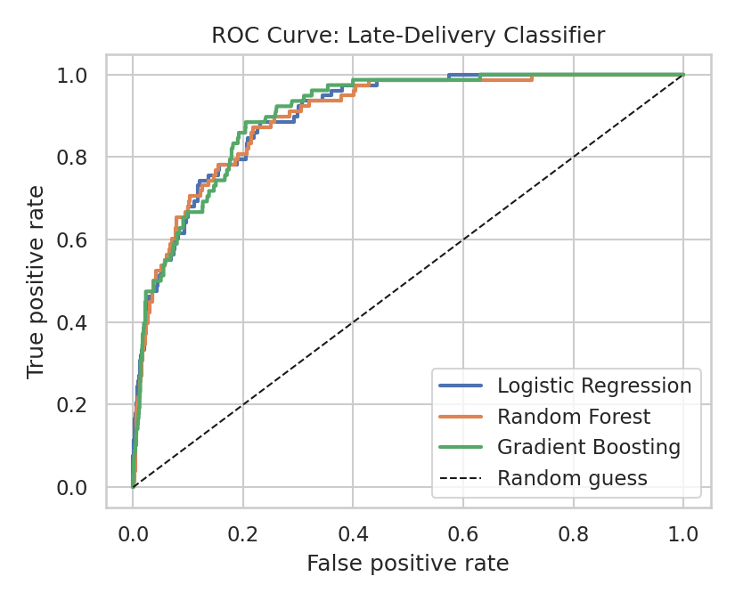
Figure 4: ROC curves of the three late-delivery classifiers
Interpretation: all three models rank risk well (ROC-AUC about 0.90) and are very close, so the simplest model, logistic regression, is competitive. Precision at the chosen threshold is about 20.2%, roughly 4.6 times the base late rate, but still means most alerts are false alarms. This is expected when only 4.4% of test shipments are late. The flag should therefore be used to prioritise attention and not as an automatic decision.
Shipments inspected (highest risk first) | Share of late shipments caught | Lift vs random inspection
Top 10% | 59.0% | 5.9x
Top 20% | 76.9% | 3.8x
Top 30% | 92.3% | 3.1x

This ranking view is the practical value of the model: reviewing the riskiest 20% of shipments, for example by re-assigning vans or sending a proactive customer message, would address about three-quarters of future late deliveries.

6. Optimization Strategies
Predictions only create value when they change decisions. Three optimization strategies are built directly on the model outputs.

6.1 Risk-Aware Van Allocation (Linear Programming)
Idea: use the classifier to estimate the probability of lateness for every van-and-district pair, then assign shipments to vans to minimise expected late deliveries, subject to every district being fully served and no van carrying more than 15% above an even share.
Formulation: minimise the sum of (late probability x penalty x shipments) over all van-district pairs; constraints: all demand of each district is assigned, and total load per van is at most the capacity limit. This is a standard transportation-style linear program, solved with scipy.optimize.linprog.
from scipy.optimize import linprog

# Optimization A: risk-aware allocation of shipments to vans (linear programming)
clf, _ = probs["Gradient Boosting"] # unweighted -> usable probabilities
vans = sorted(df["van_id"].unique())
districts = sorted(df["district"].unique())

# p[v, d] = predicted late probability if van v serves district d
P = np.zeros((len(vans), len(districts)))
for j, d in enumerate(districts):
sub = df[df["district"] == d][features].copy()
for i, v in enumerate(vans):
sub["van_id"] = v
P[i, j] = clf.predict_proba(sub)[:, 1].mean()

demand = df.groupby("district").size().reindex(districts).values # shipments per district
total = demand.sum()
cap = 1.15 * total / len(vans) # no van carries >15% above an even share
PENALTY = 150 # assumed INR cost of one late delivery

# Decision variables x[v, d], flattened row by row; minimise expected late cost
c_vec = (P * PENALTY).flatten()
A_eq = np.zeros((len(districts), P.size)); b_eq = demand.astype(float)
for j in range(len(districts)):
A_eq[j, j::len(districts)] = 1 # all demand of district j is served
A_ub = np.zeros((len(vans), P.size)); b_ub = np.full(len(vans), cap)
for i in range(len(vans)):
A_ub[i, i * len(districts):(i + 1) * len(districts)] = 1 # van capacity

res = linprog(c_vec, A_ub=A_ub, b_ub=b_ub, A_eq=A_eq, b_eq=b_eq, bounds=(0, None))
X = res.x.reshape(P.shape)

# Compare with today's roughly even split of every district across all vans
x_now = np.tile(demand / len(vans), (len(vans), 1))
late_now, late_opt = (P * x_now).sum(), (P * X).sum()
load_now, load_opt = x_now.sum(axis=1), X.sum(axis=1)
print("Model-implied late rate today: %.1f%% (actual %.1f%%)" % (100 * late_now / total, 100 * df["is_late"].mean()))
print("Expected late shipments: %.0f -> %.0f" % (late_now, late_opt))
print("Expected saving (INR): %.0f" % ((late_now - late_opt) * PENALTY))

# Figure 5: share of volume per van before vs after
fig, ax = plt.subplots(figsize=(8, 4)); idx = np.arange(len(vans))
ax.bar(idx - .2, load_now / total * 100, .4, color="#9AA5B1", label="Current (even split)")
ax.bar(idx + .2, load_opt / total * 100, .4, color=BLUE, label="Optimised")
ax.set_xticks(idx); ax.set_xticklabels(vans); ax.set_ylabel("Share of shipments (%)")
ax.set_ylim(0, 12); ax.set_title("Shipment Allocation by Van: Current vs Risk-Aware"); ax.legend(loc="upper left", ncol=2)
plt.tight_layout(); plt.savefig("figs/fig5_allocation.png", dpi=150); plt.close()
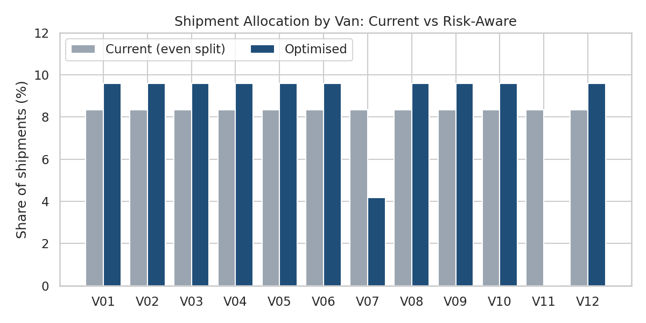
Figure 5: Share of shipments per van, current vs risk-aware allocation
Result: the model-implied late rate under the current even split is 8.0%, matching the actual rate of 8.1% (a check that the probabilities are well calibrated). The optimised plan reduces expected late shipments from 643 to 404, a reduction of 37%, worth about INR 35,811 per year at an assumed INR 150 cost per late delivery (refunds, re-delivery, lost goodwill). The plan gives V11 no volume and V07 about half a normal share until they are repaired; the healthy vans each take about 9.6% instead of 8.3%.
Practical note: this is a short-term measure. The real fix is to repair or replace the two vans; once their risk drops, the optimiser will return load to them automatically if the model is retrained.

6.2 Route Sequencing (Nearest Neighbour with 2-Opt)
Idea: inside a district, the order of stops decides the distance driven. This is a travelling-salesman problem. A nearest-neighbour tour gives a good starting route and 2-opt improves it by reversing segments that cross. For larger fleets with capacity and time windows, the OR-Tools routing solver from the Week 1 plan is the production option.
# Optimization B: route sequencing for one delivery run (nearest neighbour + 2-opt)
rng2 = np.random.default_rng(7)
depot = np.array([[0.0, 0.0]])
stops = rng2.normal([100, 60], 14, size=(15, 2)) # 15 stops in one district (km)
pts = np.vstack([depot, stops])
D = np.sqrt(((pts[:, None] - pts[None]) ** 2).sum(-1)) * 1.3 # 1.3 = road-winding factor

def route_len(r): return sum(D[r[i], r[i + 1]] for i in range(len(r) - 1))

def nearest_neighbour(D):
left, route = set(range(1, len(D))), [0]
while left:
nxt = min(left, key=lambda j: D[route[-1], j]); route.append(nxt); left.remove(nxt)
return route + [0]

def two_opt(route):
best, improved = route, True
while improved:
improved = False
for i in range(1, len(best) - 2):
for k in range(i + 1, len(best) - 1):
cand = best[:i] + best[i:k + 1][::-1] + best[k + 1:]
if route_len(cand) < route_len(best) - 1e-9:
best, improved = cand, True
return best

naive = list(range(len(D))) + [0] # visit in order received
opt = two_opt(nearest_neighbour(D))
len_naive, len_opt = route_len(naive), route_len(opt)
COST_KM = 18 # assumed INR per km operating cost
print("Route: %.0f km -> %.0f km (%.1f%% shorter)" % (len_naive, len_opt, 100 * (1 - len_opt / len_naive)))

# Figure 6: before vs after
fig, axs = plt.subplots(1, 2, figsize=(9, 4), sharex=True, sharey=True)
for ax, r, ttl, col in [(axs[0], naive, f"Order received: {len_naive:.0f} km", RED),
(axs[1], opt, f"Optimised: {len_opt:.0f} km", GREEN)]:
ax.plot(pts[r, 0], pts[r, 1], "-o", color=col, ms=4, lw=1.2)
ax.plot(*pts[0], "k*", ms=14); ax.set_title(ttl); ax.set_xlabel("km east")
axs[0].set_ylabel("km north"); plt.tight_layout()
plt.savefig("figs/fig6_route.png", dpi=150); plt.close()
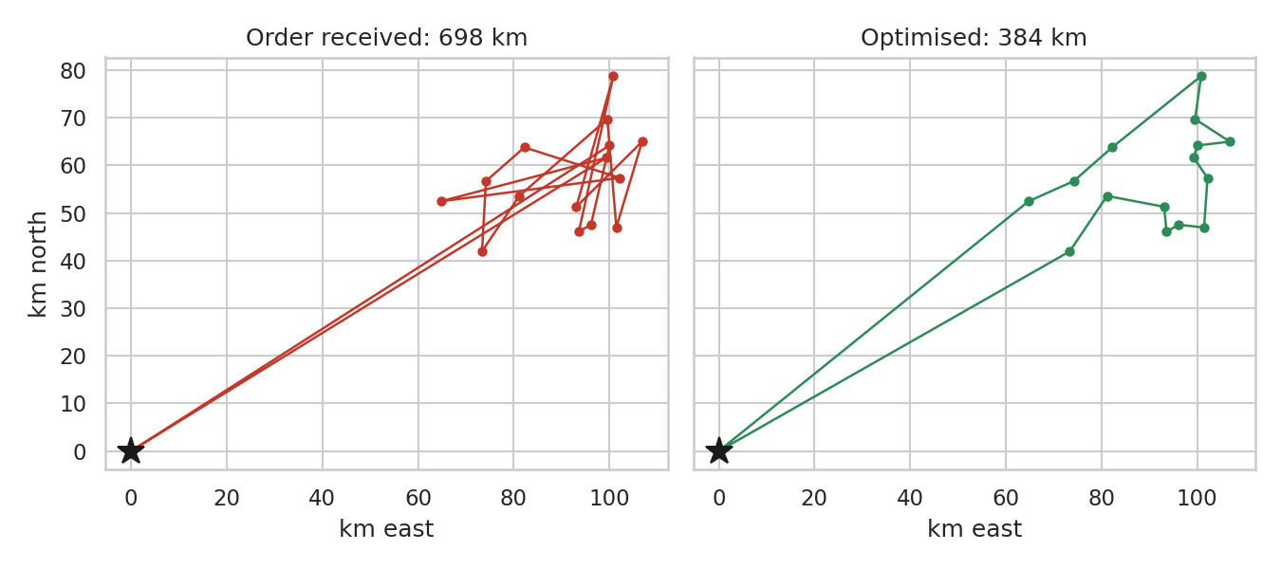
Figure 6: Delivery run of 15 stops, order received vs optimised
Result: the sample run falls from 698 km to 384 km (45% shorter), saving about INR 5,658 per run at an assumed INR 18 per km operating cost. Visiting stops in the order received is a deliberately weak baseline, so real savings against an experienced dispatcher will be smaller; the figure shows the upper bound of the gain.

6.3 Festival-Season Capacity Planning
Idea: Week 3 showed that lateness jumps in the festival window. Weekly shipment counts give the load the fleet must handle, and a simple capacity calculation shows how much extra capacity is needed.
# Optimization C: festival-season capacity planning
weekly = df.set_index("order_date").resample("W")["shipment_id"].count()
normal_week = weekly[weekly.index > "2025-12-14"].mean() # average non-festival week
festival_week = weekly[(weekly.index >= "2025-10-19") & (weekly.index <= "2025-11-23")].mean()
peak_week = weekly.max()

VANS, UTIL = 12, 0.80 # fleet size, normal average utilisation
per_van_max = normal_week / VANS / UTIL # shipments per van-week at 100% utilisation
max_capacity = VANS * per_van_max # one shift, fully loaded
second_shift = 2 * max_capacity # a second shift on the same vans
extra_vans = int(np.ceil(max(0, peak_week - max_capacity) / per_van_max))

print("Normal %.0f | festival avg %.0f | peak %.0f shipments/week" % (normal_week, festival_week, peak_week))
print("Capacity: one shift %.0f | two shifts %.0f | extra vans for single shift: %d" % (max_capacity, second_shift, extra_vans))
Measure | Shipments per week | Compared with a normal week
Normal week (average) | 134 | 1.0x
Festival window (average) | 288 | 2.2x
Worst festival week | 331 | 2.5x
Fleet capacity, one shift, fully loaded | 167 | 1.3x
Fleet capacity with a second shift | 334 | 2.5x

Result: a single shift at full load handles about 167 shipments a week, but the worst festival week reaches 331. Covering the gap with extra vans alone would need about 12 temporary vans, essentially doubling the fleet. A second shift on the existing 12 vans gives about 334 shipments of capacity, almost exactly the peak, so the cheapest plan is a second shift plus a small number of hired vans as a safety margin, and this should start from mid-October.

6.4 Further Optimization Levers
- Smart promise dates: use predicted delay to quote longer dates for risky shipments (long distance, festival, weekend) and shorter dates for safe ones.
- Warehouse cut-off rules: dispatch delay matters most when combined with festival load, so earlier cut-offs and extra picking staff in peak weeks address the warehouse side.
- Pricing: Week 3 showed faster modes cost more without better reliability; limit Priority/Express on routes the model marks as high risk, or price the risk in.
- Model monitoring: retrain monthly and track MAE and the share of late shipments caught; a drift in either signals changed conditions.

7. Insights from Model Performance
- The model captures structure, not noise. Its feature importances match the known drivers, and the two weak vans stand out individually.
- Prediction has a ceiling. R-squared of about 0.42 reflects randomness that no feature explains (for example traffic or breakdowns). Predicting the exact day is unrealistic; ranking and flagging risk is realistic and valuable.
- Simple models are strong. Linear and logistic regression come close to the ensembles, so the extra complexity of boosting is justified only by a small gain. In a real deployment a simpler model that managers can explain may be the better choice.
- Features matter more than algorithms. The gain from baseline to any model is large; the gain from tuning is small.

8. Recommendations
- Repair or replace vans V07 and V11 and rebalance load meanwhile. Model-based allocation cuts expected late shipments by about 37% (about INR 35,811 per year in the simulated network).
- Plan festival capacity from mid-October: add a second shift on the existing vans, hire a few temporary vans as margin, and extend warehouse hours. Peak weeks run at about 2.5 times normal volume.
- Use the risk flag for daily triage. Review the top 20% highest-risk shipments each morning; this reaches about 77% of future late deliveries.
- Adopt route sequencing for multi-stop runs. Even a simple nearest-neighbour plus 2-opt routine shortens routes, with larger gains where dispatchers currently assign stops by order of arrival.
- Quote risk-based delivery promises, with longer dates for long-distance, weekend and festival orders, to protect the On-Time Delivery rate.
- Validate on real data and retrain regularly. Run the same pipeline on real shipment records before committing investment.

9. Limitations
- The data is simulated, so accuracy figures are specific to this dataset. The structure of the pipeline carries over; the numbers do not.
- The test period (July to September) has no festival weeks, so the festival effect is learned from training data but not verified on unseen data. A full second year of data is needed for that check.
- The penalty per late delivery (INR 150) and operating cost per km (INR 18) are assumptions; savings scale directly with them.
- The allocation model assumes a van's late risk does not change when its load rises; in reality heavily loaded vans may become less reliable, which is why the 15% load cap was included.
- Route optimization used straight-line distances with a winding factor; real road distances (for example from OpenStreetMap) would be used in production.

10. Conclusion
This report defined a clear prediction problem, compared five models with time-aware validation, tuned the strongest two and selected Gradient Boosting on cross-validation error. The final model reduces delay error by about 25% against a baseline and correctly identifies the drivers of lateness. Its outputs then feed three optimization strategies: risk-aware van allocation, route sequencing and festival capacity planning. Together they show how a predictive model turns into measurable operational gains. The natural next step is to repeat the pipeline on real data and monitor it in operation.

References
- Pedregosa, F. et al. (2011). Scikit-learn: Machine Learning in Python. Journal of Machine Learning Research, 12.
- scikit-learn documentation: TimeSeriesSplit, GridSearchCV, GradientBoostingRegressor, model evaluation metrics. scikit-learn.org
- Friedman, J. H. (2001). Greedy function approximation: a gradient boosting machine. Annals of Statistics, 29(5).
- Breiman, L. (2001). Random Forests. Machine Learning, 45(1).
- SciPy documentation: scipy.optimize.linprog. docs.scipy.org
- Croes, G. A. (1958). A method for solving traveling-salesman problems. Operations Research, 6(6). (Origin of 2-opt.)

Appendix A: Dataset Simulation Code
The same code and random seed as Week 3 were used, so Weeks 3 and 4 analyse the identical dataset.
import numpy as np, pandas as pd

rng = np.random.default_rng(42)
n = 8000

# --- Dates: 12 months, heavier volume in the festival window (15 Oct - 20 Nov)
days = np.arange(365)
w = np.where((days >= 14) & (days <= 50), 2.2, 1.0)
day = rng.choice(days, n, p=w / w.sum())
order_date = pd.Timestamp("2025-10-01") + pd.to_timedelta(day, unit="D")
festival = ((day >= 14) & (day <= 50)).astype(int)
weekend = (order_date.dayofweek >= 5).astype(int)

# --- Destination district and road distance from the central warehouse (km)
dist_base = {"Trichy": 10, "Pudukkottai": 55, "Perambalur": 55, "Thanjavur": 60,
"Ariyalur": 70, "Karur": 80, "Madurai": 130, "Salem": 140}
district = rng.choice(list(dist_base), n, p=[.28, .10, .08, .14, .07, .10, .12, .11])
distance_km = np.array([dist_base[d] for d in district]) + rng.normal(0, 6, n)
distance_km = distance_km.clip(3)

# --- Shipment attributes
mode = rng.choice(["Standard", "Express", "Priority"], n, p=[.60, .30, .10])
sched = pd.Series(mode).map({"Standard": 3, "Express": 2, "Priority": 1}).values
weight_kg = rng.lognormal(3.0, 0.7, n).round(1)
units = rng.poisson(weight_kg / 4).clip(1)
van = rng.choice([f"V{i:02d}" for i in range(1, 13)], n)
dispatch_delay_hr = (rng.lognormal(1.0, 0.6, n) + 2 * festival).round(1)

# --- Delivery time: driven by distance, warehouse delay, festival load, weekends, weak vans
van_penalty = np.where(np.isin(van, ["V07", "V11"]), 0.7, 0.0)
delay = (-1.3 + 0.006 * distance_km + 0.05 * dispatch_delay_hr + 0.5 * festival
+ 0.2 * weekend + van_penalty + rng.normal(0, 0.45, n))
actual_days = np.maximum(1, sched + np.round(delay)).astype(int)

# --- Transport cost (INR): distance x mode rate, weight effect, festival surcharge
rate = pd.Series(mode).map({"Standard": 5.5, "Express": 7.5, "Priority": 10}).values
cost = 60 + distance_km * rate * (1 + weight_kg / 200) + 0.8 * weight_kg + 40 * festival + rng.normal(0, 40, n)

df = pd.DataFrame({
"shipment_id": np.arange(1, n + 1), "order_date": order_date, "district": district,
"distance_km": distance_km.round(1), "shipping_mode": mode, "weight_kg": weight_kg,
"units": units, "van_id": van, "dispatch_delay_hr": dispatch_delay_hr,
"scheduled_days": sched, "actual_days": actual_days, "transport_cost": cost.clip(50).round(2),
"festival_season": festival, "weekend_order": weekend})

df["delay_days"] = df["actual_days"] - df["scheduled_days"]
df["is_late"] = (df["delay_days"] > 0).astype(int)
df["cost_per_km"] = df["transport_cost"] / df["distance_km"]
df["month"] = df["order_date"].dt.to_period("M").astype(str)
df["weekday"] = df["order_date"].dt.day_name()
print(df.shape); print(df.head(3).T)

