PERSONAL ASSISTANCE FOR SENIORS WHO ARE SELF RELIANT

PROBLEM STATEMENT:

* Sometimes elderly people forget to take their medicine at the correct time.
* They also forget which medicine He / She should take at that particular time.
* And it is difficult for doctors/caretakers to monitor the patients around the clock. To avoid this problem, this medicine reminder system is developed.

LITERATURE REVIEW:

We employed a five-stage systematic review method to identify and synthesize previous knowledge. First, we identified the issue we wanted to study and defined the research questions. Then we carried out the electronic searches and the quality appraisal and analyzed and interpreted the selected papers. The final stage was to

present the results.During the first stage, we carried out the preliminary searches and

found that the systematic review was a suitable way to identify previous knowledge. This process enabled us to identify the research questions for this review.

REFERRED PAPER 1:

-->AUTHOR:

Baril et al.3, Canada, 14/21

-->AIM:

To study the impact of medication distribution technology (MDT) on medication errors reported in public nursing homes in Quebec Province.

-->METHOD:

Quantitative study in six nursing homes (800 patients). An automated pharmacy packaging device, combined with mobile dispensing carts. Medication error data were collected from nursing staff through a voluntary reporting process before and after MDT was implemented.

-->USED DEVISES:

An automated pharmacy packaging device, combined with mobile dispensing carts.

REFERRED PAPER 2:

-->AUTHORS:

Beobide-Tellería et al.6, Spain, 15/21

-->AIM:

the performance of one care unit in a nursing home Data were analyzed using statistical analysis. the safety of the medication process. To compare the rate and severity of reported dispensing errors in nursing homes using manual medication dispensation, versus automated dispensation with a specifically selected automated dispensing system.

-->METHOD:

A pre and post retrospective observational study conducted in 7 nursing homes. Compared voluntarily reported dispensing errors during 2 periods: a manual dispensing system of weekly pill boxes and an automated drug dispensing and packaging system for oral solid medications used in combination with a manual system for other drug forms. Automated Dispensing System Data were analyzed using a statistical analysis.

REFERRED PAPER 3:

-->AUTHOR:

Hoffmann et al.17, USA, 19/21

-->AIM:

To determine if use of the Automated Home Medication Dispenser improved medication adherence.

-->METHOD:

A 6-month prospective, feasibility study assessing the use of the device by 21 patient-caregiver dyads. The Automated Home Medication Dispenser. Patients were referred by their physician because of poor medication adherence and included if they resided in Rochester, New York and were on at least two different tablets. Pill counts were performed at baseline to assess previous adherence. Prospective medication adherence was assessed using the dosing information recorded by the device. Data wereanalyzed using a statistical analysis.

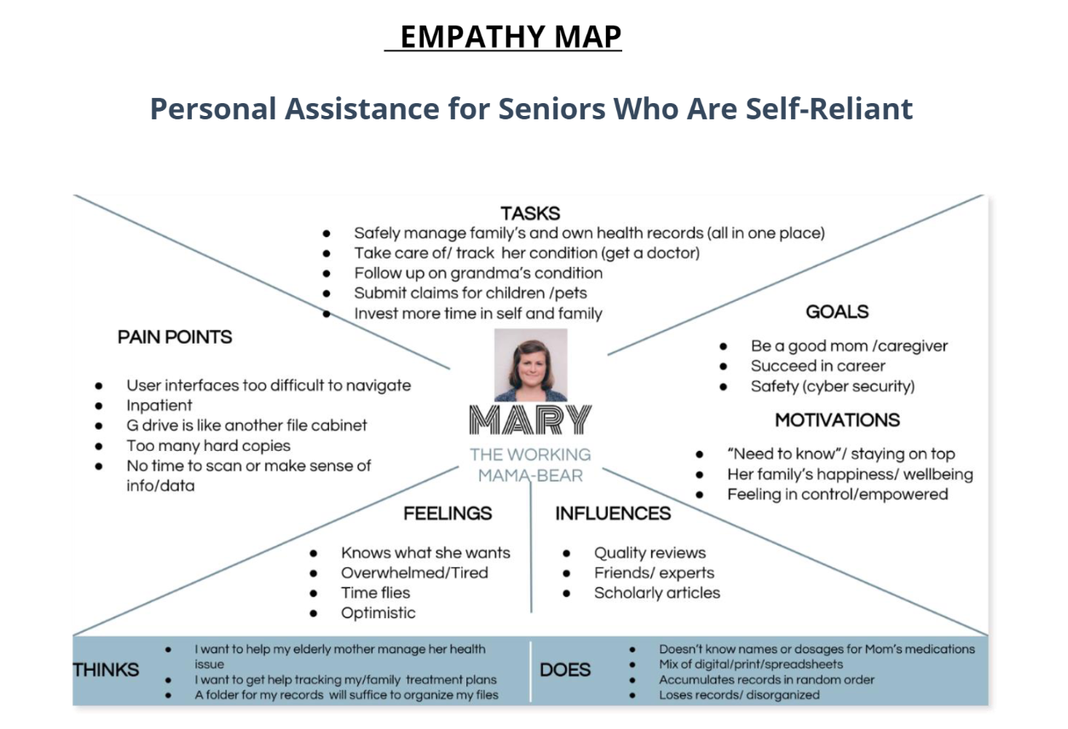

IDEATION:

If a patient needs to take medicine at 6 a.m. In the morning the box will remind him by making sound and also by sending an alarm. If he forgets the actual time of taking medicine and goes to take medicine at any time the medicine box will not open as a servo motor will make the box locked. While it’s the right time to take te medicine then the box will make sound and will give notification until the user takes medicine or open the drawer. Also, if the user is outside of the home, then the medicine box will use the Wi-Fi module to send notification to the user’s fixed email address. The system contains also a temperature sensor to measure the temperature of the user as temperature can be a vital element of the monitoring patient’s health condition. The temperature and taking medicine data will be stored in a server which can be accessed by both patient and doctor so that when it is time the doctor can review the medicine and can change if needed. Also, it will be helpful for doctors to keep updated about the patient’s physical health condition.

Before describing the proposed solution, it is essential to present the end-users of the

platform and their needs:

• Assisted person: Elderly people, from 65 year and above, with chronic health

problems or with frailty due to physical, cognitive or emotional problems, who

need formal or informal support when staying at home or in their daily living envi-

ronment for safety and security.

• Informal caregiver: responsible for providing support on a daily basis to a relative

that suffers from a chronic condition and cannot live alone and yet be safe. The

service will allow him/her to monitor the relative remotely and respond immediate-

ly and effectively in case of an emergency.

• Formal caregiver: responsible for providing systematic daily assistant at home or

at a daycare center. The service will allow the formal caregiver to coordinate dif-

ferent care recipients at the same time more efficiently as well as respond to differ-

ent emergency cases faster