CHAPTER 1
INTRODUCTION
  - ABOUT THE PROJECT
Traffic prediction plays a crucial role in urban planning, transportation management, and various other domains where the efficient movement of people and goods is essential. With the rapid growth of urban populations and the increasing complexity of transportation networks, accurately forecasting traffic conditions has become increasingly important for optimizing resource allocation, reducing congestion, and improving overall mobility.
This document aims to explore the concept of traffic prediction, its significance, challenges involved, and the methodologies employed to forecast traffic patterns. It will also delve into the advancements in technology that have enabled more accurate predictions and discuss potential future developments in this field.
Significance of Traffic Prediction:
Traffic prediction helps transportation authorities, city planners, and commuters make informed decisions regarding route planning, mode of transportation, and travel timing. It aids in the optimization of traffic flow, leading to reduced congestion, fuel consumption, and emissions. Efficient traffic prediction contributes to improved safety on roadways by identifying potential congestion points and accident-prone areas in advance. Businesses can benefit from traffic forecasts by optimizing delivery routes, scheduling shipments, and managing logistics more effectively.
Challenges in Traffic Prediction:
Traffic patterns are influenced by various factors, including weather conditions, special events, road construction, and human behavior, making prediction inherently complex. Limited availability of real-time data and the need for high-quality, reliable data sources pose challenges in accurately modeling traffic flow.
Traditional traffic prediction models often struggle to adapt to dynamic and unpredictable traffic conditions, leading to inaccuracies in forecasts.
Incorporating emerging transportation technologies such as autonomous vehicles and ride-sharing services adds further complexity to traffic prediction models.
Methodologies for Traffic Prediction:
Statistical models: These models analyze historical traffic data to identify patterns and trends, which are then used to forecast future traffic conditions. Examples include time series analysis, regression analysis, and machine learning algorithms.
Simulation models: These models simulate traffic flow based on mathematical representations of roadway networks, vehicle behavior, and traffic control systems. They are useful for predicting the impact of infrastructure changes and policy interventions on traffic patterns.
Hybrid approaches: Combining statistical and simulation models can leverage the strengths of both approaches to improve prediction accuracy and robustness.
Technological Advancements:
The proliferation of connected vehicles, smartphones, and IoT devices has enabled the collection of real-time traffic data on a large scale, enhancing the accuracy of traffic prediction models.
Advanced data analytics techniques, including deep learning and artificial intelligence, have led to significant improvements in the accuracy and efficiency of traffic forecasting algorithms.
Integration of data from multiple sources, such as GPS navigation systems, traffic cameras, and social media platforms, provides richer insights into traffic dynamics and enables more comprehensive prediction models.

Chapter 2
SYSTEM ANALYSIS

2.1 LITERATURE SURVEY
In [1] The challenge of localizing and tracking marine animals, such as sharks, fish, or lobsters, is of paramount importance in ecological studies aimed at understanding species behavior and environmental effects. Traditionally, observations of aquatic species were limited to predictable occurrences, but active acoustic telemetry offers a more precise approach. By deploying tags into animals and using moored receivers, researchers can evaluate their locations and movement patterns. This quantification of factors influencing movement is crucial for predicting population responses to environmental changes. Additionally, studying behavioral patterns within spatially-constrained areas provides insights into species-habitat interactions, aiding conservation efforts. However, underwater localization faces challenges such as under-ranked localization, where insufficient receiver coverage leads to localization ambiguities. Proposed solutions involve probabilistic approaches to resolve such ambiguities. Acoustic telemetry primarily relies on time-difference-of-arrival (TDoA) techniques for localization due to their improved accuracy, but under-ranked localization arises due to factors like low tag transmission power, high ambient noise levels, and complex underwater acoustic channels. While increasing the number of receiving elements could mitigate these issues, budget constraints and logistical challenges often limit ecological survey
In [2] The escalating concern over animal attacks among rural populations and forestry workers necessitates effective tracking mechanisms for wild animals. To achieve this, surveillance cameras and drones are commonly utilized, yet a proficient model is essential for detecting animal types, monitoring their movement, and providing location information. Swift alert systems are crucial for ensuring the safety of individuals and forestry personnel. While computer vision and machine learning techniques are prevalent for animal detection, their complexity and cost often hinder satisfactory results. This paper introduces a Hybrid Visual Geometry Group (VGG)-19 combined with Bidirectional Long Short-Term Memory (Bi-LSTM) network for animal detection and alert generation based on their behavior. Alerts are promptly relayed to local forest offices via Short Message Service (SMS) for immediate response. The proposed model demonstrates substantial enhancements in performance, boasting an average classification accuracy of 98%, a mean Average Precision (mAP) of 77.2%, and a Frame Per Second (FPS) of 170. Comprehensive testing using 40,000 images from three diverse benchmark datasets, encompassing 25 classes, yielded mean accuracy and precision exceeding 98%. This model emerges as a dependable solution for furnishing accurate animal-related information and safeguarding human lives.
[3] Conserving wildlife is crucial amidst rapid urbanization and infrastructure expansion, especially in desert and semi-desert regions where biodiversity preservation is vital. The establishment of the Dubai Desert Conservation Reserve (DDCR) in 2000 by the Dubai government was a significant step towards protecting native flora and fauna in the Dubai Desert. Key species in the United Arab Emirates (UAE) desert ecosystem include Oryxes, Camels, and Gazelles. To bolster wildlife surveillance in the DDCR, drone-based monitoring has gained traction. However, existing methods for analyzing drone-captured images rely heavily on manual inspection by human observers. While manual and basic automated techniques, as well as traditional machine learning methods, have been effective for ecological image analysis using RGB and multi-spectral images, recent advancements in deep learning offer promising avenues for animal detection in drone footage, camera trap analysis, and remote sensing applications. Drones offer advantages such as low-noise image capture, extensive coverage, and real-time, high-resolution data collection at a reasonable cost. Nevertheless, manual inspection of drone imagery presents challenges, spurring research into computer-based object detection and classification algorithms for automated analysis. Deep Neural Networks (DNNs) have emerged as powerful tools for object detection under various environmental conditions, but their deployment requires domain expertise, network optimization, and sufficient training data. This paper leverages a comprehensive dataset of drone imagery from the DDCR, Dubai drone-team, to train a Deep Neural Network based on YOLOv5, a popular CNN architecture known for its effectiveness in one-stage object detection. The interdisciplinary approach aims to optimize network parameters, ensure accurate data labeling, and ultimately improve wildlife monitoring and conservation efforts in desert environments.
One [4] Animal recognition, an evolving field within computer vision, employs sophisticated algorithms to analyze images or videos and classify animals, primarily utilizing deep learning techniques. This domain offers diverse societal benefits, notably aiding wildlife conservation by facilitating the monitoring and protection of endangered species. Furthermore, it serves to raise public awareness and enables the observation of population dynamics within animal communities over time. Accurate animal identification also provides valuable insights into the complex interplay between wildlife populations and their ecosystems, enriching our understanding of environmental processes. Researchers have developed various advanced algorithms and methodologies to study animal behavior, not only advancing scientific knowledge but also serving practical purposes. These efforts function as early warning systems, alerting humans to potential encounters with hazardous wildlife and enabling proactive measures for human safety. Our project focuses on two key phases: animal identification and alerting systems. In the first phase, our emphasis is on accurately identifying four distinct wild animals: Lions, Tigers, Elephants, and Boars. We achieve this through analyzing both static images and live video footage, capturing these animals' presence in their natural habitats. Subsequently, we implement an alerting system designed to promptly notify relevant authorities or individuals of animal intrusions in urban areas. This system employs auditory signals triggered when wild animals are detected near roadways or areas inhabited by humans. Our research contributes to the broader field of animal recognition and conservation, aligning with the goal of enhancing wildlife monitoring and safeguarding human welfare in regions prone to wildlife-human conflicts. Through a thorough examination of existing literature and methodologies, we aim to offer novel insights and advancements to this crucial domain.
In [5] Wireless sensor networks (WSNs) have been instrumental in monitoring endangered species, yet they face challenges in environments with limited access, such as polar regions. Traditional monitoring methods struggle to effectively cover large, inaccessible areas, making remote monitoring inefficient. This paper suggests characterizing animal trajectories using the random walk model to determine optimal detection range and node placement for ensuring target detection probability. Animals can be detected by static sensors on land, mobile sensors attached to animals, or land sensors detecting movement, sound, or temperature changes. However, due to animals' natural movements, they may fall outside sensor coverage. To conserve energy, nodes alternate between active and inactive states, extending system lifespan but necessitating a balance between energy consumption and reporting efficiency. Consequently, careful network design is crucial to calculate detection probability and system longevity. A mathematical model based on Markov chains is proposed and validated through numerical simulations, indicating that animal trajectories can be accurately modeled using specific distributions. In polar regions, conventional WSN setups with multiple nodes clustered together are impractical. Instead, this paper proposes a simplified model employing single sensors strategically placed in isolated locations, where direct communication between nodes is unfeasible. This novel approach streamlines network design and analysis, enabling efficient performance evaluation of the entire multi-sensor network.

  - EXISTING SYSTEM
The existing systems for traffic prediction typically rely on a combination of historical traffic data, real-time sensor data, and machine learning algorithms to forecast traffic conditions. Here's an overview of the components and techniques commonly used in traffic prediction systems:
Data Collection:
Traffic prediction systems gather data from various sources, including traffic sensors, GPS data from vehicles and smartphones, traffic cameras, weather data, and historical traffic databases. These data sources provide information about traffic flow, speed, congestion, accidents, road closures, and other factors that influence traffic conditions.
Preprocessing and Feature Extraction:
The collected data is preprocessed to clean and normalize it, removing noise and inconsistencies. Relevant features are extracted from the data, such as traffic volume, speed, time of day, day of the week, weather conditions, road type, and special events.
Machine Learning Models:
Various machine learning algorithms are used to build predictive models based on the preprocessed data.
Commonly used machine learning techniques include:
Regression models: Linear regression, polynomial regression, ridge regression, etc., for predicting continuous traffic variables like speed or volume.
Time series analysis: Autoregressive Integrated Moving Average (ARIMA), Seasonal ARIMA (SARIMA), Prophet, etc., for forecasting traffic patterns over time.
Ensemble methods: Random forests, gradient boosting machines (GBM), and ensemble neural networks for combining multiple models to improve prediction accuracy.
Deep learning: Recurrent Neural Networks (RNNs), Long Short-Term Memory (LSTM) networks, and Convolutional Neural Networks (CNNs) for capturing complex temporal and spatial patterns in traffic data.
Model Training and Validation:
The predictive models are trained on historical traffic data, typically using a portion of the data for training and the rest for validation.
Hyperparameters of the models are tuned using techniques like cross-validation to optimize performance and prevent overfitting.
Real-Time Prediction:
The predicted traffic information is visualized and presented to end-users through dashboards, maps, mobile apps, or web interfaces.
Decision support tools may provide recommendations and alerts to traffic management authorities, transportation agencies, and commuters to help them make informed decisions about route planning, traffic management, and resource allocation.
Overall, traffic prediction systems play a crucial role in improving traffic management, reducing congestion, and enhancing the overall efficiency and safety of transportation networks. Continued advancements in data collection, machine learning techniques, and real-time processing capabilities will further enhance the accuracy and reliability of traffic prediction systems in the future.
2.2.1 Disadvantages of Existing System
  - Traffic congestion problem is the main problem now a days and still now there is not a solution over that
  - Time based maintenance is not a good solution to clear the traffic now a days
  - Mostly existing solution over traffic reduction has given a low level of accuracy
  - PROPOSED SYSTEM
The proposed system of automatic traffic light control based on object count detection using Data2Vec involves leveraging machine learning techniques to analyze traffic camera feeds and dynamically adjust traffic light timings based on the count of vehicles detected. Here's an outline of the proposed system:
Data2Vec Representation:
Data2Vec is a technique used to represent data in a vector space, enabling machine learning algorithms to process and analyze the data effectively.
In the context of traffic surveillance, Data2Vec can be applied to represent features extracted from traffic camera images, such as vehicle count, vehicle types, traffic density, and motion patterns, in a vectorized format.

Data Collection and Preprocessing:
Traffic camera feeds are captured in real-time and preprocessed to extract relevant information about the traffic scene. Object detection algorithms are applied to identify and count vehicles in the camera frames. Additional data, such as time of day, weather conditions, and historical traffic patterns, may also be collected for contextual information.
Feature Extraction and Data2Vec Representation:
Features extracted from the traffic camera feeds, such as vehicle count and density, are transformed into Data2Vec representations. Data2Vec embeddings capture the spatial and temporal characteristics of traffic scenes, enabling effective representation of complex traffic patterns.
Machine Learning Model Training:
Supervised or unsupervised machine learning models are trained using the Data2Vec representations of traffic data. Supervised models may be trained to predict optimal traffic light timings based on historical traffic patterns and vehicle counts. Unsupervised models can identify patterns and clusters in traffic data, informing dynamic adjustments to traffic light timings.
Traffic Light Control:
The trained machine learning model analyzes real-time traffic data, including Data2Vec representations of vehicle counts, to determine optimal traffic light timings.
Based on the predicted traffic conditions, the system dynamically adjusts the durations of green, yellow, and red light phases at traffic intersections.
Traffic light control algorithms aim to optimize traffic flow, minimize congestion, and prioritize high-traffic directions based on real-time conditions.
2.3.1 Advantages of the Proposed System
  - Easy maintenance of the traffic light control without the intervention of a human being
  - The accuracy find out of using data2vector algorithm works good at multiple modalities
  - This reduce the congestion over road ways with a bot based control system
  - FEASIBILITY STUDY
A feasibility study for traffic prediction involves assessing the practicality, viability, and potential benefits of implementing a traffic prediction system. Here's an outline of the key aspects to consider in a feasibility study for traffic prediction:
Technical Feasibility:
Data Availability: Evaluate the availability and quality of data sources required for traffic prediction, such as traffic sensor data, GPS data, traffic camera feeds, weather data, and historical traffic databases.
Data Processing and Analysis: Assess the feasibility of processing and analyzing large volumes of data in real-time to generate accurate traffic predictions. Consider the computational resources, algorithms, and techniques required for data preprocessing, feature extraction, and machine learning model training.
Model Development: Determine the feasibility of developing and deploying machine learning models for traffic prediction, considering factors such as model complexity, training time, and performance requirements.
Integration with Existing Systems: Evaluate the feasibility of integrating the traffic prediction system with existing traffic management systems, transportation infrastructure, and data platforms.
Economic Feasibility:
Cost-Benefit Analysis: Estimate the costs associated with implementing and operating the traffic prediction system, including hardware, software, data acquisition, model development, maintenance, and personnel.
Assess the potential benefits of the traffic prediction system, such as reduced congestion, improved traffic flow, decreased travel time, fuel savings, and environmental benefits.
Calculate the return on investment (ROI) and assess whether the projected benefits outweigh the costs over the system's lifecycle.
Operational Feasibility:
Stakeholder Engagement: Identify key stakeholders, including transportation agencies, traffic management authorities, city planners, and commuters, and assess their willingness to adopt and support the traffic prediction system.
Organizational Readiness: Evaluate the readiness of organizations and personnel to implement and operate the traffic prediction system, including training needs, workflow adjustments, and change management considerations.
Legal and Regulatory Compliance: Ensure compliance with relevant laws, regulations, and privacy requirements governing data collection, storage, and usage in traffic prediction systems.
Social and Environmental Feasibility:
Social Acceptance: Assess the potential impacts of the traffic prediction system on communities, neighborhoods, and individuals. Consider factors such as equity, accessibility, and public perception.
Environmental Impact: Evaluate the potential environmental benefits of the traffic prediction system, such as reduced emissions, air pollution, and carbon footprint, resulting from improved traffic flow and reduced congestion.
Risk Assessment:
Identify potential risks and challenges associated with implementing the traffic prediction system, such as data privacy breaches, algorithmic bias, technical failures, and resistance to change.
Develop risk mitigation strategies and contingency plans to address identified risks and ensure the successful implementation and operation of the traffic prediction system.
Conclusion and Recommendations:
Summarize the findings of the feasibility study and provide recommendations regarding the viability of implementing the traffic prediction system.
Consider alternative approaches, mitigation measures, and phased implementation strategies based on the feasibility assessment.
Outline next steps, including further research, pilot projects, stakeholder engagement, and decision-making processes to move forward with the traffic prediction initiative.
By conducting a comprehensive feasibility study, transportation authorities, urban planners, and decision-makers can make informed decisions about the implementation of traffic prediction systems, ensuring their effectiveness, sustainability, and alignment with organizational goals and objectives.

CHAPTER 3
LOGICAL DEVELOPMENT
3.1 ARCHITECTURE DIAGRAM
An architectural diagram is a visual model of a system, its components, and their interactions. With supporting documentation, it can capture all the essential information of a system's design.

Fig 3.1 System architecture
3.2 DATA FLOW DIAGRAM
A two-dimensional diagram explains how data is processed and transferred in a system. The graphical depiction identifies each source of data and how it interacts with other data sources to reach a common output. Individuals seeking to draft a data flow diagram must identify external inputs and outputs, determine how the inputs and outputs relate to each other, and explain with graphics how these connections relate and what they result in. This type of diagram helps business development and design teams visualize how data is processed and identify or improve certain aspects.

Data flow Symbols:

Symbol | Description
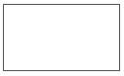 | An entity. A source of data or a destination for data.
 | A process or task that is performed by the system.
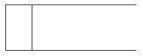 | A data store, a place where data is held between processes.
 | A data flow.

LEVEL 0:
DFD Level 0 is also called a Context Diagram. It’s a basic overview of the whole system or process being analyzed or modeled. It’s designed to be an at-a-glance view, showing the system as a single high-level process, with its relationship to external entities. It should be easily understood by a wide audience, including stakeholders, business analysts, data analysts and developers.

Fig 3.2 LEVEL 0 DFD
LEVEL 1:
DFD Level 1 provides a more detailed breakout of pieces of the Context Level Diagram. You will highlight the main functions carried out by the system, as you break down the high-level process of the Context Diagram into its sub – processes. A level 1 data flow diagram (DFD) is more detailed than a level 0 DFD but not as detailed as a level 2 DFD. It breaks down the main processes into sub processes that can then be analyzed and improved on a more intimate level.

Fig 3.3 Level 1 DFD
3.3 USE CASE DIAGRAM
A Use Case Diagram is a graphical representation used in software engineering to depict the interactions between users (actors) and a system (subject) in terms of processes or functionalities (use cases) provided by the system. It helps to capture the functional requirements of a system from a user's perspective.
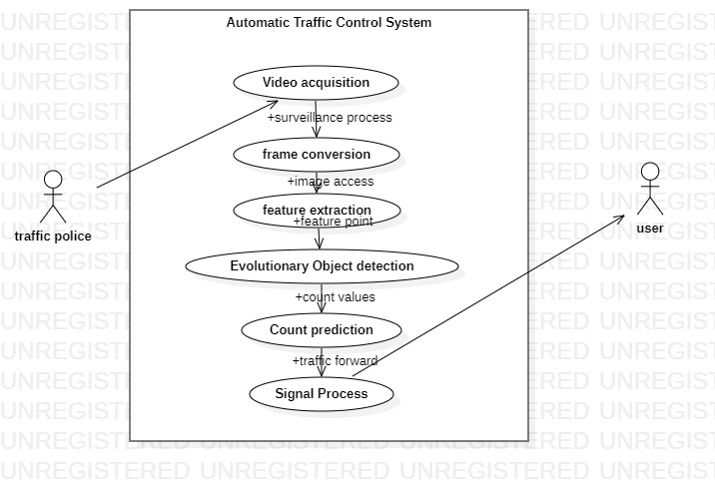

Fig 3.4 Use case diagram
3.4 ACTIVITY DIAGRAM
An activity diagram is a type of behavioral diagram in Unified Modeling Language (UML) that visually represents the flow of activities and actions within a system or process. It illustrates the sequence of actions, decisions, and transitions that occur during the execution of a particular use case or business process. Activity diagrams are commonly used in software development, business process modeling, and system analysis to depict the dynamic aspects of a system.
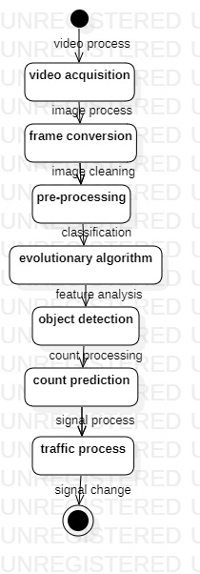

Fig 3.5 Activity Diagram

CHAPTER 4
PROGRAM DESIGN
4.1 MODULES
- Video accessing
- Frame conversion
- Image Pre –processing
- Feature extraction
- Evolutionary Object Classification
- Count prediction
- Automatic signal change
4.2 MODULES DESCRIPTION
Video accessing – In this module, video accessing is done using a normal surveillance based system. The normal video surveillance placed in road side system can be connected
Frame conversion – Frame conversion is the process of converting images from video to reduce the complexity of the system
Image Pre –processing – Image pre processing is done with the extracted frame image in which the identification of the best frame works can be done. In the pre-processing noise filters can be eliminated using median filtering methodology
Feature extraction – The Region Of Interest (ROI) feature extraction is done in the feature value maintenance in which the complete analysis of the feature values are identified
Evolutionary Object Classification – the identified feature values are passed in this module where the vehicle objects can be known. Extracted feature matching is evolved using evolutionary algorithm which exactly identifies the objects in the frame which are car, bike etc. Pre-trained dataset called synset_words.txt containing set of features can be trained using this the algorithm classifies the exact vehicle object.
Count prediction – The vehicle count values will be known with the implementation system.
Automatic signal change – The lane with higher vehicle count with automatically change into green and the remaining lane will be changed into red
4.3 ALGORITHM IMPLEMENTATION
The core challenge in the proposed intelligent agent system lies in predicting approaching speeds on roads as indicators of traffic congestion, necessitating rapid data processing. To address this, we opt for the Data2Vector algorithm due to its suitability for handling large volumes of data efficiently. Unlike traditional methods, we utilize Data2Vector in conjunction with is selected for its ability to quickly learn and converge to the optimal surface, making it well-suited for continuous variable estimation. By employing a one-pass neural network like GRNN, we aim to estimate approaching speeds accurately. In this approach, input data are presented as pairs of (x, y), where x represents a vector random variable and y is a scalar random variable. Given the assumption that traffic flow on roads exhibits regularities correlated with drivers' daily routines, such as habitual route usage, we leverage Fourier transform to identify these periodic patterns. Through the integration of Data2Vector, our system endeavors to effectively capture and predict approaching speeds on roads, thereby enabling proactive measures to alleviate traffic congestion.
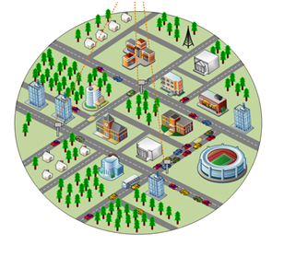
Traffic Management Platform

Forecasting
Collect
Monitor
Fig 4.1 Region Extraction from frames
Step 1: Data enters the input layer, where it is sent to the hidden layer.
Step 2: The two layers' connections give each input a random weight.
Step 3: After weights are multiplied with each input separately, a bias is added.
Step 4: The activation function receives the weighted total.
Step 5: should extract features, the activation function decides which nodes should fire.
Step 6: To deliver the output, the model applies an application function to the output layer.
Step 7: To reduce error, weights are changed and the result is back-propagated.
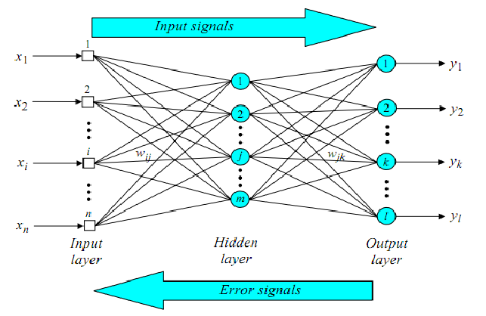
Fig 4.2 Extracted value at classification
For the above general model of artificial neural network, the net input can be calculated as follows:
y_{in}=x₁.w₁+x₂.w₂+x₃.w₃…x_{m} (1)
i.e., Net input
y_{in}=∑m_{i}x_{i}.w_{i}y_{in} (2)
The output can be calculated by applying the activation function over the net input.
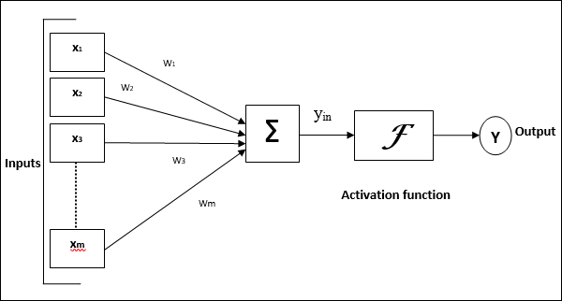
Fig 4.3 Input and output range of activation function
Y = F(yin)Y=F(yin) (5.3)
The neural network's role is determined by this function. They comprise the network's layers.

CHAPTER 5
SYSTEM REQUIREMENT SPECIFICATION
5.1 SOFTWARE REQUIREMENT
- Front End : Python
- IDE : Pycharm Jet Beans
- platform : windows 10
5.2 HARDWARE DESCRIPTION
- Processor : Intel core processor 2.6.0 GHz
- RAM : 8GB
- Hard disk : 256 GB
- Keyboard : Standard keyboard
- Monitor : 15 inch color monitor
  - SOFTWARE DESCRIPTION
5.3.1 Front End (Python)
Python is an interpreted, object-oriented, high-level programming language with dynamic semantics. Its high-level built in data structures, combined with dynamic typing and dynamic binding, make it very attractive for Rapid Application Development, as well as for use as a scripting or glue language to connect existing components together. Python's simple, easy to learn syntax emphasizes readability and therefore reduces the cost of program maintenance. Python supports modules and packages, which encourages program modularity and code reuse. The Python interpreter and the extensive standard library are available in source or binary form without charge for all major platforms, and can be freely distributed.
Often, programmers fall in love with Python because of the increased productivity it provides. Since there is no compilation step, the edit-test-debug cycle is incredibly fast. Debugging Python programs is easy: a bug or bad input will never cause a segmentation fault. Instead, when the interpreter discovers an error, it raises an exception. When the program doesn't catch the exception, the interpreter prints a stack trace. A source level debugger allows inspection of local and global variables, evaluation of arbitrary expressions, setting breakpoints, stepping through the code a line at a time, and so on. The debugger is written in Python itself, testifying to Python's introspective power. On the other hand, often the quickest way to debug a program is to add a few print statements to the source: the fast edit-test-debug cycle makes this simple approach very effective.
5.3.2 FEATURES IN PYTHON
There are many features in Python, some of which are discussed below –
1.Easy to code:
Python is high level programming language. Python is very easy to learn language as compared to other language like c, c#, java script, javaetc.It is very easy to code in python language and anybody can learn python basic in few hours or days.It is also developer-friendly language.
2. Free and Open Source:
Python language is freely available at official website and you can download it from the given download link below click on the Download Python keyword.
Download Python
Since, it is open-source; this means that source code is also available to the public. So you can download it as, use it as well as share it.
3.Object-Oriented Language:
One of the key features of python is Object-Oriented programming. Python supports object oriented language and concepts of classes, objects encapsulation etc.
4. GUI Programming Support:
Graphical Users interfaces can be made using a module such as PyQt5, PyQt4, wxPython or Tk in python.
PyQt5 is the most popular option for creating graphical apps with Python.
5. High-Level Language:
Python is a high-level language. When we write programs in python, we do not need to remember the system architecture, nor do we need to manage the memory.
6.Extensible feature:
Python is a Extensible language. we can write our some python code into c or c++ language and also we can compile that code in c/c++ language.
7. Python is Portable language:
Python language is also a portable language. for example, if we have python code for windows and if we want to run this code on other platform such as Linux, Unix and Mac then we do not need to change it, we can run this code on any platform.
8. Python is integrated language:
Python is also an integrated language because we can easily integrated python with other language like c, c++ etc.
9. Interpreted Language:
Python is an Interpreted Language. because python code is executed line by line at a time. like other language c, c++, java etc there is no need to compile python code this makes it easier to debug our code.The source code of python is converted into an immediate form called bytecode.
10. Large Standard Library
Python has a large standard library which provides rich set of module and functions so you do not have to write your own code for every single thing.There are many libraries present in python for such as regular expressions, unit-testing, web browsers etc.
11. Dynamically Typed Language:
Python is dynamically-typed language. That means the type (for example- int, double, long etc) for a variable is decided at run time not in advance.because of this feature we don’t need to specify the type of variable.
Machine Learning is the hottest trend in modern times. According to Forbes, Machine learning patents grew at a 34% rate between 2013 and 2017 and this is only set to increase in the future. And Python is the primary programming language used for much of the research and development in Machine Learning. Python is currently the most popular programming language for research and development in Machine Learning. But you don’t need to take my word for it! According to GoogleTrends, the interest in Python for Machine Learning has spiked to an all-new high with other ML languages such as R, Java, Scala, Julia, etc. lagging far behind.
Installation Procedure:

Step 1 — Downloading the Python Installer
- Go to the official Python download page for Windows.
- Find a stable Python 3 release. This tutorial was tested with Python version 3.10.10.
- Click the appropriate link for your system to download the executable file: Windows installer (64-bit) or Windows installer (32-bit).
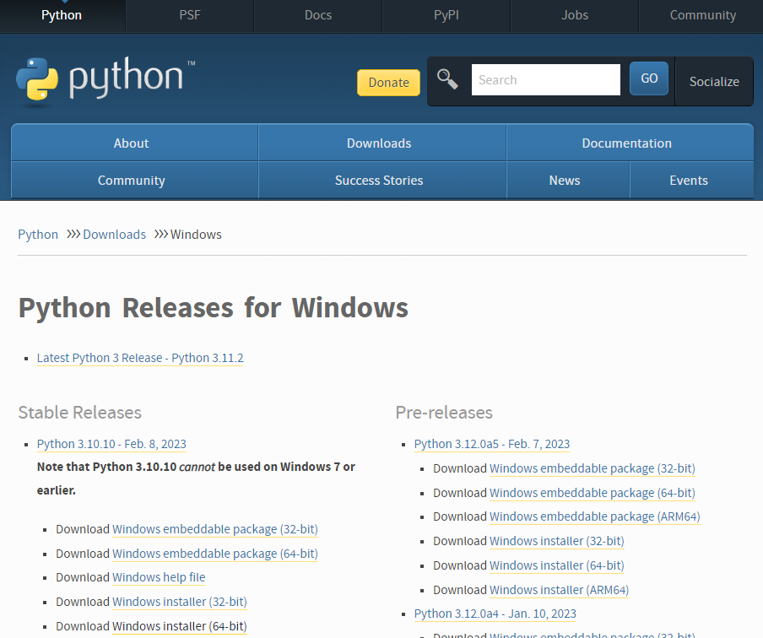

Step 2 — Running the Executable Installer
- After the installer is downloaded, double-click the .exe file, for example python-3.10.10-amd64.exe, to run the Python installer.
- Select the Install launcher for all users checkbox, which enables all users of the computer to access the Python launcher application.
- Select the Add python.exe to PATH checkbox, which enables users to launch Python from the command line.

- If you’re just getting started with Python and you want to install it with default features as described in the dialog, then click Install Now and go to Step 4 - Verify the Python Installation. To install other optional and advanced features, click Customize installation and continue.
- The Optional Features include common tools and resources for Python and you can install all of them, even if you don’t plan to use them.

Select some or all of the following options:
  - Documentation: recommended
  - pip: recommended if you want to install other Python packages, such as NumPy or pandas
  - tcl/tk and IDLE: recommended if you plan to use IDLE or follow tutorials that use it
  - Python test suite: recommended for testing and learning
  - py launcher and for all users: recommended to enable users to launch Python from the command line
- Click Next.
- The Advanced Options dialog displays.
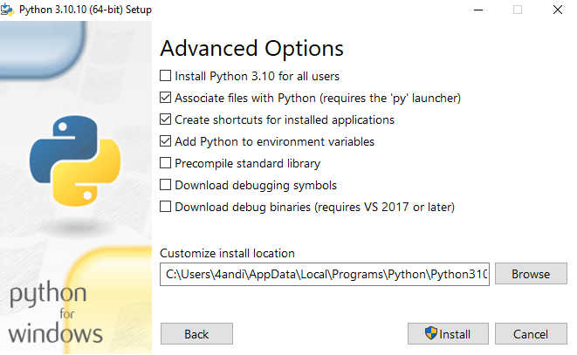
Select the options that suit your requirements:
  - Install for all users: recommended if you’re not the only user on this computer
  - Associate files with Python: recommended, because this option associates all the Python file types with the launcher or editor
  - Create shortcuts for installed applications: recommended to enable shortcuts for Python applications
  - Add Python to environment variables: recommended to enable launching Python
  - Precompile standard library: not required, it might down the installation
  - Download debugging symbols and Download debug binaries: recommended only if you plan to create C or C++ extensions
Make note of the Python installation directory in case you need to reference it later.
- Click Install to start the installation.
- After the installation is complete, a Setup was successful message displays.
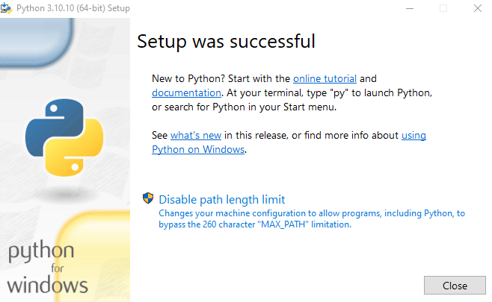

Step 3 — Adding Python to the Environment Variables (optional)
Skip this step if you selected Add Python to environment variables during installation.
If you want to access Python through the command line but you didn’t add Python to your environment variables during installation, then you can still do it manually.
Before you start, locate the Python installation directory on your system. The following directories are examples of the default directory paths:
- C:\Program Files\Python310: if you selected Install for all users during installation, then the directory will be system wide
- C:\Users\Sammy\AppData\Local\Programs\Python\Python310: if you didn’t select Install for all users during installation, then the directory will be in the Windows user path
Note that the folder name will be different if you installed a different version, but will still start with Python.
- Go to Start and enter advanced system settings in the search bar.
- Click View advanced system settings.
- In the System Properties dialog, click the Advanced tab and then click Environment Variables.
- Depending on your installation:
  - If you selected Install for all users during installation, select Path from the list of System Variables and click Edit.
  - If you didn’t select Install for all users during installation, select Path from the list of User Variables and click Edit.
- Click New and enter the Python directory path, then click OK until all the dialogs are closed.

Step 4 — Verify the Python Installation
You can verify whether the Python installation is successful either through the command line or through the Integrated Development Environment (IDLE) application, if you chose to install it.
Go to Start and enter cmd in the search bar. Click Command Prompt.

CHAPTER 6
SYSTEM TESTING
6.1 SYSTEM TESTING
System Testing is the testing of a complete and fully integrated software product. Usually, software is only one element of a larger computer-based system. Ultimately, software is interfaced with other software/hardware systems. System Testing is actually a series of different tests whose sole purpose is to exercise the full computer-based system.
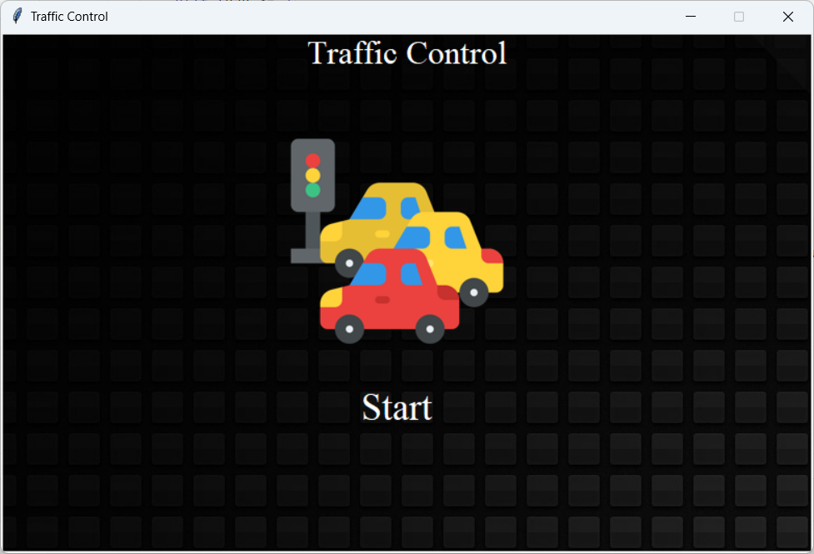
Fig 6.1 System testing
Two Category of System Testing
- Black Box Testing
- White Box Testing
System test falls under the black box testing category of software testing.
- White box testing is the testing of the internal workings or code of a software application. In contrast,
- Black box or System Testing is the opposite. System test involves the external workings of the software from the user's perspective.
System Testing involves testing the software code for following
- Testing the fully integrated applications including external peripherals in order to check how components interact with one another and with the system as a whole. This is also called End to End testing scenario.
- Verify thorough testing of every input in the application to check for desired outputs.
- Testing of the user's experience with the application. That is a very basic description of what is involved in system testing. You need to build detailed test cases and test suites that test each aspect of the application as seen from the outside without looking at the actual source code.
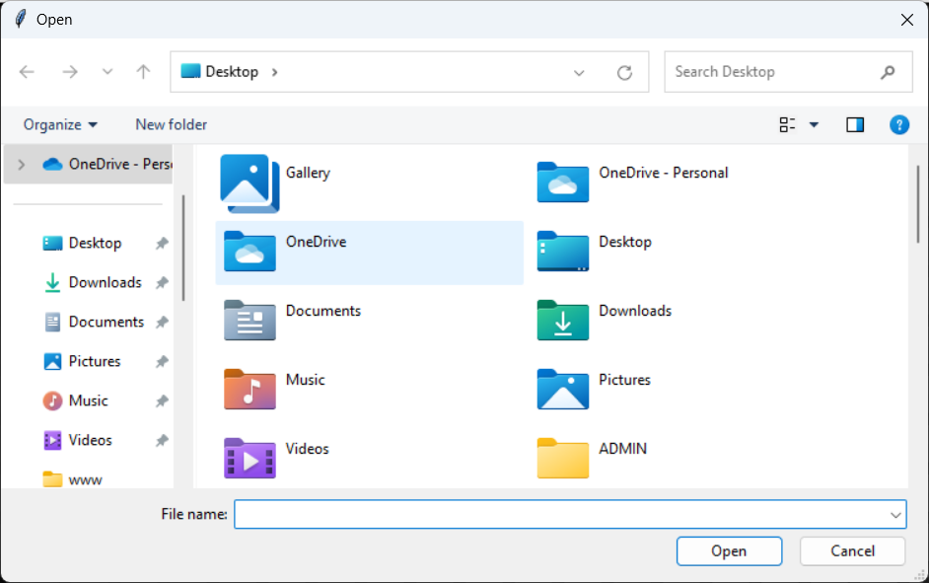
Fig 6.2 White and Black box testing
These are the steps taken to fully test new software in preparation for marketing it:
- Unit testing - testing performed on each module or block of code during development. Unit Testing is normally done by the programmer who writes the code.
- Integration testing - testing done before, during and after integration of a new module into the main software package. This involves testing of each individual code module. One piece of software can contain several modules which are often created by several different programmers. It is crucial to test each module's effect on the entire program model.
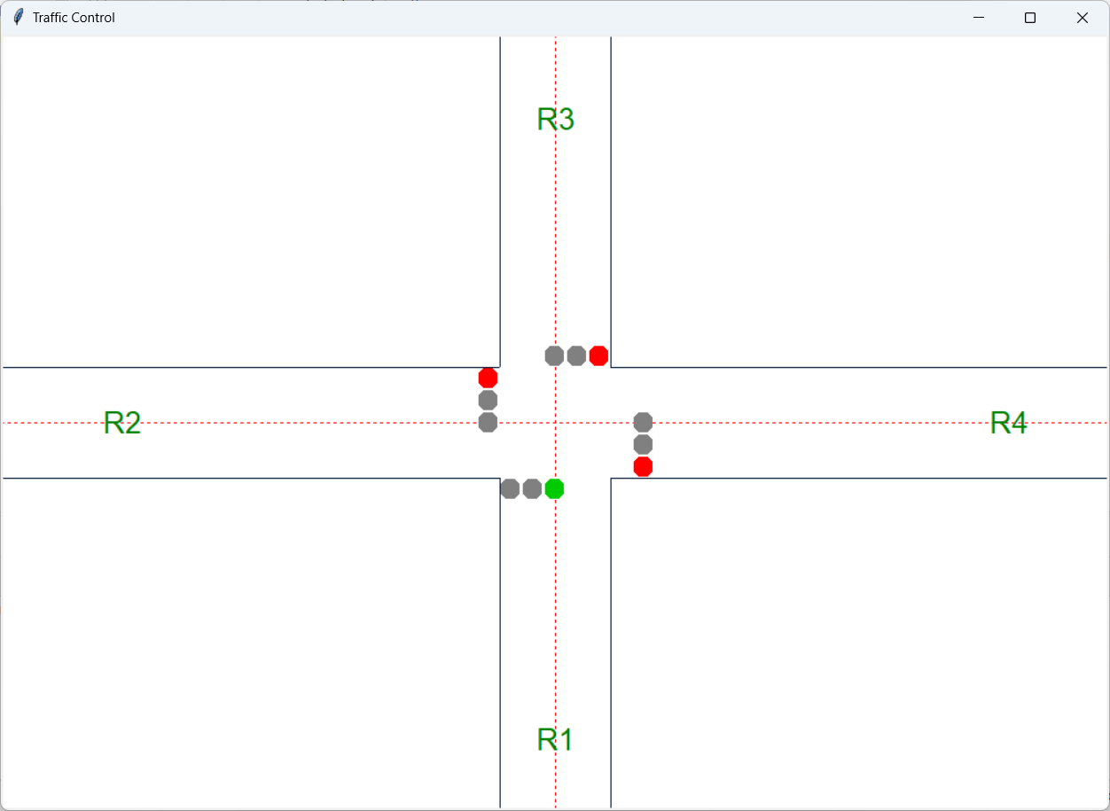
Fig 6.3 Integration testing
- Validation Testing - Validation testing is the Quality Assurance (QA) process of verifying that a software application meets the needs and requirements of its stakeholders. The main goal of validation testing is to verify whether a software product meets its acceptance criteria
- System testing - testing done by a professional testing agent on the completed software product before it is introduced to the market.
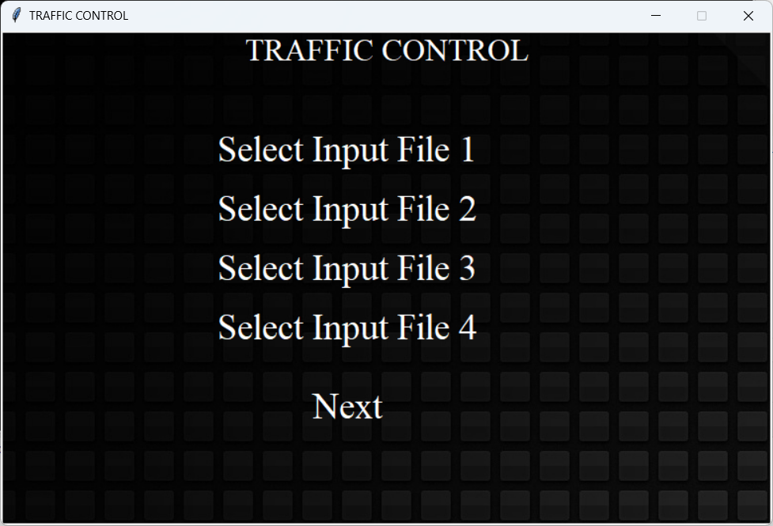
Fig 6.3 Validation Testing
Acceptance testing - beta testing of the product done by the actual end users

CHAPTER 7
SYSTEM MAINTENANCE
Maintaining a traffic prediction system involves ensuring its continued performance, reliability, and relevance over time. Here are some key aspects of system maintenance for a traffic prediction system:
Data Quality Assurance:
Continuously monitor the quality and integrity of the data sources used by the traffic prediction system. Implement data validation and cleansing processes to identify and address issues such as missing data, outliers, or inconsistencies. Regularly update data pipelines and integration mechanisms to accommodate changes in data sources or formats.
Model Performance Monitoring:
Monitor the performance of the traffic prediction models deployed in the system. Track key performance metrics such as prediction accuracy, precision, recall, and mean absolute error (MAE) over time. Set up automated alerts and notifications to flag any significant deviations or degradation in model performance.
Model Retraining and Updating:
Periodically retrain the traffic prediction models using updated data to ensure they remain accurate and effective. Define retraining schedules based on factors such as data availability, model drift, and changes in traffic patterns. Explore techniques such as online learning or incremental model updates to adapt the models to evolving traffic conditions without requiring full retraining.
Software and Infrastructure Maintenance:
Regularly update software dependencies, libraries, and frameworks used by the traffic prediction system to maintain compatibility and security.
Monitor system performance and resource utilization to identify and address any bottlenecks or scalability issues.
Implement backup and disaster recovery mechanisms to ensure data integrity and system availability in case of failures or disruptions.

Feedback Mechanisms and User Engagement:
Solicit feedback from system users, stakeholders, and domain experts to identify areas for improvement and optimization. Incorporate user feedback into system enhancements

CHAPTER 8
CONCLUSION
In conclusion, effective traffic management is critical for ensuring efficient and safe transportation systems, reducing congestion, minimizing travel time, and enhancing overall quality of life in urban areas. Traffic management plays a crucial role in optimizing the flow of vehicles and pedestrians on roads, highways, and urban streets. Well-designed traffic management strategies help alleviate congestion, reduce pollution, enhance safety, and improve accessibility for commuters and residents. Technological advancements, including sensors, cameras, GPS, and data analytics, have transformed traffic management practices. Intelligent Transportation Systems (ITS) leverage technology to collect, analyze, and disseminate real-time traffic information, enabling proactive management of traffic flow and congestion. In conclusion, addressing the challenges of urban mobility and congestion requires a holistic approach that integrates technology, policy, planning, and community engagement. By implementing proactive traffic management strategies and embracing innovation, cities can create more resilient, efficient, and sustainable transportation systems for the benefit of all.

FUTURE ENHANCEMENT
Future enhancements in traffic management can leverage emerging technologies and innovative approaches to address ongoing challenges and improve transportation efficiency. Future enhancements may focus on developing infrastructure and regulations to support AV deployment, enhancing communication between AVs and traffic management systems, and ensuring safety and cyber security.

CHAPTER 10
APPENDIX

  - SOURCE CODE

import shutil
import time
from threading import Thread
from tkinter.filedialog import askopenfilename
from tkinter import *
from PIL import Image, ImageTk
import cv2

class traffic_control:
text_color = '#FFF'
name = 'ar_master'
title = 'TRAFFIC CONTROL'
file1 = ''
file2 = ''
file3 = ''
file4 = ''
dir = "input_data"
video_frame_1=''
video_frame_2=''
video_frame_3=''
video_frame_4=''
def __init__(self):
self.title = 'Traffic Control'
self.name = 'ar_master'
self.line_color = '#001933'
self.line_tmp_color = '#FF0000'
self.gap = 50
self.duration_gap_red = 8/2
self.duration_gap_yellow = 2/2
dir = self.dir
if not os.path.exists(dir):
os.mkdir(dir)
# for f in os.listdir(dir):
# os.remove(os.path.join(dir, f))

def set_window_design(self):
root = Tk()
w = 780
h = 500
ws = root.winfo_screenwidth()
hs = root.winfo_screenheight()
x = (ws / 2) - (w / 2)
y = (hs / 2) - (h / 2)
root.geometry('%dx%d+%d+%d' % (w, h, x, y))
root.title(self.title)
root.resizable(False, False)
bg = ImageTk.PhotoImage(file='images/background_hd1.jpg')
canvas = Canvas(root, width=200, height=300)
canvas.pack(fill="both", expand=True)
canvas.create_image(0, 0, image=bg, anchor=NW)
canvas.create_text(390, 20, text=self.title, font=("Times New Roman", 24), fill=self.text_color)

def clickHandler(event):
tt = traffic_control
tt.select_files(event)
image = Image.open('images/logo.png')
img = image.resize((225, 225))
my_img = ImageTk.PhotoImage(img)
image_id = canvas.create_image(380, 200, image=my_img)
canvas.tag_bind(image_id, "<1>", clickHandler)
admin_id = canvas.create_text(380, 360, text="Start", font=("Times New Roman", 28), fill=self.text_color)
canvas.tag_bind(admin_id, "<1>", clickHandler)

root.mainloop()
def traffic_control_loop(self):
traffic_light_control_root = Toplevel()
traffic_light_control_root.attributes('-topmost', 'true')
ws = traffic_light_control_root.winfo_screenwidth()
hs = traffic_light_control_root.winfo_screenheight()
w = 1000
h = 700
x = (ws / 2) - (w / 2)
y = (hs / 2) - (h / 2)
traffic_light_control_root.geometry('%dx%d+%d+%d' % (w, h, x, y))
traffic_light_control_root.title(self.title)
bg1 = ImageTk.PhotoImage(file='images/background_hd3.jpg')
canvas = Canvas(traffic_light_control_root, width=200, height=300)
canvas.pack(fill="both", expand=True)
canvas.create_image(0, 0, image=bg1, anchor=NW)

canvas.create_line(w / 2, 0, w / 2, h, fill=self.line_tmp_color, width=1, dash=(1, 1))
canvas.create_line(0, h / 2, w, h / 2, fill=self.line_tmp_color, width=1, dash=(1, 1))
canvas.create_line(0, (h / 2) - self.gap, (w / 2) - self.gap, (h / 2) - self.gap, fill=self.line_color, width=1)
canvas.create_line(0, (h / 2) + self.gap, (w / 2) - self.gap, (h / 2) + self.gap, fill=self.line_color, width=1)
canvas.create_line((w / 2) + self.gap, (h / 2) - self.gap, w, (h / 2) - self.gap, fill=self.line_color, width=1)
canvas.create_line((w / 2) + self.gap, (h / 2) + self.gap, w, (h / 2) + self.gap, fill=self.line_color, width=1)
canvas.create_line((w / 2) - self.gap, 0, (w / 2) - self.gap, (h / 2) - self.gap, fill=self.line_color, width=1)
canvas.create_line((w / 2) + self.gap, 0, (w / 2) + self.gap, (h / 2) - self.gap, fill=self.line_color, width=1)
canvas.create_line((w / 2) - self.gap, (h / 2) + self.gap, (w / 2) - self.gap, h, fill=self.line_color, width=1)
canvas.create_line((w / 2) + self.gap, (h / 2) + self.gap, (w / 2) + self.gap, h, fill=self.line_color, width=1)
r1 = canvas.create_text((w / 2), (h / 1.1), text="R1", font="Calibri, 20", fill="green")
r2 = canvas.create_text((w / 9.2), (h / 2), text="R2", font="Calibri, 20", fill="green")
r3 = canvas.create_text((w / 2), (h / 9.2), text="R3", font="Calibri, 20", fill="green")
r4 = canvas.create_text((w / 1.1), (h / 2), text="R4", font="Calibri, 20", fill="green")
aa = PhotoImage(file="images/red.png")
r1_r = canvas.create_image((w / 2) - self.gap, (h / 2) + self.gap, anchor=NW, image=aa)
bb = PhotoImage(file="images/yellow.png")
r1_y = canvas.create_image((w / 2) - self.gap + 20, (h / 2) + self.gap, anchor=NW, image=bb)
cc = PhotoImage(file="images/green.png")
r1_g = canvas.create_image((w / 2) - self.gap + 40, (h / 2) + self.gap, anchor=NW, image=cc)
r2_r = canvas.create_image((w / 2) - self.gap - 20, (h / 2) - self.gap, anchor=NW, image=aa)
r2_y = canvas.create_image((w / 2) - self.gap - 20, (h / 2) - self.gap + 20, anchor=NW, image=bb)
r2_g = canvas.create_image((w / 2) - self.gap - 20, (h / 2) - self.gap + 40, anchor=NW, image=cc)
r3_r = canvas.create_image((w / 2) - self.gap + 80, (h / 2) - self.gap - 20, anchor=NW, image=aa)
r3_y = canvas.create_image((w / 2) - self.gap + 60, (h / 2) - self.gap - 20, anchor=NW, image=bb)
r3_g = canvas.create_image((w / 2) - self.gap + 40, (h / 2) - self.gap - 20, anchor=NW, image=cc)
r4_r = canvas.create_image((w / 2) + self.gap + 20, (h / 2) - self.gap + 80, anchor=NW, image=aa)
r4_y = canvas.create_image((w / 2) + self.gap + 20, (h / 2) - self.gap + 60, anchor=NW, image=bb)
r4_g = canvas.create_image((w / 2) + self.gap + 20, (h / 2) - self.gap + 40, anchor=NW, image=cc)
time.sleep(2)

# image = Image.open('input_data/1.jpg')
# my_img = ImageTk.PhotoImage(image)
# image_id1 = canvas.create_image(0, 0, image=my_img)

def read_lan_data():
f1 = open("input_data/1.txt", "r")
first_lan = f1.read()
f2 = open("input_data/2.txt", "r")
second_lan = f2.read()
f3 = open("input_data/3.txt", "r")
third_lan = f3.read()
f4 = open("input_data/4.txt", "r")
four_lan = f4.read()
return first_lan, second_lan, third_lan, four_lan

def first_assign_light():

ar1=(PhotoImage(file="images/red.png"))
ar2=(PhotoImage(file="images/yellow.png"))
ar3=(PhotoImage(file="images/green.png"))
ar4=(PhotoImage(file="images/gray.png"))
ar5=(PhotoImage(file="images/black.png"))

canvas.ar1 = ar1
canvas.ar2 = ar2
canvas.ar3 = ar3
canvas.ar4 = ar4
canvas.itemconfig(r1_r, image=ar4)
canvas.itemconfig(r1_y, image=ar4)
canvas.itemconfig(r1_g, image=ar3)
canvas.itemconfig(r2_r, image=ar1)
canvas.itemconfig(r2_y, image=ar4)
canvas.itemconfig(r2_g, image=ar4)
canvas.itemconfig(r3_r, image=ar1)
canvas.itemconfig(r3_y, image=ar4)
canvas.itemconfig(r3_g, image=ar4)
canvas.itemconfig(r4_r, image=ar1)
canvas.itemconfig(r4_y, image=ar4)
canvas.itemconfig(r4_g, image=ar4)

canvas.update()
traffic_light_control_root.update()
def first_delay_assign_light():
first_lan, second_lan, third_lan, four_lan = read_lan_data()

canvas.itemconfig(r1,text='R1-'+str(first_lan))
canvas.itemconfig(r2,text='R2-'+str(second_lan))
canvas.itemconfig(r3,text='R3-'+str(third_lan))
canvas.itemconfig(r4,text='R4-'+str(four_lan))

ar1=(PhotoImage(file="images/red.png"))
ar2=(PhotoImage(file="images/yellow.png"))
ar3=(PhotoImage(file="images/green.png"))
ar4=(PhotoImage(file="images/gray.png"))
ar5=(PhotoImage(file="images/black.png"))
canvas.ar1 = ar1
canvas.ar2 = ar2
canvas.ar3 = ar3
canvas.ar4 = ar4
canvas.itemconfig(r1_r, image=ar4)
canvas.itemconfig(r1_y, image=ar2)
canvas.itemconfig(r1_g, image=ar4)
canvas.itemconfig(r2_r, image=ar1)
canvas.itemconfig(r2_y, image=ar4)
canvas.itemconfig(r2_g, image=ar4)
canvas.itemconfig(r3_r, image=ar1)
canvas.itemconfig(r3_y, image=ar4)
canvas.itemconfig(r3_g, image=ar4)
canvas.itemconfig(r4_r, image=ar1)
canvas.itemconfig(r4_y, image=ar4)
canvas.itemconfig(r4_g, image=ar4)
canvas.update()
traffic_light_control_root.update()
def second_assign_light():
first_lan, second_lan, third_lan, four_lan = read_lan_data()

canvas.itemconfig(r1, text='R1-' + str(first_lan))
canvas.itemconfig(r2, text='R2-' + str(second_lan))
canvas.itemconfig(r3, text='R3-' + str(third_lan))
canvas.itemconfig(r4, text='R4-' + str(four_lan))
ar1 = (PhotoImage(file="images/red.png"))
ar2 = (PhotoImage(file="images/yellow.png"))
ar3 = (PhotoImage(file="images/green.png"))
ar4 = (PhotoImage(file="images/gray.png"))
ar5 = (PhotoImage(file="images/black.png"))
canvas.ar1 = ar1
canvas.ar2 = ar2
canvas.ar3 = ar3
canvas.ar4 = ar4
canvas.itemconfig(r1_r, image=ar1)
canvas.itemconfig(r1_y, image=ar4)
canvas.itemconfig(r1_g, image=ar4)
canvas.itemconfig(r2_r, image=ar4)
canvas.itemconfig(r2_y, image=ar4)
canvas.itemconfig(r2_g, image=ar3)
canvas.itemconfig(r3_r, image=ar1)
canvas.itemconfig(r3_y, image=ar4)
canvas.itemconfig(r3_g, image=ar4)
canvas.itemconfig(r4_r, image=ar1)
canvas.itemconfig(r4_y, image=ar4)
canvas.itemconfig(r4_g, image=ar4)
canvas.update()
traffic_light_control_root.update()
def second_delay_assign_light():
first_lan, second_lan, third_lan, four_lan = read_lan_data()

canvas.itemconfig(r1, text='R1-' + str(first_lan))
canvas.itemconfig(r2, text='R2-' + str(second_lan))
canvas.itemconfig(r3, text='R3-' + str(third_lan))
canvas.itemconfig(r4, text='R4-' + str(four_lan))
ar1 = (PhotoImage(file="images/red.png"))
ar2 = (PhotoImage(file="images/yellow.png"))
ar3 = (PhotoImage(file="images/green.png"))
ar4 = (PhotoImage(file="images/gray.png"))
ar5 = (PhotoImage(file="images/black.png"))
canvas.ar1 = ar1
canvas.ar2 = ar2
canvas.ar3 = ar3
canvas.ar4 = ar4
canvas.itemconfig(r1_r, image=ar1)
canvas.itemconfig(r1_y, image=ar4)
canvas.itemconfig(r1_g, image=ar4)
canvas.itemconfig(r2_r, image=ar4)
canvas.itemconfig(r2_y, image=ar2)
canvas.itemconfig(r2_g, image=ar4)
canvas.itemconfig(r3_r, image=ar1)
canvas.itemconfig(r3_y, image=ar4)
canvas.itemconfig(r3_g, image=ar4)
canvas.itemconfig(r4_r, image=ar1)
canvas.itemconfig(r4_y, image=ar4)
canvas.itemconfig(r4_g, image=ar4)
canvas.update()
traffic_light_control_root.update()
def third_assign_light():
first_lan, second_lan, third_lan, four_lan = read_lan_data()

canvas.itemconfig(r1, text='R1-' + str(first_lan))
canvas.itemconfig(r2, text='R2-' + str(second_lan))
canvas.itemconfig(r3, text='R3-' + str(third_lan))
canvas.itemconfig(r4, text='R4-' + str(four_lan))
ar1 = (PhotoImage(file="images/red.png"))
ar2 = (PhotoImage(file="images/yellow.png"))
ar3 = (PhotoImage(file="images/green.png"))
ar4 = (PhotoImage(file="images/gray.png"))
ar5 = (PhotoImage(file="images/black.png"))
canvas.ar1 = ar1
canvas.ar2 = ar2
canvas.ar3 = ar3
canvas.ar4 = ar4
canvas.itemconfig(r1_r, image=ar1)
canvas.itemconfig(r1_y, image=ar4)
canvas.itemconfig(r1_g, image=ar4)
canvas.itemconfig(r2_r, image=ar1)
canvas.itemconfig(r2_y, image=ar4)
canvas.itemconfig(r2_g, image=ar4)
canvas.itemconfig(r3_r, image=ar4)
canvas.itemconfig(r3_y, image=ar4)
canvas.itemconfig(r3_g, image=ar3)
canvas.itemconfig(r4_r, image=ar1)
canvas.itemconfig(r4_y, image=ar4)
canvas.itemconfig(r4_g, image=ar4)
canvas.update()
traffic_light_control_root.update()
def third_delay_assign_light():
first_lan, second_lan, third_lan, four_lan = read_lan_data()

canvas.itemconfig(r1, text='R1-' + str(first_lan))
canvas.itemconfig(r2, text='R2-' + str(second_lan))
canvas.itemconfig(r3, text='R3-' + str(third_lan))
canvas.itemconfig(r4, text='R4-' + str(four_lan))
ar1 = (PhotoImage(file="images/red.png"))
ar2 = (PhotoImage(file="images/yellow.png"))
ar3 = (PhotoImage(file="images/green.png"))
ar4 = (PhotoImage(file="images/gray.png"))
ar5 = (PhotoImage(file="images/black.png"))
canvas.ar1 = ar1
canvas.ar2 = ar2
canvas.ar3 = ar3
canvas.ar4 = ar4
canvas.itemconfig(r1_r, image=ar1)
canvas.itemconfig(r1_y, image=ar4)
canvas.itemconfig(r1_g, image=ar4)
canvas.itemconfig(r2_r, image=ar1)
canvas.itemconfig(r2_y, image=ar4)
canvas.itemconfig(r2_g, image=ar4)
canvas.itemconfig(r3_r, image=ar4)
canvas.itemconfig(r3_y, image=ar2)
canvas.itemconfig(r3_g, image=ar4)
canvas.itemconfig(r4_r, image=ar1)
canvas.itemconfig(r4_y, image=ar4)
canvas.itemconfig(r4_g, image=ar4)
canvas.update()
traffic_light_control_root.update()
def four_assign_light():
first_lan, second_lan, third_lan, four_lan = read_lan_data()

canvas.itemconfig(r1, text='R1-' + str(first_lan))
canvas.itemconfig(r2, text='R2-' + str(second_lan))
canvas.itemconfig(r3, text='R3-' + str(third_lan))
canvas.itemconfig(r4, text='R4-' + str(four_lan))
ar1 = (PhotoImage(file="images/red.png"))
ar2 = (PhotoImage(file="images/yellow.png"))
ar3 = (PhotoImage(file="images/green.png"))
ar4 = (PhotoImage(file="images/gray.png"))
ar5 = (PhotoImage(file="images/black.png"))
canvas.ar1 = ar1
canvas.ar2 = ar2
canvas.ar3 = ar3
canvas.ar4 = ar4
canvas.itemconfig(r1_r, image=ar1)
canvas.itemconfig(r1_y, image=ar4)
canvas.itemconfig(r1_g, image=ar4)
canvas.itemconfig(r2_r, image=ar1)
canvas.itemconfig(r2_y, image=ar4)
canvas.itemconfig(r2_g, image=ar4)
canvas.itemconfig(r3_r, image=ar1)
canvas.itemconfig(r3_y, image=ar4)
canvas.itemconfig(r3_g, image=ar4)
canvas.itemconfig(r4_r, image=ar4)
canvas.itemconfig(r4_y, image=ar4)
canvas.itemconfig(r4_g, image=ar3)
canvas.update()
traffic_light_control_root.update()
def four_delay_assign_light():
first_lan, second_lan, third_lan, four_lan = read_lan_data()

canvas.itemconfig(r1, text='R1-' + str(first_lan))
canvas.itemconfig(r2, text='R2-' + str(second_lan))
canvas.itemconfig(r3, text='R3-' + str(third_lan))
canvas.itemconfig(r4, text='R4-' + str(four_lan))
ar1 = (PhotoImage(file="images/red.png"))
ar2 = (PhotoImage(file="images/yellow.png"))
ar3 = (PhotoImage(file="images/green.png"))
ar4 = (PhotoImage(file="images/gray.png"))
ar5 = (PhotoImage(file="images/black.png"))
canvas.ar1 = ar1
canvas.ar2 = ar2
canvas.ar3 = ar3
canvas.ar4 = ar4
canvas.itemconfig(r1_r, image=ar1)
canvas.itemconfig(r1_y, image=ar4)
canvas.itemconfig(r1_g, image=ar4)
canvas.itemconfig(r2_r, image=ar1)
canvas.itemconfig(r2_y, image=ar4)
canvas.itemconfig(r2_g, image=ar4)
canvas.itemconfig(r3_r, image=ar1)
canvas.itemconfig(r3_y, image=ar4)
canvas.itemconfig(r3_g, image=ar4)
canvas.itemconfig(r4_r, image=ar4)
canvas.itemconfig(r4_y, image=ar2)
canvas.itemconfig(r4_g, image=ar4)
canvas.update()
traffic_light_control_root.update()
def video_car_count_1():
resize_val=(150,150)

print("call video file")
x=0
car_cascade1 = cv2.CascadeClassifier('haarcascade_car1.xml')
car_cascade2 = cv2.CascadeClassifier('haarcascade_car2.xml')
car_cascade3 = cv2.CascadeClassifier('haarcascade_car3.xml')
car_cascade4 = cv2.CascadeClassifier('haarcascade_car4.xml')
cap1 = cv2.VideoCapture(traffic_control.file1)
cap2 = cv2.VideoCapture(traffic_control.file2)
cap3 = cv2.VideoCapture(traffic_control.file3)
cap4 = cv2.VideoCapture(traffic_control.file4)
if 1==1:
while True:
x += 1
ret, frame1 = cap1.read()
gray1 = cv2.cvtColor(frame1, cv2.COLOR_BGR2GRAY)
cars1 = car_cascade1.detectMultiScale(gray1, 1.1, 3)
xx1 = len(cars1)
f1 = open("input_data/1.txt", "w")
f1.write(str(xx1))
# resized1 = cv2.resize(frame1, resize_val, interpolation=cv2.INTER_AREA)
# filename1 = 'input_data/1.jpg'
# cv2.imwrite(filename1, resized1)
# traffic_control.video_frame_1=resized1
######################### 2
ret, frame2 = cap2.read()
gray2 = cv2.cvtColor(frame2, cv2.COLOR_BGR2GRAY)
cars2 = car_cascade2.detectMultiScale(gray2, 1.1, 3)
xx2 = len(cars2)
f2 = open("input_data/2.txt", "w")
f2.write(str(xx2))
# resized2 = cv2.resize(frame2, resize_val, interpolation=cv2.INTER_AREA)
# filename2 = 'input_data/2.jpg'
# cv2.imwrite(filename2, resized2)
# traffic_control.video_frame_2 = resized2
######################### 3
ret, frame3 = cap3.read()
gray3 = cv2.cvtColor(frame3, cv2.COLOR_BGR2GRAY)
cars3 = car_cascade3.detectMultiScale(gray3, 1.1, 3)
xx3 = len(cars3)
f3 = open("input_data/3.txt", "w")
f3.write(str(xx3))
# resized3 = cv2.resize(frame3, resize_val, interpolation=cv2.INTER_AREA)
# filename3 = 'input_data/3.jpg'
# cv2.imwrite(filename3, resized3)
# traffic_control.video_frame_3 = resized3
######################### 4
ret, frame4 = cap4.read()
gray4 = cv2.cvtColor(frame4, cv2.COLOR_BGR2GRAY)
cars4 = car_cascade4.detectMultiScale(gray4, 1.1, 3)
xx4 = len(cars4)
f4 = open("input_data/4.txt", "w")
f4.write(str(xx4))
# resized4 = cv2.resize(frame4, resize_val, interpolation=cv2.INTER_AREA)
# filename4 = 'input_data/4.jpg'
# cv2.imwrite(filename4, resized4)
# traffic_control.video_frame_4 = resized4

def test():
load=0
load_nornal=0
loop_count_r1=0
loop_count_r2=0
loop_count_r3=0
loop_count_r4=0
while True:
load += 1
first_lan, second_lan, third_lan, four_lan = read_lan_data()
if load==1:
first_assign_light()
time.sleep(self.duration_gap_red)
first_delay_assign_light()
time.sleep(self.duration_gap_yellow)

second_assign_light()
time.sleep(self.duration_gap_red)
second_delay_assign_light()
time.sleep(self.duration_gap_yellow)

third_assign_light()
time.sleep(self.duration_gap_red)
third_delay_assign_light()
time.sleep(self.duration_gap_yellow)

four_assign_light()
time.sleep(self.duration_gap_red)
four_delay_assign_light()
time.sleep(self.duration_gap_yellow)

elif load >= 2:
first_lan, second_lan, third_lan, four_lan = read_lan_data()
if first_lan == '':
first_lan = 0
if second_lan=='':
second_lan=0
if third_lan=='':
third_lan=0
if four_lan=='':
four_lan=0
# print(first_lan, second_lan, third_lan, four_lan)
list=[float (first_lan),float (second_lan), float (third_lan), float (four_lan)]
mm=max(list)
ar_maxin=list.index(mm)
print(load_nornal)
if load_nornal<=-3:
load_nornal=0
elif ar_maxin==0 and loop_count_r1<2:
print("first")
first_assign_light()
time.sleep(self.duration_gap_red)
first_delay_assign_light()
time.sleep(self.duration_gap_yellow)
loop_count_r1+=1
load_nornal -= 1
elif ar_maxin==1 and loop_count_r2<2:
print("second")
second_assign_light()
time.sleep(self.duration_gap_red)
second_delay_assign_light()
time.sleep(self.duration_gap_yellow)
loop_count_r2 += 1
loop_count_r1=0
loop_count_r3=0
loop_count_r4=0
load_nornal -= 1
elif ar_maxin==2 and loop_count_r3<2:
print("third")
third_assign_light()
time.sleep(self.duration_gap_red)
third_delay_assign_light()
time.sleep(self.duration_gap_yellow)
loop_count_r3 += 1
loop_count_r1 = 0
loop_count_r2 = 0
loop_count_r4 = 0
load_nornal -= 1
elif ar_maxin == 3 and loop_count_r4<2:
print("four")
four_assign_light()
time.sleep(self.duration_gap_red)
four_delay_assign_light()
time.sleep(self.duration_gap_yellow)
loop_count_r4 += 1
loop_count_r1 = 0
loop_count_r3 = 0
loop_count_r2 = 0
load_nornal -= 1

elif load>=4:
load=0

def call_thread():
# Thread(target=test()).start()
# Thread(target=video_car_count_1()).start()

p1 = Thread(target=test)
p2 = Thread(target=video_car_count_1)

p1.start()
p2.start()

traffic_light_control_root.after(3000, lambda: call_thread())
traffic_light_control_root.mainloop()

def select_files(self):
select_files_root = Toplevel()
select_files_root.attributes('-topmost', 'true')
w = 780
h = 500
ws = select_files_root.winfo_screenwidth()
hs = select_files_root.winfo_screenheight()
x = (ws / 2) - (w / 2)
y = (hs / 2) - (h / 2)
select_files_root.geometry('%dx%d+%d+%d' % (w, h, x, y))
select_files_root.title(traffic_control.title)
select_files_root.resizable(False, False)
bg = ImageTk.PhotoImage(file='images/background_hd1.jpg')
canvas = Canvas(select_files_root, width=200, height=300)
canvas.pack(fill="both", expand=True)
canvas.create_image(0, 0, image=bg, anchor=NW)
canvas.create_text(390, 20, text=traffic_control.title, font=("Times New Roman", 24), fill='#FFF')
def first_select(event):
dataset_file_path = askopenfilename(parent=select_files_root)
fname=os.path.basename(dataset_file_path)
dst='input_data/'+fname
shutil.copyfile(dataset_file_path, dst)
traffic_control.file1=dst
admin_id = canvas.create_text(350, 120, text="Select Input File 1", font=("Times New Roman", 28), fill='#FFF')
canvas.tag_bind(admin_id, "<1>", first_select)
def second_select(event):
dataset_file_path = askopenfilename(parent=select_files_root)
fname=os.path.basename(dataset_file_path)
dst='input_data/'+fname
shutil.copyfile(dataset_file_path, dst)
traffic_control.file2=dst
admin_id = canvas.create_text(350, 180, text="Select Input File 2", font=("Times New Roman", 28), fill='#FFF')
canvas.tag_bind(admin_id, "<1>", second_select)
def third_select(event):
dataset_file_path = askopenfilename(parent=select_files_root)
fname=os.path.basename(dataset_file_path)
dst='input_data/'+fname
shutil.copyfile(dataset_file_path, dst)
traffic_control.file3=dst
admin_id = canvas.create_text(350, 240, text="Select Input File 3", font=("Times New Roman", 28), fill='#FFF')
canvas.tag_bind(admin_id, "<1>", third_select)
def four_select(event):
dataset_file_path = askopenfilename(parent=select_files_root)
fname=os.path.basename(dataset_file_path)
dst='input_data/'+fname
shutil.copyfile(dataset_file_path, dst)
traffic_control.file4=dst
admin_id = canvas.create_text(350, 300, text="Select Input File 4", font=("Times New Roman", 28), fill='#FFF')
canvas.tag_bind(admin_id, "<1>", four_select)

def select_files_next(event):
select_files_root.destroy()
ar = traffic_control()
ar1 = traffic_control()
Thread(target=ar1.traffic_control_loop()).start()
# Thread(target=ar.video_vehicle_count_and_image()).start()
#

admin_id = canvas.create_text(350, 380, text="Next", font=("Times New Roman", 28), fill='#FFF')
canvas.tag_bind(admin_id, "<1>", select_files_next)
select_files_root.mainloop()
ar=traffic_control()
ar.set_window_design()
import os
import shutil
import time
from sys import path
from tkinter import END, Tk
from tkinter.filedialog import askopenfilename
import cv2
from tkinter import *

import cv2

from PIL import Image, ImageTk

class traffic_light_control:
def __init__(self):
self.title='Traffic Control'
self.name='ar_master'
self.line_color='#001933'
self.line_tmp_color='#FF0000'
self.gap=50
self.duration_gap_red=8
self.duration_gap_yellow=2

def open_window(self):
def sample():
print("oo")
def first_assign_light():

ar1=(PhotoImage(file="images/red.png"))
ar2=(PhotoImage(file="images/yellow.png"))
ar3=(PhotoImage(file="images/green.png"))
ar4=(PhotoImage(file="images/gray.png"))
ar5=(PhotoImage(file="images/black.png"))
canvas.ar1 = ar1
canvas.ar2 = ar2
canvas.ar3 = ar3
canvas.ar4 = ar4
#################
canvas.itemconfig(r1_r, image=ar4)
canvas.itemconfig(r1_y, image=ar4)
canvas.itemconfig(r1_g, image=ar3)

canvas.itemconfig(r2_r, image=ar1)
canvas.itemconfig(r2_y, image=ar4)
canvas.itemconfig(r2_g, image=ar4)

canvas.itemconfig(r3_r, image=ar1)
canvas.itemconfig(r3_y, image=ar4)
canvas.itemconfig(r3_g, image=ar4)

canvas.itemconfig(r4_r, image=ar1)
canvas.itemconfig(r4_y, image=ar4)
canvas.itemconfig(r4_g, image=ar4)
canvas.update()
traffic_light_control_root.update()
def first_delay_assign_light():

ar1=(PhotoImage(file="images/red.png"))
ar2=(PhotoImage(file="images/yellow.png"))
ar3=(PhotoImage(file="images/green.png"))
ar4=(PhotoImage(file="images/gray.png"))
ar5=(PhotoImage(file="images/black.png"))
canvas.ar1 = ar1
canvas.ar2 = ar2
canvas.ar3 = ar3
canvas.ar4 = ar4
#################
canvas.itemconfig(r1_r, image=ar4)
canvas.itemconfig(r1_y, image=ar2)
canvas.itemconfig(r1_g, image=ar4)

canvas.itemconfig(r2_r, image=ar1)
canvas.itemconfig(r2_y, image=ar4)
canvas.itemconfig(r2_g, image=ar4)

canvas.itemconfig(r3_r, image=ar1)
canvas.itemconfig(r3_y, image=ar4)
canvas.itemconfig(r3_g, image=ar4)

canvas.itemconfig(r4_r, image=ar1)
canvas.itemconfig(r4_y, image=ar4)
canvas.itemconfig(r4_g, image=ar4)
canvas.update()
traffic_light_control_root.update()
def second_assign_light():
ar1 = (PhotoImage(file="images/red.png"))
ar2 = (PhotoImage(file="images/yellow.png"))
ar3 = (PhotoImage(file="images/green.png"))
ar4 = (PhotoImage(file="images/gray.png"))
ar5 = (PhotoImage(file="images/black.png"))
canvas.ar1 = ar1
canvas.ar2 = ar2
canvas.ar3 = ar3
canvas.ar4 = ar4
#################
canvas.itemconfig(r1_r, image=ar1)
canvas.itemconfig(r1_y, image=ar4)
canvas.itemconfig(r1_g, image=ar4)

canvas.itemconfig(r2_r, image=ar4)
canvas.itemconfig(r2_y, image=ar4)
canvas.itemconfig(r2_g, image=ar3)

canvas.itemconfig(r3_r, image=ar1)
canvas.itemconfig(r3_y, image=ar4)
canvas.itemconfig(r3_g, image=ar4)

canvas.itemconfig(r4_r, image=ar1)
canvas.itemconfig(r4_y, image=ar4)
canvas.itemconfig(r4_g, image=ar4)
canvas.update()
traffic_light_control_root.update()
def second_delay_assign_light():
ar1 = (PhotoImage(file="images/red.png"))
ar2 = (PhotoImage(file="images/yellow.png"))
ar3 = (PhotoImage(file="images/green.png"))
ar4 = (PhotoImage(file="images/gray.png"))
ar5 = (PhotoImage(file="images/black.png"))
canvas.ar1 = ar1
canvas.ar2 = ar2
canvas.ar3 = ar3
canvas.ar4 = ar4
#################
canvas.itemconfig(r1_r, image=ar1)
canvas.itemconfig(r1_y, image=ar4)
canvas.itemconfig(r1_g, image=ar4)

canvas.itemconfig(r2_r, image=ar4)
canvas.itemconfig(r2_y, image=ar2)
canvas.itemconfig(r2_g, image=ar4)

canvas.itemconfig(r3_r, image=ar1)
canvas.itemconfig(r3_y, image=ar4)
canvas.itemconfig(r3_g, image=ar4)

canvas.itemconfig(r4_r, image=ar1)
canvas.itemconfig(r4_y, image=ar4)
canvas.itemconfig(r4_g, image=ar4)
canvas.update()
traffic_light_control_root.update()
def third_assign_light():
ar1 = (PhotoImage(file="images/red.png"))
ar2 = (PhotoImage(file="images/yellow.png"))
ar3 = (PhotoImage(file="images/green.png"))
ar4 = (PhotoImage(file="images/gray.png"))
ar5 = (PhotoImage(file="images/black.png"))
canvas.ar1 = ar1
canvas.ar2 = ar2
canvas.ar3 = ar3
canvas.ar4 = ar4
#################
canvas.itemconfig(r1_r, image=ar1)
canvas.itemconfig(r1_y, image=ar4)
canvas.itemconfig(r1_g, image=ar4)

canvas.itemconfig(r2_r, image=ar1)
canvas.itemconfig(r2_y, image=ar4)
canvas.itemconfig(r2_g, image=ar4)

canvas.itemconfig(r3_r, image=ar4)
canvas.itemconfig(r3_y, image=ar4)
canvas.itemconfig(r3_g, image=ar3)

canvas.itemconfig(r4_r, image=ar1)
canvas.itemconfig(r4_y, image=ar4)
canvas.itemconfig(r4_g, image=ar4)
canvas.update()
traffic_light_control_root.update()
def third_delay_assign_light():
ar1 = (PhotoImage(file="images/red.png"))
ar2 = (PhotoImage(file="images/yellow.png"))
ar3 = (PhotoImage(file="images/green.png"))
ar4 = (PhotoImage(file="images/gray.png"))
ar5 = (PhotoImage(file="images/black.png"))
canvas.ar1 = ar1
canvas.ar2 = ar2
canvas.ar3 = ar3
canvas.ar4 = ar4
#################
canvas.itemconfig(r1_r, image=ar1)
canvas.itemconfig(r1_y, image=ar4)
canvas.itemconfig(r1_g, image=ar4)

canvas.itemconfig(r2_r, image=ar1)
canvas.itemconfig(r2_y, image=ar4)
canvas.itemconfig(r2_g, image=ar4)

canvas.itemconfig(r3_r, image=ar4)
canvas.itemconfig(r3_y, image=ar2)
canvas.itemconfig(r3_g, image=ar4)

canvas.itemconfig(r4_r, image=ar1)
canvas.itemconfig(r4_y, image=ar4)
canvas.itemconfig(r4_g, image=ar4)
canvas.update()
traffic_light_control_root.update()
def four_assign_light():
ar1 = (PhotoImage(file="images/red.png"))
ar2 = (PhotoImage(file="images/yellow.png"))
ar3 = (PhotoImage(file="images/green.png"))
ar4 = (PhotoImage(file="images/gray.png"))
ar5 = (PhotoImage(file="images/black.png"))
canvas.ar1 = ar1
canvas.ar2 = ar2
canvas.ar3 = ar3
canvas.ar4 = ar4
#################
canvas.itemconfig(r1_r, image=ar1)
canvas.itemconfig(r1_y, image=ar4)
canvas.itemconfig(r1_g, image=ar4)

canvas.itemconfig(r2_r, image=ar1)
canvas.itemconfig(r2_y, image=ar4)
canvas.itemconfig(r2_g, image=ar4)

canvas.itemconfig(r3_r, image=ar1)
canvas.itemconfig(r3_y, image=ar4)
canvas.itemconfig(r3_g, image=ar4)

canvas.itemconfig(r4_r, image=ar4)
canvas.itemconfig(r4_y, image=ar4)
canvas.itemconfig(r4_g, image=ar3)
canvas.update()
traffic_light_control_root.update()

def four_delay_assign_light():
ar1 = (PhotoImage(file="images/red.png"))
ar2 = (PhotoImage(file="images/yellow.png"))
ar3 = (PhotoImage(file="images/green.png"))
ar4 = (PhotoImage(file="images/gray.png"))
ar5 = (PhotoImage(file="images/black.png"))
canvas.ar1 = ar1
canvas.ar2 = ar2
canvas.ar3 = ar3
canvas.ar4 = ar4
#################
canvas.itemconfig(r1_r, image=ar1)
canvas.itemconfig(r1_y, image=ar4)
canvas.itemconfig(r1_g, image=ar4)

canvas.itemconfig(r2_r, image=ar1)
canvas.itemconfig(r2_y, image=ar4)
canvas.itemconfig(r2_g, image=ar4)

canvas.itemconfig(r3_r, image=ar1)
canvas.itemconfig(r3_y, image=ar4)
canvas.itemconfig(r3_g, image=ar4)

canvas.itemconfig(r4_r, image=ar4)
canvas.itemconfig(r4_y, image=ar2)
canvas.itemconfig(r4_g, image=ar4)
canvas.update()
traffic_light_control_root.update()

traffic_light_control_root = Tk()
traffic_light_control_root.attributes('-topmost', 'true')

ws = traffic_light_control_root.winfo_screenwidth()
hs = traffic_light_control_root.winfo_screenheight()
w = 1000
h = 700
x = (ws / 2) - (w / 2)
y = (hs / 2) - (h / 2)
traffic_light_control_root.geometry('%dx%d+%d+%d' % (w, h, x, y))
# pp= ImageTk.PhotoImage(file='images/background_hd1.jpg')
traffic_light_control_root.title(self.title)
bg = ImageTk.PhotoImage(file='images/background_hd2.jpg')
canvas = Canvas(traffic_light_control_root, width=200, height=300)
canvas.pack(fill="both", expand=True)
canvas.create_image(0, 0, image=bg, anchor=NW)

# image1 = Image.open('input_data/a.jpg')
# img1 = image1.resize((500, 500), Image.Resampling.LANCZOS)
# my_img1 = ImageTk.PhotoImage(img1)
# image_id1 = canvas.create_image(0, 0, image=my_img1)
canvas.create_line(w/2, 0, w/2, h, fill=self.line_tmp_color, width=1, dash=(1,1))
canvas.create_line(0, h/2, w, h/2, fill=self.line_tmp_color, width=1, dash=(1,1))

canvas.create_line(0, (h/2)-self.gap, (w/2)-self.gap, (h/2)-self.gap, fill=self.line_color, width=1)
canvas.create_line(0, (h/2)+self.gap, (w/2)-self.gap, (h/2)+self.gap, fill=self.line_color, width=1)
canvas.create_line((w/2)+self.gap, (h/2)-self.gap, w, (h/2)-self.gap, fill=self.line_color, width=1)
canvas.create_line((w/2)+self.gap, (h/2)+self.gap, w, (h/2)+self.gap, fill=self.line_color, width=1)

canvas.create_line((w/2)-self.gap,0, (w / 2) - self.gap, (h/2)-self.gap, fill=self.line_color, width=1)
canvas.create_line((w/2)+self.gap,0, (w / 2) + self.gap, (h/2)-self.gap, fill=self.line_color, width=1)
canvas.create_line((w/2)-self.gap,(h/2)+self.gap,(w/2)-self.gap,h, fill=self.line_color, width=1)
canvas.create_line((w/2)+self.gap,(h/2)+self.gap,(w/2)+self.gap,h, fill=self.line_color, width=1)

r1 = canvas.create_text((w/2), (h/1.1), text="R1", font="Calibri, 20", fill="green")
r2 = canvas.create_text((w/9.2), (h/2), text="R2", font="Calibri, 20", fill="green")
r3 = canvas.create_text((w/2), (h/9.2), text="R3", font="Calibri, 20", fill="green")
r4 = canvas.create_text((w/1.1), (h/2), text="R4", font="Calibri, 20", fill="green")

aa = PhotoImage(file="images/red.png")
r1_r=canvas.create_image((w/2)-self.gap, (h/2)+self.gap, anchor=NW, image=aa)

bb = PhotoImage(file="images/yellow.png")
r1_y=canvas.create_image((w / 2) - self.gap+20, (h / 2) + self.gap, anchor=NW, image=bb)

cc = PhotoImage(file="images/green.png")
r1_g=canvas.create_image((w / 2) - self.gap + 40, (h / 2) + self.gap, anchor=NW, image=cc)

r2_r=canvas.create_image((w / 2) - self.gap-20, (h / 2) - self.gap, anchor=NW, image=aa)
r2_y=canvas.create_image((w / 2) - self.gap - 20, (h / 2) - self.gap+20, anchor=NW, image=bb)
r2_g=canvas.create_image((w / 2) - self.gap - 20, (h / 2) - self.gap+40, anchor=NW, image=cc)
r3_r=canvas.create_image((w / 2) - self.gap+80, (h / 2) - self.gap-20, anchor=NW, image=aa)
r3_y=canvas.create_image((w / 2) - self.gap + 60, (h / 2) - self.gap-20, anchor=NW, image=bb)
r3_g=canvas.create_image((w / 2) - self.gap+40 , (h / 2) - self.gap-20, anchor=NW, image=cc)

r4_r=canvas.create_image((w / 2) + self.gap+20, (h / 2) - self.gap+80, anchor=NW, image=aa)
r4_y=canvas.create_image((w / 2) + self.gap + 20, (h / 2) - self.gap+60, anchor=NW, image=bb)
r4_g=canvas.create_image((w / 2) + self.gap + 20, (h / 2) - self.gap+40, anchor=NW, image=cc)
time.sleep(2)

def test():
first_assign_light()
time.sleep(self.duration_gap_red)
first_delay_assign_light()
time.sleep(self.duration_gap_yellow)

second_assign_light()
time.sleep(self.duration_gap_red)
second_delay_assign_light()
time.sleep(self.duration_gap_yellow)

third_assign_light()
time.sleep(self.duration_gap_red)
third_delay_assign_light()
time.sleep(self.duration_gap_yellow)

four_assign_light()
time.sleep(self.duration_gap_red)
four_delay_assign_light()
time.sleep(self.duration_gap_yellow)
traffic_light_control_root.after(10, lambda: test())
traffic_light_control_root.after(3000, lambda: test())
traffic_light_control_root.mainloop()
ar=traffic_light_control()
ar.open_window()

  - SAMPLE SCREENSHOT

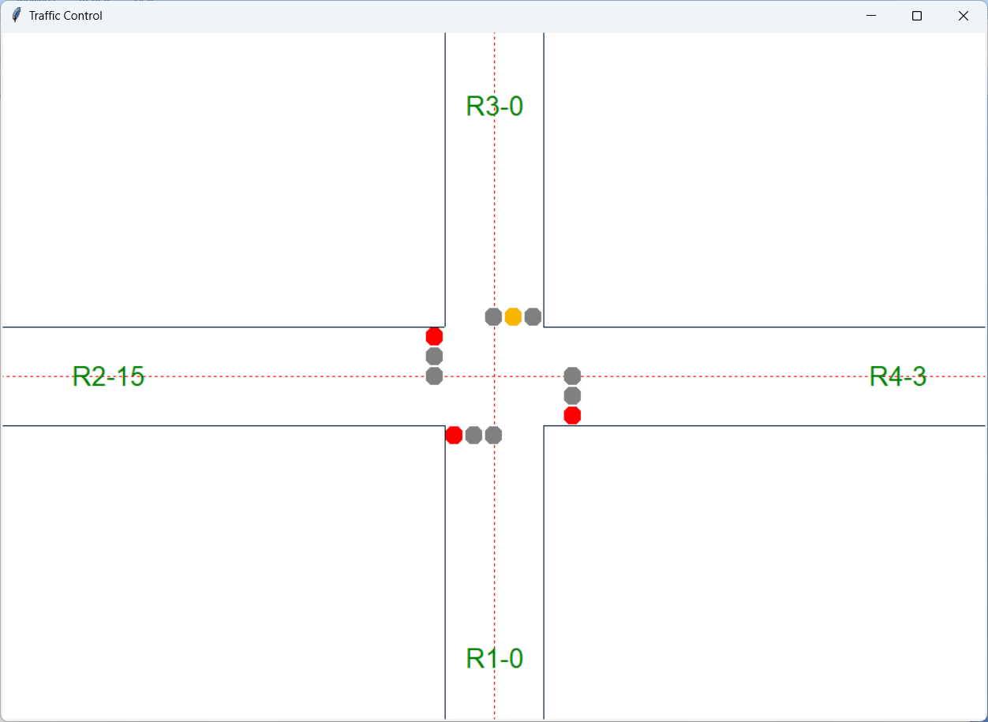

BIBLIOGRAPHY
Book reference:

Reema Thareja, “PYTHON PROGRAMMING 2E” OUP India; 2nd edition (16 February 2023); Oxford University Press India

Ryan Turner, “Python Programming: 3 books in 1 - Ultimate Beginner's, Intermediate & Advanced Guide to Learn Python Step by Step”, Nelly B.L. International Consulting Ltd. (9 February 2020)

Ramsey Hamilton, “PYTHON: PROGRAMMING: A BEGINNER’S GUIDE TO LEARN PYTHON IN 7 DAYS “ 2023

James Tudor, “Python Programming For Beginners: Learn The Basics Of Python Programming (Python Crash Course, Programming for Dummies) “, 2023
Web References:
  - https://www.python.org/
  - https://ftp.math.utah.edu/pub/tex/bib/python.pdf

